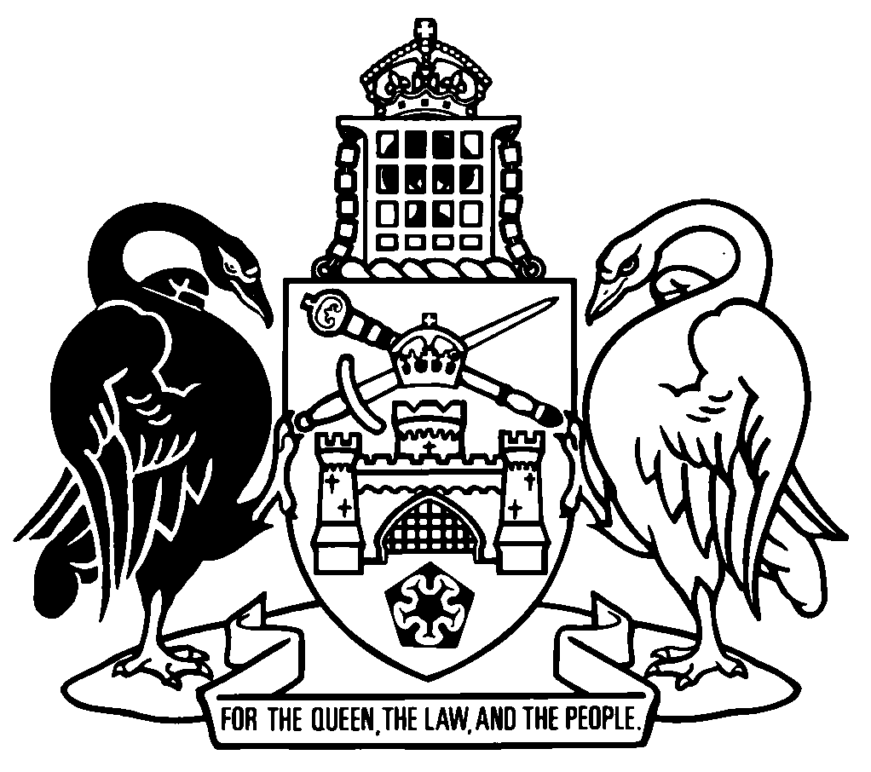
Australian Capital Territory
Human Rights (Healthy Environment) Amendment Act 2024
A2024-43

An Act to amend the Human Rights Act 2004

The Legislative Assembly for the Australian Capital Territory enacts as follows:

1 Name of Act
This Act is the Human Rights (Healthy Environment) Amendment Act 2024.

2 Commencement
This Act commences on a day fixed by the Minister by written notice.
Note 1 The naming and commencement provisions automatically commence on the notification day (see Legislation Act, s 75 (1)).
Note 2 A single day or time may be fixed, or different days or times may be fixed, for the commencement of different provisions (see Legislation Act, s 77 (1)).
Note 3 If a provision has not commenced within 6 months beginning on the notification day, it automatically commences on the first day after that period (see Legislation Act, s 79).

3 Legislation amended
This Act amends the Human Rights Act 2004.

4 Economic, social and cultural rights
Part 3A heading, note
substitute
Note 1 The primary sources of these rights are the International Covenant on Economic, Social and Cultural Rights and the United Nations General Assembly, The human right to a clean, healthy and sustainable environment, A/RES/76/300 (28 July 2022).
Note 2 Some aspects of economic, social and cultural rights are considered at international law to be subject to an obligation of progressive realisation.
Note 3 An international law relevant to interpreting progressively realisable rights is Article 8 (4) of the Optional Protocol to the International Covenant on Economic, Social and Cultural Rights. That article provides for consideration of the reasonableness of steps taken to progressively realise rights and notes that a range of possible policy measures for the implementation of rights may be adopted.

5 Right to work and other work-related rights
Section 27B, notes 2 and 3
omit

6 New section 27C
in part 3A, insert
27C Right to a healthy environment

(1) Everyone has the right to a clean, healthy and sustainable environment.

(2) Everyone is entitled to enjoy this right without discrimination.
Note 1 Section 28 sets out what must be considered in deciding whether a limit on rights is reasonable.
Note 2 Aboriginal and Torres Strait Islander peoples hold distinct cultural rights in relation to the land and waters and other resources (see s 27 (2) (b)).

7 Legal proceedings in relation to public authority actions
New section 40C (5A) and (5B)
insert

(5A) This section does not apply to a claim that a public authority has acted in contravention of section 40B if the contravention claimed is—
(a) that the public authority acted in a way that is incompatible with the human right set out in section 27C (Right to a healthy environment); or
(b) in making a decision, the public authority failed to give proper consideration to the human right set out in section 27C.

(5B) To remove any doubt, subsection (5A) does not prevent a person making a claim in relation to another human right, even if the subject matter of the claim or part of the claim is the same, similar or related to the subject matter of a claim to which subsection (5A) applies.
Example
A person may claim a public authority acted in a way that is incompatible with the human right set out in s 9 (Right to life) and the subject matter of the claim may include an exposure of the person to an environmental risk to their health that is life threatening.

8 New section 40C (8)
insert

(8) Subsections (5A), (5B) and this subsection expire on 1 October 2028.

9 New section 43
insert
43 Review of amendments made by Human Rights (Healthy Environment) Amendment Act 2024

(1) The Minister must review the operation of the amendments to this Act made by the Human Rights (Healthy Environment) Amendment Act 2024.

(2) In undertaking the review, the Minister must—
(a) consider the categorisation of the human right set out in section 27C as an economic, social and cultural right; and
(b) evaluate the prohibition under section 40C (5A) on a person starting a proceeding or relying on their rights in relation to a claim that a public authority has acted in contravention of section 40B if the contravention claimed is—
(i) that the public authority acted in a way that is incompatible with the human right set out in section 27C; or
(ii) in making a decision, the public authority failed to give proper consideration to the human right set out in section 27C; and
(c) despite section 40C (8)—consider whether the prohibition under section 40C (5A) remains appropriate.

(3) The Minister must—
(a) begin the review not later than 1 October 2027; and
(b) present a report of the review to the Legislative Assembly as soon as practicable after the report is completed.

(4) This section expires on 1 October 2028.

(5) In this section:
public authority—see section 40C (7).

10 ICESCR source of human rights
Schedule 2, new note
insert
Note 2 The primary source of the right in s 27C is the United Nations General Assembly, The human right to a clean, healthy and sustainable environment, A/RES/76/300 (28 July 2022).

Endnotes
1 Presentation speech
Presentation speech made in the Legislative Assembly on 26 October 2023.
2 Notification
Notified under the Legislation Act on 17 September 2024.
3 Republications of amended laws
For the latest republication of amended laws, see www.legislation.act.gov.au.

I certify that the above is a true copy of the Human Rights (Healthy Environment) Amendment Bill 2024, which originated in the Legislative Assembly as the Human Rights (Healthy Environment) Amendment Bill 2023 and was passed by the Assembly on 28 August 2024.

Clerk of the Legislative Assembly

© Australian Capital Territory 2024

