
Australian Capital Territory
Planning (Molonglo Town Centre) Amendment Act 2025
A2025-23

An Act to amend the Planning Act 2023

The Legislative Assembly for the Australian Capital Territory enacts as follows:

1 Name of Act
This Act is the Planning (Molonglo Town Centre) Amendment Act 2025.

2 Commencement
This Act commences on the day after its notification day.
Note The naming and commencement provisions automatically commence on the notification day (see Legislation Act, s 75 (1)).

3 Legislation amended
This Act amends the Planning Act 2023.

4 Definitions—sch 6
Schedule 6, section 6.1, new definition of Molonglo town centre
insert
Molonglo town centre means the area outlined in bold on the plan in this schedule, division 6.3.3A.

5 Schedule 6, section 6.1, definition of town centre
after
Gungahlin town centre,
insert
the Molonglo town centre,

6 Schedule 6, new division 6.3.3A
insert
Division 6.3.3A Molonglo town centre

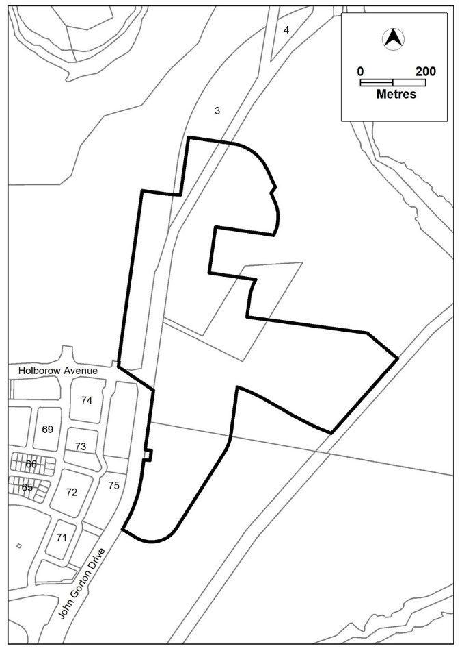

7 Dictionary, new definition of Molonglo town centre
insert
Molonglo town centre, for schedule 6 (Matters exempt from third party ACAT review)—see schedule 6, section 6.1.

Endnotes
1 Presentation speech
Presentation speech made in the Legislative Assembly on 25 June 2025.
2 Notification
Notified under the Legislation Act on 12 September 2025.
3 Republications of amended laws
For the latest republication of amended laws, see www.legislation.act.gov.au.

I certify that the above is a true copy of the Planning (Molonglo Town Centre) Amendment Bill 2025, which was passed by the Legislative Assembly on 4 September 2025.

Clerk of the Legislative Assembly

© Australian Capital Territory 2025

