Consultation on the exposure draft of the
Animal Welfare Legislation Amendment Bill 2019
The consultation period for the exposure draft will be Thursday 13 December 2018 to
Thursday 7 February 2019.
Submissions to: communityengagement@act.gov.au
See also: www.yoursay.act.gov.au

Overview
The ACT Government released the ACT Animal Welfare and Management Strategy 2017-22 (the Strategy) in September 2017. The Strategy committed to a review of animal welfare and management laws in the ACT to ensure, among other things, that the laws were up-to-date, best practice and in line with community expectations to ensure the highest standards of animal welfare and management. The strategy was developed in partnership with the Animal Welfare Advisory Committee (AWAC), the ACT Veterinary Surgeons Board, RSPCA ACT and ACT Wildlife.
Substantial amendments were made to the Domestic Animals Act 2000 in December 2017 and April 2018. These amendments delivered on the commitment in the Strategy around animal management laws, with a strong focus on managing dangerous dogs and ensuring community safety.
A review of the Animal Welfare Act 1992 (AW Act) has now been completed, in partnership with the RSPCA ACT and AWAC, to deliver on the commitment to review animal welfare laws. This review has considered national and international best-practice, and the views of the community put forward during consultation on the Strategy.
An Animal Welfare Amendment Bill 2019 (the Bill) is now proposed to give effect to this review.
The proposed Bill is intended to deliver a comprehensive suite of amendments to the AW Act, as well as minor amendments to the Domestic Animals Act 2000 and other consequential amendments as required, to ensure that the ACT has a best-practice, contemporary and effective regulatory system that protects and promotes the welfare of animals, prevents and deters cruelty to animals and responds appropriately to animal welfare abuses
(see Figure 1).
The proposed Bill seeks to improve the legislative framework by making a number of amendments that fit within the overall objective of the new legislative framework which is to:
- recognise animals are sentient beings;
- ensure animals are shown compassion and have an acceptable quality of life;
- protect and promote animal welfare;
- prevent and deter cruelty to animals; and
- respond appropriately to animal welfare offences.

Consistent with the objectives of the Strategy, the amendments aim to:
- create a robust and flexible regulatory framework that ensures animal welfare outcomes;
- be able to respond to changes in the attitudes and expectations of the community, animal industries and welfare organisations;
- be proportionate to risk; and
- be responsive to emerging evidence based animal welfare trends.

Figure 1: Aim of the Animal Welfare Amendment Bill 2019

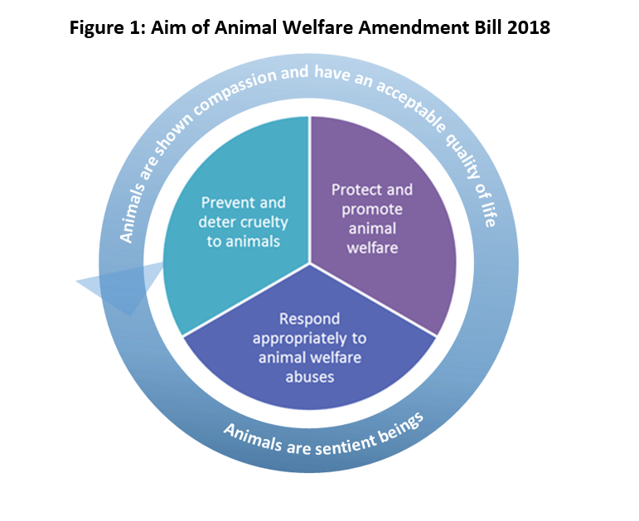
Key features of the framework are:
- regulation of some pet businesses, specifically boarding establishments and pet shops, as well as assistance animals for better animal welfare outcomes;
- an effective regulatory response framework that ensures animals at risk can be seized, detained and rehomed where appropriate, and a person can quickly and efficiently be prevented from owning other animals; and
- introduce new classifications of minor animal welfare offences that attract warnings and fines to ensure an escalating enforcement framework exists under the AW Act.
The Licensing and Compliance area of TCCS, which includes Domestic Animal Services (responsible for animal welfare) published an Accountability Commitment in September 2018.
All regulatory actions by Domestic Animal Services are supported by a Regulatory Advisory Committee (RAC). To support the recent legislative changes to the Domestic Animals Act 2000 the Government commissioned an independent expert review of the management of dogs in the ACT, including the regulatory response framework under the Domestic Animals Act 2000. The review was undertaken by a panel of international and local experts in the fields of animal regulation, veterinary practice and animal law. The panel found that the RAC was world-leading and considered to be a best-practice approach to decision making, which is now being considered for introduction in international jurisdictions.
The Independent Expert Review, Government Response and Accountability Commitment is available at www.tccs.act.gov.au.

The Animal Welfare Act 1992
The AW Act has been in place in the ACT for over 25 years. It was introduced to replace the Prevention of Cruelty to Animals Act 1959 which was considered to no longer provide the degree of protection and control the community required in relation to animal welfare, and was intended to reflect modern attitudes to, and introduce efficient controls on, the keeping and use of animals.
The AW Act was designed to promote the welfare of animals in three ways:
- prescribing behaviour which is considered to be cruel or against the health and welfare of animals;
- a control system of licences, authorisations and permits for:
  - research, teaching and breeding;
  - conducting a circus; using restricted animal traps; and
- promoting and enhancing awareness and understanding of the proper treatment of animals by the adoption of Codes of Practice.
The Act is supported by the Animal Welfare Regulation 2001 and Magistrates Court (Animal Welfare Infringement Notices) Regulation 2014 that sets out a supporting infringement notice (fine) framework for the Act.
The AW Act allows the Chief Executive to appoint inspectors for the purposes of enforcing the Act. Officers from within the RSPCA ACT have been appointed as inspectors due to their outstanding knowledge of the types of actions or omissions of actions that constitute an offence under the Act. This is similar to models in other jurisdictions in Australia.
The ACT Government and RSPCA ACT work together to ensure animals in the ACT receive appropriate levels of welfare.
Previous consultation
The Animal Welfare and Management Strategy was developed with extensive stakeholder input and a public consultation process was undertaken in April and May 2017. Collaboration occurred with AWAC, RSPCA ACT, ACT Wildlife and the ACT Veterinary Surgeons Board. A number of other animal welfare stakeholders were also consulted during the development of the Strategy.
110 submissions were received during the public consultation period on the Strategy. Some key themes emerging from the public consultation process were:
- people are concerned about animal welfare;
- legislation should be reviewed frequently;
- animals should be recognised as sentient in the legislation;
- improved enforcement of animal legislation is needed;
- fines and penalties need to be increased and early intervention should be provided for;
- there is not enough being done about animal abuse;
- pet businesses should be licenced/regulated;
- make it a specific offence to strike or hit an animal; and
- electric shock collars should not be allowed.

Summary of proposed changes
In summary, the proposed Bill will:
- update the objects of the AW Act to ensure that animals are recognised as sentient beings with intrinsic value, that animals are shown compassion and have an acceptable quality of life and to reflect the community’s expectations around animal welfare and the proper treatment of all animals. The objects of the Act will also now expressly include the prevention and deterrence of animal cruelty and the importance of appropriately responding to animal welfare offences.
- establish a governance framework so that the Animal Welfare Advisory Committee (AWAC) can act as an advisory board to the Animal Welfare Authority, as well as the Minister for City Services. This delivers on a key action in the Animal Welfare and Management Strategy to review the AWAC governance arrangements.
- set out a high level framework for regulating pet businesses, specifically boarding kennels and pet shops. It is not intended to be overly burdensome on businesses, but to be outcomes focussed and ensure a reputable system of operating pet businesses for the community where animal welfare can be assured
(see Figure 2 below). There will be the ability to include additional pet businesses in the future as needed.

Figure 2: what regulation of pet businesses could look like
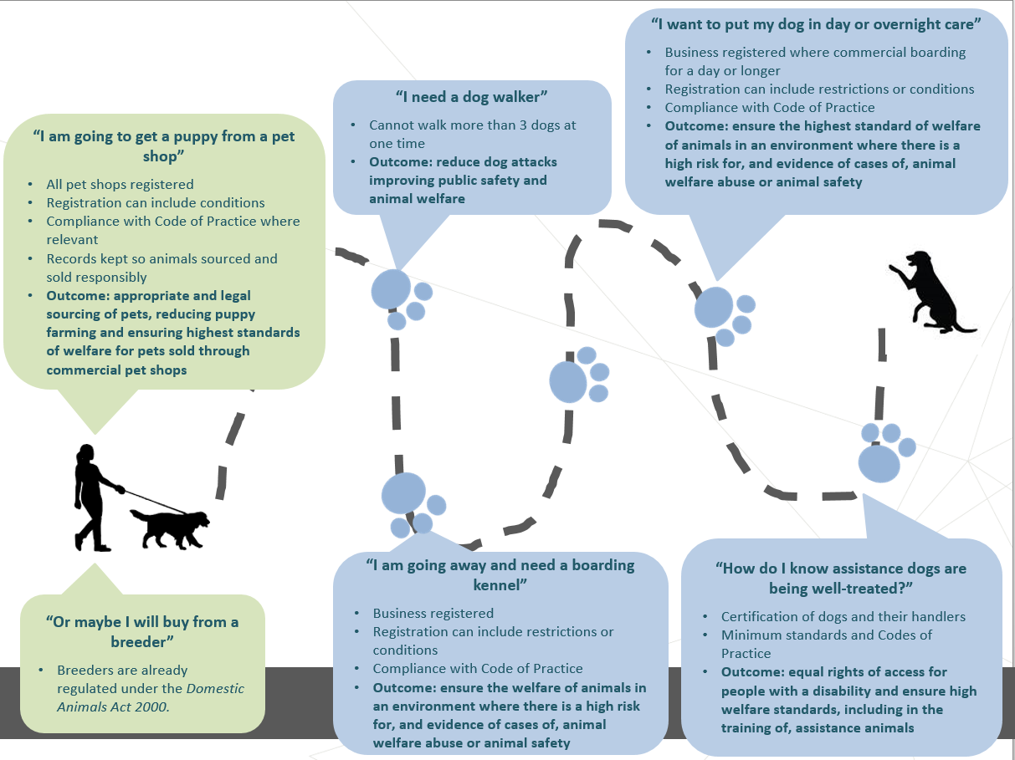

- Restrict any one person to walking a maximum of three dogs at any one time. This has been a recurrent issue in the ACT that can result not only in animal welfare concerns, but also be a contributing factor to dog attacks in the ACT. No more than three dogs can reside at one premises at one time under the Domestic Animals Act 2000 and where a multiple dog licence is granted for more than three dogs to reside at a premises a condition is placed on that licence stating that a person cannot take more than three of those dogs into a public place at one time, for the reasons mentioned above. This will align these provisions. NSW currently has a limitation on walking no more than four dogs at one time.
- Set out a regulatory framework for assistance animals, and in particular assistance dogs, to model off best practice in other jurisdictions and following feedback from the assistance dogs industry. This will provide for appropriate animal welfare protection for dogs being trained as assistance dogs, appropriate registration, identification and certification of assistance animals, as well as provide for improved rights of access for people with a disability (see Figure 3 below). The scheme will allow for a person to train their own assistance animal and this can be accredited in a number of ways, including by the ACT Government to ensure appropriate access and consideration for all people, including low income earners.

Figure 3: proposed new assistance dog framework
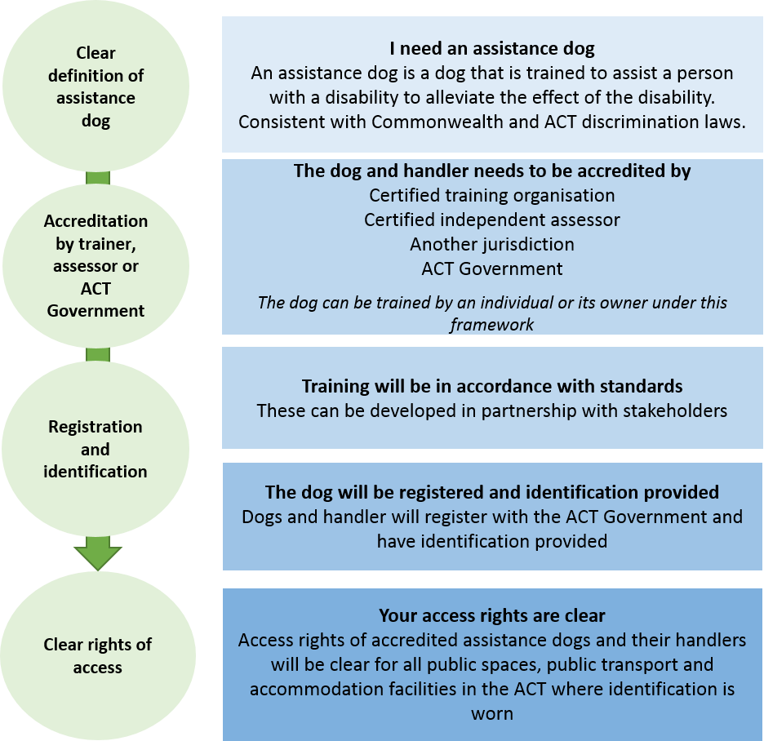

- set out a framework, similar to the Domestic Animals Act 2000, where the Animal Welfare Authority can make administrative decisions, supported by a Regulatory Advisory Committee, to:
  - impose an interim ownership ban of up to 6 months where the Animal Welfare Authority believes and offence has been committed and has serious concerns about the welfare of an animal or animal/s. This will be an appealable decision;
  - seize, retain and/or sell or rehome a seized animal where appropriate;
  - impound an animal at a premises other than a Government pound (e.g. keeping seized puppies with an animal rescue organisation).
- introduce a new offence category for minor duty-of-care or cruelty offences where warnings and fines can be issued where appropriate (for example, where a person does not leave out water for their dog or kicks a dog in anger). The existing serious offences that attract significant financial and court penalties will remain and still be available.
- make a number of amendments to introduce new or amend current offences in the Act. Key changes include:
  - requiring a person to report the injury of a mammal within 2 hours, rather than the current 24 hours in the Act (e.g. where a person hits a kangaroo with their car and the kangaroo needs urgent medical treatment) and making this a fineable offence;
  - introducing provisions that expressly address dog fighting and allow for effective enforcement of dog fighting offences. Currently there is no offence or enforcement available specifically for dog fighting or violent animal activities. Provision are modelled from South Australia;
  - capturing the working of unfit animals in the context of ‘showing animals’ as an offence (e.g. showing a seriously unwell dog in a dog show);
  - capturing the working of unfit animals in the context of ‘showing animals’ (e.g. showing a seriously unwell dog in a dog show);
  - ensuring that there is an ability to issue a direction to comply with a mandatory code of practice to a business, as well as a non-business. This is particularly important to support the proposed regulation of pet businesses;
  - increase maximum court imposed penalty for cruelty and aggravated cruelty offences, following internal review and feedback from prosecutions; and
  - expressly making it an offence for a person to leave an animal in a hot car, and providing appropriate provision to break into a car to rescue an animal; and
- make other minor changes to support the practical implementation and enforcement of the Act. For example, improving the provisions around animal ownership bans, including mutual recognition of ownership bans across States and Territories.

