Australian Capital Territory
Road Transport (General) (Application of Road Transport Legislation) Declaration 2004 (No 5)
Disallowable instrument — DI2004-54
made under the
Road Transport (General) Act 1999, s12 (Power to include or exclude areas in road transport legislation)

I declare that the road transport legislation does not apply to the ACT roads or road related areas used or impinged on by any vehicle participating in a ‘green’ special stage of:

- the Subaru Rally of Canberra pre-event testing sessions, from 3 May 2004 to 5 May 2004, both dates inclusive; and

- the Subaru Rally of Canberra, on 8 May 2004 and 9 May 2004.

For this declaration, the following definitions apply:

Competing vehicle means:
Any vehicle used for participating in a ‘green’ special stage of the Subaru Rally of Canberra pre-event test sessions or of the Subaru Rally of Canberra.

‘Green’ special stage means:
The period from the time when a special stage is declared to be active for rally competition or rally testing until the time when course control for that special stage is closed.

Special stage means:
- The test routes shown on Map 1 (Hyles Block), Map 2 (Bullock 2), Map 3 (Miowera), Map 4 (Block 12), Map 5 (Sinclairs), Map 6 (Pierce’s Creek Forest) and Map 7 (Kowen North); and

- The competitive routes for the special stages shown on Map 8:
  - Special Stage 1 (SS1) – Greenhills West I; and
  - Special Stage 9 (SS9) – Greenhills West II;

- The competitive route for the special stage shown on Map 9:
  - Special Stage 2 (SS2) – Lees Padovans

- The competitive routes for the special stages shown on Map 10:
  - Special Stage 3 (SS3) – Bluetts I; and
  - Special Stage 7 (SS7) – Bluetts II;

- The competitive route for the special stage shown on Map 11:
  - Special Stage 4 (SS4) – Oakey Creek;

- The competitive route for the special stage shown on Map 12:
  - Special Stage 5 (SS5) – Mineshaft Long;

- The competitive routes for the special stages shown on Map 13:
  - Special Stage 6 (SS6) – Fairbairn Park Super Special I; and
  - Special Stage 14 (SS14) – Fairbairn Park Super Special II;

- The competitive route for the special stage shown on Map 14:
  - Special Stage 8 (SS8) – East West Brain;

- The competitive routes for the special stages shown on Map 15:
  - Special Stage 10 (SS10) – Kowen Road I; and
  - Special Stage 13 (SS13) – Kowen Road II;

This declaration has effect during the ‘green’ special stages of:

- the Subaru Rally of Canberra pre-event testing sessions, from 3 May 2004 to 5 May 2004, both dates inclusive; and

- the Subaru Rally of Canberra, on 8 May 2004 and 9 May 2004.

Indicative start times for vehicles participating in each ‘green’ special stage for the competitive stages of the Subaru Rally of Canberra are set out in the attached event itinerary.

This declaration expires on 10 May 2004.

Bill Wood
Minister for Urban Services
27 April 2004

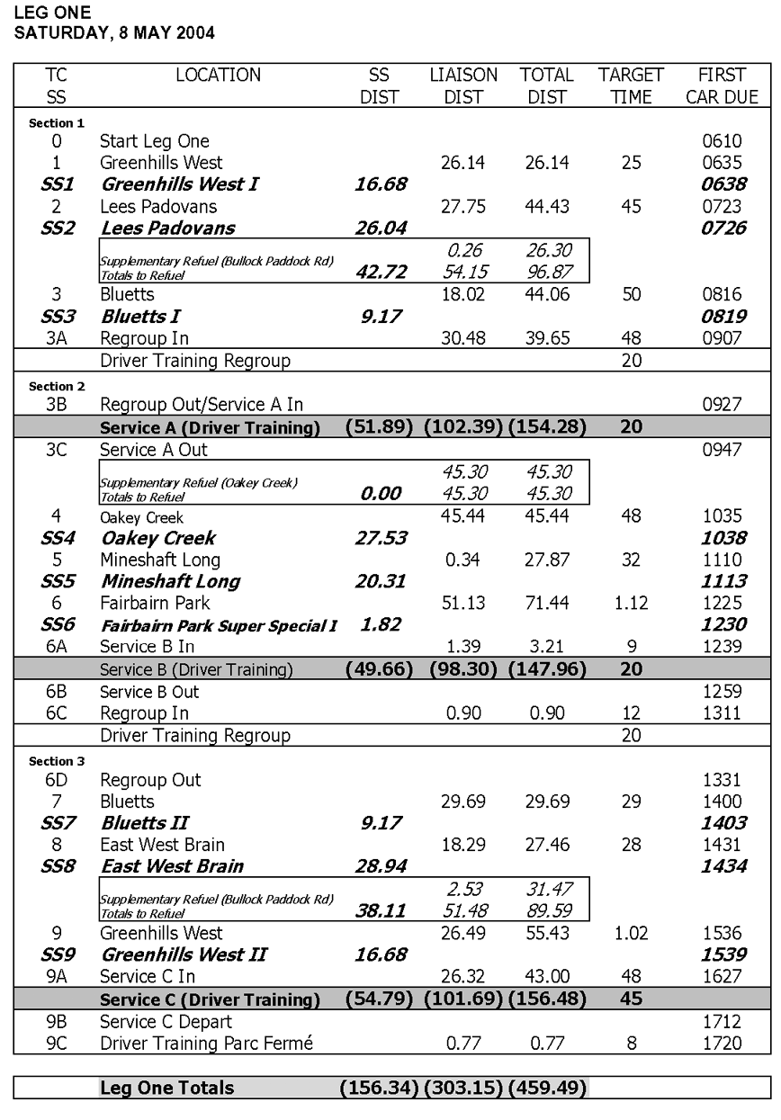
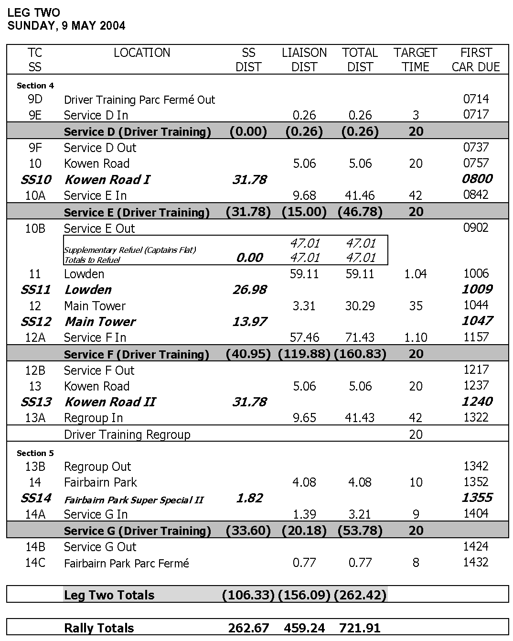
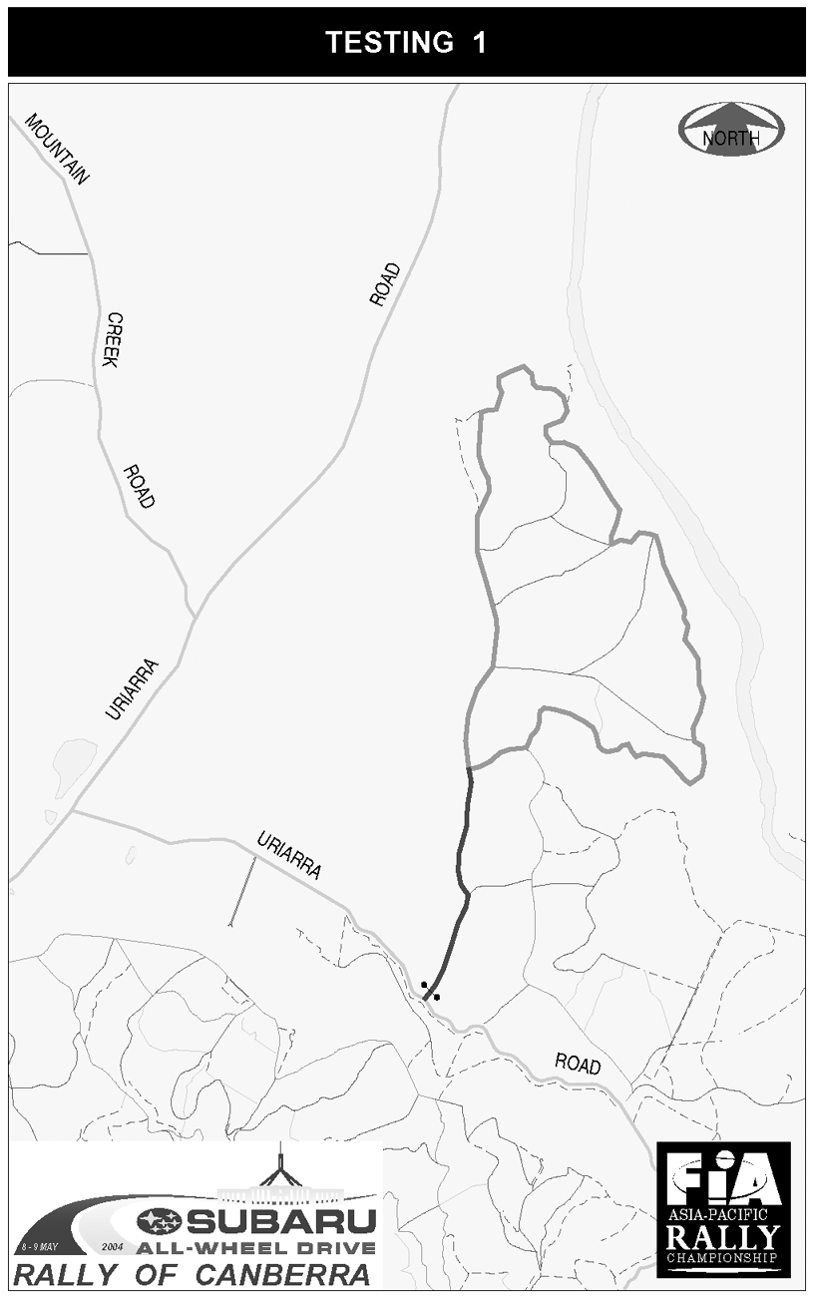
MAP 1
MAP 2
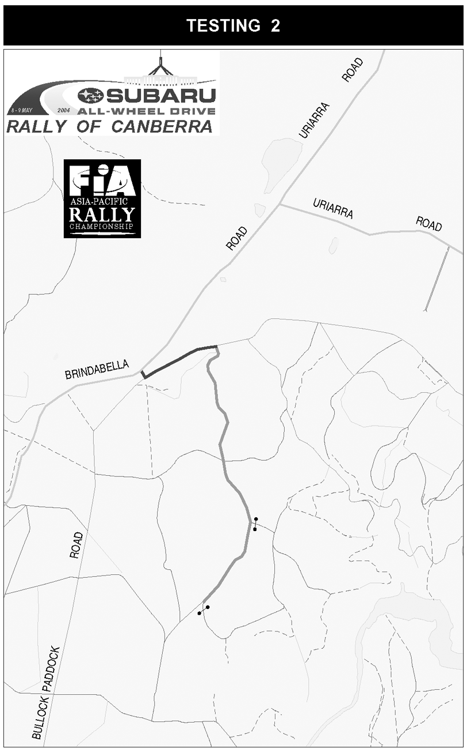
MAP 3
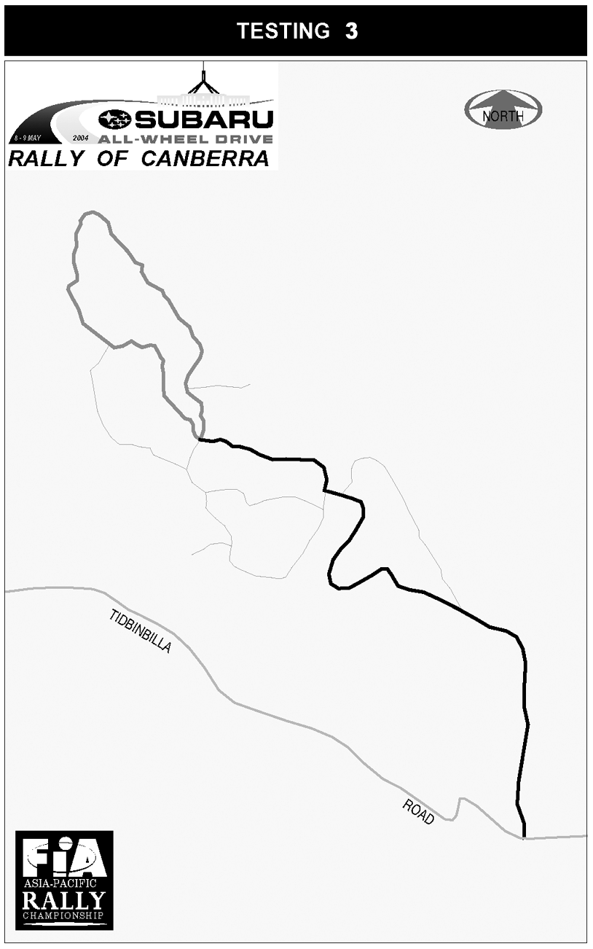
MAP 4
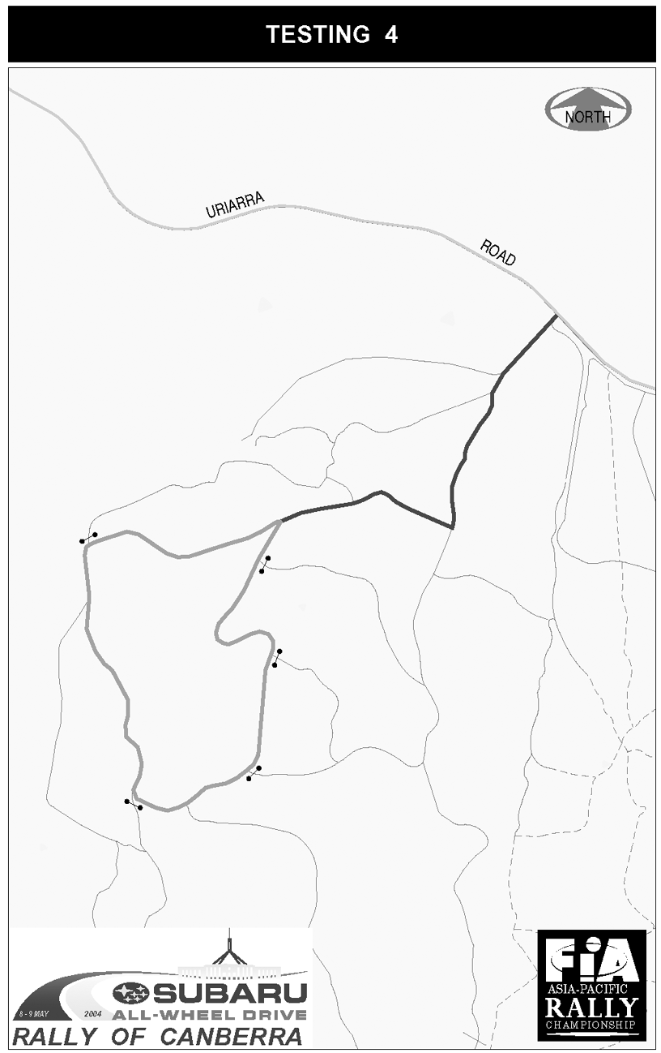
MAP 5
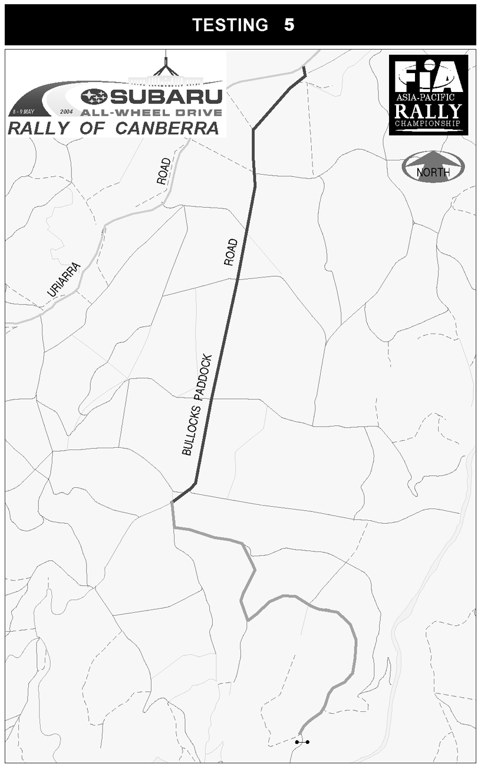
TESTING
MAP 6
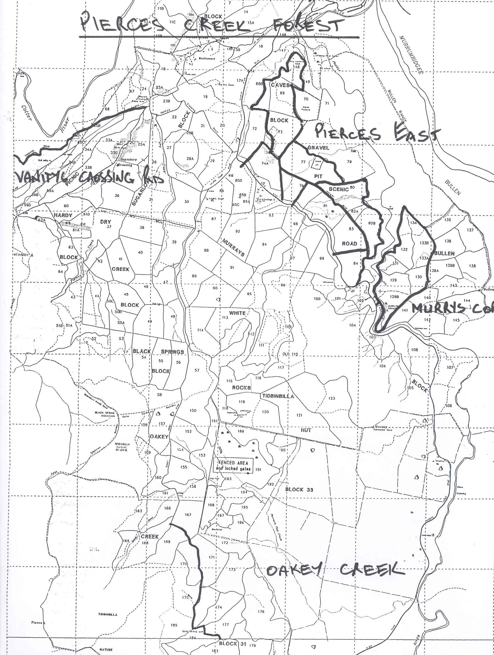
TESTING – KOWEN NORTH
MAP 7
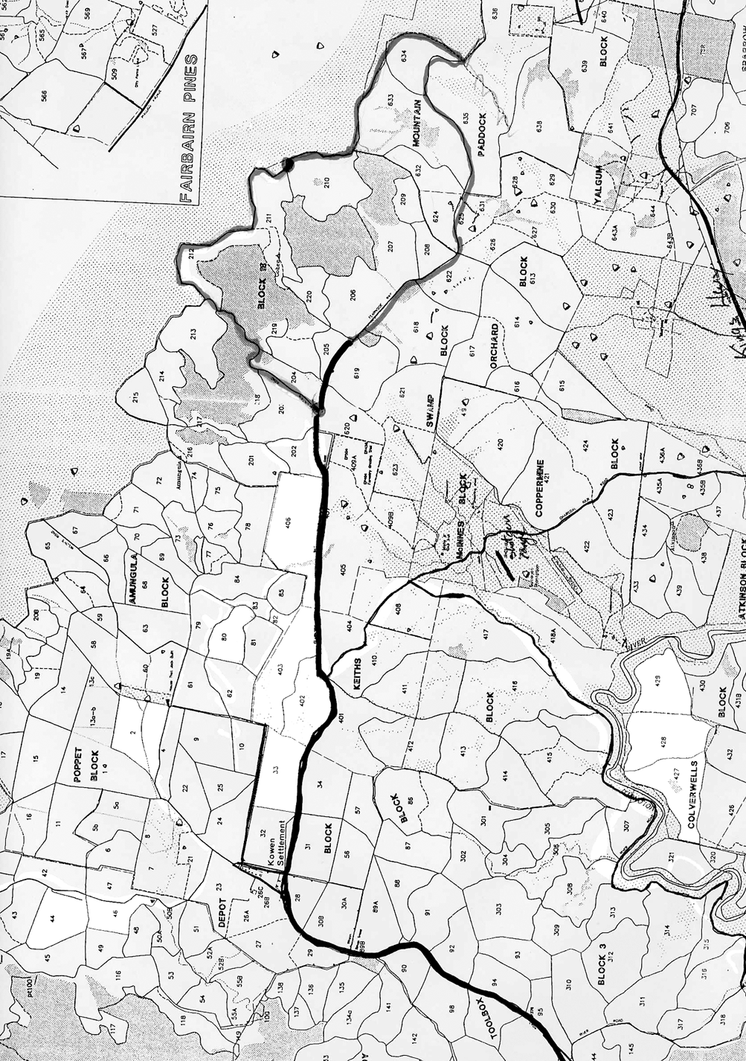
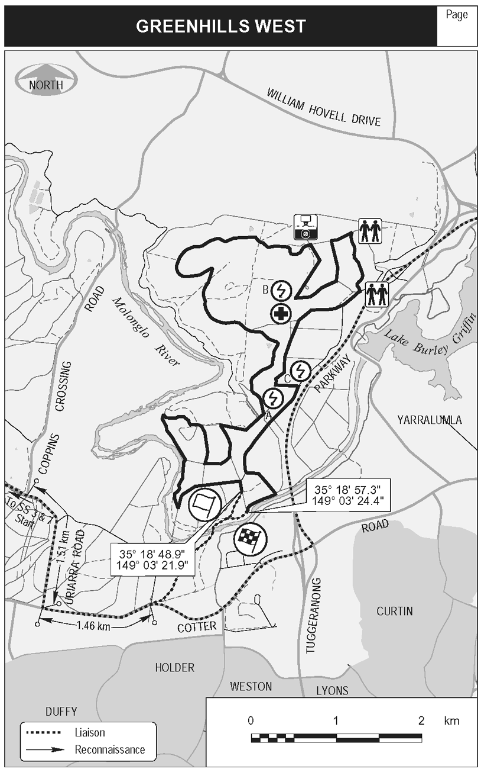
MAP 8
MAP 9
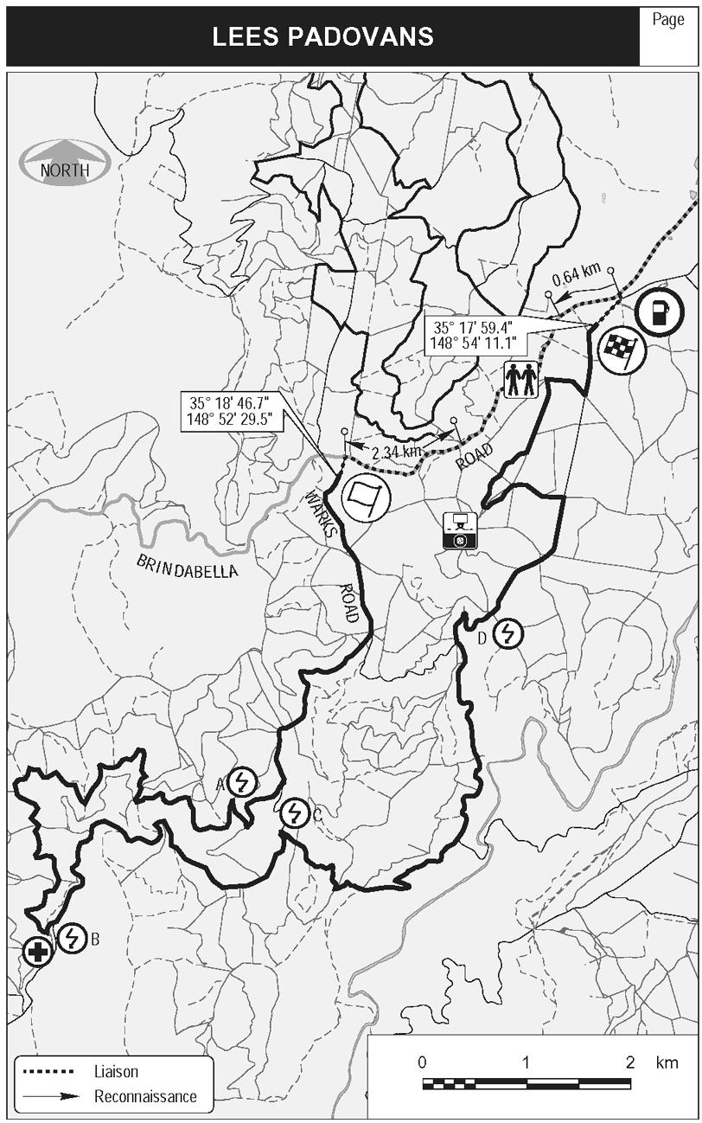
MAP 10
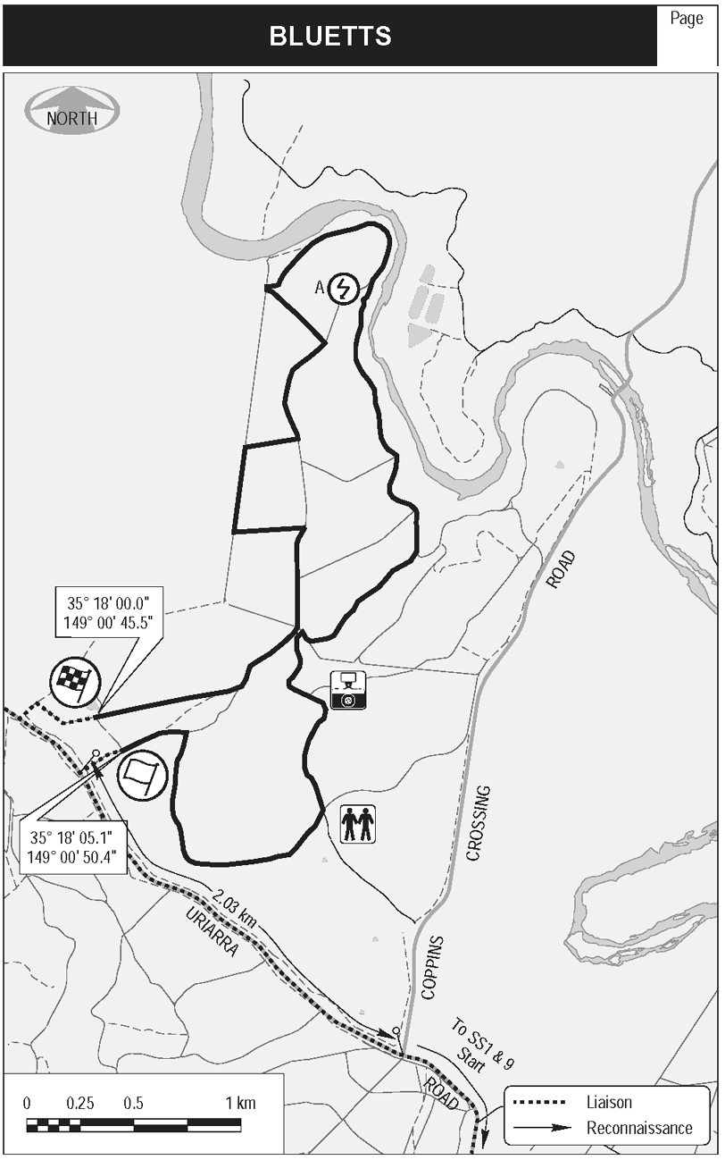
MAP 11
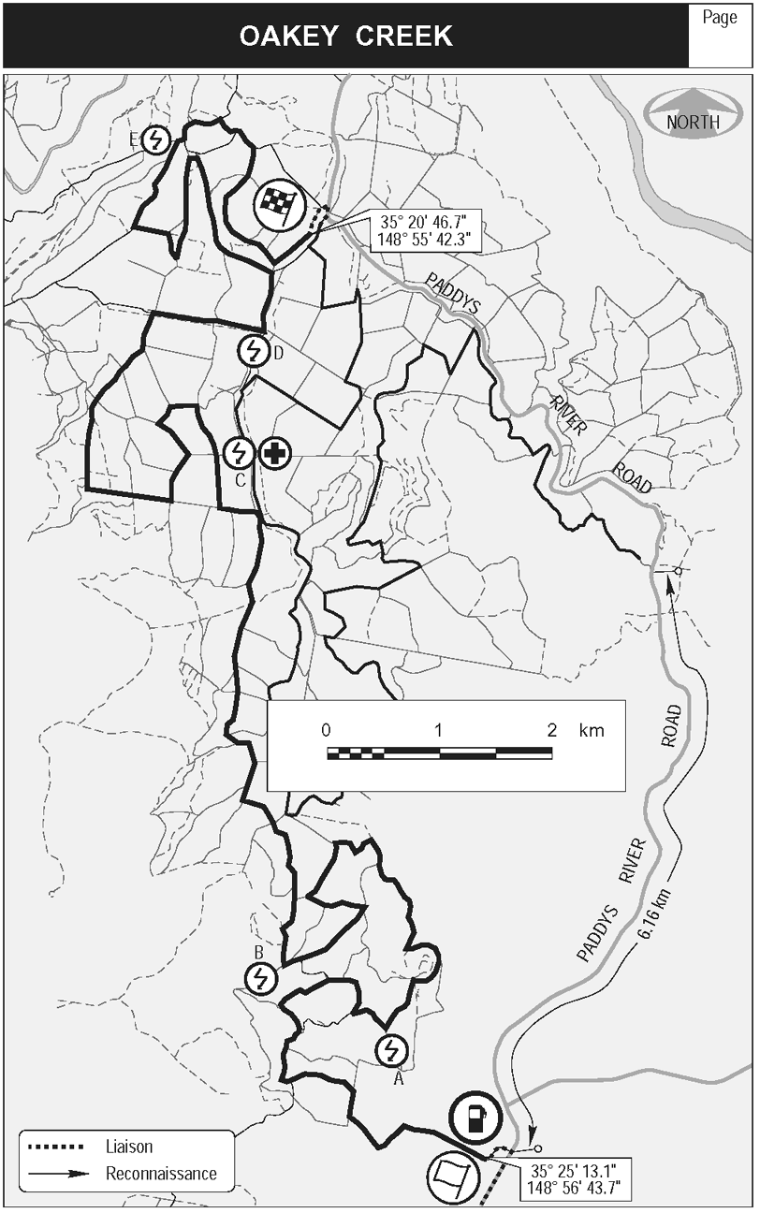
MAP 12
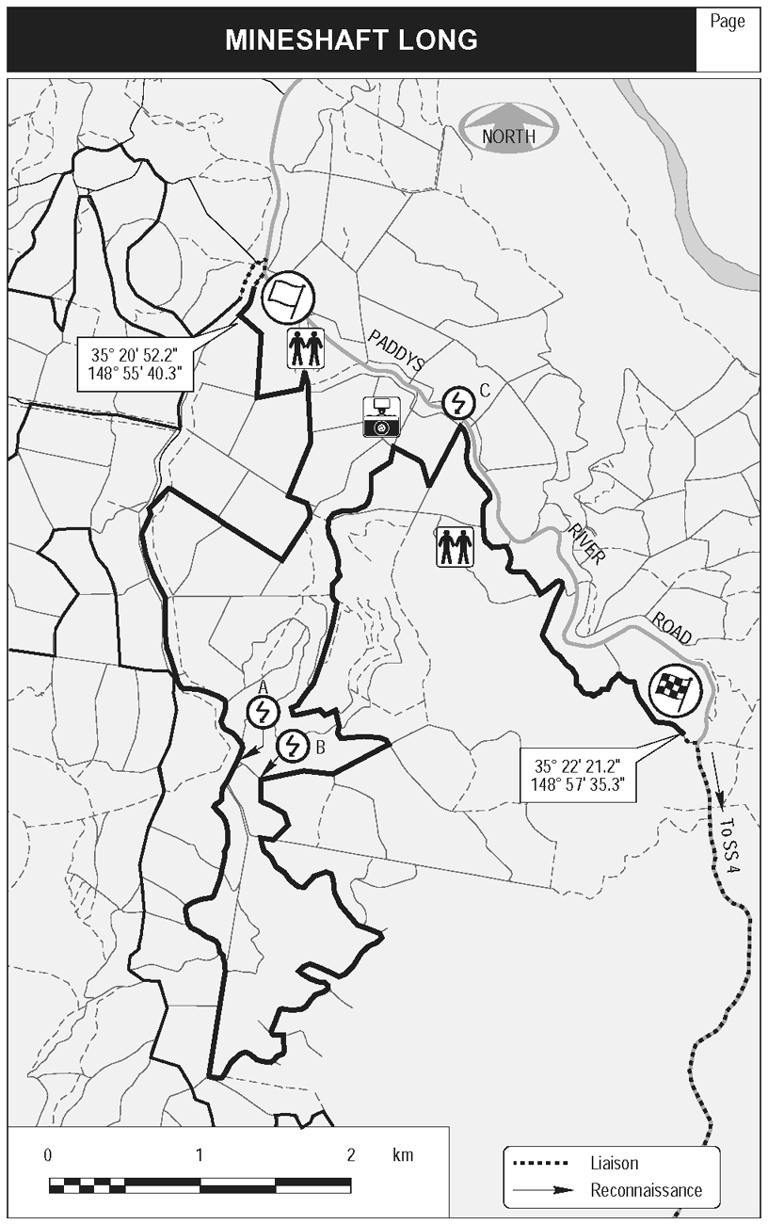
MAP 13
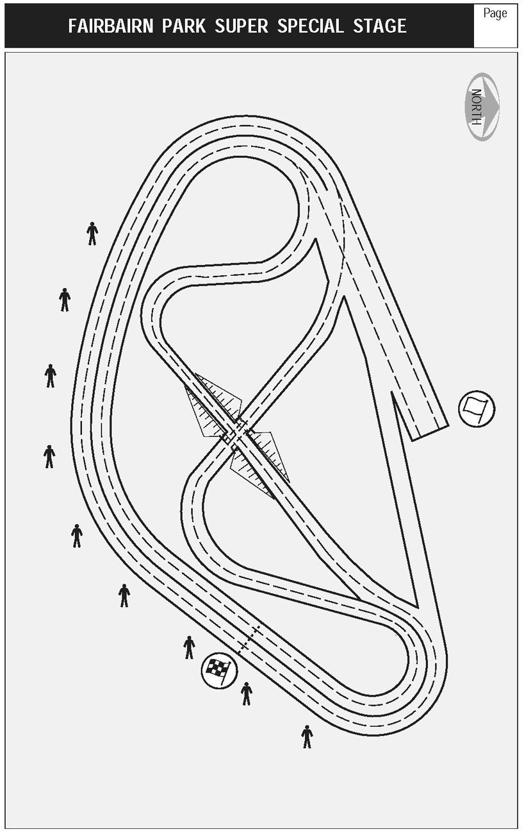
MAP 14
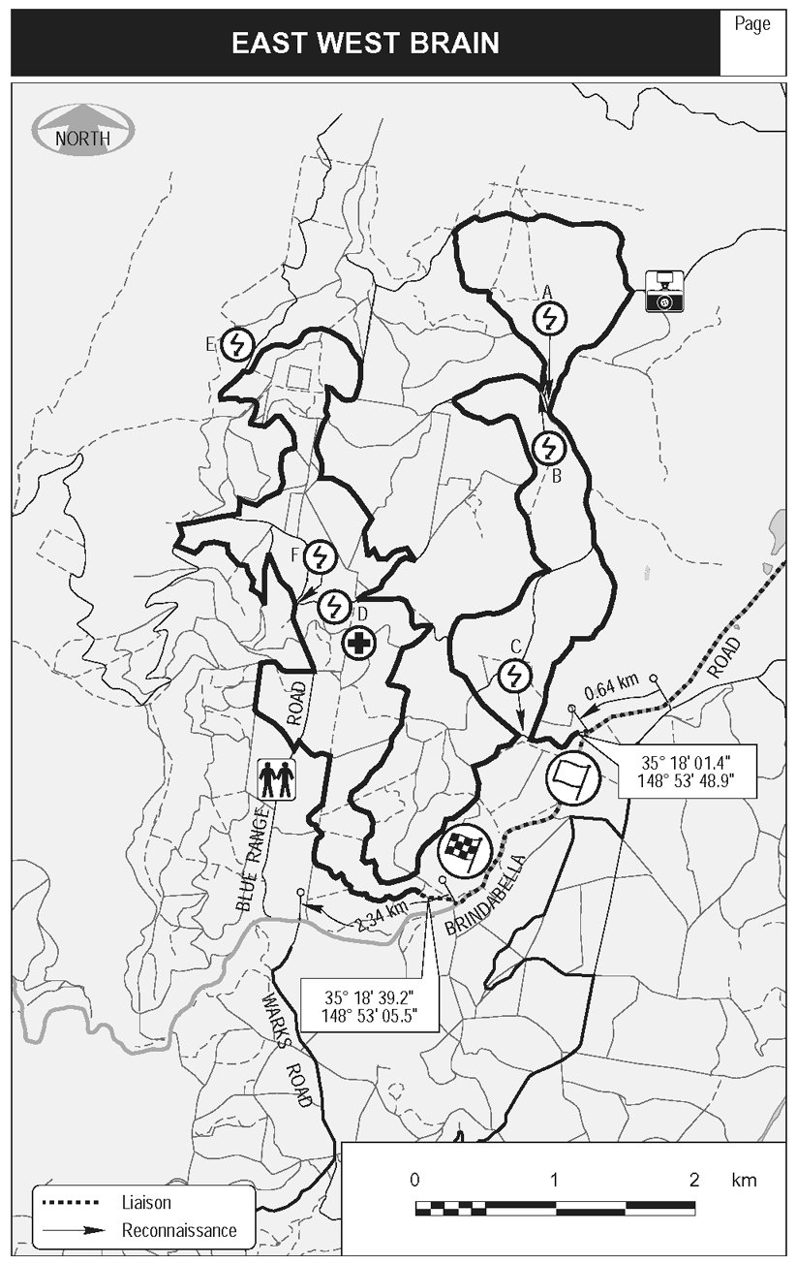
MAP 15
