Australian Capital Territory
Road Transport (General) (Application of Road Transport Legislation) Declaration 2006 (No 9)
Disallowable instrument DI2006—198
made under the
Road Transport (General) Act 1999, s13 (Power to exclude vehicles, persons or animals from road transport legislation)

1 Name of instrument
This instrument is the Road Transport (General) (Application of Road Transport Legislation) Declaration 2006 (No 9).
2 Commencement
This instrument commences on 1 September 2006.
3 Declaration
I declare that the road transport legislation does not apply to the ACT roads or road related areas used or impinged on by any competing vehicle participating in a special stage of the Brindabella Motor Sport Club Snap-On Fyshwick Classic Stages Rally on 2 September 2006.
This declaration has effect during the competitive special stages of the event.
Indicative start times and start control close times for vehicles participating in each competitive special stage of the event are set out in the attached Event Itinerary.
This declaration expires on 4 September 2006.
For this declaration, the following definitions apply:

Competing vehicle means:
Any vehicle used for participating in a special stage of the event.

Event means:
The Brindabella Motor Sport Club Snap-On Fyshwick Classic Stages Rally on 2 September 2006.

Special stage means:

The period from the time when an event official declares a special stage active for rally competition until the time when an event official declares course control for that special stage closed.

The competitive routes for the following special stages shown on the attached maps:
- Special stage 1 – Half Inch Socket I;
- Special stage 2 – Impact Drill I;
- Special stage 3 – Mega Toolbox I;
- Special stage 4 – Half Inch Socket II
- Special stage 5 – Impact Drill II; and
- Special stage 6 – Mega Toolbox II.

John Hargreaves
Minister for the Territory & Municipal Services
15 August 2006

Itinerary 2 September 2006
Stage Name | Total distance (km) | Comp. Distance (km) | Section | Service Time (mins) | Time Allowed (h:min) | "000" Start time | "00" Start time | "0"  Start time | Car 1 Start time | Your car Start time | Car 40 Start time | Control closes | Average speed (kph)
Start of leg one
(Liaison from start) | 3.39 | 0.00 | 1.0-1.1 | nil | 0:07 | 9:30 | 10:00 | 10:15 | 10:30 |  | 11:48 | 12:08 | 29.06
Half Inch Socket I | 15.14 | 7.34 | 1.1-1.2 | nil | 0:20 | 9:42 | 10:12 | 10:27 | 10:42 |  | 12:00 | 12:20 | 45.42
Impact Drill I | 34.30 | 20.20 | 1.2-1.3 | 25 | 1:00 | 10:05 | 10:35 | 10:50 | 11:05 |  | 12:23 | 12:43 | 34.30
MegaToolbox I | 48.02 | 34.62 | 1.3-1.4 | 30 | 1:15 | 11:08 | 11:38 | 11:53 | 12:08 |  | 13:26 | 13:46 | 38.42
Half Inch Socket II | 15.14 | 7.34 | 1.4-1.5 | nil | 0:20 | 12:28 | 12:58 | 13:13 | 13:28 |  | 14:46 | 15:06 | 45.42
Impact Drill II | 34.30 | 20.20 | 1.5-1.6 | 25 | 1:00 | 12:51 | 13:21 | 13:36 | 13:51 |  | 15:09 | 15:29 | 34.30
MegaToolbox II | 44.88 | 34.62 | 1.6-1.7 | nil | 0:50 | 13:54 | 14:24 | 14:39 | 14:54 |  | 16:12 | 16:32 | 53.86
(Finish) |  |  |  |  |  | 14:49 | 15:19 | 15:34 | 15:49 |  | 17:07 | 17:27
TOTAL | 195.17 | 124.32
Time in Control SS1 & 4 | 0:05 | mins
Time in Control | 0:03 | mins
Diff Car 1-40 | 1:18 | mins
Late Time | 0:20 | mins
"000" | 1:00 | hours
"00" | 0:30 | mins
"0" | 0:15 | mins

SPECIAL STAGE 1 : HALF INCH SOCKET I

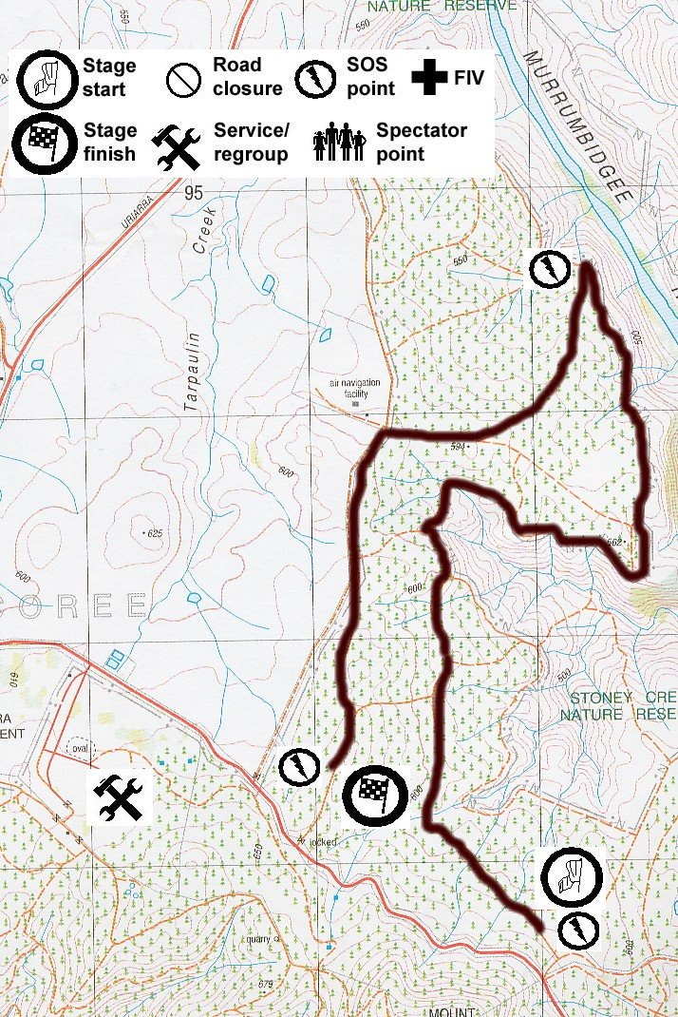

SPECIAL STAGE 2 : IMPACT DRILL I

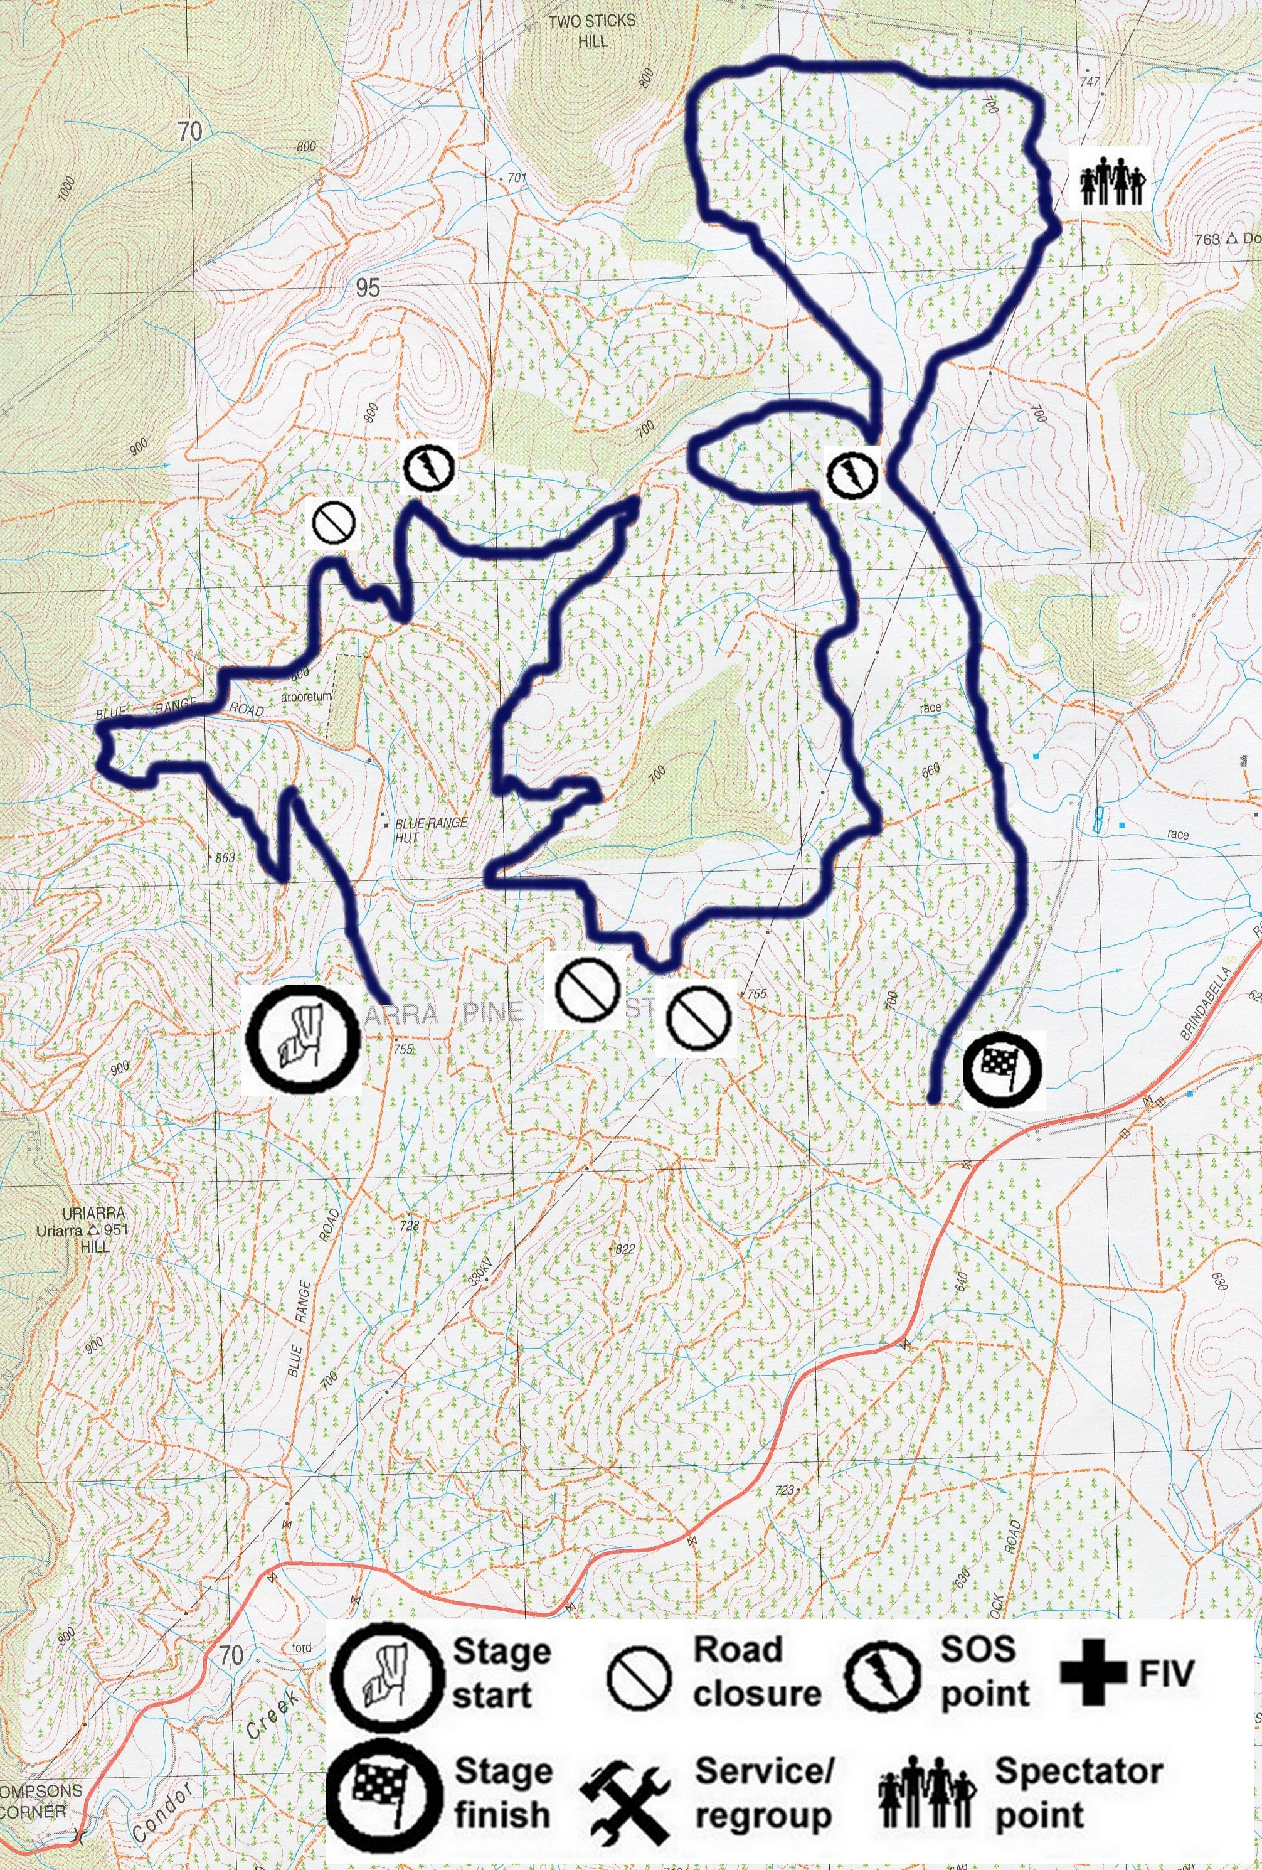

SPECIAL STAGE 3 : MEGA TOOLBOX I

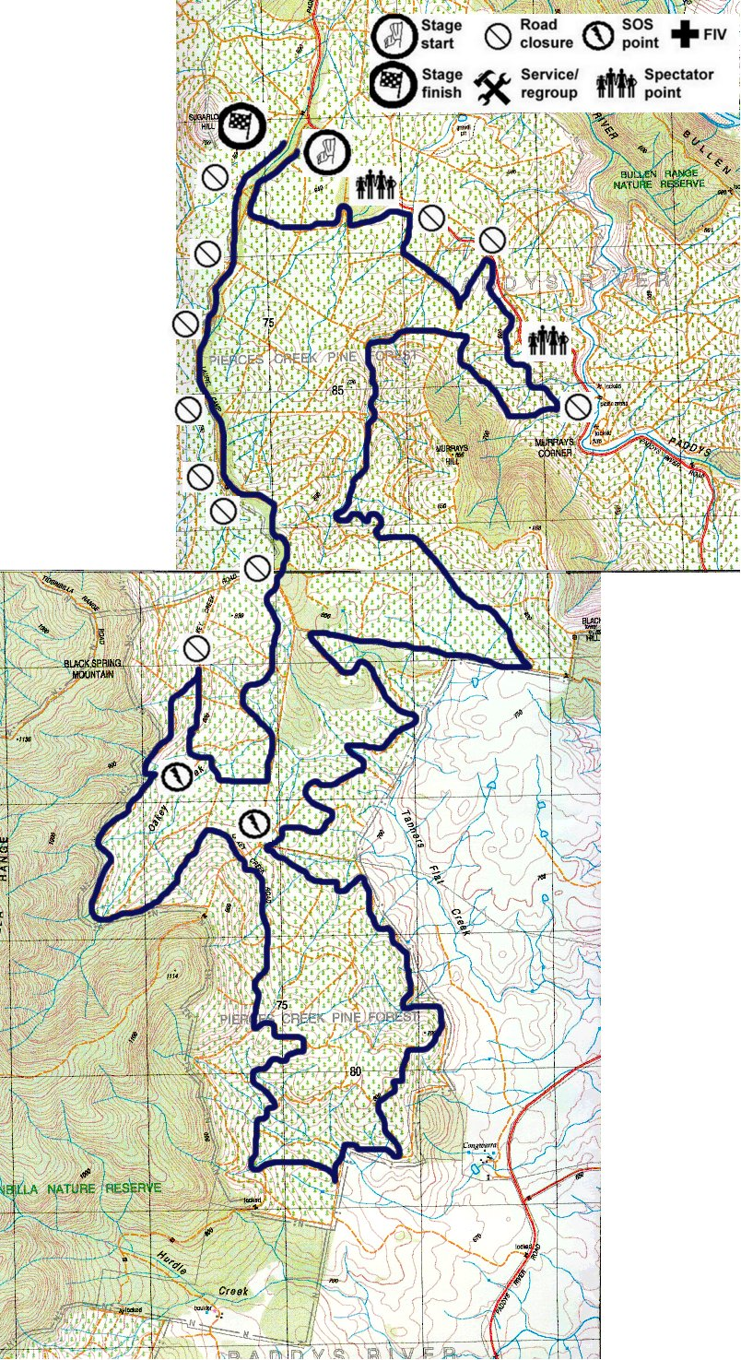

SPECIAL STAGE 4 : HALF INCH SOCKET II

SPECIAL STAGE 5 : IMPACT DRILL II

SPECIAL STAGE 6 : MEGA TOOLBOX II

