Australian Capital Territory
Surveyors (Surveyor-General) Practice Directions 2010 (No 2)
Disallowable Instrument DI2010-267
made under the
Surveyors Act 2007, section 55 – Surveyor-General Practice Directions

1 Name of instrument
This instrument is the
Surveyors (Surveyor-General) Practice Directions 2010 (No. 2) and may also be referred to as the Surveyors Practice Directions.
2 Commencement
This instrument commences on the day after it is notified.

3 Revocation

This instrument revokes the Surveyors (Surveyor-General) Practice Directions 2010 (No 1) (DI 2010-40)

Bill Hirst
Surveyor-General
30 September 2010
Contents

 | PAGE
Preliminary - Name, commencement, application, mining definitions,  Definitions (Directions 1-5) | Title Page
Division 1 - General Duties of a Surveyor (Directions 6-14) | 5
Division 2 - Adoption of datum lines and bench marks  (Directions 15-16) | 7
Division 3 - Measurement and Calculations (Directions 17-32) | 8
Subdivision A Use of Equipment (Directions 17-20) | 8
Subdivision B Partial Surveys and Easements (Directions 21-22) | 8
Subdivision C Re-determination of Boundaries (Directions 23-28) | 9
Subdivision D Calculation and Accuracy (Directions 29-32) | 10
Division 4 - Survey Marks and Monuments (Directions 33-45) | 12
Subdivision A Description of Marks (Directions 33-36) | 12
Subdivision B Marking of Surveys (Directions 37-45) | 14
Urban (Directions 37-39) | 14
Rural (Directions 40-42) | 15
Urban and Rural (Directions 43-45) | 17
Division 5 - Boundaries formed by tidal and non-tidal waters and  other natural features (Directions 46-51) | 18
Division 6 - Field Notes (Directions 52-59) | 20
Division 7 - Survey Plans (Directions 60-65) | 22
Division 8 - Stratum Title (Direction 66) | 23
Division 9 - Community Title (Direction 67) | 24
Division 10 - Unit Title (Direction 68) | 24
Subdivision A Legislative Requirements (Direction 68) | 24
Subdivision B General info for unit plans (Directions 69-70) | 25
Subdivision C Site Plans (Directions 71-72) | 25
Subdivision D Floor Plans (Directions 73-74) | 26
Subdivision E Addition requirements (Directions 75-76) | 27
Schedule 1: Forms | 29
Schedule 2: Definition of ACT Survey Grid Coordinates | 30
Schedule 3: Unit Plan Diagrams | 31
Schedule 4: Supervision of persons by a Registered Surveyor | 40

Preliminary Continued

Mining surveys | 4. | Not used
Definitions | 5. | In these directions, unless the contrary intention appears:
ACT Standard Grid Coordinates:
See Schedule 2

 |  | ‘AHD’ means Australian Height Datum as defined in the National Mapping Council (now ANZLIC) Special Publication 10 (NMC SP10) published in May 1971.
 |  | ‘Appropriate accuracy’ means such accuracy as is reasonably possible of attainment in any particular survey.
 |  | ‘Surveyor-General’ means the person occupying the position of Surveyor-General of the Australian Capital Territory.
 |  | ‘Control Survey’ means a high accuracy geodetic survey or a breakdown of a high accuracy geodetic survey established for the purpose of setting out any other survey or to which any existing survey can be related, shown on a plan signed by a registered surveyor and available from a government authority.
 |  | ‘Control Mark’ means a survey mark of a durable nature established and maintained as part of a horizontal or vertical control survey network.
 |  | ‘Co-ordinated Reference Mark’ or ‘CRM’ means a reference mark, registered by a government authority, which has been or will be connected to a control survey such that co-ordinates derived from that control survey have been or will be attributed to the mark.

‘Established Survey Control Mark’ means a survey mark that has a horizontal positional accuracy equal to or better than Class C as defined in SP1.

‘GNSS’ means Global Navigation Satellite System (including GPS)

‘GPS’ means Global Positioning System.

‘Guidelines’ means guidelines for surveyors authorised by the Surveyor-General, or his predecessors, and available via:
http://www.actpla.act.gov.au/tools_resources/maps_land_survey/surveying_data/surveyors_information

‘Identification Survey’ means a survey of a previously measured parcel of land made for the purpose of re-identification of the boundaries of that land and of their location in relation to relevant improvements and interests. An identification survey cannot be used to create new boundaries.

‘Monument’ means a natural or artificial object or point thereon which is used for the purpose of locating or relocating a boundary or point thereon.

‘Mean High Water Mark’ means the line of mean high tide between the ordinary high-water spring and ordinary high-water neap tides.

‘Plan’ means any drawing or record, signed by a registered surveyor, of either a partial or complete survey of land.

‘Reference Mark’ means a survey mark of a durable nature placed or situated near and connected by measurement to a corner, angle or tangent point of any survey.

‘Rural Survey’ means a survey, as defined by the Act, other than an urban survey, of land within the Territory.

‘SP1’ means the publication titled Standards and Practices for Control Surveys (SP1) as amended from time to time, published by the Inter-Governmental Committee on Surveying and Mapping.

‘Stratum’ means any parcel of land consisting of a space of any shape below, on or above the surface of the land or partly below and partly above the surface of the land, all dimensions of which are limited.

“Survey/Land Survey” means any activity carried out by a registered surveyor which results in a plan required in connection with any disposition of, or interest in, land under any Act.

‘Survey Mark’ means any mark placed in accordance with these Directions or shown on a plan of a survey.

‘The Act’ means the Surveyors Act 2007.

‘Urban Survey’ means a survey, as defined by the Act, of land within the Territory for urban development, as defined by the Planning and Development Act 2007.

 |  |  | Division I – General Duties of a Surveyor
General provisions for undertaking a survey |  | 6. | When undertaking a survey in accordance with these Directions the surveyor shall:
 |  |  | - during the course of the survey locate or relocate with appropriate accuracy the boundaries of the land surveyed;
 |  |  | - place or if required replace such survey marks as are required by that survey considering the purpose of the survey;
 |  |  | (iii) determine with appropriate accuracy the position of all monuments relevant to the survey; and
 |  |  | (iv) in the absence of adjacent surface reference marks, determine with appropriate accuracy connections to kerbs as laid;
 |  |  | - make complete field notes of the survey in accordance with Division 6 of these Directions; and
 |  |  | - if so required prepare a plan of the land surveyed and if necessary a report on the survey.
 | Power of entry | 7. | A written notice of intention to enter upon land given under section 45 of the Act shall be in or to the effect of Form 1 in Schedule 1 to these Directions.
Survey search information |  | 8. | A surveyor shall procure all information necessary to locate or relocate the boundaries of any land surveyed.
Requisition |  | 9. | (1) A surveyor must promptly answer, and comply with, any requisitions from the Surveyor-General or Registrar General.
 |  |  | - After certification of the plan by the Surveyor-General amendments shall be made by striking through the erroneous information and inserting the correct information.
 |  |  | - Amendments and additional information added to a plan shall be initialled and dated by the surveyor.
Surveys of lesser accuracy |  | 10. | - A surveyor may make a survey for a purpose not requiring strict accuracy under arrangement made between the surveyor and the surveyor’s client and in such a manner and with such marking as may be agreed upon between them. A sketch made in accordance with this Direction shall show monuments as approximately located.
 |  |  | - Where a survey is made in accordance with this Direction the surveyor shall endorse on the sketch a certificate in or to the effect of Form 2 in Schedule 1 to these Directions.
 |  |  | - Where a survey is made in accordance with this Direction no other provision of these Directions shall apply in respect thereof.
Identification surveys or  re-marking |  | 11. | - A surveyor may make:
 |  |  | - an Identification Survey in such a manner as may be required by the nature of such survey; and
 |  |  | - a survey requiring the remarking of a previously surveyed parcel of land in such a manner and with such marks in such positions as may be specially required by the client, but such survey shall not include a survey required in connection with any disposition of land or of any interest in land.
 |  |  | - Where such a survey is made in accordance with this Direction, the provision of Directions 6 (a)(i), (ii), (iii), (b), 8, 12, 14, 17, 22(2), and 52 to 59 both inclusive (but no other provision of these Directions) shall apply in respect thereof.
 |  |  | - Surveys made in accordance with this Direction are not surveys of lesser accuracy as described in Direction 10.
 | Lodging of plans | 12. | - Plans or sketches prepared in association with surveys made under Directions 10 and 11 may be lodged with the Surveyor-General who shall keep a register of all such plans.  - Notwithstanding section (1) above, plans of Identification Surveys required under the provisions of Section 43 (2) Building Act 2004 approval purposes must be lodged with the Surveyor-General.
Requirements for supervision |  | 13. | No requirements of these Directions shall be construed as to allow any survey to be made by other than a registered surveyor or without the supervision of a registered surveyor.
Supervision |  | 14. | - A surveyor:  - Is solely responsible for surveys carried out under his or her supervision, and  - Should exercise a standard of supervision that will ensure the survey reflects his or her professional responsibilities and complies with all relevant statutes including these directions.
 |  |  | - Supervision shall be carried out in accordance with Schedule 4 of these directions

 |  | Division 2 – Adoption of Datum Line and Bench Marks
Datum line for orientation | 15. | - Before adopting a line as the datum for orientation of a survey, a surveyor shall determine and confirm the position of the marks defining such line.
 |  | - The bearing used for the orientation of the survey shall:
 |  | - where possible and practical, be calculated from co-ordinate values of established survey control marks. Such coordinates shall be obtained from the ACT Government Survey Control Mark Register within 3 months before the completion of the survey and be accurate to Class C Order 3 or better; or
 |  | - be taken from a registered or approved survey plan either directly or by calculations from stated dimensions; or
 |  | - be obtained from GNSS observations; or
 |  | - be obtained from astronomical observations.
 |  | - The bearing adopted under subclause 2(a) must be verified by angular connection, and (if practicable) distance connection, to at least one other established survey control mark.
 |  | - Whenever possible the defining marks adopted in accordance with subclause (2)(b) above shall be contained within a single registered or approved survey.
Bench marks | 16. | Reduced levels should be obtained, and bench marks should be placed, in accordance with Survey Guideline No. 2.

 |  | Division 3 – Measurement and Calculations
 |  | Subdivision A - Use of Equipment
Standardisation and calibration of equipment | 17. | - In making a survey, the surveyor shall ensure that all equipment used in the survey is in accurate adjustment, standardised and properly calibrated.
 |  | - Electronic distance measuring equipment must be calibrated at least once every 12 months and immediately after repairs on a certified baseline established by or acceptable to the Surveyor-General.
- GNSS equipment must be verified at least once every
12 months, and immediately after repairs, on a geodetic network approved by the Surveyor-General.

 |  | - Details and results of a calibration or verification of equipment used for making a survey are to be supplied to the Surveyor-General on request.
Surveys using GNSS | 18. | - When making a survey of other than an irregular natural boundary using GNSS equipment, a surveyor must use an approved GNSS surveying technique that will achieve an accuracy of Class B or better, as specified in SP1.
 |  | - When making a survey of an irregular natural boundary using GNSS equipment, a surveyor must use an approved GNSS surveying technique that will achieve an accuracy of Class C or better, as specified in SP1.
 |  | - The procedures used when operating GNSS must be in a manner approved by the Surveyor-General, and the details and results of the observation reductions are to be supplied to the Surveyor-General on request.
Use of direct measurements | 19. | A surveyor shall measure all boundaries and lines by the most direct method that is reasonable and practicable.
Use of remote sensing or photogrammetric methods | 20. | Notwithstanding the provisions of Direction 19, the Surveyor-General may authorise the determination of natural boundaries by photogrammetric methods, or by a remote-sensing method approved by the Surveyor-General.
 |  | Subdivision B – Partial Surveys and Easements
Partial surveys | 21. | If surveying part of the land in a document of title, the surveyor shall connect such part by actual measurement to monuments or points having a known relation to a corner of the land in the title.
Location of easements or proposed easements | 22. | - Where the land being surveyed is subject to or it is proposed that it be subject to any form of easement the surveyor shall connect such easement or proposed easement by measurement to essential relevant monuments and where practical to corners of the parcel in which the easement is or is to be located.
 |  | - The surveyor shall show on the plan the essential dimensions of the site and shall note it thereon as ‘easement’ or ‘proposed easement’ as appropriate, provided that the essential dimensions to be shown on the plan need not be determined by measurement of the boundaries of the easement or proposed easement unless the circumstances so require.
 |  | - The essential dimensions referred to in subclause (2) above must be sufficient to allow a check closure of such dimensions.
 |  | Subdivision C – Re-determination of Boundaries
Adoption of original survey marks | 23. | In the absence of evidence to the contrary, where a surveyor makes a resurvey of land in a Crown Grant or Crown Lease or part thereof the boundaries as originally marked on the ground shall be adopted as the true boundaries, even though the bearings and lengths appearing in a relevant plan or document do not agree with those between the corresponding monuments.
Location of irregular boundaries | 24. | - Where an irregular fence, wall or other structure must be used to define a boundary a surveyor shall traverse it and place the angle points of the boundary in such a way that the boundary shall follow the material of the fence, wall or structure at the surface of the ground.  - Unless it is impractical to do so, angle points in the irregular fence, wall or other structure shall be substantially marked by the surveyor, and the nature of the mark shown on the plan.  - The surveyor shall indicate on the survey plan the age, nature and construction material of the structure, as at the date of survey. Where the construction material is a paling fence, the construction material need not be specified.
Variation from original dimensions to be shown | 25. | Where a corner peg and reference mark or control mark are found a surveyor shall determine the bearing and distance between them, and if a difference from the original reference is disclosed the surveyor shall decide from other evidence which of the monuments to adopt, and shall note details of such evidence and difference on the plan.
Practice to be adopted where original marks are missing or disturbed | 26. | Where monuments of an original survey are missing or disturbed the surveyor shall determine the boundaries and corners of the subject land by measurement in correct relation to boundaries of adjacent parcels of land and parcels of land on opposite sides of roads, and to fences, and to such other evidence of correct location as may be found after full investigation and inquiry.
Disclosure of excess or shortage | 27. | - Where a measurement discloses a boundary of land surveyed to be longer or shorter than is indicated in the document of title to such land a surveyor shall verify the length of such boundary and record appropriate entries in field notes, and show in such notes and on any plan of the survey the monuments adopted.
 |  | - In the absence of monuments defining the land surveyed a surveyor shall indicate whether there is sufficient land available to permit the adoption of such measurement without causing any encroachment upon or hiatus with any road, street or lane or upon any adjoining or adjacent parcel of land.
Reference to old marks to be shown on field notes and plans | 28. | - A surveyor shall indicate in field notes and in any plan of survey the nature and position, or non-existence of all monuments relevant to the survey.
- A monument that is important for the definition of the land must be shown in the surveyor’s field notes, and on the survey plan, with the annotation “found”, “not found”, “gone”, “disturbed” or “inaccessible” as appropriate.

- A monument must not be recorded as “gone” unless a thorough search for it has been made and the measurements of its probable site recorded on the surveyor’s field notes.

 |  | - Where a surveyor ascertains during the making of any survey that control marks or co-ordinated reference marks are missing, disturbed or likely to be disturbed the surveyor shall report the fact to the Surveyor-General.
 |  | Subdivision D – Calculations and Accuracy
Angular checks | 29. | A surveyor who makes a survey which exceeds a length of 10km shall check the surveyor’s angular work by astronomical observations, by GNSS observations, by a complete angular close or by comparison against Established Survey Control Marks and shall not, for this purpose, interpolate any angular measurement made by another surveyor.
Angular closure | 30. | Wherever practical a complete angular close shall be obtained. The observed angular misclose shall not exceed 20 seconds plus 10√n seconds where ‘n’ is the number of traverse angular stations either for the whole surround or between and including established survey control marks, or astronomical or GNSS observations for azimuth have been made; provided always that any misclose shall not exceed 2 minutes.
Accuracy of measurement | 31. | - A length measurement must be verified, either directly by means of a second measurement of that length or indirectly by calculation of that length from the measurements of other lengths and angles.  - When making a survey, a surveyor must measure all lengths to an accuracy of 6mm + 30 ppm or better at a confidence level of 95%.
Closure of surround | 32 | - A surveyor shall check all measurements and where the nature of the survey permits, the check shall be by the mathematical closure of the lines in all surrounds in the survey.  - The closure of any survey must be such that the length of the misclose vector must not exceed 15mm + 100 ppm of the perimeter.  - The length of the misclose vector may be determined as √(a²+b²) where ‘a’ is the misclose in eastings and ‘b’ is the misclose in northings.  - All computations and transformations to be used in the preparation of a survey plan must be checked for accuracy.

 |  |  |  | Division 4 –Survey Marks and Monuments
 |  |  |  | Subdivision A - Description of Marks
Description of marks |  | 33. |  | - Where any line or corner of any portion of a survey is required to be marked in accordance with these Directions, the points shall be firmly marked with a peg; drill hole in rock, concrete, or other similar material; a chisel mark or nail in fixed timber; or otherwise suitably marked.
 |  |  |  | - For rural surveys, or surveys of blocks of 5000 square metres or more, all pegs shall be of sound durable wood at least 350mm long and not less than 75mm by 75mm section at the top end.
 |  |  |  | - For urban surveys of blocks less than 5000 square metres pegs shall be of sound durable wood at least 250mm long and not less than 75mm by 35mm section at the top end.
 |  |  |  | - Angles and tangent points along road or street frontages in rural surveys shall be marked with pegs of sound durable wood at least 350mm long and not less than 75mm x 75mm in section at the top end.
 |  |  |  | - All pegs shall be pointed for approximately two-thirds of their length and shall be bevelled at the top.
 |  |  |  | - The centre of the top of all pegs shall represent the survey point, provided that where conditions prevent the correct centring of pegs a tack shall be placed eccentrically thereon to represent the survey point.
 |  |  |  | - All pegs are to be placed upright, point downwards so that the top is not more than 75mm above the ground level in the case of a rural survey and 40mm above the ground level in the case of an urban survey and the surrounding earth shall be securely rammed.
 |  |  |  | - If a peg projecting above the surface of the ground may be hazardous or inconvenient to the public the peg may, at the discretion of the surveyor, be placed flush with the surface of the ground. If that is done, the fact must be noted on the survey plan.
 |  |  |  | - Lockspits shall consist of trenches at least 1m long, 200mm wide at the surface and 150mm deep dug in the direction of the boundary lines and commencing 300mm from each corner or angle or may consist of packed stones of similar dimensions.
 |  |  |  | - Where any corner, angle or other point is marked other than with a peg, where practicable wings shall be cut in solid rock, concrete or fixed timber, 75mm long 20mm wide and 10mm deep commencing 50mm from the corner or where the surface renders it desirable, lines may be painted at least 300mm long and 20mm wide.
 |  |  |  | - Where practicable, a corner or angle may be marked using a boundary mark token securely attached to timber, post, fence or other surface using a non-corrodible nail, spike, rivet or screw. The boundary mark token shall be at least 32mm diameter and 1.5mm thick, with “Boundary Mark” permanent stamped or etched on the upper surface.
Description of reference marks |  | 34. |  | (1) Where a surveyor is required to place reference marks in accordance with these Directions - they shall consist of:
 |  |  |  | - a reinforced concrete block in the form of a truncated pyramid at least 375mm long, 150mm square at the lower end and 100mm square at the upper end, with a galvanised nail or other suitable non-corrodible metal plug not less than 75mm long fixed therein;
- a galvanised iron pipe at least 300mm long and internal diameter not less than 10mm with a wall thickness of not less than 3mm;

- a solid non-corrodible metal spike at least 300mm long and having an external diameter of at least 20mm;

 |  |  |  | - a galvanised iron spike at least 100mm long driven into fixed timber with a wing 75mm long cut into the timber and directed to the galvanised iron spike;
 |  |  |  | - a drill hole cut into a kerb or other substantial structure at least 5mm in diameter and 10mm deep with a wing at least 75mm long, 20mm wide and 10mm deep at the base, and the point directed thereto;
 |  |  |  | - a drill hole at least 10mm in diameter and 25mm deep cut into bedrock with a wing 75mm long and directed thereto where such bedrock exists within 300mm of the natural surface of the ground;
 |  |  |  | - an appropriate chisel mark cut into the sound wood of a suitable tree; or
 |  |  |  | - a mark of a durable character or a specific point on a permanent or substantial structure.
- Where a surveyor has placed or has found a reference mark referred to in either sub-clause (1)(a), (1)(b) or (1)(c) of this Direction or a control mark more than 400mm below the natural surface of the ground, the depth shall be indicated on the plan.

- Where a surveyor has placed a reference mark referred to in either sub-clause 1(a), (1)(b) or 1(c) of this direction it must be placed vertically at least 80mm below the surface of the ground, or deeper if it is likely to be disturbed.

Description of CRMs |  | 35. |  | A CRM shall be:
- a non-corrodible metal plaque set in a concrete kerb; or

- a non-corrodible metal plaque set in the top of a concrete block in the form of a truncated pyramid at least 500mm long, 450mm square at the lower end and 300mm square at the upper end with a minimum volume of concrete of at least 0.07cubic metres. Such mark shall be placed such that its highest point is flush with or below the surface of the ground; or

 |  |  |  | - a deep driven stainless steel rod.
Other marks |  | 36 |  | The Surveyor-General may approve the use of other marks of a durable character as a substitute for marks described in directions 33 to 35.
 |  |  |  | Subdivision B - Marking of Surveys
 |  |  |  | Urban
Marking urban surveys |  | 37. |  | (1) Where a surveyor makes an urban survey the surveyor shall whenever possible firmly mark each corner thereof (including corners of each parcel of land in a subdivision) with a peg or mark of a nature as prescribed in Direction 33.
- Where it is not possible or practical to mark a corner the surveyor shall:

- place a reference mark in accordance with Direction 43 (1), and

(b) note on the plan that the corner was not marked and show the connection from the reference mark to the corner.

 |  |  |  | - Where a surveyor makes an urban survey the surveyor shall mark distinctly and durably all lines which form or are to form the boundaries between parcels on unfenced boundaries with pegs or marks as prescribed in Direction 33 placed at intervals of not more than 200 metres, and the position shown on the plan.
 |  |  |  | - Marking of urban surveys shall not be completed until land servicing has reached a stage where all CRMs, reference marks and corner marking will be durable and stable.
Placement of reference marks for urban surveys |  | 38. |  | - Where a surveyor makes an urban survey for any purpose and the land surveyed:
 |  |  |  | - abuts a road or street in which, within the limits of the frontage of the land surveyed,:
 |  |  |  | - reference marks have not been placed or have been disturbed, the surveyor shall place a reference mark near each extremity of the boundary of the land where it abuts the road or street, including at road intersections;
 |  |  |  | - reference marks or CRMs have not been placed or have been disturbed, the surveyor shall place reference marks at intervals of not more than 150 metres throughout the length of the frontage of the land surveyed;
 |  |  |  | - does not abut a road or street, the surveyor shall place 2 reference marks suitable for orientation.
 |  |  |  | (2) The requirement of subclause (1)(a) is subject to the condition that a reference mark need not be placed within 25 metres of another reference mark or CRM.
Connections to CRMs where available |  | 39. |  | Where a surveyor makes an urban survey and the land surveyed abuts or comprises a road or street or other public place in which CRM(s) have been placed within 200 metres of the survey the surveyor shall:
 |  |  |  |  | - connect the subject land to such CRM(s) in accordance with Guideline No 2 by a closed traverse which includes the CRM(s) and established survey control marks; and
 |  |  |  |  | - record the derived co-ordinate values of the CRM(s) on the plan of survey in accordance with Guideline No 2.
 |  |  |  | Rural
Marking rural surveys |  | 40. |  | (1) Where a surveyor makes a rural survey the surveyor shall mark distinctly and durably all lines which form or are to form the boundaries between parcels:
 |  |  |  | - with a peg or mark as prescribed in Direction 33 together with lockspits cut in the direction of each unfenced boundary from each corner and angle; and
 |  |  |  | - on unfenced boundaries with pegs or marks and lockspits as prescribed in Direction 33 placed at intervals of not more than 200 metres where one peg or mark cannot be seen from the next, or 500 metres, where one peg or mark can be seen from the next, and the position shown on the plan.
(2) Where it is not possible or practical to mark a corner the surveyor shall:

- place a reference mark in accordance with Direction 43 (1), and

(b) note on the plan that the corner was not marked.

 | Reference marks for rural surveys | 41. |  | Reference marks shall be placed on rural surveys in accordance with the following:
 |  |  |  | - where the land surveyed is not being subdivided - at least two reference marks suitable for redefinition of the survey;
 |  |  |  | - where the land surveyed is being sub-divided - at least 2 reference marks in respect of each parcel;
 |  |  |  | - where a boundary other than a road frontage exceeds 2,400 metres - additional reference marks at intervals of not more than 1,500 metres; and
 |  |  |  | - where a boundary required to be marked in accordance with the Directions is a road frontage - pairs of reference marks suitable for orientation so that the interval between any two successive reference marks does not exceed 1,000 metres, and one reference mark at each extremity of that boundary.
Surveys of rural or reserved roads |  | 42. |  | When making a survey of a rural or reserved road a surveyor shall
 |  |  |  | - measure and mark definitely and durably all lines which form the boundary of one side of the road with pegs or marks and lockspits of the nature prescribed in Direction 34;
 |  |  |  | - place pegs or marks at each angle along the surveyed boundary. Where the distance between angles is in excess of 200 metres marks are to be placed at intervals of not more than 200 metres except where angle marks are intervisible. Where marks are intervisible the distance between them should not exceed 500 metres
 |  |  |  | - mark with the prescribed pegs or marks each angle of the unsurveyed boundary; and
 |  |  |  | - place pairs of reference marks suitable for survey orientation so that the interval between any two successive reference marks does not exceed 1,000 metres, and one reference mark at each extremity thereof.
 |  |  |  | Rural and Urban
Placement of reference marks and CRMs |  | 43. |  | - Where these Directions require a surveyor to place reference marks the surveyor shall place them adjacent to the corner, angle or line mark, in selected positions designed to preserve them from disturbance, and the reference mark shall not be more than 30 metres from the corner, angle or line mark to which it refers.
 |  |  |  | - Where a reference mark is placed in a road it shall be placed at a suitable distance from the existing road boundary; such distance shall be determined at the discretion of the surveyor having regard to the existence of any water, lighting or other services for which provision is or has to be made.
 |  |  |  | - CRMs of a type described in Direction 35 (b) or (c) are required to be placed at a ratio of at least 1 such CRM per one 100 parcels of land or part thereof.
 |  |  |  | - CRMs of the type described in Direction 35 (a) shall be installed along roads at intervals of not more than 150 metres throughout the length of the land surveyed and should have a clear line of sight to adjacent CRMs.
 |  |  |  | - Where a CRM is installed in such a position that it has, or the surveyor may have reason to consider that it may have in future, clear line of sight only to one other CRM then the surveyor shall place nearby a reference mark and shall connect the CRM to it by closed traverse.
 |  |  |  | - Where these Directions require a surveyor to place a CRM of the type described in Direction 35, the surveyor shall determine the AHD reduced level of the CRM in accordance with Direction 16 and promptly provide the results to the Surveyor-General.
Connections to be shown |  | 44. |  | Where a surveyor is required to place a reference mark, the requirement shall include the connection by direct measurement from the mark to the survey made by the surveyor.
 | Connection to control marks | 45. |  | - If the land being surveyed is not connected by survey to a control survey, a surveyor shall connect the survey to the nearest established survey control marks if within 200 metres of the survey in an urban area and 1,000 metres of the survey in a rural area. Such connections should comply with Guideline No 2.
 |  |  |  | - Measurements between all control marks found or placed, and connections to the survey, must be proved by closed traverse
 |  |  |  | - If GNSS equipment is used in the making of a survey the surveyor shall connect to at least three Established Survey Control Marks the co-ordinates of which are known in the appropriate geocentric datum.
 |  |  |  | Division 5 Boundaries formed by tidal and non-tidal waters and other natural features
Definitions |  | 46 |  | In this Division:  ‘Bed’, in relation to a lake or stream, includes any portion of the lake or stream:  - that is alternately covered and left bare with an increase or diminution in the supply of water, and  - that is adequate to contain the lake or stream at its average or mean stage without reference to extraordinary freshets in time of flood or to extreme droughts.  ‘Lake’ includes any permanent or temporary lagoon or a similar collection of water not contained in an artificial work, but does not include tidal waters.  ‘Natural feature’ includes any cliff face or ridgeline, but does not include any tidal or non-tidal waters.  ‘Stream’ includes any non-tidal waters that are not a lake.
Surveys where boundary includes tidal or non-tidal or other natural features |  | 47 |  | (1) A boundary formed by tidal waters, or by a lake, stream or natural feature, must be surveyed so that each change of course or direction of the boundary is determined with appropriate accuracy.  (2) If the actual position of the mean high-water mark of tidal waters, the bank of the lake or stream or the natural feature is substantially different to the adopted position of the boundary, both the actual position and the adopted position are to be shown on the survey plan.  (3) If:  - the middle line of a stream is the boundary of land and has not previously been defined by survey, or  - the middle line of a stream is otherwise required to be determined,  both banks of the stream must be surveyed and shown on the survey plan together with the determination of the middle line.  (4) The middle line of a stream need not be marked unless the purpose for which the survey is made so requires.
Changes in boundaries formed by tidal waters |  | 48 |  | (1) If, since the date of a previous survey, there has been a change in the position of the mean high-water mark of tidal waters forming a boundary of land to be surveyed:  (a) if the change arose from natural, gradual and imperceptible accretion or erosion—the position of the mean high-water mark as it is as the result of the change is to be adopted, or  (b) if the change arose otherwise than from natural, gradual and imperceptible accretion or erosion—the position of the mean high-water mark as it was before the change is to be adopted.  (2) Approval to the adoption of a changed position referred to in subclause (1) (a) must be obtained from the Surveyor-General.  (3) When seeking approval to a determination under subclause (2), a surveyor must provide the Surveyor-General with a comprehensive report regarding the surveyor’s determination.  (4) A comprehensive report under this clause must include:  (a) the basis and method of determining the position of the mean high-water mark, and  (b) the surveyor’s opinion as to the reason for any change in that position and the process by which the change has taken place, and  (c) such photographs, documents or other information relevant to the position of the mean high-water mark as is reasonably required by the person to whom the report is to be provided.
Changes in boundaries formed by lakes, streams and natural features |  | 49 |  | (1) If, since the date of a previous survey, there has been a change in the position of the bank of a lake forming a boundary of land to be surveyed, then, in any subsequent survey, the position of the bank, as it was before the change, must be adopted.  (2) If, since the date of a previous survey, there has been a change in the position of the bank of a stream, or of some other natural feature, forming a boundary of land to be surveyed, then, in any subsequent survey:  (a) for any change arising from natural, gradual and imperceptible accretion or erosion, the position of the bank or natural feature, as it is as a result of the change, must be adopted, or  (b) for any change arising otherwise than from natural, gradual and imperceptible accretion or erosion, the position of the bank or natural feature, as it was before the change, must be adopted.  - A surveyor who determines a new position for the bank of a stream, or for a natural feature, must lodge, together with the survey plan, a comprehensive report regarding the surveyor’s interpretation of the new position. The report is to include:  (a) the basis and method of determining the position of the bank of stream or natural feature, and  (b) the surveyor’s opinion as to the reason for any change in that position and the process by which the change has taken place, and  (c) such photographs, documents or other information relevant to the position of the bank of stream or natural feature as is reasonably required by the person to whom the report is to be provided.
References to high water mark, tidal waters, lakes streams and other natural features in previous surveys |  | 50 |  | For the purposes of preparing a survey, in any previous survey plan or other description of land:  - a reference to high-water mark is taken to be a reference to mean high-water mark, and  - a reference to, or description of, a boundary that abuts tidal waters is taken to be a reference to, or description of, a boundary that abuts mean high-water mark, and  - a reference to a bank of a lake or stream is taken to be a reference to the limit of the bed of the lake or stream, and  - a reference to, or description of, a boundary that abuts a lake or stream is taken to be a reference to, or a description of, a boundary that abuts the limit of the bed of the lake or stream, unless a contrary intention appears.
Area to be Determined by Survey |  | 51. |  | The area of land abutting on a non-tidal stream or on tidal water shall be ascertained by the surveyor, and shall include all lands to the bank or the mean high-water mark as the case may be.
 |  |  |  | Division 6 Field notes
 | Field Notes | 52. |  | - A surveyor shall make neat, precise, complete and readily intelligible field notes of every survey.
- Facts, readings and observations must be recorded immediately after they are ascertained.

- A surveyor must keep an archive of:
- all field notes made by the surveyor, with indexes and cross-references set out in a manner that facilitates the preparation of a complete and accurate survey plan, and
- all other information and documentation relevant to those field notes.

 |  |  |  | - No erasures shall be made and all amendments shall be initialled by the surveyor.
Surveyor to retain electronic records |  | 53. |  | - If a survey has been recorded in whole or in part by electronic methods other than GNSS methods:  - an electronic copy (in the same form as the recording), and  - a copy of the reduced and formatted data,  must be retained in a manner that facilitates the preparation of a complete and accurate survey plan.  - If a survey has been recorded in whole or in part by GNSS methods:  - an electronic copy of all recorded data, and  - a copy of the reduced baseline or positional results,  must be retained in a form that facilitates the preparation of a complete and accurate survey plan.
Disclosure of difficulties |  | 54 |  | A surveyor shall disclose any doubt, discrepancy or difficulty suggested by or encountered in a survey in the field notes.
 | Datum line to be recorded | 55 |  | A surveyor must clearly indicate in the surveyor’s field notes the datum line of the survey and the origin of the orientation adopted.
 | Astronomical observations to be recorded | 56 |  | If a surveyor makes an astronomical observation in the course of a survey, the surveyor must enter the time and date and the latitude and longitude of the relevant station, together with full particulars of all observations.
 | Landmarks to be recorded | 57 |  | A surveyor must enter the names of estates, houses, roads, rivers, creeks, lakes and the like, and house numbers, as far as they are material to the survey and ascertainable by the surveyor.
Surveyor to sign and date field notes |  | 58. |  | - In the case of a survey that has been performed by a surveyor personally or under the surveyor’s supervision, the surveyor must personally sign, date and retain each page or sheet of the field notes and (in the case of a survey recorded by electronic means) each page or sheet of the reduced and formatted data.  - Before signing each page or sheet, the surveyor must be satisfied that the notes are accurate and that the date the work was performed is recorded.
Recording angles and bearings |  | 59 |  | All angles and bearings must be observed and recorded in degrees, minutes and seconds, and expressed clockwise from zero to 360 degrees.

Division 7 Survey plans

Standards for plans | 60. | The “Standards and Specifications for Plans” may be reviewed by the Surveyor-General, and promulgated as a disallowable instrument.
Datum to be shown | 61. | - A surveyor shall show the datum line of the orientation of a survey in the plan by distinguishing letters placed at the terminals thereof and the nature of the marks defining the datum line shall be noted therein.  - If astronomical or GNSS observations are used to determine or confirm the orientation of the survey, the results of the observations are to be shown in a table on the survey plan under the headings “Occupied station”, “Observed station” and “Astronomical body” or “GNSS”, together with the derived bearing between the occupied and observed stations.

Description of marks and connections to be shown | 62. | A surveyor shall indicate on the plan:  - the nature of any corner, angle or line mark placed which is not a peg;
 |  | - the nature of any reference mark placed together with the relevant essential measurements;
 |  | - the nature of any reference mark or CRM found and connected to, together with the relevant measurements; and
 |  | - Closed connections between control marks.
Information to be shown on Plan | 63. | A surveyor shall show in a plan of re-survey or of a subdivision:
 |  | - the nature of all boundaries at the time of the re-survey or of the subdivision, irrespective of how they are marked or defined; and
 |  | (ii) if a wall is on a boundary, the boundary shall be described in the plan as ‘face of wall’ or ‘passing through wall’, or otherwise, as appropriate: A wall shall not be described as a ‘party wall’ except in accordance with Section 32 of the City Area Leases Ordinance 1936, as applied and modified by Section 5 of the National Lands Ordinance 1989, and/or Sections 27 and 28 of the Common Boundaries Act 1981;
 |  | - the description and width of all walls used in common and the position of the boundary therein;
- the description (including the age, nature, construction material and relationship to the boundary) of any substantial structure (including any fence):
- that is within one metre of the boundary of the land surveyed, or
- that is otherwise relevant to the boundary definition.

GNSS derived lines to be indicated | 64 | A survey plan that includes lines derived from GNSS observations must indicate which of those lines have been so derived.
Certification | 65. | - Where a surveyor is required to furnish a plan of a survey for lodgement at the Registrar-General’s Office the surveyor shall endorse thereon a certificate in or to the effect of Form 3 in Schedule 1 to these Directions.
 |  | - Such certification must be an original signature made by the surveyor in their own hand and may not be an electronic facsimile.
 |  | - Such certificate may be incorporated in any certificate required by any law to be endorsed on such plan.
 |  | - A surveyor shall disclose any doubt, discrepancy or difficulty suggested by or encountered in a survey in the plan thereof or in an annexure thereto or in an accompanying report.
 |  | - Unless written approval is obtained from the Surveyor-General, a certificate referred to in subclause (1) and (2) above must not be issued until all survey marks required to be placed in connection with the survey have been duly placed.

 |  | Division 8 – Stratum Surveys
Requirement for stratum surveys | 66. | Where a plan of survey of a stratum is required the surveyor shall:
 |  | - mark at ground level the projection of the extremities of the stratum block and relate it to existing boundaries and occupations;
 |  | - define the stratum by dimensions of regular, or description of irregular surfaces;
 |  | - delineate on the plan the extent of any easement and fully describe its purpose and limits;
 |  | - show on the plan elevations and sections sufficient to delineate the stratum using reduced levels based on the AHD;
 |  | - verify AHD reduced levels by closed height difference between two control marks, the AHD reduced levels of which have been obtained from the ACT Government Survey Control Mark Register within 3 months before completion of the survey and are to an accuracy of Class LC or better, as specified in SP1;
 |  | - show on the plan the position and reduced level of at least two permanent physical objects adjacent to the stratum; and
 |  | - determine all reduced levels to an accuracy of Class LC or better, as specified in SP1.
 |  | Division 9 – Community Title
Survey and plan requirements | 67. | - Where a surveyor is required to carry out a survey for the preparation of a Community Title (within the meaning of the Community Titles Act 2001) it shall be treated as a sub-division in accordance with the Districts Act 2002 and/or the Unit Titles Act 2001 and carried out in accordance with these directions.
 |  | - References to roads in these directions includes private roads, or easements for access, within a community title unless the Surveyor-General has provided written advice to the contrary.
 |  | Division 10 – Unit Title
 |  | Subdivision A – Legislative requirements
Related legislation and directions | 68 | - Directions within this Division are supplementary to the requirements of the Unit Titles Act 2001 and associated regulations. In the event of an inconsistency between the Act or regulation and these directions, the former take precedence.
 | . | - Where a surveyor is required to carry out a survey for the preparation of a Units Plan (within the meaning of the Unit Titles Act 2001) it shall be done in accordance with this Division, the provision of Directions 6 (a)(i), (ii), (iii), (b), 7,8, 14, 17, 22(2), and 52 to 59 both inclusive (but no other provision of these Directions) shall apply in respect thereof.
 |  | - Drawings supplied in Schedule 3 are provided as a guide to style and quality of presentation. These diagrams have been reduced to A4 for this document.
 |  | Subdivision B – General information for Unit Plans
General information for Unit Plans | 69 | - Units Plans shall be drawn on plan forms acceptable to the Registrar-General.
 |  | - Dimensions shall be expressed in the manner prescribed in Section 4 of the Standards and Specifications for Deposited Plans
 |  | - Scales, symbols, line-work and abbreviations used on plans shall generally be in accordance with the guidelines set out in Section 6 of the Standards and Specifications for Deposited Plans.
 |  | - Every boundary of a unit or unit subsidiary or any other designated area, must be capable of being defined in relation to the parcel boundaries or to physical features, or fixed by measurement to these physical features, or the boundaries of the parcel.
 |  | - Plans found to be incomplete, faulty or failing to achieve clarity of presentation may be rejected.
 |  | - Details to be shown on site plans as listed below may be shown on floor plans instead, and vice versa, if this adds to the clarity of the plan.
Unit subsidiaries | 70 | - The number of unit subsidiaries identified in the schedule of unit entitlements must be reconciled with the subsidiaries shown on the site and floor plans for each unit.
 |  | - Where a Unit Plan involves 20 or more units, a separate Unit and Subsidiary Index should be added showing unit numbers, unit door numbers (address number) if known, all subsidiaries related to each unit, and the page number of the plan where the details of each unit are shown. An example is provided in Schedule 3-I.
 |  | Subdivision C – Site Plans
Site plan scale | 71 | Site plans shall be drawn to a scale sufficient to enable all details and notations to be clearly shown. If necessary a site plan diagram may commence on one sheet and continue on a subsequent sheet or sheets and, in such a case, the diagrams shall be so drawn that the complementary parts or lines on the several sheets show, when placed side by sided, the completed diagram.
Site plan details | 72 | Site Plans shall be drawn showing:
 |  | A north point which shall be generally directed towards the top of the plan and situated, where possible, in the top right corner;
 |  | The boundaries of the parcel, together with complete dimensions;
 |  | The block and section number and DP number of the parcel;
 |  | The identifiers of all adjoining lands, including where appropriate, block, section and plan numbers, Territory lands, pathways and roads;
 |  | The position, at ground level, or in an appropriate case, the position projected to ground level, of the extremities of each building or, in the case of staged developments, buildings in course of erection on the parcel;
 |  | A general description of existing buildings and where appropriate the distinguishing number of each unit and unit subsidiary;
 |  | The boundaries of any Class B units; and the boundaries of any ground level Class B unit subsidiaries; so drawn that the relationship of those boundaries to one another and to the parcel boundaries is clear;
 |  | The site and nature of any existing easement or proposed easement affecting the parcel, reference to the instrument or plan by which it was created and sufficient information to define such site and its relationship to the boundaries of the parcel;
 |  | Offsets to all permanent features relevant to Unit Boundaries;
 |  | Offsets to relevant features, including fences and walls, erected on or within one metre of the parcel boundaries;
 |  | The nature and extend of any encroachment and its relationship to the parcel or unit boundaries;
 |  | The area of the parcel; and
 |  | The reduction ratio to which the plan is drawn together with a graphic bar scale.
 |  | Subdivision D – Floor Plans
Floor plan scale | 73 | Floor plans shall be drawn to a scale sufficient to enable all details and annotations to be clearly shown. Floor plans shall accurately show the extent and shape of the units and unit subsidiaries each of which must be clearly identified.
 |  | Each part of a single floor area shown on a Units Plan shall be drawn at the same scale
Floor plan details | 74 | Floor plans shall be drawn showing:
 |  | A north point which shall be generally directed towards the top of the plan and situated, where possible, in the top right corner;
 |  | A description of the type of the unit subsidiaries and, for class B Units, basic construction material of units.;
 |  | The reduction ratio to which the plan is drawn together with a graphic bar scale;
 |  | The distinguishing number of each unit and unit subsidiary in accordance with Schedule 1 Part 1.3 of the Land Titles (Unit Titles) Act 1970;
 |  | The adjoining sheet numbers;
 |  | Height limitations of any units or unit subsidiaries that are not implied in the provisions of Division 2.2 of the Unit Title Act 2001;
 |  | Sufficient annotations and/or dimensions to ensure that each unit or unit subsidiary is fully and unambiguously defined;
 |  | Sheet references for parts of units that appear on other sheets;
 |  | Sufficient details to identify the location of units and unit subsidiaries in relation to the parcel boundaries; and
 |  | Subdivision E – Additional Requirements for Class A and B Units
Additional Requirements for Class A Units | 75 | Additional requirements for Class A unit developments:
 |  | Floor plans shall show sufficient description in relation to existing structures or dimensions to identify the boundary of each unit and unit subsidiary in relation to one another and, where appropriate, to the parcel boundaries;
 |  | Units that occupy more than one level shall be described as Part or “Pt” of the unit on each level. Floor areas of each part of a unit shall be shown on the floor plans with the total area of the unit and references to the sheets on which other parts of the units are shown;
 |  | The approximate floor areas of units and unit subsidiaries shall be shown on the plan. Floor areas should preferably be calculated using dimensions to the inside face of the walls;
 |  | Where the boundary of a Class A unit or unit subsidiary is other than the centre of existing walls, floors and ceilings it shall be so described;
 |  | Mezzanine levels within a Unit may be shown as a dashed line on the floor plan or, where complex, on a separate floor plan. Where a separate floor plan is used, it should retain the same floor number as the underlying floor however the word ‘mezzanine’ should be placed after the floor number. Eg. 3 mezzanine; and
 |  | Mezzanine floor areas should be added to the underlying floor area in a way which enables each area to be determined.
Additional Requirements for Class B Units | 76 | Additional requirements for Class B unit developments:
 |  | The plan shall show sufficient connections between parcel, unit and unit subsidiary boundaries so that each unit and unit subsidiary can be identified in relation to the parcel boundaries and to one another.
 |  | The plan shall show the relationship, by offset or description, of the buildings or, in the case of staged developments, buildings in the course of erection, to the unit boundaries.
 |  | Extra connections should be shown between units to reduce the number of lines in a mathematical closure of large common property areas.
SCHEDULE 1

Form 1 Direction 7
Surveyors Practice Directions
Surveyors Act 2007

To the owner of................................. .......................................................................
(here insert reference to land proposed to be entered)

In pursuance of Section 45 of the Surveyors Act 2007 notice is hereby given that I, the undersigned registered Surveyor, intend to enter the above mentioned land on ....................................................................for the purpose of making a survey.
(here insert dates of proposed entry)

Dated this .................................... day of .............................................. 20 ..........

(Name).........................................................

(Signature).........................................................
Registered Surveyor

(Address) .........................................................

Form 2 Direction 10
SURVEYORS PRACTICE DIRECTIONS

Surveyors Act 2001

I ....................................................................... of ....................................................
a surveyor registered under the Surveyors Act 2007 hereby certify that the survey represented in this sketch being a survey which does not require strict accuracy was made in accordance with Direction 10 of the Surveyors Practice Directions.

(Name).........................................................

(Signature).........................................................

Surveyor, Registered under the

Surveyors Act 2007

Form 3 Direction 65
SURVEYORS PRACTICE DIRECTIONS

Surveyors Act 2007

I ....................................................................... of.....................................................
a surveyor registered under the Surveyors Act 2007 hereby certify that the survey represented on this plan is accurate and has been made in accordance with the Surveyors Practice Directions and was completed on ...............................................

(Name).........................................................

(Signature).........................................................
Surveyor, Registered under the

Surveyors Act 2007

SCHEDULE 2

Australian Capital Territory Standard Grid Coordinates (SGC)

Datum:
The Australian Capital Territory Standard Grid Coordinates (SGC) system is based upon the Australian Geodetic Datum as proclaimed in the Commonwealth Gazette No. 84 of 6 October 1966 (AGD66).

This datum is described fully in the National Mapping Council of Australia (now the Intergovernmental Committee on Surveying and Mapping (ICSM)) Special Publication No. 10 (SP10) titled ‘The Australian Geodetic Datum Technical Manual’.

Projection:
Standard Grid Coordinates are derived from a Transverse Mercator projection of latitudes and longitudes on the AGD66. This grid has the following parameters:

Coordinates are in metres;

Central Meridian
149 degrees 00 minutes 33.46139 seconds east of Greenwich (Stromlo Trigonometrical Station);

False Origin
Based on Stromlo Trigonometrical Station having:
- Latitude: 35 degrees 19 minutes 03.85060 seconds south of the equator
- Longitude: 149 degrees 00 minutes 33.46139 seconds east of Greenwich
- Grid coordinates of E 200 000.000 metres
N 600,000.000 metres
- The Scale Factor at the Central Meridian is 1.000 086

For further information on SGC see:

Wellspring, K. H., Some aspects of the conversion from imperial to metric coordinates in the Australian Capital Territory, Technical papers of the 16th Australian Survey Congress, Canberra, Australia, 1973.
SHEDULE 3-A
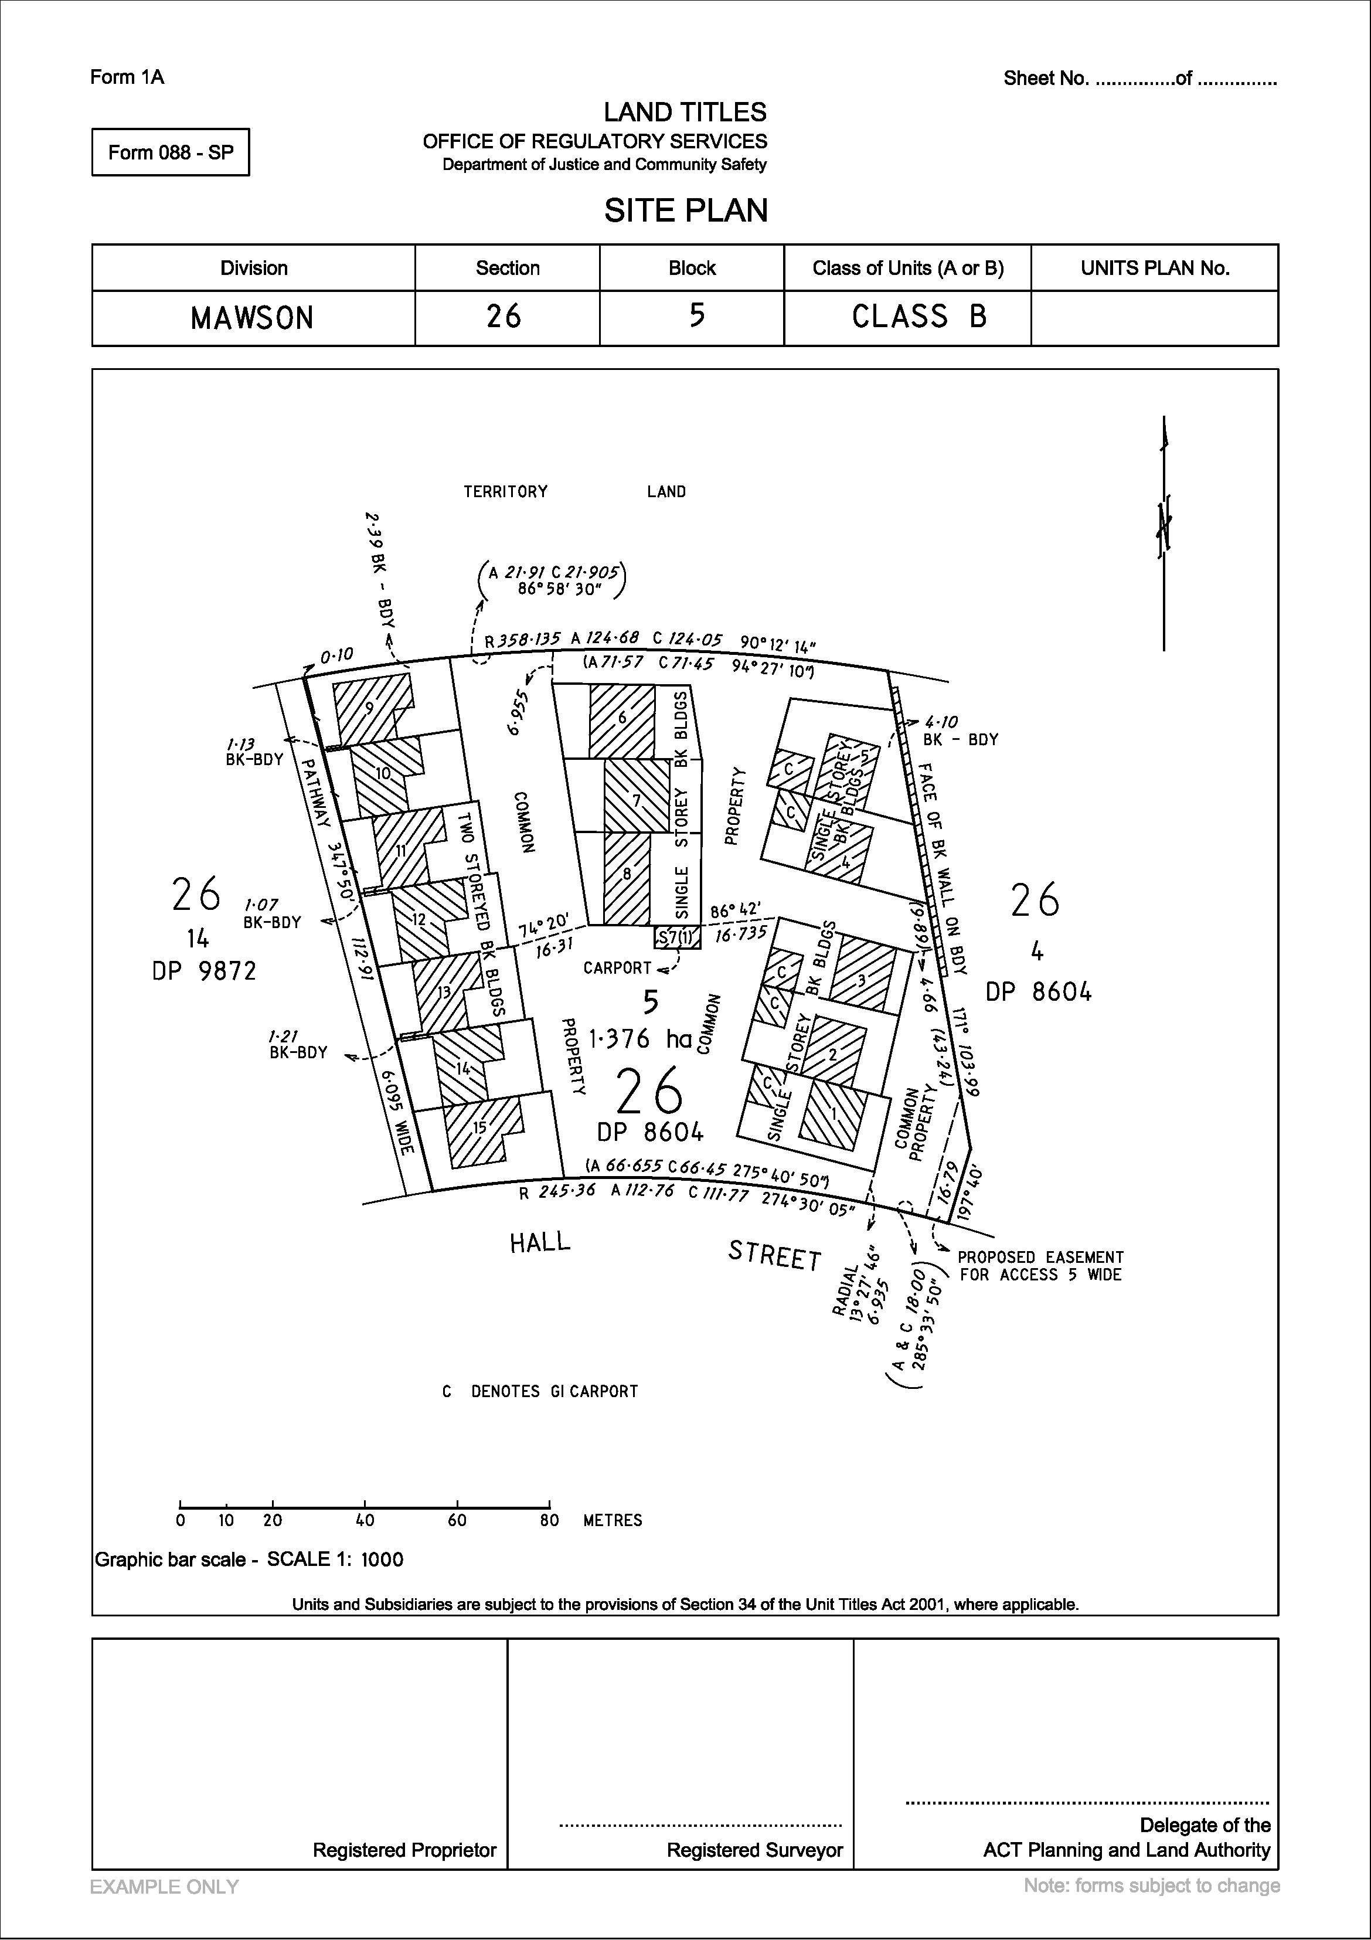
SHEDULE 3-B 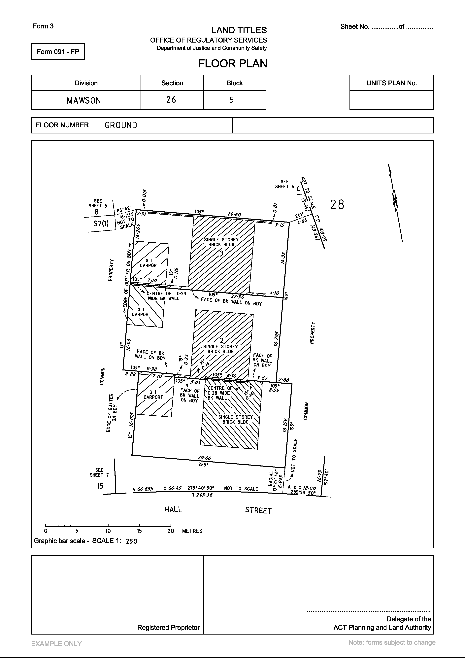
SHEDULE 3-C 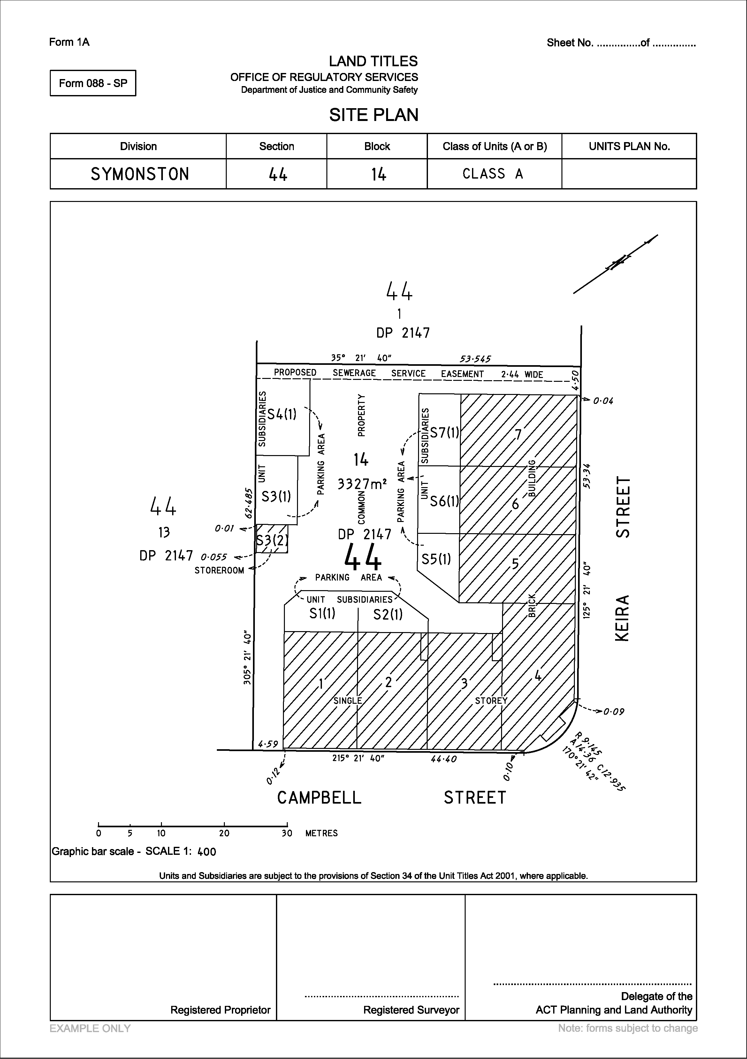
SHEDULE 3-D 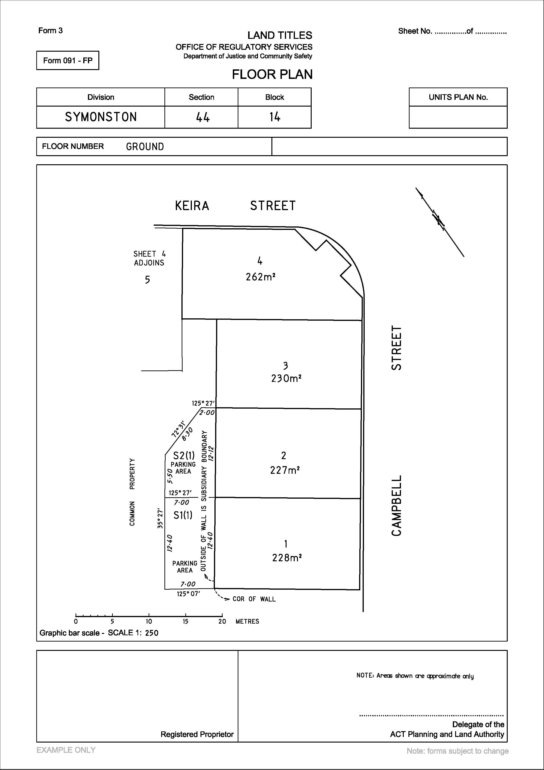
SHEDULE 3-E 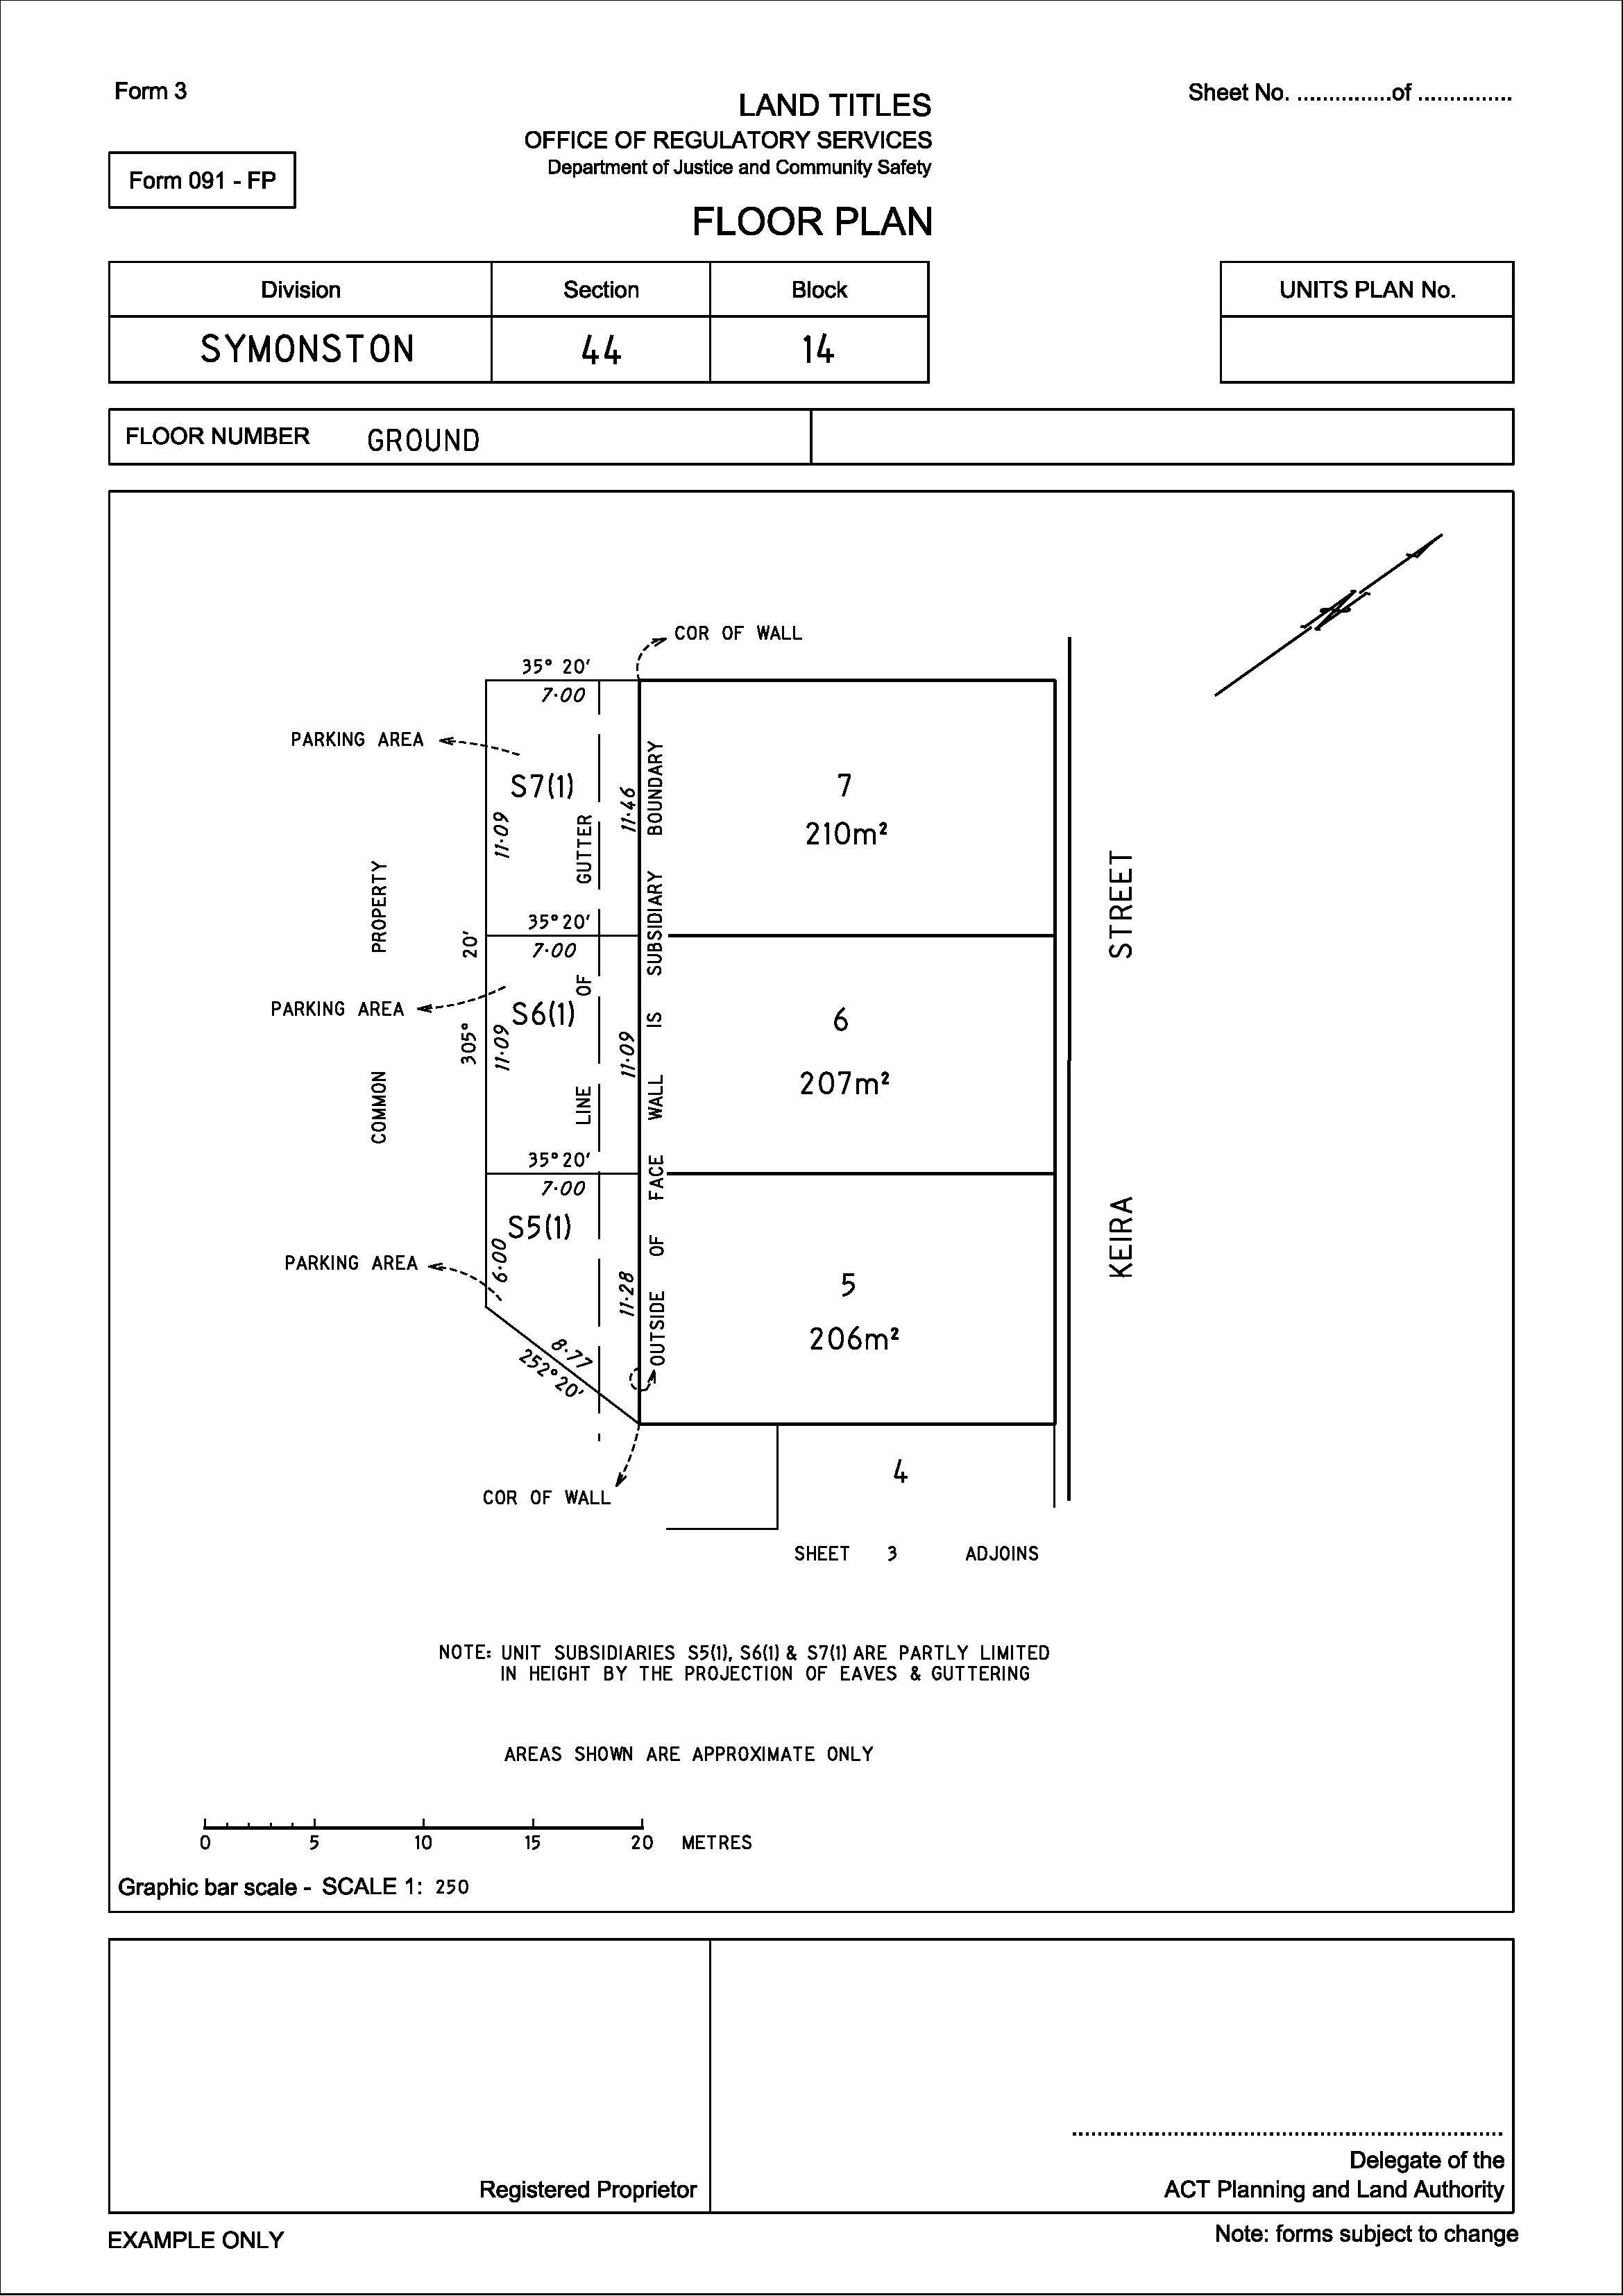
SHEDULE 3-F 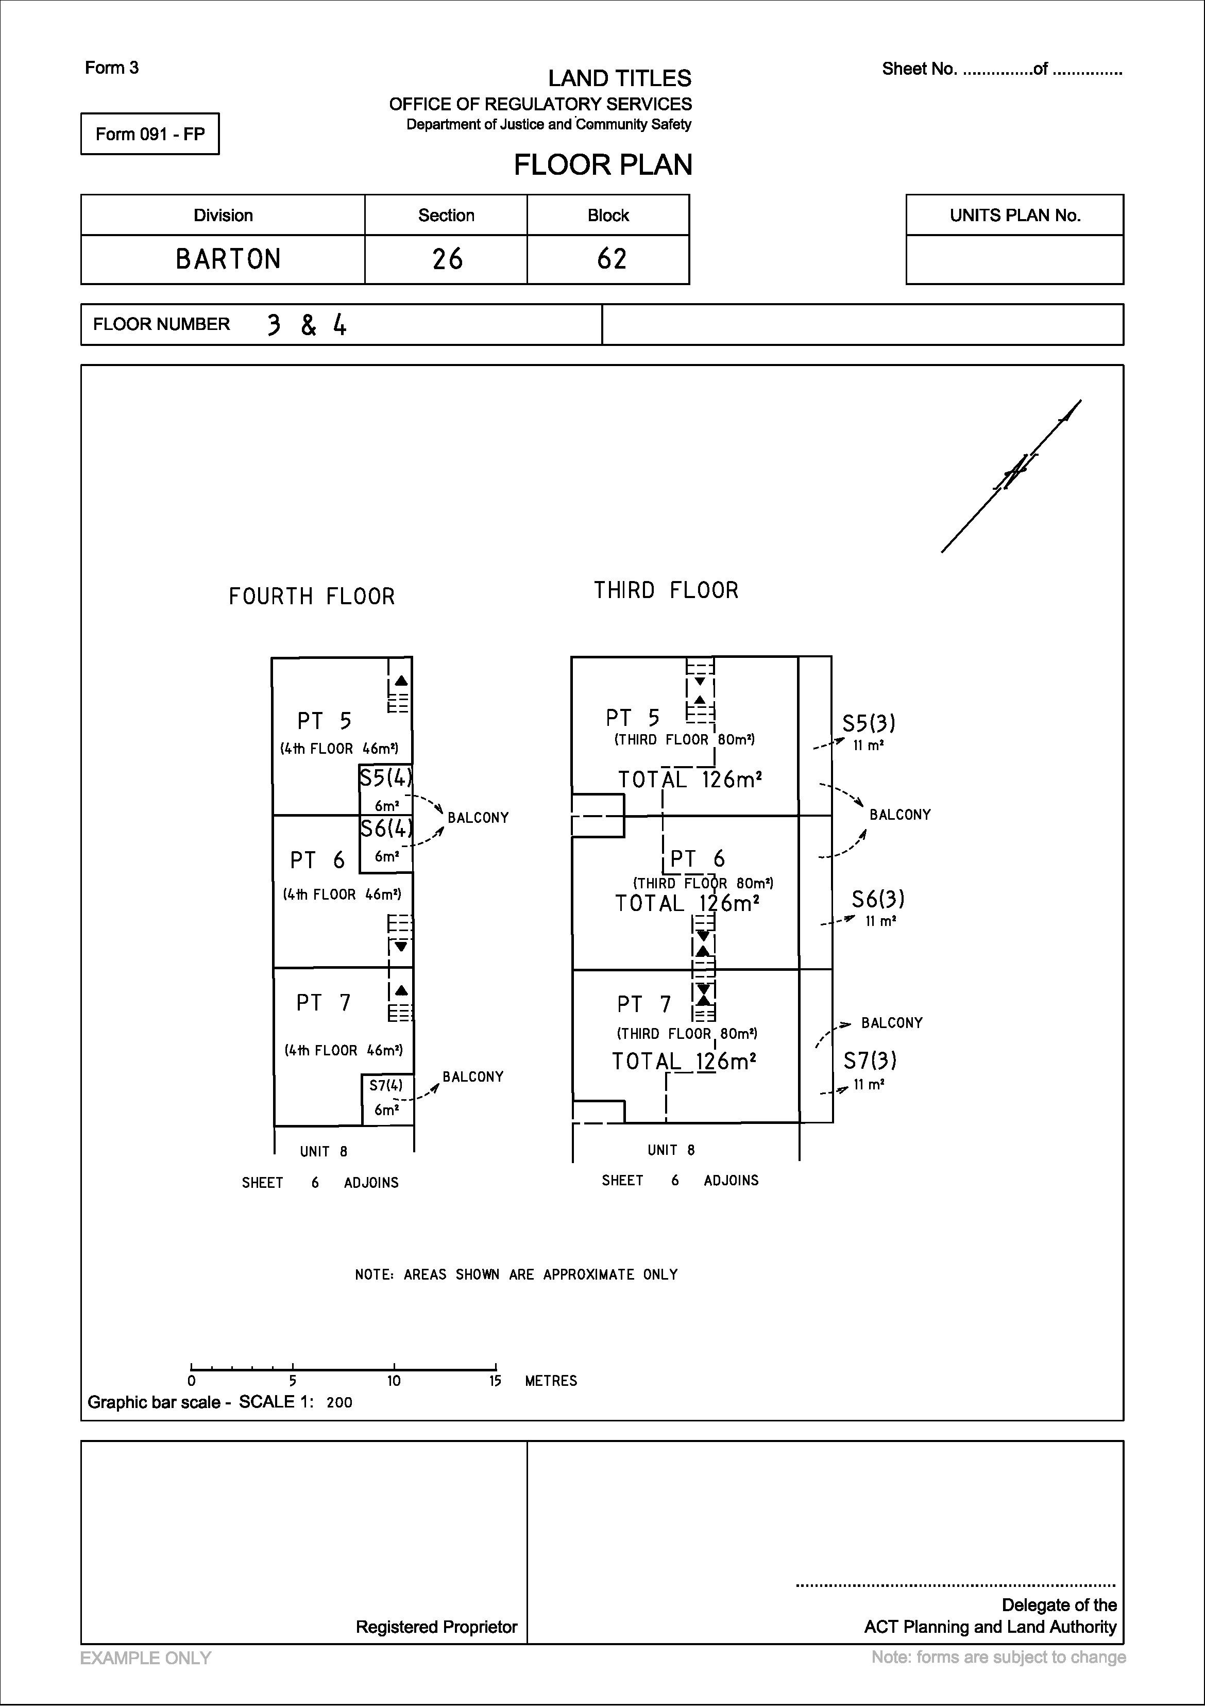
SHEDULE 3-G 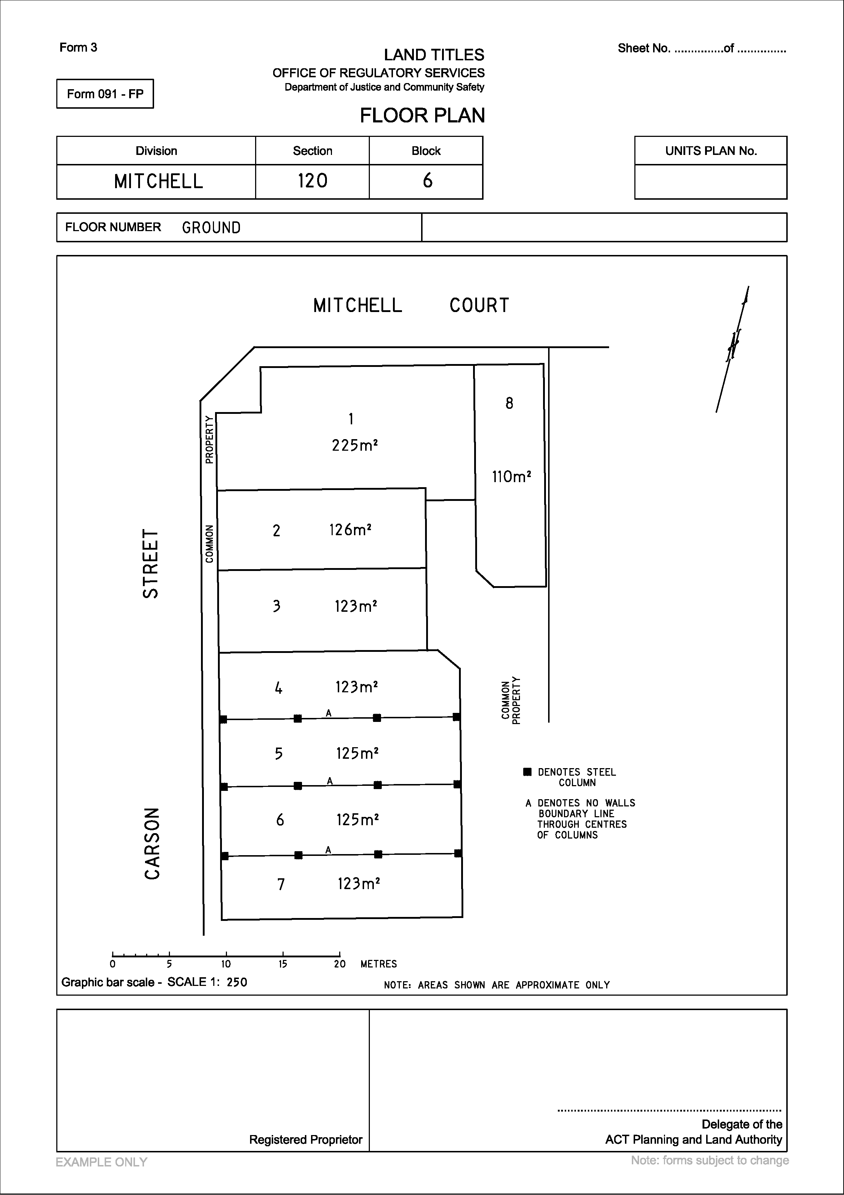
SHEDULE 3-H 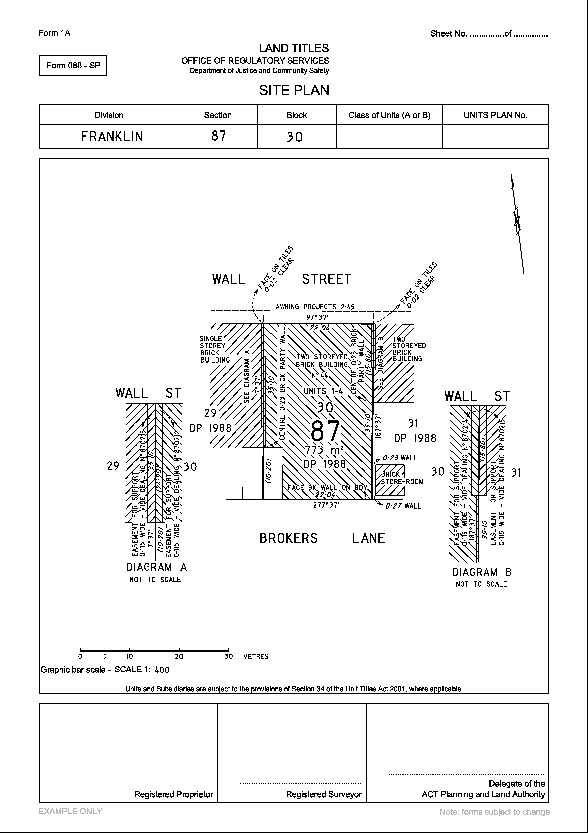
SHEDULE 3-I 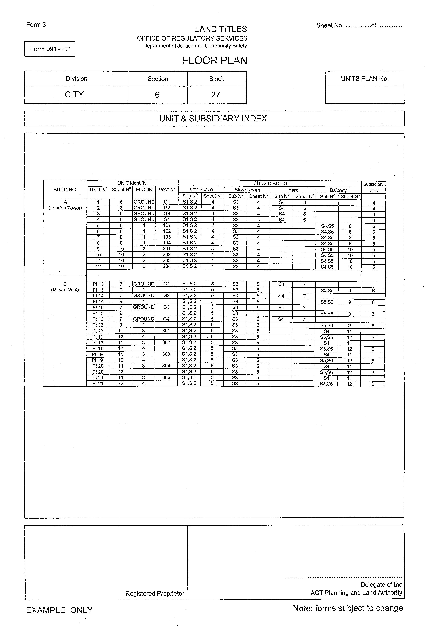
Schedule 4

Supervision of persons by Registered Surveyors

S4-1 Background

‘Supervision’ may be defined as the act, process or function of overseeing, directing or managing work, workers or a project.
In the land and mining survey context, a supervising surveyor has an important role in guiding the training of future professionals and also has certain obligations in undertaking the preparation and instruction of a supervised person.
A supervising surveyor must provide appropriate direction to employed persons and may provide guidance and direction in relation to the preparation of a person for relevant NSW Board of Surveying and Spatial Information (‘the Board’) examinations. Supervision may be through the exercise of ‘general supervision’ and/or ‘immediate supervision’ both in the office environment and in the field.
This direction is intended to provide guidance to supervising surveyors regarding their role and responsibilities in relation to the supervision of persons.

S4-2 Objectives of supervision of persons by Registered Surveyors

The supervising surveyor is responsible for ensuring that the supervised person is aware of the importance of the surveyor’s role in:
- maintaining the integrity of the cadastre and the high quality of surveys;

- providing professional and high quality services to the public;

- producing a high quality survey product prepared in accordance with legislative requirements;

- ensuring that work is undertaken in a safe and responsible manner (OH&S) and in accordance with other relevant legislation; and

- a continuing professional responsibility to the wider survey profession.

S4-3 Definitions

A ‘supervising surveyor’ means a person who either:
(1) supervises the activities of others in order to fulfil legal and professional responsibilities and obligations; or
(2) has agreed to supervise a graduate
or both, and is a registered surveyor.
A supervised person may include:
- an unqualified person who acts under the registered surveyor’s direction and assists the registered surveyor in the performance of the registered surveyor’s legal and professional responsibilities;
- a surveyor’s assistant;
- a survey graduate;
- a student of surveying;
- a person holding a recognised qualification as determined by the Board;
- a candidate for examination;
- a survey drafter or
- other such person as the Surveyor-General may determine from time to time.

S4-4 Levels of supervision – ‘Immediate’ and ‘General’

A supervising surveyor:
- is solely responsible for surveys carried out under his or her supervision, and
- is responsible for the health and safety at work of the supervised person in accordance with relevant ACT and Commonwealth legislation..
- should exercise a standard of supervision that will ensure the survey reflects his or her professional responsibilities and complies with relevant statutes.
It is a matter for the supervising surveyor in the circumstances relating to each individual supervised person as to the level of oversight required and to ensure that the supervised person is capable of carrying out their role at their level of ability. In relation to survey graduates and students of surveying, this involves an exposure to a broad range of surveys and experience to appropriately prepare them for their future role as a professional surveyor.
The extent of supervision required will vary according to the experience, skills and ethics of the supervised person.
The following information is provided for guidance only and is not intended to be an exhaustive list of matters which may be considered by a supervising surveyor in the exercise of the role.
In relation to immediate supervision, the supervising surveyor is expected to have a significant level of involvement with the supervised person. This involves but is not necessarily restricted to:
- briefing the supervised person on the purpose and details of their required duties before the supervised person commences his or her involvement with the survey and associated tasks;
- accompanying the supervised person on site at the early stage of the supervised person’s training;
- being present on sufficient occasions to ensure that the supervised person’s questions and issues are able to be addressed expeditiously;
- inspecting the marking and physical aspects of the survey and associated tasks ,including but not limited to the field notes, closes, etc upon completion and effecting such checks and verification of the supervised persons work as to be confident of the quality and accuracy of the work product supplied. Again it is noted that the supervising surveyor is solely responsible for the correctness of the surveys undertaken by a supervised person under their supervision and direction;
- discussing all aspects of the survey at the completion of their work.
It is a matter for the supervising surveyor to determine on the circumstances of each case when this level or frequency of ‘immediate’ supervision should be reduced, taking into consideration the demonstrated ability of the supervised person to plan and implement their work program including addressing occupational health and safety risks and undertaking a leadership role in undertaking the survey.
In relation to general supervision the supervising surveyor continues to be wholly responsible for the work of the supervised person however the level of oversight and review is reduced, as compared to immediate supervision, reflecting the level of the supervising surveyor’s confidence in the knowledge, skill and competency of the supervised person.
General supervision may apply, for example, to a supervised person who has had some level of recognised technical qualification and has attained an appropriate level of experience. General supervision would normally only apply to a student of surveying, or surveyor’s assistant.
General supervision may involve:
- instruction on the requirements for and any unusual or difficult aspects of the survey and associated tasks and possible methods of approach, especially if new procedures are involved;
- progress checks of the unusual or complex features of the survey task;
- a detailed and comprehensive review of the assignment on completion.
Regardless of what level of supervision is exercised, the supervising surveyor should be aware of any risks or circumstances which may not be evident from office examination and deliberations. This may require the supervising surveyor to visit the site.

S4-5 Supervision in the office and in the field

Whether the supervised person is working in the office or the field it is the role of the supervising surveyor to ensure that the supervised person is appropriately supervised. Any deficiencies in their skills, the quality of their work product, and professionalism (particularly in relation to clients) should be addressed and rectified. The supervising surveyor takes full responsibility for the work of the supervised person undertaken in the course of their employment.
During the course of their employment, and while under direct supervision, supervised persons should be exposed to a variety of surveys including complex and challenging situations through which they can gain a wide range of experience.
In addition a supervising surveyor should impress upon the supervised person the importance of:
- professional presentation and ethical conduct, through both example and instruction, and
- adherence to and maintenance of safe work methods, practices and procedures in the field and in the office environment.

S4-6 Power of entry

Section 45 of the Surveyors Act 2007 (the Act) provides that a registered surveyor has a power of entry onto land under the conditions of this section.
Section 45(4) of the Act provides that an assistant (including unaccompanied supervised person) does not have a power of entry under the Act unless accompanied by the registered surveyor or the owner has given written permission.

S4-7 Supervision in relation to NSW Board Examinations

The supervision of candidates for land and mining survey qualification is a fundamental responsibility of a well trained Survey professional.
The Board recognises the importance of academic qualification and the examination and granting of certificates of competency by the Board itself as key elements in preparing a supervised person for their future professional role. However, it is the role of the supervising surveyor to assist the supervised person for both the examination of the candidate’s competency and to prepare the supervised person for their work as a Survey professional.
The supervising surveyor is best placed to assess the character, level of knowledge and preparedness to undertake the examination process.
At the completion of the supervision period, the supervised person should have attained a broad range of training and experience.
Poorly presented candidates reflect on the reputation of the supervising surveyor.

