Australian Capital Territory

Road Transport (General) Application of Road Transport Legislation Declaration 2018 (No 10)

Disallowable instrument DI2018–281
made under the
Road Transport (General) Act 1999, s 12 (Power to include or exclude areas in road transport legislation)

1 Name of instrument
This instrument is the Road Transport (General) Application of Road Transport Legislation Declaration 2018 (No 10).

2 Commencement
This instrument commences on the day after its notification day.

3 Declaration
I declare that for the period set out in clause 4, the following provisions of the Road Transport (Road Rules) Regulation 2017 do not apply to the areas identified in the schedules:
- section 205 (Parking for longer than indicated); and
- section 205A (Parking outside time indicated); and
- section 207 (Parking where fee payable); and
- section 211 (Parking in parking bay); and
- section 213I (Ticket parking—parking in space); and
- section 213J (Ticket parking—parking in space—motorbike); and
- section 213K (Ticket parking—display of ticket); and
- section 213M (Ticket parking—maximum length of stay).

4 Period of effect of declaration
The declaration has effect during the following periods:

(a) The declaration has effect in the areas identified in schedule 1 during the period commencing at 6:00am on Friday, 23 November 2018 and ending at 11:59pm on Sunday, 25 November 2018.

(b) The declaration has effect in the areas identified in schedule 2 during the period commencing at 6:00am on Saturday, 24 November 2018 and ending at 11:59pm on Saturday, 24 November 2018.

5 Expiry
This instrument expires on 26 November 2018.

Mick Gentleman MLA
Minister for Planning and Land Management
21 November 2018

Schedule 1 - Road and road related areas where specified road transport legislation is to be disapplied for South Fest

(see clauses 3 and 4)

The parking area where specified parking rules are suspended for South Fest are the areas shown within the dark solid lines.

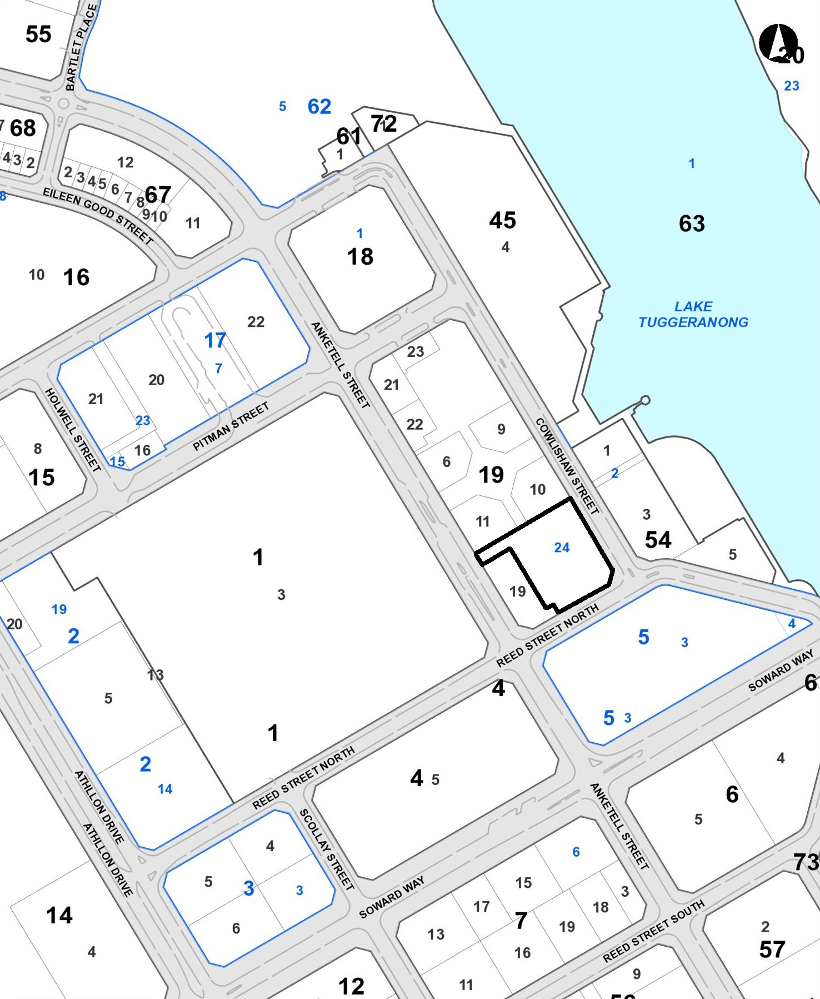

Schedule 2 - Road and road related areas where specified road transport legislation is to be disapplied for South Fest

(see clauses 3 and 4)

The parking area where specified parking rules are suspended for South Fest are the areas shown within the dark solid lines.

