Australian Capital Territory

Road Transport (General) Application of Road Transport Legislation Declaration 2019 (No 9)

Disallowable instrument DI2019–208
made under the
Road Transport (General) Act 1999, section 12 (Power to include or exclude areas in road transport legislation)

1 Name of instrument
This instrument is the Road Transport (General) Application of Road Transport Legislation Declaration 2019 (No 9).

2 Commencement
This instrument commences on the day after its notification day.

Declaration
- I declare that the following provisions of the Road Transport (Road Rules) Regulation 2017 do not apply to the areas identified in Schedule 1 of this instrument during the period identified in clause 4 (a):
- Section 207 (Parking where fee payable);
- Section 213I (Ticket parking – parking in space);
- Section 213J (Ticket parking – parking in space – motorbike);
- Section 213K (Ticket parking – display of ticket); and
- Section 213M (Ticket parking – maximum length of stay).

- I declare that the following provisions of the Road Transport (Road Rules) Regulation 2017 do not apply to the areas identified in Schedule 2 and Schedule 3 of this instrument during the period identified in clause 4 (b) and (c):
- Section 205 (Parking for longer than indicated);
- Section 205A (Parking outside time indicated);
- Section 207 (Parking where fee payable);
- Section 211 (Parking in parking bay);
- Section 213I (Ticket parking – parking in space);
- Section 213J (Ticket parking – parking in space – motorbike);
- Section 213K (Ticket parking – display of ticket); and
- Section 213M (Ticket parking – maximum length of stay).

Period of effect of declaration
The declaration in clause 3 has effect during the following periods:
- The declaration has effect in the areas identified in schedule 1 during the period commencing at 7:00am on Tuesday, 3 September 2019 and ending at 10:00pm on Friday, 8 November 2019.
- The declaration has effect in the areas identified in schedule 2 during the period commencing at 7:00am on Saturday, 12 October 2019 and ending at 6:00am on Monday, 11 November 2019.
- The declaration has effect in the areas identified in schedule 3 during the period commencing at 10:00pm on Friday, 8 November 2019 and ending 6:00am on Monday, 11 November 2019.

Expiry
This instrument expires on 12 November 2019.

Mick Gentleman MLA
Minister for Planning and Land Management
Acting Minister for Justice, Consumer Affairs and Road Safety

30 August 2019

Schedule 1
(See clauses 3 and 4)
The areas where the specified provisions of the road transport legislation are suspended are the areas marked by the yellow shading.

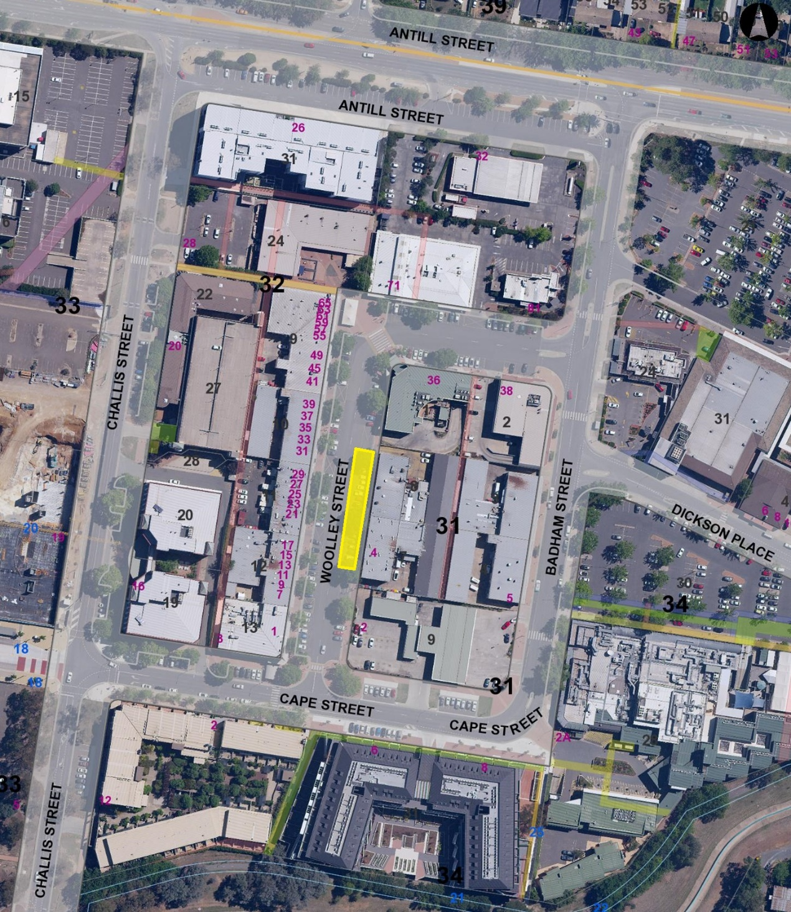

Schedule 2
(See clauses 3 and 4)

The areas where the specified provisions of the road transport legislation are suspended are the areas marked by the yellow shading.

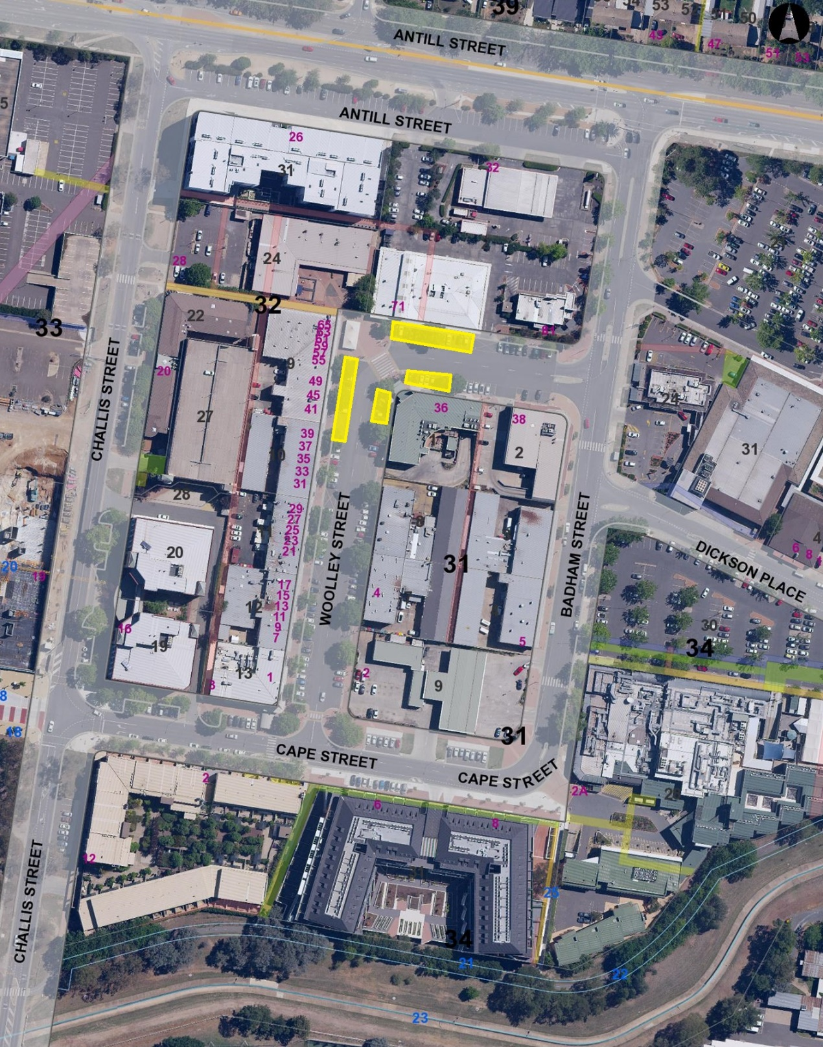

Schedule 3
(See clauses 3 and 4)
The areas where the specified provisions of the road transport legislation are suspended are the areas marked by the yellow shading.
