Australian Capital Territory

Road Transport (General) Application of Road Transport Legislation Declaration 2019 (No 11)

Disallowable instrument DI2019–254
made under the
Road Transport (General) Act 1999, section 12 (Power to include or exclude areas in road transport legislation)

1 Name of instrument
This instrument is the Road Transport (General) Application of Road Transport Legislation Declaration 2019 (No 11).

2 Commencement
This instrument commences on 14 November 2019.

Declaration
We declare that the following provisions of the Road Transport (Road Rules) Regulation 2017 do not apply to the areas identified in the schedules to this instrument:
- Section 205 (Parking for longer than indicated);
- Section 205A (Parking outside time indicated);
- Section 207 (Parking where fee payable);
- Section 211 (Parking in parking bay);
- Section 213I (Ticket parking – parking in space);
- Section 213J (Ticket parking – parking in space – motorbike);
- Section 213K (Ticket parking – display of ticket); and
- Section 213M (Ticket parking – maximum length of stay).

Period of effect of declaration
The declaration has effect during the following periods:
- The declaration has effect in the areas identified in schedule 1 to this instrument during the period commencing at 6:00am on Friday, 15 November 2019 and ending at 6:00am on Saturday, 16 November 2019.
- The declaration has effect in the areas identified in schedule 2 to this instrument during the period commencing at 6:00am on Saturday, 16 November 2019 and ending at 6:00pm on Saturday, 16 November 2019.

Expiry
This instrument expires on 17 November 2019.

Mick Gentleman MLA | Shane Rattenbury MLA
Minister for Planning and Land Management  13 November 2019 | Minister for Justice, Consumer Affairs, and Road Safety  13 November 2019

Schedule 1

The areas (Parts of Block 24, Section 19 Greenway) where the specified provisions of the road transport legislation are suspended are the areas marked by the yellow shading.

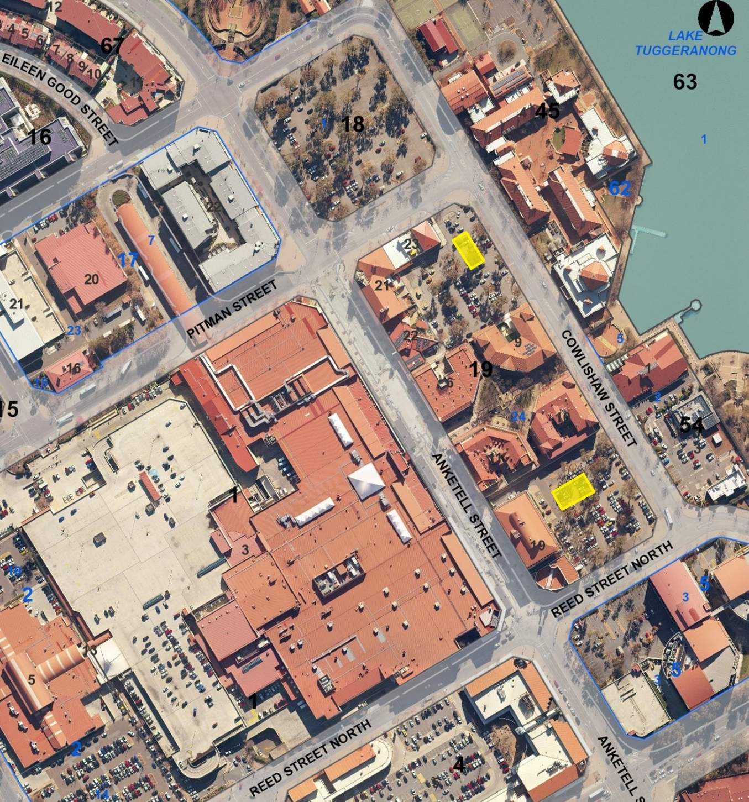

Schedule 2
The areas (Block 24, Section 19 Greenway and part Block 1, Section 18 Greenway) where the specified provisions of the road transport legislation are suspended are the areas marked by the yellow shading.

