Australian Capital Territory
Road Transport (General) Exclusion of Road Transport Legislation (Summernats) Declaration 2019 (No 1)
Disallowable instrument DI2019—269
made under the
Road Transport (General) Act 1999, section 13 (Power to exclude vehicles, persons or animals from road transport legislation)

1 Name of instrument
This instrument is the Road Transport (General) Exclusion of Road Transport Legislation (Summernats) Declaration 2019 (No 1).

2 Commencement
(1) This instrument (other than clause 3) commences on 1 January 2020.
(2) Clause 3 commences on 2 January 2020.

3 Vehicle use—declaration
(1) I declare that section 5B (Improper use of motor vehicle) of the Road Transport (Safety and Traffic Management) Act 1999 does not apply to a designated vehicle while being used in the:

(a) declared drifting area for any period beginning on a drifting official declaring (in whatever manner the drifting official describes) the drifting course active for a testing session, media event or ticketed event and ending on a drifting official declaring the drifting course inactive; and
(b) declared power skid area for any period beginning on a power skid official declaring (in whatever manner the power skid official describes) the power skid course active for a testing session, media event or use by a designated vehicle and ending on a power skid official declaring the power skid course inactive.

4 Third-party insurance—declaration
(1) The Road Transport (Third-Party Insurance) Act 2008 does not apply to a designated vehicle within the declared area of Exhibition Park in Canberra (EPIC).
(2) However subclause (1) does not apply if the designated vehicle is—
(a) covered under a policy of compulsory third-party insurance of a place other than the ACT or under a law of the Commonwealth; or
(b) subject to coverage under a compulsory motor vehicle or trailer accident compensation scheme of a place other than the ACT or of the Commonwealth.
(3) In this clause:
designated vehicle means any of the following vehicles:
(a) a registered entrant motor vehicle;
(b) a registered promotional vehicle;
(c) an unidentified motor vehicle;
(d) an uninsured motor vehicle.
Note For the application of this clause to trailers, see the definitions of the relevant terms.
registered means registered under the Road Transport (Vehicle Registration) Act 1999.
unidentified motor vehicle—see the Road Transport (Third-Party Insurance) Act 2008, section 62.
uninsured motor vehicle—see the Road Transport (Third-Party Insurance) Act 2008, section 60.

5 Vehicle registration and standards—declaration
(1) The prescribed vehicle registration and standards provisions do not apply to a relevant vehicle within the declared area of Exhibition Park in Canberra (EPIC).
(2) In this clause:
prescribed vehicle registration and standards provisions means—
(a) the following provisions of the Road Transport (Vehicle Registration) Act 1999:
(i) section 18 (Prohibition on using unregistered registrable vehicles or vehicles with suspended registration);
(ii) section 26 (Using certain defective vehicles); and
(b) the following provisions of the Road Transport (Vehicle Registration) Regulation 2000:
(i) section 108 (Emission control systems to be fitted and properly maintained);
(ii) section 109 (Light motor vehicles not complying with sch 1);
(iii) section 110 (Light trailers not complying with sch 1);
(iv) section 111 (Light combinations not complying with sch 1).
relevant vehicle means—
(a) an entrant motor vehicle; or
(b) a promotional vehicle.
Note For the application of this clause to trailers, see the definitions of the relevant terms.

6 Driver licences – declaration
(1) The prescribed conditions applying to high powered vehicle restrictions on a person’s driver licence from another jurisdiction do not apply within the declared area of Exhibition Park in Canberra (EPIC).
(2) In this clause:
prescribed conditions means—
(a) the following provision of the Road Transport (Driver Licensing) Regulation 2000:
(i) section 60 (Conditional licence holders to comply with conditions).
7 Notes
A reference to an Act in this instrument includes a reference to the statutory instruments made or in force under the Act, including any regulation (see Legislation Act, s104).

8 Definitions
In this instrument:
declared area, of Exhibition Park in Canberra, means that part of Exhibition Park in Canberra enclosed by the fence outlined in Schedule 1.
declared drifting area, of Exhibition Park in Canberra, means that part of Exhibition Park in Canberra highlighted in red in Schedule 2.
declared power skid area, of Exhibition Park in Canberra, means that part of Exhibition Park in Canberra highlighted in blue in Schedule 2.
drifting official means a person who holds an official’s licence from the Confederation of Australian Motor Sport Ltd that authorises the official to declare the drifting course active or inactive.
drifting course means a road or road related area used as a course designed and approved under the ‘CAMS Drifting Standing regulations’.
designated vehicle means any of the following vehicles:
(a) a registered entrant motor vehicle;
(b) a registered promotional vehicle;
(c) an unidentified motor vehicle;
(d) an uninsured motor vehicle.
entrant motor vehicle means a motor vehicle or trailer that is entered in the event.
event means the event known as Summernats 33 Car Festival held at Exhibition Park in Canberra on 2 January 2020 to 5 January 2020 and includes preparatory activities for the event occurring within Exhibition Park in Canberra on 1 January 2020.
power skid course means a road or road related area used as a course for participants to use designated vehicles not for their intended use.
power skid official means an area manager for the power skid course.
promotional vehicle means a motor vehicle or trailer that is categorised by Summernats Pty Ltd, ACN 139 042 961, as a promotional vehicle for the event.
registered means registered under the Road Transport (Vehicle Registration) Act 1999.
unidentified motor vehicle—see the Road Transport (Third-Party Insurance) Act 2008, section 62.
uninsured motor vehicle—see the Road Transport (Third-Party Insurance) Act 2008, section 60.

9 Expiry
(1) This instrument (other than section 3) expires at 12:00pm on 6 January 2020
(2) Section 3 expires at 6:00pm on 5 January 2020.

Shane Rattenbury
Minister for Justice, Consumer Affairs and Road Safety
9 December 2019

Schedule 1
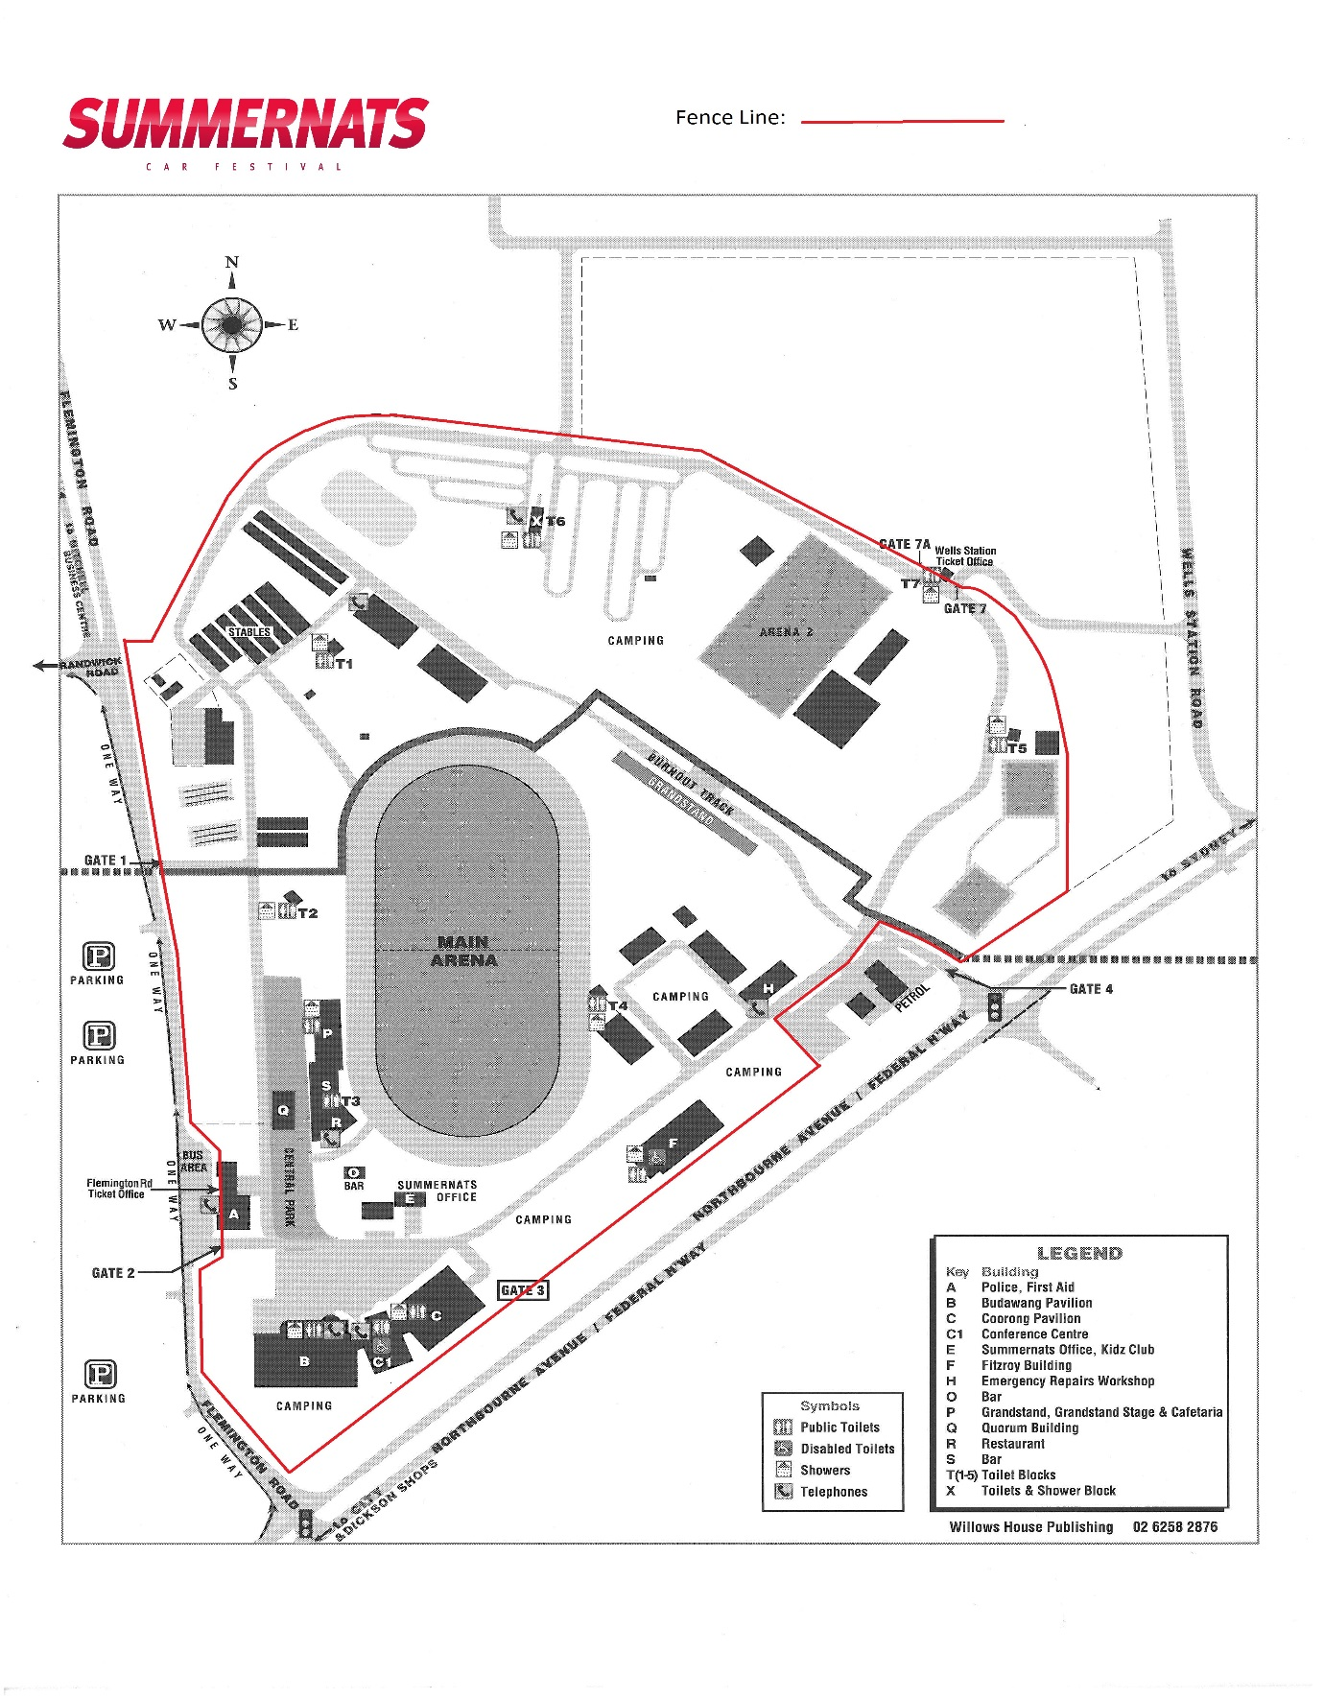

Schedule 2

