Australian Capital Territory

Road Transport (General) Application of Road Transport Legislation Declaration 2020 (No 1)

Disallowable instrument DI2020–19
made under the
Road Transport (General) Act 1999, section 12 (Power to include or exclude areas in road transport legislation)

1 Name of instrument
This instrument is the Road Transport (General) Application of Road Transport Legislation Declaration 2020 (No 1).

2 Commencement
This instrument commences on 20 February 2020.

Declaration
We declare that the following provisions of the Road Transport (Road Rules) Regulation 2017 do not apply to the areas identified in the schedules to this instrument:
- Section 205 (Parking for longer than indicated);
- Section 205A (Parking outside time indicated);
- Section 207 (Parking where fee payable);
- Section 208 (Parallel parking on road);
- Section 208A (Parallel parking in road related area);
- Section 211 (Parking in parking bay);
- Section 213I (Ticket parking – parking in space);
- Section 213J (Ticket parking – parking in space – motorbike);
- Section 213K (Ticket parking – display of ticket); and
- Section 213M (Ticket parking – maximum length of stay).

Period of effect of declaration
The declaration has effect during the following periods:
- The declaration has effect in the areas identified in schedule 1 during the period commencing at 6:00am on Thursday, 20 February 2020 and ending at 12:01am on Monday, 24 February 2020
- The declaration has effect in the areas identified in schedule 2 during the period commencing at 12:01am on Friday, 21 February 2020 and ending at 6:00am on Monday, 24 February 2020.

Expiry
This instrument expires on 25 February 2020.

Mick Gentleman MLA | Shane Rattenbury MLA
Minister for Planning and Land Management  17 February 2020 | Minister for Justice, Consumer Affairs and Road Safety  17 February 2020

Schedule 1 (see clause 3)
The areas where the specified provisions of the road transport legislation are suspended are the areas marked by the yellow shading.

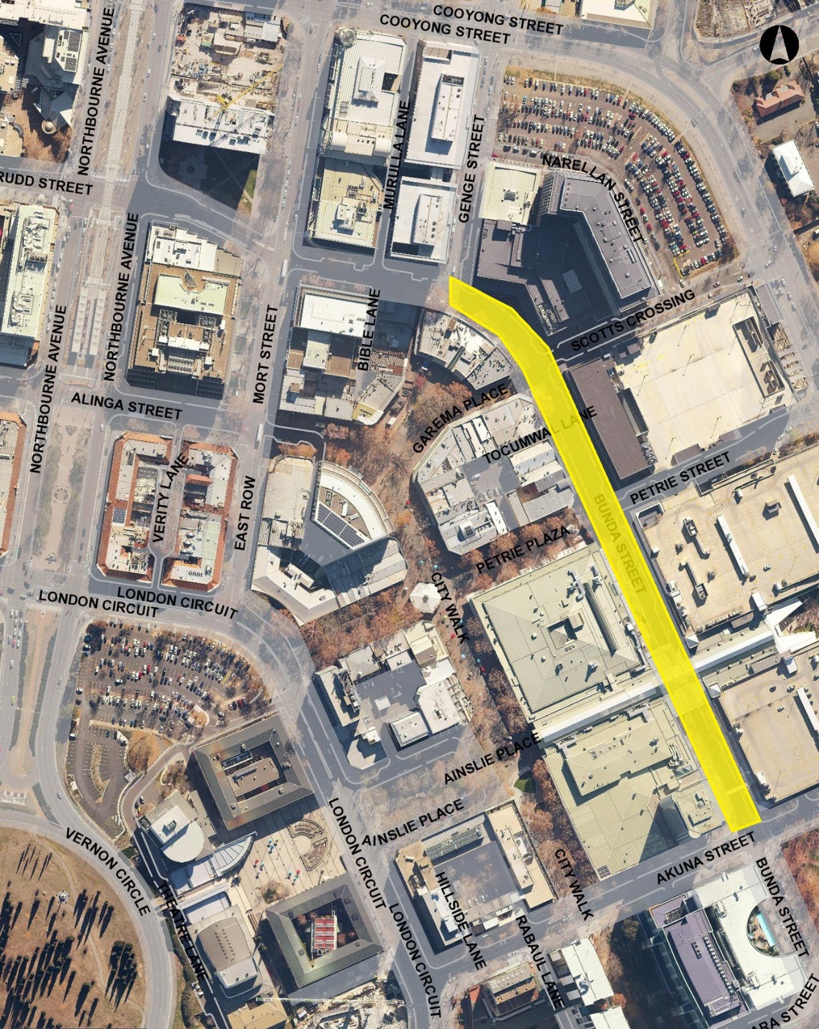

Schedule 2 (see clause 3)
The areas where the specified provisions of the road transport legislation are suspended are the areas marked by the yellow shading.

