Australian Capital Territory

Road Transport (General) Application of Road Transport Legislation Declaration 2021 (No 2)

Disallowable instrument DI2021-9
made under the
Road Transport (General) Act 1999, section 13 (Power to exclude vehicles, persons or animals from road transport legislation)

1 Name of instrument
This instrument is the Road Transport (General) Application of Road Transport Legislation Declaration 2021 (No 2).

2 Commencement
This instrument commences on 18 January 2021.

3 Declaration - Motor accident injuries insurance
I declare that the Motor Accident Injuries Act 2019 does not apply to:
- a designated vehicle; or
- a motor vehicle involved in a motor accident with a designated vehicle;
while the designated vehicle is being used or operated on a road or road related area identified in Schedule 1 during the period set out in clause 5 for the purpose of filming activities.

4 Declaration – other road transport legislation
(1) I declare that the Road Transport (Safety and Traffic Management) Act 1999 and
the Road Transport (Road Rules) Regulation 2017 do not apply to:
- a designated vehicle; or
- the driver of a designated vehicle;
while the designated vehicle is being used or operated on a road or road related area identified in Schedule 1 during the period set out in clause 5 for the purpose of filming activities.

5 Period of effect of declaration
The declaration in clauses 3 and 4 has effect in the areas identified in Schedule 1 when filming activities occur during the period 06:00 pm 18 January 2021 to 09:00 am 19 January 2021.

6 Expiry
This instrument expires on 20 January 2021.

7 Definitions
designated vehicle means any of the following motor vehicles:
- A motor vehicle issued an unregistered vehicle permit in accordance with section 86 of the Road Transport (Vehicle Registration) Regulation 2000 for the purpose of filming activities;
- A camera tracking motor vehicle provided by AJK Grips; or
- A motor vehicle that is owned or hired by Blacklight Pty Ltd, or an entity related to Blacklight Pty Ltd, for the purposes of filming activities, including but not limited to:
- The Dodge SRT Challenger Hellcat (VIN 2C3CDZC9XKH500038);
- The Dodge SRT Challenger Hellcat (VIN 2C3CDZC97KH500272);
- The Dodge SRT Challenger Hellcat (VIN 2C3CDZC91KH500039);
- The IVECO ACCO 6X4 Garbage Truck (VIN 6F2-252300-6DN00228); and
- The IVECO ACCO 6X4 Garbage Truck (VIN F22523005DM00091).

filming activities means activities related to the making of the motion picture ‘Blacklight’ including rehearsals and takes, however, does not include when pedestrians, local traffic or a motor vehicle that is not a designated vehicle is provided access to the road or road related area identified in Schedule 1.

motor accident – refer to section 10 of the Motor Accident Injuries Act 2019.

Chris Steel MLA
Minister for Transport and City Services
Special Minister of State

15 January 2021
Schedule 1 – Filming location
(see clause 3 and 4)
The filming locations are marked on the maps below within the Canberra City CBD and surrounding roads. The routes are marked on the maps below.

London Circuit between Northbourne Ave & Akuna Street

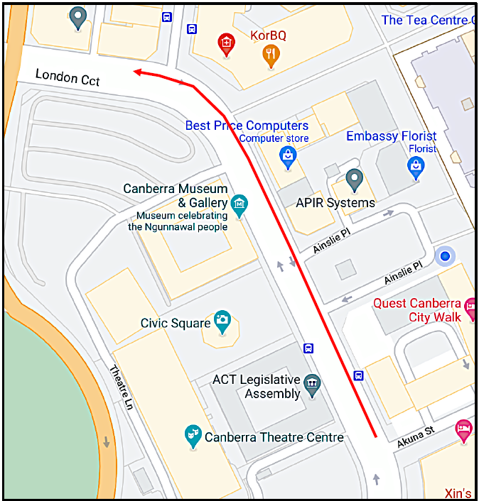

Edinburgh Avenue overpass to Parkes Way (eastbound)

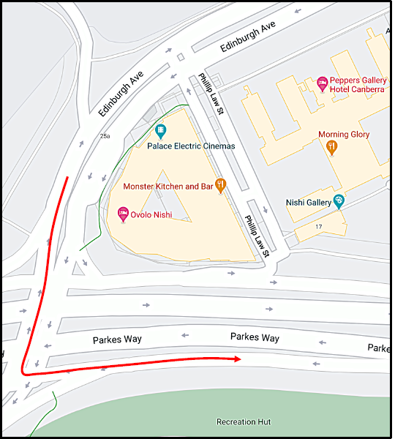

Parkes Way loop between Coranderrk Street roundabout and Clunies Ross Street/Lady Denman Drive

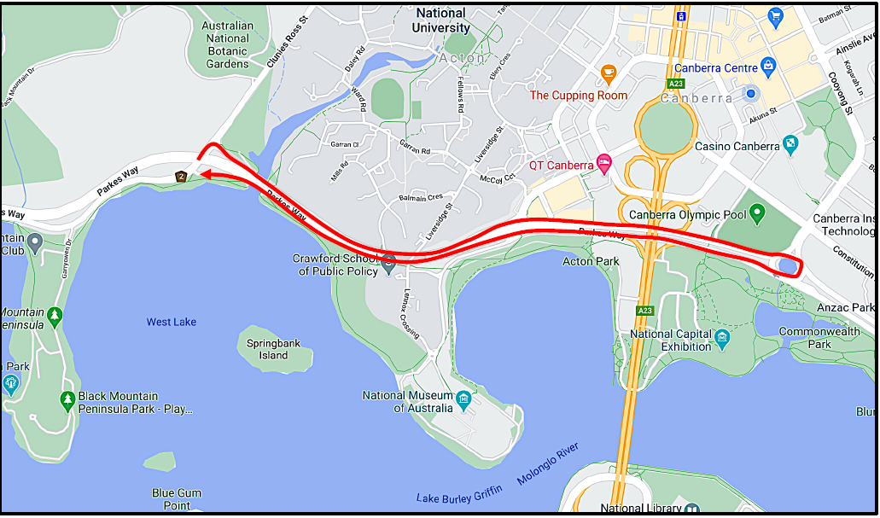

Majura Way / Tambreet Street underpass & western on/off ramps

