Australian Capital Territory
Building (ACT Appendix to the Building Code) Determination 2023 (No 3)
Disallowable instrument DI2023–304
made under the
Building Act 2004, s 136 (Building code)

1 Name of instrument
This instrument is the Building (ACT Appendix to the Building Code) Determination 2023 (No 3).
2 Commencement
This instrument commences on the day after its notification day.
3 Making of ACT appendix
I make the ACT Appendices to the Building Code of Australia at schedule 1 and schedule 2 of this instrument.
Note The Act, s 136, provides that the building code means a document prescribed by regulation, and the Building Code of Australia, prepared and published by the Australian Building Codes Board, as amended from time to time by that board, and the ACT Appendix to the building code.
4 Application
(1) Schedule 1 of this instrument applies to:
  - all building approvals determined on or after 1 May 2023 and on or before 14 January 2024; and
  - all building work that does not require a building approval started on or after 1 May 2023 and on or before 14 January 2024.
(2) Schedule 2 of this instrument applies to:
- all building approvals determined on or after 15 January 2024; and
- all building work that does not require a building approval started on or after 15 January 2024.

5 Disapplication of Legislation Act
The Legislation Act 2001, section 47 (5), does not apply to this instrument.
Note 1 Australian Standards are available for purchase at www.standards.org.au.
Note 2 Free copies of the National Construction Code are available at www.abcb.gov.au.
6 Revocation
This instrument revokes the Building (ACT Appendix to the Building Code) Determination 2023 (No 2) (DI2023-236).

Rebecca Vassarotti MLA
Minister for Sustainable Building and Construction

13 December 2023

Schedule 1
(see s 3)

Australian Capital Territory Appendix to the
Building Code of Australia – Volumes 1 and 2

APPLIES BETWEEN 1 MAY 2023 to 14 JANUARY 2024

Contents
Volume 1 4
Section D Access and egress 4
PART D2 Provision for escape 5
Part D4 Access for people with a disability 6
Section F Health and amenity 6
Section G Ancillary provisions 8
Part G2 Boilers, pressure vessels, heating appliances, fireplaces, chimneys and flues 8
Section J Energy efficiency 9
Part J5 Air-conditioning and ventilation systems 11
Schedule 4 Referenced documents 12
Volume 2 13
Part H4 Health and amenity 13
Part H7 Ancillary provisions and additional construction requirements 14
Energy Efficiency 15
Schedule 4 Referenced documents 32

Volume 1

Volume 1 of the Building Code of Australia is amended as follows.

These provisions are based on NCC 2022.

Section D Access and egress
Add ACT D1P0.1 to ACT D1P0.5 as follows:
Performance requirements

ACT D1P0.1 Existing passenger lift or existing toilet concession
Access to passenger lifts or toilets need not be provided in accordance with the requirements of Sections D, E or F, insofar as they relate to matters covered by D1P0.2 or D1P0.3, and specifically only relate to people with a disability if the relevant concession in D1P0.2 or D1P0.3 applies.

ACT D1P0.2 Lift concession
- The requirements in E3D8(b) that a lift is to have a floor dimension of not less than 1400 mm x 1600 mm does not apply to an existing passenger lift if that is in a new part, or an affected part, of a building, if the lift—
- travels more than 12 m; and
- has a lift floor that is not less than 1100 mm x 1400 mm.

ACT D1P0.3 Toilet concession
- The requirements in F4D5 Accessible sanitary facilities, to the extent that they require compliance with AS 1428.1 - 2009, Design for access and mobility, Part 1: General requirements for access - New building work, may comply with the alternative requirements of paragraph (b) for —

- existing accessible sanitary compartments; and
- existing sanitary compartments suitable for use by people with a disability.
- The alternative requirements mentioned in paragraph (a) for sanitary compartments mentioned in paragraphs (i) and (ii) are:

- Compliance with AS1428.1-2001, Design for access and mobility, Part 1: General requirements for access - New building work.

ACT D1P0.4 Application to Class 1b buildings
- Where the BCA applies to the following kinds of Class 1b buildings, the provisions of Volume One that indicate they apply to Class 1b buildings, apply only to the following kinds of Class 1b buildings, insofar as they specifically only relate to people with a disability-
- a new building with 1 or more bedrooms used for rental accommodation; or
- an existing building with 4 or more bedrooms used for rental accommodation; or
- a building that comprises 4 or more single dwellings that are-
    - on the same allotment; and
    - used for short-term holiday accommodation.

ACT D1P0.5 Meaning of certain terms
Terms in ACT D1P0.1, ACT D1P0.2, ACT D1P0.3 or ACT D1P 0.4 that also have their meaning defined in the Disability (Access to Premises - Buildings) Standards 2010, determined under the Disability Discrimination Act 1992 (Commonwealth), have that meaning.
Explanatory information:
ACT D1P0.1 to ACT D1P0.4 mirror the respective provisions of the Disability (Access to Premises - Buildings) Standards 2010, determined under the Disability Discrimination Act 1992 (Commonwealth). Where a provision of ACT D1P0.1, ACT D1P0.2, ACT D1P0.3 or ACT D1P0.4 indicates it applies to something in the NCC, insofar as the thing specifically only relates to people with a disability, the provision does not permit other relevant NCC provisions to not apply.
ACT legislation other than the BCA also regulates for access and mobility.
Practitioners should ensure they check the latest version of relevant legislation, and the latest version of this Appendix, available through the ACT legislation register at www.legislation.act.gov.au.

PART D2 Provision for escape
Add ACT D2D2.01 and ACT D2D2.02 as follows:

ACT D2D2.01 Notices on fire-isolated stairs
- Every fire-isolated stairway must have a notice displayed in a conspicuous position at the landing on each storey level to the effect of the following:

OFFENCES RELATING TO FIRE STAIRS
Under the Emergencies Act 2004 (ACT) it is an offence to:
- Place anything in this stairway or any associated passageway leading to the exterior of the building which may impede the free passage of persons; or
- Interfere with or cause obstruction or impediment to the normal operation of fire doors providing access to this stairway; or
- Remove, damage or otherwise interfere with this notice.
- In any notice displayed in accordance with (a)-
- the words "OFFENCES RELATING TO FIRE STAIRS" must be in letters not less than 20 mm in height; and
- all other letters and figures in the remainder of the notice must be not less than 3 mm in height; and
- the notice must be clearly legible with lettering of a colour contrasting with the background embossed or cast into a permanent plate securely and permanently fixed to the wall.

ACT D2D2.02 Access for people with disabilities
Other requirements must be considered in respect of requirements for people with disabilities, including the ACT Territory Plan under the Planning and Development Act 2007 (ACT) or legislation that replaces it and the Disability Discrimination Act 2004 (Cth) and any further applicable amendments to this Appendix. Where additional provisions of the ACT Appendix to Volume One have been made by instrument under the Building Act 2004, relevant building work or buildings may comply with the applicable provisions, as permitted by the provisions. Volume One users should check the latest ACT BCA appendices made under the Building Act 2004 through the ACT legislation register at www.legislation.act.gov.au.

Part D4 Access for people with a disability
Add ACT D4D5(d) as follows:
ACT D4D5(d) Exemptions
- an area covered by, and in the respective circumstances covered by, and to the relevant extent provided for by, ACT D1P0.1, ACT D1P0.2, ACT D1P0.3 or ACT D1P0.4.

Section F Health and amenity

Part F8 Condensation management
In “Introduction to this Part” add:
Notes: ACT Part F8 Condensation management
For the ACT, from 1 May 2023 to 14 January 2024 Part F6 of NCC 2019 Volume One Amendment 1 applies instead of Part F8 of NCC 2022 Volume One. From 15 January 2024 Part F8 of NCC 2022 Volume One applies.

ACT F6 Condensation management
These provisions refer to NCC 2019.

Verification methods

In FV6 add:

Note
There is no specific Australian standard for this type of analysis. The ASHRAE 160 Criteria for Moisture-Control Design Analysis in Buildings methodology can be used appropriately in the Australian climate. That standard provides for analysis of rain penetration and moisture performance evaluation criteria. A comprehensive assessment includes specification of vapour permeability of waterproofing coatings, membranes, insulation, interior lining, paints and any other material layers in the construction.

Read only versions of certain ASHRAE Standards can be accessed for free at https://www.ashrae.org/technical-resources/standards-and-guidelines/read-only-versions-of-ashrae-standards

Deemed-to-Satisfy provision

Insert:
Explanatory information
Thermal bridging can be a cause of condensation in buildings. Thermal bridging occurs where a more conductive or less insulated material provides a pathway for heat to flow across a thermal barrier. When warm air comes into contact with cooler air or cooler surfaces, the loss of energy causes the water vapour to condense. Condensation management should be considered in relation to ventilation of the building. For information about minimising thermal bridging and providing ventilation to prevent the build-up of moisture in a building see the Condensation in Buildings – Tasmanian Designers’ Guide at https://www.cbos.tas.gov.au/__data/assets/pdf_file/0004/463630/Condensation-in-buildings-guide-2019.pdf

These provisions are based on NCC 2022.

ACT Part F9 Control of litter on building sites
Add ACT Part F9 and ACT Part F10 as follows:
ACT F9O1 Objective
The Objective is to prevent windblown litter from building sites fouling roads and public land.
ACT F9F1 Functional statement
Building litter must be prevented from spreading around and beyond the allotment boundary.
ACT F9P1 Performance requirements
Sufficient containers must be provided on building sites to store building waste that is likely to become windblown.
ACT F9D1 Deemed-to-Satisfy provision
- The requirements of ACT F9P1 (Performance Requirement) are satisfied by on site building waste that is stored in suitably sized plastic or metal bins and removed from the site at regular intervals.

- For the purposes of this clause, building waste includes plastic containers and plastic and paper wrappings or any waste that can be carried by wind.

ACT Part F10 Waste management
ACT F10O1 Objective
The Objective is to safeguard people from injury caused by infection or contamination from solid waste.
ACT F10F1 Functional statement
Buildings must be provided with space and facilities for the collection, and safe hygienic holding prior to disposal of solid waste arising from the intended use of the building.
ACT F10P1 Performance requirements
Where provision is made within buildings for the collection and temporary holding of solid waste, the design shall accommodate screening, volume of waste, disposal, logistics and access.
ACT F10D1 Deemed-to-Satisfy provision
The requirements of ACT F10P1 (Performance Requirement) are satisfied by garbage facilities designed and constructed in accordance with the Development Control Code for Best Practice Waste Management in the ACT.

Section G Ancillary provisions

ACT G1 Minor structures and components
ACT G1P2 Performance requirement
After G1P2 (2), add ACT G1P2 as follows:

ACT G1P2 Swimming pool access and water recirculation systems
- Indoor or outdoor permanent bathing, wading and swimming pools must—
  - where the capacity of the pool exceeds 10 m³—
  - be of the recirculation type in which the water circulation is maintained through the pool by pumps, the water drawn from the pool being clarified and disinfected before being returned to the pool; and
  - have means of egress provided in the form of ladders, steps in the floor of the pool or a ramp; and
  - be capable of being completely emptied and any discharge or overflow and pool backwash filter must be connected to the sewer drainage system.

- Pools in or forming part of buildings other the Class 1 buildings—
- Where in any part of the pool the depth is less than 1500mm, the floor grade must not exceed a slope of 1 in 20; and
- Permanent signs must be displayed on the side of the pool (or adjacent concourse for flush concourse waterline pools), showing the depth at 300mm change intervals for the length of the pool and the depth at the deep and shallow ends.

Part G2 Boilers, pressure vessels, heating appliances, fireplaces, chimneys and flues
After G2D2 (b), add ACT G2D2 as follows:
ACT G2D2 Installation of appliances
(c) An industrial fuel-fired appliance: AS 1375.
- Storage tanks and other associated fittings: AS 1692.

Part G7 Livable housing design
In “Introduction to this Part” add:
Notes: ACT Part G7 Livable Housing design
For the ACT, Part G7 does not take effect until 15 January 2024.

ACT Part G10 Building over drains
ACT Part G10 Performance requirement
Performance provisions
Existing drains, or parts of drains, in currently operational drainage systems must be sound and able to work effectively without leaking before any building that will be constructed over the drain or restrict access to the drain is constructed.
ACT Part G10 Deemed-to-Satisfy provision
- The requirements of ACT Part G10 (Performance Requirement) are satisfied if—
- Before building work that will result in a building, or part of a building, being constructed over, or restricting access to, an existing drain in currently operational drainage system is carried out, the relevant part of the drain, must be tested for soundness in accordance with section 15 of AS/NZS 3500.2.
- If the drain is found not be sound after testing in accordance with (i), it is made sound before the building work commences.

Section J Energy efficiency
In “Introduction to this Part” in the following parts add the below notes:
- Part J1 Energy efficiency performance requirements
- Part J2 Energy efficiency
- Part J3 Elemental provisions for a sole-occupancy unit of a Class 2 building or a Class 4 part of a building
- Part J4 Building fabric
- Part J5 Building sealing
- Part J6 Air-conditioning and ventilation
- Part J7 Artificial lighting and power
- Part J8 Heated water supply and swimming pool and spa pool plant
- Part J9 Energy monitoring and on-site distributed energy resources
Notes: ACT Section J Energy Efficiency
For the ACT, from 1 May 2023 to 14 January 2024 Section J of NCC 2019 Volume One Amendment 1 applies instead of Section J of NCC 2022 Volume One. From 15 January 2024 Section J of NCC 2022 Volume One applies.

The following Section J Energy efficiency provisions refer to NCC 2019.

ACT J5.9(a) Space heating
Verification methods

JV1 NABERS Energy for Offices
Delete JV1 and insert ACT JV1

ACT JV1 NABERS Energy for Offices

- For a Class 5 building, compliance with JP1 is verified when—
- A NABERS Energy for Offices base building Commitment Agreement is obtained; and
- the energy model required for (i) demonstrates—
    - the base building’s energy use, less energy use from renewable energy generated and used on site, complies with JP1 (f), excluding —
        - tenant supplementary heating and cooling systems; and
        - external lighting; and
        - carpark services; and
    - the thermal comfort level of between a Predicted Mean Vote of -1 to +1 is achieved across not less than 95% of the floor area of all occupied zones for not less than 98% of the annual hours of operation of the building; and
- the building complies with the additional requirements in Specification JVA.

- The calculation method for (a) must comply with ANSI/ASHRAE Standard 140.

JV2 Green Star
Delete JV2 and insert ACT JV2

ACT JV2 Green Star

- For a Class 3, 5, 6, 7, 8 or 9 building, or common area of a class 2 building, compliance with JP1 is verified when—
  - The building complies with the simulation requirements, and is registered, for a Green Star – Design & As-Built rating; and
  - the simulation of energy use in accordance with the requirements for (i) demonstrates the annual modelled energy use is less than 90% of the annual modelled energy use of the reference building; and
  - in the proposed building, a thermal comfort level of between a Predicted Mean Vote of -1 to +1 is achieved across not less than 95% of the floor area of all occupied zones for not less than 98% of the annual hours of operation of the building; and
  - the building complies with the additional requirements in Specification JVA.

- The calculation method for (a) must comply with—
- ANSI/ASHRAE Standard 140; and
- Specification JVb.

JV3 Verification using a reference building

Delete JV3 and insert ACT JV3

ACT JV3 Verification using a reference building

- For a Class 3, 5, 6, 7, 8 or 9 building, or common area of a class 2 building, compliance with JP1 is verified when—
- it is determined that the annual modelled energy use of the proposed building is not more than the annual modelled energy use of a reference building when—
- the proposed building is modelled with the proposed services; and
- the proposed building is modelled with the same services as the reference building; and
- in the proposed building, a thermal comfort level of between a Predicted Mean Vote of -1 to +1 is achieved across not less than 95% of the floor area of all occupied zones for not less than 98% of the annual hours of operation of the building; and
- the building complies with the additional requirements in Specification JVA.

- The annual modelled energy use of the proposed building may be offset by—
- renewable energy generated and used on site; and
- another process such as reclaimed energy, used on site.

- The calculation method for (a) and (b) must comply with—
- ANSI/ASHRAE Standard 140; and
- Specification JVb.

Specification JVb Modelling Parameters

Replace all references to annual greenhouse gas emissions in the specification with “annual modelled energy use”.

Explanatory Information
Table 3a does not apply in the ACT. National emissions factors are not applicable to calculations for buildings in the ACT as they do not take into account investments in renewable electricity generation in the national electricity market made by the ACT. From 2020, the ACT’s electricity usage will either be renewable energy or offset with investments in renewable energy. Due to this, only energy metrics are allowable for verifications in the ACT.

Part J5 Air-conditioning and ventilation systems

Delete J5.9(a) and insert ACT J5.9(a)

ACT J5.9(a) Space heating

- A heater used for air-conditioning or as part of an air-conditioning system must be—
- a solar heater; or
- a gas heater; or
- a heat pump heater; or
- a heater using reclaimed heat from another process such as reject heat from a refrigeration plant; or
- an electric heater if the heating capacity is not more than the value specified in Table J5.9 for climate zone 7, and the in-duct heater complies with J5.2(a)(ii)(C); or
- any combination of (i) to (v).

Schedule 4 Referenced documents

Schedule of referenced documents
In Table 1, insert additional references as follows:

No. | Date | Title | Volume One | Volume Two | Volume Three
AS 1375 | 2013 | Industrial fuel-fired appliances | ACT G2.2 | N/A | N/A
AS 1692 | 2006 Amdt 1 | Tanks for flammable and combustible liquids | ACT G2.2 | N/A | N/A
N/A |  | Development Control Code for Best Practice Waste Management in the ACT | ACT F10D1 | ACT H4D11 | N/A

Volume 2

Volume 2 of the Building Code of Australia is amended as follows.

These provisions are based on NCC 2022.

Part H4 Health and amenity

Add ACT 1 and ACT 2 as follows:

After Part H4 add Part H4 ACT Health and amenity as follows:

ACT H4O10 Control of litter on building sites
The Objective is to prevent windblown litter from building sites fouling roads and public land.
ACT H4F10 Functional statement
Building litter must be prevented from spreading around and beyond the allotment boundary.
ACT H4P10 Performance requirement
Sufficient containers must be provided on building sites to store building waste that is likely to become windblown.
ACT H4D10 Deemed-to-Satisfy provision
- The requirements of ACT H4P8 (Performance Requirement) are satisfied by on site building waste that is stored in suitably sized plastic or metal bins and removed from the site at regular intervals.

- For the purposes of this clause, building waste includes plastic containers and plastic and paper wrappings or any waste that can be carried by wind.

ACT H4O11 Waste management
The Objective is to safeguard people from injury caused by infection or contamination from solid waste.
ACT H4F11 Functional statement
Buildings must be provided with space and facilities for the collection, and safe hygienic holding prior to disposal of solid waste arising from the intended use of the building.
ACT H4P11 Performance requirement
Where provision is made within buildings for the collection and temporary holding of solid waste, the design shall accommodate screening, volume of waste, disposal, logistics and access.
ACT H4D9 Condensation management
Notes: ACT Part H4D9 Condensation management
For the ACT, from 1 May 2023 to 14 January 2024 P2.4.7, V2.4.7 and Part 3.8.7 of NCC 2019 Volume Two Amendment 1 applies instead of H4P7, H4VR and H4D9 of NCC 2022 Volume One. From 15 January 2024 H4P7, H4V5 and H4D9 of NCC 2022 Volume Two applies.
ACT H4D11 Deemed-to-Satisfy provision
The requirements of ACT H4P11 (Performance Requirement) are satisfied by garbage facilities that are designed and constructed in accordance with the Development Control Code for Best Practice Waste Management in the ACT.

ACT 3 Condensation management
These provisions are based on NCC 2019 and apply from 1 May 2023 until 14 January 2024.
Verification methods
V2.4.7 Verification of condensation management

In V2.4.7 add ACT V2.4.7

ACT V2.4.7 Verification of condensation management

Note
There is no specific Australian standard for this type of analysis. The ASHRAE 160 Criteria for Moisture-Control Design Analysis in Buildings methodology can be used appropriately in the Australian climate. That standard provides for analysis of rain penetration and moisture performance evaluation criteria. A comprehensive assessment includes specification of vapour permeability of waterproofing coatings, membranes, insulation, interior lining, paints and any other material layers in the construction.

Read only versions of certain ASHRAE Standards can be accessed for free at https://www.ashrae.org/technical-resources/standards-and-guidelines/read-only-versions-of-ashrae-standards

Acceptable construction practices

In 3.8.7.2 add ACT 3.8.7.2

Explanatory information
Thermal bridging can be a cause of condensation in buildings. Thermal bridging occurs where a more conductive or less insulated material provides a pathway for heat to flow across a thermal barrier. When warm air comes into contact with cooler air or cooler surfaces, the loss of energy causes the water vapour to condense. Condensation management should be considered in relation to ventilation of the building. For information about minimising thermal bridging and providing ventilation to prevent the build up of moisture in a building see the Condensation in Buildings – Tasmanian Designers’ Guide at https://www.cbos.tas.gov.au/__data/assets/pdf_file/0004/463630/Condensation-in-buildings-guide-2019.pdf

Part H7 Ancillary provisions and additional construction requirements

These provisions are based on NCC 2022.
In H7P1 add ACT H7P1 as follows:

ACT H7P1 Swimming pool access
- have means of egress provided in the form of ladders, steps in the floor of the pool or a ramp where the capacity of the pool exceeds 10 m³
In H7P2 add ACT H7P2 as follows:

ACT H7P2 Swimming pool reticulation systems
Indoor or outdoor permanent bathing, wading and swimming pools, where the capacity of the pool exceeds 10 m³ must—
- be of the recirculation type in which the water circulation is maintained through the pool by pumps, the water drawn from the pool being clarified and disinfected before being returned to the pool; and
- be capable of being completely emptied and any discharge or overflow and pool backwash filter must be connected to the sewer drainage system in accordance with AS/NZS 3500.2.

After H7P6 add ACT H7P7 as follows:

ACT H7P7 Building over drains
Existing drains, or parts of drains, in currently operational drainage systems must be sound and able to work effectively without leaking before any building that will be constructed over the drain or restrict access to the drain is constructed.
After H7D5 add ACT H7D7 as follows:

ACT H7D7 Building over drains
- The requirements of ACT H7P7 (Performance Requirement) are satisfied if—
- Before building work that will result in a building, or part of a building, being constructed over, or restricting access to, an existing drain in a currently operational drainage system is carried out, the relevant part of the drain, must be tested for soundness in accordance with section 15 of AS/NZS 3500.2.
- If the drain is found not be sound after testing in accordance with (i), it is made sound before the building work commences.

Energy Efficiency

These provisions are based on NCC 2019 and apply from 1 May 2023 until 14 January 2024.

Notes:
For the ACT, from 1 May 2023 to 14 January 2024 Part 2.6 and Part 3.12 of NCC 2019 Volume Two Amendment 1 applies instead of Part H6 of NCC 2022 Volume One. From 15 January 2024 Part H6 of NCC 2022 Volume Two applies.
ACT legislation other than the BCA also regulates for sustainability when constructing or altering buildings, including their services. For example, the Water and Sewerage Act 2000 and Plumbing Code of Australia have relevant provisions about water heaters, water and sanitary plumbing, and sanitary drainage, which are intended to facilitate a reduction in water usage and energy used to heat water, and greenhouse gas emissions. If there is an inconsistency between requirements for the same aspect of water heaters in the BCA and the Water and Sewerage Act 2000, the latter prevails to the extent of the inconsistency.

The Building (General) Regulation 2008 has provisions about applying certain BCA provisions and alternatives to those provisions, to pre-existing parts of certain buildings, aimed at increasing the energy efficiency of the pre-existing part, amongst other things, when the pre-existing building is substantially altered or extended.

Practitioners should ensure they check the latest version of relevant legislation, and the latest version of this appendix, available through the ACT legislation register at www.legislation.act.gov.au.

ACT 6 Energy efficiency – building services

Add ACT 6 as follows:

Explanatory information
The intent of these provisions is to reduce greenhouse gas emissions. From 2020, the ACT’s electricity usage has been renewable energy or offset with investments in renewable energy. Therefore, certain electric options are permitted in the ACT.

Corresponding changes have been made for water heaters in a heated water supply system (see 3.12.5.6 and ACTB2.2 in the ACT Appendix to the Plumbing Code of Australia).

For electric resistance space heating, the energy efficiency provisions in 3.12.5.4 continue to apply.

ACT 7 Energy efficiency – alterations and additions

ACT Part 7.1

Application:
ACT Part 7.1 applies to work in relation to adding to or extending a completed building that can be lawfully occupied or used, where there is not otherwise a requirement to bring the unaltered part of the building into compliance with the current BCA.

Certain substantial alterations or extensions to completed buildings can trigger a requirement under ACT law to bring the unaltered part of the building into BCA compliance. ACT Part 7.1 does not relate to any mandatory requirements to change the otherwise unaltered part of a building, but ACT Part 7.1 can apply to the addition or extension and to unaltered parts where permitted by this part.

The BCA’s provisions generally are intended to apply to construction of entire new buildings and are not inherently intended to apply to altering or extending completed buildings. Nevertheless, ACT law requires certain alterations and additions to pre-existing buildings to be done only in a way that produces a building, or affected part, that complies with the BCA.

For the purposes of applying ACT Part 7.1, it is taken as providing additional BCA requirements that only apply in the case of relevant additions and alterations.

ACT 7.1.2(c) and ACT 7.1.4(d) prevent alterations and additions reducing the existing energy efficiency of certain buildings. Nothing in ACT 7.1.2(c) or ACT 7.1.4(d) necessarily requires an energy efficiency rating to demonstrate compliance. Compliance could be demonstrated, for example, through checking that the alteration or addition does not adversely impact on aspects of the existing building that contribute to assessment of its energy efficiency.

Note:
The ABCB publishes non-mandatory, non-regulatory information handbooks, about BCA energy efficiency provisions, which clarify that State and Territory laws apply, or vary the application of, BCA provisions to pre-existing buildings or to alterations or additions to buildings. Some jurisdictions permit hypothetical simulation of upgrading elements of pre-existing buildings to facilitate the energy efficiency of new elements in a building extension, without requiring construction to match the simulation. For example, to suppose that glazing units in a dwelling will be upgraded to comparable performance levels of new glazing units in an extension to the dwelling, in order to reduce the burden on the new glazing that arises from having to compensate for the poorer performance of the old glazing. That is not the case in the ACT, and the older glazing’s actual performance must be assessed where applicable, unless a relevant law provides otherwise.

Explanatory information:

ACT Part 7.1 is intended to help make designs for house extensions comply with the intent of the BCA’s main energy efficiency provisions, P2.6.1 and P2.6.2. It provides a range of extra options to achieve, compliance, in addition to the BCA’s options. Some of the options cannot be used in combination with others, but others can be used in combination, as explained in the respective clauses. The options are summarised below, and provide for:

- Allowing the extension to the house to be assessed using house energy rating software, rather than that software only being applicable to the whole of a house (see ACT 7.1.2).
- Allowing the house extension to meet the elemental provisions (insulation levels, window performance, sealing, etc) of the BCA’s energy efficiency provisions, rather than the BCA’s house energy rating requirements (see ACT 7.1.3).
- Allowing the effect of window treatments such as blinds, curtains and pelmets to be taken account of when assessing the thermal performance of pre-existing windows (see ACT 7.1.4(a)).
- Excluding assessment of thermal performance of a pre-existing window if it is treated with a solar control film (see ACT 7.1.4(d) and the dispensation under the Building (General) Regulation 2008, section 29 (1), which is about windows not having to comply with the BCA if they have the prescribed film applied).
- Excluding assessment of thermal performance of a pre-existing window if it is thermally isolated from windows that must be assessed (see ACT 7.1.4(d) and the dispensation under the Building (General) Regulation 2008, section 29 (2), which is about isolated windows not having to comply with the BCA if they are separated from windows that have to be assessed by prescribed walls, floors, ceilings and doors).
- Allowing the use of the ABCB 2009 glazing calculator or later to determine window thermal performance compliance where northerly glazing is impractical to provide in a house extension (see ACT 7.1.4(c)).
- Concessions on use of pre-existing building services, such as reuse of and sealing of ducted air conditioning and reuse of hot water services (see ACT 7.1.6).
This is explained in the following flow chart.

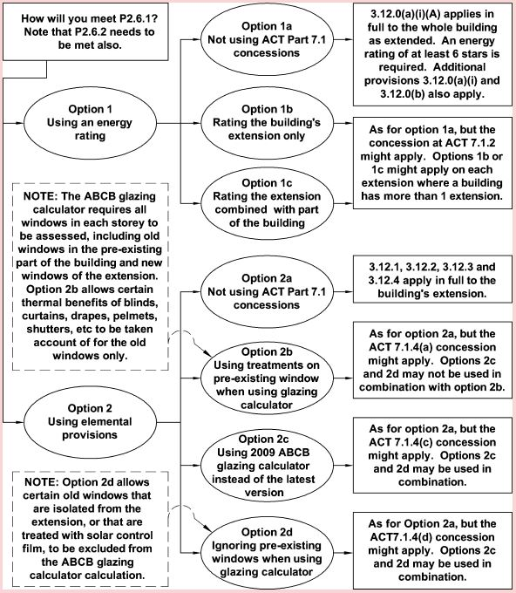

ACT 7.1.1 Application of Part 3.12 and ACT 7

Alterations, additions and extensions to pre-existing completed buildings that would be subject to Part 3.12 if built now, must comply with Part 3.12 except to the extent that ACT 7 permits otherwise.
ACT 7 provides concessions on certain aspects of Part 3.12. The BCA does not directly require unaltered parts of the pre-existing building to be brought into BCA compliance, but certain other requirements do. For example—
- the Building Act 2004 requires certain buildings that have more than 50% of their floor area altered in a 3-year period to brought into BCA compliance, subject to concessions in the Building (General) Regulation 2008;
- use of the ABCB’s glazing calculator requires all relevant glazing in each storey of a building to be assessed. In the case of an extension to a pre-existing building with pre-existing windows, any new windows in the extension as well as old windows in the pre-existing part of the building need to be assessed together if they are on the same storey, subject to concessions in ACT 7; and
- certain discretionary concessions in ACT 7 require certain energy efficiency measures to be in place in the pre-existing part of the building to be extended, such as thermal insulation to the pre-existing roof, or window blinds, curtains, drapes pelmets or shutters to pre-existing windows.

ACT 7.1.2 Heating & cooling loads

- Subject to (b) to (f), 3.12.0(a)(i) may apply to—
- a whole dwelling as added to or as extended; or
- a house-like addition or extension as if 3.12.0.1 expressly indicated it applied to a large part of a building and as if the rating scheme and protocol mentioned in 3.12.0.1 applied to rating large additions or extensions to buildings rather than rating a whole building.

- For (a)(ii), an addition or extension is not house-like unless—
- it has a contiguous floor area of at least 100 m² including any contiguous existing floor area up to no more than 50 m² of the unaltered part of the building, that needs to be incorporated into the rating to minimise inaccuracy due to the effect of nearby elements of the unaltered parts; and
- it has at least 1 kitchen within the floor area mentioned in (i); and
- the floor area mentioned in (i) is isolated from other buildings and from the remainder of the unaltered part of the building by a draft-proof barrier such as walls, floor, ceiling and a draft-sealed door, all of which comply with 3.12.3.

- If (a)(ii) is applied, the following must be included as part of determining the rating mentioned in (a)(ii) —
- the relevant properties of any existing and unaltered roof, internal wall, or external wall that is taken as being part of the thermal envelope of the contiguous floor area of the addition or extension; and
- the remainder of the unaltered part of the building must be taken as a separate building adjoining the addition or extension, if it adjoins the part of the building being rated.

- ACT 7.1.2 does not apply if compliance with it would result in a building (or part thereof), as extended or altered, having its energy efficiency reduced below—
- the relevant statutory minimum, which is the minimum energy efficiency requirement , if any, that all or part of the building, respectively, was required to achieve when constructed or altered; or
- for a building that has not been altered or extended, the current energy efficiency of the building, which is the lesser of its energy efficiency determined using the factors Part 3.12 covers, or the energy efficiency it would be required to achieve under Part 3.12 if it was to be built now; or
- for the following parts of a building-an unaltered, unextended, altered, or extended part-the energy efficiency for the part as per (ii) as if (ii) applied to the part.

Example for ACT 7.1.2(d):
A house constructed in 1980 was not required to be energy efficient. However, recently R4.0 bulk thermal insulation batts were installed in the roof space. Part 3.12 covers thermal insulation performance of roofs. ACT 7.1.2 does not apply to removing the bulk thermal insulation for use in an extension to the house. The house was extended in 2008 (the first extension). The first extension was required to comply with BCA 2008. A proposed second extension will shade northerly glazing in the first extension, bringing the first extension out of compliance with BCA 2008. Therefore, ACT 7.1.2 does not apply to shading the window without offsetting the detrimental effect that shading would have to the first extension's energy efficiency even though the first extension does not comply with the requirements of current Part 3.12.

- Dispensations in any ACT building legislation, however described, that may allow existing elements to not comply with the BCA under a deemed-to-satisfy method must not be applied to an energy efficiency rating under 3.12.0.1 or ACT 7.1.2. All relevant existing elements must be assessed in respect of their actual performance without dispensation.

- For ACT 7.1.2, the addition or extension need not comply with the separate heating and cooling load limits for 3.12.0.1 (a).

Explanatory information:

An alternative option to the EER provisions option is to make the relevant building elements comply with the respective energy efficiency provisions. That alternative option is referred to as the ‘elemental provisions’. Elemental provisions are set out at 3.12.0(a)(ii) and at ACT 7.1.3 to ACT 7.1.5.

Explanatory information:

The energy rating scheme and protocol mentioned in 3.12.0.1 are intended to only apply to whole houses, not to only an addition or extension to a house, nor to part of a house that is less than the entire thermal envelope of the house. However, they can apply to attached houses to rate one or other attached house separately. Thus, they can produce reasonably reliable information about an extension to a house if the extension is comparable to adding an additional house to the pre-existing house to form 2 attached houses.

If only an addition or extension to a house is rated, the rating is not necessarily a reflection of the house’s overall rating. Although area correction factors are included in relevant energy rating software, the accuracy of ratings can decrease with reduced size and number of rooms rated. Therefore, ACT 7.1.2 limits use of a rating to large additions or extensions.

As the energy rating scheme mentioned in 3.12.0.1 is intended to apply to a whole building, an assessment in regulatory mode must include a kitchen zone. In order to avoid the pretence of applying false heating and cooling loads to a zone, ACT 7.1.2 is limited to house additions or extensions containing a kitchen in the rated area. This can include a pre-existing or new kitchen area.

ACT 7.1.2 permits small parts of a pre-existing house to be incorporated into the addition or extension, to take account of draft-proof barriers that are not located at the interface between the pre-existing building and the addition or extension. The construction details of any pre-existing part incorporated into an addition or extension for rating purposes must not be assessed as having the same relevant details as the remainder of the addition or extension unless they are actually the same in both. For example, if the pre-existing part is bounded by an internal wall with no bulk thermal insulation added, that wall must not be assessed as having the same properties as the remainder of the insulated bounding walls, unless they actually have the same relevant properties, (see Figure ACT 7.1.1).

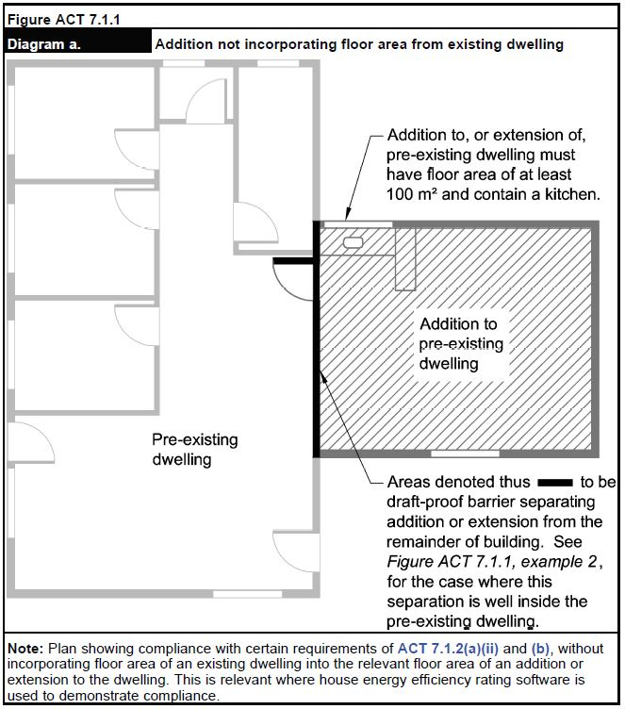

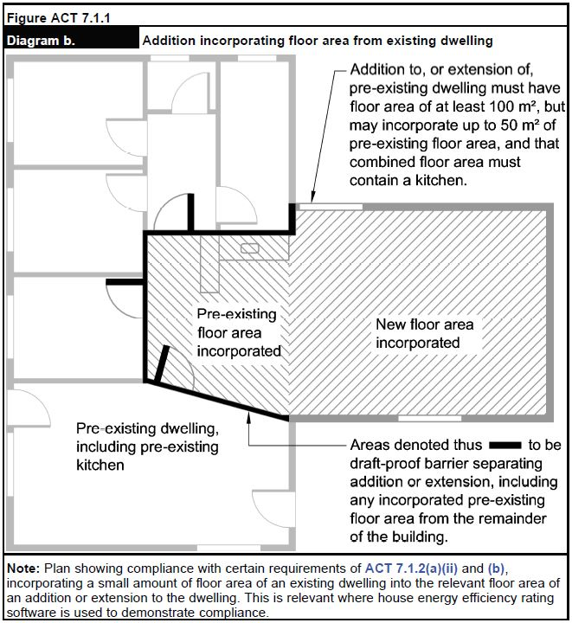

ACT 7.1.3 Building fabric-application of Part 3.12.1
Where Part 3.12.1 requires building elements such as walls to have thermal insulation that forms a continuous thermal barrier, but an addition or extension opens directly, or by a common door, onto the unaltered part of building, the thermal barrier need not extend into the unaltered part of the building, except where contrary intention appears in Part 3.12.1.

ACT 7.1.4 External glazing-application of Part 3.12.2
- Subject to (b), in applying Part 3.12.2 to an addition or extension all glazing on the respective storey, including the addition or extension and any existing glazing in the unaltered part of the storey, must be assessed where Part 3.12.2 indicates the whole storey must be assessed. However, the Total System U-Value of an existing glazing unit in the unaltered part of the building can take account of any of the following:

- Window treatments listed in Table ACT 7.1.4.1, to the extent provided in that table, where the glazing unit incorporates the respective treatment in compliance with the notes to that table.
- Window shutters mentioned in Annex G of international standard ISO 10077-1, (Thermal performance of windows, doors and shutters - Calculation of thermal transmittance), where the glazing unit is readily closed in by the shutters, and the shutters can be readily opened so they do not shade the glazing of the unit, and the closed shutters comply with the respective construction, material and permeability provisions of that Annex G.
Note:
The Total System U-Value of the existing glazing unit, incorporating shutters, can be calculated by adding the inverse of the respective shutters' value of additional thermal resistance, ΔR, from Table G.1 (Additional thermal resistance for windows with closed shutters), of the above-mentioned Annex G.

- ACT 7.1.4(a) does not apply to windows otherwise dealt with under (c) or (d).

- If an addition or alteration fails to incorporate a wall that can contain translucent glazing with an area of at least 1 m² or 1% of the addition's or alteration's floor area, whichever is the greater, not overshadowed by a building in winter, and orientated within the north sector shown in Figure 3.12.2.1, then all glazing (existing or otherwise) in the storey need not comply with the requirements of 3.12.2.1 that relate to aggregate conductance of the glazing if-
- the addition or alteration has a total floor area not exceeding 50 m²; and
- compliance with the requirements of 3.12.2.1 that relate to aggregate conductance of the glazing would not result in a building (or part thereof), as extended or altered, having its energy efficiency reduced below-
    - the relevant statutory minimum, which is the minimum energy efficiency requirement, if any, that all or part of the building, respectively, was required to achieve when constructed or altered; or
    - for a building that has not been altered or extended, the current energy efficiency of the building, which is the lesser of its energy efficiency determined using the factors Part 3.12 covers, or the energy efficiency it would be required to achieve under Part 3.12 if it was to be built now; or
    - for the following parts of a building-an unaltered, unextended, altered, or extended part-the energy efficiency for the part as per (ii) as if (ii) applied to the part-
(aa) the aggregate conductance of the glazing is in accordance with BCA requirements that applied in the ACT immediately before or any time after the adoption of BCA 2010 in the ACT; and
(bb) bulk thermal insulation has been added to the roof of the unaltered part of the building, in accordance with the requirements of 3.12.1.2 that apply to roofs with an upper surface solar absorptance value of not more than 0.4.
- Section 29 (2) (b) of the Building (General) Regulation 2008, prescribes when windows with solar control film or when "isolated glazing" need not comply with the BCA, Part 3.12.2, in relation to a substantial alteration mentioned in the Building Act 2004, section 29 (Approval requirements). Those alternative energy efficiency provisions may apply to existing windows that ACT 7 applies to whether or not the window is in respect of a "substantial alteration" as defined in the Building (General) Regulation 2008. However, the storey's area mentioned in 3.12.2.1(b) must exclude the enclosed area, Δ A, that the isolated glazing unit is located in. Isolated units must be in an area enclosed by walls and doors (a "zone"), and all glazing units in the zone must be treated as isolated units. Δ A is the zone's area, and must be counted only once for a particular zone, even if the zone has more than one isolated unit. If the ABCB's glazing calculator is used to demonstrate compliance, isolated unit details need not be entered (they may be disregarded), and if so, the entry for the storey's area must be reduced by the sum of each Δ A value for each zone. The Δ A reduction does not apply to glazing units disregarded because of the solar control film, because they lack zone requirements.

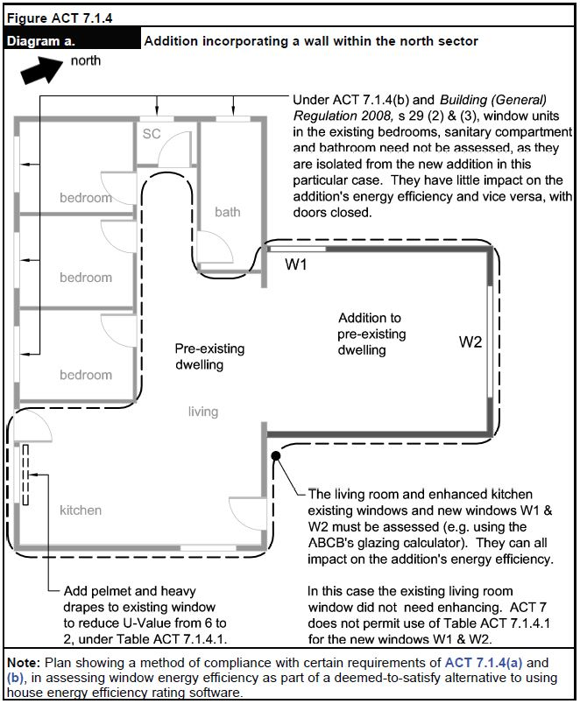

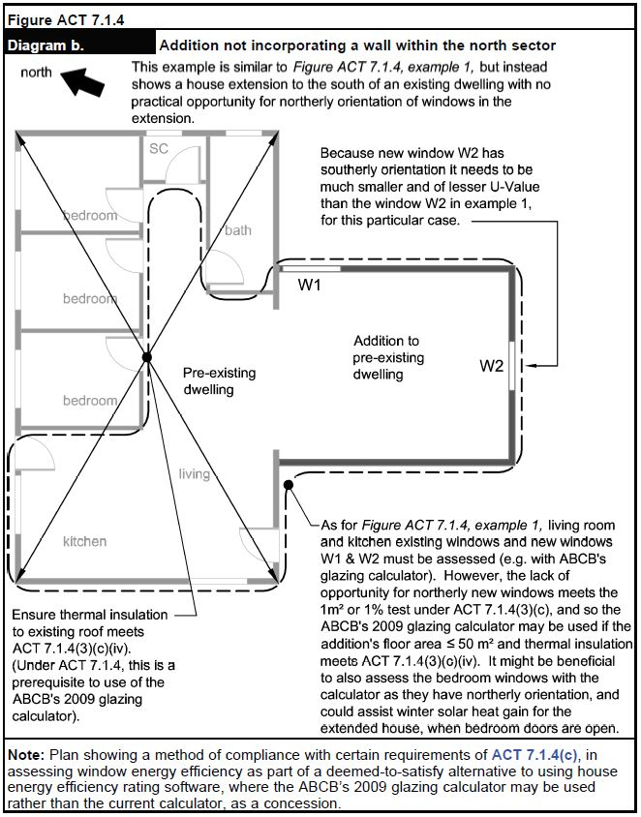

Table ACT 7.1.4.1 Glazing unit U-values
Glazing unit U-Values |  | Improved U-Values with window treatments
 |  | A | B | C | D | E
Glazing unit (not taking account of any window treatments) |  | Holland blinds only | Closed weave curtains  only | Heavy drapes only | Closed weave curtains + pelmet | Heavy drapes + pelmet
U-Value | R-Value
7.8 | 0.13 | 6.32 | 6.32 | 5.46 | 4.20 | 2.18
7.6 | 0.13 | 6.19 | 6.19 | 5.36 | 4.14 | 2.17
7.4 | 0.14 | 6.06 | 6.06 | 5.26 | 4.08 | 2.15
7.2 | 0.14 | 5.92 | 5.92 | 5.16 | 4.02 | 2.13
7.0 | 0.14 | 5.79 | 5.79 | 5.05 | 3.95 | 2.11
6.8 | 0.15 | 5.65 | 5.65 | 4.95 | 3.89 | 2.10
6.6 | 0.15 | 5.51 | 5.51 | 4.84 | 3.82 | 2.08
6.4 | 0.16 | 5.37 | 5.37 | 4.73 | 3.76 | 2.06
6.2 | 0.16 | 5.23 | 5.23 | 4.62 | 3.69 | 2.04
6.0 | 0.17 | 5.08 | 5.08 | 4.51 | 3.61 | 2.01
5.8 | 0.17 | 4.94 | 4.94 | 4.40 | 3.54 | 1.99
5.6 | 0.18 | 4.79 | 4.79 | 4.28 | 3.47 | 1.97
5.4 | 0.19 | 4.65 | 4.65 | 4.16 | 3.39 | 1.94
5.2 | 0.19 | 4.50 | 4.50 | 4.04 | 3.31 | 1.91
5.0 | 0.20 | 4.35 | 4.35 | 3.92 | 3.23 | 1.89
4.8 | 0.21 | 4.20 | 4.20 | 3.80 | 3.14 | 1.86
4.6 | 0.22 | 4.04 | 4.04 | 3.67 | 3.05 | 1.83
4.4 | 0.23 | 3.89 | 3.89 | 3.54 | 2.96 | 1.79
4.2 | 0.24 | 3.73 | 3.73 | 3.41 | 2.87 | 1.76
4.0 | 0.25 | 3.57 | 3.57 | 3.28 | 2.78 | 1.72
3.8 | 0.26 | 3.41 | 3.41 | 3.14 | 2.68 | 1.69
3.6 | 0.28 | 3.25 | 3.25 | 3.01 | 2.58 | 1.65
3.4 | 0.29 | 3.09 | 3.09 | 2.86 | 2.47 | 1.60
3.2 | 0.31 | 2.92 | 2.92 | 2.72 | 2.37 | 1.56
3.0 | 0.33 | 2.75 | 2.75 | 2.58 | 2.26 | 1.51
2.8 | 0.36 | 2.58 | 2.58 | 2.43 | 2.14 | 1.46
2.6 | 0.38 | 2.41 | 2.41 | 2.27 | 2.02 | 1.40
2.4 | 0.42 | 2.24 | 2.24 | 2.12 | 1.90 | 1.34
2.2 | 0.45 | 2.06 | 2.06 | 1.96 | 1.77 | 1.27
2.0 | 0.50 | 1.89 | 1.89 | 1.80 | 1.64 | 1.20
1.8 | 0.56 | 1.71 | 1.71 | 1.64 | 1.50 | 1.13
1.6 | 0.63 | 1.53 | 1.53 | 1.47 | 1.36 | 1.05
1.4 | 0.71 | 1.34 | 1.34 | 1.30 | 1.21 | 0.96
1.2 | 0.83 | 1.16 | 1.16 | 1.13 | 1.06 | 0.86
1.0 | 1.00 | 0.97 | 0.97 | 0.95 | 0.90 | 0.75
0.8 | 1.25 | 0.78 | 0.78 | 0.77 | 0.74 | 0.63
0.6 | 1.67 | 0.59 | 0.59 | 0.58 | 0.56 | 0.50

Notes to Table ACT 7.1.4.1:
- Values in the table may be interpolated to more accurately reflect U-Values.
- Closed weave curtains have threads or yarns that generally abut, producing a fabric with negligible interstices. Thus, light, air and water pass through a closed weaved cotton fabric, but with significant filtering, unless the fabric is treated to block their passage; and they prevent visual detail being seen by eye through their fabric if woven from opaque thread or yarn. Closed weave curtains do not include open weave curtains, as open weave fabric is woven so that warp threads rarely abut each other, leaving interstices in the fabric, which includes lace, sheer or net fabrics. Open weave curtains provide negligible change to window U-values.
- Heavy drapes permit no or negligible visible or UV light to pass through their fabric, which may include a composite of layered materials. They also do not readily allow air to pass through. They include closed weave heavy fabrics, such as velvet or velour or heavy cotton or comparable synthetics, with a rubber, acrylic, or similar, solar blocking backing layer bonded to the fabric. The presence of a light source, including the sun, cannot be detected by eye through the fabric. A key requirement of heavy drapes is to have sufficient inertia to maintain a barrier to air movement by remaining relatively stationary in a draft.
- Drapes or curtains must fully cover the window and form part of an enclosure of the layer of air between the drape or curtain and window to minimise air movement caused by convection air currents and air movement cause by HVAC systems, fans, or use of the room. That is achieved, where curtains or drapes—
- are fully within and abut the window recess (reveals) and abut the reveals, head and sill; or
- overlap side edges of the window by at least 150mm or abut a return wall if the window is in a re-entrant corner, and abut the floor; and
- close together (where openable) with no, or with negligible gaps.
For the purposes of this note, a drape or curtains is take to abut a surface where the drape or curtain is not more than 10mm from that surface.
- Pelmets must be box pelmets and must work in combination with the curtain or drape to enclose the top of a curtain or drape to prevent air plunging by convection from beside or above the pelmet to the window, and must extend to the width of the window plus any required curtain overlap of the window edge. It must overlap the top of the curtain by 50mm or more.

ACT 7.1.5 Building sealing—application of Part 3.12.3

- In applying Part 3.12.3.6 to an addition or extension all requirements of the part must be satisfied except as provided otherwise in (b) or (c) below.

- If the addition or extension houses an evaporative cooler to which 3.12.3.6 applies, the cooler must comply with 3.12.3.6 unless it—

- has been relocated from the pre-existing part of the building as part of constructing the addition or extension; and
- was not required to meet a provision like 3.12.3.6 when it was previously installed in the pre-existing part of the building; and
- does not have a self-closing damper or the like; and
- has all outlets serving a heated space or a habitable room, in the addition or extension, having an automatic means, or a readily accessible manual means, of closing the outlet or the duct serving the outlet, such as a closable baffle or closable louvers on an outlet register. For this provision, an outlet with a manual means of closure is readily accessible if it is mounted in the ceiling of a room, and can be closed by a reasonable person standing on a step ladder and activating a baffle closer or by closing movable louvers or the like, by hand without a tool.

- If the addition or extension contains a heated space or habitable room to which 3.12.3.6 applies, that is served by an evaporative cooler, the cooler must comply with 3.12.3.6 unless—

- the cooler served, and continues to serve, the pre-existing part of the building; and
- the cooler was not required to meet a provision like 3.12.3.6 when it was previously installed in the pre-existing part of the building; and
- the cooler does not have a self-closing damper or the like; and
- all the cooler’s outlets serving a heated space or a habitable room in the addition or extension have an automatic means, or readily accessible manual means, of closing the outlet, or the duct serving the outlet, such as a closable baffle or closable louvers on an outlet register. For this provision, an outlet with a manual means of closure is readily accessible if it is mounted in the ceiling of a room, and can be closed by a reasonable person standing on a step ladder and activating a baffle closer or by closing movable louvers or the like, by hand without a tool.

ACT 7.1.6 Services—application of Part 3.12.5

- In applying Part 3.12.5 to an addition or extension all requirements of the part must be satisfied except as provided otherwise in (b) or (c) below.

- If the addition or extension houses or has mounted on it or in association with it, a heater or pump to which 3.12.5.4, 3.12.5.6 or 3.12.5.7 applies, the heater or pump must comply with those provisions unless—

- the service is a heater or pump that has been relocated from the pre-existing part of the building as part of constructing the addition or extension; and
- the heater or pump was not required to meet a provision like 3.12.5.4, 3.12.5.6 or 3.12.5.7 when it was previously installed in the pre-existing part of the building; and
- the heater or pump does not comply with 3.12.5.4, 3.12.5.6 or 3.12.5.7; and
- where the heater or pump serves the addition or extension through a hot water supply system, piping, or duct to which Part 3.12.5 applies, the portion of the system, piping or duct that is within, or mounted on or in association with, the addition or extension complies with that part.

- If the addition or extension is served by a heater or pump to which 3.12.5.4, 3.12.5.6 or 3.12.5.7 applies, the heater or pump must comply with those provisions unless—

- the heater or pump served, and continues to serve, the pre-existing part of the building; and
- the heater or pump was not required to meet a provision like 3.12.5.4 when it was previously installed in the pre-existing part of the building; and
- the heater or pump does not comply with 3.12.5.4, 3.12.5.6 or 3.12.5.7; and
- where the heater or pump serves the addition or extension through a hot water supply system, piping, or duct to which Part 3.12.5 applies, the portion of the system, piping or duct that is within, or mounted on or in association with, the addition or extension complies with that part.

Explanatory information:

Example for ACT 7.1.6.

A house has a pre-existing evaporative air conditioner, ducted gas central space heater, electric resistance storage water heater, and electric lighting. The house is to be extended by adding a new bedroom with ensuite bathroom, and a small section of hallway. The extension must comply fully with Part 3.12.5, except that the following approach to the use of concessions under ACT 7 could apply.

A new duct will be run from the nearest pre-existing air conditioner duct to an outlet in the new bedroom. When the pre-existing air conditioner was installed in 2003 it was not required to have a self-closing damper or the like, and it does not have one. Such a damper or the like does not need to be provided as otherwise required by 3.12.3.6, because of ACT 7.1.5(b). The new outlet in the bedroom will be mounted in the ceiling. To comply with ACT 7.1.5(b), the new outlet of the air conditioner duct will have an outlet register with manually closable baffle that is actuated by turning a knob on the register outlet while standing on a step ladder. When the space heating is operating, heat loss from hot air rising up through the register and out to the atmosphere through the air conditioner can be reduced by closing the register baffle. The extent of the new duct that is contained within the extension will have to comply with 3.12.5.3, which is about insulation and sealing of heating and cooling ducts. That will reduce efficiency losses as cooled air travels along the new duct.

The new ensuite’s shower and hand basin will be serviced with hot water from new piping connected to the nearest pre-existing hot water piping from the pre-existing water heater. ACT 7.1.6 permits the pre-existing water heater to be used to serve the extension even if the water heater fails to comply with 3.12.5.6, which is about energy source of water heaters and other matters. However, the portions of the new piping that are within the extension must comply with 3.12.5.0(a), which covers insulation of piping. That will reduce efficiency losses from hot water in the pipe losing heat.

Artificial lighting of a new hallway will rely on light from a pre-existing light fitting located in the pre-existing part of the house. Because of ACT 7.1.6(b), artificial lighting of the new hallway does not have to comply with 3.12.5.5, which includes limitations of the power density of lamps or illumination. However, new artificial lights in the form of electric light fittings in the new bedroom and new ensuite must comply with 3.12.5.5 insofar as it applies to the new extension, other than the new hallway.

Schedule 4 Referenced documents

Schedule of referenced documents
In Table 1, insert additional references as follows:

No. | Date | Title | Volume One | Volume Two | Volume Three
N/A |  | Development Control Code for Best Practice Waste Management in the ACT | ACT F2.2 | ACT 2.2 | N/A
N/A |  | Development Control Code for Best Practice Waste Management in the ACT | ACT F10D1 | ACT H4D11 | N/A
ISO 10077-1 | 2017 | Thermal performance of windows, doors and shutters — Calculation of thermal transmittance | N/A | ACT 7.1.4 | N/A

Schedule 2
(see s 3)

Australian Capital Territory Appendix to the
Building Code of Australia – Volumes 1 and 2

APPLIES FROM 15 JANUARY 2024

Version as at December 2023.

Contents
Volume 1 5
Section D Access and egress 5
PART D2 Provision for escape 6
Part D4 Access for people with a disability 7
Section F Health and amenity 7
Section G Ancillary provisions 9
Part G2 Boilers, pressure vessels, heating appliances, fireplaces, chimneys and flues 10
Part G7 Livable housing design 10
Section J Energy efficiency 10
Part J5 Air-conditioning and ventilation systems 13
Schedule 4 Referenced documents 14
Volume 2 14
Part H4 Health and amenity 14
Part H7 Ancillary provisions and additional construction requirements 16
Energy Efficiency 17
Schedule 4 Referenced documents 34
Definitions 37
Volume 1 37
Section D Access and egress 37
PART D2 Provision for escape 39
Part D4 Access for people with a disability 39
Section F Health and amenity 40
Part G2 Boilers, pressure vessels, heating appliances, fireplaces, chimneys and flues 42
Part G7 Livable housing design 42
Section J Energy efficiency 43
ACT Part J6 Air-conditioning and ventilation 45
J6D10 Space heating 45
ACT Part J7 Artificial lighting and power 46
ACT Part J8 Heated water supply and swimming pool and spa pool plant 46
ACT Part J9 Energy monitoring and on-site distributed energy resources 46
Schedule 2 Referenced documents 46
Volume 2 47
Part H4 Health and amenity 47
ACT Part H6 Energy Efficiency 49
Part H7 Ancillary provisions and additional construction requirements 61
Part H8 Livable housing design 62
Schedule 1 Referenced documents 66

Definitions
Alteration | In the context of this Appendix, an alteration refers to building work on an existing building, as defined by section 6 of the Building Act 2004. It includes additions or extensions to the existing building and internal changes to layout and use. However, it does not include basic building work, as defined by section 10 of the Building Act 2004.
Existing building | A building as defined by the Building Act 2004 that can be lawfully occupied or used.
Unaltered part | The part of an altered or substantially altered building that is not altered.
Substantial alteration | A substantial alteration to a building is defined in section 23 of the Building (General) Regulation 2008.

Volume 1

Volume 1 of the Building Code of Australia (BCA) is amended as follows.

Section D Access and egress
Add ACT D1P0.1 to ACT D1P0.5 as follows:
Performance requirements

ACT D1P0.1 Existing passenger lift or existing toilet concession
Access to passenger lifts or toilets need not be provided in accordance with the requirements of Sections D, E or F, insofar as they relate to matters covered by D1P0.2 or D1P0.3, and specifically only relate to people with a disability if the relevant concession in D1P0.2 or D1P0.3 applies.

ACT D1P0.2 Lift concession
- The requirements in E3D8(b) that a lift is to have a floor dimension of not less than 1400 mm x 1600 mm does not apply to an existing passenger lift if that is in a new part, or is part of an alteration to an existing building, if the lift—
- travels more than 12 m; and
- has a lift floor that is not less than 1100 mm x 1400 mm.

ACT D1P0.3 Toilet concession
- The requirements in F4D5 Accessible sanitary facilities, to the extent that they require compliance with AS 1428.1 - 2009, Design for access and mobility, Part 1: General requirements for access - New building work, may comply with the alternative requirements of paragraph (b) for —

- existing accessible sanitary compartments; and
- existing sanitary compartments suitable for use by people with a disability.
- The alternative requirements mentioned in paragraph (a) for sanitary compartments mentioned in paragraphs (i) and (ii) are:

- Compliance with AS1428.1-2001, Design for access and mobility, Part 1: General requirements for access - New building work.

ACT D1P0.4 Application to Class 1b buildings
- Where the BCA applies to the following kinds of Class 1b buildings, the provisions of Volume One that indicate they apply to Class 1b buildings, apply only to the following kinds of Class 1b buildings, insofar as they specifically only relate to people with a disability-
- a new building with 1 or more bedrooms used for rental accommodation; or
- an existing building with 4 or more bedrooms used for rental accommodation; or
- a building that comprises 4 or more single dwellings that are-
- on the same allotment; and
- used for short-term holiday accommodation.

ACT D1P0.5 Meaning of certain terms
Terms in ACT D1P0.1, ACT D1P0.2, ACT D1P0.3 or ACT D1P 0.4 that also have their meaning defined in the Disability (Access to Premises - Buildings) Standards 2010, determined under the Disability Discrimination Act 1992 (Commonwealth), have that meaning.
Explanatory information:
ACT D1P0.1 to ACT D1P0.4 mirror the respective provisions of the Disability (Access to Premises - Buildings) Standards 2010, determined under the Disability Discrimination Act 1992 (Commonwealth). Where a provision of ACT D1P0.1, ACT D1P0.2, ACT D1P0.3 or ACT D1P0.4 indicates it applies to something in the NCC, insofar as the thing specifically only relates to people with a disability, the provision does not permit other relevant NCC provisions to not apply.
ACT legislation other than the BCA also regulates for access and mobility.
Practitioners should ensure they check the latest version of relevant legislation, and the latest version of this Appendix, available through the ACT legislation register at www.legislation.act.gov.au.

PART D2 Provision for escape
Add ACT D2D2 (1) and ACT D2D2 (2) as follows:

ACT D2D2 (1) Notices on fire-isolated stairs
- Every fire-isolated stairway must have a notice displayed in a conspicuous position at the landing on each storey level to the effect of the following:

OFFENCES RELATING TO FIRE STAIRS
Under the Emergencies Act 2004 (ACT) it is an offence to:
- Place anything in this stairway or any associated passageway leading to the exterior of the building which may impede the free passage of persons; or
- Interfere with or cause obstruction or impediment to the normal operation of fire doors providing access to this stairway; or
- Remove, damage or otherwise interfere with this notice.

- In any notice displayed in accordance with (a)-
- the words "OFFENCES RELATING TO FIRE STAIRS" must be in letters not less than 20 mm in height; and
- all other letters and figures in the remainder of the notice must be not less than 3 mm in height; and
- the notice must be clearly legible with lettering of a colour contrasting with the background embossed or cast into a permanent plate securely and permanently fixed to the wall.

ACT D2D2 (2) Access for people with disabilities
Other requirements must be considered in respect of requirements for people with disabilities, including the ACT Territory Plan (and any interim plan) under the Planning Act 2023 (ACT) and the Disability Discrimination Act 2004 (Commonwealth) and any further applicable amendments to this Appendix. Where additional provisions of the ACT Appendix to Volume One have been made by instrument under the Building Act 2004, relevant building work or buildings may comply with the applicable provisions, as permitted by the provisions. Volume One users should check the latest ACT BCA appendices made under the Building Act 2004 available through the Legislation Register at www.legislation.act.gov.au.

Part D4 Access for people with a disability
Add ACT D4D5(d) as follows:
ACT D4D5(d) Exemptions
- an area covered by, and in the respective circumstances covered by, and to the relevant extent provided for by, ACT D1P0.1, ACT D1P0.2, ACT D1P0.3 or ACT D1P0.4.

Section F Health and amenity

Part F8 Condensation management
In “Introduction to this Part” add:
Notes: ACT Part F8 Condensation management
For the ACT, from 15 January 2024 Part F8 of NCC 2022 Volume One applies.
ACT F8D1 Deemed-to-Satisfy provisions
Insert:
Explanatory information:
Thermal bridging can be a cause of condensation in buildings. Thermal bridging occurs where a more conductive or less insulated material provides a pathway for heat to flow across a thermal barrier. When warm air comes into contact with cooler air or cooler surfaces, the loss of energy causes the water vapour to condense. Condensation management should be considered in relation to ventilation of the building. For information about minimising thermal bridging and providing ventilation to prevent the build up of moisture in a building see the ABCB Condensation in Buildings Handbook https://abcb.gov.au/sites/default/files/resources/2023/Condensation-in-buildings-handbook.pdf

Add ACT Part F9 and ACT Part F10 as follows:

ACT Part F9 Control of litter on building sites
Add ACT Part F9 and ACT Part F10 as follows:
ACT F9O1 Objective
The Objective is to prevent windblown litter from building sites fouling roads and public land.
ACT F9F1 Functional statement
Building litter must be prevented from spreading around and beyond the allotment boundary.
ACT F9P1 Performance requirements
Sufficient containers must be provided on building sites to store building waste that is likely to become windblown.
ACT F9D1 Deemed-to-Satisfy provision
- The requirements of ACT F9P1 (Performance Requirement) are satisfied by on site building waste that is stored in suitably sized plastic or metal bins and removed from the site at regular intervals.

- For the purposes of this clause, building waste includes plastic containers and plastic and paper wrappings or any waste that can be carried by wind.

ACT Part F10 Waste management
ACT F10O1 Objective
The Objective is to safeguard people from injury caused by infection or contamination from solid waste.
ACT F10F1 Functional statement
Buildings must be provided with space and facilities for the collection, and safe hygienic holding prior to disposal of solid waste arising from the intended use of the building.
ACT F10P1 Performance requirements
Where provision is made within buildings for the collection and temporary holding of solid waste, the design shall accommodate screening, volume of waste, disposal, logistics and access.
ACT F10D1 Deemed-to-Satisfy provision
The requirements of ACT F10P1 (Performance Requirement) are satisfied by garbage facilities designed and constructed in accordance with the Development Control Code for Best Practice Waste Management in the ACT.
Section G Ancillary provisions

ACT G1 Minor structures and components
After “Introduction to this Part” add:
Notes: ACT Part G1 Minor structures and components
The ACT has introduced new swimming pool safety requirements and a new definition of regulated swimming pool through the Building (Swimming Pool Safety) Legislation Amendment Bill 2023. The new definition and prescribed safety standards for access to swimming pools commence on 1 May 2024 with a transition period for existing pools to become compliant. New pools must continue to meet the requirements in the NCC as amended from time to time.

ACT G1P2 Performance requirements
After G1P2 Swimming pool access and water recirculation systems add:
ACT G1P2 (1) Swimming pool access – Application
G1P2 (1) applies to a regulated swimming pool as regulated by the Building Act 2004 and Building (General) Regulation 2008. G1P2 (1) must be applied in the ACT in accordance with that regulation.

ACT G1D2 Deemed-to-Satisfy Provisions

replace G1D2 (1) with the following:

ACT G1D2 Swimming pools
- A swimming pool with a depth of water more than 300 mm and which is associated with a Class 2 or 3 building or Class 4 part of a building must have suitable barriers to restrict access by young children to the immediate pool surrounds in accordance with the Building Act 2004 and the Building (General) Regulation 2008.
Notes: The Building Act 2004 and Building (General) Regulation 2008 define what is a regulated swimming pool and regulate the circumstances in which a barrier is required and prevails in the case of any inconsistency.
After G1D2 (2) add:
- Indoor or outdoor permanent bathing, wading and swimming pools must—
- where the capacity of the pool exceeds 10 m³—
- be of the recirculation type in which the water circulation is maintained through the pool by pumps, the water drawn from the pool being clarified and disinfected before being returned to the pool; and
- have means of egress provided in the form of ladders, steps in the floor of the pool or a ramp; and
- be capable of being completely emptied and any discharge or overflow and pool backwash filter must be connected to the sewer drainage system.

- Pools in or forming part of buildings other than Class 1 buildings—
- Where in any part of the pool the depth is less than 1500mm, the floor grade must not exceed a slope of 1 in 20; and
- Permanent signs must be displayed on the side of the pool (or adjacent concourse for flush concourse waterline pools), showing the depth at 300mm change intervals for the length of the pool and the depth at the deep and shallow ends.

Part G2 Boilers, pressure vessels, heating appliances, fireplaces, chimneys and flues
After G2D2 (b), add ACT G2D2 as follows:
ACT G2D2 Installation of appliances
(c) An industrial fuel-fired appliance: AS 1375.
- Storage tanks and other associated fittings: AS 1692.
ACT Part G10 Building over drains
ACT Part G10 Performance requirement
Performance provisions
Existing drains, or parts of drains, in currently operational drainage systems must be sound and able to work effectively without leaking before any building that will be constructed over the drain or restrict access to the drain is constructed.
ACT Part G10 Deemed-to-Satisfy provision
- The requirements of ACT Part G10 (Performance Requirement) are satisfied if—
- Before building work that will result in a building, or part of a building, being constructed over, or restricting access to, an existing drain in currently operational drainage system is carried out, the relevant part of the drain, must be tested for soundness in accordance with section 15 of AS/NZS 3500.2.
- If the drain is found not be sound after testing in accordance with (i), it is made sound before the building work commences.

Part G7 Livable housing design
In “Introduction to this Part” add:
Notes: ACT Part G7 Livable Housing design
For the ACT, Part G7 does not take effect until 15 January 2024.

Section J Energy efficiency

ACT Part J1 Energy efficiency performance requirements

In “Introduction to this Part” add:
Notes: ACT Section J Energy Efficiency
For the ACT, from 15 January 2024 Section J of NCC 2022 Volume One applies from 15 January 2024. Between 1 May 2023 and14 January 2024 Section J of NCC 2019 Volume One Amendment 1 applied instead of Section J of NCC 2022 Volume One.
Verification methods
J1V1 NABERS Energy

Add the following text:

Replace all references to annual greenhouse gas emissions with “annual modelled energy use”.

Explanatory Information:
National emissions factors are not applicable to calculations for buildings in the ACT as they do not take into account investments in renewable electricity generation in the national electricity market made by the ACT. Since 2020, the ACT’s electricity usage is either from renewable energy or offset with investments in renewable energy. Due to this, only energy metrics are allowable for verifications in the ACT.
ACT J1V2 Green Star

Add the following text:

Replace all references to annual greenhouse gas emissions with “annual modelled energy use”.

Explanatory Information:
National emissions factors are not applicable to calculations for buildings in the ACT as they do not take into account investments in renewable electricity generation in the national electricity market made by the ACT. Since 2020, the ACT’s electricity usage is either from renewable energy or offset with investments in renewable energy. Due to this, only energy metrics are allowable for verifications in the ACT.

ACT J1V3 Verification using a reference building

Add the following text:

Replace all references to annual greenhouse gas emissions with “annual modelled energy use”.

Explanatory Information:
National emissions factors are not applicable to calculations for buildings in the ACT as they do not take into account investments in renewable electricity generation in the national electricity market made by the ACT. Since 2020, the ACT’s electricity usage is either from renewable energy or offset with investments in renewable energy. Due to this, only energy metrics are allowable for verifications in the ACT.

ACT J1V5 Verification using a reference building for a Class 2 sole-occupancy unit

Add the following text:

Replace all references to annual greenhouse gas emissions with “annual modelled energy use”.

Explanatory Information:
National emissions factors are not applicable to calculations for buildings in the ACT as they do not take into account investments in renewable electricity generation in the national electricity market made by the ACT. Since 2020, the ACT’s electricity usage is either from renewable energy or offset with investments in renewable energy. Due to this, only energy metrics are allowable for verifications in the ACT.
ACT Specification 34 Modelling Parameters for J1V3

Add the following text:

Replace all references to annual greenhouse gas emissions in the specification with “annual modelled energy use”.

Explanatory Information:
Table S34C3 does not apply in the ACT. National emissions factors are not applicable to calculations for buildings in the ACT as they do not take into account investments in renewable electricity generation in the national electricity market made by the ACT. Since 2020, the ACT’s electricity usage is either from renewable energy or offset with investments in renewable energy. Due to this, only energy metrics are allowable for verifications in the ACT.

ACT Part J2 Energy efficiency

In “Introduction to this Part” add:
Notes: ACT Section J Energy Efficiency
For the ACT, from 15 January 2024 Section J of NCC 2022 Volume One applies. Between 1 May 2023 and 14 January 2024 Section J of NCC 2019 Volume One Amendment 1 applied instead of Section J of NCC 2022 Volume One.

ACT Part J3 Elemental provisions for a sole-occupancy unity of a Class 2 building or a Class 4 part of a building

In “Introduction to this Part” add:
Notes: ACT Section J Energy Efficiency
For the ACT, from 15 January 2024 Section J of NCC 2022 Volume One applies. Between 1 May 2023 to 14 January 2024 Section J of NCC 2019 Volume One Amendment 1 applied instead of Section J of NCC 2022 Volume One.

ACT Part J4 Building fabric

In “Introduction to this Part” add:
Notes: ACT Section J Energy Efficiency
For the ACT, from 1 May 2023 to 14 January 2024 Section J of NCC 2019 Volume One Amendment 1 applies instead of Section J of NCC 2022 Volume One. From 15 January 2024 Section J of NCC 2022 Volume One applies.

ACT Part J5 Building sealing

In “Introduction to this Part” add:
Notes: ACT Section J Energy Efficiency
For the ACT, from 15 January 2024 Section J of NCC 2022 Volume One applies. Between 1 May 2023 to 14 January 2024 Section J of NCC 2019 Volume One Amendment 1 applied instead of Section J of NCC 2022 Volume One.

Deemed-to-Satisfy provisions

ACT Part J6 Air-conditioning and ventilation
In “Introduction to this Part” add:
Notes: ACT Section J Energy Efficiency
For the ACT, from 15 January 2024 Section J of NCC 2022 Volume One applies. Between 1 May 2023 to 14 January 2024 Section J of NCC 2019 Volume One Amendment 1 applied instead of Section J of NCC 2022 Volume One.

J6D10 Space heating
Delete J6D10(1e) and insert ACT J6D10(1)(e)
ACT J6D10(1) Space heating
- A heater used for air-conditioning or as part of an air-conditioning system must be—
- an electric heater if the heating capacity is not more than the value specified in Table J6D10, and the in-duct heater complies with J6D3(1)(b)(iii); or

ACT Part J7 Artificial lighting and power
In “Introduction to this Part” add:
Notes: ACT Section J Energy Efficiency
For the ACT, from 15 January 2024 Section J of NCC 2022 Volume One applies. Between 1 May 2023 to 14 January 2024 Section J of NCC 2019 Volume One Amendment 1 applied instead of Section J of NCC 2022 Volume One.

ACT Part J8 Heated water supply and swimming pool and spa pool plant
In “Introduction to this Part” add:
Notes: ACT Section J Energy Efficiency
For the ACT, from 15 January 2024 Section J of NCC 2022 Volume One applies. Between 1 May 2023 to 14 January 2024 Section J of NCC 2019 Volume One Amendment 1 applied instead of Section J of NCC 2022 Volume One.

ACT Part J9 Energy monitoring and on-site distributed energy resources
In “Introduction to this Part” add:
Notes: ACT Section J Energy Efficiency
For the ACT, from 15 January 2024 Section J of NCC 2022 Volume One applies. Between 1 May 2023 to 14 January 2024 Section J of NCC 2019 Volume One Amendment 1 applied instead of Section J of NCC 2022 Volume One.

Schedule 2 Referenced documents
Schedule of referenced documents
In Table 1, insert additional references as follows:
No. | Date | Title | Volume One | Volume Two | Volume Three
AS 1375 | 2013 | Industrial fuel-fired appliances | ACT G2D2 | N/A | N/A
AS 1692 | 2006 Amdt 1 | Tanks for flammable and combustible liquids | ACT G2D2 | N/A | N/A
N/A |  | Development Control Code for Best Practice Waste Management in the ACT | ACT F10D1 | ACT 2 | N/A
AS/NZS 3500.2 | 2021 | Plumbing and drainage Part 2: Sanitary plumbing and drainage | ACT Part G10 | ACT H7D7 ACT H7P2 | N/A

Volume 2

Part H4 Health and amenity

Add ACT 1 and ACT 2 as follows:

After Part H4 add Part H4 ACT Health and amenity as follows:

ACT H4O10 Control of litter on building sites
The Objective is to prevent windblown litter from building sites fouling roads and public land.
ACT H4F10 Functional statement
Building litter must be prevented from spreading around and beyond the allotment boundary.
ACT H4P10 Performance requirement
Sufficient containers must be provided on building sites to store building waste that is likely to become windblown.

ACT H4D10 Deemed-to-Satisfy provision
- The requirements of ACT H4P8 (Performance Requirement) are satisfied by on site building waste that is stored in suitably sized plastic or metal bins and removed from the site at regular intervals.

- For the purposes of this clause, building waste includes plastic containers and plastic and paper wrappings or any waste that can be carried by wind.

ACT H4O11 Waste management
The Objective is to safeguard people from injury caused by infection or contamination from solid waste.
ACT H4F11 Functional statement
Buildings must be provided with space and facilities for the collection, and safe hygienic holding prior to disposal of solid waste arising from the intended use of the building.
ACT H4P11 Performance requirement
Where provision is made within buildings for the collection and temporary holding of solid waste, the design shall accommodate screening, volume of waste, disposal, logistics and access.
ACT H4D9 Condensation management
Notes: ACT Part H4D9 Condensation management
For the ACT, from 15 January 2024 H4P7, H4V5 and H4D9 of NCC 2022 Volume Two applies. From 1 May 2023 to 14 January 2024 P2.4.7, V2.4.7 and Part 3.8.7 of NCC 2019 Volume Two Amendment 1 applied instead of H4P7, H4VR and H4D9 of NCC 2022 Volume One.
ACT H4D11 Deemed-to-Satisfy provision
The requirements of ACT H4P11 (Performance Requirement) are satisfied by garbage facilities that are designed and constructed in accordance with the Development Control Code for Best Practice Waste Management in the ACT.

ACT H4O7 Condensation and water vapour management
In H4O7 add:

Explanatory information:
Thermal bridging can be a cause of condensation in buildings. Thermal bridging occurs where a more conductive or less insulated material provides a pathway for heat to flow across a thermal barrier. When warm air comes into contact with cooler air or cooler surfaces, the loss of energy causes the water vapour to condense. Condensation management should be considered in relation to ventilation of the building. For information about minimising thermal bridging and providing ventilation to prevent the build up of moisture in a building see the ABCB Condensation in Buildings Handbook www.abcb.gov.au/resource/handbook/condensation-buildings-handbook-0

ACT Part H6 Energy Efficiency

In “Introduction to this Part” add:
Notes: ACT Part H6 Energy Efficiency
For the ACT, from 15 January 2024 Part H6 of NCC 2022 Volume Two applies.
From 1 May 2023 to 14 January 2024 Part 2.6 and Part 3.12 of NCC 2019 Volume Two Amendment 1 applied instead of Part H6 of NCC 2022 Volume One.
ACT legislation other than the BCA also regulates for sustainability when constructing or altering buildings, including their services. For example, the Water and Sewerage Act 2000 and Plumbing Code of Australia have relevant provisions about water heaters, water and sanitary plumbing, and sanitary drainage, which are intended to facilitate a reduction in water usage and energy used to heat water, and greenhouse gas emissions. If there is an inconsistency between requirements for the same aspect of water heaters in the BCA and the Water and Sewerage Act 2000, the latter prevails to the extent of the inconsistency.
The Building (General) Regulation 2008 and the Building (General) (Alternative requirements for unaltered parts) Determination (as amended from time to time) have provisions about applying certain BCA provisions and alternatives to those provisions, to pre-existing parts of substantially altered class 1, class 10a and class 10b buildings, aimed at increasing the energy efficiency of the pre-existing part, amongst other things, when the pre-existing building is substantially altered or extended.
Practitioners should ensure they check the latest version of relevant legislation, and the latest version of this appendix, available through the ACT legislation register at www.legislation.act.gov.au.

ACT Part H6 Energy efficiency – alterations to existing buildings
In H6O1 add:
Explanatory information:
The intent of these provisions is to reduce greenhouse gas emissions. Since 2020, the ACT’s electricity usage is from either renewable energy or offset with investments in renewable energy. Therefore, certain electric options are permitted in the ACT.
Corresponding changes have been made for water heaters in a heated water supply system (see 13.7.7 of the Housing Provisions and ACTB2D2 in the ACT Appendix to the Plumbing Code of Australia).
For electric resistance space heating, the following energy efficiency provisions of the ABCB Housing Provisions apply: 13.7.5 - Electric resistance space heating, continue to apply.

ACT H6O10
Application:
ACT H6O10 applies to work in relation to adding to or extending a completed building that can be lawfully occupied or used, where there is not otherwise a requirement to bring the unaltered part of the building into compliance with the BCA current at the time of Building Approval.
Certain substantial alterations or extensions to completed buildings can trigger a requirement under ACT law to bring the unaltered part of the building into BCA compliance. ACT H6O10 does not relate to any mandatory requirements to change the otherwise unaltered part of a building, but ACT H6O10 can apply to the addition or extension and to unaltered parts where permitted by this appendix.
The BCA’s provisions generally are intended to apply to construction of entirely new buildings and are not inherently intended to apply to altering or extending completed buildings. Nevertheless, ACT law requires certain alterations to existing buildings to be done only in a way that produces a building, or altered part, that complies with the BCA.
For the purposes of applying ACT H6O10, it is taken as providing additional BCA requirements that only apply in the case of relevant alterations to existing buildings.

Note:
The ABCB publishes non-mandatory, non-regulatory information handbooks, about BCA energy efficiency provisions, which clarify that State and Territory laws apply, or vary the application of, BCA provisions to pre-existing buildings or to alterations or additions to buildings. Some jurisdictions permit hypothetical simulation of upgrading elements of pre-existing buildings to facilitate the energy efficiency of new elements in a building extension, without requiring construction to match the simulation. For example, to suppose that glazing units in a dwelling will be upgraded to comparable performance levels of new glazing units in an extension to the dwelling, in order to reduce the burden on the new glazing that arises from having to compensate for the poorer performance of the old glazing. That is not the case in the ACT, and the older glazing’s actual performance must be assessed where applicable, unless a relevant law provides otherwise.

Explanatory information:
ACT H6O10 is intended to help make designs for alterations to existing buildings comply with the intent of the BCA’s main energy efficiency Performance Requirements, H6P1 and H6P2. It provides a range of options to achieve, compliance, in addition to the BCA’s options.
- Allowing the alteration to meet the elemental provisions (insulation levels, window performance, sealing, etc) of the BCA’s energy efficiency provisions.
- Allowing the effect of window treatments such as blinds, curtains and pelmets to be taken into account when assessing the thermal performance of pre-existing windows (see ACT H6D12).
- Excluding the use of house energy rating software, unless the entire building is modelled (both new and existing parts).
- Excluding assessment of thermal performance of a pre-existing window if it is thermally isolated from windows that must be assessed (see ACT H6D12(4) and the Building (General) (Alternative requirements for unaltered parts) Determination (as amended from time to time), which is about isolated windows not having to comply with the BCA if they are separated from windows that have to be assessed.
- Not requiring a glazing calculator pass on “Winter Performance” where northerly glazing is impractical to provide in a house extension (see ACT H6D14(3).
- Concessions on use of pre-existing building services, such as reuse of and sealing of ducted air conditioning and reuse of hot water services (see ACT H6D14).

ACT H6D10 Application of Part H6 for alterations to existing buildings
Add ACT H6D10
- Performance Requirement H6P1 and H6P2 for the energy efficiency of an alteration to an existing building is satisfied by complying with one of the methods described in clause (2) or (3).
NatHERS software
- Compliance with clause (1) can be achieved by using house energy rating software (as defined by NCC 2022) and as specified in Vol 1 S42C2(1)(a) when applied to the entire house (altered and unaltered parts).

  - The heating and cooling load limits in S42C2(2) are not required for (1).
  - Compliance with the energy value of a building’s domestic services (H6P2(1) is not required (see ACT H6P2)
  - the following Elemental Provisions of the ABCB Housing Provisions are also required:
    - Part 13.2.2 for building fabric (subject to ACT H6D11);
    - Part 13.4 for building sealing (subject to ACT H6D13); and
    - Part 13.7 for building services (subject to ACT H6D14).
DTS Elemental provisions
- Compliance with clause (1) can be achieved using the following Elemental Provisions of the ABCB Housing Provisions:
- Part 13.2 for the building fabric (subject to ACT H6D11);
- Part 13.3 for the external glazing and shading (subject to ACT H6D12);
- Part 13.4 for building sealing (subject to ACT H6D13); and
- Part 13.7 for building services (subject to ACT H6D14).
General
- Alterations to existing buildings that would be subject to Part H6 if built now, must comply with Part H6 except to the extent that ACT H6D10 permits.
- ACT H6D10 provides concessions on certain aspects of Part H6. The BCA does not directly require unaltered parts of the existing building to be brought into BCA compliance, but certain other requirements do. For example—
- the Building Act 2004 requires certain buildings that have more than 50% of their floor area altered in a 3-year period to be brought into BCA compliance, subject to concessions in the Building (General) Regulation 2008;
- use of the ABCB’s 2022 glazing calculator requires all relevant glazing in each storey of a building to be assessed. In the case of an extension to an existing building with pre-existing windows, any new windows in the extension as well as old windows in the pre-existing part of the building need to be assessed together if they are on the same storey, subject to concessions in ACT H6D12; and
- certain discretionary concessions in ACT H6D12 require certain energy efficiency measures to be in place in the pre-existing part of the building to be extended, such as thermal insulation to the pre-existing roof, or window blinds, curtains, drapes, pelmets or shutters to pre-existing windows.

ACT H6D11 Building fabric-application for alterations to existing buildings
Add ACT H6D11
- At the interface where an extension or addition’s building element (ie, wall, floor, ceiling or roof) joins an existing building element, the extension or addition’s thermal insulation need not form a continuous thermal barrier with the existing building element, as per Part 13.2.2 (1)(a) or (b) of the Housing Provisions, unless the existing building element also requires new insulation.
Explanatory information:
This is due to the fact that the existing building element may not contain insulation to abut or adjoin to

ACT H6D12 External glazing-application for alterations to existing buildings
Add ACT H6D12
- Subject to ACT H6D12(2), in applying Part 13.3 of the Housing Provisions to an alteration to an existing building, all glazing on the respective storey, including the addition or extension and any existing glazing in the unaltered part of the storey, must be assessed where Part 13.3 of the Housing Provisions indicates the whole storey must be assessed. However, the Total System U-Value of an existing glazing unit in the unaltered part of the building can take account of any of the following:

- Window treatments listed in Table ACT H6D12(a), to the extent provided in that table, where the glazing unit incorporates the respective treatment in compliance with the notes to that table.
- Window shutters mentioned in Annex G of international standard ISO 10077-1, (Thermal performance of windows, doors and shutters - Calculation of thermal transmittance), where the glazing unit is readily closed in by the shutters, and the shutters can be readily opened so they do not shade the glazing of the unit, and the closed shutters comply with the respective construction, material and permeability provisions of that Annex G.
Note
The Total System U-Value of the existing glazing unit, incorporating shutters, can be calculated by adding the inverse of the respective shutters' value of additional thermal resistance, ΔR, from Table G.1 (Additional thermal resistance for windows with closed shutters), of the above-mentioned Annex G.

- ACT H6D12(1) does not apply to windows otherwise dealt with under (3) or (4).

- If an alteration fails to incorporate a wall that can contain translucent glazing with an area of at least 1 m² or 1% of the addition's or alteration's floor area, whichever is the greater, not overshadowed by a building in winter, and orientated within the north sector shown in Figure 13.3.2a of the Housing Provisions, then all glazing (existing or otherwise) in the storey need not comply with the requirements of Part 13.3.2 of the Housing Provisions that relate to aggregate conductance of the glazing (ie “Winter Outcomes” in the 2022 ABCB Glazing Calculator) if-
- the alteration has a total floor area not exceeding 50 m²; and
- bulk thermal insulation has been added to the roof of the unaltered part of the building to achieve a minimum of R5.0 of insulation.
- The Building (General) (Alternative requirements for unaltered parts) Determination (as amended from time to time) prescribes when "isolated glazing" need not comply with the BCA, Part 13.3.3 of the Housing Provisions, in relation to a substantial alteration mentioned in the Building Act 2004, section 29 (Approval requirements). Those alternative energy efficiency provisions may apply to existing windows that ACT H6D12 applies to whether or not the window is in respect of a "substantial alteration" as defined in the Building (General) Regulation 2008. However, the storey's area mentioned in Part 13.3.3 must exclude the enclosed area, Δ A, that the isolated glazing unit is located in. Isolated units must be in an area enclosed by walls and doors (a "zone"), and all glazing units in the zone must be treated as isolated units. Δ A is the zone's area, and must be counted only once for a particular zone, even if the zone has more than one isolated unit. If the ABCB's 2022 glazing calculator is used to demonstrate compliance, isolated unit details need not be entered (they may be disregarded), and if so, the entry for the storey's area must be reduced by the sum of each Δ A value for each zone.
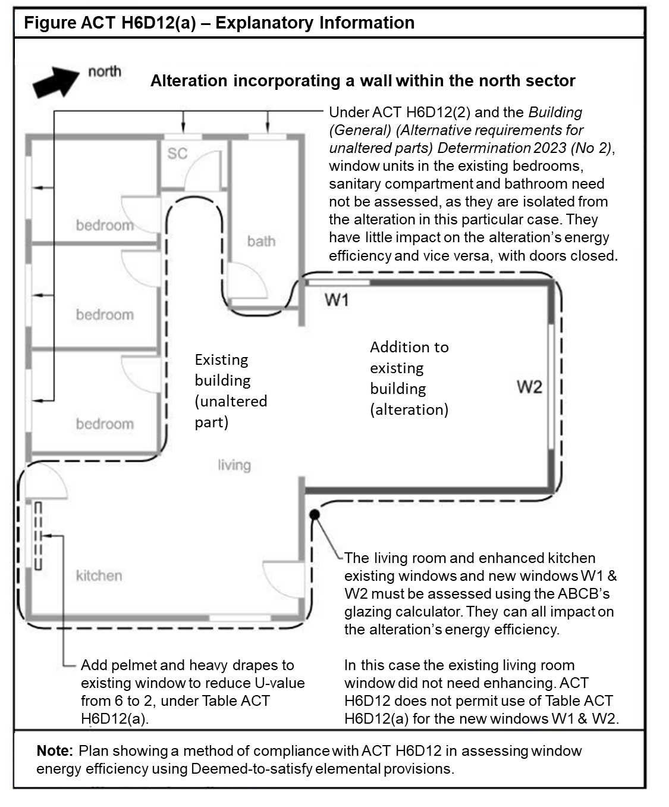

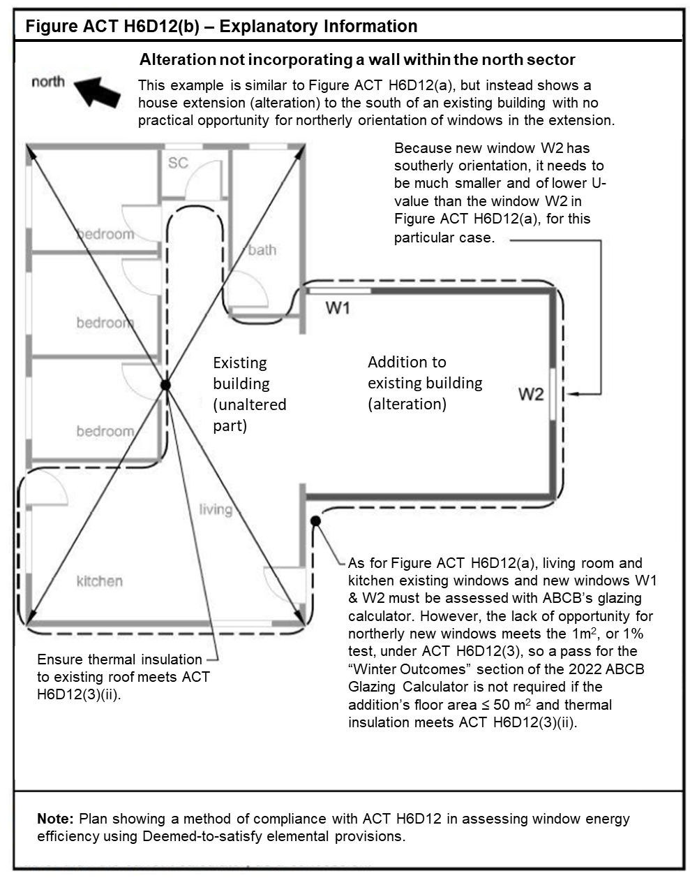
Table ACT H6D12(a) Glazing unit U-values
Glazing unit U-Values |  | Improved U-Values with window treatments
 |  | A | B | C | D | E
Glazing unit (not taking account of any window treatments) |  | Holland blinds only | Closed weave curtains  only | Heavy drapes only | Closed weave curtains + pelmet | Heavy drapes + pelmet
U-Value | R-Value
7.8 | 0.13 | 6.32 | 6.32 | 5.46 | 4.20 | 2.18
7.6 | 0.13 | 6.19 | 6.19 | 5.36 | 4.14 | 2.17
7.4 | 0.14 | 6.06 | 6.06 | 5.26 | 4.08 | 2.15
7.2 | 0.14 | 5.92 | 5.92 | 5.16 | 4.02 | 2.13
7.0 | 0.14 | 5.79 | 5.79 | 5.05 | 3.95 | 2.11
6.8 | 0.15 | 5.65 | 5.65 | 4.95 | 3.89 | 2.10
6.6 | 0.15 | 5.51 | 5.51 | 4.84 | 3.82 | 2.08
6.4 | 0.16 | 5.37 | 5.37 | 4.73 | 3.76 | 2.06
6.2 | 0.16 | 5.23 | 5.23 | 4.62 | 3.69 | 2.04
6.0 | 0.17 | 5.08 | 5.08 | 4.51 | 3.61 | 2.01
5.8 | 0.17 | 4.94 | 4.94 | 4.40 | 3.54 | 1.99
5.6 | 0.18 | 4.79 | 4.79 | 4.28 | 3.47 | 1.97
5.4 | 0.19 | 4.65 | 4.65 | 4.16 | 3.39 | 1.94
5.2 | 0.19 | 4.50 | 4.50 | 4.04 | 3.31 | 1.91
5.0 | 0.20 | 4.35 | 4.35 | 3.92 | 3.23 | 1.89
4.8 | 0.21 | 4.20 | 4.20 | 3.80 | 3.14 | 1.86
4.6 | 0.22 | 4.04 | 4.04 | 3.67 | 3.05 | 1.83
4.4 | 0.23 | 3.89 | 3.89 | 3.54 | 2.96 | 1.79
4.2 | 0.24 | 3.73 | 3.73 | 3.41 | 2.87 | 1.76
4.0 | 0.25 | 3.57 | 3.57 | 3.28 | 2.78 | 1.72
3.8 | 0.26 | 3.41 | 3.41 | 3.14 | 2.68 | 1.69
3.6 | 0.28 | 3.25 | 3.25 | 3.01 | 2.58 | 1.65
3.4 | 0.29 | 3.09 | 3.09 | 2.86 | 2.47 | 1.60
3.2 | 0.31 | 2.92 | 2.92 | 2.72 | 2.37 | 1.56
3.0 | 0.33 | 2.75 | 2.75 | 2.58 | 2.26 | 1.51
2.8 | 0.36 | 2.58 | 2.58 | 2.43 | 2.14 | 1.46
2.6 | 0.38 | 2.41 | 2.41 | 2.27 | 2.02 | 1.40
2.4 | 0.42 | 2.24 | 2.24 | 2.12 | 1.90 | 1.34
2.2 | 0.45 | 2.06 | 2.06 | 1.96 | 1.77 | 1.27
2.0 | 0.50 | 1.89 | 1.89 | 1.80 | 1.64 | 1.20
1.8 | 0.56 | 1.71 | 1.71 | 1.64 | 1.50 | 1.13
1.6 | 0.63 | 1.53 | 1.53 | 1.47 | 1.36 | 1.05
1.4 | 0.71 | 1.34 | 1.34 | 1.30 | 1.21 | 0.96
1.2 | 0.83 | 1.16 | 1.16 | 1.13 | 1.06 | 0.86
1.0 | 1.00 | 0.97 | 0.97 | 0.95 | 0.90 | 0.75
0.8 | 1.25 | 0.78 | 0.78 | 0.77 | 0.74 | 0.63
0.6 | 1.67 | 0.59 | 0.59 | 0.58 | 0.56 | 0.50

Notes to Table ACT H6D12(a):
- Values in the table may be interpolated to more accurately reflect U-Values.
- Closed weave curtains have threads or yarns that generally abut, producing a fabric with negligible interstices (gaps). Thus, light, air and water pass through a closed weaved cotton fabric, but with significant filtering, unless the fabric is treated to block their passage; and they prevent visual detail being seen by eye through their fabric if woven from opaque thread or yarn. Closed weave curtains do not include open weave curtains, as open weave fabric is woven so that warp threads rarely abut each other, leaving interstices (gaps) in the fabric, which includes lace, sheer or net fabrics. Open weave curtains provide negligible change to window U-values.
- Heavy drapes permit no or negligible visible or UV light to pass through their fabric, which may include a composite of layered materials. They also do not readily allow air to pass through. They include closed weave heavy fabrics, such as velvet or velour or heavy cotton or comparable synthetics, with a rubber, acrylic, or similar, solar blocking backing layer bonded to the fabric. The presence of a light source, including the sun, cannot be detected by eye through the fabric. A key requirement of heavy drapes is to have sufficient inertia to maintain a barrier to air movement by remaining relatively stationary in a draft.
- Drapes or curtains must fully cover the window and form part of an enclosure of the layer of air between the drape or curtain and window to minimise air movement caused by convection air currents and air movement caused by HVAC systems, fans, or use of the room. That is achieved, where curtains or drapes—
- are fully within and abut the window recess (reveals) and abut the reveals, head and sill; or
- overlap side edges of the window by at least 150mm or abut a return wall if the window is in a re-entrant corner, and abut the floor; and
- close together (where openable) with no, or with negligible gaps.
For the purposes of this note, a drape or curtain is taken to abut a surface where the drape or curtain is not more than 10mm from that surface.
- Pelmets must be box pelmets and must work in combination with the curtain or drape to enclose the top of a curtain or drape to prevent air plunging by convection from beside or above the pelmet to the window, and must extend to the width of the window plus any required curtain overlap of the window edge. It must overlap the top of the curtain by 50mm or more.

ACT H6D13 Building sealing—application for alterations to existing buildings
Add ACT H6D13
- In applying Part 13.4.7 of the Housing Provisions to an alteration, all requirements of the part must be satisfied except as provided otherwise in (2) or (3) below.

- If the alteration houses an evaporative cooler to which Part 13.4.7 of the Housing Provisions applies, the cooler must comply with 13.4.7 unless it—

- has been relocated from the pre-existing part of the building as part of constructing the addition or extension; and
- was not required to meet a provision like 13.4.7 when it was previously installed in the pre-existing part of the building; and
- does not have a self-closing damper or the like; and
- has all outlets serving a heated space or a habitable room in the alteration, having an automatic means, or a readily accessible manual means, of closing the outlet or the duct serving the outlet, such as a closable baffle or closable louvers on an outlet register. For this provision, an outlet with a manual means of closure is readily accessible if it is mounted in the ceiling of a room, and can be closed by a reasonable person standing on a step ladder and activating a baffle closer or by closing movable louvers or the like, by hand without a tool.

- If the alteration contains a heated space or habitable room to which Part 13.4.7 of the Housing Provisions applies, that is served by an evaporative cooler, the cooler must comply with13.4.7 unless—

- the cooler served, and continues to serve, the pre-existing part of the building; and
- the cooler was not required to meet a provision like 13.4.7 when it was previously installed in the pre-existing part of the building; and
- the cooler does not have a self-closing damper or the like; and
- all the cooler’s outlets serving a heated space or a habitable room in the alteration, have an automatic means, or readily accessible manual means, of closing the outlet, or the duct serving the outlet, such as a closable baffle or closable louvers on an outlet register. For this provision, an outlet with a manual means of closure is readily accessible if it is mounted in the ceiling of a room, and can be closed by a reasonable person standing on a step ladder and activating a baffle closer or by closing movable louvers or the like, by hand without a tool.

ACT H6P2 Energy usage —application for alterations to existing buildings
H6P2(1) (Energy value of a building’s domestic services) does not apply to building work (including exempt or partially exempt building work as contained in Schedule 1 of the Building (General) Regulation 2008)) in relation to alterations to an existing building.

ACT H6D14 Services—application for alterations to existing buildings
Add ACT H6D14
- In applying Part 13.7 of the Housing Provisions to an alteration of an existing building, all requirements of the part must be satisfied except as provided otherwise in (2) or (3) below.

- If the alteration houses, or has mounted on it, or in association with it, a heater or pump to which 13.7.5, 13.7.7 or 13.7.8 applies, the heater or pump must comply with those provisions unless—

- the service is a heater or pump that has been relocated from the pre-existing part of the building as part of the alteration; and
- the heater or pump was not required to meet a provision like 13.7.5, 13.7.7 or 13.7.8 when it was previously installed in the pre-existing part of the building; and
- the heater or pump does not comply with 13.7.5, 13.7.7 or 13.7.8; and
- where the heater or pump serves the addition or extension through a hot water supply system, piping, or duct to which Part 13.7 of the Housing Provisions applies, the portion of the system, piping or duct that is within, or mounted on or in association with, the addition or extension complies with that part.

- If the alteration is served by a light, a heater or pump to which 13.7.5, 13.7.6, 13.7.7 or 13.7.8 applies, the light, heater or pump must comply with those provisions unless—

- the light, heater or pump served, and continues to serve, the pre-existing part of the building; and
- the light, heater or pump was not required to meet a provision like in Part 13.7 when it was previously installed in the pre-existing part of the building; and
- the light, heater or pump does not comply with 13.7.5, 13.7.6, 13.7.7 or 13.7.8; and
- where the heater or pump serves the addition or extension through a hot water supply system, piping, or duct to which Part 13.7.3 or 13.7.4 of the Housing Provisions applies, the portion of the system, piping or duct that is within, or mounted on or in association with, the addition or extension complies with that part.
Explanatory information:
Example for ACT H6D13 and ACT H6D14
A house has a pre-existing evaporative air conditioner, ducted gas central space heater, electric resistance storage water heater, and electric lighting. The house is to be extended by adding a new bedroom with ensuite bathroom, and a small section of hallway. The extension must comply fully with Part 13.4.7 of the Housing Provisions, except that the following approach to the use of concessions under ACT H6D13 would apply.
A new duct will be run from the nearest pre-existing air conditioner duct to an outlet in the new bedroom. When the pre-existing air conditioner was installed in 2003 it was not required to have a self-closing damper or the like, and it does not have one. Such a damper or the like does not need to be provided as otherwise required by 13.4.7, because of ACT H6D13(2). The new outlet in the bedroom will be mounted in the ceiling. To comply with ACT H6D13(2), the new outlet of the air conditioner duct will have an outlet register with a manually closable baffle that is actuated by turning a knob on the register outlet while standing on a step ladder. When the space heating is operating, heat loss from hot air rising up through the register and out to the atmosphere through the air conditioner can be reduced by closing the register baffle.
As per ACT H6D14, the extent of the new duct that is contained within the extension will have to comply with 13.7.4 of the Housing Provisions, which is about insulation and sealing of heating and cooling ducts. That will reduce efficiency losses as cooled air travels along the new duct.
The new ensuite’s shower and hand basin will be serviced with hot water from new piping connected to the nearest pre-existing hot water piping from the pre-existing water heater. ACT H6D14 permits the pre-existing water heater to be used to serve the extension even if the water heater fails to comply with 13.7.7, which is about energy source of water heaters and other matters. However, the portions of the new piping that are within the extension must comply with 13.7.3, which covers insulation of piping. That will reduce efficiency losses from hot water in the pipe losing heat.
Artificial lighting of a new hallway will rely on light from a pre-existing light fitting located in the pre-existing part of the house. Because of ACT H6D14(3), artificial lighting of the new hallway does not have to comply with 13.7.6, which includes limitations of the power density of lamps or illumination. However, new artificial lights in the form of electric light fittings in the new bedroom and new ensuite must comply with 13.7.6 insofar as it applies to the new extension, other than the new hallway.

Part H7 Ancillary provisions and additional construction requirements
Add after H7P1:
ACT H7P1 Swimming pool access - Application
H7P1 applies to a regulated swimming pool as regulated by the Building Act 2004 and Building (General) Regulation 2008. H7P1 must be applied in the ACT in accordance with that regulatory framework.

Replace H7D2 (1) and (2) with ACT H7D2 (1) and (2) as follows:
ACT H7D2 Swimming pools
- Performance Requirement H7P1 is satisfied for a swimming pool with a depth of water more than 300 mm and which is associated with a Class 1 building, if it has:
  - safety barriers installed in accordance with the Building Act 2004 and the Building (General) Regulation 2008, and
  - has means of egress provided in the form of ladders, steps in the floor of the pool or a ramp where the capacity of the pool exceeds 10 m3.
- Performance Requirement H7P2 is satisfied for a water recirculation system of a swimming pool with a depth of water more than 300 mm, if it—
- complies with AS 1926.3; and
- is of the recirculation type in which the water circulation is maintained through the pool by pumps, the water drawn from the pool being clarified and disinfected before being returned to the pool; and
- is capable of being completely emptied and any discharge or overflow and pool backwash filter must be connected to the sewer drainage system in accordance with AS/NZS 3500.2.

Add the following ACT Application to H7D2:
ACT Application: H7D2 applies to a regulated swimming pool as defined by the Building Act 2004 and Building (General) Regulation 2008

After H7P6 add ACT H7P7 as follows:
ACT H7P7 Building over drains
Existing drains, or parts of drains, in currently operational drainage systems must be sound and able to work effectively without leaking before any building that will be constructed over the drain or restrict access to the drain is constructed.
After H7D5 add ACT H7D7 as follows:
ACT H7D7 Building over drains
- The requirements of ACT H7P7 (Performance Requirement) are satisfied if—
- Before building work that will result in a building, or part of a building, being constructed over, or restricting access to, an existing drain in a currently operational drainage system is carried out, the relevant part of the drain, must be tested for soundness in accordance with section 15 of AS/NZS 3500.2.
- If the drain is found not be sound after testing in accordance with (i), it is made sound before the building work commences.

ACT Part H8 Livable housing design
In “Introduction to this Part” add:
Notes: ACT Part H8 Livable housing design
For the ACT, Part H8 takes effect from 15 January 2024.
If there is an inconsistency between requirements for the same aspect in the BCA and the Building Act 2004, the latter prevails to the extent of the inconsistency.
The Building (General) Regulation 2008 and the Building (General) (Alternative requirements for unaltered parts) Determination (as amended from time to time) have provisions about applying certain BCA provisions and alternatives to those provisions to pre-existing parts of substantially altered class 1, class 10a and class 10b buildings, when the existing building is substantially altered or extended.
Practitioners should ensure they check the latest version of relevant legislation, and the latest version of this appendix, available through the ACT legislation register at www.legislation.act.gov.au.

ACT Part H8 Livable housing design —application for alterations to existing buildings
- An alteration of an existing building need not comply with Part H8 if the building work associated with the alteration is basic building work, as defined by the Building Act 2004.

- An alteration of an existing building that undergoes building work, as defined by the Building Act 2004, need not comply with Part H8 as a whole if the altered and unaltered parts comply with the alternative requirements determined under subsections (3) to (7).
Dwelling entrance
- For Dwelling Entrance (Part 2 of the ABCB Livable Housing Design Standard)
  - Altered facades of dwellings listed on the ACT Heritage Register, under the Heritage Act 2004, need not comply with Part 2.
  - Altered parts need not comply with Part 2 if there is another Dwelling Entrance that complies with Part 2.
  - Subject to subclauses (a) and (b), an altered front entrance (or main entrance) must be made compliant with Part 2.
  - Subject to subclause (b), an altered or new internal garage connecting door must:
    - be made compliant with Part 2.1 (Clear opening width); and
    - have a complaint threshold (Part 2.2), unless the height difference between the existing finished floor levels of the garage and inside floor mean that ramping would be incapable of complying with Part 2.2 (c) in terms of gradient and length.
  - Altered or new alternative entrance doors (for example, back or side entrance doors not covered by (c) or (d)) need not comply.
  - Unaltered parts need not comply.
Internal doors and corridors
- For Internal doors and corridors (Part 3 of the ABCB Livable Housing Design Standard)
  - Altered parts must comply with Parts 3.1 and 3.3 of the ABCB Livable Housing Design Standard to the extent that door clear opening widths and corridor widths are not narrower than the original widths, where compliance cannot be achieved due to space restrictions of the existing home.
  - Unaltered parts need not comply.
Sanitary compartments
- For Sanitary compartments (Part 4 of the ABCB Livable Housing Design Standard)
  - A new sanitary compartment on the ground floor or entry level of a dwelling must comply with Part 4 unless there is another sanitary compartment that complies with Part 4.
  - An altered sanitary compartment on the ground floor or entry level of a dwelling must comply with Part 4, unless there is another sanitary compartment that complies with Part 4, to the extent that circulation space is not decreased from the original layout, if compliance cannot be achieved due to subclauses (i) or (ii);
    - Any underlying concrete slab would need to be modified to meet compliance; or
    - Space restrictions of the existing sanitary compartments.
  - New or altered sanitary compartments other than for subclause (a) need not comply.
  - Unaltered parts need not comply.

Showers
- For Showers (Part 5 of the ABCB Livable Housing Design Standard)
  - If an additional shower is added to an existing building, it must comply with Part 5 unless there is another shower that complies with Part 5.
  - An altered shower must comply with Part 5, unless
    - there is another shower that complies with Part 5; or
    - compliance cannot be achieved due to the underlying slab needing to be modified in order to meet compliance; or
    - compliance cannot be achieved without undertaking unplanned structural work to the floor or walls.
  - Unaltered parts need not comply.
Reinforcement of bathroom and sanitary compartment walls
- For Reinforcement of bathroom and sanitary compartment walls (Part 6 of the ABCB Livable Housing Design Standard)
  - Alterations subject to clauses (5) or (6) must also comply with Part 6 of the ABCB Livable Housing Design Standard.
  - Unaltered parts need not comply.
Explanatory information:
Part 1 of the ABCB Livable Housing Design Standard (Dwelling Access) does not apply to alterations of an existing building.
Determining the “ground floor or entry level” of an alteration of an existing building when applying it to clause 5 (sanitary compartments) may require practitioner judgement. New dwellings will require accessible access (ie Part 1 of the Standard) that will help define the “entry level” for this application. However, an alteration of an existing building does not need to have a compliant dwelling access, and an accessible entrance (ie Part 2 of the Standard) may not be required. Therefore, the entry level of an existing home would generally be allowed to incorporate the pre-existing front entrance, regardless of whether an extension adds a floor above or below the original floor and front entrance. If the entry level contains a split in levels (e.g a front door foyer at door level, with two internal steps up to the living area proper), this split can be ignored for the purposes of locating the sanitary compartment.
The Building Act 2004 contains definitions for building work (section 6) and basic building work (section 10). This Appendix does not require basic building work, such as non-structural work, to be made compliant with the NCC Livable housing design requirements.
Example 1
Replacing an internal door is non-structural in nature, so the requirements of ACT H8P1 (3) and (4) do not apply. However, replacing a lintel over a door opening is of a structural nature and would require Building Approval, so ACT H8P1 (3) and (4) may apply.

Example 2
Replacing bathroom tiles is non-structural in nature, so the requirements of ACT H8 do not apply. However, changing a structural bathroom wall would require Building Approval, so ACT H8P1 (5) and (6) may apply.
Example 3
A ground floor extension consisting of a master bedroom and ensuite is added to an existing dwelling. The dwelling has no pre-existing accessible sanitary compartment, so the ensuite must comply with the Livability Standard (Parts 3, 4 and 6). Furthermore, if there is no pre-existing accessible shower, the new shower must comply with the Livability Standard (Parts 5 and 6).
Example 4
A single storey dwelling on a sloping block is to be extended out the back. This extension is on a lower level than the existing house, due to the sloping nature of the block. This new, lower level would not generally be considered the “ground floor or entry level” for the application of clause 5 (sanitary compartments).
Example 5
Building work is occurring to a dwelling’s only sanitary compartment, however, due to space requirements, a door with a clear opening width of 820 mm will not fit. Therefore, the existing clear opening width is acceptable, but a smaller clear opening width is not. Furthermore, the existing sanitary compartment circulation space does not comply with Part 4.2 of Livability Standard. The sanitary compartment is not being extended, so the existing circulation space is acceptable, but cannot be made smaller. NB wall reinforcement, as per clause 7, may still be required.
Example 6
Building work is occurring to a dwelling’s only shower recess. It sits on a concrete slab. The slab would need to be partially removed to achieve hobless, step free access or proper drainage. Therefore, the requirements of clause 6 need not apply. NB wall reinforcement, as per clause 7, may still be required.
Example 7
Building work is occurring to remove a structural wall between a dwelling’s bathroom and toilet, creating a single, larger space. It sits on a suspended timber floor. The floor would need further, otherwise unplanned, structural work (e.g. modification of the joists) to achieve hobless, step free access and proper drainage. Therefore, the requirements of clause 6 need not apply. Furthermore, this new space is still too small to achieve the required circulation space in front of the toilet, as per Part 4.2 of Livability Standard. The new circulation space does not need to comply, as long as it is not smaller than the original circulation space. NB wall reinforcements, as per clause 7, may still be required.

Schedule 1 Referenced documents
Schedule of referenced documents
In Table 1, insert additional references as follows:

No. | Date | Title | Volume One | Volume Two | Volume Three
N/A |  | Development Control Code for Best Practice Waste Management in the ACT | ACT F2.2 | ACT 2.2 | N/A
ISO 10077-1 | 2017 | Thermal performance of windows, doors and shutters — Calculation of thermal transmittance | N/A | ACT H6D12 | N/A
AS/NZS 3500.2 | 2021 | Plumbing and drainage Part 2: Sanitary plumbing and drainage | ACT Part G10 | ACT H7D7 ACT H7P2 | N/A
N/A | 2022 | ABCB Livable Housing Design Standard | N/A | ACT H8P1 | N/A
N/A | 2022 | ABCB Housing Provisions Standard | N/A | ACT H6D11  ACT H6D12  ACT H6D13  ACT H6D14 | N/A

