Australian Capital Territory

Road Transport (General) Application of Road Transport Legislation (Blue Range Rallysprint) Declaration 2024 (No 1)

**Disallowable instrument DI2024–284**

made under the

*Road Transport (General) Act 1999*, section 13 (Power to exclude vehicles, persons or animals from road transport legislation)

**1 Name of instrument**

This instrument is the *Road Transport (General) Application of Road Transport Legislation (Blue Range Rallysprint) Declaration 2024 (No 1)*.

**2 Commencement**

This instrument commences at 7:00am on 26 October 2024.

**3 Motor accident injury insurance declaration**

1. I declare that the *Motor Accident Injuries Act 2019* does not apply to:

(a) a **designated vehicle**; or

(b) a motor vehicle involved in a motor accident with a **designated vehicle**;

while the **designated vehicle** is being used to participate in a **special stage** for the **event** for any period beginning on an event official declaring (in whatever manner the event official describes) the special stage active for a testing session, media event, corporate event day or rally competition and ending on an event official declaring the special stage inactive.

1. On the day the event officials declare a **special stage** for the event active, I declare that the *Motor Accident Injuries Act 2019* does not apply to:

(a) a **designated vehicle**; or

(b) a motor vehicle involved in a motor accident with a **designated vehicle**;

while the **designated vehicle** is being used to participate in the **transport stage** for the event.

**4 Declaration – other road transport legislation**

I declare that the following road transport legislation does not apply to a **designated vehicle** or the driver of a **designated vehicle** while participating in a **special stage** for the **event** for any period beginning on an **event official** declaring (in whatever manner the event official describes) the stage active for a testing session, media event, corporate event day or rally competition and ending on an **event official** declaring the stage inactive:

(a) *Road Transport (Driver Licensing) Act 1999*:

- Section 31 – Driver must be licensed;

- Section 33A – Contravening interlock condition;

(b) *Road Transport (Vehicle Registration) Act 1999*:

- Section 18 – Prohibition on using unregistered registerable vehicles or vehicles with suspended registration;

(c) *Road Transport (Vehicle Registration) Regulation 2000*:

- Section 59 – Display of numberplates;

- Section 60 – Using vehicle without numberplate etc;

(d) *Road Transport (Safety and Traffic Management) Act 1999*:

- Section 5A – Races, attempts on speed records, speed trails etc;

- Section 5B – Improper use of motor vehicle;

- Section 7 – Furious, reckless or dangerous driving;

- Section 8 – Menacing driving;

(e) *Road Transport (Road Rules) Regulation 2017*:

- Part 3 – Speed limits;

- Part 4 – Making turns;

- Part 5 – Change of direction and stop signals;

- Part 7 – Giving way;

- Part 8 - Traffic signs and road markings;

- Division 11.1 General;

- Division 11.2 Keeping to Left;

- Division 11.3 Overtaking;

- Part 13 – Lights and warning devices;

- Section 288 – Driving on path.

**5 Declaration – other road transport legislation**

On the day the **event official** declares a **special stage** for the **event** active, I declare that the following road transport legislation does not apply to a **designated vehicle** or the driver of a **designated vehicle**, while participating in the **transport stage** for the **event**:

(a) *Road Transport (Driver Licensing) Act 1999*:

- Section 33A – Contravening interlock condition

(b) *Road Transport (Vehicle Registration) Act 1999*:

- Section 18 – Prohibition on using unregistered registerable vehicles or vehicles with suspended registration

(c) *Road Transport (Vehicle Registration) Regulation 2000*:

- Section 59 – Display of numberplates

- Section 60 – Using vehicle without numberplate etc

**6 Definitions**

In this instrument:  
  
***designated vehicle*** means any of the following vehicles:

(a) an event registered motor vehicle; or

(b) a promotional or official vehicle.  
  
***event registered motor vehicle*** means a vehicle entered to participate in the event, and may be an unregistered, unidentified or uninsured motor vehicle.  
  
***promotional or official vehicle*** means a registered vehicle being used for promotional or official purposes during the special stages.  
***event*** means the Blue Range Rallysprint 2024.  
  
***event official*** means an official for the event who holds a Clerk of Course role from Australian Autosport Alliance.  
  
***registered*** means registered under the *Road Transport (Vehicle Registration) Act 1999* or equivalent legislation.  
  
***special stage*** means a road or road related area identified as a special stage in the map, outlined in orange or purple, at Schedule 1.  
  
***transport stage*** means a road or road related area identified as a transport stage in the map, outlined in yellow, at Schedule 1.  
  
***unidentified motor vehicle***—see the *Motor Accident Injuries Act 2019*, section 327.  
  
***uninsured motor vehicle***—see the *Motor Accident Injuries Act 2019*, section 325.

**7 Expiry**

This instrument expires on 23 November 2024.

Chris Steel MLA

Minister for Transport

Special Minister of State

6 September 2024

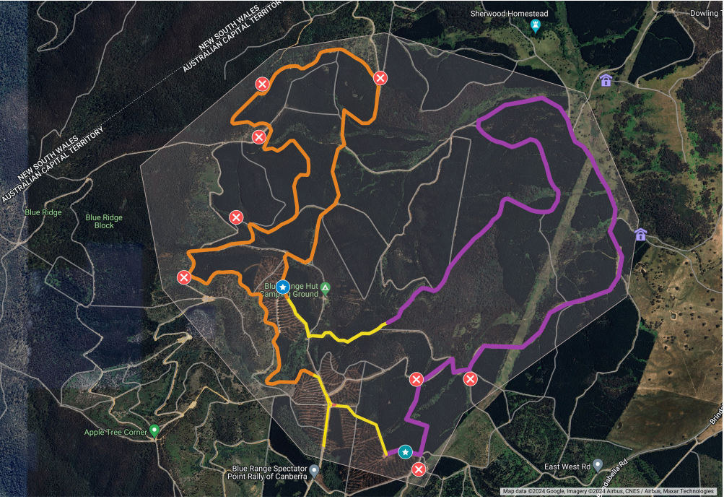

**Legend**

Special stage

Special stage

Transport stage