Australian Capital Territory

# Road Transport (General) Application of Road Transport Legislation (National Multicultural Festival) Declaration 2025

## Disallowable instrument DI2025-4

made under the

*Road Transport (General) Act 1999*, section 12 (Power to include or exclude areas in road transport legislation)

### 1 Name of instrument

This instrument is the *Road Transport (General) Application of Road Transport Legislation (National Multicultural Festival) Declaration 2025*.

### 2 Commencement

This instrument commences at 6:00am on 28 January 2025.

### Declaration – Disapplication of parking legislation for event preparation

I declare that the ***disapplied no parking legislation***, ***disapplied road path legislation***, and ***disapplied timed parking legislation*** do not apply to ***designated vehicles*** during the period commencing 6:00am on Tuesday 28 January 2025 to 6:00pm Friday 21 February 2025 within the ***contractor designated areas*** in Schedule 1.

This declaration only applies while a ***designated vehicle*** either:

1. is stopped or parked for a ***festival preparation purpose***; or
2. is in motion over a path/strip in a built up area to access a location for a ***festival preparation purpose*** and the vehicle is travelling at no more than 5km/hr with hazard lights activated.

### Declarations – Disapplication of parking legislation for Glebe Park Rotunda access, Civic Square access and Akuna Street (North)

1. I declare that the ***disapplied no parking legislation*** does not apply to a vehicle stopping or parking at the ***Civic Square lane*** for a ***festival preparation purpose*** during the period commencing at 6:00am on Wednesday 29 January 2025 and ending at 6:00pm on Friday 14 February 2025.
2. I declare that the ***disapplied no parking legislation*** does not apply to a vehicle stopping or parking at the ***Akuna Street north lane*** during the period commencing at 10:00pm on Wednesday 5 February 2025 and ending at 6:00pm on Monday 10 February 2025 if that vehicle is stopped or parked for the purposes of installation, removal, or provision of infrastructure (including coolrooms) and supplies for the National Multicultural Festival 2025.
3. I declare that the ***disapplied no parking legislation*** does not apply to a vehicle stopping or parking for a ***festival preparation purpose*** at the ***Rotunda access lane*** during the following periods:
4. Commencing 6:00am on Saturday 8 February 2025 and ending at 9:00am on the same day;
5. Commencing 7:00pm on Saturday 8 February 2025 and ending at 9:00pm on the same day.

### Declaration – Disapplication of parking legislation for Festival Shuttle Bus

I declare that during the period commencing 3:00pm on Friday 7 February 2025 and ending at 8:00pm on Sunday 9 February 2025:

1. the ***disapplied timed parking legislation*** do not apply to the ***shuttle bus zones***; and
2. the ***disapplied no parking legislation*** do not apply to any ***festival shuttle bus*** stopping or parking at the ***shuttle bus zones***.

### Declaration – Disapplication of parking legislation at event location

I declare that the ***disapplied timed parking legislation*** does not apply to the areas identified in schedule 2 for the following periods:

1. The area highlighted sky blue during the period commencing 10:00pm on Tuesday 28 January 2025 and ending at 6:00pm on Friday 14 February 2025;
2. The area highlighted blue during the period commencing 6:00am Monday 3 February 2025 and ending at 6:00pm on Friday 14 February 2025;
3. The area highlighted red during the period commencing 8:00pm Tuesday 4 February 2025 and ending at 8:00pm Tuesday 11 February 2025;
4. The area highlighted dark green during the period commencing 10:00pm on Wednesday 5 February 2025 and ending at 6:00pm on Monday 10 February 2025;
5. The areas highlighted yellow during the period commencing 4:00am on Thursday 6 February 2025 and ending at 6:00am on Monday 10 February 2025;
6. The areas highlighted orange during the period commencing 8:00pm on Thursday 6 February 2025 and ending at 6:00am on Monday 10 February 2025;
7. The area highlighted light green during the period commencing 4:00am on Friday 7 February 2025 and ending at 6:00am on Monday 10 February 2025;
8. The areas highlighted pink during the period commencing 3:00pm on Friday 7 February 2025 and ending at 8:00pm on Sunday 9 February 2025.

### Definitions

***Akuna Street north lane*** means the road lane closest to Glebe Park for the area highlighted black in Schedule 2.

***Civic Square lane*** means the area highlighted dark blue in Schedule 2.

***contractor designated areas*** mean the areas highlighted green in Schedule 1.

***designated vehicles*** mean vehicles owned and operated by the following businesses or companies:

1. Eclipse Lighting and Sound Pty Ltd (ACN: 147 994 367);
2. AVL Australia (ABN: 47 109 066 390);
3. Mashera Pty Ltd t/a Barlens Event Hire (ACN: 061 968 474); and
4. W.R. Electrical Pty Ltd t/a Affinity Electrical Technologies (ACN: 094 182 779).

***disapplied no parking legislation*** means the following provisions of the *Road Transport (Road Rules) Regulation 2017*:

1. Section 168 (No parking sign);
2. Section 179 (Stopping in loading zone);
3. Section 182 (Stopping in taxi zone);
4. Section 183 (Stopping in bus zone);
5. Section 183A (Stopping public bus in bus zone);
6. Section 203 (Stopping in parking area for people with disabilities).

***disapplied road path legislation*** means the following provision of the *Road Transport (Road Rules) Regulation 2017*:

1. Section 197 (Stopping on path, dividing strip, nature strip, painted island or traffic island).

***disapplied timed parking legislation*** means the following provisions of the *Road Transport (Road Rules) Regulation 2017*:

1. Section 205 (Parking for longer than indicated);
2. Section 205A (Parking outside time indicated);
3. Section 207 (Parking where fee payable);
4. Section 208 (Parallel parking on road (except in median strip parking area));
5. Section 208A (Parallel parking in road related area (except in median strip parking area));
6. Section 211 (Parking in parking bay);
7. Section 213I (Ticket parking – parking in space);
8. Section 213J (Ticket parking – parking in space – motorbike);
9. Section 213K (Ticket parking – display of ticket);
10. Section 213M (Ticket parking – maximum length of stay).

***festival preparation purpose*** mean either:

1. installation or removal of infrastructure or decorations for the National Multicultural Festival 2025, or
2. loading or unloading infrastructure, supplies, or equipment for the National Multicultural Festival 2025.

***festival shuttle bus*** means a bus operated by QCity Transit Pty Ltd t/a CDC Canberra (ACN: 001 260 242) to transport people between any of the shuttle bus zones without requiring a fare or other consideration.

***Rotunda access lane*** means the one road lane closest to Glebe Park for the area highlighted in dark purple in Schedule 2.

***shuttle bus zones*** mean the areas highlighted brown in Schedule 2.

### Expiry

This instrument expires on 22 February 2025.

|  |
| --- |
| Tara Cheyne MLA |
| Minister for City and Government Services |
| 22 January 2025 |

**Schedule 1**

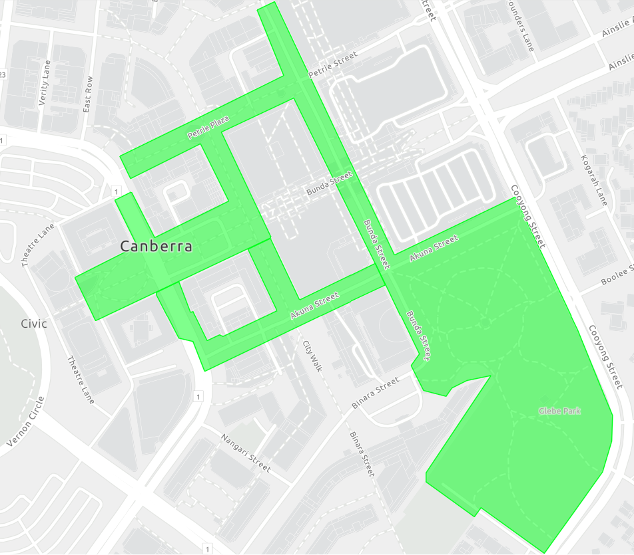

**Schedule 2**

