Australian Capital Territory
Major Events (National Multicultural Festival 2026) Declaration 2026
Disallowable instrument DI2026-3
made under the
Major Events Act 2014, section 6 (Major event – declaration)

1 Name of instrument
This instrument is the Major Events (National Multicultural Festival 2026) Declaration 2026.
2 Commencement
This instrument commences on the day after it is notified.
3 Declaration of major event—Act, subsections 6 (1) and s 7 (1) (a)
The National Multicultural Festival 2026 to be held in the Canberra City Centre from 6-8 February 2026 is declared as a major event.
4 Event organiser—Act, subsection 7 (1) (b)
The organiser of the major event is the Health and Community Services Directorate, ACT Government.
5 Proposed time and date—Act, subsection 7 (1) (c)
The proposed times and dates for the major event are:
- 5:00pm to 11:00pm on 6 February 2026;
- 10:00am to 11:00pm on 7 February 2026;
- 10:00am to 5:00pm on 8 February 2026.
6 Event venue—Act, subsection 7 (1) (d)
The location of the venue for the major event is the grounds, including any buildings situated on the grounds, specified in schedule 1.
7 When declaration is in force—Act, subsection 7 (1) (e)
This declaration is in force for the period –
- 5:00pm to 11:00pm on 6 February 2026;
- 10:00am to 11:00pm on 7 February 2026;
- 10:00am to 5:00pm on 8 February 2026.
8 Notice given under other provisions—Act, subsections s 26 (1), s 32 (1) and s 39 (1)
Notice will not be given under the following provisions for this declaration:
- s 26 (Notice of protected symbol);
- s 32 (Notice of clean zone);
- s 39 (Notice of protection of ticketing arrangements).
9 Exclusion of prohibited item—Act, subsection 12 (1) (a)
The following items are excluded from the meaning of prohibited item for the major event declaration:
- alcohol;
- a drug of dependence or prohibited substance;
- a fire extinguisher;
- paint stored in a container of any kind;
- a loud hailer, megaphone or any other device that can amplify the human voice;
- broadcast equipment or any device that may interfere with broadcast equipment authorised by the event organiser to be used in the event venue;
- a whistle, horn or bugle or a similar thing likely to be used to interfere with the event;
- a flag that is longer or wider than 900mm;
- an egg or ball;
- an animal, other than—
(A) if a person is accompanied by an assistance animal—the animal; or
(B) a police dog, police horse or other animal used for the management of the event; or
(C) an animal competing or participating in the event;
- a bicycle, scooter, skateboard, roller skates, roller blades or similar wheeled device, other than a wheeled device used by—
(A) a person with disability for mobility; or
(B) a police officer or another person for the management of the event; or
(C) a person competing or participating in the event.
10 Expiry
This instrument expires on 9 February 2026.

Tara Cheyne MLA Andrew Barr MLA
Attorney-General Chief Minister
6 January 2026 6 January 2026

Schedule 1
(See section 6)

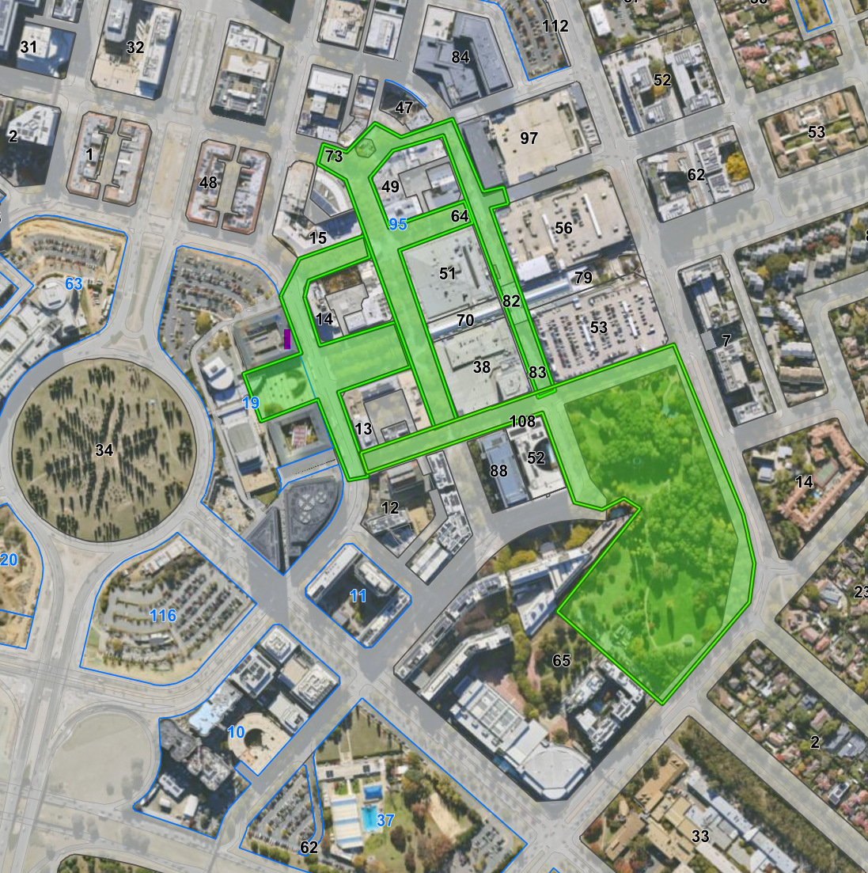
The location of the major event are the grounds
highlighted in green within the City Centre, Canberra
ACT 2601.

This includes the outdoor space at City Walk,
Garema Place, Ainslie Place, Civic Square and
Glebe Park, Canberra Museum & Gallery, and
Libraries ACT (Central Library).

