Australian Capital Territory

Planning and Development (Draft Variation No 288) Notice 2008

Changes to Residential Zones Multi-Unit Housing Development Code Part A(5)and Residential Zone Changes for Blocks 3 and 4 Section 69 Lyons and Block 8 Section 47 Lyons

**Notifiable instrument NI2008—273**

made under the

*Planning and Development Act 2007*, section 63 (Public consultation - notification) and section 64 (Public consultation – notice of interim effect etc)

Draft variation No. 288 to the Territory Plan has been prepared by the ACT Planning and Land Authority in accordance with section 63 of the

*Planning and Development Act 2007* (the Act).

The draft variationproposes height limits of up to 6 storeys in the Residential High Density Zone (RZ5) controls contained within the Residential Zones Multi Unit Housing Development Code Part A(5). The draft variation also proposes to allow a maximum of ten storeys in height within a 60 metre radius of the corner of Melrose Drive and Launceston Street via a site specific rule. All existing RZ5 Zones will retain current height restrictions via site specific controls. A zoning change is proposed for Blocks 3 and 4 Section 69 Lyons and Block 8 Section 47 Lyons from RZ4 (Residential Medium Density Zone) to RZ5 (Residential High Density Zone).

A copy of the draft variation is attached for information.

The documents relating to this draft plan variation may be obtained from:

* the Authority’s website at:

<http://www.actpla.act.gov.au/topics/your_say> ; or

* the Authority’s Customer Service Centre, Ground Floor, South Building, Dame Pattie Menzies House, 16 Challis Street, Dickson (opposite the Motor Registry) 8:30am to 4:30pm weekdays.

Note that access to the Internet is available free of charge at all ACT Public Libraries during library opening hours.

**Written comments** from the public are invited on the draft plan variation by  
**COB Monday 11 August 2008.** Comments should include reference to this draft variation, a return postal address, and be addressed to:

The Manager, Development Policy Section

ACT Planning and Land Authority

Comments may be submitted in one of the following ways:

* Hand deliver to:

The Authority’s Customer Service Centre, 16 Challis Street, Dickson

* Post to: GPO Box 1908

CANBERRA ACT 2601

* Email: [terrplan@act.gov.au](mailto:terrplan@act.gov.au)

Section 72 does not apply in relation to the draft plan variation and therefore it does not have interim effect.

Copies of all written comments received from the public will be made available for public inspection at the Authority’s Customer Service Centre, Dickson, during normal office hours for a period of not less than 15 working days after the closing date listed above.

Jacqui Lavis

Delegate of the ACT Planning and Land Authority

2 July 2008



Planning & Development Act 2007

Draft

Variation to the

Territory Plan

No. 288

Changes to Residential Zones Multi-Unit Housing Development Code Part A(5)

and

Residential Zone Changes for Blocks 3 and 4 Section 69 Lyons and Block 8 Section 47 Lyons

July 2008

Table of Contents

1. INTRODUCTION 3

1.1 Summary of the Proposal 3

1.2 Outline of the process 3

1.3 This document 3

1.4 Public Consultation 3

2. EXPLANATORY STATEMENT 3

2.1 Background 3

2.2 National Capital Plan 3

2.3 Site Description 3

2.4 Current Territory Plan Provisions 3

2.5 Proposed Changes 3

2.6 Reasons for the Proposed Variation 3

2.7 Planning Context 3

2.8 Interim Effect 3

2.9 Consultation with Government Agencies 3

3. DRAFT PLAN VARIATION 3

3.1 Variation to the Territory Plan Map 3

3.2 Variation to the Territory Plan Written Statement 3

1. INTRODUCTION
   1. Summary of the Proposal

The draft variationproposes height limits of up to 6 storeys in the Residential High Density Zone (RZ5) controls contained within the Residential Zones Multi Unit Housing Development Code Part A(5). The draft variation also proposes to allow a maximum of ten storeys in height within a 60 metre radius of the corner of Melrose Drive and Launceston Street via a site specific rule. All existing RZ5 Zones will retain current height restrictions via site specific controls. A zoning change is proposed for Blocks 3 and 4 Section 69 Lyons and Block 8 Section 47 Lyons from RZ4 (Residential Medium Density Zone) to RZ5 (Residential High Density Zone). The anticipated range of heights across the site is depicted in the concept plan at **Figure 2.1**.

* 1. Outline of the process

The Commonwealth’s *Australian Capital Territory (Planning and Land Management) Act 1988* allows for the Legislative Assembly to make laws to establish a Territory Planning Authority and for that Authority to prepare and administer a Territory Plan. The *Planning and Development Act 2007* (the P&D Act) establishes the ACT Planning and Land Authority as the Authority which prepares and administers the Territory Plan, including continually reviewing and proposing amendments as necessary.

The Territory Plan (the Plan) is comprised of the written statement and a map. The written statement contains a number of parts, namely Governance; Strategic Direction; Zones; Precinct Codes; General Codes; Overlays; Definitions; Structure Plans, Concept Plans and Development Codes for Future Urban Areas.

The Territory Plan Map graphically represents the applicable land use zones (under the categories of Residential, Commercial, Industrial, Community Facility, Urban Parks and Recreation, Transport and Services and Non Urban), precincts and overlays. The zone, precinct and overlay requirements are detailed in the written volumes of the Territory Plan.

Draft variations to the Territory Plan are prepared in accordance with the P&D Act. Following the release of the draft plan variation under section 63 of the Act, submissions from the public are invited. At the conclusion of the consultation period the ACT Planning and Land Authority (the Authority or ACTPLA) submits a report on consultation and a recommended final plan variation to the Minister for Planning for approval. The Minister has the discretion to determine if referral to the Legislative Assembly Standing Committee on Planning and Environment is warranted prior to approval, depending on the nature and significance of the proposal. If the draft variation is referred to the Committee, the Minister must consider the findings of the Committee before deciding whether to approve the draft plan variation. If the Minister approves the plan variation, the variation and associated documents will be tabled in the Legislative Assembly. Unless disallowed by the Legislative Assembly within five sitting days, the plan variation commences on a day nominated by the Minister.

* 1. This document

This document contains the background information in relation to the proposed variation. It comprises the following parts:

Part 1 - This **Introduction**.

Part 2 - An **Explanatory Statement**, which gives reasons for the proposed variation and describes its effect.

Part 3 - The **Draft Plan Variation**, which details the precise changes to the Territory Plan that are proposed.

* 1. Public Consultation

Comments from the public are invited on the draft variation. Subject to consideration of responses received, the Authority proposes to submit this draft variation to the Minister for Planning in accordance with the P&D Act.

The documents relating to this draft plan variation may be obtained from:

* the Authority’s website at:

<http://www.actpla.act.gov.au/topics/your_say> ; or

* the Authority’s Customer Service Centre, Ground Floor, South Building, Dame Pattie Menzies House, 16 Challis Street, Dickson (opposite the Motor Registry) 8:30am to 4:30pm weekdays.

Note that access to the Internet is available free of charge at all ACT Public Libraries during library opening hours.

**Written comments** from the public are invited on the draft plan variation by  
**11 August 2008**. Comments should include reference to this draft variation, a return postal address, and be addressed to:

The Manager, Development Policy Section

ACT Planning and Land Authority

Comments may be submitted in one of the following ways:

* Hand deliver to:

The Authority’s Customer Service Centre, 16 Challis Street, Dickson

* Post to: GPO Box 1908

CANBERRA ACT 2601

* Email: [terrplan@act.gov.au](mailto:terrplan@act.gov.au)

Copies of all written comments received from the public will be made available for public inspection at the Authority’s Customer Service Centre, Dickson, during normal office hours for a period of not less than 15 working days after the closing date listed above.

1. EXPLANATORY STATEMENT
   1. Background

**(a) Residential Zones Multi-Unit Development Code Changes**

The proposed increased height limits for the Lyons Estate Redevelopment on Blocks 3 and 4 Section 69 Lyons was the catalyst for the ACT Planning and Land Authority to take the opportunity to review height limits for the Residential RZ5 zone (High Density Residential) in the Territory Plan. The Residential Zones Multi-Unit Housing Development Code currently restricts the height of buildings in the RZ5 zone to a maximum of three storeys which is the same height limit applied to RZ4 zones. However some existing RZ5 zones in Kingston/Griffith and Belconnen allow for increased heights above the three storey limit subject to meeting specific Rules or Criteria that apply to those sites.

Although it is not proposed to change the building height restrictions that apply to existing RZ5 zones, it is proposed to include a new building height policy in the Territory Plan that would apply both to the subject site in Lyons and to future RZ5 zones, if and when they are to be identified. The identification of future RZ5 zones, if and when this were to occur, would be based on principles set out in the Territory’s Spatial Plan such as proximity to commercial (town) centres, major transport routes and major employment. This is in keeping with the Government’s policies on encouraging a more compact city through residential densification in appropriate locations where close to significant employment generators and service providers, and where sustainable modes of transport such as walking, commuter cycling and public transport could be readily utilised by residents in these areas.

It is proposed to amend the Residential Zones Multi-Unit Housing Development Code Part A(5) to permit increased building heights in RZ5 areas provided that specific rules or criteria are addressed. These take into account surrounding development where any proposed development must not result in significant detrimental impacts on adjacent uses and/or residents.

Existing RZ5 zones as detailed in the Multi Unit Housing Development Code have their own specific height policies which will not be changed by this variation.

Any areas proposed to be zoned RZ5 in the future will be required to go through the rigorous Territory Plan Variation process to determine the suitability and appropriateness of such a change.

A Technical Amendment (Code Variation No. 2008-02) has been prepared which includes making adjustments to the Residential Zones Multi Unit Housing Development Code Part A(5) to clarify the policy intent of the existing height controls to be maintained for RZ5 zones in Kingston, Griffith and Belconnen. The Technical Amendment can be viewed on the ACTPLA website at: http://www.actpla.act.gov.au/tools_resources/legislation_plans_registers/plans/current_territory_plan_variations.

**(b) Lyons Estate Redevelopment**

The site of the Lyons Estate Redevelopment Proposal (Blocks 3 and 4 Section 69 Lyons – see Figure 2.2 Locality Plan) was originally developed during the mid 1970’s to initially accommodate the shortage of housing and consisted of 264 units, mainly single bed-sitters, and was commonly known as “Burnie Court”. Due to a range of management issues, a decision was made to demolish the complex which was carried out in 2001.

Proposed development options for the site have been through a series of revisions since the demolition of Burnie Court. A master plan was prepared in 2001 and in 2003 the Commissioner for Housing offered a portion of the subject site (formerly known as Block 1 Section 68) for sale in accordance with the development conditions set out in the master plan. The land was passed in at auction, as it did not meet the reserve price.

Following reconsideration it was decided to release all the land for sale and the blocks were to be amalgamated, the result being Blocks 3 and 4 Section 69 Lyons.

In 2004, the sale process for the former Burnie Court site commenced and in 2005 this was finalised with Hindmarsh being announced as the preferred tenderer for the site. A Joint Venture has been established between Hindmarsh Living and the Commissioner for Housing for the development of the site.

A number of revisions to the design concepts have been prepared in consultation with ACTPLA and the community to determine how best to develop the site. The preferred concept plan developed by the Joint Venture partners as outlined in the latest version of the planning study proposed increases in building heights beyond the three storey maximum allowed under the existing RZ4 Medium Density Residential Zone. The Lyons Estate Redevelopment Planning Study November 2007 is available on the ACTPLA website along with the draft variation document at: <http://www.actpla.act.gov.au/topics/your_say>

The proposal is to vary the Territory Plan to facilitate the construction of a residential/retirement development that allows for four to six storeys for that part of the site abutting Melrose Drive and the northern portion of the site, with a maximum of 10 storeys on the corner of Melrose Drive and Launceston Street. The retirement component is contained on Block 3 and will be a maximum of four to six storeys and the non-retirement residential component of the redevelopment will be contained on Block 4 and comprise of a number of apartment buildings ranging in height from four to ten storeys, with the ten-storey element providing a focal point addressing the entrance to the Woden Town Centre at the intersection of Melrose Drive and Launceston Street (See **Figure 2.1 Concept Plan** for building heights across the site). The proposal, with buildings stepping down towards the suburb of Lyons, is designed to retain an appropriate streetscape on Burnie Street and to the adjoining RZ2 Suburban Core Zone. The remainder of the retirement component on Block 3 up to three storeys in height is compliant with the current Territory Plan provisions and a Development Application was approved on 11 April 2008 by the Authority for this first stage of the development. Blocks C-H as shown in **Figure 2.1 Concept Plan** form part of Stage 1 of the redevelopment.

A portion (approximately 12 units) of the residential component will be purchased and managed by a community housing provider. This is in addition to the 24 public housing retirement units (Freycinet) that have been built on the southernmost block (Block 8 Section 47 Lyons) adjacent the Lutheran church. Block 8 Section 47 Lyons, although recently redeveloped with the Freycinet complex with no intention by Housing ACT to increase the height of the building, has also been included in the change to the RZ5 zoning to ensure consistency of zoning across the entire former Burnie Court site.



**Figure 2.1 Concept Plan Blocks 3 and 4 Section 69 Lyons**

* 1. National Capital Plan

Under the National Capital Plan the subject site falls within the Urban Area classification and is located adjacent to a Town Centre (Woden). Under Section 4.4 Policies for Urban Areas in the National Capital Plan sub-section (b) states that:

“The planning of urban areas should seek to introduce measures through which urban consolidation may occur”

It is considered that the changes proposed in the draft Variation by encouraging intensification of residential development in RZ5 (High Density Residential) Zones will support this policy and is therefore consistent with the provisions of the National Capital Plan.

* 1. Site Description

**Lyons Estate Redevelopment**

The site lies in the suburb of Lyons, and directly adjacent to the Woden Town Centre which is to the east of the subject site, separated by Melrose Drive, a major arterial road that links Woden to Civic via Yarra Glen/ Adelaide Avenue.

The site is within walking distance of the Woden Town Centre which is accessible via a signalised pedestrian crossing at the intersection of Melrose Drive and Launceston Street, and via a pedestrian underpass south of Corinna Street.

To the west of the site on the opposite side of Burnie Street are residential dwellings, generally single storey in height, within the RZ2 Suburban Core Zone. To the north of Block 4 Section 69 Lyons is a Church of Christ on Community Facility (CFZ) land and to the south of Block 8 Section 47 Lyons is a Lutheran Church also on Community Facility land.

The Lyons local shopping centre is within walking distance of the site, and the suburb also contains access to facilities such as the Primary School and childcare centre and the Lyons oval.

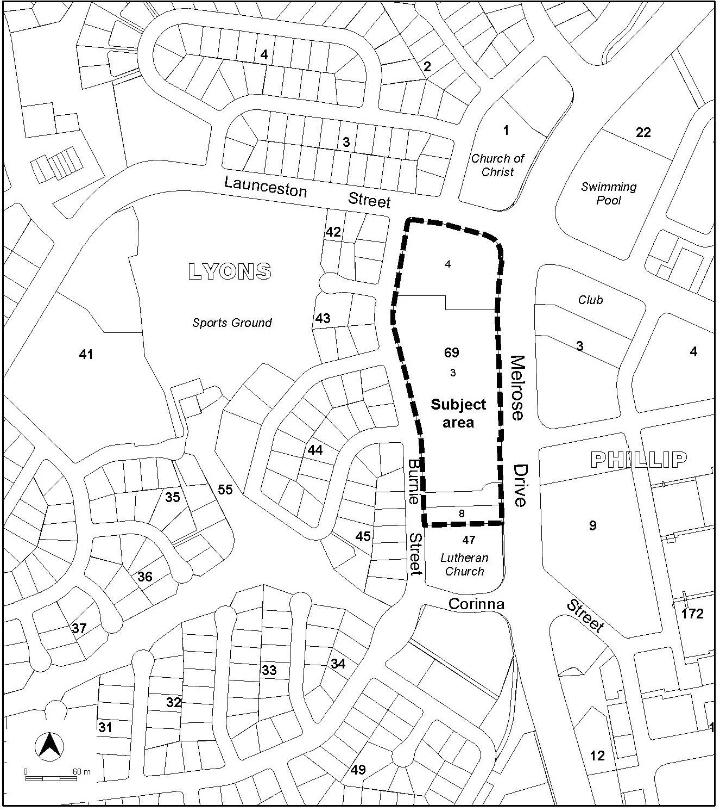

**Figure 2.2 Locality Plan/ Context**

* 1. Current Territory Plan Provisions

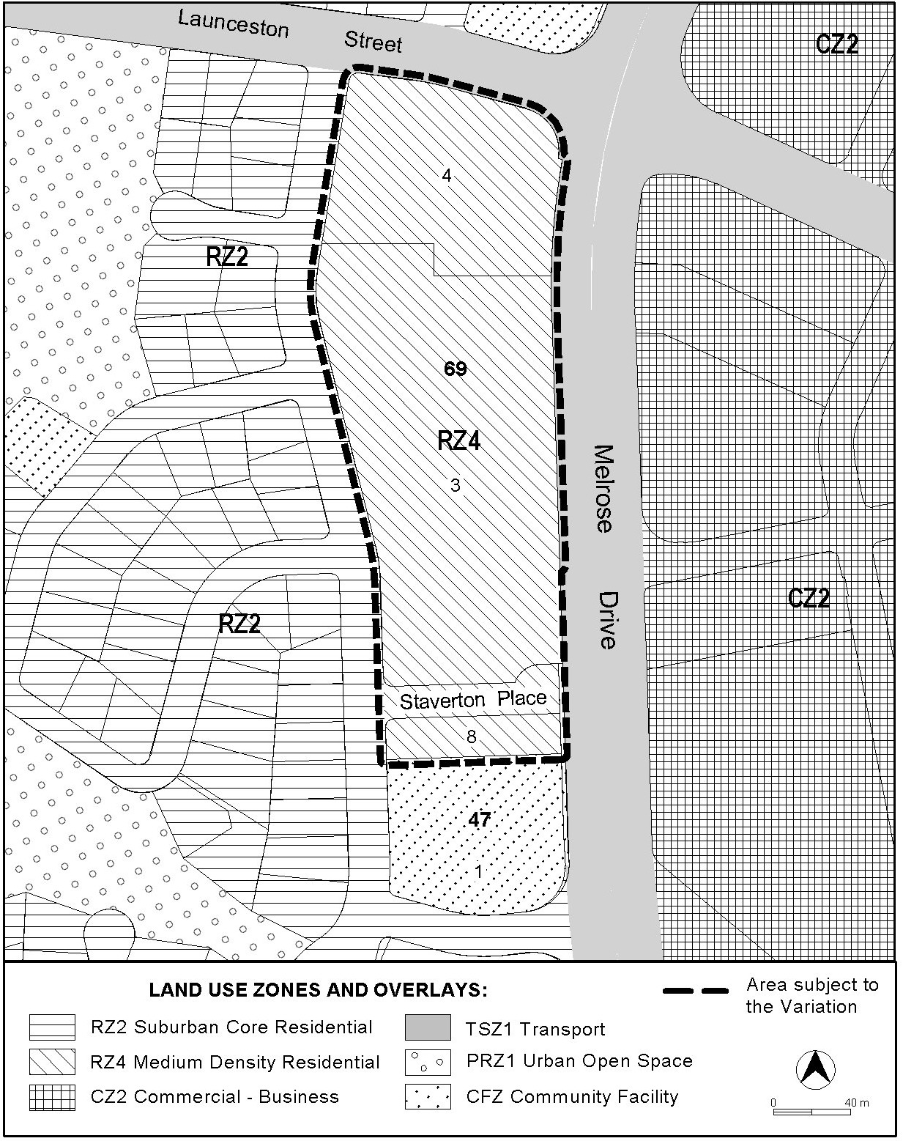

**Figure 2.3 Current Territory Plan Zones Map**

* 1. Proposed Changes
     1. Proposed Changes to the Territory Plan Map

The proposed changes to the Territory Plan map are indicated in **Figure 3.1** at Part 3 of this document and are detailed as follows:

Substitute the RZ4 zone (Medium Density Residential) with RZ5 zone (High Density Residential) over Blocks 3 and 4 Section 69 Lyons and Block 8 Section 47 Lyons.

* + 1. Proposed Changes to Territory Plan Written Statement

It is proposed to amend the Residential Zones Multi-Unit Housing Development Code Part A(5) to allow for increased building heights above three storeys up to a maximum of six storeys in all future RZ5 zones provided that specific rules or criteria are met. The variation will ensure that the redevelopment of areas in any new RZ5 zones will not compromise development on adjoining land which may be subject to alternative zoning.

The draft variation also proposes to permit a taller building height up to a maximum of ten storeys on Block 4 Section 69 Lyons on the corner of Launceston Street and Melrose Drive. This will be achieved through the inclusion of an additional Rule in the Residential Zones Multi Unit Housing Development Code Part A(5). Rule 27A (See Section 3.2 of this document) defines the dimensions for the location of the 10 storey building. Figure 2.4 below graphically depicts this height control.



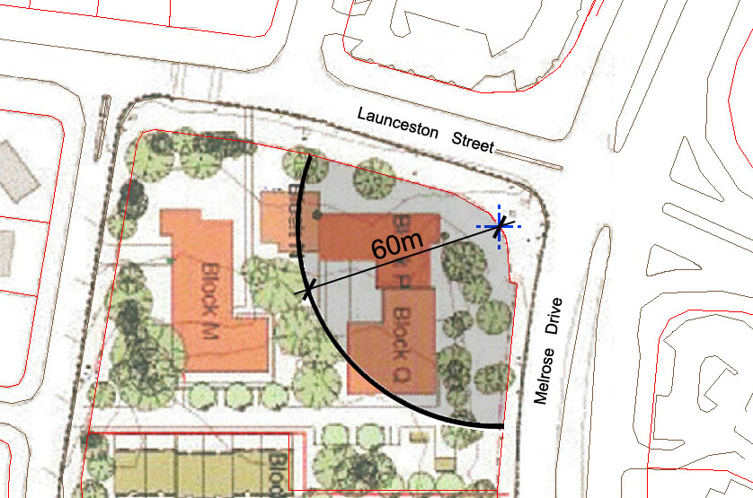

**Figure** **2.4 Block 4 Section 69 Lyons – 10 Storey 60 Metre Radius**

* 1. Reasons for the Proposed Variation

The reasons for the proposed Variation are as follows:

* Provide for a diversity of housing types and densities close to commercial (town) centres and adjacent to major transport routes to increase choice, provide opportunities for affordable housing, and encourage some intensification of development whilst maintaining residential amenity in accordance with the strategic directions of the Territory Plan.
* Facilitate the construction of a development with an appropriate bulk and scale that recognises the context and location of the site adjacent to the Woden Town Centre while taking into account the surrounding area and land uses.
* The context and importance of development along Melrose Drive has been taken into consideration given the likely scale and height of future buildings within the Woden Town Centre. Redevelopment of Commercial sites north of Launceston Street abutting Melrose Drive is expected to result in significantly increased building heights on those sites, reflecting building heights already existing across the town centre.
* By allowing for increased building heights, site coverage is reduced (less than that of the previous development), thereby maximising opportunities for open landscaped communal and recreational spaces, and for retaining a significant portion of the existing mature trees and vegetation.
* Recent traffic impact assessments, prepared during the development of the Planning Study, found that the road network will accommodate the future traffic generated once the site is fully developed.
* All resident and visitor parking associated with both the residential and retirement developments will be accommodated on site thereby mitigating the impact on surrounding local streets in terms of on-street car parking.
  1. Planning Context
     1. National Capital Plan

The *Australian Capital Territory (Planning and Land Management*) *Act 1988* established the National Capital Authority (NCA) with two of its functions being to prepare and administer a National Capital Plan and to keep the Plan under constant review and to propose amendments to it when necessary.

The National Capital Plan (NCP), which was published in the Commonwealth Gazette on 21 January 1990, is required to ensure that Canberra and the Territory are planned and developed in accordance with their national significance. The *Australian Capital Territory (Planning and Land Management*) *Act 1988* also required that a Territory Plan be prepared by a Territory Planning Authority responsible to the ACT Legislative Assembly and that the Territory is planned and developed in a manner not inconsistent with the NCP.

* + 1. Territory Plan

The proposal is consistent with the Territory Plan’s Statement of Strategic Directions in terms of Environmental, Economic and Social Sustainability and Spatial Planning and Urban Design Principles such as:

Planning policies will seek to ensure efficient use of all resources and to reduce consumption of non-renewable resources. Waste minimisation, reuse and recycling will be encouraged, whilst energy-rating and conservation measures will be applied wherever appropriate, particularly in transport, subdivision planning, and building design and construction.

In planning future development and redevelopment, particular emphasis will be placed on cost-effective provision and management of existing and new infrastructure and services, taking into account whole-of-life and whole-of-system costs, including the ecological footprint of proposed developments and activities.

Provision of affordable, adaptable and special-needs housing will be promoted throughout the city, as well as modification or redevelopment of existing stock to meet emerging social needs.

Higher density development will be encouraged within and near major centres, and in other suitable locations that are well served by public transport.

* + 1. Spatial Plan

The Spatial Plan outlines the strategic direction for growth to achieve social, environmental and economic sustainability for Canberra. It aims to intensify residential densities around the major employment centres (including town centres) and provide a greater housing choice in higher density developments.

The proposal responds to the principles of the Spatial Plan by providing higher density housing types in close proximity to employment centres while retaining ease of movement by encouraging people to use alternative modes of transport other than the private motor vehicle.

The proposal will intensify residential development around the Woden Town Centre and provide a variety of housing options and choice in the area. It will also promote the opportunities for people to ‘age in place’ within the suburb.

* + 1. Sustainable Transport Plan

The proposed development meets the broad objectives of the Sustainable Transport Plan in terms of encouraging the use of more sustainable modes of transport (such as walking, cycling and bus) in the context of the site’s location in close proximity to the Woden Town Centre and major transport corridors.

* 1. Interim Effect

The draft variation does not have interim effect and therefore section 65 of the Planning and Development Act 2007 does not apply.

The current Territory Plan will continue to apply while the variation remains in draft form.

* 1. Consultation with Government Agencies
     1. National Capital Authority

In preparing this draft plan variation the Planning and Land Authority is required under section 61(b)(i) of the *Planning and Development Act 2007* to consult with the National Capital Authority in relation to the proposed draft plan variation.

The National Capital Authority provided the following comments:

“*1. Explanatory Statement should identify the current provisions of the National Capital Plan as articulated for the Territory Plan*

*2. Section 2.6 Planning Context should represent the hierarchy of planning documents in the ACT and as such should commence with the National Capital Plan; and*

*3. The document should identify if the proposed DV is consistent or otherwise with the National Capital Plan.*

It is noted, on the information provided, that it appears the proposed DV is consistent with the National Capital Plan.”

Response

Comments have been taken into account and the draft variation document has been amended to respond to the three items listed above.

* + 1. Conservator of Flora and Fauna

In preparing this draft plan variation the Planning and Land Authority is required under section 61(b)(ii) of the *Planning and Development Act 2007* to consult with the Conservator of Flora and Fauna in relation to the proposed draft plan variation.

The Conservator made the following comments:

“*In accordance with Section 61(b) of the Planning and Development Act 2007, I advise that I have had the Draft Variation to the Territory Plan No. 288, Change from Residential RZ4 Zone to RZ5 Zone for Blocks 3 and 4 Section 69 Lyons and Block 8 Section 47 Lyons and Changes to Residential Zones Multi Unit Housing Development Code Part A(5), examined and have no comment to provide other than to note my support*”

Response:

Noted.

* + 1. Environment Protection Authority

In preparing this draft plan variation the Planning and Land Authority is required under section 61(b)(iii) of the *Planning and Development Act 2007* to consult with the Environment Protection Authority in relation to the proposed draft plan variation.

The Environment Protection Authority provided the following comments:

*“In accordance with Section 61(b) of the Planning and Development Act 2007, I advise that I have had the Draft Variation to the Territory Plan No. 288, Change from Residential RZ4 Zone to RZ5 Zone for Blocks 3 and 4 Section 69 Lyons and Block 8 Section 47 Lyons and Changes to Residential Zones Multi Unit Housing Development Code Part A(5), examined and have no comment to provide other than to note my support.”*

Response

Noted.

* + 1. Heritage Council

In preparing this draft plan variation the Planning and Land Authority is required under section 61(b)(iv) of the *Planning and Development Act 2007* to consult with the Heritage Council in relation to the proposed draft plan variation.

The Heritage Council provided the following comments:

The Variation does not “raise any heritage concerns, and consequently the Heritage Council has no further comment.”

Response

Noted.

3. DRAFT PLAN VARIATION

3.1 Variation to the Territory Plan Map

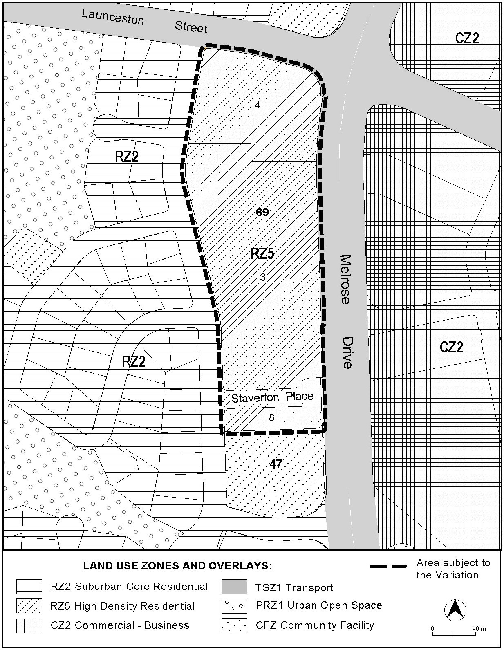

**Figure 3.1 Changes to Territory Plan Map**

3.2 Variation to the Territory Plan Written Statement

Amend the Residential Zones Multi-Unit Housing Development Code Part A(5) Element 2 Item 2.1 Height to substitute new R25 Rule wording and insert new C25 Criteria to read as follows:

|  |  |
| --- | --- |
| Rules | Criteria |
| 2.1 Height | |
| R25   1. The height of any building within 50 m of the boundaries of blocks in the RZ1, RZ2 and RZ3 zones and within 40 m of the CFZ, PRZ1 or PRZ2 zones does not exceed 3 storeys. 2. The height of any building elsewhere on the block does not exceed 6 storeys or 4 storeys where a building is adjacent to development in an RZ4 zone.   Note:  1. Roof top plant that is set back and screened from the street is not included in the maximum number of storeys.  2. Buildings may also include a basement and/ or an attic in addition to the specified number of storeys referred to above.  Exception: Area specific height restrictions apply to:   * Kingston/ Griffith (see Rule R26 and Criterion C26A). * Belconnen Section 66; Section 67 Block 3 and part Block 2; Section 88 part Block 1; and Section 55 Block 37 (see Criteria C27). * Block 4 Section 69 Lyons (see Rule 27A) | C25  Building heights comply with all of the following:   1. are compatible with existing or future desired character of adjacent development; 2. are appropriate to the scale and function of the use; 3. minimise detrimental impacts on the character of adjacent residential zones by limiting overshadowing, maximising access to sunlight and ensuring that the height, scale, setbacks and built form establish an appropriate visual streetscape character; 4. do not prevent the solar access requirements of existing or future development on adjoining residential land being achieved (Solar access requirements are set out in the Single Dwelling Housing Development Code and/or the Multi Unit Housing Development Code whichever is applicable (see Element 5 of Part C(1) of those codes). |

And,

Amend the Residential Zones Multi-Unit Housing Development Code Part A(5) Item 2.1 Height to insert new R27A Rule wording to read as follows:

|  |  |
| --- | --- |
| Rules | Criteria |
| 2.1 Height | |
| R27A  On Block 4 Section 69 Lyons within a 60m radius of the midpoint of the curve of the property boundary at the intersection of Melrose Drive and Launceston Street, the maximum building height does not exceed 10 storeys. | There is no applicable criterion. |

**Interpretation service**

