Australian Capital Territory

Planning and Development (Plan Variation No 288) Notice 2009

Notifiable Instrument NI2009 – 391

made under the

Planning and Development Act 2007, section 76 (3)

**1 Name of instrument**

This instrument is the *Planning and Development Act 2007* *(Variation No 288)* *Notice 2009*.

**2 Plan Variation No 288**

On 11 August 2009, the Minister for Planning approved a draft of the attached plan variation under s 76 (3).

Kelvin Walsh

Delegate of the Planning and Land Authority

14 August 2009



Planning & Development Act 2007

**Variation to the**

**Territory Plan**

**No. 288**

Changes to Residential Zones Multi Unit Housing Development Code Part A(5) and Residential Zone Changes for Blocks 3 and 4 Section 69 Lyons and Block 8 Section 47 Lyons

August 2009

**Table of Contents**

1. EXPLANATORY STATEMENT 3

1.1 Background 3

1.2 Summary of the Proposal 5

1.3 National Capital Plan 6

1.4 Site Description 6

1.5 Current Territory Plan Provisions 8

1.6 Proposed Changes 9

1.7 Consultation on the exhibited Draft Variation 10

1.8 Revisions to the Exhibited Draft Variation 10

2. VARIATION 11

2.1 Variation to the Territory Plan Map 11

2.2 Variation to the Territory Plan Written Statement 12

1. EXPLANATORY STATEMENT
   1. Background

**(a) Residential Zones Multi Unit Development Code Changes**

The proposed increased height limits for the Lyons Estate Redevelopment on Blocks 3 and 4 Section 69 Lyons was the catalyst for the ACT Planning and Land Authority to take the opportunity to review height limits for the Residential RZ5 zone (High Density Residential) in the Territory Plan. The Residential Zones Multi Unit Housing Development Code currently restricts the height of buildings in the RZ5 zone to a maximum of three storeys which is the same height limit applied to RZ4 zones. However some existing RZ5 zones in Kingston/Griffith and Belconnen allow for increased heights above the three storey limit subject to meeting specific Rules or Criteria that apply to those sites.

Although it is not proposed to change the building height restrictions that apply to existing RZ5 zones, it is proposed to include a new building height policy in the Territory Plan that would apply both to the subject site in Lyons and to future RZ5 zones, if and when they are to be identified. The identification of future RZ5 zones, if and when this were to occur, would be based on principles set out in the Territory’s Spatial Plan such as proximity to commercial (town) centres, major transport routes and major employment. This is in keeping with the Government’s policies on encouraging a more compact city through residential densification in appropriate locations where close to significant employment generators and service providers, and where sustainable modes of transport such as walking, commuter cycling and public transport could be readily utilised by residents in these areas.

It is proposed to amend the Residential Zones Multi Unit Housing Development Code Part A(5) to permit increased building heights in RZ5 areas provided that specific rules or criteria are addressed. These take into account surrounding development where any proposed development must not result in significant detrimental impacts on adjacent uses and/or residents.

Existing RZ5 zones as detailed in the Multi Unit Housing Development Code have their own specific height policies which will not be changed by this variation.

Any areas proposed to be zoned RZ5 in the future will be required to go through the rigorous Territory Plan Variation process to determine the suitability and appropriateness of such a change.

**(b) Lyons Estate Redevelopment**

The site of the Lyons Estate Redevelopment Proposal (Blocks 3 and 4 Section 69 Lyons – see Figure 1.2 Locality Plan) was originally developed during the mid 1970’s to initially accommodate the shortage of housing and consisted of 264 units, mainly single bed-sitters, and was commonly known as “Burnie Court”. Due to a range of management issues, a decision was made to demolish the complex which was carried out in 2001.

Proposed development options for the site have been through a series of revisions since the demolition of Burnie Court. A master plan was prepared in 2001 and in 2003 the Commissioner for Housing offered a portion of the subject site (formerly known as Block 1 Section 68) for sale in accordance with the development conditions set out in the master plan. The land was passed in at auction, as it did not meet the reserve price.

Following reconsideration it was decided to release all the land for sale and the blocks were to be amalgamated, the result being Blocks 3 and 4 Section 69 Lyons.

In 2004, the sale process for the former Burnie Court site commenced and in 2005 this was finalised with Hindmarsh being announced as the preferred tenderer for the site. A Joint Venture has been established between Hindmarsh Living and the Commissioner for Housing for the development of the site.

A number of revisions to the design concepts have been prepared in consultation with ACTPLA and the community to determine how best to develop the site. The preferred concept plan developed by the Joint Venture partners as outlined in the latest version of the planning study proposed increases in building heights beyond the three storey maximum allowed under the existing RZ4 Medium Density Residential Zone. The Lyons Estate Redevelopment Planning Study November 2007 is available on the ACTPLA website along with the draft variation document at: <http://www.actpla.act.gov.au/topics/your_say>

The proposal is to vary the Territory Plan to facilitate the construction of a residential/retirement development that allows for four to six storeys for that part of the site abutting Melrose Drive and the northern portion of the site, with a maximum of 10 storeys on the corner of Melrose Drive and Launceston Street. The retirement component is contained on Block 3 and will be a maximum of four to six storeys and the non-retirement residential component of the redevelopment will be contained on Block 4 and comprise of a number of apartment buildings ranging in height from four to ten storeys, with the ten-storey element providing a focal point addressing the entrance to the Woden Town Centre at the intersection of Melrose Drive and Launceston Street (See **Figure 1.1 Concept Plan** for building heights across the site). The proposal, with buildings stepping down towards the suburb of Lyons, is designed to retain an appropriate streetscape on Burnie Street and to the adjoining RZ2 Suburban Core Zone. The remainder of the retirement component on Block 3 up to three storeys in height is compliant with the current Territory Plan provisions and a Development Application was approved on 11 April 2008 by the Authority for this first stage of the development. Blocks C-H as shown in **Figure 1.1 Concept Plan** form part of Stage 1 of the redevelopment.

A portion (approximately 12 units) of the residential component will be purchased and managed by a community housing provider. This is in addition to the 24 public housing retirement units (Freycinet) that have been built on the southern most block (Block 8 Section 47 Lyons) adjacent the Lutheran church. Block 8 Section 47 Lyons, although recently redeveloped with the Freycinet complex with no intention by Housing ACT to increase the height of the building, has also been included in the change to the RZ5 zoning to ensure consistency of zoning across the entire former Burnie Court site.



**Figure 1.1 Concept Plan Blocks 3 and 4 Section 69 Lyons**

* 1. Summary of the Proposal

The draft variationproposes height limits of up to 6 storeys in the Residential High Density Zone (RZ5) controls contained within the Residential Zones Multi Unit Housing Development Code Part A(5). The draft variation also proposes to allow a maximum of ten storeys in height within a 60 metre radius of the corner of Melrose Drive and Launceston Street via a site specific rule. All existing RZ5 Zones will retain current height restrictions via site specific controls. A zoning change is proposed for Blocks 3 and 4 Section 69 Lyons and Block 8 Section 47 Lyons from RZ4 (Residential Medium Density Zone) to RZ5 (Residential High Density Zone). The anticipated range of heights across the site is depicted in the concept plan at **Figure 1.1**.

* 1. National Capital Plan

Under the National Capital Plan the subject site falls within the Urban Area classification and is located adjacent to a Town Centre (Woden). Under Section 4.4 Policies for Urban Areas in the National Capital Plan sub-section (b) states that:

“The planning of urban areas should seek to introduce measures through which urban consolidation may occur”

It is considered that the changes proposed in the draft Variation by encouraging intensification of residential development in RZ5 (High Density Residential) Zones will support this policy and is therefore consistent with the provisions of the National Capital Plan.

* 1. Site Description

**Lyons Estate Redevelopment**

The site lies in the suburb of Lyons, and directly adjacent to the Woden Town Centre which is to the east of the subject site, separated by Melrose Drive, a major arterial road that links Woden to Civic via Yarra Glen/ Adelaide Avenue.

The site is within walking distance of the Woden Town Centre which is accessible via a signalised pedestrian crossing at the intersection of Melrose Drive and Launceston Street, and via a pedestrian underpass south of Corinna Street.

To the west of the site on the opposite side of Burnie Street are residential dwellings, generally single storey in height, within the RZ2 Suburban Core Zone. To the north of Block 4 Section 69 Lyons is a Church of Christ on Community Facility (CFZ) land and to the south of Block 8 Section 47 Lyons is a Lutheran Church also on Community Facility land. The site and the locality are shown in **Figure 1.2**.

The Lyons local shopping centre is within walking distance of the site, and the suburb also contains access to facilities such as the Primary School and childcare centre and the Lyons oval.

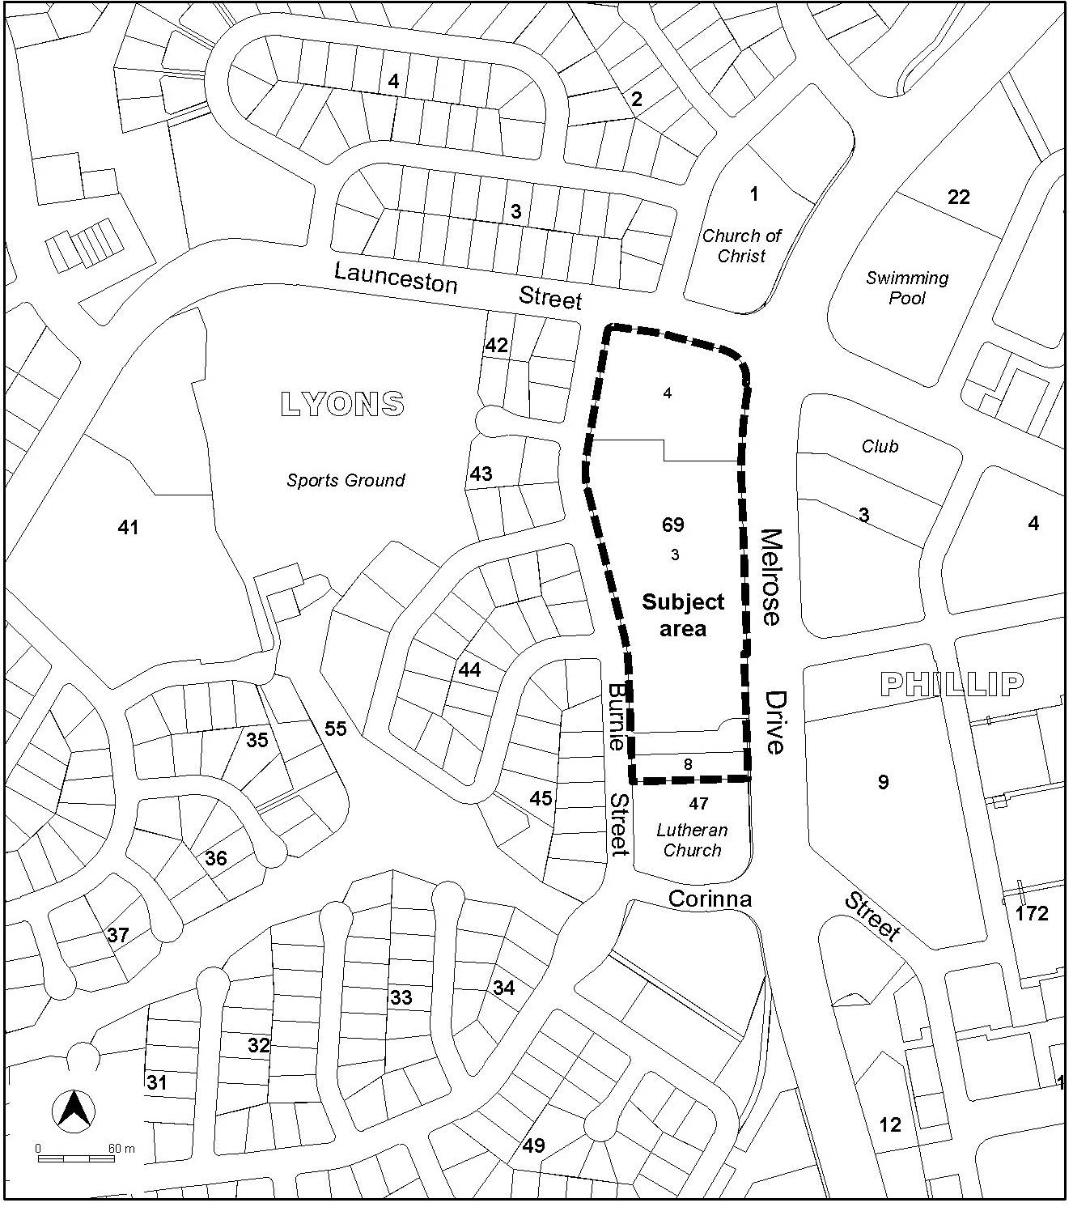

**Figure 1.2 Locality Plan/ Context**

* 1. Current Territory Plan Provisions

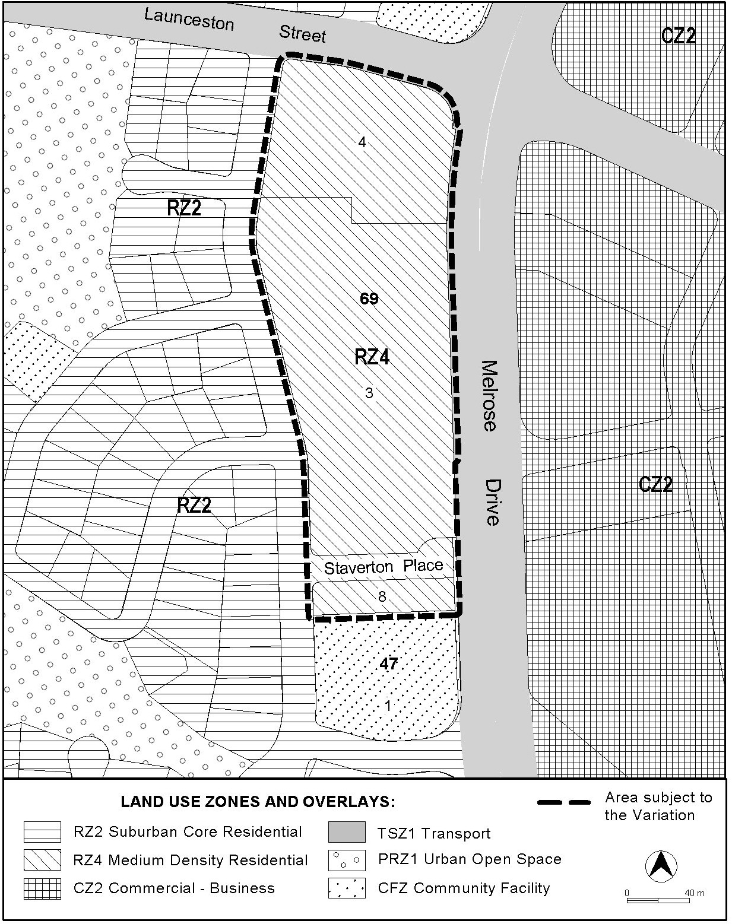

**Figure 1.3 Current Territory Plan Zones Map**

* 1. Proposed Changes
     1. Proposed Changes to the Territory Plan Map

The proposed changes to the Territory Plan map are indicated in **Figure 2.1** at Part 2 of this document and are detailed as follows:

* Substitute the RZ4 zone (Medium Density Residential) with RZ5 zone (High Density Residential) over Blocks 3 and 4 Section 69 Lyons and Block 8 Section 47 Lyons.
  + 1. Proposed Changes to Territory Plan Written Statement

It is proposed to amend the Residential Zones Multi Unit Housing Development Code Part A(5) to allow for increased building heights above three storeys up to a maximum of six storeys in all future RZ5 zones provided that specific rules or criteria are met. The variation will ensure that the redevelopment of areas in any new RZ5 zones will not compromise development on adjoining land which may be subject to alternative zoning.

The draft variation also proposes to permit a taller building height up to a maximum of ten storeys on Block 4 Section 69 Lyons on the corner of Launceston Street and Melrose Drive. This will be achieved through the inclusion of an additional Rule in the Residential Zones Multi Unit Housing Development Code Part A(5). Rule 27A (See Section 3.2 of this document) defines the dimensions for the location of the ten storey building. Figure 2.4 below graphically depicts this height control.

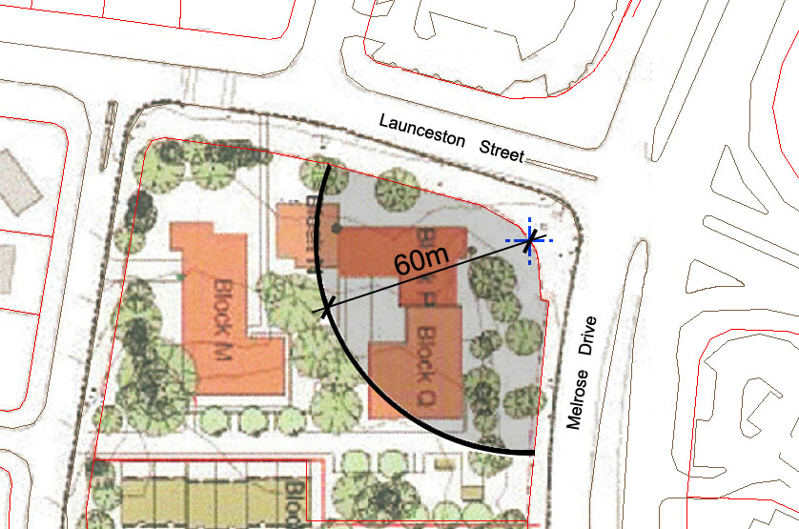

**Figure 1.4 Block 4 Section 69 Lyons – Ten Storey 60 Metre Radius**

* 1. Consultation on the exhibited Draft Variation

The draft Variation was released for public comment from 4 July 2008 to 11 August 2008. At the end of the consultation period, a total of 34 written submissions were received. Among the submissions, 29 submissions were from individuals, three from organisations, one from the Woden Valley Community Council and one petition was signed by 53 people. A total of 40 issues were raised during the public consultation. However, many of these issues relate to a number of key concerns regarding:

* the proposed increase in the height of buildings from four storeys to six storeys across the site with a ten storey building proposed on the corner of Melrose Drive and Launceston Street;
* the need for tall buildings outside the town centre and the precedence this may set regarding additional tall buildings in the surrounding areas of Lyons;
* the lack of transition between single storey dwellings surrounding the site and the six and ten storeys on the site and the impact that could have on the character of Lyons;
* the poor design and proposed location of the taller buildings on site in relation to overshadowing and passive solar access for other dwellings on the site, privacy and possible wind tunnel effects;
* the poor sustainability performance of tall buildings in terms of the carbon footprint and resource consumption as well as in relation to affordability and the social suitability of such buildings as retirement dwellings;
* consultation issues relating to access to the Planning Report for public consultation;
* concerns about the consistency and accuracy of information provided by the proponent relating to building heights on the site; and
* potential pedestrian safety and traffic and parking impacts on local streets which already suffer congestion during peak times.
  1. Revisions to the Exhibited Draft Variation

The following revisions were made to the draft variation as a result of the Standing Committee on Planning, Public Works and Territory and Municipal Services Report No. 2.

* The key revision is the incorporation of part (e) to criterion number 25, to protect the solar access requirements of development on the same land.

2. VARIATION

2.1 Variation to the Territory Plan Map

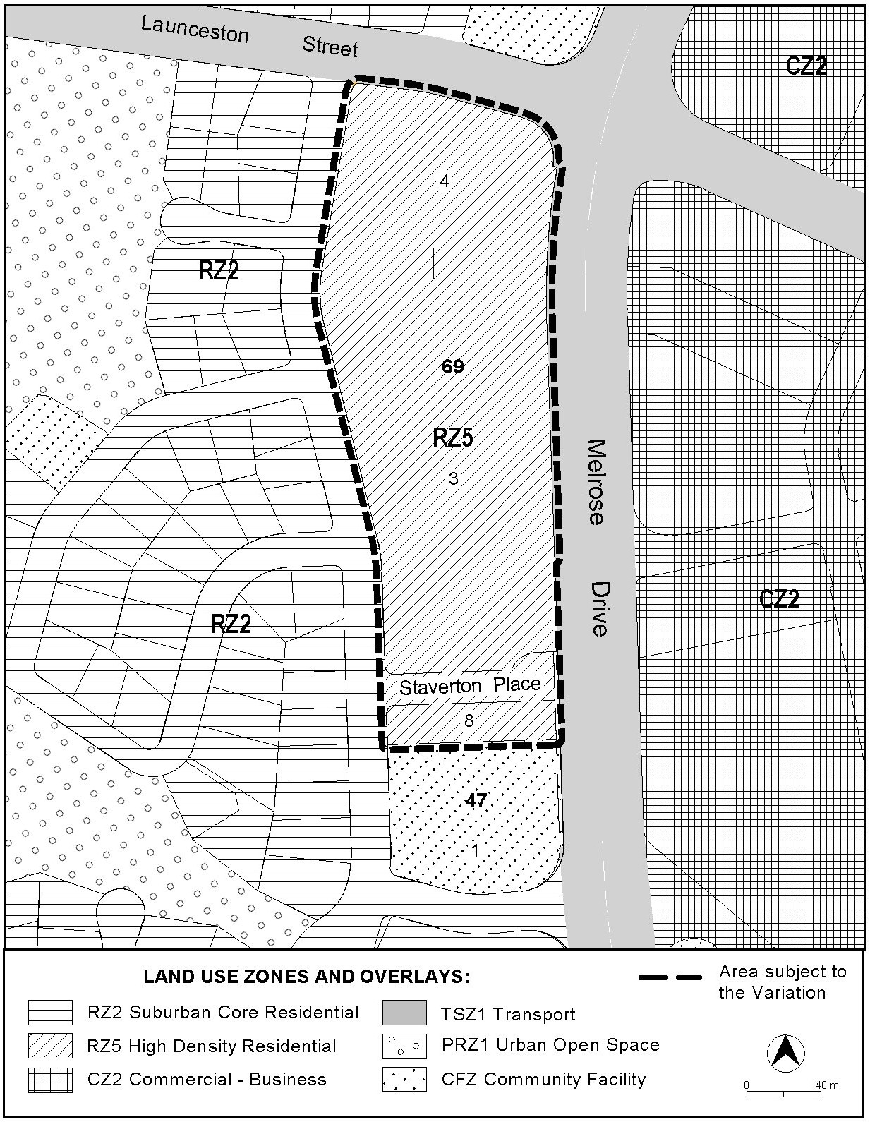

**Figure 2.1 Changes to Territory Plan Map**

2.2 Variation to the Territory Plan Written Statement

Amend the Residential Zones Multi Unit Housing Development Code Part A(5) Element 2 Item 2.1 Height to substitute new R25 Rule wording and insert new C25 Criteria to read as follows:

|  |  |
| --- | --- |
| **Rules** | **Criteria** |
| **2.1 Height** | |
| R25   1. The height of any building within 50 m of the boundaries of blocks in the RZ1, RZ2 and RZ3 zones and within 40 m of the CFZ, PRZ1 or PRZ2 zones does not exceed 3 storeys. 2. The height of any building elsewhere on the block does not exceed 6 storeys or 4 storeys where a building is adjacent to development in an RZ4 zone.   Note:  1. Roof top plant that is set back and screened from the street is not included in the maximum number of storeys.  2. Buildings may also include a basement and/ or an attic in addition to the specified number of storeys referred to above.  Exception: Area specific height restrictions apply to:   * Kingston/ Griffith (see Rule R26 and Criterion C26A). * Belconnen Section 66; Section 67 Block 3 and part Block 2; Section 88 part Block 1; and Section 55 Block 37 (see Criteria C27). * Block 4 Section 69 Lyons (see Rule 27A) | C25  Building heights comply with all of the following:   1. are compatible with existing or future desired character of adjacent development; 2. are appropriate to the scale and function of the use; 3. minimise detrimental impacts on the character of adjacent residential zones by limiting overshadowing, maximising access to sunlight and ensuring that the height, scale, setbacks and built form establish an appropriate visual streetscape character; 4. do not prevent the solar access requirements of existing or future development on adjoining residential land being achieved (Solar access requirements are set out in the Single Dwelling Housing Development Code and/or the Multi Unit Housing Development Code whichever is applicable (see Element 5 of Part C(1) of those codes);   e) do not prevent the solar access requirements of any existing development on the same parcel of land being achieved (see Element 5 Part C5 of the Multi Unit Housing Development Code). |

And,

Amend the Residential Zones Multi Unit Housing Development Code Part A(5) Item 2.1 Height to insert new R27A Rule wording to read as follows:

|  |  |
| --- | --- |
| **Rules** | **Criteria** |
| **2.1 Height** | |
| R27A  On Block 4 Section 69 Lyons within a 60m radius of the midpoint of the curve of the property boundary at the intersection of Melrose Drive and Launceston Street, the maximum building height does not exceed 10 storeys. | This is a mandatory requirement. There is no applicable criterion. |

**Interpretation service**

