Australian Capital Territory
Planning and Development (Technical Amendment—Single Dwelling Housing Development Code) Plan Variation 2009 (No 1)
Notifiable instrument NI2009- 488
Technical Amendment Number 2009-24
made under the
Planning and Development Act 2007, section 89 (Making technical amendments)

This plan variation commences on 2 October 2009.

Variation 2009-24 to the Territory Plan has been approved by the Planning and Land Authority.

Kelvin Walsh
Delegate of the Planning and Land Authority

30 September 2009

ANNEXE A
FINAL PLAN VARIATION 2009-24

Planning & Development Act 2007

Technical Amendment
to the Territory Plan

Code Variation
2009-24

Amendments to the
Single Dwelling Housing Development Code

October 2009

Table of Contents
1 . INTRODUCTION 1
Outline of the process 1
2 . EXPLANATORY STATEMENT 1
Introduction 1
Proposed Changes and Reasons 2
3. TECHNICAL AMENDMENT 3
Variation to the Single Dwelling Housing Development Code 3

- . INTRODUCTION
Outline of the process
The Commonwealth’s Australian Capital Territory (Planning and Land Management) Act 1988 allows for the Legislative Assembly to make laws to establish a Territory Planning Authority and for that Authority to prepare and administer a Territory Plan.
The Planning and Development Act 2007 (the Act) establishes the ACT Planning and Land Authority as the Authority which prepares and administers the Territory Plan, including continually reviewing and proposing amendments as necessary.
Technical amendments to the Territory Plan are prepared in accordance with the Act.
A code variation is a technical amendment that
- would only change a code; and
- is consistent with the policy purpose and policy framework of the code; and
- is not an error variation.
Following the release of the code variation under section 90 of the Act, submissions from the public are invited. At the conclusion of the limited consultation period, any representations are considered by the ACT Planning and Land Authority (the Authority). The Authority then determines a day when the code variation is to commence by way of a Commencement Notice.

- . EXPLANATORY STATEMENT
Introduction
The technical amendment introduces a new Part C(4) – Single Dwelling Housing – Mid Sized Blocks (>250 – 500m²) in New Estates into the single dwelling housing development code. Part C(4) of the code provides additional controls to, or controls that are to be applied in lieu of those in Parts A and C(1) for single dwellings. Part B of the code also applies.
Part C(4) introduces provisions for front setbacks, side setbacks and rear setbacks of single dwelling housing on midsized blocks. It also guides the design and siting of courtyard walls and private open space on midsized blocks.
In addition to Part C(4), the technical amendment makes provision for residential blocks of any size where identified in a concept plan (precinct code) to comply, as necessary, with the relevant bushfire provisions of the Building Code of Australia.
Provision is also made for surveillance blocks where identified in a concept plan (precinct code) to ensure that there are habitable rooms with windows overlooking the rear lane.
There are also a number of other related minor amendments to the single dwelling housing development code to ensure that it is updated to reflect the introduction of the new Part C(4).
Proposed Changes and Reasons
The residential and subdivision codes of the Territory Plan are currently under review. In the mean time there is a need to continue to assess and decide estate development plans for new estates.
Some 40% of residential blocks in new estates fall into the midsized block range (>250 – 500m²). This reflects a general shift towards smaller residential blocks in order to improve housing efficiency and to increase housing choice.
The existing Territory Plan provisions were designed to accommodate predominantly standard residential blocks greater than 500m ². In
March 2008, the compact block provisions were introduced to accommodate blocks 250m² or less. The proposed technical amendment deals with blocks greater than 250m² up to and including blocks of 500m².
The intent of the technical amendments is to provide a greater opportunity for single dwellings on midsized blocks to be exempt from requiring development approval whilst still retaining residential amenity and increased housing choice.
The midsized block provisions contained in Part C(4) will be reviewed as part of the broader review of the residential and subdivision codes. This may result in changes to these provisions in the future.
The exhibited draft Technical Amendment for midsize blocks and other amendments to the Single Dwelling Housing Development Code attracted six submissions, including two late submissions which were granted extensions of time. The provisions were amended as a result of the submissions.

3. TECHNICAL AMENDMENT
Variation to the Single Dwelling Housing Development Code

1 Introduction Structure of codes
Add the following dot point after the dot point for Part C(3):

- Part C(4) Single dwelling housing – Mid Sized Blocks (>250 – 500m²) in New Estates provide the controls for single dwelling housing on residential blocks with a site area of greater than 250m² up to and including 500m² in new estates.

2 Part B – Additional Items 2.7 Bushfire and 2.8 Blocks between 500m² and 550m²
Insert the following additional Item 2.7 Rule 18A after Rule 18 item 2.6 Plot Ratio:

2.7 Bushfire
R20A  Where identified in a Precinct Code or Lease and Development Conditions as being within a bushfire prone area buildings are to be constructed in accordance with the relevant BCA bushfire provisions. | This is a mandatory requirement. There is no applicable criterion.
2.8 Blocks between 500m² and 550m²
R20B  Where identified in a Precinct Code blocks from 500m² up to 550m² will be subject to Part C(4) Single Dwelling Housing – Midsized Blocks (>250 – 500m²) in New Estates. Rules and Criteria of Part C(1) still apply to these blocks where relevant. | This is a mandatory requirement. There is no applicable criterion.

3 Part C – Development Type Controls

Substitute the first two paragraphs of the preamble with the following wording:

This part of the Code provides the controls for single dwelling housing. It is divided into four sub-parts.

Part C(1) Single Dwelling Housing provide the controls for single dwelling housing in all residential zones, except where provided for by Parts C(2), C(3) or C(4). Part C(1) also applies to the commercial zones and the rural zone. As such, it is the default position for single dwelling housing.

Insert the following additional sentence at the end of the preamble:

Part C(4) provide the controls for single dwelling housing on residential blocks with a site area of greater than 250m² up to and including 500m² in new estates.

4 Part C(1) – Single Dwelling Housing

Substitute the first sentence of the preamble with the following:

This part of the code applies to development applications for single dwelling housing in all residential zones, except where provided for by Parts C(2), C(3) or C(4).

5 Part C(1) Additional Item 2.5 Surveillance Blocks

Insert the following additional Item 2.5 Rule 32B after rule 32A item 2.4 Allowable Encroachments.

2.5 Surveillance Block
32B  Where identified in a Precinct Code as being a surveillance block provide habitable room(s) above the garage with windows facing and overlooking the rear lane. | This is a mandatory requirement. There is no applicable criterion.

6 Part C(3) Additional item 2.7 Surveillance Blocks

Insert the following additional Item 2.7 Rule 65A after Rule 65 item 2.6 Side Setbacks – Corner Blocks

2.7 Surveillance Block
65A  Where identified in a Precinct Code as being a surveillance block provide habitable room(s) above the garage with windows facing and overlooking the rear lane. | This is a mandatory requirement. There is no applicable criterion.

7 Additional Part C(4) – Single Dwelling Housing – Midsized Blocks
(>250 – 500m²) in New Estates

Insert the following new Part C(4) after Part C(3)

Part C(4) - Single Dwelling Housing – Midsized Blocks (>250 – 500m²) in New Estates
This part of the Code applies to development applications for single dwelling housing on residential midsized blocks >250m² and up to and including 500m² in new estates.
This part of the code provides additional controls to, or controls that are to be applied in lieu of, those in Parts A and C(1) for single dwellings. Part B of the Code also applies.
Residential midsized blocks aim to increase the range of housing alternatives in new estates to meet the diverse housing requirements of the Canberra community.

Element 2: Building and Site Controls
- Intent:
a) To ensure buildings complement the built form, siting and scale of surrounding properties and are of an appropriate residential character
b) To ensure buildings are designed and sited to:
i) Provide privacy between neighbours and between occupants and the public
ii) Provide adequate light and natural ventilation between dwellings
iii) Contribute to attractive streetscapes

Rules | Criteria
2.1 Building Envelope (Replaces Part A R3, R6, R9 & R11)
R81  Buildings are sited wholly within the building envelope (Refer Figure A4) defined by:  a) Boundaries that are the north facing boundary of an adjoining residential block:  i) within the primary building zone (PBZ), planes projected at 45 degrees above horizontal from a height of 2.0m above natural ground level at the side boundary, up to a maximum building height of 8.5m above natural ground level, or  where a wall is located on this boundary, planes projected at 30 degrees above the horizontal from a height of 3.0m above natural ground level of the boundary up to a maximum height of 8.5m above the natural ground level.  ii) within the rear zone (RZ), planes projected at 30 degrees above horizontal from a height of 2.0m above natural ground level at the side and rear boundary, up to a maximum of 8.5m above natural ground level.  (b) for all other side and rear boundaries:  i) within the primary building zone (PBZ), planes projected at 45 degrees above the horizontal from a height of 4.5m above natural ground level at the side boundary, up to a maximum building height of 8.5m above natural ground level  ii) within the rear zone (RZ), planes projected at 30 degrees above the horizontal from a height of 3.5m above natural ground level at the side boundary, up to a maximum building height of 8.5m above natural ground level. | C81  The built form does not adversely impact on the amenity of neighbouring properties by ensuring:  a) sufficient spatial separation between adjoining developments  b) the protection of a reasonable amount of privacy and solar access to adjacent dwellings and their associated private open space.

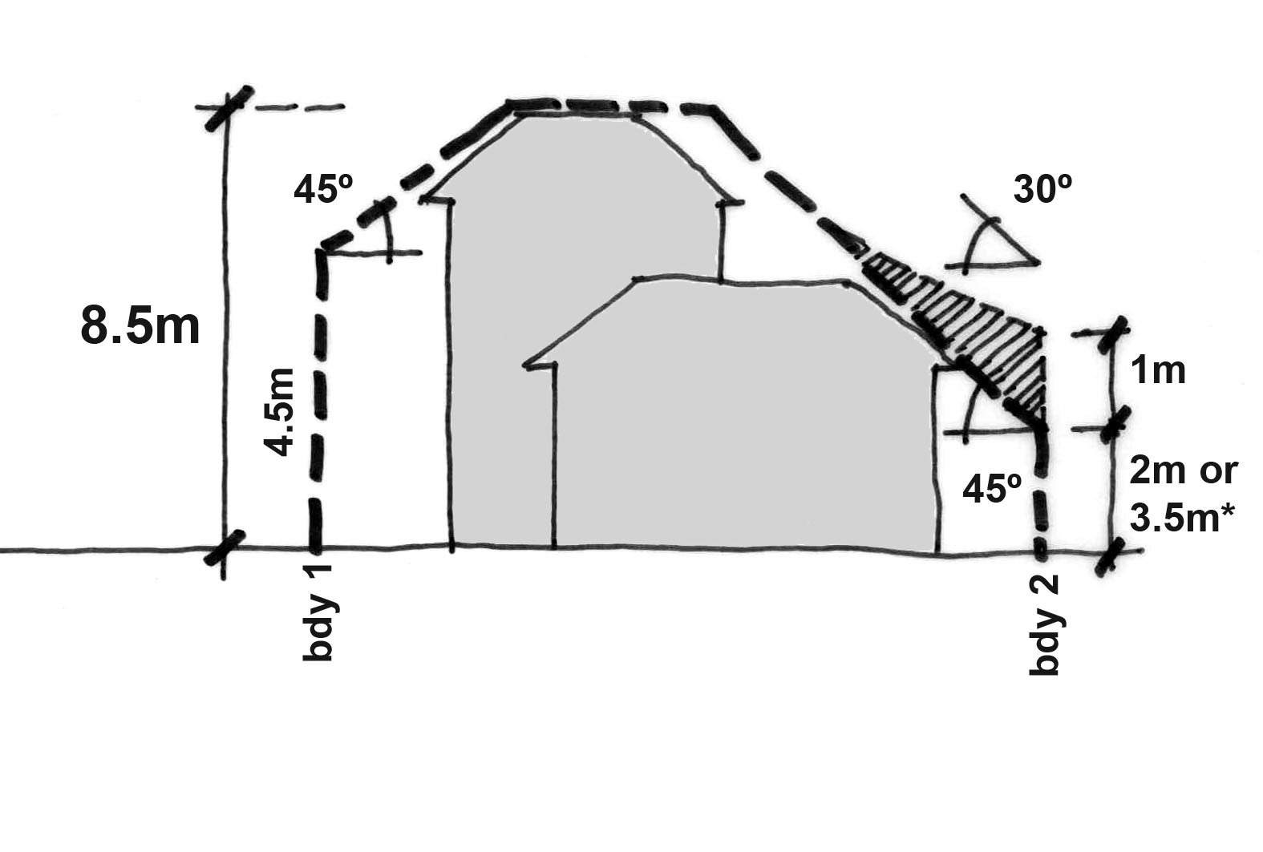  Within the Primary Building Zone  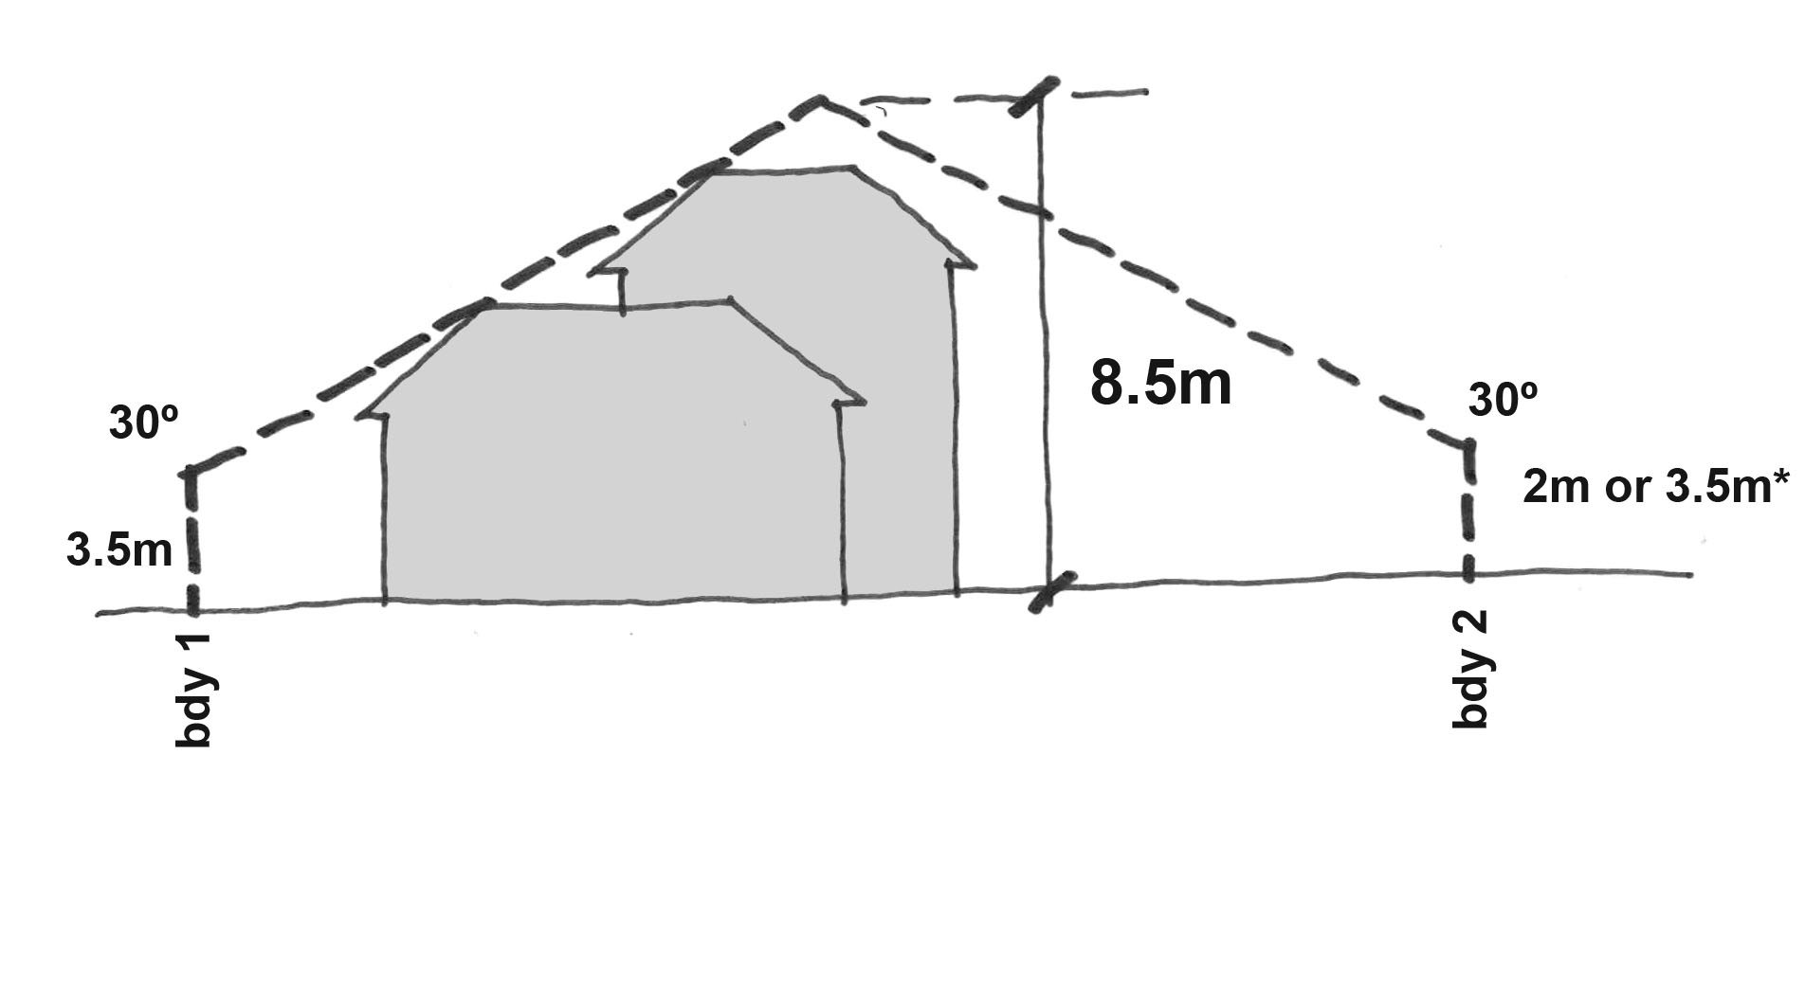  Within the Rear Zone | 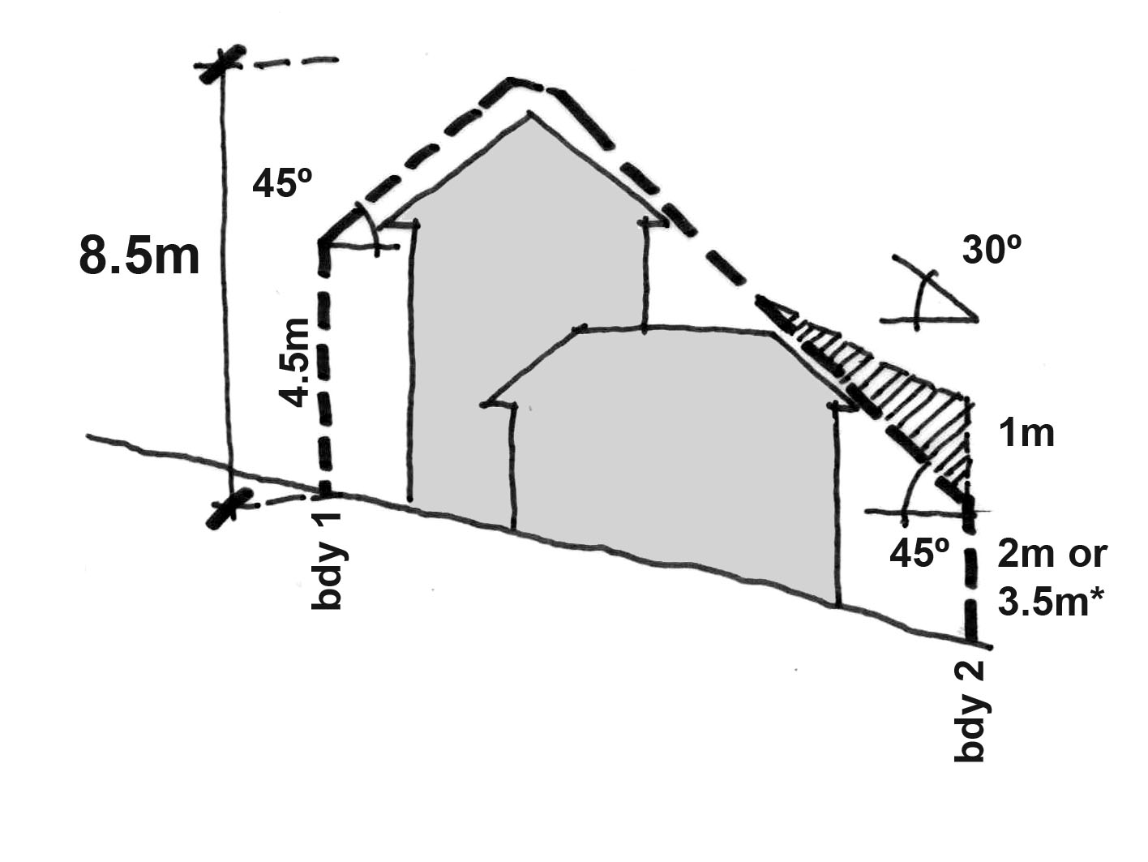  Within the Primary Building Zone  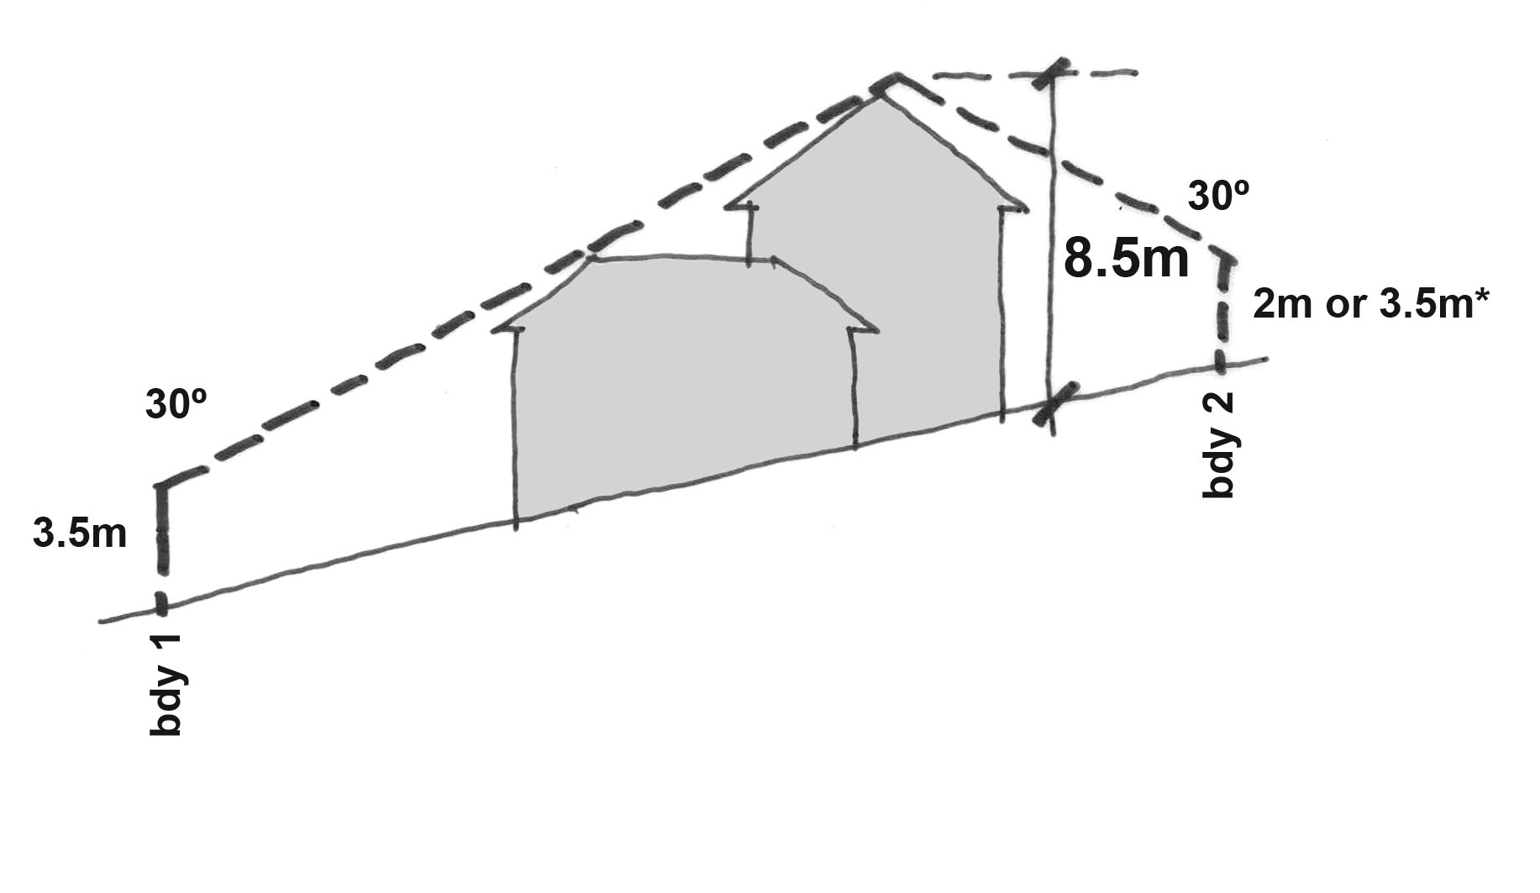  Within the Rear Zone
Flat Site | Sloping Site
Figure A4 Building Envelope

*2 metres where the boundary is a north facing boundary of an adjoining residential block.
/// Hatched area indicates permissible encroachment under rule R81 a. i) for a garage, non-habitable room or habitable room with a cavity wall.

Rules | Criteria
2.2 Front setback (Replaces R30)
R82  Minimum front setbacks as specified in Table 1:  Articulation elements are permitted to encroach a maximum of 1m into the minimum front setback provided they do not contribute to the calculation of Gross Floor Area (GFA)*. | C82  The front setback:  a) reflects the existing or proposed streetscape character  b) provides for the most efficient use of the site  c) will not significantly compromise the amenity of residents of the proposed building and residents of adjoining and adjacent dwellings  d) is related to the height of the building and to the width of the street to ensure pedestrian scale at street level  e) space is provided for street trees to grow to maturity  f) parking and garages do not dominate the frontage of the development.
* Articulation elements can include verandahs, porches, awnings, shade devices, pergolas and the like (a carport is not considered an articulation element)

Table 1 – Front Boundary Setbacks (Refer Figures C5 – C7)
 | Front boundary including short front boundary of corner block | Long front boundary of a corner block | Rear lane front boundary of a rear loading block*
Lower Floor Level & Upper Floor Level  (LFL & UFL) | 4.0m | 3.0m | 0m
Garage / Carport | 5.5m with a minimum of 1.5m behind the front building line | 5.5m with a minimum of 1.5m behind the front building line | 0m
Garage / Carport | 5.5m where there is a courtyard wall in the front zone of the block | 5.5m where there is a courtyard wall in the front zone of the block | 0m
* provided the rear lane width accommodates vehicular access and egress to and from the rear loading block and appropriate sightlines are achieved in accordance with A2890.1 The Australian Standard for Off-street Parking.

Rules | Criteria
2.3 Side setback (Replaces R31)
R83  Minimum option 1 side setbacks are as specified in  Table 2 , or  Where identified in a precinct code as having the option 2 side setbacks the minimum side setbacks are prescribed in Table 3. | C83  a) Buildings and other structures are sited and reflect residential (suburban) scale, height and length to ensure:  i) sufficient spatial separation between adjoining developments  ii) the protection of a reasonable amount of privacy and solar access to the dwelling (or adjacent dwellings) and outdoor spaces (or adjacent outdoor spaces).  b) Setbacks are progressively increased as wall heights increase to reduce bulk and scale of the building.

Table 2: Side Boundary Setbacks –Option 1 (Refer Figures C4 & C5)
 | Side Boundary 1 | Side Boundary 2*
LFL in the PBZ | 1.5m | 1.5m or  0m**
LFL in the RZ | 3.0m | 0.9m
UFL1 in the PBZ*** | 1.5m | 3.0m
UFL 2 in PBZ**** | 6.0m | 6.0m
UFL in the RZ | 6.0m | 6.0m
* Boundary 2 location is as specified in Figure C4 or as otherwise stipulated in a precinct code.
** Provided the total length of the wall on the boundary does not exceed 13m (may extend up to 2.5m into the rear zone). Blank walls on boundaries may include walls to garages and non habitable rooms and cavity walls to habitable rooms.
*** Blank walls, walls with windows with sill heights ≥ 1.7m or with permanent fixed panes of obscure glass, or screen walls.
**** Walls with other windows, outer faces of unscreened decks, balconies and external stairs.
Figure C(4) Location of side boundary 2, relative to orientation

Denotes the location of side boundary 2

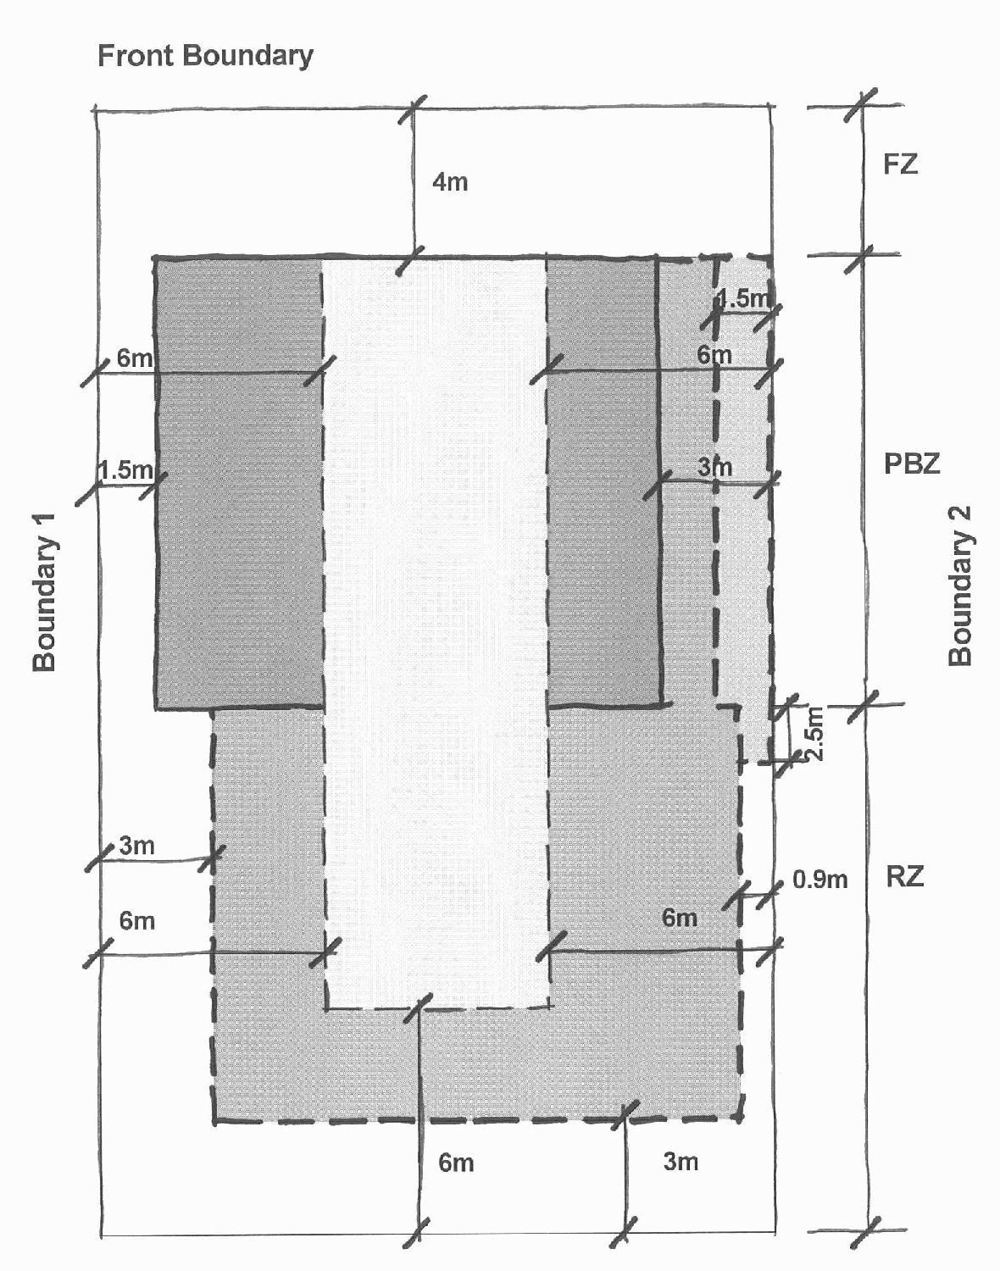
Figure C5 Setbacks –Option 1
 | Lower Floor Level Setbacks
 | Lower Floor Level Setback | Where the total length of the wall on the boundary does not exceed 13m (may extend up to 2.5m into the rear zone). Blank walls on boundaries may include walls to garages and non habitable rooms and cavity walls to habitable rooms.
 | Upper Floor Level Setback | Where design incorporates blank walls, walls with windows with sill heights ≥ 1.7m or with permanent fixed panes of obscure glass, or screen walls.
 | Upper Floor Level Setback | Where design incorporates other windows, outer faces of unscreened decks, balconies and external stairs.
RZ = Rear Zone | PBZ = Primary Building Zone | FZ = Front Zone
Table 3 - Side Boundary Setbacks –Option 2 (blocks must be nominated in a precinct code) (Refer Figures C6 and C7)

 | South^ Facing Boundary | North^^ Facing Boundary | East/ West^^^ Facing Boundary 1 | East / West^^^ Facing Boundary 2*
LFL in the PBZ | 1.5m  0m** | 1.5m  4.0m+ | 1.5m | 1.5m  0m**
LFL in the RZ | 1.5m | 1.5m  4.0m+ | 1.5m | 1.5m
UFL 1 in PBZ*** | 1.5m | 1.5m  4.0m+ | 1.5m | 1.5m
UFL 1in RZ*** | Not permitted | Not permitted | 3.0m | 3.0m
UFL 2 in the PBZ**** | 6.0m | 6.0m | 6.0m | 6.0m
UFL 2 in the RZ**** | Not permitted | Not permitted | 6.0m | 6.0m
^ South facing boundary means a boundary of a block where a line drawn perpendicular to the boundary outwards is orientated between south 30 degrees west and south 20 degrees east.
^^ North facing boundary means a boundary of a block where a line drawn perpendicular to the boundary outwards is orientated between north 20 degrees west and north 30 degrees east.
^^^ East/West boundary means a boundary of a block where a line drawn perpendicular to the boundary outwards is orientated either between east 20 degrees north and east 30 degrees south or between west 30 degrees north and west 20 degrees south.
* Boundary 2 may be stipulated in a precinct code.
** Provided the total length of the wall on the boundary does not exceed 13m (may extend up to 2.5m into the rear zone). Blank walls on boundaries may include walls to garages and non habitable rooms and cavity walls to habitable rooms.
*** Blank walls, walls with windows with sill heights ≥ 1.7m or with permanent fixed panes of obscure glass, or screen walls.
**** Walls with other windows, outer faces of unscreened decks, balconies and external stairs.
+ The dwelling is required to be setback 4m from the north facing boundary for 50% or greater of the building length commencing from 4m or greater behind the front building line. The building length is measured 4m behind the front building line.

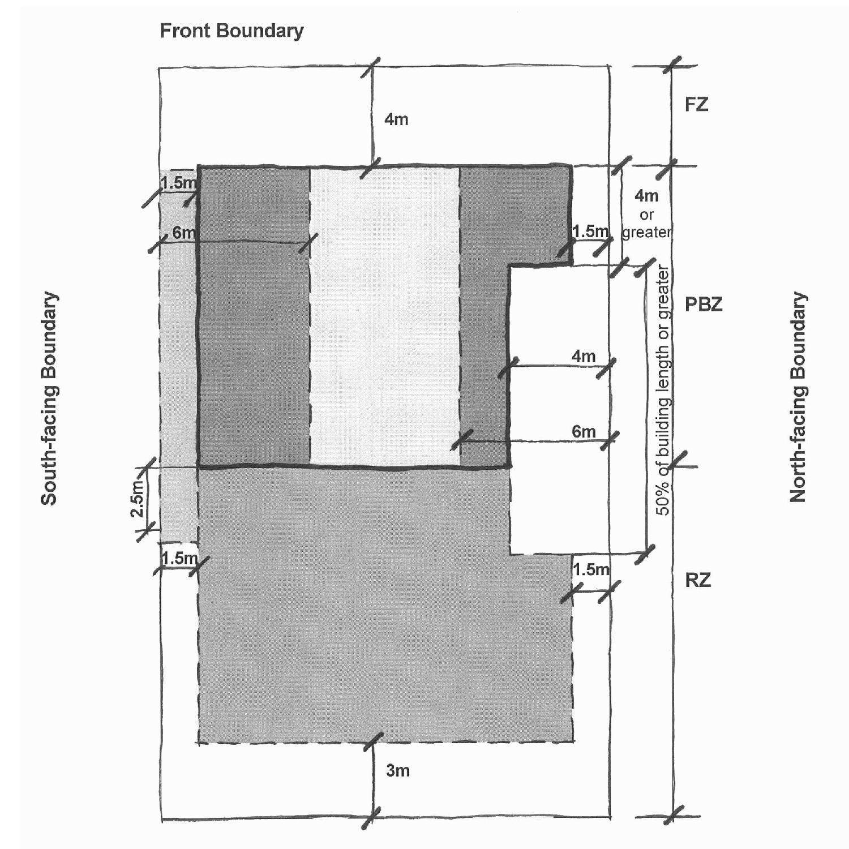
Figure C6 Setbacks –Option 2 – North and south facing side boundaries
 | Lower Floor Level Setbacks
 | Lower Floor Level Setback | Where the total length of the wall on the boundary does not exceed 13m (may extend up to 2.5m into the rear zone). Blank walls on boundaries may include walls to garages and non habitable rooms and cavity walls to habitable rooms.
 | Upper Floor Level Setback | Where design incorporates blank walls, walls with windows with sill heights ≥ 1.7m or with permanent fixed panes of obscure glass, or screen walls.
 | Upper Floor Level Setback | Where design incorporates other windows, outer faces of unscreened decks, balconies and external stairs.
RZ = Rear Zone | PBZ = Primary Building Zone | FZ = Front Zone

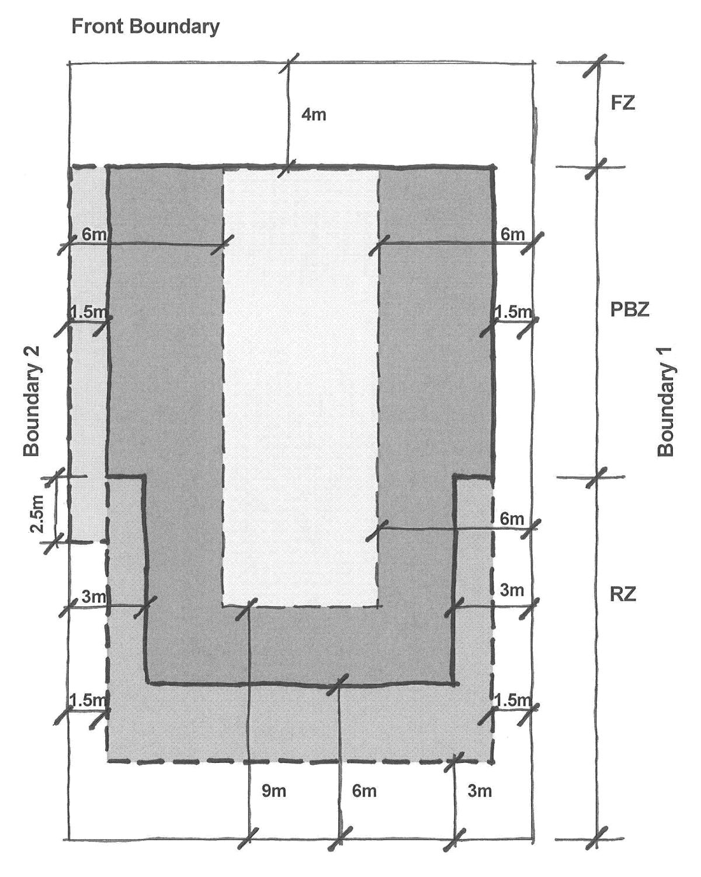
Figure C7 – Setbacks - Alternative Option - East and west facing side boundaries
 | Lower Floor Level Setbacks
 | Lower Floor Level Setback | Where the total length of the wall on the boundary does not exceed 13m (may extend up to 2.5m into the rear zone). Blank walls on boundaries may include walls to garages and non habitable rooms and cavity walls to habitable rooms.
 | Upper Floor Level Setback | Where design incorporates blank walls, walls with windows with sill heights ≥ 1.7m or with permanent fixed panes of obscure glass, or screen walls.
 | Upper Floor Level Setback | Where design incorporates other windows, outer faces of unscreened decks, balconies and external stairs.
RZ = Rear Zone | PBZ = Primary Building Zone | FZ = Front Zone

Rules | Criteria
2.4 Rear setback (Replaces R32)
R84  Rear setbacks are a minimum of:  - 3m to the lower floor level  - 6m to the upper floor level, or  Where identified in a precinct code as having the option 2 side setbacks, the minimum rear setbacks for blocks with east/ west facing side boundaries are:  - 3m to the lower floor level  - 6m to the upper floor level*  - 9m to the upper floor level**. | C84  Buildings and other structures are sited and reflect residential (suburban) scale, height and length to ensure:  a) sufficient spatial separation between adjoining developments  b) the protection of a reasonable amount of privacy and solar access to the dwelling (or adjacent dwellings) and outdoor spaces (or adjacent outdoor spaces).
* Blank walls, walls with windows with sill heights ≥ 1.7m or with permanent fixed panes of obscure glass, or screen walls.
** Walls with other windows, outer faces of unscreened decks, balconies and external stairs.

Element 3: Built Form
- Intent:
a) To ensure that the design of buildings are compatible with, and complement, the built form of surrounding properties
b) To allow flexibility in design and use of materials and colours and encourage high quality architectural standards that contribute to visually harmonious and attractive streetscapes
c) To ensure that rear and side fencing will assist in providing privacy to open space areas
d) To ensure buildings are designed and sited to provide privacy between neighbours and between occupants and the public
e) To provide adequate light and natural ventilation between dwellings
f) To ensure that the design of buildings provides visual variety and interest within overall harmony with surrounding development

Rules | Criteria
3.1 Interface (Replaces R37)
R85  Courtyard walls forward of the building line have a minimum front setback of 1m provided:  - the maximum height of the courtyard wall does not exceed 1.5m, and  - the total length of the courtyard wall measured parallel to the front street boundary does not exceed 6.5m or 50% of the width of the block whichever is the greater, and  - the wall is finished and constructed to match or complement the dwelling, and  - the area between the wall and the front street boundary is planted with shrubs, and  - the proposal demonstrates that the location of the courtyard wall does not obstruct sightlines for vehicles and pedestrians on public paths or roads in accordance with A2890.1 – The Australian Standard for Off-Street Parking. | C85  a) Courtyard walls forward of the building line may be considered where the existing front building facade is maintained as the dominant built element in the streetscape.  b) The courtyard wall reads as a secondary built element of appropriate proportions and character with respect to:  i) height  ii) relationship to verge footpath  iii) total proportion relative to the building width  iv) colour and design features  v) transparency and articulation  vi) protection of existing desirable landscape features  vii) tree and shrub planting forward of the wall.  c) Courtyard walls do not obstruct sight lines for vehicles and pedestrians on public paths or driveways in accordance with AS2890.1- The Australian Standard for Off-Street Parking.

Element 5: Amenity
- Intent:
a) Development is sited and designed to promote energy efficiency and maximise solar access to private open space and living areas of dwellings
b) Dwellings are provided with private and useable private open space that is integrated with, and directly accessible from, the living areas of the dwelling
Rules | Criteria
5.2 Private Open Space (Replaces Rule 47, 48, 49 and 50 )
R86  - The development:  - provides a minimum of 60% of the area of the block, less 50m² as private open space; or  - If the block is identified in a precinct code as an alternative side setback block, provides a minimum of 40% of the area of the block,  - At least one area of private open space on the block meets one of the following minimum dimension, area, location and screening requirements:  - 6m x 6m and 10% of the block area, screened from public view and behind the building line or enclosed by a courtyard wall forward of the building, or  - If the block is identified in a precinct code as an alternative side setback, 6m x 4m and 20% of the block area, screened from public view and behind the building or enclosed by a courtyard wall and forward of the building  - The area of private open space provided under R86 (b) is:  - For R86 (b) i) located to maintain a minimum three hours sunlight onto 50% of the ground area between the hours of 9:00am and 3:00pm on 21 June (winter solstice),  - For R86 (b) ii) located to maintain a minimum three hours sunlight onto 25% of the ground area between the hours of 9:00am and 3:00pm on 21 June (winter solstice),  - at ground level and directly accessible from a main daytime living area of the dwelling. | C86  Private open space provided in the development:  - Has dimensions to suit the projected requirements of the dwelling’s occupants and to accommodate both outdoor recreation needs as well as providing space for service functions such as clothes drying and domestic storage.  - Is capable of enabling an extension of the function of the dwelling for relaxation, dining, entertainment, recreation, and is directly accessible from the dwelling.  - Where forward of the front of the building ensures the amenity of the private open space and the dwelling is protected whilst maintaining opportunities for passive surveillance.  - Takes account of outlook, natural features of the site and neighbouring buildings or open space and to provide for maximum year round use.
R87  A minimum of 50% of the private open space is to be retained as planting area. | C87  Unpaved or unsealed areas are provided to facilitate on-site infiltration of stormwater run-off and provision of landscaping.

8 Table of Contents Single Dwelling Housing Development Code

Update the Table of Contents to reflect the new Part C(4) and other changes

Interpretation service
