Australian Capital Territory

Planning and Development (Technical Plan Variation—boundary changes) Notice 2009

Notifiable instrument NI2009 — 59
Technical Variation No 2009-05
made under the
Planning and Development Act 2007, section 89 (Making technical amendments) (see also s96A Rezoning – boundary changes)

This instrument (and the plan variation in it) commences on the day after it is notified.

The variation specifies miscellaneous changes to zone boundaries to be consistent with the road reservation boundary for Gungahlin Drive and does not affect existing leasehold.

Areas that are affected by this change are identified on the following maps:

Annexures A, B and C – District of Belconnen and Canberra Central

Variation No. 2009-05 to the Territory Plan has been approved by the Planning and Land Authority.

Neil Savery
Planning and Land Authority
Date: 6 February 2009
THIS IS PAGE ONE OF ANNEXURE A
TO NOTIFIABLE INSTRUMENT NI2009 - 59

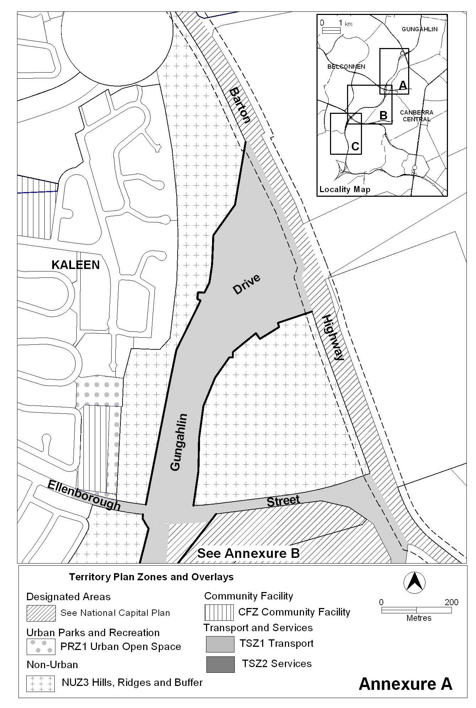

Neil Savery
Planning and Land Authority
Date: 6 February 2009
THIS IS PAGE ONE OF ANNEXURE B
TO NOTIFIABLE INSTRUMENT NI2009 - 59

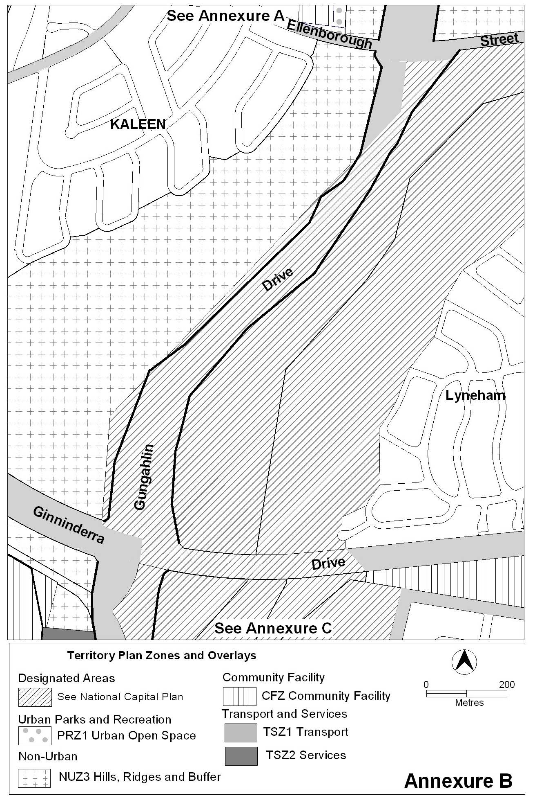

Neil Savery
Planning and Land Authority
Date: 6 February 2009
THIS IS PAGE ONE OF ANNEXURE C
TO NOTIFIABLE INSTRUMENT NI2009 - 59

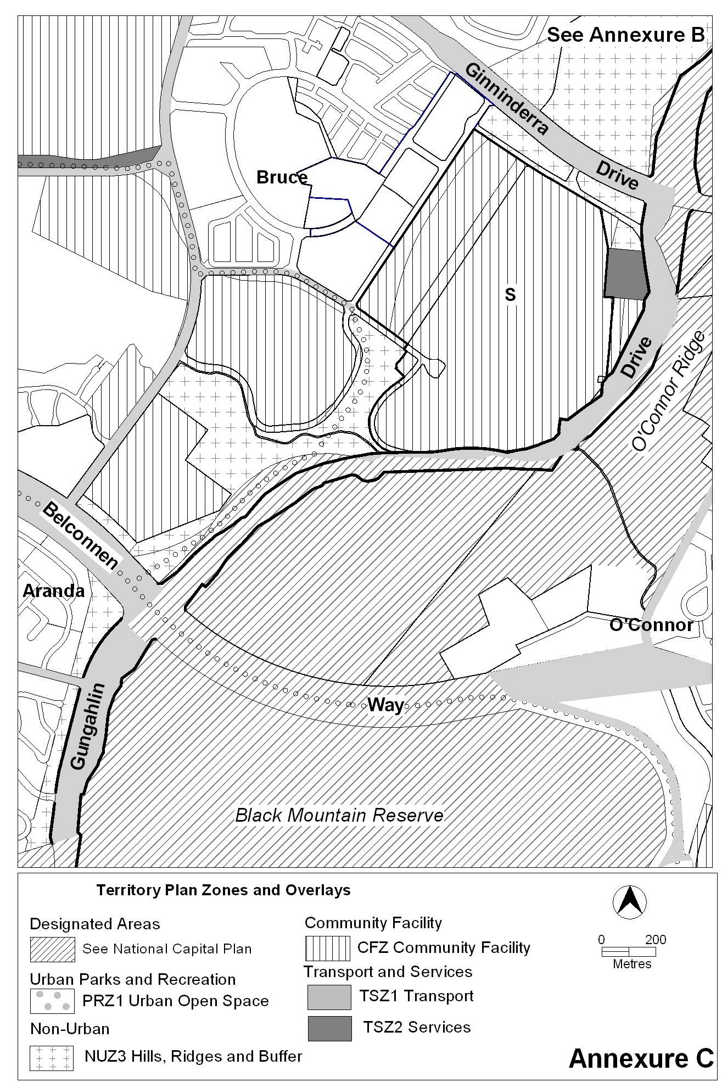

Neil Savery
Planning and Land Authority
Date: 6 February 2009

