ACT Planning and Land Authority

Planning and Development (Draft Variation No 298) Consultation Notice 2010*

Changes to zoning at Holt section 99 block 11 and the introduction of a structure plan and concept plan (precinct code) for Holt section 99 part block 11 (Belconnen golf course)

Notifiable instrument NI2010–146

made under the Planning and Development Act 2007 section 63 (Public consultation—notification) and section 64 (public consultation—notice of interim effect etc)

Draft variation number 298 to the Territory Plan (see Annexure A) proposes to amend the zoning on a disused part of the Belconnen golf course at Holt section 99 block 11 in the district of Belconnen to enable residential development. A structure plan and concept plan (precinct code) will be introduced to guide development at the site.

Documents relating to this draft variation may be obtained from:
• www.actpla.act.gov.au
• ACTPLA’s customer service centre, 16 Challis Street, Dickson, from 8:30am until 4:30pm weekdays

Written comments from the public are invited on this draft variation by COB Monday 17 May 2010. Comments should include reference to the draft variation, a return postal address and be addressed to Manager, Development Policy Section.

Comments may be submitted via:
• ACTPLA’s customer service centre at the above address
• ACT Planning and Land Authority, GPO Box 1908, Canberra ACT 2601
• terrplan@act.gov.au

Copies of comments received will be made available for public inspection at the customer service centre in Dickson during working hours for no less than 15 working days after the closing date listed above.

The draft variation does not have interim effect and therefore section 65 of the Planning and Development Act 2007 does not apply. The current Territory Plan will continue to apply while the variation remains in draft form.

Kelvin Walsh
Delegate of the Planning and Land Authority
24 March 2010

ANNEXURE A: DV298 Belconnen golf course

Planning & Development Act 2007

Draft Variation to the Territory Plan
Number 298

Structure Plan, Concept Plan and Zone Changes—Holt section 99 part block 11
(Belconnen Golf Course)

March 2010

Table of Contents

1. INTRODUCTION 1
1.1 Summary of the Draft Variation 1
1.2 Outline of the process 1
1.3 This document 2
1.4 Public Consultation 2
2. EXPLANATORY STATEMENT 3
2.1 Background 3
2.2 Site Description 3
2.2.1 Current Territory Plan Provisions 5
2.3 Proposed Changes 6
2.3.1 Proposed Changes to the Territory Plan Map 6
2.3.2 Other proposed Changes to the Territory Plan 6
2.4 Reasons for the Draft Variation 6
2.5 Planning Context 6
2.5.1 Territory Plan 6
2.5.2 Spatial Plan 7
2.5.3 National Capital Plan 7
2.6 Interim Effect 8
2.7 Consultation with Government Agencies 8
3. DRAFT VARIATION 10

INTRODUCTION

Summary of the Draft Variation
This draft variation proposes to amend the Territory Plan map by changing the parks and recreation PRZ2 restricted access recreation zone at Holt section 99 block 11 (part) to residential RZ1 suburban zone to enable residential development.
The proposal is to develop approximately 330 dwellings of various housing types to a maximum of two storeys at the site. Its proximity to the two residential estates—Woodhaven and Wiluna—will connect it to an existing neighbourhood.
The draft variation proposes to include a future urban area overlay at the site and to insert a site-specific structure plan and concept plan into the Territory Plan to guide the development and assessment of a comprehensive estate development plan. The concept plan is deemed to be a precinct code under section 93 of the Planning and Development Act 2007.

Outline of the process
The Commonwealth’s Australian Capital Territory (Planning and Land Management) Act 1988 allows for the Legislative Assembly to make laws to establish a Territory Planning Authority and for that Authority to prepare and administer a Territory Plan. The Planning and Development Act 2007 (the Act) establishes the ACT Planning and Land Authority (ACTPLA) as the Authority which prepares and administers the Territory Plan, including continually reviewing and proposing amendments as necessary.
The Territory Plan is comprised of the written statement and a map. The written statement contains a number of parts, namely governance; strategic directions; zones; precinct codes; general codes; overlays; definitions; structure plans, concept plans and development codes for future urban areas.
The Territory Plan map graphically represents the applicable land use zones (under the categories of residential, commercial, industrial, community facility, parks and recreation, transport and services and non urban), precincts and overlays. The zone, precinct and overlay requirements are detailed in the volumes of the Territory Plan.
Draft variations to the Territory Plan are prepared in accordance with the Act. Following the release of the draft variation under section 63 of the Act, submissions from the public are invited. At the conclusion of the consultation period the ACTPLA submits a report on consultation and a recommended final variation to the Minister for Planning for approval. The Minister has the discretion to determine if referral to the Legislative Assembly Standing Committee on Planning, Public Works and Territory and Municipal Services is warranted prior to approval, depending on the nature and significance of the proposal.
If the draft variation is referred to the Committee by the Minister or otherwise, the Minister must consider the findings of the Committee before deciding whether to approve the draft variation. If the Minister approves the variation, the variation and associated documents will be tabled in the Legislative Assembly. Unless disallowed by the Legislative Assembly within five sitting days, the variation commences on a day nominated by the Minister.

This document
This document contains the background information in relation to the proposed variation. It comprises the following parts
- Part 1 Introduction
- Part 2 Explanatory Statement providing reasons for the proposed variation and describes its effect
- Part 3 Draft Variation including proposed changes to the Territory Plan

Public Consultation
Documents relating to this draft plan variation may be obtained from:
- www.actpla.act.gov.au
- ACTPLA’s customer service centre, 16 Challis Street, Dickson from 8:30am until 4:30pm weekdays
Note that free internet access is available at all ACT Public Libraries.
Written comments from the public are invited on DV298 by COB Monday 17 May 2010. Comments should include reference to the draft variation, a return postal address and be addressed to Manager, Development Policy Section.
Comments may be submitted via:
- ACTPLA’s customer service centre at the address above
- ACT Planning and Land Authority, GPO Box 1908, Canberra ACT 2601
- terrplan@act.gov.au
Copies of comments received will be made available for public inspection at the customer service centre in Dickson for no less than 15 working days after the closing date listed above.
Subject to consideration of responses received, ACTPLA proposes to submit this draft variation to the Minister for Planning in accordance with the Act.

EXPLANATORY STATEMENT

Background
The parks and recreation PRZ2 restricted access recreation zone makes provision for a range of facilities which will meet the sporting and recreational needs and demands of the community and are appropriately located for the potential users of the facility.
The site was originally developed as part of an 18-hole golf course in the 1980s. The course was expanded to a 27-hole course in the 1990s. At the same time the concessional lease over the site was discharged and two residential estates were developed and named Woodhaven and Wiluna. In 2003 the use of the nine holes at the subject site was discontinued because of declining membership and increasing watering costs.
The planning report has been prepared by the proponent for block 11 (part) section 99 Holt (October 2009) and it recommended that the site is considered suitable for residential use. The proponents intend to develop approximately 330 dwellings of various housing types to a maximum of two storeys at the site. Its proximity to the two residential estates—Woodhaven and Wiluna—will enable the development to be connected to an existing neighbourhood. The mix of housing types is expected to meet some demands of Canberra’s ageing community.
The site of the existing clubhouse on Britten-Jones Drive is proposed to be used as a community hub for residents of the estate. The hub may include a range of uses that are ancillary to the estate including recreational facilities and limited commercial uses including a health facility, office and shop.
The planning report includes a discussion about the possible future location of the golf course clubhouse which is position at the eastern side of the golf course on Spofforth Street. The location and scale of a relocated clubhouse can be assessed against the existing provisions of the Territory Plan and is therefore not considered as a part of this draft variation.

Site Description
The draft variation applies to part of block 11 section 99 Holt. The land is located to the west of the suburb of Holt in the district of Belconnen and can be accessed from Stockdill Drive (see Figure 1). The site is Territory land and is currently leased to Woodhaven Investments. The subject site is approximately 23 hectares and is comprised of disused fairways at Belconnen golf course.
Belconnen golf course and the two residential estates adjoin the site along the northern and eastern boundary. The land to the west of the site is currently open farmland. It is zoned non urban NUZ1 broadacre zone and is able to be developed for a range of uses. The land to the south of the site is also open farmland and is predominantly zoned non urban NUZ3 hills, ridges and buffer (see figure 2).
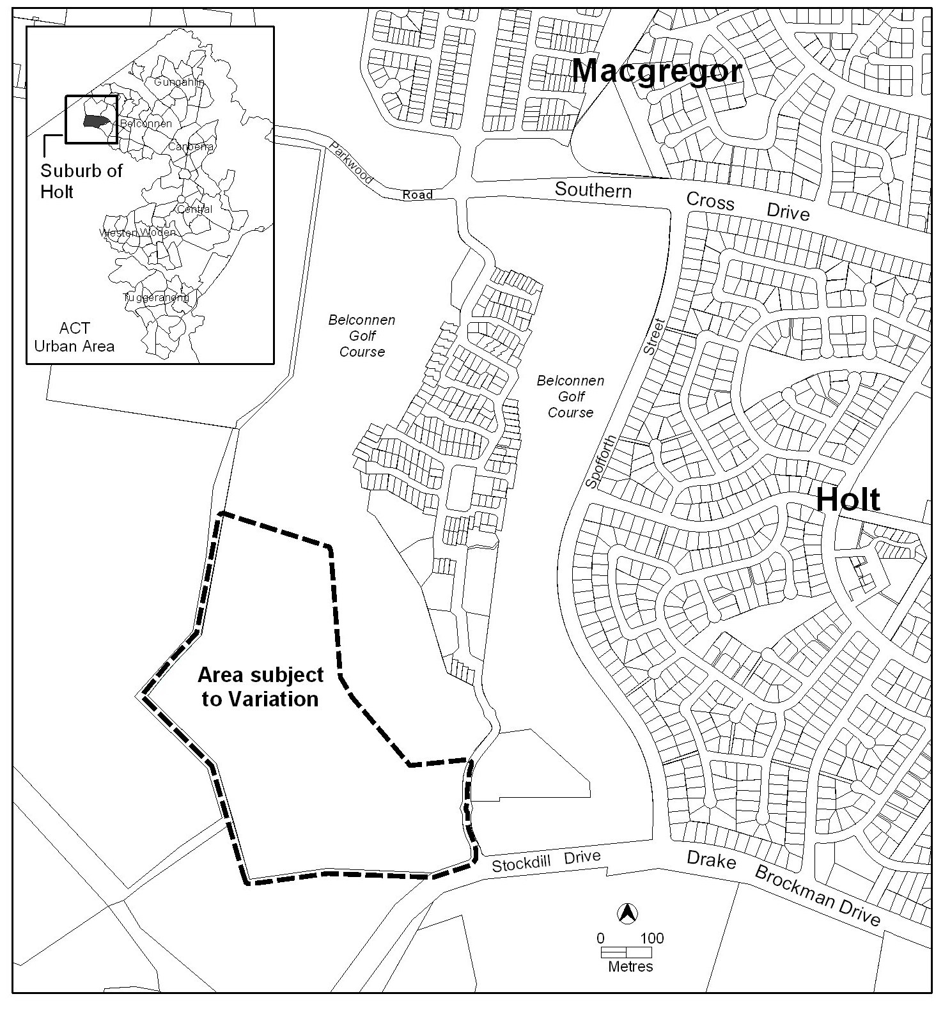
Figure 1 Location of area subject to draft variation in district of Belconnen
The map indicates the proposed site boundaries as accurately as possible but these may be adjusted following detailed surveys.

Current Territory Plan Provisions
The area subject to the draft variation and the current Territory Plan zoning is indicated in Figure 2. The site is currently zoned parks and recreation PRZ2 restricted access recreation.
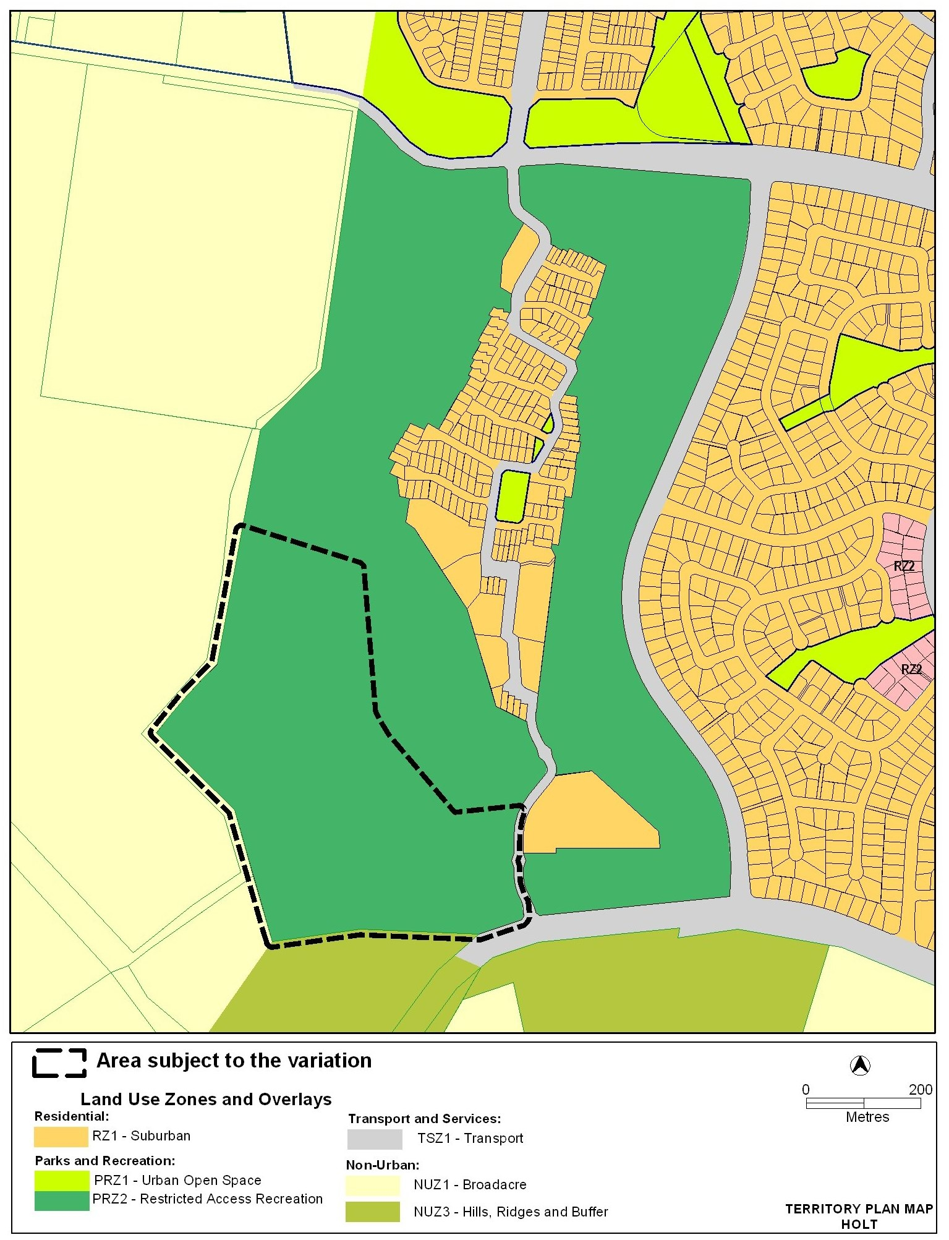
Figure 2 Current zoning on Territory Plan map of area subject to draft variation

Proposed Changes

Proposed Changes to the Territory Plan Map
The changes to the Territory Plan map are shown at Figure 3 in Part 3 of this document and involve the following:
- insert a future urban area overlay for the subject site
- remove parks and recreation PRZ2 restricted access recreation zone
- insert residential RZ1 suburban zone for residential development. Buildings in the RZ1 zone are limited to a maximum of two storeys
The map indicates the proposed land use zone boundaries as accurate as possible, but these may be adjusted following detailed surveys.

Other proposed Changes to the Territory Plan
It is also proposed to amend the Territory Plan in the following manner
1. At Part 14 Structure Plans, insert a new part
Holt section 99 block 11(Belconnen Golf Course) Structure Plan
(see Appendix A)
2. After Part 15 Concept Plans—Precinct codes for the purposes of section 93 of the Planning and Development Act 2007, insert a new part
Holt section 99 block 11(Belconnen Golf Course) Concept Plan
(see Appendix B)

Reasons for the Draft Variation
ACTPLA has examined the proponent’s planning report for block 11 (part) section 99 Holt and considers that the site is suitable for residential development subject to a variation to the Territory Plan. The land is in the existing urban footprint and within 15 kilometre radius of the city centre. Its proximity to the two existing residential estates—Woodhaven and Wiluna—will enable the development to connect to an existing neighbourhood. The range of housing types proposed will result in a greater diversity of dwelling types which addresses the needs of an ageing community. Several sustainability initiatives are included as part of the proposal. The proposal includes a response to the Affordable Housing Action Plan of the ACT which involves the provision of a proportion of dwellings at a price of approximately $300 000.

Planning Context

Territory Plan
The Territory Plan includes a statement of strategic direction which sets out the principles for giving effect to the main object of the Territory Plan as required by the Planning and Development Act 2007.
The proposal is consistent with the statement of strategic directions, particularly the following
- Urban expansion will be contained in order to minimise impacts on valuable natural and rural areas
- Economic, social and environmental objectives will be pursued in a balanced and integrated way, having regard to both short-term and long-term factors, such that present needs can be met without prejudicing the welfare of future generations, and without serious or irreversible loss of life-supporting natural resources or damage to the environment
- Planning policies will seek to ensure the efficient use of all resources and to reduce consumption of non-renewable resources
- Provision of affordable, adaptable and special-needs housing will be promoted throughout the city, as well as modification or redevelopment of existing stock to meet emerging social needs
- Canberra will continue to develop as a series of discrete urban areas within a landscape setting of hills, ridges and other open spaces. For instance, each town will offer a diversity of housing types

Spatial Plan
The Canberra Spatial Plan (2004) is one of the Territory’s key strategic planning documents for directing and managing urban growth and change over the next 30 years. The Spatial Plan outlines the strategic direction for urban growth to achieve social, environmental and economic sustainability for Canberra.
The Spatial Plan establishes a framework that encourages and facilitates population growth and seeks to ensure that provision is made for the expected growth and age profile of the Canberra community. The proposal achieves these objectives by developing land in the existing urban footprint and within a 15 kilometre radius of Canberra city centre. The proposal also includes several sustainability initiatives to minimise the demand on potable water, stormwater and the sewerage system.

National Capital Plan
The Australian Capital Territory (Planning and Land Management) Act 1988 established the National Capital Authority (NCA) with two of its functions being to prepare and administer a National Capital Plan (the Plan) and to keep the Plan under constant review and to propose amendments to it when necessary.
The Plan, which was published in the Commonwealth Gazette on 21 January 1990, is required to ensure that Canberra and the Territory are planned and developed in accordance with their national significance. The Australian Capital Territory (Planning and Land Management) Act 1988 also requires that the Territory Plan is not inconsistent with the NCP. The area proposed for rezoning is within the urban areas as defined by the NCP.
The NCA was consulted during the preparation of this draft variation and its comments are included at 2.7 Consultation with Government Agencies.

Interim Effect
The draft variation does not have interim effect and therefore section 65 of the Planning and Development Act 2007 does not apply. The current Territory Plan will continue to apply while the variation remains in draft form.

Consultation with Government Agencies
ACTPLA is required to, in preparing a draft variation under section 60(b) consult with each of the following in relation to the proposed draft variation
- the national capital authority
- the conservator of flora and fauna
- the heritage council
- if the draft variation would, if made, be likely to affect unleased land or leased public land—each custodian for the land likely to be affected.
National Capital Authority
The NCA provided the following comments on 4 December 2009
The land identified to be varied from PRZ2 Restricted Access Recreation Zone to RZ1 Suburban is within Urban Areas under the General Policy Plan - Metropolitan Canberra. The NCA therefore has no objection to the variation proceeding.
Response
Noted.
Environment Protection Authority
Environment Protection Authority provided the following comments on 9 March 2010
The site has been assessed to the satisfaction of the Environment Protection Unit (EPU) and found suitable for the proposed development subject to the stockpiles at the site being managed in accordance with an EPU endorsed contaminant management plan.
Therefore, the Environment Protection Authority supports the Draft Variation to the Territory Plan number 298
Response
Noted.
Heritage Council of the ACT
The Heritage Council provided the following comments on 1 December 2009
Given that the planned variation does not preclude any requirements for the development to adhere to the Heritage Act 2004, the Heritage Council has no concerns.
Response
Noted.
Conservator of Flora and Fauna
The Conservator made the following comments on 16 December 2009
The variation relates to the changing of the land use zone of a disused portion of the Belconnen Golf Course from restricted access recreation zone to residential to allow the construction of approximately 330 dwellings.
The Ecological Assessment of the site shows that the site has low conservation value being heavily disturbed by the construction of the golf course. However, there are numerous mature remnant native trees that have been assessed as being in good condition. These trees should be retained within open space areas, wherever possible. Trees with hollows should also be considered for retention as they may provide important habitat.
The Concept Plan would benefit from showing the open space network that incorporates the protection of these trees.
Response
The residential subdivision development code, which is to be read in conjunction with the concept plan, provides for the protection and retention of all exceptional, high and medium value trees identified in a tree management plan and endorsed by the Conservator of Flora and Fauna. The inclusion of this information in an open space network diagram would involve unnecessary duplication.

DRAFT VARIATION
Variation to the Territory Plan Map
The Territory Plan map is varied as indicated in Figure 3.1 for the area shown as subject to the draft variation as follows:
- at part block 11 section 99 Holt in the district of Belconnen as identified in Figure 3, substitute the parks and recreation PRZ2 restricted access recreation zone with residential RZ1 suburban zone.
The map indicates the proposed land use zone boundaries as accurately as possible, but these may be adjusted following detailed surveys.
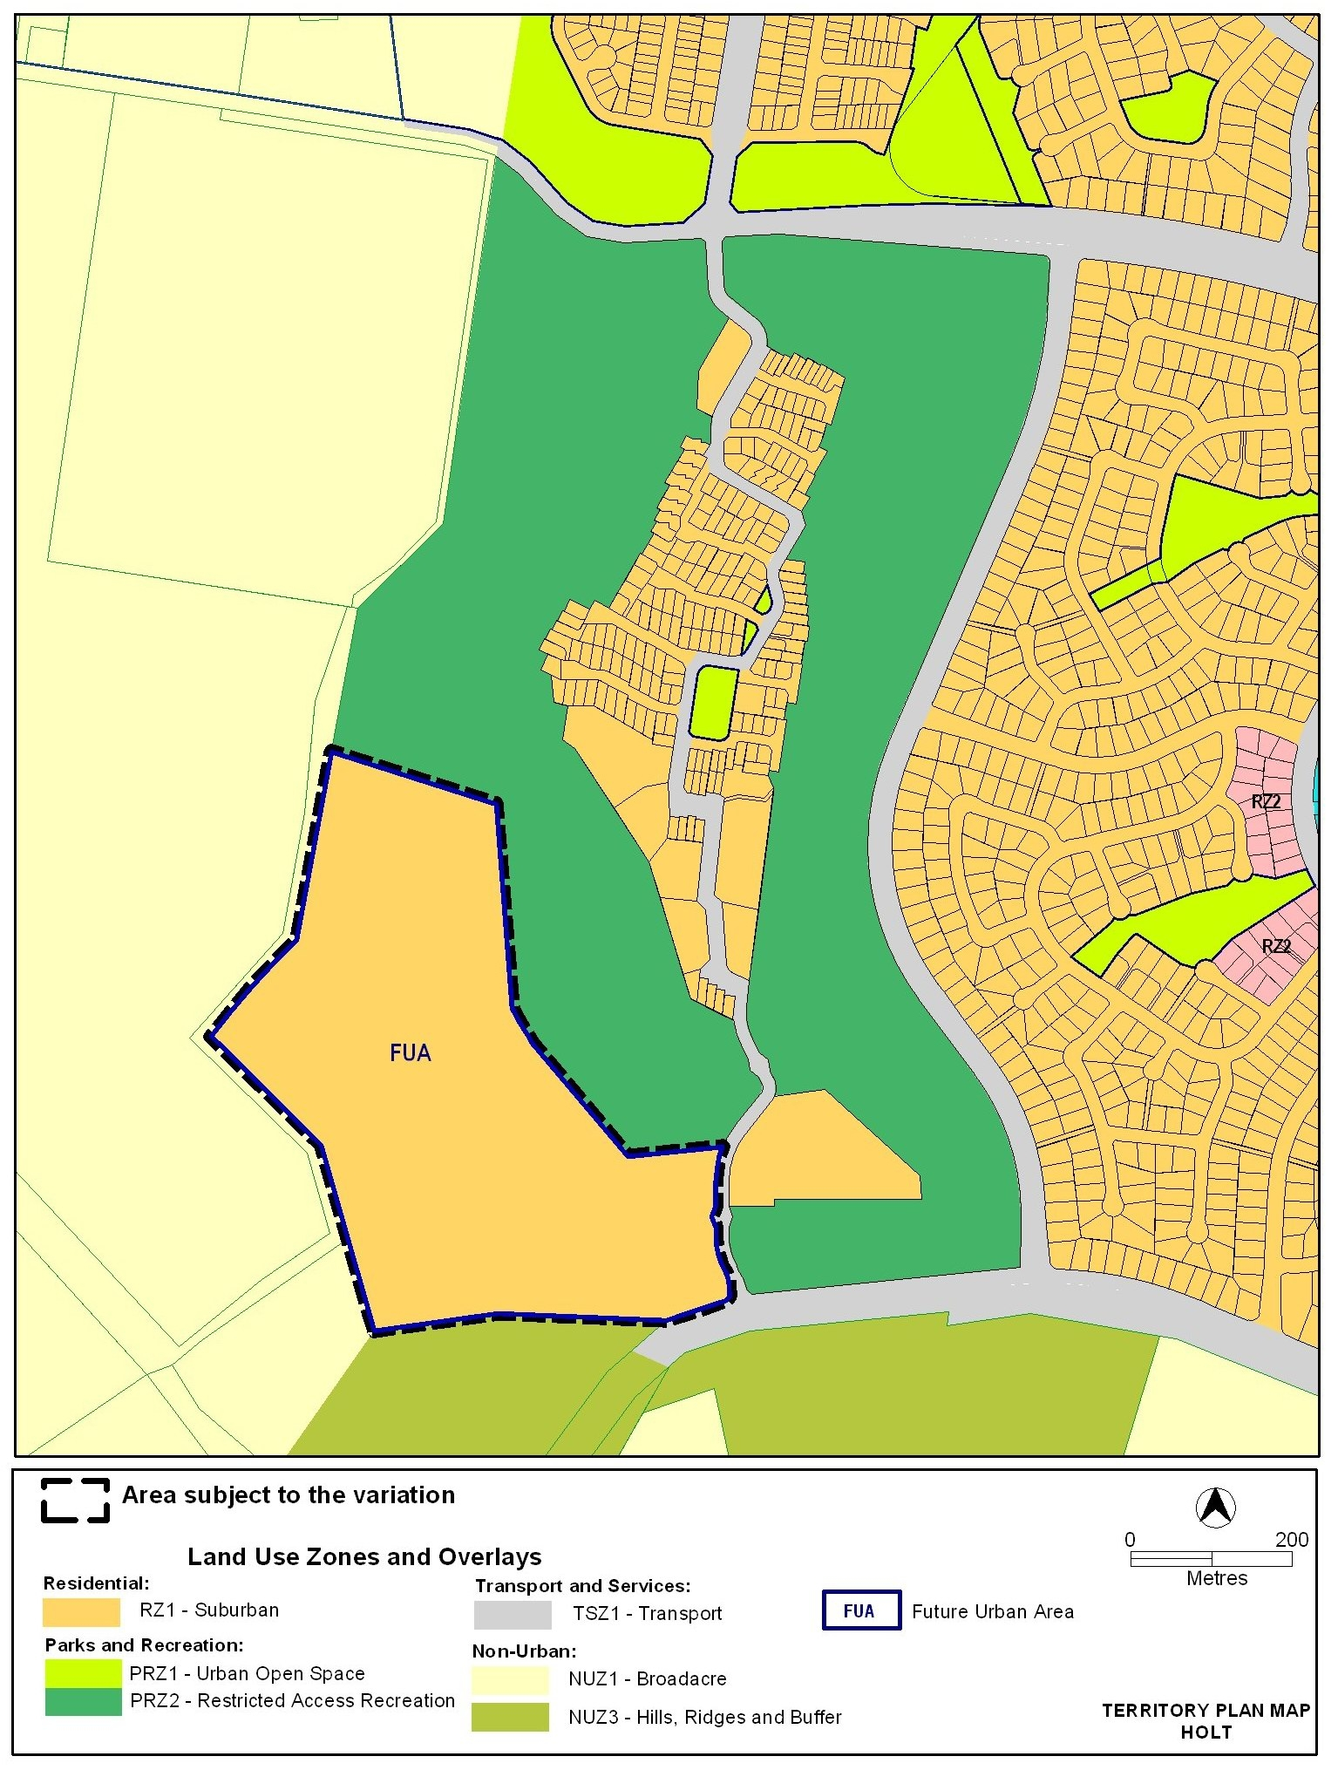
Figure 3 Proposed zoning on Territory Plan map of area subject to draft variation

Variation to Residential RZ1 – Suburban zone development table

- Assessable Development table, under the heading
Specific areas have additional developments that may be approved subject to assessment. These areas and the additional developments are listed below
Insert the following
Holt section 99 block 11 (part) | SHOP | Holt section 99 block 11 (Belconnen Golf Course) Concept Plan  Residential Zones – Multi Unit Housing Development Code

Variation to Structure Plans

- after Molonglo and North Weston structure plan
Insert the following
Holt section 99 block 11 Structure Plan (see Appendix A)

Variation to Concept Plans— Precinct Codes for section 93 of the Planning and Development Act 2007

- after Coombs and Wright concept plan
Insert the following
Holt section 99 block 11 Concept Plan (see Appendix B)

Interpretation service
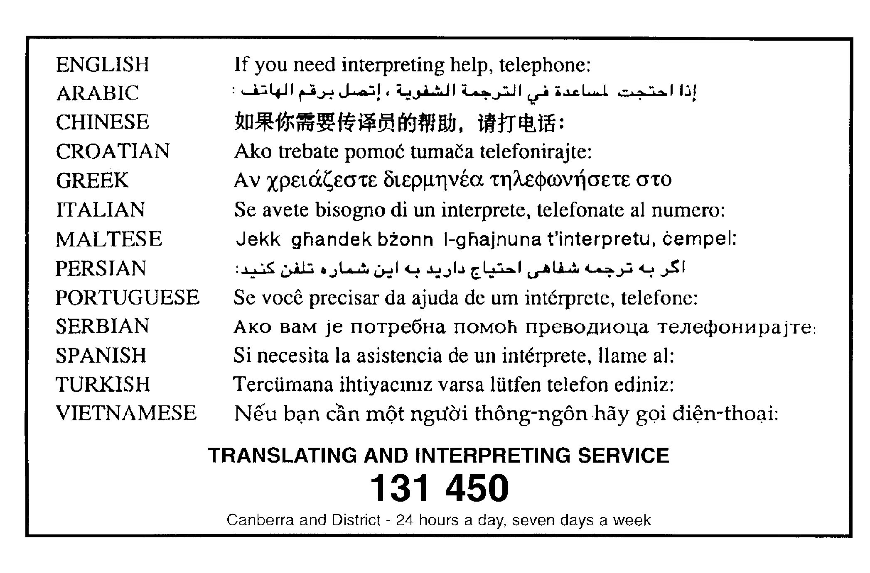

Appendix A Holt section 99 Structure Plan

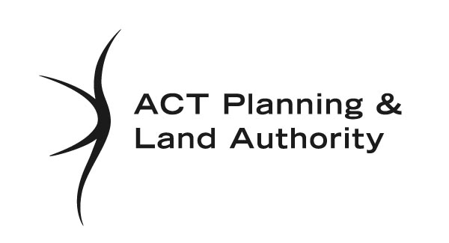

Holt section 99 block 11
(Belconnen Golf Course)
Structure Plan

March 2010

- INTRODUCTION
This structure plan sets out the principles and policies that apply to development at the future urban area on section 99 Holt in accordance with section 91 of the Planning and Development Act 2007.
- APPLICATION
This structure plan applies to the future urban area shown in Figure 1. Land that ceases to be part of the future urban area after the application of section 96 of the Planning and Development Act 2007 ceases to be affected by this structure plan.
- PROHIBITED DEVELOPMENT
For the purposes of section 136(2) of the Planning and Development Act 2007, development by an entity that is not the Territory or Territory entity is not prohibited.
- PRINCIPLES FOR THE DEVELOPMENT OF FUTURE URBAN AREA
1. The development will accord with the principles contained in the Statement of Strategic Directions in the Territory Plan (see figure 1).
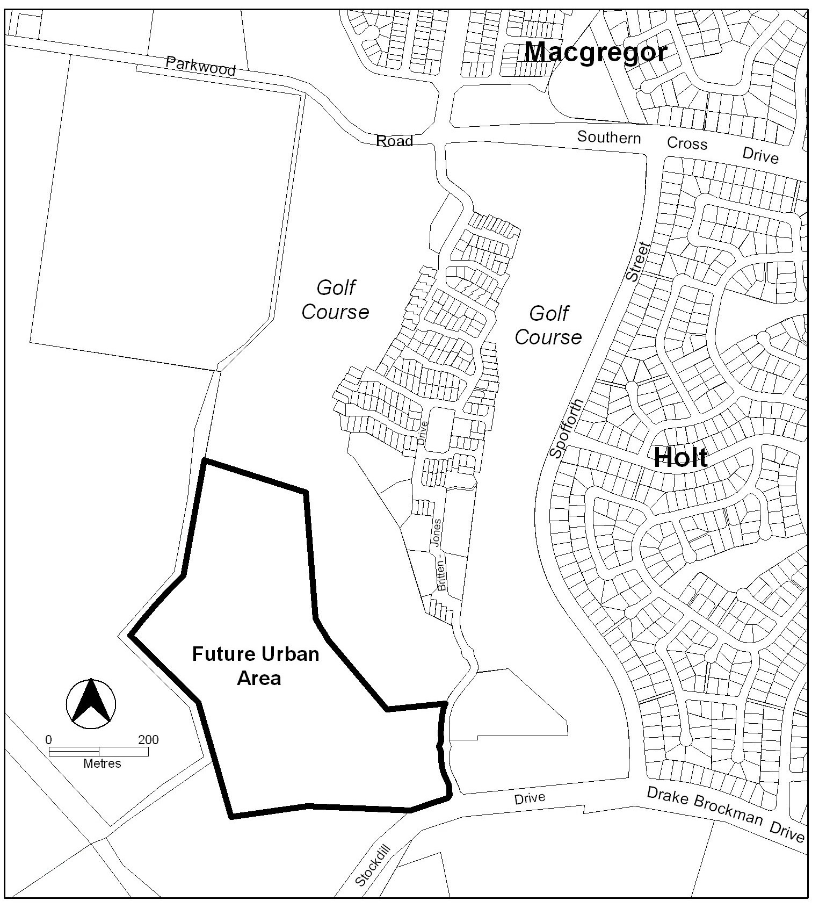
Figure 1: Future urban area at commencement of Holt section 99 block (11 part) Structure Plan
- POLICIES FOR THE DEVELOPMENT OF FUTURE URBAN AREA

General
2. Development within the future urban area shown in Figure 1 will be in accordance with the residential RZ1 suburban zone in the Territory Plan.
Notes:
1. The future urban area will diminish as development proceeds. Land that ceases to be part of the future urban area through the application of s96 of the Planning and Development Act 1997 ceases to be affected by this structure plan.
2. The nature and extent of the RZ1 zone under the Territory Plan will be confirmed after land ceases to be part of the future urban area.

Bushfire protection
3. Buffers for bushfire protection are to be provided to the satisfaction of the Emergency Services Agency (ESA) along the western and southern boundaries of the site.

Residential
4. Dwellings abutting the rural interface be constructed to satisfy Bushfire Attack Level 19 of Australian Standard of construction of buildings in bushfire-prone areas (AS 3959: 2009) and that other dwellings at the estate be constructed to satisfy Bushfire Attack Level 12.5 (AS 3959:2009) as noted in the corrigendum to the Planning Report November 2009—Bushfire protection requirements based on AS3595:2009 or as agreed by the ESA.

Road and movement network
5. The estate is to be provided with an entrance from Stockdill Drive and not from Britten Jones Drive.
6. An access way for cycle use and pedestrians is to provide a connection between the main entry off Stockdill Drive to the nearest bus stop.
7. A secondary access point to the site for emergency access and egress is to be located and constructed to the satisfaction of ESA.

Infrastructure
8. Provision will be made for the relocation and undergrounding of the overhead 132 kilovolt transmission lines to enable contiguous residential development.

Community activity centre
9. Provision for a community activity centre with ancillary uses of shop, health facility, office and store is to be located close to the intersection of Stockdill Drive and Britten Jones Drive. Shop of no more than 200 m² gross floor area may be included within the community activity centre.

Open space and landscape
10. The provision for open space for active recreation will accord with the relevant Territory guidelines.
11. Landscape buffers will be provided to screen urban development from Stockdill Drive.

Appendix B Holt section 99 Concept Plan (Precinct Code)

Holt section 99 block 11
(Belconnen Golf Course)
Concept Plan

March 2010

Contents

Introduction 1
Part A – Land use 3
1. Land use plan 3
2. Community precinct 3
Part B – Subdivision 5
3. Dwelling yield 5
4. Bushfire protection 5
5. Road network 5
6. Infrastructure 5
7. Open space and landscaping 6
Part C – Buildings and structures 6
8. Community precinct 6

Introduction
Application
This plan applies to land at Holt section 99 block 11 (part) in the district of Belconnen, as shown on Figure 1.
Figure 1: Location of Holt section 99 in district of Belconnen
Part A Land Use and Part B Subdivision of this plan apply only to the future urban area (FUA) within Holt section 99 block 11 (part). The FUA will be removed following the approval of the estate development plans and finalisation of the zone boundary under section 96 of the Planning and Development Act 2007.
This plan contains rules, which provide definitive controls for development, and criteria, which provide provisional controls for development. In some instances rules are mandatory. Mandatory rules are marked by the words “This is a
mandatory requirement. There is no applicable criterion” in the criteria column. Non-compliance with a mandatory rule will result in the refusal of a development application. In other instances the words “There is no applicable rule”. In this case the proposal is assessed against the relevant criterion. Where both rule and criterion apply, compliance with the rule is deemed to satisfy the particular requirement. A departure from strict compliance with the rule can be allowed provided that the relevant criterion is met.
Purpose
The purpose of this plan is to:
- guide the design and assessment of estate development plans (subdivision proposals) at Holt section 99 block 11
- guide the development of individual blocks in concert with other relevant codes under the Territory Plan
Desired planning outcomes
The purpose of the development controls (i.e. rules and criteria) is to:
- provide diverse housing types, densities and affordability to meet the changing needs of households and to encourage the formation of a diverse community
- ensure the appropriate protection of existing high value trees
- incorporate principles of contemporary best practice for energy efficiency, water conservation, solar access and ecological sustainability
- provide a legible road network that integrates safe and adequate pedestrian and cycle access throughout the site and connectivity to adjacent areas
- employ stormwater management measures
- encourage efficient use of water through water sensitive urban design
- adopt bushfire protection measures appropriate to the site
- relocate 132 kilovolt transmission line to enable contiguous development
- if developed as a community title scheme, capacity to provide for community facilities that incorporates small scale commercial uses
Code hierarchy
This concept plan is deemed to be a precinct code under section 93 of the Planning and Development Act 2007.
More than one type of code may apply to a particular development proposal. Occasionally inconsistencies between the provisions arise, particularly where a precinct code seeks to apply special provisions in response to particular local circumstances or planning issues. Where this occurs, a precinct code prevails over a development code and a general code, but only to the extent of the inconsistency.

Part A – Land use
Note: The land referred to in this part is shown on Figure 2.
Rules | Criteria
  - Land use plan
R1  The land use plan submitted with an estate development plan (EDP) is to be in accordance with the residential RZ1 suburban zone in Territory Plan map under the future urban area overlay. | This is a mandatory requirement. There is no applicable criterion.
  - Community precinct
R2  If a community activity centre is proposed for the site then the estate is to be developed as a community title scheme and the centre is to be located in the community precinct (as identified by ‘area proposed for community activity centre’ in Figure 2). | This is a mandatory requirement. There is no applicable criterion.
There is no applicable rule. | C3  The community precinct may include a community activity centre and a range of ancillary uses including both indoor and outdoor recreation facility and limited commercial uses (shop, health facility, office and store) to serve the community title scheme.

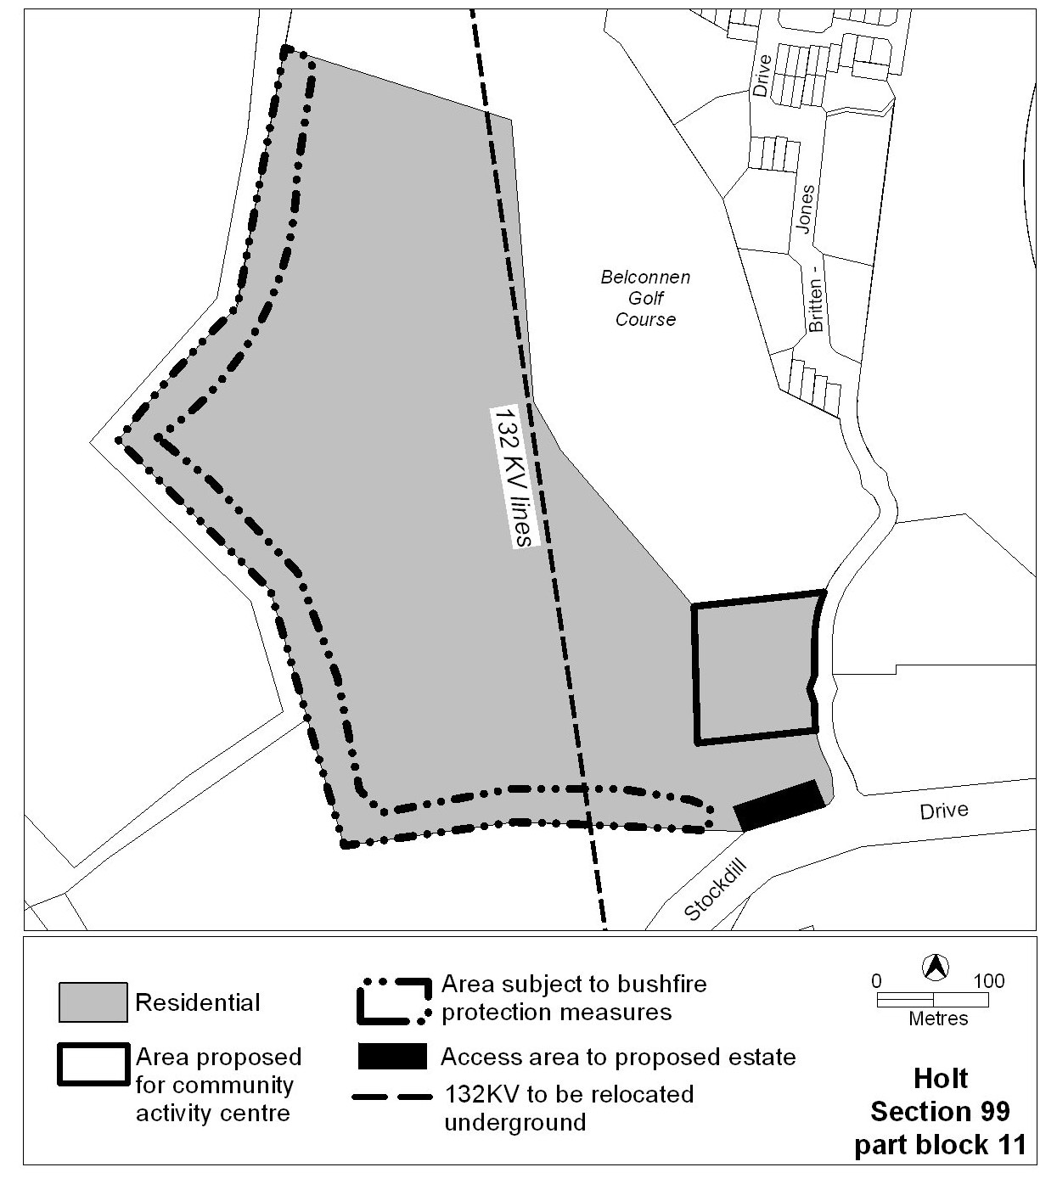
Figure 2: Concept Plan for Holt section 99

Part B – Subdivision
Note: This part should be read in conjunction with:
Residential Subdivision Development Code
Guidelines for the Preparation of Estate Development Plans
Water Ways: Water Sensitive Urban Design General Code.
Rules | Criteria
  - Dwelling yield
R4  The estate provides a range of dwelling types, densities and block sizes which results in the construction of between 300 and 350 dwellings. | This is a mandatory requirement. There is no applicable criterion.
  - Bushfire protection
R5  EDP identifies the bushfire protection measures, including higher construction standards required of buildings in bushfire prone areas as endorsed by the ACT Emergency Services Agency. | This is a mandatory requirement. There is no applicable criterion.
  - Road network
R6  The entrance to the estate is to be located off Stockdill Drive as shown in Figure 2. | This is a mandatory requirement. There is no applicable criterion.
There is no applicable rule. | C7  The development is to incorporate a continuous pathway, which provides a slope which allows access for persons with a disability, between the estate and the location of the closest bus stop.
R8  A second vehicular access point to the estate for emergency use is to be provided and endorsed by the ACT Emergency Services Agency. | This is a mandatory requirement. There is no applicable criterion.
  - Infrastructure
R9  The 132 kilovolt transmission line, as shown in Figure 2, is to be relocated and under grounded in accordance with ActewAGL requirements. | This is a mandatory requirement. There is no applicable criterion.

  - Open space and landscaping
There is no applicable rule. | C10  A buffer area is provided between Stockdill Drive and residential blocks which contains landscape treatment of a similar scale and width as the existing treatment for the perimeter of the golf course.

Part C – Buildings and structures
  - Community precinct
Rules | Criteria
R11  If a community activity centre is included in the estate then the ancillary uses of shop, health facility, office and store may be integrated into the centre provided all of the following are met:  - total combined gross floor area of shop, health facility and office is to be no greater than 300m² and within this area, total gross floor area of shop is to be no greater than 200m²  - total gross floor area of store is to be no greater than 500m². | This is a mandatory requirement. There is no applicable criterion.

