Australian Capital Territory
Road Transport (Public Passenger Services) Driver Authority Card Guidelines 2010 (No 1)
Notifiable Instrument NI 2010—188
made under the
Road Transport (Public Passenger Services) Regulation 2002, section 307 (Driver authority card to be displayed or shown)

1 Name of instrument

This instrument is the Road Transport (Public Passenger Services) Driver Authority Card Guidelines 2010 (No 1).

2 Commencement

This instrument commences on the day after notification.

3 Position for display of driver authority cards – sedans and passenger vans
(1) For a sedan, a driver authority card may be displayed within the shaded area of the diagram below so that the information on the photo-side of the card can reasonably be read by a passenger in any of the passenger seating positions in the sedan.
(2) For a passenger van, a driver authority card may be displayed within the shaded area of the diagram below so that the information on the photo-side of the card can reasonably be seen by a passenger in any of the passenger seating positions in the van.

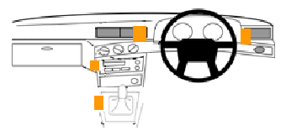

Shaded area
Position of other taxi equipment

Example of driver authority card displayed within shaded area
The driver authority card displayed in the following photograph is displayed within the shaded area of the diagram.
Figure 1 – Vehicle (Car) Dashboard
Note An example is part of the instrument, is not exhaustive and may extend, but does not limit, the meaning of the provision in which it appears (see Legislation Act, s 126 and s 132).

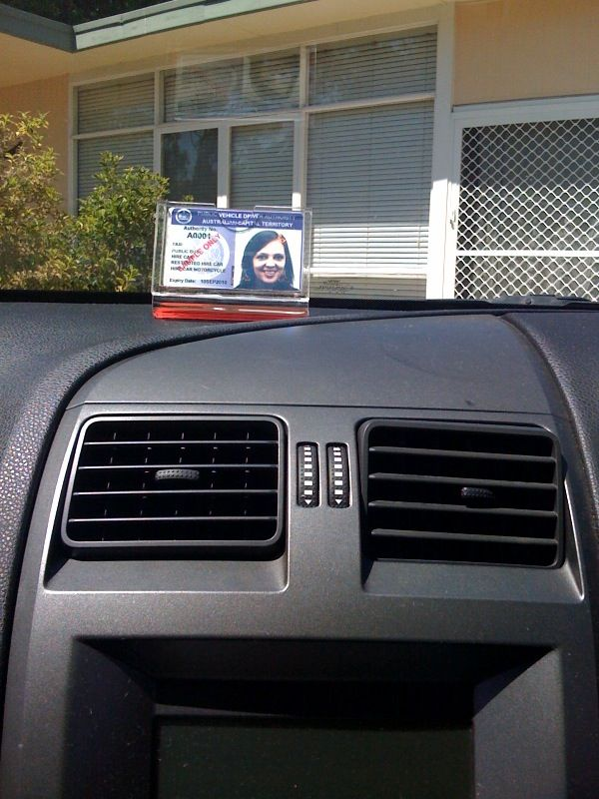

4 Position for display of driver authority cards – buses
(1) For a bus, the photo-side side of a driver authority card may be displayed above the bus’s windscreen in accordance with the photographs below.
(2) However, if the bus has a front-area layout similar to that of a sedan, the photo-side side of a driver authority card may be displayed within the shaded area shown in the diagram for clause 3.
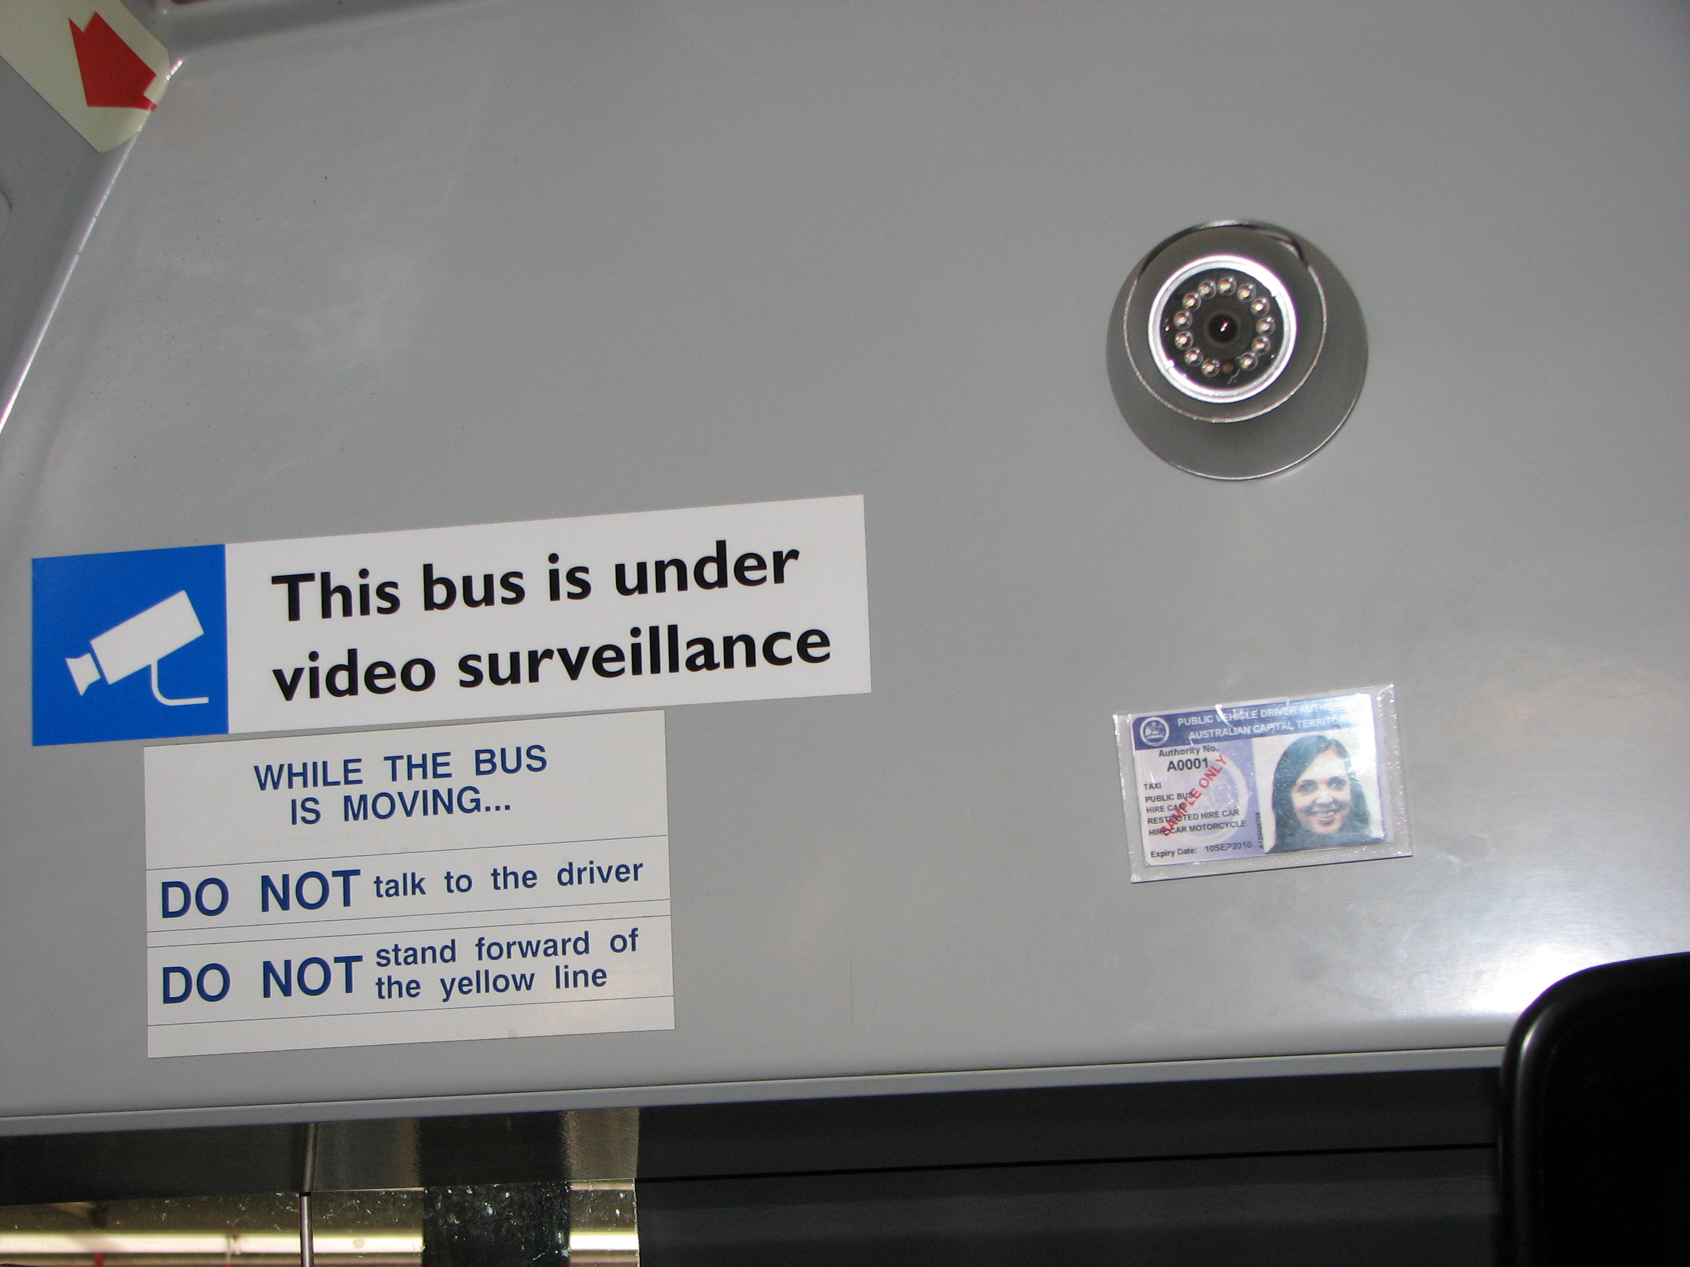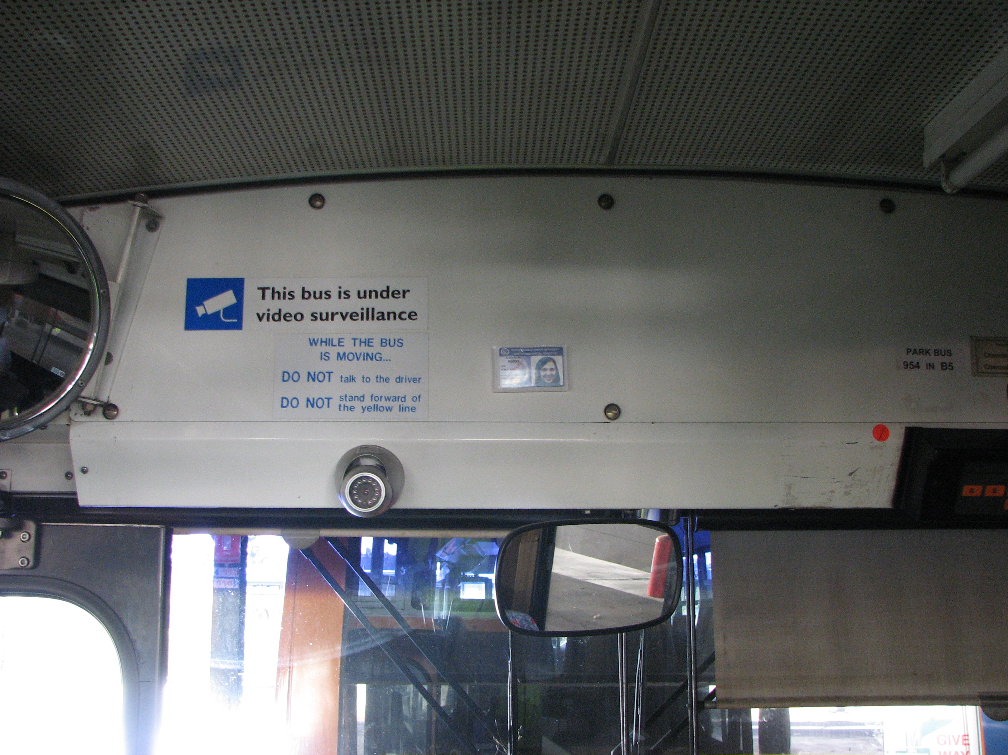

Note A driver who is authorised under a law of another jurisdiction to drive a public vehicle for hire or reward that has been issued a driver photographic identity card (however described) under that jurisdiction's law for use when operating the public vehicle may continue to display the driver’s home-jurisdiction identity card while driving in the ACT and is not required to also display an ACT-issued drive authority card (see Road Transport (Public Passenger Services) Regulation 2002, s 306, def driver authority card, par (b)).

Gary Byles
Road Transport Authority
31 March 2010

