Australian Capital Territory

Planning and Development (Technical Amendment—Miscellaneous Amendments and Corrections) Plan Variation 2010 (No 1)
Notifiable instrument NI2010 — 217
Technical Amendment No 2010-06
made under the
Planning and Development Act 2007, section 89 (Making technical amendments)

This technical amendment commences on 7 May 2010.

Technical amendment number 2010-06 to the Territory Plan has been approved by the Planning and Land Authority

Kelvin Walsh
Delegate of Planning and Land Authority

3 May 2010

Planning & Development Act 2007

Proposed
Technical Amendment
to the Territory Plan

2010-06

Miscellaneous Amendments
and Corrections

May 2010

Table of Contents
1. INTRODUCTION 1
Outline of the process 1
2. EXPLANATORY STATEMENT 1
Proposed Changes and Reasons 1
3. TECHNICAL AMENDMENT 4

INTRODUCTION

Outline of the process
The Commonwealth’s Australian Capital Territory (Planning and Land Management) Act 1988 allows for the Legislative Assembly to make laws to establish a Territory Planning Authority and for that Authority to prepare and administer a Territory Plan.
The Planning and Development Act 2007 (the Act) establishes the ACT Planning and Land Authority as the Authority which prepares and administers the Territory Plan, including continually reviewing and proposing amendments as necessary.
Technical amendments to the Territory Plan are prepared in accordance with the Act.
A variation under section 87(a) is a technical amendment that
(i) would not adversely affect anyone’s rights if approved; and
(ii) has as its only object the correction of a formal error in the plan.

EXPLANATORY STATEMENT

Proposed Changes and Reasons
- Wells Station references in Territory Plan – items 30-35

The ACT place names register was amended by notification in the ACT Legislation Register in DI2006-242 on 9 November 2006 and the ‘s’ was removed from places named Well Station. This was done in recognition of the original spelling of the property name. However, there are some instances where the incorrect spelling still occurs in the Territory Plan, namely in the Flemington Road corridor concept plan, the Gungahlin town centre and central area structure plan and the east Gungahlin structure plan. This technical amendment corrects those instances.

- Changes to provisions relating to Lyneham Section 55

A number of issues have arisen from the introduction of the restructured Territory Plan which came into effect on 31 March 2010, relating to Lyneham section 55. The necessary changes, to ensure the original policy intent is applied are described individually below:

a) inclusion of reference to Part C(3) of multi unit housing development code into the Northbourne Avenue precinct code – items 20-21

The subject section is included in both the commercial CZ5 mixed use zone and in the Northbourne Avenue precinct code. However, the redevelopment potential is primarily medium density residential in nature reflecting the original intent of the former section master plan for the area and which was not conveyed in the restructured Territory Plan. Part C(3) of the multi unit housing development code is relevant to such development. On this basis a reference to Part C(3) for Lyneham Section 55 is to be included in the Northbourne Avenue precinct code to ensure that residential amenity outcomes are addressed which are appropriate for the intended scale and type of development.

b) change to criteria C30 and C31 of Northbourne Avenue precinct code to indicate that these criteria do not apply to Lyneham Section 55 – items 22-23

Criteria C30 and C31 in the Northbourne Avenue precinct code are not considered to be appropriate or desirable for the type of residential development envisaged for Lyneham Section 55 as they relate to more to commercial development. For this reason the criteria have been revised to include a note to advise the applicant/assessor that these criteria do not apply to the subject section.

c) removal of Section 55 from the inner north precinct code Control Plan for Lyneham – item 27

Section 55 is to be removed from the inner north precinct code control plan for Lyneham as it has no effect and was inadvertently included in the restructured Territory Plan 2008.

- Inclusion of reference to other zones in Part C(3) of multi unit housing development code – item 1

To ensure adequate cross-referencing to the appropriate part of the multi unit housing development code, reference to other zones where Part C(3) is applicable for assessment purposes is to be included in Part C(3) of the multi unit housing development code. This will ensure that the relevant code applies to guide residential development in areas such as Lyneham Section 55 and other non-residentially zoned land.

- Inclusion of water sensitive urban design provisions in the Northbourne Avenue precinct code– item 25

Revised water sensitive urban design provisions were incorporated into the codes via technical amendment 2009-25 (commenced 2 October 2009). However the revised provisions were not substituted into the Northbourne Avenue precinct code. The revised provisions are incorporated into the precinct code via this amendment.

- Change to a rule to clarify the intent of the term ‘redevelopment’ in the inner north precinct code – item 26

Rule R18 in the inner north precinct code provides controls for block redevelopment in the RZ4 medium density residential zone and is intended to avoid isolation of single dwellings being surrounded by developments of more than two dwellings on both side boundaries. The provisions have been transcribed from the requirements contained in section master plans under the previous Territory Plan and were intended to apply to redevelopment of more than two dwellings.

R18 will be corrected to refer to redevelopment of more than two dwellings.

- Correction of Australian Standard – AS1158.3.1 numbering
– items 5-11,13-15,19, 24,28

In technical amendment 2009-23 (commenced 10 July 2009) the numbering of ‘Australian Standard AS1158.1.3’ within the multi unit housing development code Part C(3) Element 3.5 – Crime Prevention Rule 132 was identified as numerically incorrect. ‘AS1158.1.3’ was changed to ‘AS1158.3.1’ as a result of the technical amendment.

The incorrect Australian Standard number has been further identified in various codes throughout the Territory Plan. This technical amendment corrects the numbering.

- Removal of the term playing field from prohibited tables in various zones and revision of the definition – items 2,3,12,16-18,29

An outdoor recreation facility is an assessable use in the commercial CZ5 mixed use and CZ6 leisure and accommodation zones, the community facility zone CFZ, the NUZ1 broadacre zone, NUZ2 rural zone and NUZ3 hills ridges and buffer zone. A playing field is deemed to fall under the broad description of an outdoor recreation facility. However ‘playing field’ is listed as prohibited in the development tables. This is a contradiction to an outdoor recreation facility being an assessable use. This amendment removes ‘playing field’ from the prohibited table in the CZ5, CZ6, CFZ, NUZ1, NUZ2 and NUZ3 zones. The ‘playing field’ definition will also be revised to incorporate reference to this use being included in the broader description of an outdoor recreation facility.

- Correction of surge protection line and pink tailed worm lizard habitat map in the Coombs and Wright concept plan – items 36-37

The surge protection line as shown in Figure 4 Concept plan of the Coombs and Wright precinct code has been found to be incorrect. A revised diagram has been prepared rectifying this situation and delineating the correct alignment.

The wording of rule R48 in the concept plan has also been revised in relation to the amended diagram to ensure that no leases are issued down-slope of the surge protection line until it is demonstrated that Scrivener Dam meets flood safety and operational requirements, based on the applicable Australian National Committee on Large Dams (ANCOLD) guidelines.

The information relating to pink tailed worm lizard habitat has been updated following recent surveys. A revised map has been prepared showing the updated information.

- City centre development code typographical correction R20 a) – item 4

A closed bracket has been left out after ‘Garema Place’. This is corrected in this technical amendment.

TECHNICAL AMENDMENT

Variation to multi unit housing development code
- Part C(3) – Multi Unit Housing – Inner North Canberra and Gungahlin District – RZ3 and RZ4 Zones

Substitute wording as underlined below:

This Part of the Code applies to development applications for multi unit housing in the RZ3 – Urban and RZ4 – Medium Density Zones in Inner North Canberra and the Gungahlin District and other zones where referred to elsewhere in the Territory Plan. These controls apply instead of those contained in Part C(1) of the Code. Parts A and B of the Code also apply.

Variation to the commercial CZ5 mixed use zone development table
- Prohibited Development

Remove ‘playing field’

Variation to the commercial CZ6 leisure and accommodation zone development table
- Prohibited Development

Remove ‘playing field’

Variation to the city centre development code
- Part A(1) City Centre – CZ1 Core Zone, Element 2 Building and Site Controls, Item 2.7 East of Northbourne Avenue and London Circuit, R20 a)

After ‘Garema Place’ close brackets.

- Part B General Development Controls, Element 5 Amenity, Item 5.2 Lighting R79

Substitute AS1158.1.3 with:

AS1158.3.1

Variation to town centres development code
- Part B General Development Controls, Element 5 Amenity, Item 5.2 Lighting R79

Substitute AS1158.1.3 with:

AS1158.3.1

Variation to group centres development code
- Part B General Development Controls, Element 5 Amenity, Item 5.2 Lighting R53

Substitute AS1158.1.3 with:

AS1158.3.1

Variation to local centres development code
- Part A General Development Controls, Element 5 Amenity, Item 5.2 Lighting R29

Substitute AS1158.1.3 with:

AS1158.3.1

Variation to CZ2 office areas outside centres development code
- Part A General Development Controls, Element 5 Amenity, Item 5.2 Lighting Rule 23

Substitute AS1158.1.3 with:

AS1158.3.1

Variation to CZ5 mixed use zone development code
- Part A General Development Controls, Element 5 Amenity, Item 5.2 Lighting R23

Substitute AS1158.1.3 with:

AS1158.3.1

Variation to CZ6 leisure and accommodation zone development code
- Part A General Development Controls, Element 5 Amenity, Item 5.2 Lighting R25

Substitute AS1158.1.3 with:

AS1158.3.1

Variation to the CFZ community facility zone development table
- Prohibited

Remove ‘playing field’

Variation to community facility zone development code
- Part A General Development Controls, Element 5 Amenity Item 5.2 Lighting R24

Substitute AS1158.1.3 with:

AS1158.3.1

Variation to parks and recreation zone development code
- Part B General Development Controls Element 5 Amenity Item 5.2 Lighting R27

Substitute AS1158.1.3 with:

AS1158.3.1

Variation to transport and services zone development code
- Part B General Development Controls Element 5 Amenity Item 5.1 Lighting R19

In R19 substitute AS1158.1.3 with:

AS1158.3.1

Variation to the NUZ1 broadacre zone development table
- Prohibited

Remove ‘playing field’

Variation to the NUZ2 rural zone development table
- Prohibited

Remove ‘playing field’

Variation to the NUZ3 hills ridges and buffer zone development table
- Prohibited

Remove ‘playing field’

Variation to non urban zones development code
- Part B General Development Controls Element 5 Amenity Item 5.1 Lighting R30

Substitute AS1158.1.3 with

AS1158.3.1

Variation to Northbourne Avenue precinct code
- Introduction – Application of this code, second paragraph, second sentence

Substitute wording as underlined below:

For multi unit housing refer to part C(5) of the Multi Unit Housing Development Code except for Lyneham Section 55 where part C(3) of the Multi Unit Housing Development Code applies.

- Part B General Development Controls Element 1 Restrictions on Use, 1.1 Residential Use R18

Substitute with:

All multi unit housing is designed to comply with Part C(5) of the Residential Zones Multi Unit Housing Development Code except for Lyneham Section 55 where Part C(3) applies.

- Part B General Development Controls Element 3 Built Form, 3.1 Building Design C30

Insert the following:

Note: this criterion does not apply to Lyneham Section 55

- Part B General Development Controls Element 3 Built Form, 3.1 Building Design C31

Insert the following:

Note: this criterion does not apply to Lyneham Section 55

- Part B General Development Controls Element 5 Amenity Item 5.2 Lighting R53

Substitute AS1158.1.3 with:

AS1158.3.1

- Part B General Development Controls Element 6 Environment, Intent a)

Insert the following:

6.1 Water Sensitive Urban Design
Note: Refer to the Water Ways: Water Sensitive Urban Design General Code for more information on Water Sensitive Urban Design
R57  Evidence is provided that shows the development achieves a minimum 40% reduction in mains water consumption compared to an equivalent development constructed in 2003 using the ACTPLA on-line assessment tool or another tool as included in the Water Ways: Water Sensitive Urban Design General Code. The 40% target is met without any reliance on landscaping measures to reduce consumption.  This requirement does not apply for extensions with an increase in the combined roof plan area, driveway, car manoeuvring areas and car parking areas of less than 25% of the original area. | This is a mandatory requirement. There is no applicable criterion.
R58  All sites of size greater than 2,000m² need to provide evidence of stormwater storage greater than or equal to the volume of 1.4kL per 100m² of impervious area and release over a period of 1 to 3 days. 50% of the volume of rainwater tanks with a toilet connection may be regarded as contributing towards this requirement.  This requirement does not apply for extensions with an increase in the combined roof plan area, driveway, car manoeuvring areas and car parking areas of less than 25% of the original area. | C58  Evidence is provided that demonstrates that for all sites of size greater than 2,000m², a reduction of 1-in-3 month stormwater peak run off flow to pre-development levels with release of captured flow over a period of 1 to 3 days can be achieved.  This requirement does not apply for extensions with an increase in the combined roof plan area, driveway, car manoeuvring areas and car parking areas of less than 25% of the original area.
R59  Sites of size greater than 5,000m² need to provide evidence showing a reduction in average annual stormwater pollutant export load of:  a) suspended solids by 60%  b) total phosphorous by 45%  c) total nitrogen by 40%  compared to an urban catchment with no water quality management controls, using the MUSIC model to demonstrate compliance.  This requirement does not apply for extensions with an increase in the combined roof plan area, driveway, car manoeuvring areas and car parking areas of less than 25% of the original area. | C59  Sites of size greater than 5,000m² need to provide evidence showing a reduction in average annual stormwater pollutant export load of:  a) suspended solids by 60%  b) total phosphorous by 45%  c) total nitrogen by 40%  compared to an urban catchment with no water quality management controls, using any other method.  This requirement does not apply for extensions with an increase in the combined roof plan area, driveway, car manoeuvring areas and car parking areas of less than 25% of the original area.
R60  All sites of size greater than 2,000m² and subject to redevelopment need to ensure that the capacity of the existing pipe (minor) stormwater connection to the site is not exceeded in the 1-in-20 year storm event.  All sites of size greater than 2,000m² and subject to redevelopment need to ensure that the capacity of the existing overland (major) stormwater system to the site is not exceeded in the 1-in-100 year storm event.  For estate and multiple block developments larger than 5,000m², retardation of stormwater to meet the above requirements are to be met at the estate scale rather than by measures on individual blocks. | C60  Evidence is provided by a suitably qualified person that shows that for all sites of size greater than 2,000m² and subject to redevelopment  EITHER  a reduction of 1-in-5 year and 1-in-100 year stormwater peak run off flow to pre-development levels. See WaterWays General Code for more detail.  OR  That the capacity of the downstream piped stormwater system to its outlet with an open channel is not exceeded in the 1-in-20 year storm event.  For estate and multiple block developments larger than 5,000m², retardation of stormwater to meet the above requirements are to be met at the estate scale unless it can be demonstrated that this is less feasible than measures on individual blocks.

Variation to inner north precinct code
- Part A General Development Controls, Element 3 Built Form, Item 3.2 Interface R18

Substitute wording as underlined below:
Redevelopment of more than two dwellings on a block in RZ4 is not permitted where it adjoins an existing single dwelling that has an existing or approved redevelopment of more than two dwellings on the other side boundary, unless the single dwelling site is one or more of the following:

- Part B Control Plans, Control Plan - Lyneham (page 14)

Substitute ‘Control Plan – Lyneham’ with the amended control plan at Appendix A

Variation to access and mobility general code
- Part A General Development Controls Element 2 External Access to Entrances Item 2.2 Lighting R5

Substitute AS1158.3 with

AS1158.3.1

Variation to Definitions
- Part A Definitions of Development – Playing field

Substitute wording as underlined below:

Playing field means the use of land which is unrestricted to public access and which is used as an outdoor recreation facility for activities such as the conduct of sports, athletics and games and includes facilities with such land for the enjoyment or convenience of the public such as kiosks, car parks, changing facilities, pavilions and the like.

Variation to structure plans Gungahlin town centre and central area
- Urban Structure Principles Central Area, Central Area Land Use 7

In the second line substitute ‘Wells’ with:
Well

- Urban Structure Principles Central Area, Central Area Heritage 4

In the first line substitute ‘Wells’ with:

Well

- Urban Structure Principles Central Area, Central Area Heritage 5

In the first line substitute ‘Wells’ with:

Well

Variation to structure plans east Gungahlin
- Part 1.2 Principles and Policies for East Gungahlin, 1.2.2 Kenny and part Harrison, Specific Policies 4
Substitute ‘Wells’ with:
Well

- Part 1.2 Principles and Policies for East Gungahlin, 1.2.3 Throsby, Specific Policies 1
Substitute ‘Wells’ with:

Well

Variation to concept plans – Precinct codes for section 93 of the Planning and Development Act 2007 Flemington Road corridor
- Part 2.0 FLEMINGTON ROAD CONCEPT PLAN, 2.4 Indicative Development Plan – Primary Elements, Item 2.4.12 Natural and Cultural Heritage Features
At the fourth dot point under the paragraph that ends with the sentence ‘Details of these measures are as follows’ substitute ‘Wells’ with:
Well

Variation to concept plans – Precinct codes for section 93 of the Planning and Development Act 2007 Coombs and Wright
- Part B – Subdivision Element 9 Stormwater R48

Insert wording as underlined below:

Molonglo surge protection line is provided in Coombs as indicated on figure 4. No leases (other than holding leases) are to be issued down-slope of this line until it is demonstrated that Scrivener Dam meets flood safety and operational requirements, based on the applicable Australian National Committee on Large Dams (ANCOLD) guidelines.

- Part C – Buildings and structures Figure 4 and Figure 5

Substitute with Figure 4 Concept Plan and Figure 5 Areas of pink-tailed worm lizard (Aprasia parapulchella) habitat at Appendix B.

Interpretation service
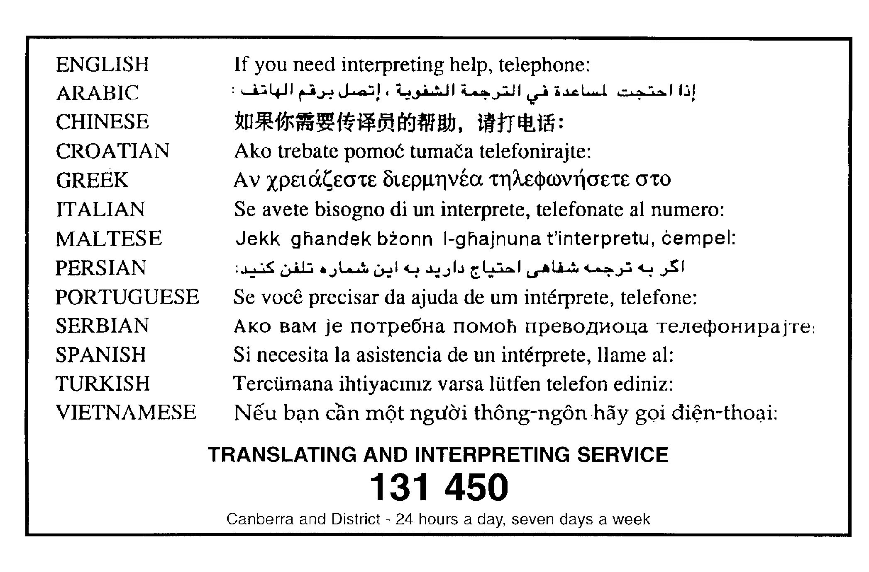
Appendix A
Lyneham Control Plan
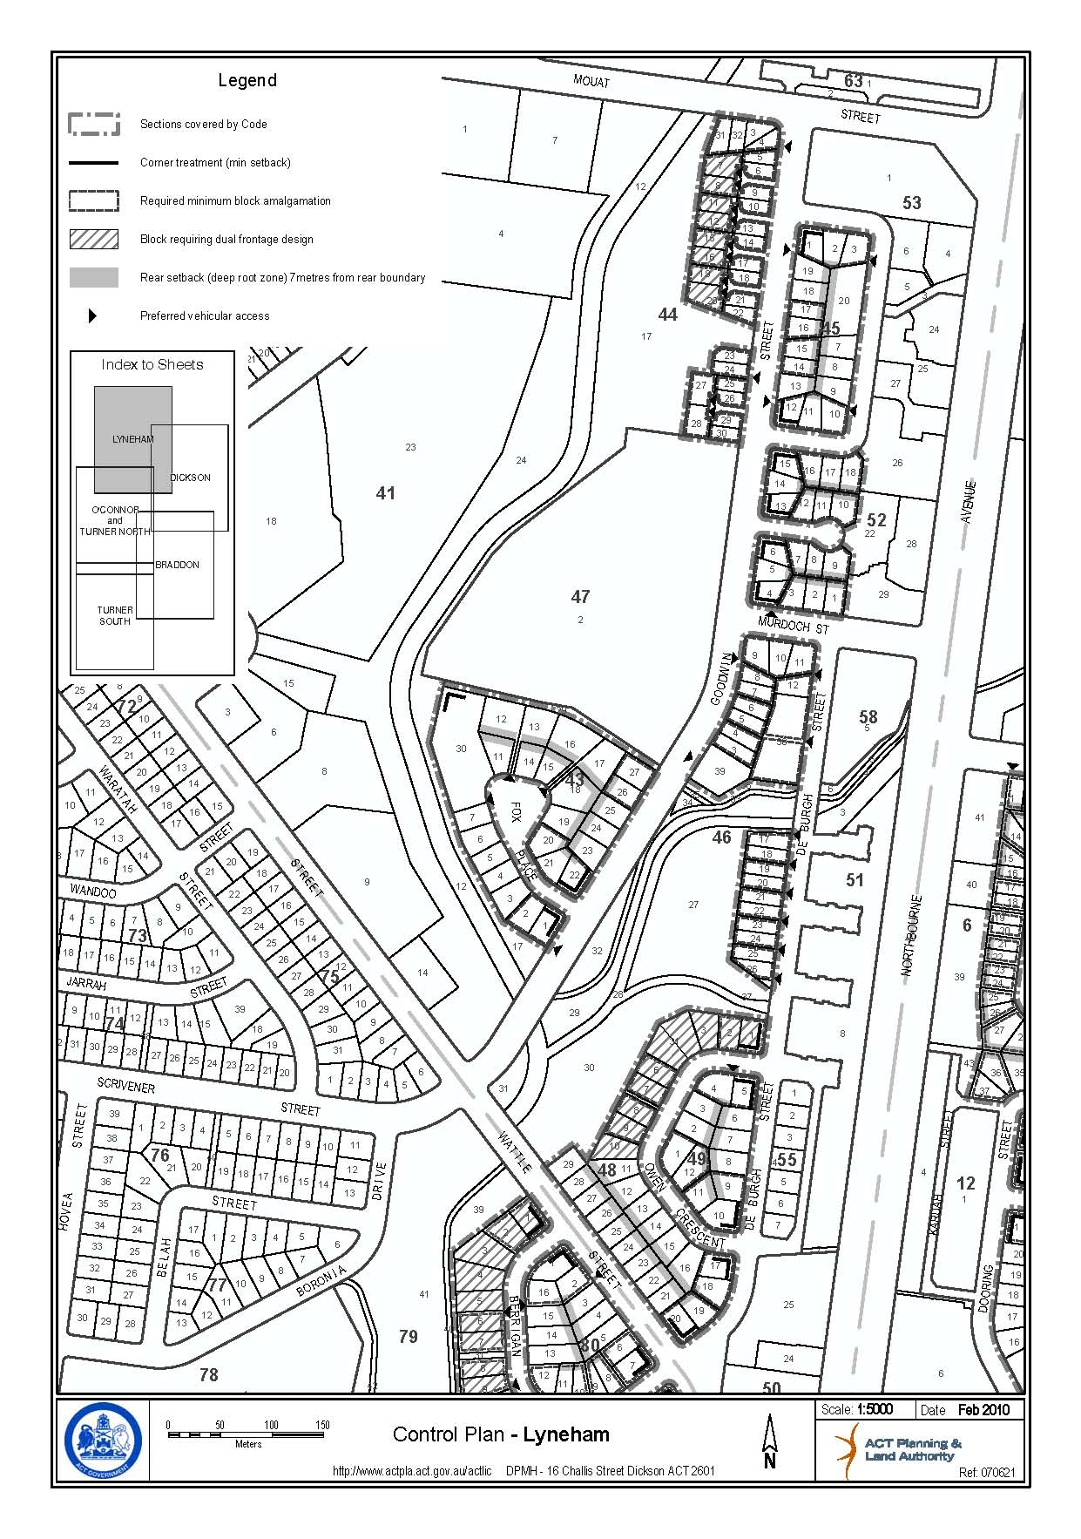

Appendix B

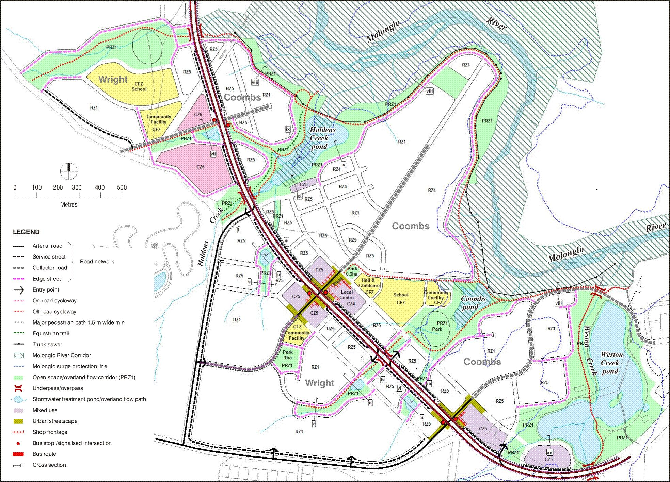
Figure 4 Concept Plan
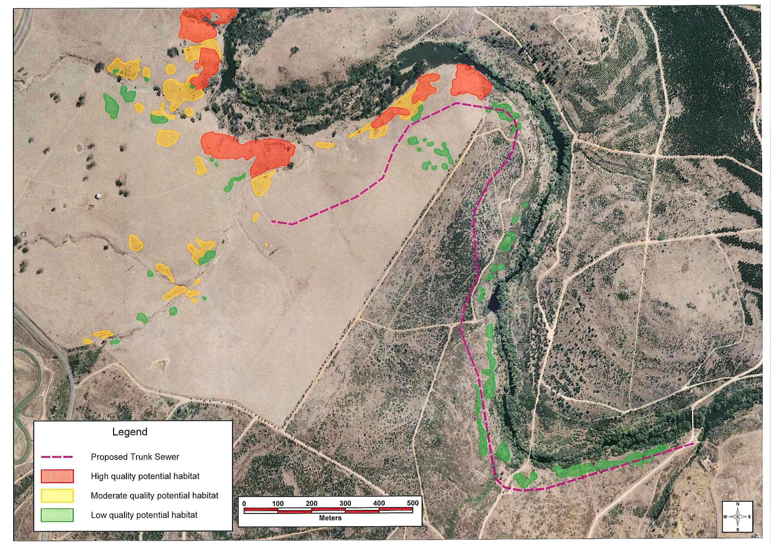
Figure 5: Areas of pink-tailed worm lizard (Aprasia parapulchella) habitat

