Australian Capital Territory
Planning and Development (Draft Variation No. 302) Consultation Notice 2010

Community Facility Zone: replacement of zone objectives, development table, development code and rezoning of Belconnen section 87 blocks 12–15

Notifiable instrument NI2010–222
Made under the Planning and Development Act 2007, section 63 (Public consultation—notification) and section 64 (Public consultation—notice of interim effect etc)

Draft Variation No. 302 to the Territory Plan (see Annexure A) has resulted from a general review of the policies in the Territory Plan relating to the community facility zone. The draft variation proposes to replace the zone objectives, development table and development code. It also proposes, as a consequence, to rezone Belconnen section 87 blocks 12–15.
You can get copies of draft variation documents:
- online at www.actpla.act.gov.au (note free internet access is available at ACT public libraries)
- at ACTPLA’s customer service centre, 16 Challis Street, Dickson during business hours.
Written comments from the public are invited by COB Tuesday 22 June 2010.
Comments should include reference to the draft variation, a return postal address and be addressed to Manager, Development Policy Section.
Comments can be:
- delivered to ACTPLA’s customer service centre at the above address
- mailed to ACTPLA, GPO Box 1908, Canberra ACT 2601
- emailed to terrplan@act.gov.au
Copies of comments received will be made available for public inspection at ACTPLA’s customer service centre in Dickson during business hours for no less than 15 working days after the closing date.
The draft variation does not have interim effect and therefore section 65 of the Planning and Development Act 2007 does not apply. The current Territory Plan will continue to apply while the variation remains in draft form.

Kelvin Walsh
Delegate of the ACT Planning and Land Authority
05 May 2010

Planning & Development Act 2007

Draft
Variation to the
Territory Plan
Number 302

Community Facility Zone:
Replacement of Zone Objectives, Development Table,
Development Code and Rezoning of Belconnen section 87 blocks 12–15

May 2010

Table of Contents
1. INTRODUCTION 3
1.1 Summary of the Proposal 3
1.2 Outline of the process 3
1.3 This document 4
1.4 Public Consultation 4
2. EXPLANATORY STATEMENT 5
2.1 Background 5
2.2 Current Territory Plan Provisions 5
2.3 Summary of Key Changes 6
2.4 Reasons for the Proposed Changes 8
2.5 Planning Context 13
2.6 Interim Effect 14
2.7 Consultation with Government Agencies 14
3. DRAFT VARIATION 18

- INTRODUCTION
Summary of the Proposal
This draft variation proposes changes to the Community Facility Zone in the Territory Plan and includes changes to the zone objectives, development table and development code and a consequential rezoning of Belconnen section 87 blocks 12–15 from community facilities to residential and urban open space. The changes arise from the general policy review of the Territory Plan. Details of the key changes and the reasons for the changes are included in Part 2 of this document.

Outline of the process
The Commonwealth’s Australian Capital Territory (Planning and Land Management) Act 1988 allows for the Legislative Assembly to make laws to establish a Territory Planning Authority and for that Authority to prepare and administer a Territory Plan. The Planning and Development Act 2007 (the P&D Act) establishes the ACT Planning and Land Authority (ACTPLA) as the Authority which prepares and administers the Territory Plan, including continually reviewing and proposing amendments as necessary.

The Territory Plan is comprised of the written statement and a map. The written statement contains a number of parts, namely Governance; Strategic Directions; Zones; Precinct Codes; General Codes; Overlays; Definitions; Structure Plans, Concept Plans and Development Codes for Future Urban Areas.

The Territory Plan Map graphically represents the applicable land use zones (under the categories of Residential, Commercial, Industrial, Community Facility, Urban Parks and Recreation, Transport and Services and Non Urban), precincts and overlays. The zone, precinct and overlay requirements are detailed in the volumes of the Territory Plan.

Draft variations to the Territory Plan are prepared in accordance with the P&D Act. Following the release of the draft variation under section 63 of the P&D Act, submissions from the public are invited. At the conclusion of the consultation period the ACTPLA submits a report on consultation and a recommended final variation to the Minister for Planning for approval. The Minister has the discretion to determine if referral to the Legislative Assembly Standing Committee on Planning, Public Works and Territory and Municipal Services is warranted prior to approval, depending on the nature and significance of the proposal. If the draft variation is referred to the Committee by the Minister or otherwise, the Minister must consider the findings of the Committee before deciding whether to approve the draft variation. If the Minister approves the variation, the variation and associated documents will be tabled in the Legislative Assembly. Unless disallowed by the Legislative Assembly within five sitting days, the variation commences on a day nominated by the Minister.

This document
This document contains the background information in relation to the proposed variation. It comprises the following parts:
- Part 1 - This Introduction.
- Part 2 - An Explanatory Statement, which gives reasons for the proposed variation and describes its effect.
- Part 3 - The Draft Variation, which details the precise changes to the Territory Plan that are proposed.

Public Consultation
Comments from the public are invited on the draft variation. Subject to consideration of responses received, ACTPLA proposes to submit this draft variation to the Minister for Planning in accordance with the P&D Act.
The documents relating to this draft variation may be obtained from
- www.actpla.act.gov.au/tools_resources/legislation_plans_registers/plans/
territory_plan/current_territory_plan_variations
- ACTPLA’s Customer Service Centre, 16 Challis Street, Dickson between 8:30am and 4:30pm weekdays
Note that free internet access is available at all ACT Public Libraries.
Written comments from the public are invited on the draft variation by COB Tuesday 22 June 2010. Comments should include reference to the draft variation and a return postal address.
Comments may be submitted via
- Manager Development Policy Section,
GPO Box 1908, Canberra ACT 2601
- ACTPLA’s customer service centre (at the address above)
- terrplan@act.gov.au
Copies of all written comments received from the public will be made available for public inspection at the ACTPLA’s Customer Service Centre, Dickson for a period of not less than 15 working days after the closing date listed above.
- EXPLANATORY STATEMENT
Background
As part of the reform of the ACT planning system, a restructured Territory Plan came into effect on 31 March 2008. However, most of the policy content in this document remained unchanged. In 2009 the ACT Planning and Land Authority (ACTPLA) commenced a general review of the policy content of the Territory Plan, including policy relating to the community facility zone.

Following initial research, including reviewing practices in other jurisdictions and recent operational experiences within the ACT, an issues paper was released for public comment in September 2009. In preparing this draft variation, comments received from the public, community organisations, and ACT Government agencies have been considered.

Current Territory Plan Provisions
Planning policies for the community facility zone are contained in the zone objectives, development table, and the community facility zone development code (development code).

The zone objectives are specified and the development table indicates the relevant assessment track for development applications for different forms of land use in the zone.

The development code provides planning controls used in the development assessment process. These policies, which provide guidance for assessing development, are grouped into the following broad ‘elements’.

      - Restrictions on Use
      - Building and Site Controls
      - Built Form
      - Parking and Site Access
      - Amenity
      - Environment
      - Services

Summary of Key Changes
Proposed changes to the Community Facilities Zone Objectives and Development Table
A Revise zone objectives to clarify and include social inclusion, social sustainability and community formation principles.
B Replace the existing development table with a new table which introduces the following changes:
- Adds types of lease variations to code, merit and impact tracks (items B1, B2 and B4)
- Deletes area specific provisions for sites at Forrest and Belconnen (item B3)
- Removes superfluous references to other codes (item B5)
- Removes ‘funeral parlour’ from the merit track and inserts it into the prohibited development list (item B6)

Proposed changes to the Community Facility Zone Development Code
C Replace the existing development code with a new code which introduces the following:
- New schedule indicating which community facility zoned sites are required for COMMUNITY USE which includes all existing sites with an ‘E –Education’ overlay (items C1 and C2)
- New rule clarifying that all RESIDENTIAL USES in the community facility zone cannot be unit titled or separately subdivided (item C3)
- Changes to the rules and criteria for business agency, office and public agency (item C4)
- Removal of criterion relating to meeting requirements of general codes as this applicability of these codes is contained in a new table (item C5)
- Convert the existing criterion relating to the community and recreation facilities location guidelines general code into a rule and create a new criterion in its place (item C6)
- Changes to the height limits for RESIDENTIAL USE (item C7)
- Introduce a sunset date for application of the current code provision relating to neighbourhood plans (item C8)
- Removal of duplication of provisions requiring solar access (item C9)

Proposed changes to the Territory Plan Map
- Remove the existing ‘E - Education’ overlay from the map
- Rezone Belconnen section 87 blocks 13, 14 and 15 from community facility zone to residential RZ3 urban residential zone and Belconnen section 87 block 12 from community facility zone to parks and recreation PRZ1 urban open space

Reasons for the Proposed Changes

A Revised Zone Objectives
The current zone objectives are to be replaced with new zone objectives.
Whilst maintaining a similar overall intent, the proposed changes to the zone objectives more clearly state the goals of the community facility zone in achieving social inclusion and community formation. The changes also incorporate the social sustainability principles identified in the statement of strategic directions of the Territory Plan. Minor changes to the wording have been made to several objectives for the purposes of clarification.
B New Development Table

B1 Lease variations have been added to the merit track of the development table to reflect their status as ‘development’ under the Planning and Development Act 2007.

B2 A list of development applications that may be assessed under the code track assessment process have been added to the development table. The types of development added relate to minor lease variations involving changes that are largely administrative in nature and do not change the development rights afforded by the lease. On this basis code track assessment is considered appropriate due to the minor nature of these ‘developments’.

B3 Details of site specific provisions for additional development at Belconnen section 87 and Forrest section 24 block 7 and their respective figures (figures 1 and 3) have been deleted. The sites have now either been fully developed or are subject to lease and development conditions and the provisions are no longer relevant. It should be noted that Belconnen section 87 blocks 12–15 are to be rezoned as detailed under E below.

A site specific provision at Forrest has been deleted. The site specific use of ‘shop’ was historically added to Forrest section 24 block 7 to facilitate a Catholic bookshop related to the ‘religious associated use’ of this site. The provision is no longer necessary as the use “shop” can be accommodated as an “ancillary use” under the restructured Territory Plan (2008).

B4 Addition of an item that can be assessed under the impact track – that is “varying a lease to add a use assessable under the impact track”. This type of lease variation was an omission in the current Territory Plan.

B5 Under the development table heading “relevant codes” reference is only made to the community facilities zone development code. References to other codes have been removed as the introduction to the community facilities development code includes a statement which details the hierarchy and applicability of the codes and makes this reference superfluous.

B6 ‘Funeral parlour’ has been removed from the merit track and added to the prohibited list. There are no funeral parlours currently located on community facility zoned land. Any funeral parlour proposal would be able to compete in the commercial market for other suitably zoned land, and this change would therefore protect community facility zoned land for other community uses.

C Revised Community Facility Zone Development Code

The key changes to the development code, together with the reason for the change, are listed below. Various other changes have also been made to improve expression without changing policy controls.

C1 A schedule has been introduced into the development code indicating which community facility zoned sites are required for COMMUNITY USE.
The current development code includes a rule which states that proposals for supportive housing may only be permitted if the site has not been identified by ACTPLA as being required for COMMUNITY USE. The latter is a defined umbrella term in the Territory Plan which includes the following uses:- child care centre, community activity centre, community theatre, cultural facility, educational establishment, health facility, hospital, place of worship, and religious associated use. All of these types of development are also separately defined in the Territory Plan.

The proposal to include a schedule of sites which are required for COMMUNITY USE enables ACTPLA to consider supply and demand for community uses and other uses in a strategic context, rather than having to respond to individual proposals at the development application stage. Proposals for residential care accommodation, retirement complex or supportive housing may be considered on community facilities zoned land not in the schedule.

The schedule will be updated as needed to reflect changing community needs and the leasing of blocks over time.

C2 All sites currently identified with an ‘E –Education’ overlay are to be incorporated into the schedule of sites required for COMMUNITY USE (discussed above under C1).

The ‘E-Education’ overlay was used as a mechanism for limiting the range of uses assessable on specified parts of some public school sites. It is proposed to replace the existing overlay by including these sites in the schedule of sites required for COMMUNITY USE.

Replacing the current ‘E-Education’ overlay by listing all the relevant sites in a schedule will ensure that CFZ land on current public school grounds is unable to be used for supportive housing. At the same time it will allow greater flexibility should land be needed in the future for other forms of community facilities.

C3 A rule is introduced to clarify that all RESIDENTIAL USES in the community facility zone cannot be unit titled or separately subdivided.

Currently there is only a rule prohibiting the subdivision of supportive housing. The proposed new rule will formally clarify that all other types of RESIDENTIAL USES in the community facility zone, such as retirement complex and residential care accommodation, cannot be unit titled or separately subdivided.

The policy intent is to ensure that residential development for housing with supportive services is retained on community facility zoned land. If land is subdivided and sold separately supportive services are unlikely to be able to be retained as body corporate rules are not designed to serve this function.

C4 Changes are made to the rules and criteria for business agency, office and public agency to clarify provisions.

A rule will limit the gross floor area of a business agency, office or public agency on community facility zoned land to 400m², thereby introducing a numerical standard which specifies appropriate scale. The existing criterion relating to business agency, office and public agency is retained to allow some flexibility whilst still requiring a small scale of development or to occupy surplus ACT Government community facilities buildings (such as closed school sites) with a maximum lease term of five years.

The current development code criterion is primarily intended to facilitate the re-use of former school sites for small scale offices, public agencies, or business agencies. The insertion of the word ‘government ‘ in front of ‘surplus community facility building’ will clarify that this provision does not apply to non-government lessees of community facility zoned land where a lease purpose variation may be sought.

C5 The existing criterion which mandates meeting the requirements of the Crime Prevention through Environmental Design General Code and the Access and Mobility General Codes have been removed as their applicability is noted under the heading “Part A – Relevant Codes”.

C6 The existing criterion requiring compliance with the community and recreation facilities location guidelines general code has been converted into a rule and a new criterion introduced.

The wording of the existing criterion is similar to a rule rather than a criterion. On this basis it is converted to a rule and a new criterion introduced to facilitate a level of flexibility in interpreting the code.

The applicability of the Community and Recreation Facilities Location Guidelines General Code has been captured as a rule, rather than via reference in “Part A – Relevant Codes” (see discussion above under C5), as it is not in the standard rules and criteria format.

C7 It is proposed to amend the existing height limits for all assessable building types including for RESIDENTIAL USE.

RESIDENTIAL USE is an umbrella term that includes residential care accommodation, retirement complex and supportive housing, all of which are permissible on community facility zoned land, subject to conditions.

The development of RESIDENTIAL USE in the community facilities zone has at times been controversial, particularly in relation to questions of density, height, and the character of existing residential areas. The lack of specification of heights within the existing policy has exacerbated this issue. Height limits for RESIDENTIAL USE in particular were raised in community comments on the public issues paper which was released in September 2009.

The new rule is introduced to specify building height to ensure maintenance of residential amenity where located within 30m of a residential block and provides an overall limit of 4 storeys. This will provide greater certainty for both residents and proponents. The criterion will allow some flexibility and provide greater guidance and consideration of the development context, where the strict rule is not able to be met.

C8 A sunset date is introduced for the application of the current code provision relating to neighbourhood plans. This will remove the requirement for development to demonstrate a response to the key strategies of the relevant neighbourhood plan beyond 1 January 2011. The current reference in the development code to the existing neighbourhood plans written in the early 2000s is becoming outdated.

C9 Provisions requiring solar access for dwellings are removed as such requirements are contained within the relevant residential housing development codes, which include solar access requirements. These codes are called up for residential development under the heading “Part A – Relevant Codes”.

D Changes to the Territory Plan Map

D1 The ‘E-Education’ Overlay is to be removed from the Territory Plan Map. This change follows from changes to the community facilities zone development code as outlined above under C1 and C2.

D2 Belconnen section 87 blocks 13, 14 and 15 are rezoned from community facility zone to residential RZ3 urban residential zone.
This land is currently within a community facility zone, with RESIDENTIAL USE (a defined umbrella term within the Territory Plan) being permitted as an additional use.

Block 13 has already been developed for two storey housing. Blocks 14 and 15 are proposed to be developed for residential use although are currently undeveloped.

Development proposals for blocks 14 and 15 will be assessed under the existing approved lease and development conditions, which stipulate that they may be developed for multi-unit housing up to four (4) storeys.

Belconnen section 87 block 12 is rezoned from community facility zone to parks and recreation PRZ1 urban open space. Block 12 is currently used for open space purposes. As it is a long narrow piece of land, isolated from other community facility zoned land, it would not be an appropriate location to develop for community facilities.

The map is, therefore, changed to reflect the revised zoning to more appropriately reflect the purpose for which these blocks will be used.

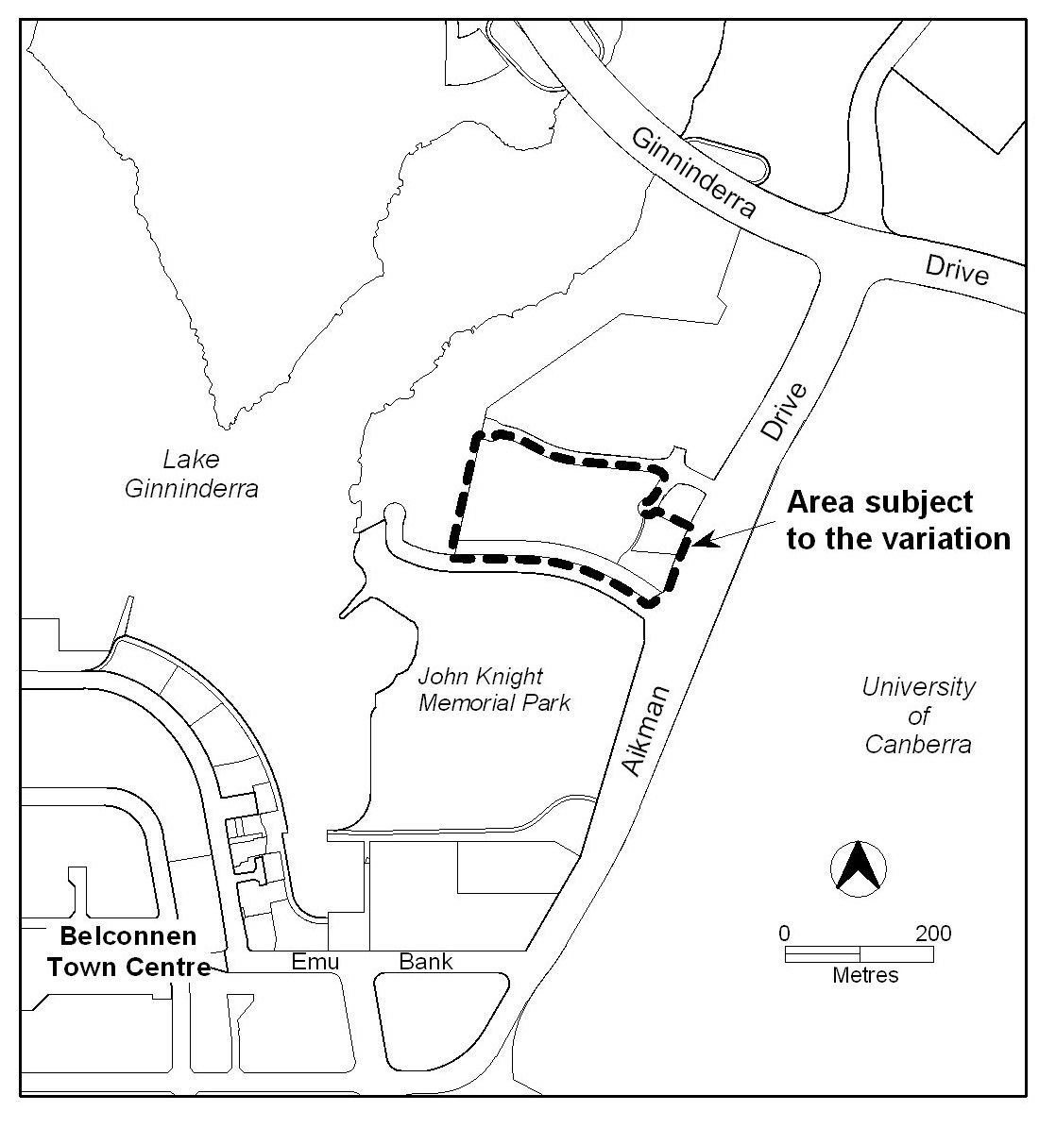
Figure 1: Location plan of the area to be rezoned

Planning Context
    - National Capital Plan
The Australian Capital Territory (Planning and Land Management) Act 1988 established the National Capital Authority (NCA) with two of its functions being to prepare and administer a National Capital Plan (NCP) and to keep the NCP under constant review and to propose amendments to it when necessary.
The NCP, which was published in the Commonwealth Gazette on
21 January 1990 is required to ensure that Canberra and the Territory are planned and developed in accordance with their national significance. The ACT (Planning and Land Management) Act 1988 also requires that the Territory Plan is not inconsistent with the NCP.

    - Territory Plan

The proposals are consistent with the Territory Plan’s Statement of Strategic Directions in terms of Environmental, Economic and Social Sustainability.

The introduction of a list of sites required for community use in schedule one of the Community Facility Zone Development Code responds to principle 1.18 which indicates that “sites will be safeguarded where necessary for particular community needs.”

The objectives for the Community Facility Zone relating to social sustainability and inclusion have been strengthened and the zone objectives and provisions within the Community Facility Zone encourage multi use of community facilities, especially close to public transport routes. This responds to principle 1.20 under the heading of Social Sustainability and 1.10 under the heading of Environmental Sustainability.

Principle 1.21 encourages the provisions of adaptable and special-needs housing. The Community Facilities Zone encourages these types of residential developments and provisions relating to height have been clarified and strengthened to minimise impacts from such developments on adjacent residential areas.

    - Spatial Plan

The proposals are consistent with the goals, objectives, and initiatives of the Canberra Spatial Plan.

Interim Effect
This draft variation does not have interim effect.
Consultation with Government Agencies
ACTPLA is required to, in preparing a draft variation under section 61 (b) consult with each of the following in relation to the proposed draft variation
- the national capital authority
- the conservator of flora and fauna
- the environment protection authority
- the heritage council
- if the draft variation would, if made, be likely to affect unleased land or leased public land – each custodian for the land likely to be affected

National Capital Authority (NCA)

The NCA provided the following comments on 18 March 2010:
The NCA has no objection to the draft variation proceeding, and in particular supports the revised objectives for the Community Facility Zone which promotes social inclusion, sustainability and community formation.

Response
Comments from the NCA and it support for the changes has been noted.

Conservator of Flora and Fauna

The Conservator of Flora and Fauna provided the following comments on 26 March 2010:
I advise that I have examined the draft variation and have no comments to provide other than to note my support for the change in land use of Belconnen section 87 block 12 to public land, urban open space.
Response
Comments from the Conservator of Flora and Fauna and it support for the change in land use of Belconnen section 87 block 12 have been noted.

Environment Protection Authority (EPA)

The EPA provided the following comments on 1 April 2010:
The EPA doesn’t have issues with the key changes outlined in section 2.3 of the explanatory statement. Instead the comments relate to some minor changes to the Community Facility Zone Development Code.
A new section entitled ‘Excavation’ has been added under Element 6: Environment rule R18 which appears to be a duplicate of rule R20 but they are under different subheadings – ‘Excavation’ and ‘Water Sensitive Urban Design”. It is not clear why this rule is duplicated.
The updated rules rule R28 and R29 more accurately reflect the processes of the EPA than the previous version, so the change is supported.
Some of the wording in the development code has been slightly adjusted, but generally conveys the same information as the previous version. As the development codes are progressively updated/varied the EPA would advise consistency of wording across the codes. For example the EPA recently comments on the proposed Estate Development Code and suggest that any changed wording is consistent with that code.

Response
The two rules mentioned above were duplicates of each other. On this basis one of the rules has been removed and the rule (renumbered to R19) has been retained under the Waster Sensitive Urban Design heading.
It has been noted that rule R28 and R29 accurately reflect EPA processes.
Consistency of wording across codes being revised as part of the Territory Plan review has been checked and the draft variation updated accordingly. Whilst striving for consistency as the codes are progressively reviewed, some development of phrasing or terminology may occur.

Heritage Council

The Heritage Council provided the following comments on 25 March 2010:
It is understood that the proposal involves changes to the community facility zone policies, and replaces development code with new zone objectives, development table and development code. It is also understood that the proposal involves a rezoning of Belconnen section 87 blocks 12-15 from community facilities to residential and urban open space. Further details about the proposed changes are noted on page 6 of the draft variation report submitted.
It should be noted that the subject blocks where the proposed variation occurs are located adjacent to John Knight Memorial Park which is registered on the ACT Heritage Register.
The Heritage Council has considered the proposed changes to the Community Facility Zone and the Territory Plan Map, and advises that the proposal will not generate detrimental impacts on the heritage significance of the John Knight Memorial Park. Consequently, the Council supports the proposal.
Response
Comments from the Heritage Council and it support for the changes have been noted.

Land Custodians

The following ACT Government Land Custodians provided comment:
Territory and Municipal Services
It is understood that, as a result of the proposed rezoning, Belconnen section 87 block 12 would become a Territory and Municipal Services asset, with the attendant maintenance responsibilities.
TAMS already maintains block 12 and has no objection to it being rezoned as urban open space.
Response
Comments from TAMS regarding the change of zoning at Belconnen section 87 block 12 to urban open space have been noted.

Department of Education and Training (DET)
On 13 April 2010 DET indicated that it is pleased to advise that the Department supports the proposal.

Response
DET’s support for the support for the proposal has been noted.

- DRAFT VARIATION
Variation to the Territory Plan Map

- Territory Plan Map

Omit ‘E-Education’ Overlay from all sites identified in the Territory Plan Map

- Territory Plan Map – Belconnen

Substitute the ‘Area subject to the variation’ in Figure 2 with the ‘Area subject to the variation’ in Figure 3.
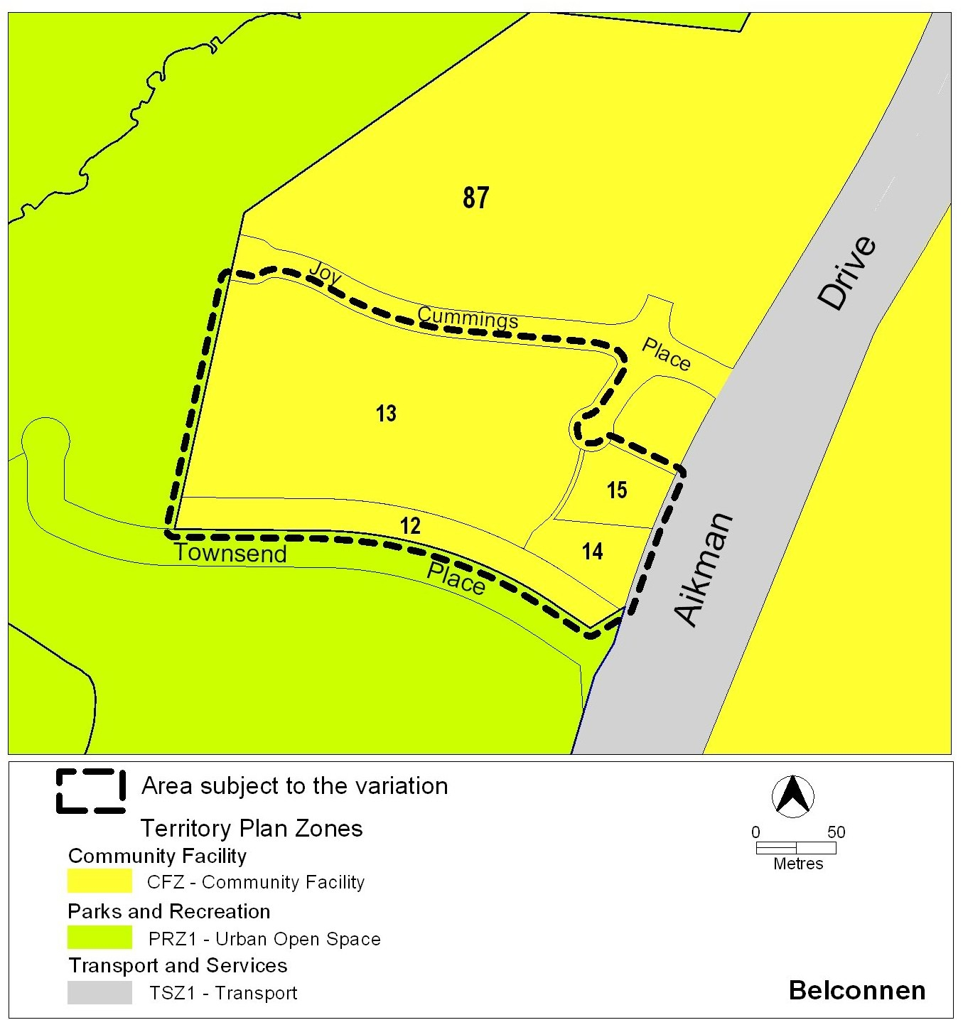
Figure 2 Current Territory Plan map showing area subject to the variation

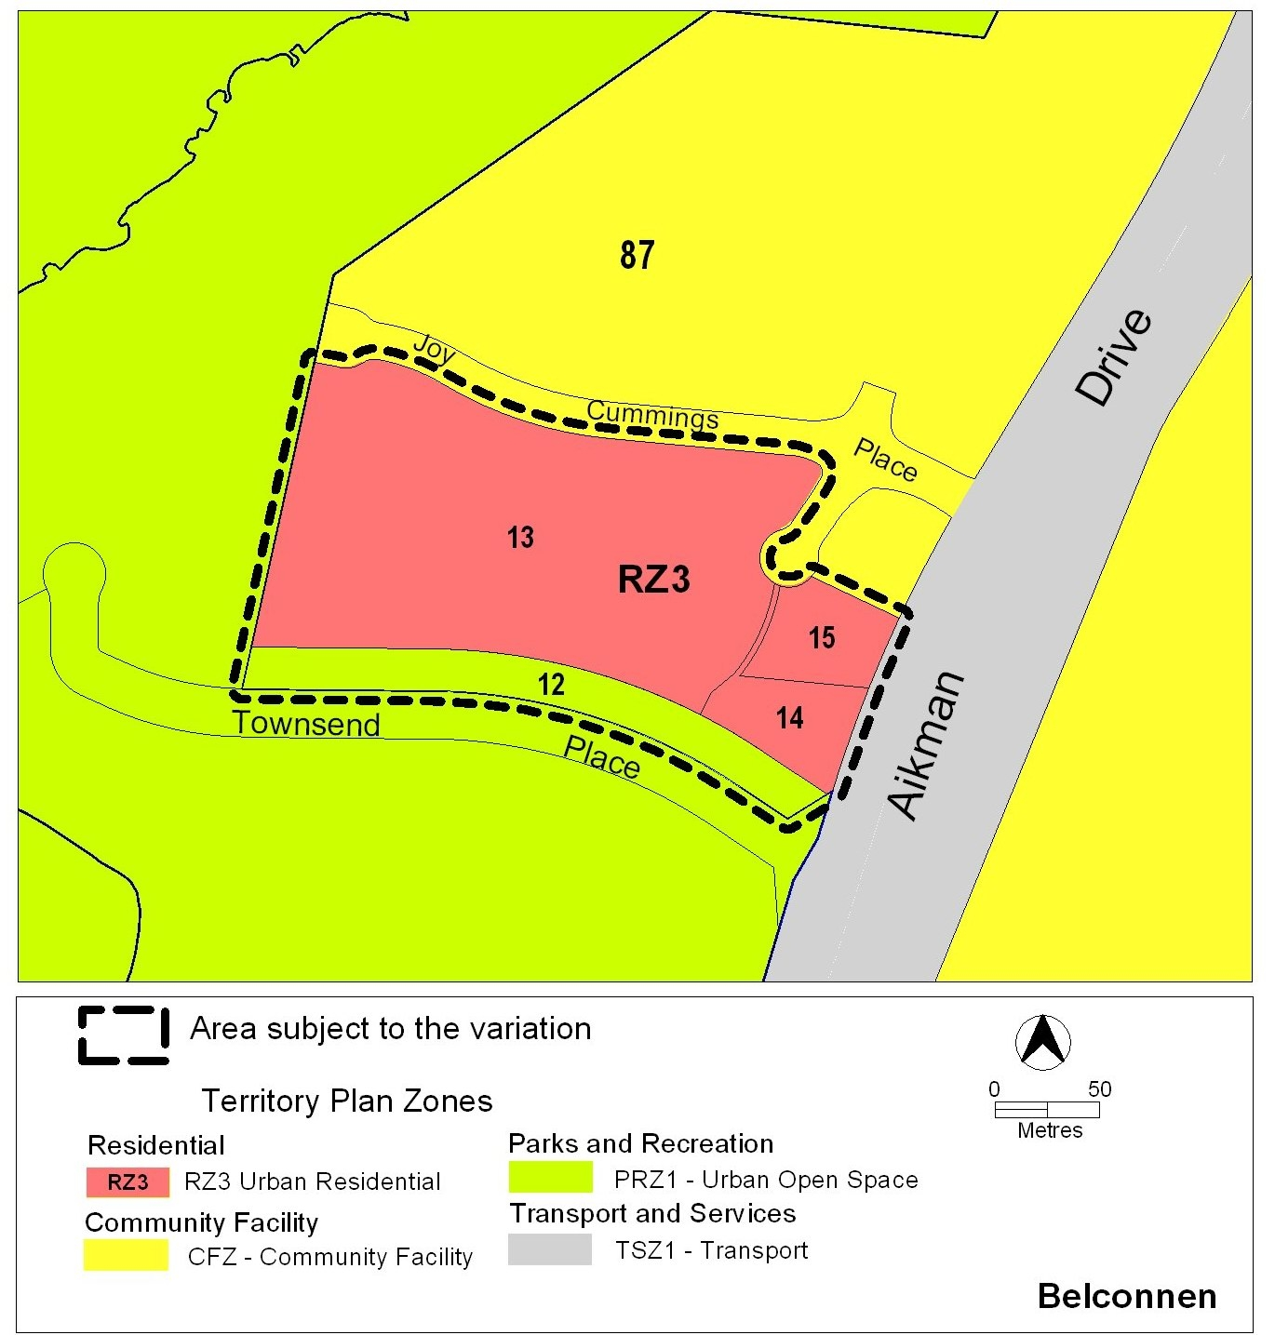
Figure 3 Proposed map showing land use zones in Belconnen

Variation to Community Facility Zones

- CFZ Objectives and Development Table

Substitute the existing Zone Objectives and Development Table with Appendix A.

- Community Facility Zone Development Code

Substitute the existing Community Facility Zone Development Code with Appendix B.

Interpretation service
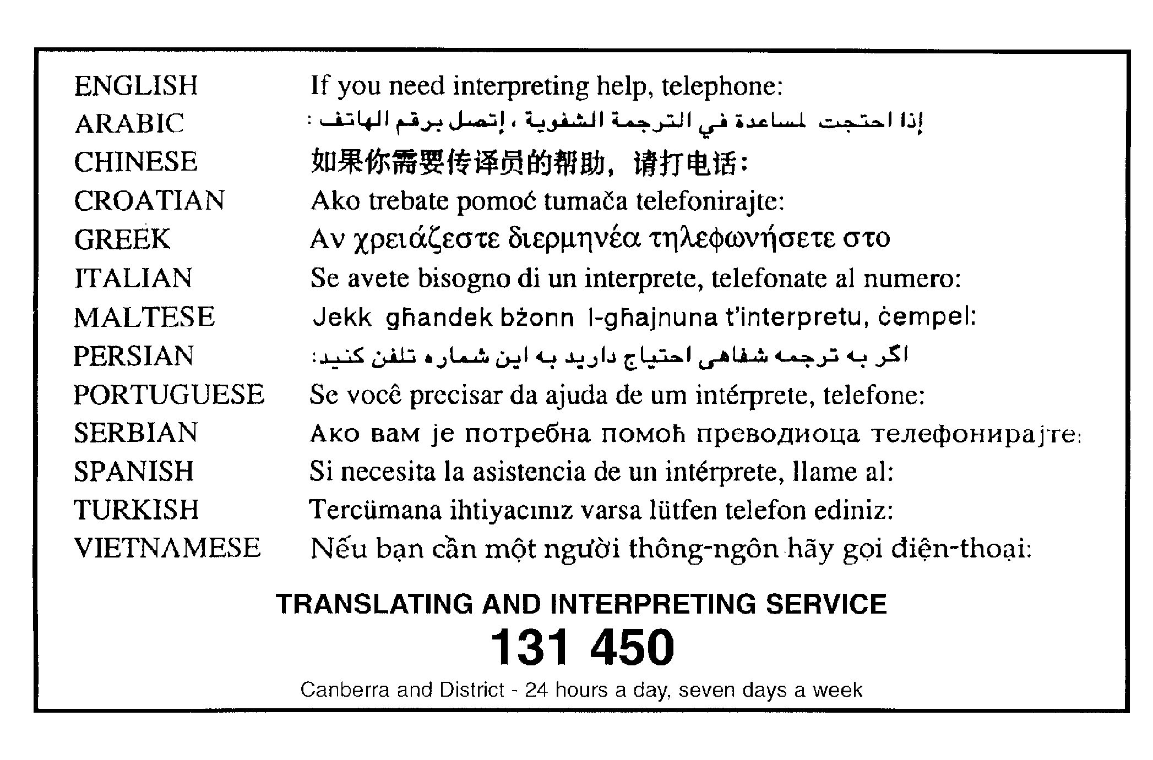
Appendix A Community Facility Zone Objectives and Development Table

CFZ - Community Facility Zone

Zone Objectives

- To facilitate social sustainability and inclusion through providing accessible sites for key localised government and non-government services for individuals, families, and communities.

- To provide accessible sites for civic life and community organisations meeting the needs of the Territory’s various forms of community.

- To protect these social and community uses from competition from other uses.

- To enable the efficient use of land through facilitating the grouping, co-location, and multi-use of community facilities, generally near public transport routes.

- To provide sites for adaptable and affordable housing for persons in need of residential support or care.

- To safeguard the amenity of surrounding residential areas against unacceptable adverse impacts.

CFZ – Community Facility Zone Development Table

EXEMPT DEVELOPMENT
Development approval not required, may need building approval
Development must be authorised by a lease, unless the land is unleased
Exempt development identified in section 20 and schedule 1 of the Planning and Development Regulation 2008.

Assessable Development
Development application required
Development must be authorised by a lease, unless the land is unleased
MINIMUM ASSESSMENT TRACK
CODE
Development application required and assessed in the code track

Development
varying a lease to do one or more of the following
- express the number of units
- remove easements
MINIMUM ASSESSMENT TRACK
MERIT
Development application required and assessed in the merit track, unless specified in schedule 4 of the Planning and Development Act 2007 (as impact track)

Development
ancillary use |  | office
business agency |  | outdoor recreation facility
child care centre |  | parkland
community activity centre |  | place of worship
community theatre |  | public agency
consolidation |  | religious associated use
cultural facility |  | residential care accommodation
demolition |  | retirement complex
educational establishment |  | sign
emergency services facility |  | subdivision
health facility |  | supportive housing
hospital |  | temporary use
indoor recreation facility |  | varying a lease (other than development in the code track)
minor use
Specific areas have additional developments that may be approved subject to assessment. These areas and the additional developments are listed below
Site identifier |  | Additional development
Campbell Section 38 Blocks 4 and 5  (Figure 1) |  | Scientific research establishment
Richardson Section 450 Block 1 (Figure 2) |  | Agriculture
MINIMUM ASSESSMENT TRACK
IMPACT
Development application required and assessed in the impact track
- a development that is not an exempt, code track or merit track development (see section 134 of the Planning and Development Act 2007).
- a development that is permissible under the National Capital Plan but is listed as a prohibited use in this table.
- development specified in schedule 4 of the Planning and Development Act 2007 and not listed as a prohibited use in this table.
- development that is permitted in a lease and listed as a prohibited development in this table.
- development declared under section 123 or section 124 of the Planning and Development Act 2007 and not listed as a prohibited development in this table.
- varying a lease to add a use assessable under the impact track.
PROHIBITED DEVELOPMENT
These uses cannot be added to a territory lease within a community facility zone.
For unleased Territory Land within a community facility zone, a development application cannot be lodged for any of these uses, unless it is listed as assessable development in this table.
agriculture | mining industry
airport | mobile home park
animal care facility | multi-unit housing
animal husbandry | municipal depot
aquatic recreation facility | nature conservation area
boarding house | offensive industry
bulk landscape supplies | overnight camping area
car park | pedestrian plaza
caretakers residence | place of assembly
caravan park/camping ground | plant and equipment hire establishment
cemetery | plantation forestry
civic administration | playing field
club | produce market
communications facility | public transport facility
COMMERCIAL ACCOMMODATION USE | railway use
corrections facility | recyclable materials collection
craft workshop | recycling facility
defence installation | relocatable unit
drink establishment | restaurant
drive-in cinema | road
farm tourism | sand and gravel extraction
financial establishment | scientific research establishment
freight transport facility | serviced apartment
funeral parlour | service station
general industry | SHOP
group or organised camp | single dwelling housing
habitable suite | special dwelling
hazardous industry | stock/sale yard
hazardous waste facility | store
home business | tourist facility
incineration facility | transport depot
indoor entertainment facility | vehicle sales
industrial trades | veterinary hospital
land fill site | warehouse
land management facility | waste transfer station
light industry | woodlot
liquid fuel depot | zoological facility
MAJOR UTILITY INSTALLATION
In addition to the above, the following uses are prohibited in the areas specified
RELEVANT CODE
Development proposals in community facility zone must comply with the Community Facilities Zone Development Code.

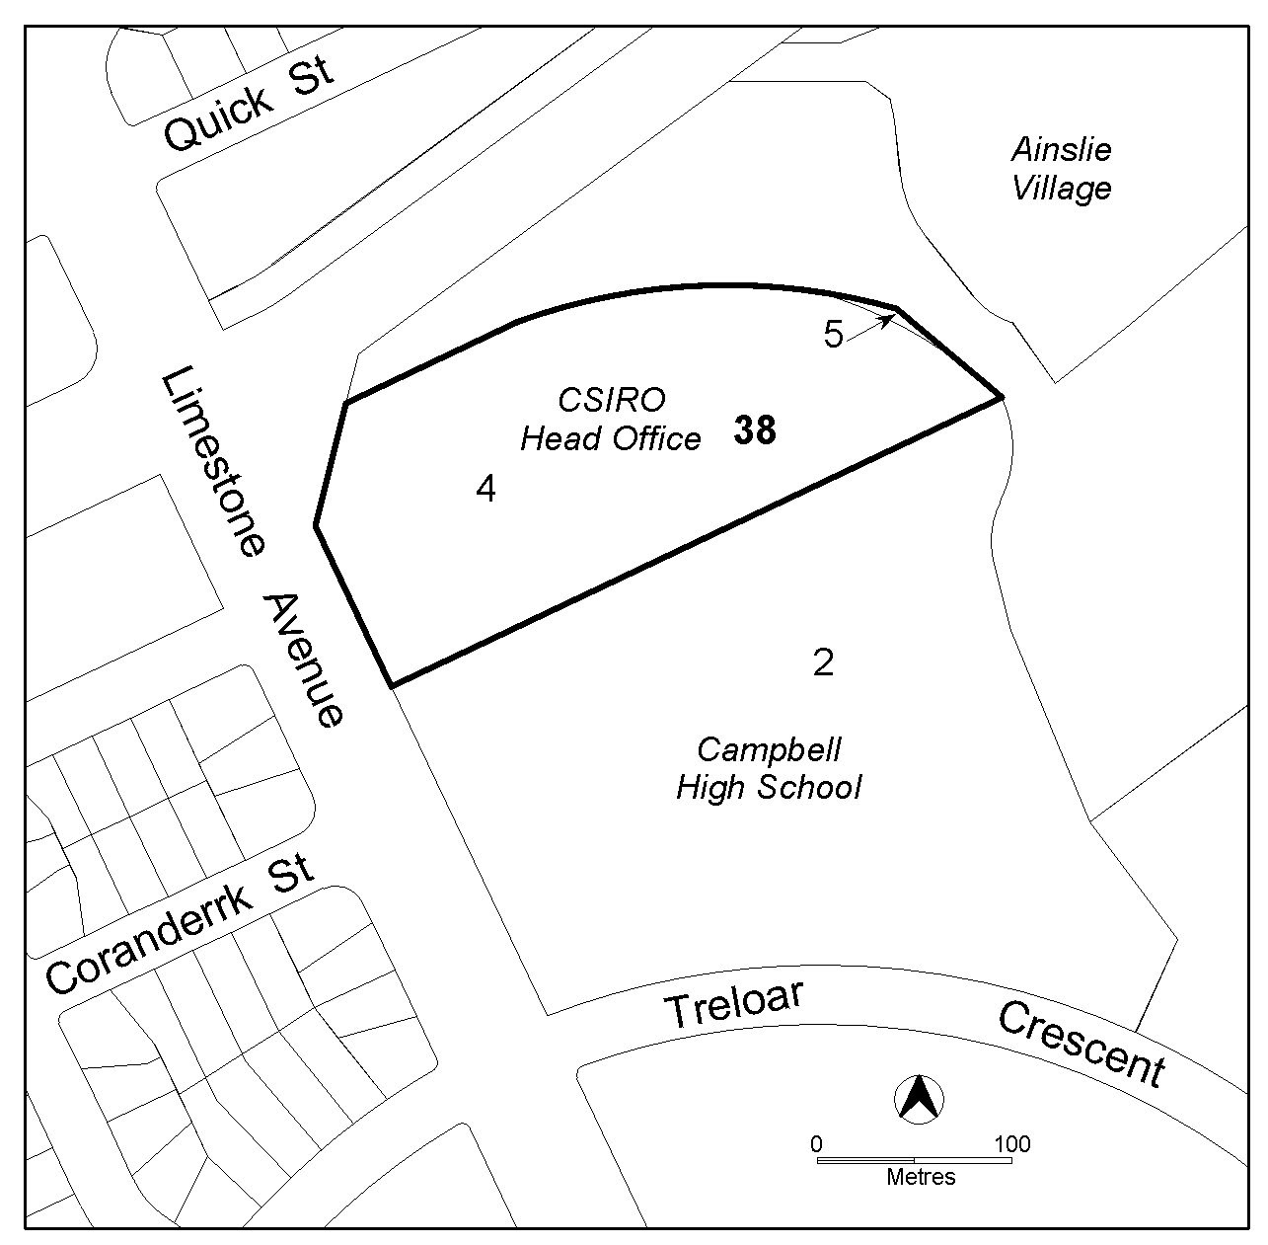

Figure 1 Campbell, Section 38 Blocks 4 and 5

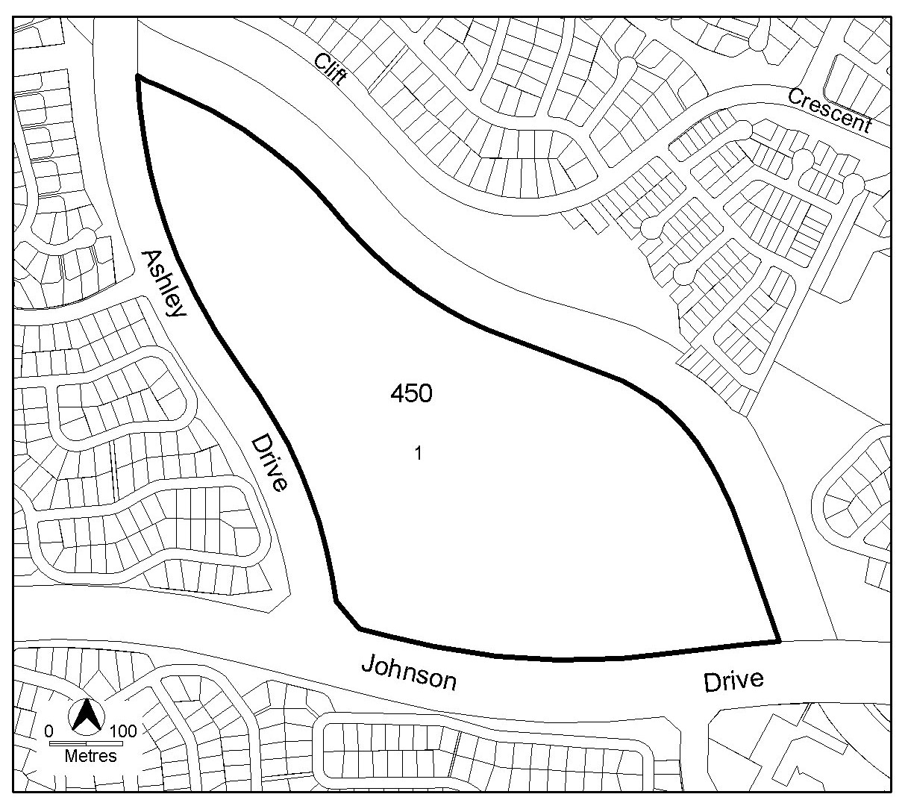
Figure 2 Richardson, Section 450 Block 1

Appendix B Community Facility Zone Development Code

Community Facility Zone Development Code

PUBLIC CONSULTATION

DRAFT VARIATION VERSION

May 2010
Contents
Introduction 3
Part A – Relevant Codes 5
Part B – General Development Controls 7
Element 1: Location 7
1.1 Location Requirements for Community and Recreation Facilities 7
Element 2: Restrictions on Use 7
1.1 Residential Use – Subdivision 7
1.2 Supportive Housing 7
1.3 Business Agency, Office, Public Agency 7
1.4 Emergency Services Facility, Indoor Recreation Facility, Outdoor Recreation Facility 8
1.5 Development proposals where there are pre-existing approved Lease and Development Conditions 8
Element 2: Building and Site Controls 9
2.1 Subdivision 9
2.2 Demolition 9
2.3 Number of Storeys 9
2.4 Setbacks 10
Element 3: Built Form 10
3.1 Materials and Finish 10
3.2 Interface 11
Element 4: Parking and Site Access 11
4.1 Traffic Generation 11
Element 5: Amenity 11
5.1 Neighbourhood Plan 11
Element 6: Environment 12
6.1 Excavation 12
6.2 Water Sensitive Urban Design 12
6.3 Heritage 14
6.4 Trees 14
6.5 Hazardous Materials 14
6.6 Contamination 15
6.6 Erosion and Sediment Control 15
Element 7: Services 16
7.1 Waste Water 16
7.2 Storage 16
Schedule 1 - Land Required for COMMUNITY USE 17
Appendix 1 – Definitions of terms used in this code 20

Introduction

Name
The name of this code is Community Facilities Zone Development Code.
Application
This code applies to all development in the community facility zone.
National Capital Plan
Where a development is subject to special requirements under the National Capital Plan, or any relevant development control plan prepared under the National Capital Plan, the development is not inconsistent with the special requirements or development control plan. Where any provision of this code is inconsistent with special requirements under the National Capital Plan, or any relevant development control plan prepared under the National Capital Plan, that provision has no effect.
Purpose
This code provides additional planning, design and environmental controls to support the objectives of the community facilities zone.
It will be used by the Authority to assess development applications. It also offers guidance to intending applicants in designing development proposals and preparing development applications.
Structure
This code has two parts:
Part A – Relevant Codes identifies other development and general codes that are relevant to development in the community facilities zone.
Part B – General Development Controls provide general controls that are applicable to all development within the zone.
Generally, each part is divided into one or more elements. Each element has one or more rules, each having an associated criterion (unless the rule is mandatory). Rules provide quantitative, or definitive, controls, while criteria are chiefly qualitative in nature.
In some instances rules are mandatory and are accompanied by the words “This is a mandatory requirement. There is no applicable criterion”. Non-compliance with a mandatory rule will result in the refusal of the development application. Conversely, the words “There is no applicable rule” is found where a criterion only is applicable.
Assessment tracks
Assessment track for a particular developments are specified in the community facilities zone development table.
Proposals in the code track must comply with all rules relevant to the development.
Proposals in the merit track and impact track must comply with a rule or its associated criterion, unless the rule is mandatory (ie. it has no related criterion). Where a rule is fully met, no reference to the related criterion needs to be made. Where there is a departure from a rule, or where a criterion only applies, the onus is on the applicant to demonstrate that the relevant criterion is satisfied, through supporting drawings and/or written documentation. In addition, the applicant for proposals in the impact track must justify any non-compliance by reference to the Statement of Strategic Directions.

Code hierarchy
Where more than one type of code applies to a development, the order of precedence when there is inconsistency of provisions between codes is precinct code, development code, and general code, as defined by the Planning and Development Act 2007. Where more than one development code applies it is the zone development code that takes precedence if there is inconsistency of provisions.
Definitions
Defined terms are italicised.
Definitions of terms used in this code are listed in the appendix.

Part A – Relevant Codes
Development codes (including this code) that apply to certain development or use in the community facilities zone are marked Y in Table A1.
Table A1 – Development codes applicable to development and uses in community facilities zone
DEVELOPMENT/  USE | COMMUNITY FACILITY ZONE DEVELOPMENT CODE | LEASE VARIATION DEVELOPMENT CODE | SINGLE DWELLING HOUSING DEVELOPMENT CODE | MULTI UNIT HOUSING DEVELOPMENT CODE
ancillary use | Y
business agency | Y
child care centre | Y
community activity centre | Y
community theatre | Y
consolidation | Y
cultural facility | Y
demolition | Y
educational establishment | Y
emergency services facility | Y
health facility | Y
hospital | Y
indoor recreation facility | Y
lease variation |  | Y
minor use | Y
office | Y
outdoor recreation facility | Y
parkland | Y
place of worship | Y
public agency | Y
religious associated use | Y
residential care accommodation | Y |  |  | Y
retirement complex | Y
sign | Y
subdivision | Y
supportive housing | Y |  | Y³ | Y
temporary use | Y
scientific research establishment ¹ | Y
agriculture ² | Y
Notes to Table A1:
^{1 –} Development specific to Section 38 Blocks 4 and 5 CAMPBELL.
^{2 –}Development specific to Section 450 Block 1 RICHARDSON.
^{3 –} Applicable only where supportive housing is in the form of a single dwelling

In addition to the development codes specified above, general codes may be relevant. The following general codes, in particular, may be relevant to development in the community facilities zone. Development must comply with the relevant general code, subject to the code hierarchy outlined above.
Access and Mobility General Code
Bicycle Parking General Code
Community and Recreational Facilities Location Guidelines General Code
Crime Prevention through Environmental Design General Code
Parking and Vehicular Access General Code
Signs General Code
Water Ways: Water Sensitive Urban Design General Code
General codes are found in part 11.

Part B – General Development Controls
Element 1: Location
Rules | Criteria
1.1 Location Requirements for Community and Recreation Facilities
The development complies with the Community and Recreation Facilities Location Guidelines General Code. | The development is appropriately located, being both accessible to potential users, and not undermining the amenity or conduct of adjoining uses.

Element 2: Restrictions on Use

Rules | Criteria
1.1 Residential Use – Subdivision
Subdivision of a lease developed for RESIDENTIAL USE, including subdivision under the Unit Titles Act 2001, is not permitted. | This is a mandatory requirement. There is no applicable criterion.
1.2 Supportive Housing
Development for supportive housing complies with all of the following:  - the occupation of individual dwellings in a supportive housing complex is restricted by the lease to persons with special housing needs for reasons of age or disability  - the site has not been identified in Schedule 1 as being required for COMMUNITY USE  - all dwellings comply with Australian Standard AS4299 – Adaptable Housing. | This is a mandatory requirement. There is no applicable criterion.
1.3 Business Agency, Office, Public Agency
For a not-for-profit organisation, the maximum gross floor area for the use of land for a business agency, office, or public agency is 400m². | Development for the purposes of a business agency, office or public agency may only be permitted where one (1) of the following is achieved:  - the uses are small-scale and conducted by not-for-profit organisations providing community facilities or services that meet the social, cultural, leisure, health, community wellbeing, or educational needs of the ACT community and its visitors  - the use occupies surplus ACT Government community facility buildings only with a maximum lease term of five years.
1.4 Emergency Services Facility, Indoor Recreation Facility, Outdoor Recreation Facility
Development of any of the following:  - emergency services facility  - indoor recreation facility  - outdoor recreation facility  complies with all of the following:  - AS 2107 -Acoustics -Recommended design sound levels and reverberation times for building interiors  - AS 3671- Acoustics – Road traffic noise intrusion – Building siting and construction. | This is a mandatory requirement. There is no applicable criterion.
1.5 Development proposals where there are pre-existing approved Lease and Development Conditions
The development proposal complies with approved and current lease and development conditions applying to the site. Where there is an inconsistency between the lease and development conditions and the provisions of this code, the former shall take precedence, but only to the extent of the inconsistency. | The development meets the intent of any approved and current lease and development conditions applying to the site.

Element 2: Building and Site Controls

Rules | Criteria
2.1 Subdivision
Subdivision is permitted only where all of the following are complied with:  a) the subdivision is part of a development application for another assessable development  b) it is demonstrated that any residual block can accommodate another assessable development designed in accordance with the relevant sections of this code. | This is a mandatory requirement. There is no applicable criterion.
2.2 Demolition
The application is accompanied by a statement of endorsement for utilities (including water, sewerage, stormwater, electricity and gas) in accordance with section 148 of the Planning and Development Act 2007 for all of the following:  - all network infrastructure on or immediately adjacent the site has been identified on the plan  - all potentially hazardous substances and conditions (associated with or resulting from the demolition process) that may constitute a risk to utility services have been identified  - all required network disconnections have been identified and the disconnection works comply with utility requirements  - all works associated with the demolition comply with and are in accordance with utility asset access and protection requirements. | This is a mandatory requirement. There is no applicable criterion.
2.3 Number of Storeys
Buildings comply with all of the following:  - within 30m of residential blocks buildings are no higher than the highest permissible height of building on any adjacent residential block or two (2) storeys, whichever is greater  - the building is no higher than 4 storeys or 15m above natural ground level, whichever is greater. | Buildings achieve all of the following:  - consistency with the desired character  - reasonable solar access to dwellings on adjoining residential blocks and their associated private open space.
2.4 Setbacks
Minimum setback of buildings to boundaries of blocks in a Residential Zone is 6m. | Buildings and other structures are sited to achieve all of the following:  - consistency with the desired character  - reasonable separation between adjoining developments  - reasonable privacy for dwellings on adjoining residential blocks  - reasonable privacy for principal private open space on adjoining residential blocks  - reasonable solar access to dwellings on adjoining residential blocks and their associated principal private open space.

Element 3: Built Form

Rules | Criteria
3.1 Materials and Finish
There is no applicable rule. | Where development presents a blank façade to an adjoining block or public space, a visually interesting architectural treatment is applied to that wall such as through the use of colour, articulation, materials and shadows.
There is no applicable rule. | Buildings use high quality materials and have facades with visually interesting architectural treatments through the use of elements such as colour, materials, shadows or deep framing profiles.
3.2 Interface
There is no applicable rule. | Where appropriate, compatible uses of any existing buildings are integrated with new development and provide physical connections and linkages between buildings, and between buildings and public spaces.
There is no applicable rule. | Elements of the development that interface with a street promote an attractive and appropriate streetscape.

Element 4: Parking and Site Access

Rules | Criteria
4.1 Traffic Generation
There is no applicable rule. | The existing road network can accommodate the amount of traffic likely to be generated by the development.

Element 5: Amenity

Rules | Criteria
5.1 Neighbourhood Plan
There is no applicable rule. | Where an approved neighbourhood plan exists, development demonstrates response to the key strategies of the relevant neighbourhood plan. This provision will cease to be effective after  1 January 2011.

Element 6: Environment

Rules | Criteria
6.1 Excavation
There is no applicable rule. | Onsite cut and fill is minimised and managed to ameliorate negative off site impacts.
6.2 Water Sensitive Urban Design
This rule applies to all development except for minor extensions.  The development achieves a minimum 40% reduction in mains water consumption compared to an equivalent development constructed in 2003, without any reliance on landscaping measures.  A report by a suitably qualified person using the ACTPLA on-line assessment tool or another tool referred to in the Water Ways: Water Sensitive Urban Design General Code demonstrates compliance with this rule. | This is a mandatory requirement. There is no applicable criterion.
Evidence is provided that shows the development achieves a minimum 40% reduction in mains water consumption compared to an equivalent development constructed in 2003 using the ACTPLA on-line assessment tool or another tool as included in the Water Ways: Water Sensitive Urban Design General Code. The 40% target is met without any reliance on landscaping measures to reduce consumption.  This requirement does not apply for extensions with an increase in the combined roof plan area, driveway, car manoeuvring areas and car parking areas of less than 25% of the original area. | This is a mandatory requirement. There is no applicable criterion.
This rule applies to all development except minor extensions.  On sites larger than 2000m² provision for the retention of stormwater on the block complies with one (1) of the following:  - it is equivalent to at least 1.4kl per 100m2 of impervious area, and its release over a period of 1 to 3 days  - it is equivalent to at least the 1-in-3 month stormwater peak pre-development runoff and its release over a period of 1 to 3 days.  The capacity of rainwater tanks connected to at least the toilet and all external taps may be counted towards this requirement.  A report by a suitably qualified person demonstrates compliance with this rule. | This is a mandatory requirement. There is no applicable criterion.
This rule applies to all multi-unit housing development except minor extensions.  For blocks 5000m² or larger, the average annual stormwater pollutant export is reduced for all of the following:  - suspended solids by at least 60%  - total phosphorous by at least 45%  - total nitrogen by at least 40%  compared with an urban catchment with no water quality management controls.  A report by a suitably qualified person, using the MUSIC model or another nationally recognised model, demonstrates compliance with this rule. | This is a mandatory requirement. There is no applicable criterion.
Stormwater management on previously developed blocks larger than 2000m² complies with 1 of the following:  - the capacity of the existing pipe (minor) stormwater connection is not exceeded in  1-in-10 year storm event and the capacity of the existing major overland stormwater system is not exceeded in 1-in-100 year storm event  - the 1-in-5 year and 1-in-100 year stormwater peak run off does not exceed pre-development levels.  A report by a suitably qualified person demonstrates compliance with this rule. | This is a mandatory requirement. There is no applicable criterion.
6.3 Heritage
In accordance with section 148 of the Planning and Development Act 2007, applications for developments on land or buildings subject to provisional registration or registration under s.41 of the Heritage Act 2004 are accompanied by advice from the Heritage Council stating that the development meets the requirements of the Heritage Act 2004.  Note: If advice from the Heritage Council is required but not provided, the application will be referred to the Heritage Council and its advice considered before the determination of the application. | This is a mandatory requirement. There is no applicable criterion.
6.4 Trees
In accordance with section 148 of the Planning and Development Act 2007, where the development proposal requires groundwork within the tree protection zone of a protected tree, or is likely to cause damage to or removal of, any protected trees, the application is accompanied by a tree management plan approved under the Tree Protection Act 2005.  Note 1: Protected tree is defined under the Tree Protection Act 2005.  Note 2: If an approved tree management plan is required but not provided, a draft tree management plan is to accompany the application. The draft tree management plan will be referred to the relevant agency in accordance with the requirements of the Planning and Development Act 2007. | This is a mandatory requirement. There is no applicable criterion.
6.5 Hazardous Materials
Demolition of:  - multi unit housing (including garages and carports) for which a certificate of occupancy was issued prior to 1985, or  - commercial or industrial premises for which a certificate of occupancy was issued before 2005,  is undertaken in accordance with hazardous materials survey (including an asbestos survey) endorsed by the Environment Protection Authority.  A hazardous materials survey includes, as a minimum, the identification of a disposal site for hazardous materials, including asbestos, that complies with one (1) of the following:  - is a licensed disposal facility in the ACT  - another site outside the ACT.  If hazardous materials, including asbestos, are to be transported for disposal interstate, approval from the Environment Protection Authority prior to removal of material from the site  An appropriately licensed contractor is engaged for the removal and transport of all hazardous materials (including asbestos) present at the site.  Note: If an endorsed hazardous materials survey is required but not provided, the application will be referred to the relevant agency in accordance with the requirements of the Planning and Development Act 2007. | This is a mandatory requirement. There is no applicable criterion.
6.6 Contamination
The site is assessed for land contamination in accordance with the ACT Government Strategic Plan – Contaminated Sites Management 1995 and the ACT Environment Protection Policy 2000,  If land contamination is identified, the development complies with the requirements of Environment Protection Authority.  Note: If no evidence of assessment of the site for land contamination is provided, the application may be referred to the relevant agency in accordance with the requirements of the Planning and Development Act 2007. | This is a mandatory requirement. There is no applicable criterion.
6.6 Erosion and Sediment Control
For sites less than 3000m², the development complies with the Environment Protection Authority, Environment Protection Guidelines for Construction and Land Development in the ACT. | This is a mandatory requirement. There is no applicable criterion
For sites 3000m² or larger, the development complies with an erosion and sediment control plan endorsed by the ACT Environment Protection Authority. | This is a mandatory requirement. There is no applicable criterion.

Element 7: Services

Rules | Criteria
7.1 Waste Water
Subject to ActewAGL approval, all under cover areas drain to the sewer. | This is a mandatory requirement. There is no applicable criterion.
7.2 Storage
Outdoor storage areas are screened from view from any road or other public area. | Where the proposed use of the site requires open areas for storage of goods and materials, adequate provision is to be included in the design layout of the site and should not encroach on car parking areas, driveways or landscaped areas and be adequately screened from public view.

Schedule 1 - Land Required for COMMUNITY USE

DISTRICT | DIVISION | SECTION | BLOCK
BELCONNEN | ARANDA | 1 | 2
BELCONNEN | CHARNWOOD | 93 | 1
BELCONNEN | EVATT | 11 | 1
BELCONNEN | EVATT | 52 | 14
BELCONNEN | EVATT | 82 | 1
BELCONNEN | FRASER | 40 | 2
BELCONNEN | GIRALANG | 80 | 4
BELCONNEN | HAWKER | 2 | 1
BELCONNEN | HAWKER | 5 | 1
BELCONNEN | HAWKER | 22 | 9
BELCONNEN | HIGGINS | 11 | 2
BELCONNEN | HOLT | 48 | 1
BELCONNEN | KALEEN | 28 | 58
BELCONNEN | KALEEN | 45 | 1
BELCONNEN | KALEEN | 101 | 1
BELCONNEN | KALEEN | 120 | 1
BELCONNEN | LATHAM | 30 | 2
BELCONNEN | MACGREGOR | 81 | 3
BELCONNEN | MACGREGOR | 140 | 9
BELCONNEN | MACQUARIE | 18 | 2
BELCONNEN | MACQUARIE | 52 | 5
BELCONNEN | MCKELLAR | 52 | 4
BELCONNEN | MELBA | 27 | 1
BELCONNEN | MELBA | 44 | 1
BELCONNEN | SCULLIN | 13 | 1
BELCONNEN | SCULLIN | 43 | 21
BELCONNEN | WEETANGERA | 20 | 5
CANBERRA CENTRAL | AINSLIE | 43 | 1
CANBERRA CENTRAL | BARTON | 29 | 1
CANBERRA CENTRAL | BRADDON | 31 | 1
CANBERRA CENTRAL | BRADDON | 31 | 1
CANBERRA CENTRAL | CAMPBELL | 29 | 3
CANBERRA CENTRAL | CAMPBELL | 38 | 2
CANBERRA CENTRAL | DEAKIN | 35 | 76
CANBERRA CENTRAL | DICKSON | 76 | 1
CANBERRA CENTRAL | LYNEHAM | 47 | 2
CANBERRA CENTRAL | NARRABUNDAH | 87 | 1
CANBERRA CENTRAL | NARRABUNDAH | 124 | 6
CANBERRA CENTRAL | RED HILL | 27 | 11
CANBERRA CENTRAL | TURNER | 67 | 16
CANBERRA CENTRAL | WATSON | 31 | 15
CANBERRA CENTRAL | YARRALUMLA | 82 | 12
GUNGAHLIN | BONNER | 26 | 6
GUNGAHLIN | BONNER | 26 | 10
GUNGAHLIN | FRANKLIN | 31 | 1

DISTRICT | DIVISION | SECTION | BLOCK
GUNGAHLIN | GIRALANG | 80 | 2
GUNGAHLIN | GUNGAHLIN | 59 | 2
GUNGAHLIN | GUNGAHLIN | 60 | 3
GUNGAHLIN | GUNGAHLIN | 455 | 1
GUNGAHLIN | NICHOLLS | 73 | 20
HALL | HALL | 6 | 7
NORTH CANBERRA | AINSLIE | 27 | 10
NORTH CANBERRA | HACKETT | 12 | 12
SOUTH CANBERRA | DEAKIN | 45 | 7
SOUTH CANBERRA | GRIFFITH | 78 | 34
SOUTH CANBERRA | NARRABUNDAH | 29 | 7
SOUTH CANBERRA | NARRABUNDAH | 94 | 24
SOUTH CANBERRA | YARRALUMLA | 53 | 2
TUGGERANONG | BONYTHON | 21 | 4
TUGGERANONG | CALWELL | 751 | 21
TUGGERANONG | CALWELL | 795 | 11
TUGGERANONG | CHISHOLM | 540 | 6
TUGGERANONG | CHISHOLM | 540 | 11
TUGGERANONG | CHISHOLM | 550 | 1
TUGGERANONG | CHISHOLM | 567 | 2
TUGGERANONG | CONDER | 212 | 10
TUGGERANONG | CONDER | 229 | 13
TUGGERANONG | CONDER | 281 | 6
TUGGERANONG | CONDER | 286 | 2
TUGGERANONG | GILMORE | 58 | 7
TUGGERANONG | GORDON | 410 | 15
TUGGERANONG | GOWRIE | 228 | 1
TUGGERANONG | GOWRIE | 229 | 3
TUGGERANONG | GOWRIE | 282 | 4
TUGGERANONG | GOWRIE | 282 | 7
TUGGERANONG | GOWRIE | 291 | 4
TUGGERANONG | ISABELLA PLAINS | 856 | 41
TUGGERANONG | KAMBAH | 239 | 1
TUGGERANONG | KAMBAH | 277 | 9
TUGGERANONG | KAMBAH | 277 | 21
TUGGERANONG | KAMBAH | 285 | 1
TUGGERANONG | KAMBAH | 286 | 24
TUGGERANONG | KAMBAH | 353 | 1
TUGGERANONG | MACARTHUR | 398 | 7
TUGGERANONG | MONASH | 161 | 24
TUGGERANONG | RICHARDSON | 452 | 2
TUGGERANONG | RICHARDSON | 477 | 5
TUGGERANONG | THEODORE | 659 | 7
TUGGERANONG | THEODORE | 668 | 3
TUGGERANONG | WANNIASSA | 130 | 16
TUGGERANONG | WANNIASSA | 132 | 48
TUGGERANONG | WANNIASSA | 141 | 1
TUGGERANONG | WANNIASSA | 142 | 1
TUGGERANONG | WANNIASSA | 253 | 1

DISTRICT | DIVISION | SECTION | BLOCK
WESTON CREEK | CHAPMAN | 12 | 3
WESTON CREEK | CHAPMAN | 12 | 4
WESTON CREEK | DUFFY | 23 | 2
WESTON CREEK | HOLDER | 45 | 7
WESTON CREEK | RIVETT | 28 | 11
WESTON CREEK | RIVETT | 28 | 13
WESTON CREEK | STIRLING | 24 | 2
WESTON CREEK | WARAMANGA | 39 | 1
WESTON CREEK | WARAMANGA | 45 | 1
WESTON CREEK | WESTON | 64 | 32
WODEN VALLEY | CURTIN | 60 | 1
WODEN VALLEY | FARRER | 33 | 2
WODEN VALLEY | GARRAN | 33 | 1
WODEN VALLEY | HUGHES | 35 | 34
WODEN VALLEY | HUGHES | 44 | 10
WODEN VALLEY | ISAACS | 501 | 8
WODEN VALLEY | LYONS | 41 | 5
WODEN VALLEY | MAWSON | 17 | 1
WODEN VALLEY | O'MALLEY | 31 | 23
WODEN VALLEY | O'MALLEY | 31 | 24
WODEN VALLEY | TORRENS | 22 | 10
WODEN VALLEY | TORRENS | 22 | 13

Appendix 1 – Definitions of terms used in this code

Authority means the Planning and Land Authority established by section 7 of the Planning and Land Act 2002.

Block means a parcel of land, whether or not the subject of a lease.

Building line means a line drawn parallel to any front boundary along the front face of the building or through the point on a building closest to the front boundary. Where a terrace, landing, porch, balcony or verandah is more than 1.5 metres above the adjoining finished ground level or is covered by a roof, it shall be deemed to be part of the building.

Business agency means the use of land for the purpose of providing a commercial service directly and regularly to the public.

Communal open space means common outdoor open space for recreation and relaxation of residents of a housing development.

COMMUNITY USE is an “umbrella term” for a number of similar uses – see section 13 of the Territory Plan

Desired character means the form of development in terms of siting, building bulk and scale, and the nature of the resulting streetscape that is consistent with the relevant zone objectives.

Dwelling means a building or part of a building used as a self contained residence which must include:
- food preparation facilities;
- a bath or shower; and
- a closet pan and wash basin.
It includes outbuildings and works normal to a dwelling.

Emergency services facility means the use of land for the purpose of providing emergency services and protection for the community.

Height of building means the vertical distance between natural ground level to the highest point or points of the building.

Gross floor area (GFA) means the sum of the area of all floors of the building measured from the external faces of the exterior walls, or from the centre lines of walls separating the building from any other building, excluding any area used solely for rooftop fixed mechanical plant and/or apartment car parking.

Indoor recreation facility means the use of land for sporting activities where such use is primarily indoors.

Outdoor recreation facility means the use of land for a recreation facility serving the sporting or recreational needs of people where the activities are undertaken predominantly outdoors.

Lease has the same meaning as in the Planning and Development Act 2007.

Lease and development condition means a condition, other than a condition contained in the lease or an agreement collateral to the lease, that—
- was approved by the Territory when the lease was granted; and
- relates to the development or use of the land that is subject to the lease

Lower floor level (LFL) means a finished floor level which is 1.8 metres or less above natural ground level at any point.

Multi unit housing means the use of land for more than one dwelling and includes but is not limited to dual occupancy housing and triple occupancy housing.

Minor extension means an extension where the increase in the combined roof plan area, driveway, car manoeuvring areas and car parking areas is less than 25% of the total of the areas of these components at the date of lodgement of the development application.

Natural ground level means the ground level at the date of grant of the lease of the block.

Northern boundary means a boundary of a block where a line drawn perpendicular to the boundary is oriented between 45º west of north and 45º east of north.

Office means the use of land used for the purpose of administration, clerical, technical, professional or like business activities, including a government office, which does not include dealing with members of the public on a direct and regular basis except where this is ancillary to the main purpose of the office.

Plot ratio means the gross floor area in a building divided by the area of the site.

Principal private open space means private open space that is directly accessible from a habitable room other than a bedroom.

Public agency means the use of land for the purpose of providing a public service directly and regularly to the public and includes a government agency, which provides a commercial service to the public.

Residential block means a block that has at least one of the following characteristics –
- zoned residential
- affected by a lease which authorises residential use

RESIDENTIAL USE is an “umbrella term” for a number of similar uses – see section 13 of the Territory Plan

Setback means the minimum horizontal distance between a building wall or the outside face of a balcony, deck or supporting posts of a carport or verandah roof and the relevant block boundary.

Single dwelling housing means the use of land for residential purposes for a single dwelling only.

Single dwelling block means a block with one of the following characteristics
- originally leased or used for the purpose of single dwelling housing
- created by a consolidation of blocks, at least one of which was originally leased or used for the purpose of single dwelling housing

Storey means a space within a building that is situated between one floor level and the floor level next above, or if there is no floor level above, the ceiling or roof above but does not include an attic or a basement.

Streetscape includes the visible components within a street (or part of a street) including the private land between facing buildings, including the form of buildings, treatment of setbacks, fencing, existing trees, landscaping, driveway and street layout and surfaces, utility services and street furniture such as lighting, signs, barriers and bus shelters.

Subdivision means
- the surrender of 1 or more leases held by the same lessee, and the grant of new leases held by the same lessee, and the grant of new leases to the lessee to subdivide the parcels of land in the surrendered leases; but
- does not include the subdivision of land under the Unit Titles Act 2001.

Supportive housing means the use of land for residential accommodation for persons in need of support, which is managed by a Territory approved organisation that provides a range of support services such as counselling, domestic assistance and personal care for residents as required. Although such services must be able to be delivered on site, management and preparation may be carried out on site or elsewhere. Housing may be provided in the form of self-contained dwellings.

