Australian Capital Territory

Heritage (Decision about Provisional Registration for Griffith Oval No. 1, Griffith) Notice 2010

**Notifiable Instrument NI 2010 - 240**

made under the

*Heritage Act 2004* section 34 Notice of Decision about Provisional Registration

1. **Name of instrument**This instrument is the Heritage (Decision about Provisional Registration for Griffith Oval No. 1, Griffith) Notice 2010 -
2. **Registration details of the place**

Registration details of the place are at Attachment A: Provisional Register entry for the Griffith Oval No. 1, Griffith.

1. **Reason for decision**

The ACT Heritage Council has decided that the Griffith Oval No. 1, Griffith meets one or more of the heritage significance criteria at s 10 of the *Heritage Act 2004*. The provisional register entry is at Attachment A.

1. **Date of Provisional Registration**14 May 2010
2. **Indication of council's intention**

The Council intends to decide whether to register the amended entry under Division 6.2.

1. **Public consultation period**

The Council invites public comment by Wednesday 16 June 2010 on the provisional registration of the Griffith Oval No. 1 to:

The Secretary

ACT Heritage Council

GPO Box 158

CANBERRA ACT 2601

**Gerhard Zatschler  
Secretary   
ACT Heritage Council   
14 May 2010**

|  |  |
| --- | --- |
|  | **AUSTRALIAN CAPITAL TERRITORY**  **HERITAGE REGISTER**  **(Provisional Registration Details)**  **Place No:** |

*The following is mandatory:*

For the purposes of s. 33 of the *Heritage Act 2004*, an entry to the heritage register has been prepared by the ACT Heritage Council for the following place:

Griffith Oval No.1, Corner of Captain Cook Crescent and Austin Street, Griffith, ACT

Blocks 13 and 17, Section 42, Griffith, Canberra Central

**DATE OF PROVISIONAL REGISTRATION**

Notified:[14 May 2010] Notifiable Instrument: [2010]/[240]

PERIOD OF EFFECT OF PROVISIONAL REGISTRATION

Start Date 14 May 2010 End Date 14 October 2010

**Extended Period (if applicable) Start Date** ________ **End Date** ________

Copies of the Register Entry are available for inspection at the ACT Heritage Unit. For further information please contact:

The Secretary

ACT Heritage Council

GPO Box 158, Canberra, ACT 2601

Telephone: 13 22 81 Facsimile: (02) 6207 2229

**IDENTIFICATION OF THE PLACE**

* Griffith Oval No.1, Corner of Captain Cook Crescent and Austin Street, Griffith, ACT

Blocks 13 and 17, Section 42, Griffith, Canberra Central

**STATEMENT OF HERITAGE SIGNIFICANCE**

Griffith Oval No. 1 has historic heritage significance against three of the criteria of the *Heritage Act 2004.*

The place has a strong and special association with the Eastern Suburbs Rugby Union Club (Eastern Suburbs or Easts) as their home ground since 1952. The Easts have been integral to the history of rugby union within the ACT, as one of the capital’s inaugural teams. They have contributed to the developmental process that has seen Canberra become known world wide as an influential and respected rugby playing city.

Griffith Oval No. 1 is a rare and unique example in its comparative intactness of mature deciduous plantings which form a dense perimeter ring around the oval, providing a largely intact historical landscape setting. The mature plantings represent sequential planting at the site which began in the 1930s and extended through to the 1950s.

The aesthetic qualities of the oval’s mature plantings are valued by the neighbourhood community, the public who use the oval and the wider community for the immediate and uncompromised visual backdrop they provide to the oval.

**FEATURES INTRINSIC TO THE HERITAGE SIGNIFICANCE OF THE PLACE**

Features intrinsic to the heritage significance of the place which require conservation include:

* The oval together with its historical landscape setting, including the perimeter ring of mature deciduous plantings, forming an immediate and unimpeded aesthetic backdrop to the oval.

**APPLICABLE HERITAGE GUIDELINES**

The Heritage Guidelines adopted under s27 of the *Heritage Act* 2004 are applicable to the conservation of Griffith Oval No. 1, corner of Captain Cook Crescent and Austin Street, Griffith, ACT.

The guiding conservation objective is that Griffith Oval No. 1, corner of Captain Cook Crescent and Austin Street, Griffith, ACT, shall be conserved and appropriately managed in a manner respecting its heritage significance and the features intrinsic to that heritage significance, and consistent with a sympathetic and viable use or uses. Any works that have a potential impact on significant fabric (and / or other heritage values) shall be guided by a professionally documented assessment and conservation policy relevant to that area or component (i.e. a Statement of Heritage Effects – SHE).

Any actions impacting on the significance of the Griffith Oval No. 1 are to be based on professional landscape conservation planning.

**REASON FOR PROVISIONAL REGISTRATION**

Griffith Oval No. 1, corner of Captain Cook Crescent and Austin Street, Griffith, ACT has been assessed against the heritage significance criteria and been found to have heritage significance when assessed against three criteria under the ACT Heritage Act including (b), (f) and (h).

**ASSESSMENT AGAINST THE HERITAGE SIGNIFICANCE CRITERIA**

Pursuant to s.10 of the *Heritage Act 2004,*a place or object has heritage significance if it satisfies one or more of the following criteria. Significance has been determined by research as accessed in the references below. Future research may alter the findings of this assessment.

1. it demonstrates a high degree of technical or creative achievement (or both), by showing qualities of innovation, discovery, invention or an exceptionally fine level of application of existing techniques or approaches;

not applicable

1. **it exhibits outstanding design or aesthetic qualities valued by the community or a cultural group;**

The mature plantings of Griffith Oval No. 1 exhibit outstanding aesthetic qualities which are valued by the community. These aesthetic qualities include the sequential plantings which began in the 1940s, and which form a dense ring of mature species around the perimeter of the oval. Species include English Elm and Poplar.

The plantings provide the Griffith Oval with its historical landscape character and aesthetic setting. The setting is enhanced by the lack of any visual intrusions between the playing field and the plantings.

The place meets the threshold for heritage listing in relation to this criterion.

1. **it is important as evidence of a distinctive way of life, taste, tradition, religion, land use, custom, process, design or function that is no longer practised, is in danger of being lost or is of exceptional interest;**

not applicable

1. **it is highly valued by the community or a cultural group for reasons of strong or special religious, spiritual, cultural, educational or social associations;**

There is currently not enough information available to determine whether the place meets this criterion.

1. **it is significant to the ACT because of its importance as part of local Aboriginal tradition**

not applicable

1. **it is a rare or unique example of its kind, or is rare or unique in its comparative intactness**

Original plantings dating from the 1930s and later are common throughout Griffith and neighbouring areas. Plantings are also common at ovals and sporting grounds throughout the ACT, including at some of Canberra’s other early sports fields.

However, Griffith Oval No. 1 is of historic significance as it demonstrates a rare and unique example of mature plantings which form a largely intact dense perimeter ring around a sports oval in the ACT. The mature plantings represent sequential planting at the site which began in the 1940s and extended through to later years.

The plantings at Griffith Oval No. 1 are also rare and unique in their strong visual relationship with the oval. This relationship is uncompromised by development or infrastructure between the oval and its perimeter plantings.

The plantings contribute a landscape character and aesthetic quality to the oval which is unparalleled at other early ovals in the ACT.

The place meets the threshold for heritage listing in relation to this criterion.

1. **it is a notable example of a kind of place or object and demonstrates the main characteristics of that kind**

not applicable

1. **it has strong or special associations with a person, group, event, development or cultural phase in local or national history**

Griffith Oval No. 1 is of historic heritage significance for its strong and special associations with the Eastern Suburbs Rugby Union Club (Eastern Suburbs, or Easts).

Griffith Oval No. 1 has been the home ground of the Easts since 1952, with many home games since this time played at this place.

The Easts were one of the inaugural rugby union teams in the ACT in 1937, along with the Northern Suburbs Rugby Union Club, Royal Military College and University.

The team is important within the context of the history of the ACT for their contribution to the formation of rugby union in the ACT and its rise to popularity, as well as forming an integral part of the developmental process that has seen Canberra become known world wide as an influential and respected rugby playing city.

The place meets the threshold for heritage listing in relation to this criterion.

1. **it is significant for understanding the evolution of natural landscapes, including significant geological features, landforms, biota or natural processes**

not applicable

1. **it has provided, or is likely to provide, information that will contribute significantly to a wider understanding of the natural or cultural history of the ACT because of its use or potential use as a research site or object, teaching site or object, type locality or benchmark site**

not applicable

1. **for a place—it exhibits unusual richness, diversity or significant transitions of flora, fauna or natural landscapes and their elements**

not applicable

1. **for a place—it is a significant ecological community, habitat or locality for any of the following:**

(i) the life cycle of native species;

(ii) rare, threatened or uncommon species;

(iii) species at the limits of their natural range;

(iv) distinct occurrences of species.

not applicable

*‘The place is assessed as not being significant in relation to the following criteria: a,c, d, e, g, i, j, k and l.*

**SUMMARY OF THE PLACE**

**HISTORY AND PHYSICAL DESCRIPTION**

**HISTORY**

Development and plantings

Griffith Oval No. 1 has been in use as a sports facility since at least 1937 when *The Canberra Times* (Monday 17 May 1937) refers to a hockey match being played at Griffith Oval ‘in somewhat unpleasant conditions’.

1933 articles in *The Canberra Times* (Friday 28 April 1933 and Monday 15 May 1933) indicate that Griffith Oval had been developed since at least this time, with references to ‘the new ground at Griffith not being yet available’ and ‘the newly prepared area at Griffith being too small’.

An aerial image taken in 1946 shows young plantings at the site dating from this time, forming an oval shape (NAA A1200, L6689A 7462597). In this image, the suburbs of Forrest, Barton, Kingston and Griffith are well developed with established plantings. The smaller plantings at the Griffith Oval suggest that it was planted subsequent to the development of neighbouring suburbs.

These early plantings were done under TG Weston’s successor Alexander Bruce from seedlings raised by Chief Nurseryman Thomas Hobday, who succeeded Bruce as Director of Parks and Gardens in 1935.

A cricket pitch at the Griffith Oval is clearly visible in an image dated 1950 (NAA A7973 INT7: 11713655). Also in this image, two square playing fields are located adjacent to the main oval, with at least two small buildings – possibly change sheds.

In a later image, dated 1955, the plantings at the Griffith Oval appear slightly more substantial, and there is a greater amount of nearby development in the suburbs of Red Hill and Griffith (NAA, M1570, 16: 7818536, 1955).

In a 1992 interview, Lindsay Pryor includes some of the original plantings at Griffith Oval in his selection of four places within the ACT which he considers to have ‘worked well’ in the landscape planning and development of the national capital. Pryor states that:

*‘I think parts of Griffith Park are quite satisfying… It doesn’t hold together as well as it might if the planting had been done treating the thing as a whole at the beginning. To some extent, opportunities came to do a relatively small amount, and to develop an overall plan for what might happen was so unlikely to be achieved in the foreseeable time that mostly there was sequential development’* (*Higgins, 1992, p.226-229).*

Griffith Oval is one of Canberra’s few original early public ovals, with at least one other at Turner. Other early ovals, including Manuka, Kingston, Ainslie, Northbourne and Duntroon, were enclosed ovals for senior sport and were generally not available for public recreational use (information supplied by nominator).

Activity and use

Historical records indicate that the Griffith Oval has been used for a number of different sporting events since its first recorded use in 1937. The first cricket game at Griffith Oval appears to have been played in 1948 (*The Canberra Times,* Wednesday 15 December 1948). In 1950, National Football was played there, and in 1952, rugby and soccer. In 1953 a Scouts sports day was held at the Griffith Oval (*The Canberra Times* Monday 26 June 1950, Friday 29 February 1952, Monday 16 June 1952, and Friday 11 September 1953).

Many local teams from many suburbs as well as Queanbeyan and Duntroon Royal Military College have used the oval.

Although sporting events have occurred at the site since the 1930s, it was not until the mid-late 1940s that an attempt was made to formalise the Griffith Oval as a sporting field (*The Canberra Times* Wednesday 18 June 1947:4).

Subsequent works to the oval in the early 1950s were undertaken in an attempt to decentralise sporting activities, and relieve the pressure from other nearby ovals, including Manuka and Kingston, which were undergoing heavy weekend use (*The Canberra Times,* Wednesday 18 June 1947:4).

Throughout the 1940s and 1950s, the grounds at Griffith Oval were used heavily for hockey matches, with many references in *The Canberra Times*.

In addition to sporting games, the grounds have been used for many training purposes since the late 1940s.

ACT Rugby Union and the Eastern Suburbs Rugby Union Club

The Federal Capital Territory Rugby Union (FCTRU) was established in 1937 and a committee formed at this time. The committee decided not to form a competition until 1938, although informal matches were organised during 1937 (Christopher, 2001: 15).

The Eastern Suburbs Rugby Union Football Club (Eastern Suburbs or Easts) was established on 13 December 1937, one month after the Northern Suburbs Rugby Union Football Club (Christopher, 2001: 17). Other original teams who were formed at this time include the Royal Military College and University.

The Easts played their first FCTRU match against University College in April 1938 (Christopher, 2001: 263).

These four original teams together established the popularity of rugby within Canberra. ‘Club rugby’ was the focus of the code in the ACT from 1938 – 1996, prior to the establishment of the ACT Brumbies, and of the Canberra Vikings (formerly Kookaburras) playing in Sydney. With these changes, attention has shifted towards the elite professional level in recent years (Christopher, 2001: 253). However, club rugby still plays an important role in ACT rugby sports.

The Eastern Suburbs have always been based from the Manuka and Kingston areas, and are named after the Eastlake area (Christopher, 2001: 263).

In 1952 the Easts adopted the tri-colours of the Eastern Suburbs Rugby Club in Sydney (Christopher, 2001: 263).

The Club disbanded in 1947, before reforming again in February 1952. Prior to their disbanding, the club’s training venue had been at Manuka Oval.

After 1952, the club began to use Griffith Oval No.1, and this has been their home ground since this time. The club’s first training session was held at Griffith Oval in March 1952 (Christopher, 2001: 264). This training match was advertised in the *Canberra Times* on Friday 29 February 1952, and is the first reference within the newspaper to the Easts at Griffith Oval.

A lack of lighting at Griffith Oval forced the club to move its training sessions to the nearby Kingston Oval. In 1953, with the removal of the Manuka Oval lights to Griffith, the Easts were able to again resume training at that location (Christopher, 2001: 264).

Around the same time, the Easts obtained a clubhouse at Griffith Oval (Christopher, 2001: 264). The building was one of the abandoned Riverside Hostel Huts near the Kingston Railway Station. It is no longer extant at the site.

In 1953 the Easts became premiership finalists and won the Canberra Cup (Christopher, 2001: 264).

Throughout the 1970s the Easts were a strong team and were consistently in the top three clubs in the Club Championship (Christopher, 2001: 265).

The Easts currently have one of the ACTs strongest women’s teams in rugby union (Christopher, 2001: 266).

Their clubhouse is located in Kingston in 2010.

After attending an Easts V’s Royals match in 2005, *Canberra Times* columnist Alison Cooke wrote:

‘*Surely there is no more beautiful place on earth to watch a game of rugby. If as they say, rugby is the game they play in Heaven, Griffith Oval most certainly has to be the celestial stadium. As I stood in the coruscating sunlight and watched those rugged, yet handsome Easts boys run around, I was overcome by a deep sense of appreciation for this magnificent place. Egypt has the pyramids, North America has the Grand Canyon, but let it be known to the world that Australia has Griffith Oval’ (*[*http://en.wikipedia.org/wiki/Eastern_Suburbs_RUFC_(Canberra)*](http://en.wikipedia.org/wiki/Eastern_Suburbs_RUFC_(Canberra))*, date accessed: 24 March 2010).*

In recent years there has been a growing trend amongst ACT rugby clubs to charge spectators an entrance fee. The Easts are one of few clubs who have not introduced a fee and the clubs administrators have remained adamant that Griffith Oval should continue to be accessed by the public free of charge. On Grading Night 2007, Club Captain Jeremy Osborne stated in his speech that:

‘*Griffith Oval is a public asset. It is our duty to preserve this sacred piece of earth, and to ensure that a price is never charged to the humble souls who wish to indulge in its magic’* [*http://en.wikipedia.org/wiki/Eastern_Suburbs_RUFC_(Canberra)*](http://en.wikipedia.org/wiki/Eastern_Suburbs_RUFC_(Canberra))*, date accessed: 24 March 2010).*

**PHYSICAL DESCRIPTION**

Griffith Oval No. 1 is located in the suburb of Griffith, on a corner block abutting Captain Cook Crescent and Austin Street. The oval is located to the southern portion of this block.

It is a large open space and has a number of playing fields that cater for different sports, including senior and junior competition.

Griffith Oval is bordered by a diverse range of deciduous and evergreen trees including English Elms and Poplars, which form a dense perimeter ring around the oval.

Most of the original planting remains intact, providing landscape character and a historical setting for the oval.

The oval’s setting is further enhanced by a simple timber picket fence of unknown date which surrounds the oval.

Comparative analysis

Canberra’s early sporting ovals include Northbourne, Manuka, Kingston, Ainslie, Turner, Duntroon and Griffith Ovals. Original plantings remain at the Northbourne, Manuka, Duntroon and Griffith Ovals.

At Northbourne, mature Monterey Pines form a circle around the oval. At Manuka, original Elms and other deciduous species remain in a dense planting particularly to the western sides of the oval, though the original plantings are more dilapidated and patchy in other areas around the oval. Extensive grandstand areas stand between the oval and the plantings, divorcing the oval from its original setting and landscape character.

Original plantings from the 1920s and 1930s at Duntroon Oval remain, though these form a patchy ring around the oval.

Canberra’s other early ovals show few signs of intact mature plantings forming a perimeter ring around the oval.

**REFERENCES**

Publications

Christopher, R., 2001, *From Chook Raffles to Super 12s: A History of Rugby Union in the ACT,* Ginninderra Press, ACT.

Gibbney, J., 1988, *Canberra 1913-1953*, Australian Government Publishing Service, Canberra.

Higgins, M., 1992, *Transcript of Oral History, Lindsay Dixon Pryor,* National Trust of Australia (ACT).

*The Canberra Times* articles

Friday 28 April 1933

Monday 15 May 1933

Wednesday 15 December 1948

Monday 26 June 1950

Friday 29 February 1952

Monday 16 June 1952

Friday 11 September 1953

Wednesday 18 June 1947

Images

(photographer unknown), ‘Canberra View [picture], ca.1930, nla.pic-vn3704514-v, National Library of Australia.

(photographer unknown), ‘Griffith, aerial view looking south to the ranges’, May 1953, Act Heritage Library Images ACT 009646.

(photographer unknown), ‘**Aerial photograph of Telopea Park, Kingston, Manuka and Barton, Canberra’, 1955,** National Archives of Australia, M1570,16: 7818536.

Websites

[*http://en.wikipedia.org/wiki/Eastern_Suburbs_RUFC_(Canberra)*](http://en.wikipedia.org/wiki/Eastern_Suburbs_RUFC_(Canberra))*, date accessed: 24 March 2010).*

**non-statutory background information**

**HISTORY**

The suburbs neighbouring Griffith Oval No. 1, including Griffith, Kingston, Barton and Forrest were constructed in the 1920s as garden city precincts, to provide accommodation for public servants relocating from Melbourne to the nations’ new capital for the opening of Parliament House in 1927.

Contemporaneously, a number of social elements were built into the area for the new community, including Manuka Oval in the 1920s and Manuka Pool in the 1930s. The area at Griffith Oval formed a part of the garden city planning as open space.

Canberra’s earliest sporting ground is the Northbourne Oval, which has been used continuously since 1925. It is an important place associated with the history of cricket, Rugby League and Australian Rules Football in the ACT.

**PHYSICAL DESCRIPTION**

The Griffith Oval is a district sportsground, and is the sporting focus of several suburbs.

A 1970s painted brick single storey clubhouse, with a corrugated iron roof and narrow verandah with slender railings, stands to the south-east of the oval.

Associated infrastructure evident at the site includes goal posts, simple timber grand stands, and lighting.

**HISTORICAL IMAGES**

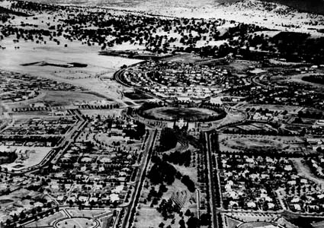

City - Canberra - Aerial view [photographic image]. 1 photographic negative: b&w, acetate 1946

NAA A1200, L6689A 7462597

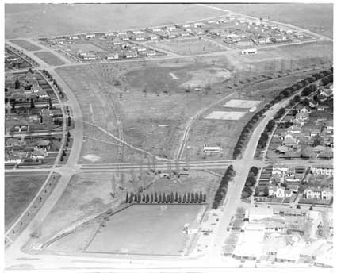

Cities and towns - Canberra - Flinders Way, Manuka, , Canberra, 9.10.1950

NAA A7973, INT7, 11713655

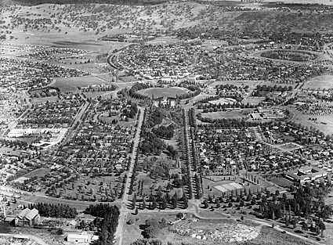

(photographer unknown), ‘**Aerial photograph of Telopea Park, Kingston, Manuka and Barton, Canberra’, 1955,** NAA, M1570,16: 7818536

**SITE PLAN**

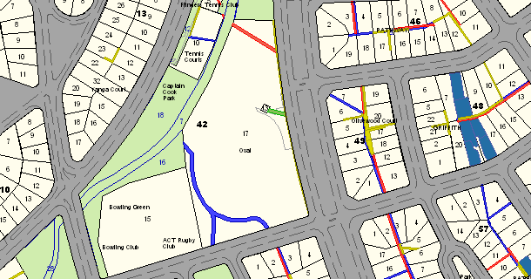

Boundary Map – Griffith Oval No. 1 is shown as Blocks 17 and 13, Section 42, Griffith.

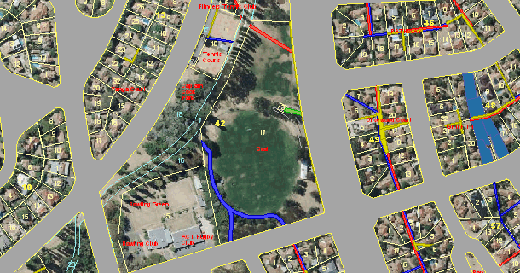

Aerial view of Blocks 17 and 13, Section 42, Griffith