Australian Capital Territory

Planning and Development (Technical Amendment - Miscellaneous Amendments) Plan Variation 2010 (No 2)*

Notifiable instrument NI2010 - 409

Technical Amendment No 2010–24
made under the

Planning and Development Act 2007, section 89 (Making technical amendments)

This plan variation commences on the day after it is notified.

Variation No. 2010–24 to the Territory Plan has been approved by the Planning and Land Authority.

The variation specifies miscellaneous corrections to the Territory Plan as detailed in Annexe A.

Kelvin Walsh
Delegate of the Planning and Land Authority

21 July 2010

ANNEXE A
PLAN VARIATION 2010–24

Planning & Development Act 2007

Technical Amendment
to the Territory Plan
Variation 2010–24

Miscellaneous corrections –
Casey precinct code

July 2010

Table of Contents

1 INTRODUCTION 1
Outline of the process 1
2. EXPLANATORY STATEMENT 1
Background 1
Proposed Changes and Reasons 1
3. ERROR VARIATION 1
Variation to Territory Plan map 1

1 INTRODUCTION

Outline of the process
The Commonwealth’s Australian Capital Territory (Planning and Land Management) Act 1988 allows for the Legislative Assembly to make laws to establish a Territory Planning Authority and for that Authority to prepare and administer a Territory Plan. The Planning and Development Act 2007 (the Act) establishes the ACT Planning and Land Authority as the Authority which prepares and administers the Territory Plan, including continually reviewing and proposing amendments as necessary. Part 5.4 section 87 of the Act allows for technical amendments to be made to the Territory Plan in a number of circumstances.

This technical amendment is subject to approval of the ACT Planning and Land Authority (ACTPLA) under section 87(a) of the Act. It is not subject to the limited consultation requirements under section 90 of the Act. On approval, the variation will commence in accordance with the commencement notice in the Legislation Register and will be notified in a daily newspaper. The Territory Plan will be updated to reflect the changes that are approved in the technical amendment.

2. EXPLANATORY STATEMENT

Background
Under section 87(a) of the Act, an error variation is defined as a variation that:
(i) would not adversely affect anyone’s rights if approved and
(ii) has as its only object the correction of a formal error in the plan.
A formal error is defined as:
a) a clerical error or
b) an error arising from an accidental slip or omission or
c) a defect of form.

Proposed Changes and Reasons
Casey precinct code map
The Casey TA2010-20 precinct code (which commenced on Friday 16 July 2010) contained a map that omitted to show three blocks of land where ‘Mid-Block - Option 2’ applies.

TA2010-20 introduced the first precinct code under section 96 of the Planning and Development Act 2007. Three blocks were not identified as being subject to
‘side setbacks – option 2’ under the single dwelling housing development code. For this reason the miscellaneous technical amendment TA2010-24, as defined under section 87(b) of the Act, has been prepared to correct the omission.

3. ERROR VARIATION

Variation to precinct codes

1 Casey Precinct Code, Part A Suburb of Casey – ongoing block specific provisions

Substitute the current map with the following map:

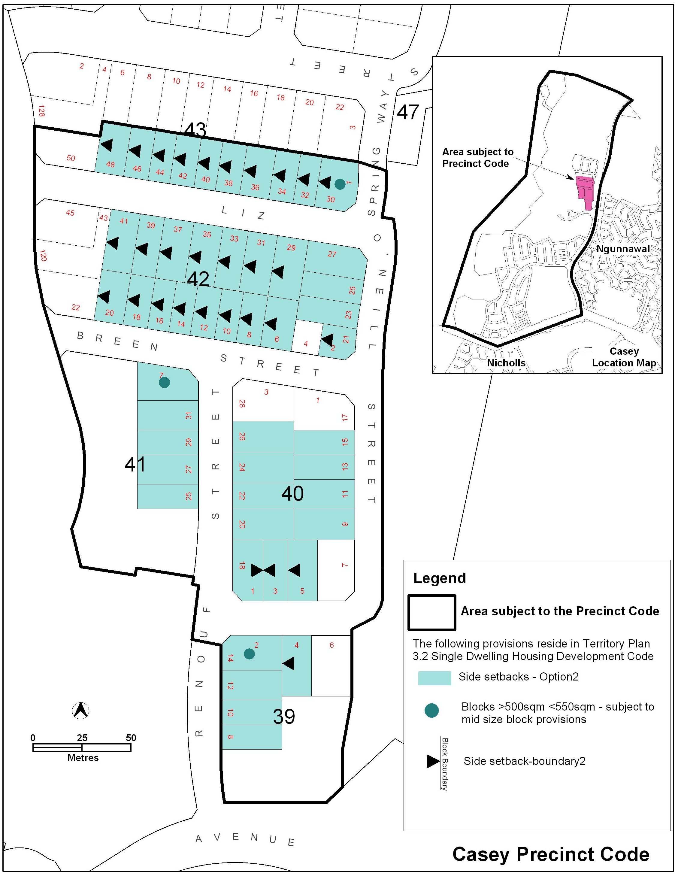

Interpretation service
