Australian Capital Territory

Planning and Development (Technical Amendment—Casey) Plan Variation 2010 (No 4)*

Notifiable instrument NI2010—566
Technical Amendment No 2010-30
made under the
Planning and Development Act 2007, section 89 (Making technical amendments) (s96 land ceases to be in future urban area)

This plan variation commences on the day after it is notified.

Variation No 2010-30 to the Territory Plan has been approved by the Planning and Land Authority

The variation specifies that the land identified on the map at Annexure A being land within the Division of Casey, may be used for the purposes indicated in the Annexure.

The variation also substitutes page 3 of ‘Part A Suburb of Casey – ongoing block specific provisions’ at Section 10.4 of the Territory Plan as identified at Annexure B.

Kelvin Walsh
Delegate of Planning and Land Authority

Date: 28 September 2010
THIS IS PAGE ONE OF ANNEXURE A
TO NOTIFIABLE INSTRUMENT NI2010 –566

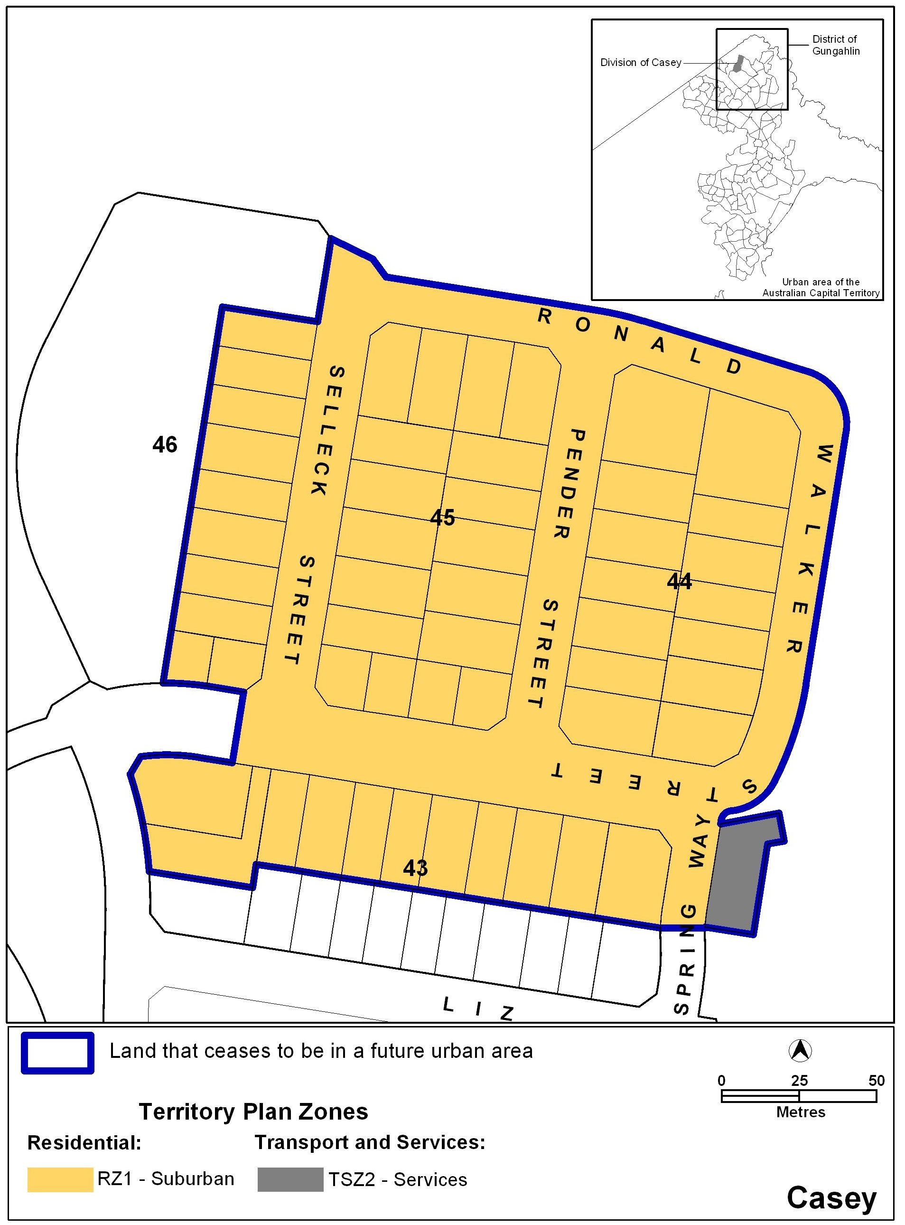

THIS IS PAGE ONE OF ANNEXURE B
TO NOTIFIABLE INSTRUMENT NI2010 –566
Part S provisions
Part A Suburb of Casey – ongoing block specific provisions

