Australian Capital Territory

Planning and Development (Technical Amendment—Miscellaneous amendments and corrections, changes to bring the Territory Plan in line with the National Capital Plan, and removal of redundant provisions) Plan Variation 2011
Notifiable instrument NI2011—206
Technical Amendment No 2011-03
made under the
Planning and Development Act 2007, section 89 (Making technical amendments)

This technical amendment commences on 29 April 2011.

Technical amendment number 2011-03 to the Territory Plan has been approved by the Planning and Land Authority.

Neil Savery
Planning and Land Authority

18 April 2011

Planning & Development Act 2007

Technical Amendment
to the Territory Plan
Variation 2011-03

Miscellaneous amendments and corrections, changes to bring the Territory Plan in line with the National Capital Plan, and removal of redundant provisions

April 2011
Table of Contents

1 INTRODUCTION 2
Outline of the process 2
2 EXPLANATORY STATEMENT 2
Proposed Changes and Reasons 3
3. TECHNICAL AMENDMENT 8

1 INTRODUCTION

Outline of the process

The Commonwealth’s Australian Capital Territory (Planning and Land Management) Act 1988 allows for the Legislative Assembly to make laws to establish a Territory Planning Authority and for that Authority to prepare and administer a Territory Plan. The Planning and Development Act 2007 (the Act) establishes the ACT Planning and Land Authority as the Authority which prepares and administers the Territory Plan, including continually reviewing and proposing amendments as necessary. Part 5.4 section 87 of the Act allows for technical amendments to be made to the Territory Plan in a number of circumstances.

This technical amendment is subject to approval of the ACT Planning and Land Authority (the Authority) under sections 87(a), 87(e), and 87(f) of the Act.

A variation under section 87(a) is a technical amendment that:
(i) would not adversely affect anyone’s rights if approved; and
(ii) has as its only object the correction of a formal error in the plan.

Section 87(e) of the Act provides for a variation required to bring the Territory Plan into line with the National Capital Plan. These changes are not subject to the limited consultation requirements under section 90 of the Act.

A variation under section 87(f) is a technical amendment to omit something that is obsolete or redundant in the territory plan.

The date of commencement of this technical amendment is provided on the attached notifiable instrument (commencement notice).

2 EXPLANATORY STATEMENT

2.1 Proposed Changes and Reasons

- Removal of urban open space (Pe) overlay from City section 19 block 21 and part blocks 11 and 20 to bring into line with the National Capital Plan (item 1)

The land identified as City section 19 block 21 and part blocks 11 and 20, is located at the western end of Constitution Avenue, between Vernon Circle and London Circuit. The public land overlay Urban Open Space (Pe) applies to this land and the designation is inconsistent with the National Capital Plan, as changed by Amendment 59 – City Hill precinct. The change encourages urban development to occur on the subject land and the extension of Constitution Avenue across London Circuit to the intersection with Vernon Circle. The public land overlay has been removed from this site to bring the Territory Plan in line with the National Capital Plan.

- Correction to Rule R55(b) in CZ5 mixed use zone development code (item 4)

Rule R55(b) limits the gross floor area of NON RETAIL COMMERCIAL USE in the Bruce office precinct to 2,000m² per lease. This limitation is inconsistent with the requirements of Part 3 of the National Capital Plan as the Bruce office precinct is classified as a ‘Defined Office Employment Centre’. This rule has been removed to ensure consistency with the National Capital Plan.

- Correction to wording of Part A of group centres development code (spelling mistake) (item 2)

Objective a of the Group centres development code, Part A – Group centres – Overview, commences with the words ‘Provide or’. The correct wording is ‘Provide for’.

- Remove reference to ‘office’ as additional development in industrial mixed use zone development table (item 6)

Under the merit assessment track, the following sites are identified as places where the additional use of ‘office’ may occur: Fyshwick section 6 blocks 6, 25, 27, section 7 blocks 6 and 7, and section 39 blocks 6 and 7.

The Territory Plan definitions include ‘office’ within the NON RETAIL COMMERCIAL USE umbrella term which is a merit assessable use within the IZ2 industrial mixed use zone. The reference to ‘office’ as a separate use for the subject blocks is therefore redundant and has been removed from the table.

- Remove reference to ‘road’ as prohibited development in the non urban zones NUZ1 - broadacre zone development table (item 7)

Under the merit assessment track, ‘road’ is listed as a merit assessable use, however it is listed as a prohibited use in several site specific locations. This was unintended and occurred when the provisions were transferred from the former Territory Plan into the restructured Plan which came into effect on 31 March 2008. ‘Road’ has been removed from the site identifier table for:
  - Jerrabomberra Blocks 2223, 2100, 2099, 2000 and 2101 (Figure 2)
  - Pialligo Areas ‘a’ and ‘b’ (Figure 6)
  - Symonston Area ‘a’ (Figure 7).

- Amend references to the Liquor Act 2010 and the Children and Young People Act 2008 (item 8)

These legislative instruments are referred to in the Territory Plan definitions and are updated as follows: The Liquor Act 1975 has been replaced by the Liquor Act 2010 which came into effect on 1 December 2010, and the Children and Young People Act 2008 which is incorrectly dated 1999.

- Correction to wording in the IZ1 general industrial zone development table, under OTHER CODES, ‘GENERAL CODES’ section (item 5)

‘Community and Recreation Facilities Location Guidelines’ is incorrectly stated as ‘Location of Community and Recreation Facilities’. Water Ways: Water Sensitive Urban Design is incorrectly stated as ‘Water Sensitive Urban Design’. The titles have been amended accordingly.

- Correction to rule R47 in town centres development code CZ3 mixed services zone regarding application of maximum building heights (item 3)

Rule R47 in the town centres development code states that the maximum building height in the CZ3 services zone for Woden is 3 storeys. The corresponding criterion refers to the area as shown in Figure A10 in the code. This depicts the areas within the Phillip residential and mixed service area where a greater building height, in accordance with criterion C47 of up to 4 storeys and a 5th level as attic may be considered. It is not clear from the rule that the 3 storey mandatory height limit is intended to refer only to those areas shown in Figure A10. Rule R43 in the code for heights in general in the commercial CZ3 services zone stipulates a maximum building height of 2 storeys. Under the previous Territory Plan it was evident that the 3 storey height limit only referred to the mixed services area (now called the Phillip residential and mixed service area). The clear intention of this provision has not been adequately translated into the new Territory Plan and requires correction. Rule R47 has therefore been revised to include reference to Figure A10 to avoid any confusion and misinterpretation and maintain the policy neutrality intended for the restructured Territory Plan which came into effect on 31 March 2008.

2.2 Statement of compliance with the Planning and Development Act*

* Planning and Development Act 2007

A Removal of urban open space (Pe) overlay from City section 19
block 21 and part blocks 11 and 21 to bring into line with the
National Capital Plan

Section of Act | Statement of compliance with Act
s87(e) a variation required to bring the Territory Plan into line with the National Capital Plan | The proposed change is in accordance with the National Capital Plan.

B Correction to Rule R55(b) in CZ5 mixed use zone development
code

Section of Act | Statement of compliance with Act
s87(e) a variation required to bring the Territory Plan into line with the National Capital Plan | The proposed amendment is in accordance with Part 3 of the National Capital Plan.

C Correction to wording of Part A of group centres development
code (spelling mistake)

Section of Act | Statement of compliance with Act
s87(a) a variation that -
(i) would not adversely affect anyone’s rights if approved; and | The proposed amendment will not adversely affect anyone’s rights.
(ii) has as its only object the correction of a formal error in the plan | The amendment corrects a spelling mistake.

D Remove reference to ‘office’ as additional development in
industrial mixed use zone development table

Section of Act | Statement of compliance with Act
s87(f) a variation to omit something that is obsolete or redundant in the Territory Plan | The Territory Plan definitions include ‘office’ within the NON RETAIL COMMERCIAL USE umbrella term which is a permissible use within the IZ2 zones and therefore references to ‘office’ as a separate use is redundant.

E Remove reference to ‘road’ as prohibited development in
broadacre zone development table

Section of Act | Statement of compliance with Act
s87(a) a variation that -
(i) would not adversely affect anyone’s rights if approved; and | The proposed amendment will not adversely affect anyone’s rights.
(ii) has as its only object the correction of a formal error in the plan | The amendment corrects a provision that was incorrectly carried over from the former Territory Plan (prior to 31 March 2008).

F Amend references to the Liquor Act 2010 and the Children and
Young People Act 2008

Section of Act | Statement of compliance with Act
s87(a) a variation that -
(i) would not adversely affect anyone’s rights if approved; and | The proposed amendment will not adversely affect anyone’s rights.
(ii) has as its only object the correction of a formal error in the plan | The amendment corrects the dates of outdated and misquoted legislation.

G Correction to wording in the IZ1 general industrial zone development table, general codes section

Section of Act | Statement of compliance with Act
s87(a) a variation that -
(i) would not adversely affect anyone’s rights if approved; and | The proposed amendment will not adversely affect anyone’s rights.
(ii) has as its only object the correction of a formal error in the plan | The amendment corrects the names of general codes that have been incorrectly stated.

H Correction to rule R47 in town centres development code CZ3 mixed services zone regarding application of maximum building heights

Section of Act | Statement of compliance with Act
s87(a) a variation that -
(i) would not adversely affect anyone’s rights if approved; and | The proposed amendment will not adversely affect anyone’s rights.
(ii) has as its only object the correction of a formal error in the plan | The amendment corrects rule R47 to ensure policy neutrality is maintained in the translation of the provision from the former Territory Plan to the restructured Territory Plan (from 31 March 2008) and to avoid misinterpretation of the requirements of the rule.

3. TECHNICAL AMENDMENT

Variation to Territory Plan Map

- City section 19 block 21 and part blocks 11 and 20

Substitute with

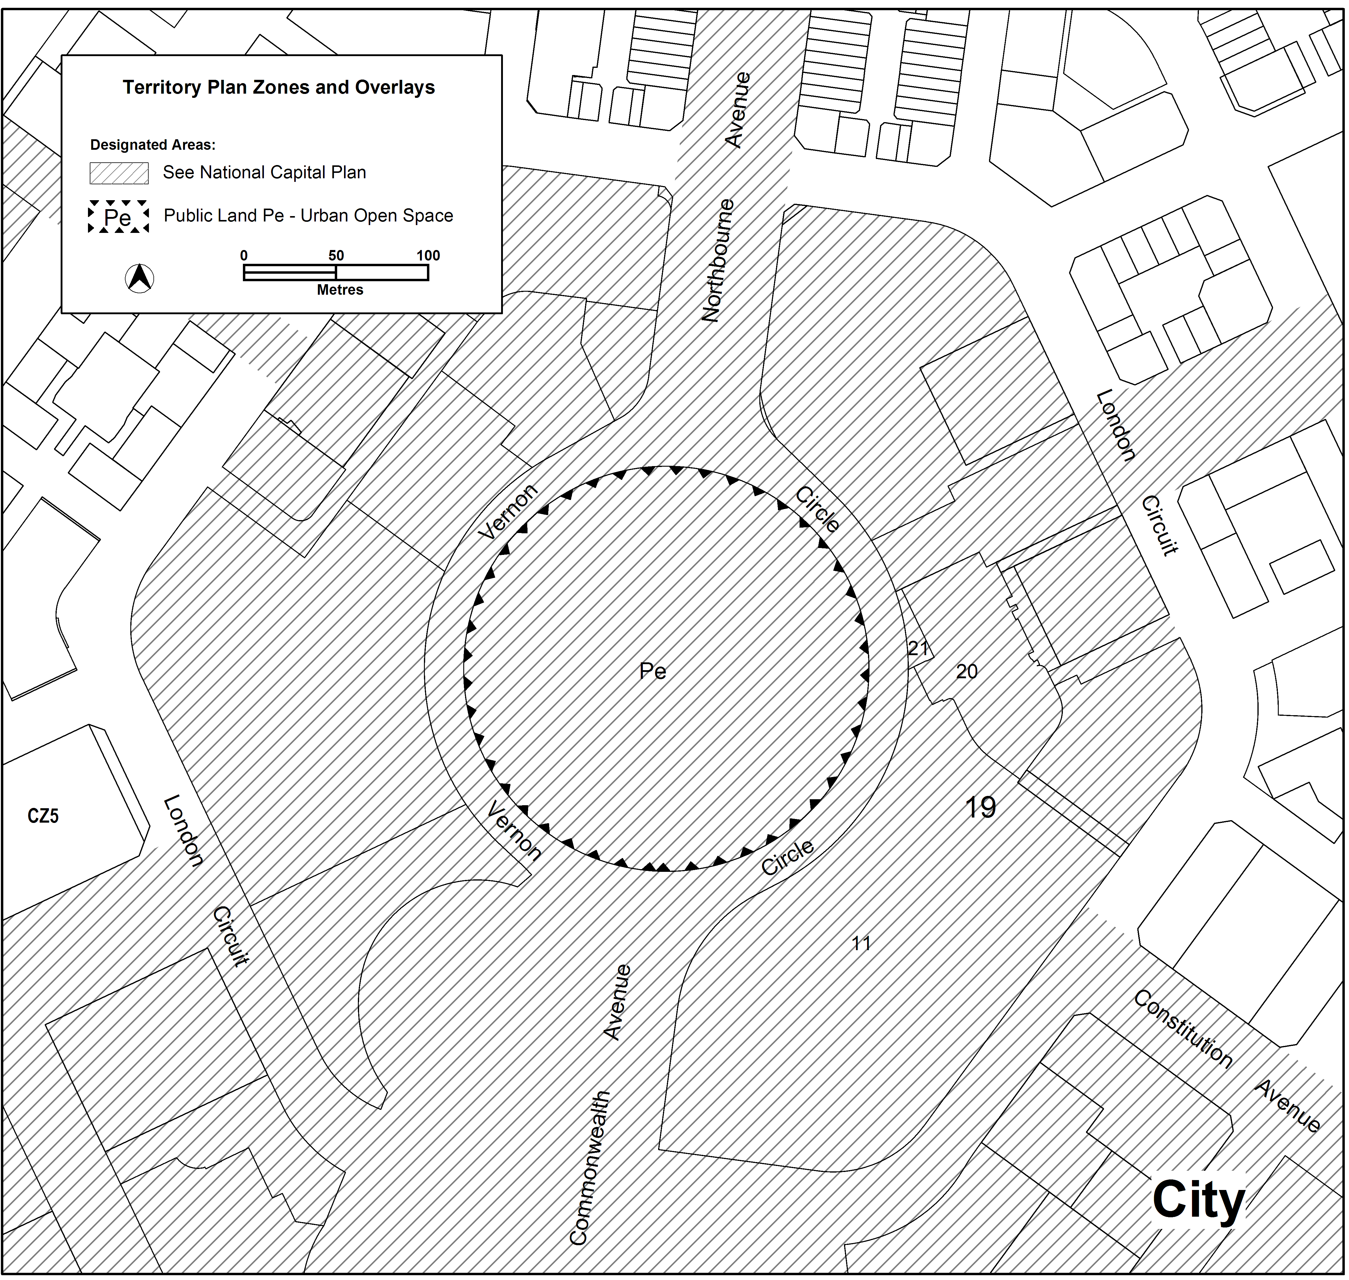

Variation to Group Centres Development Code

- Part A – Centre and Zone Specific Requirements, Part A – Group Centres – Overview, Objectives, a)

Substitute ‘Provide or’ with

Provide for

Variation to Town Centres Development Code

- Part A(3) – CZ3 Services Zone, Element 2 Building and Site Controls, Item 2.4 Woden, R47

Substitute with

Within the area shown in Figure A10, maximum building heights are 3 storeys.

Variation to CZ5 – Mixed Use Development Code

- Part B – Site Specific Controls, Element 1: Restrictions on Use, Rule R55

Omit

Rule R55(b)

Variation to IZ1 General Industrial Zone Development Table

- OTHER CODES – GENERAL CODES

a) Substitute ‘Location of Community and Recreation Facilities’ with

Community and Recreation Facilities Location Guidelines

- Substitute ‘Water Sensitive Urban Design’ with

Water Ways: Water Sensitive Urban Design

Variation to IZ2 Industrial Mixed Use Zone Development Table

- Minimum assessment track merit, specific areas have additional developments that may be approved subject to assessment

a) Omit from Site Identifier column

Fyshwick Section 6 Blocks 6, 25, and 26
Fyshwick Section 7 Blocks 6 and 7
Fyshwick Section 39 Blocks 6 and 7

b) Omit from Additional Development column

Office

Variation to NUZ1 Broadacre Zone Development Table

- Minimum assessment track merit, prohibited development

For the following Site Identifiers, omit ‘road’ from the Development column:

Jerrabomberra Blocks 2223, 2100, 2099, 2000 and 2101 (Figure 2)
Pialligo Areas ‘a’ and ‘b’ (Figure 6)
Symonston Area ‘a’ (Figure 7)

- Definitions

a) Substitute ‘Liquor Act 1975’ in the development column of the following definitions:

Club
Hotel
Motel
Tourist resort
Drink establishment
Restaurant

with:

Liquor Act 2010

- Substitute ‘Children and Young People Act 1999’ in the development column of the Child care centre definition with:

Children and Young People Act 2008

Interpretation service

