Australian Capital Territory

Planning and Development (Technical Amendment—Changes to multi unit housing development code, industrial zones development code, inner north precinct code and parking and vehicular access general code) Plan Variation 2011*
Notifiable instrument NI2011–207
Technical Amendment No. 2011–04
made under the
Planning and Development Act 2007, section 89 (Making technical amendments)

This technical amendment commences on 29 April 2011.

Technical amendment number 2011-04 to the Territory Plan has been approved by the Planning and Land Authority.

Neil Savery
Delegate of Planning and Land Authority

18 April 2011

Planning & Development Act 2007

Technical Amendment
to the Territory Plan

Variation 2011-04

Changes to multi unit housing development code, industrial zones development code, inner north precinct code and parking and vehicular access general code

April 2011

Table of Contents

1. INTRODUCTION 2
Outline of the process 2
2. EXPLANATORY STATEMENT 3
2.1 Proposed Changes and Reasons 3
2.2 Statement of compliance with the Planning and Development Act* 4
3. TECHNICAL AMENDMENT 7
3.3 Code Amendment 7

INTRODUCTION

Outline of the process
The Commonwealth’s Australian Capital Territory (Planning and Land Management) Act 1988 allows for the Legislative Assembly to make laws to establish a Territory Planning Authority and for that Authority to prepare and administer a territory plan.
The Planning and Development Act 2007 (the Act) establishes the ACT Planning and Land Authority as the Authority which prepares and administers the territory plan, including continually reviewing and proposing amendments as necessary.
Technical amendments to the territory plan are prepared in accordance with the Act. This technical amendment has been prepared in accordance with the following two sections of the Act:
A code variation (section 87(b) of the Act) is a technical amendment that
- would only change a code; and
- is consistent with the policy purpose and policy framework of the code; and
- is not an error variation.
A variation under section 87(g) of the Act is a technical amendment that clarifies the language in the territory plan, provided it does not change the substance of the plan.

Following the release of the variation under section 90 of the Act, submissions from the public were invited. At the conclusion of the limited consultation period, representations (if any) were considered by the ACT Planning and Land Authority (the Authority). The Authority then determined a day when the code variation commences by way of a commencement notice. The date of commencement is provided on the attached notifiable instrument (commencement notice).

EXPLANATORY STATEMENT
    - Proposed Changes and Reasons

- Multi unit housing development code – changes to rule R24 to remove restrictions on plot ratio for former B1 Area Specific Policy land (Item 1)

Rule R24 restricts the plot ratio for development in the RZ4 medium density residential zone to a maximum of 80%. The RZ4 zone is made up of land that was previously subject to the B1, B8 and B11 area specific policies (ASP) under the former Territory Plan. While the B11 ASP did include an 80% plot ratio limit on development the B1 and B8 ASPs did not. The introduction of the restructured Territory Plan in 2008 intended to remove this anomaly. However it was not intended to apply the plot ratio restriction to sites within the former B1 and B8 areas that had already been sold for development without a plot ratio restriction and which had not been developed. It was considered appropriate in these instances that the lessees be entitled to develop the land without the plot ratio restrictions imposed by rule R24 in the multi unit housing development code. As a result this rule has been modified to include an exception to this effect.

- Industrial zones development code – Hume west new industrial estate bushfire prone blocks (Items 2-3)

Some blocks within the new Hume West industrial estate were identified through the estate development planning process as being potentially bushfire prone due to their location and proximity to bushland. Any buildings on these specific blocks are required to be constructed in accordance with the specified construction bushfire attack level (BAL) contained in Australian Standard AS3959. To enable this requirement to be imposed, a provision and diagram has been incorporated though a change to the industrial zones development code to ensure that future development of this land continues to meet any requirements for specific construction standards based on meeting bushfire risk assessment outcomes. Such ongoing measures would usually be incorporated as a part of a technical amendment (not requiring consultation) for a future urban area uplift, as ongoing provisions. However, in this instance there was no future urban area overlay and therefore it was not possible to use that method.

- Inner north precinct code – clarification of original intent of criterion C12 (Item 4)

Criterion C12 permits a maximum site coverage of 100% in the primary building zone subject to the agreement of adjoining lessees and lodging a plan for integrated development. However the current wording of the criterion could be interpreted to mean that agreement is not required if 100% site coverage is not reached for a development proposal even if the development is proposed to be built to the boundaries.

The original intent of criterion C12 was to accommodate terrace style housing where adjoining owners were in agreement. In this regard, C12 has used site coverage to deal with proposals to build to the boundary (i.e. zero side setback) in the primary building zone.

The wording of the criterion has been revised by adding a note to clarify the original intent of the provision in that building to the boundary may be permitted subject to the agreement of adjoining lessees.

- Parking and vehicular access general code – sections 3.1.4 and 3.2.2 (Items 5 and 6)

Some changes have been made to the wording of provisions in the parking and vehicular access general code to clarify the intent of the requirements.

Table 3.1.4 has been amended to include visitor parking in the requirements for short stay parking.

The special condition for city centre CZ3 zone (section 3.2.2) has been clarified to ensure that more than one use is required where a parking provision of 3 spaces per 100m² GFA is applied.

    - Statement of compliance with the Planning and Development Act*

* Planning and Development Act 2007

A Multi unit housing development code – changes to Rule R24 to remove restrictions on plot ratio for former B1 Area Specific Policy land

Section of Act | Statement of compliance with Act
s87(b) a variation (a code variation) that -
(i) would only change a code; and | Would only modify a rule in the multi unit housing development code.
(ii) is consistent with the policy purpose and policy framework of the code; and | The purpose of the code is to provide additional planning, design and environmental controls to support the zone objectives and assessable uses in the development tables. The amendment is considered to be consistent with the purpose of the residential multi unit housing development code.  The amendment makes no changes and does not affect the application of the RZ4 medium density zone objectives that provide a framework for the particular provisions contained in the code. The change to the rule is consistent with the objectives for the specific residential zone.  The technical amendment seeks to transcribe into the current Territory Plan a requirement contained in the previous Territory Plan that was not incorporated in the current provision at the time the new Territory Plan was introduced.
(iii) is not an error variation | Is not a formal error

B. Industrial zones development code – Hume west new industrial estate bushfire prone blocks

Section of Act | Statement of compliance with Act
s87(b) a variation (a code variation) that -
(i) would only change a code; and | Would only add a rule to the industrial zones development code as a result of a condition for approval of the estate development plan to incorporate appropriate bushfire protection requirements into the construction of buildings on the specified bushfire prone blocks.
(ii) is consistent with the policy purpose and policy framework of the code; and | The purpose of the code is to provide additional planning, design and environmental controls to support the zone objectives and assessable uses in the Development Tables. The amendment is considered to be consistent with the purpose of the industrial zones development code.
(iii) is not an error variation | Is not a formal error

C. Changes to parking and vehicular access general code

Section of Act | Statement of compliance with Act
s87(b) a variation (a code variation) that -
(i) would only change a code; and | Only changes the parking and vehicular access general code sections 3.1.4 and 3.2.2
(ii) is consistent with the policy purpose and policy framework of the code; and | The purpose of the code is to ensure that development achieves the relevant objectives of the Territory Plan and will be used by the Authority in the assessment of development applications involving development, redevelopment and lease variations. The code specifies vehicular access and parking requirements for development.  The proposed changes seek to clarify and/or tighten existing controls to ensure better design and development outcomes in terms of parking provision requirements.
(iii) is not an error variation | Is not a formal error

D. Inner north precinct code – clarification of original intent of criterion C12

Section of Act | Statement of compliance with Act
s87(g) a variation to clarify the language in the territory plan if it does not change the substance of the plan | The change to C12 is intended to clarify the original intent of the provision through clearer wording of the criterion.

TECHNICAL AMENDMENT
    - Code Amendment

Variation to multi unit housing development code
- Part A – Zone Specific Controls, Part A(4) – RZ4 – Medium Density Residential Zone, Element 2: Building and Site Controls, Item 2.4 Plot Ratio, R24

Substitute with

R24*  Maximum plot ratio does not exceed 80% except where all of the following are met:  - the land was subject to either a Residential B1 or B8 area specific policy under the Territory Plan immediately prior to the commencement of the Planning and Development Act 2007 on 31 March 2008  - the land was held under a holding lease immediately prior to the commencement of the Planning and Development Act 2007 on 31 March 2008. | This is a mandatory requirement. There is no applicable criterion.

Variation to industrial zones development code
- Part A – Zone Specific Controls, Part A(1) – IZ1 – General Industrial Zone, Element 2: Building and Site Controls

Insert a new item:

2.2 Bushfire
R1A  Where identified in the figure at Appendix A, buildings are to be designed and constructed in accordance with the specified bushfire construction level of Australian Standard  AS3959. | This is a mandatory requirement. There is no applicable criterion.

- Industrial zones development code

After Part C(4) Symonston insert

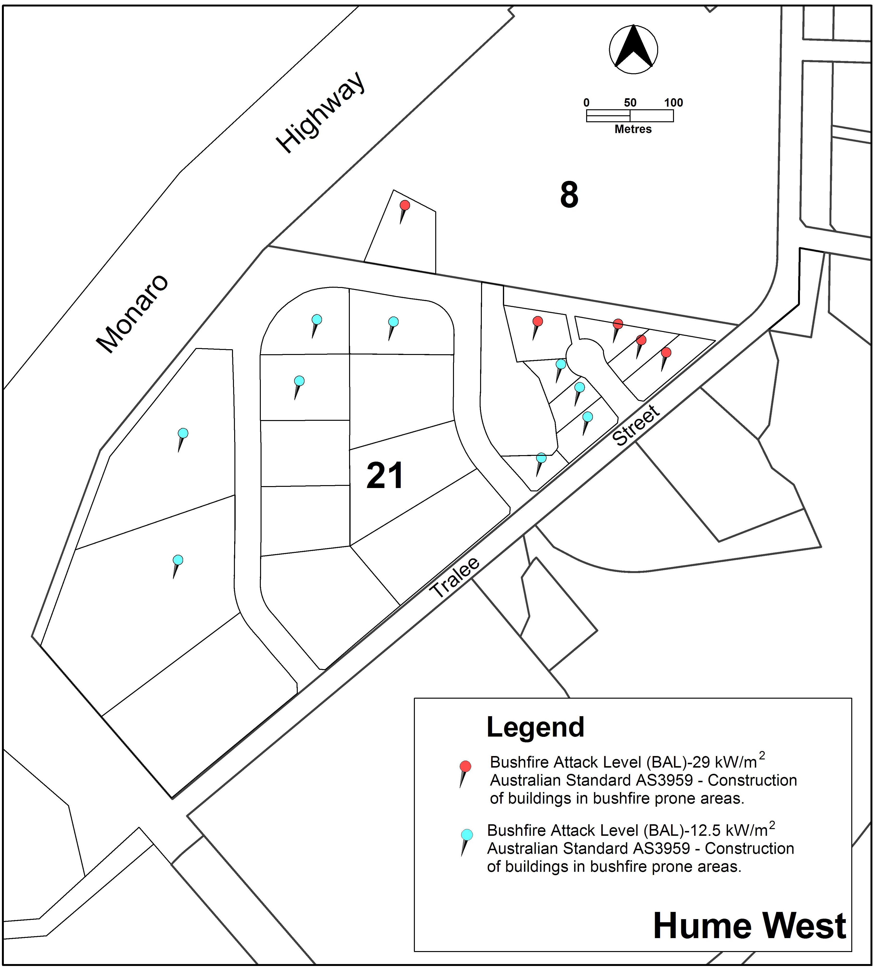
Appendix A: Hume West Industrial Estate bushfire provisions

Variation to the inner north precinct code
- Part A – General Development Controls, Element 2: Building and Site Controls, Item 2.6: Site Coverage, C12

Substitute with

There is no applicable rule. | C12  Maximum site coverage of up to 100% in the Primary Building Zone may be permitted subject to the agreement of adjoining lessees and lodging a plan for integrated development.  Note: This requirement applies to all built-to-boundary proposals less than 100% site coverage in the Primary Building Zone.

Variation to parking and vehicular access general code
- 3. Parking and Vehicular Access, 3.1.4 Locational requirements

Substitute with

The following are specific requirements for the location of long stay, short stay and operational parking (ie vehicles uses directly as part of the operation within the development, eg fleet cars)

 | Development | Long Stay Parking | Short Stay/ Visitor Parking | Operational Parking
(i) | Residential use | On-site | On-site or within 100 metres | On-site
(ii) | Child care | On-site or adjacent | On-site or within 100 metres | On-site
(iii) | Residential care accommodation, special dwelling | On-site | On-site or within 100 metres | On-site
(iv) | All other uses excluding those listed in (i), (ii) and (iii) above | On-site or within 200 metres | On-site or within 100 metres | On-site

- 3. Parking and Vehicular Access, 3.2.2 Parking provision rates, Special condition for city centre CZ3 zone

Substitute the first paragraph with:

“For mixed use developments of greater than 1000m² GFA where the lease permits a mixture of two or more of the following land uses and two or more of the following are to be developed on the site, the maximum rate applicable shall be 3 spaces per 100m² GFA:

Interpretation service
