Australian Capital Territory

Planning and Development (Technical Amendment—Dickson) Plan Variation 2011 (No 1)

Notifiable instrument NI2011—238
Technical Amendment No 2011-20
made under the
Planning and Development Act 2007, section 89 (Making technical amendments) (s96 land ceases to be in future urban area) (s96A Rezoning – boundary changes)

This plan variation commences on the day after it is notified.

Variation No 2011-20 to the Territory Plan has been approved by the Planning and Land Authority.

The variation specifies the changes to zone and does not affect existing leasehold.

Area that is affected by this change is identified on the Annexure A.

Neil Savery
Planning and Land Authority
12 May 2011
THIS IS PAGE ONE OF ANNEXURE A
TO NOTIFIABLE INSTRUMENT NI2011 – 238

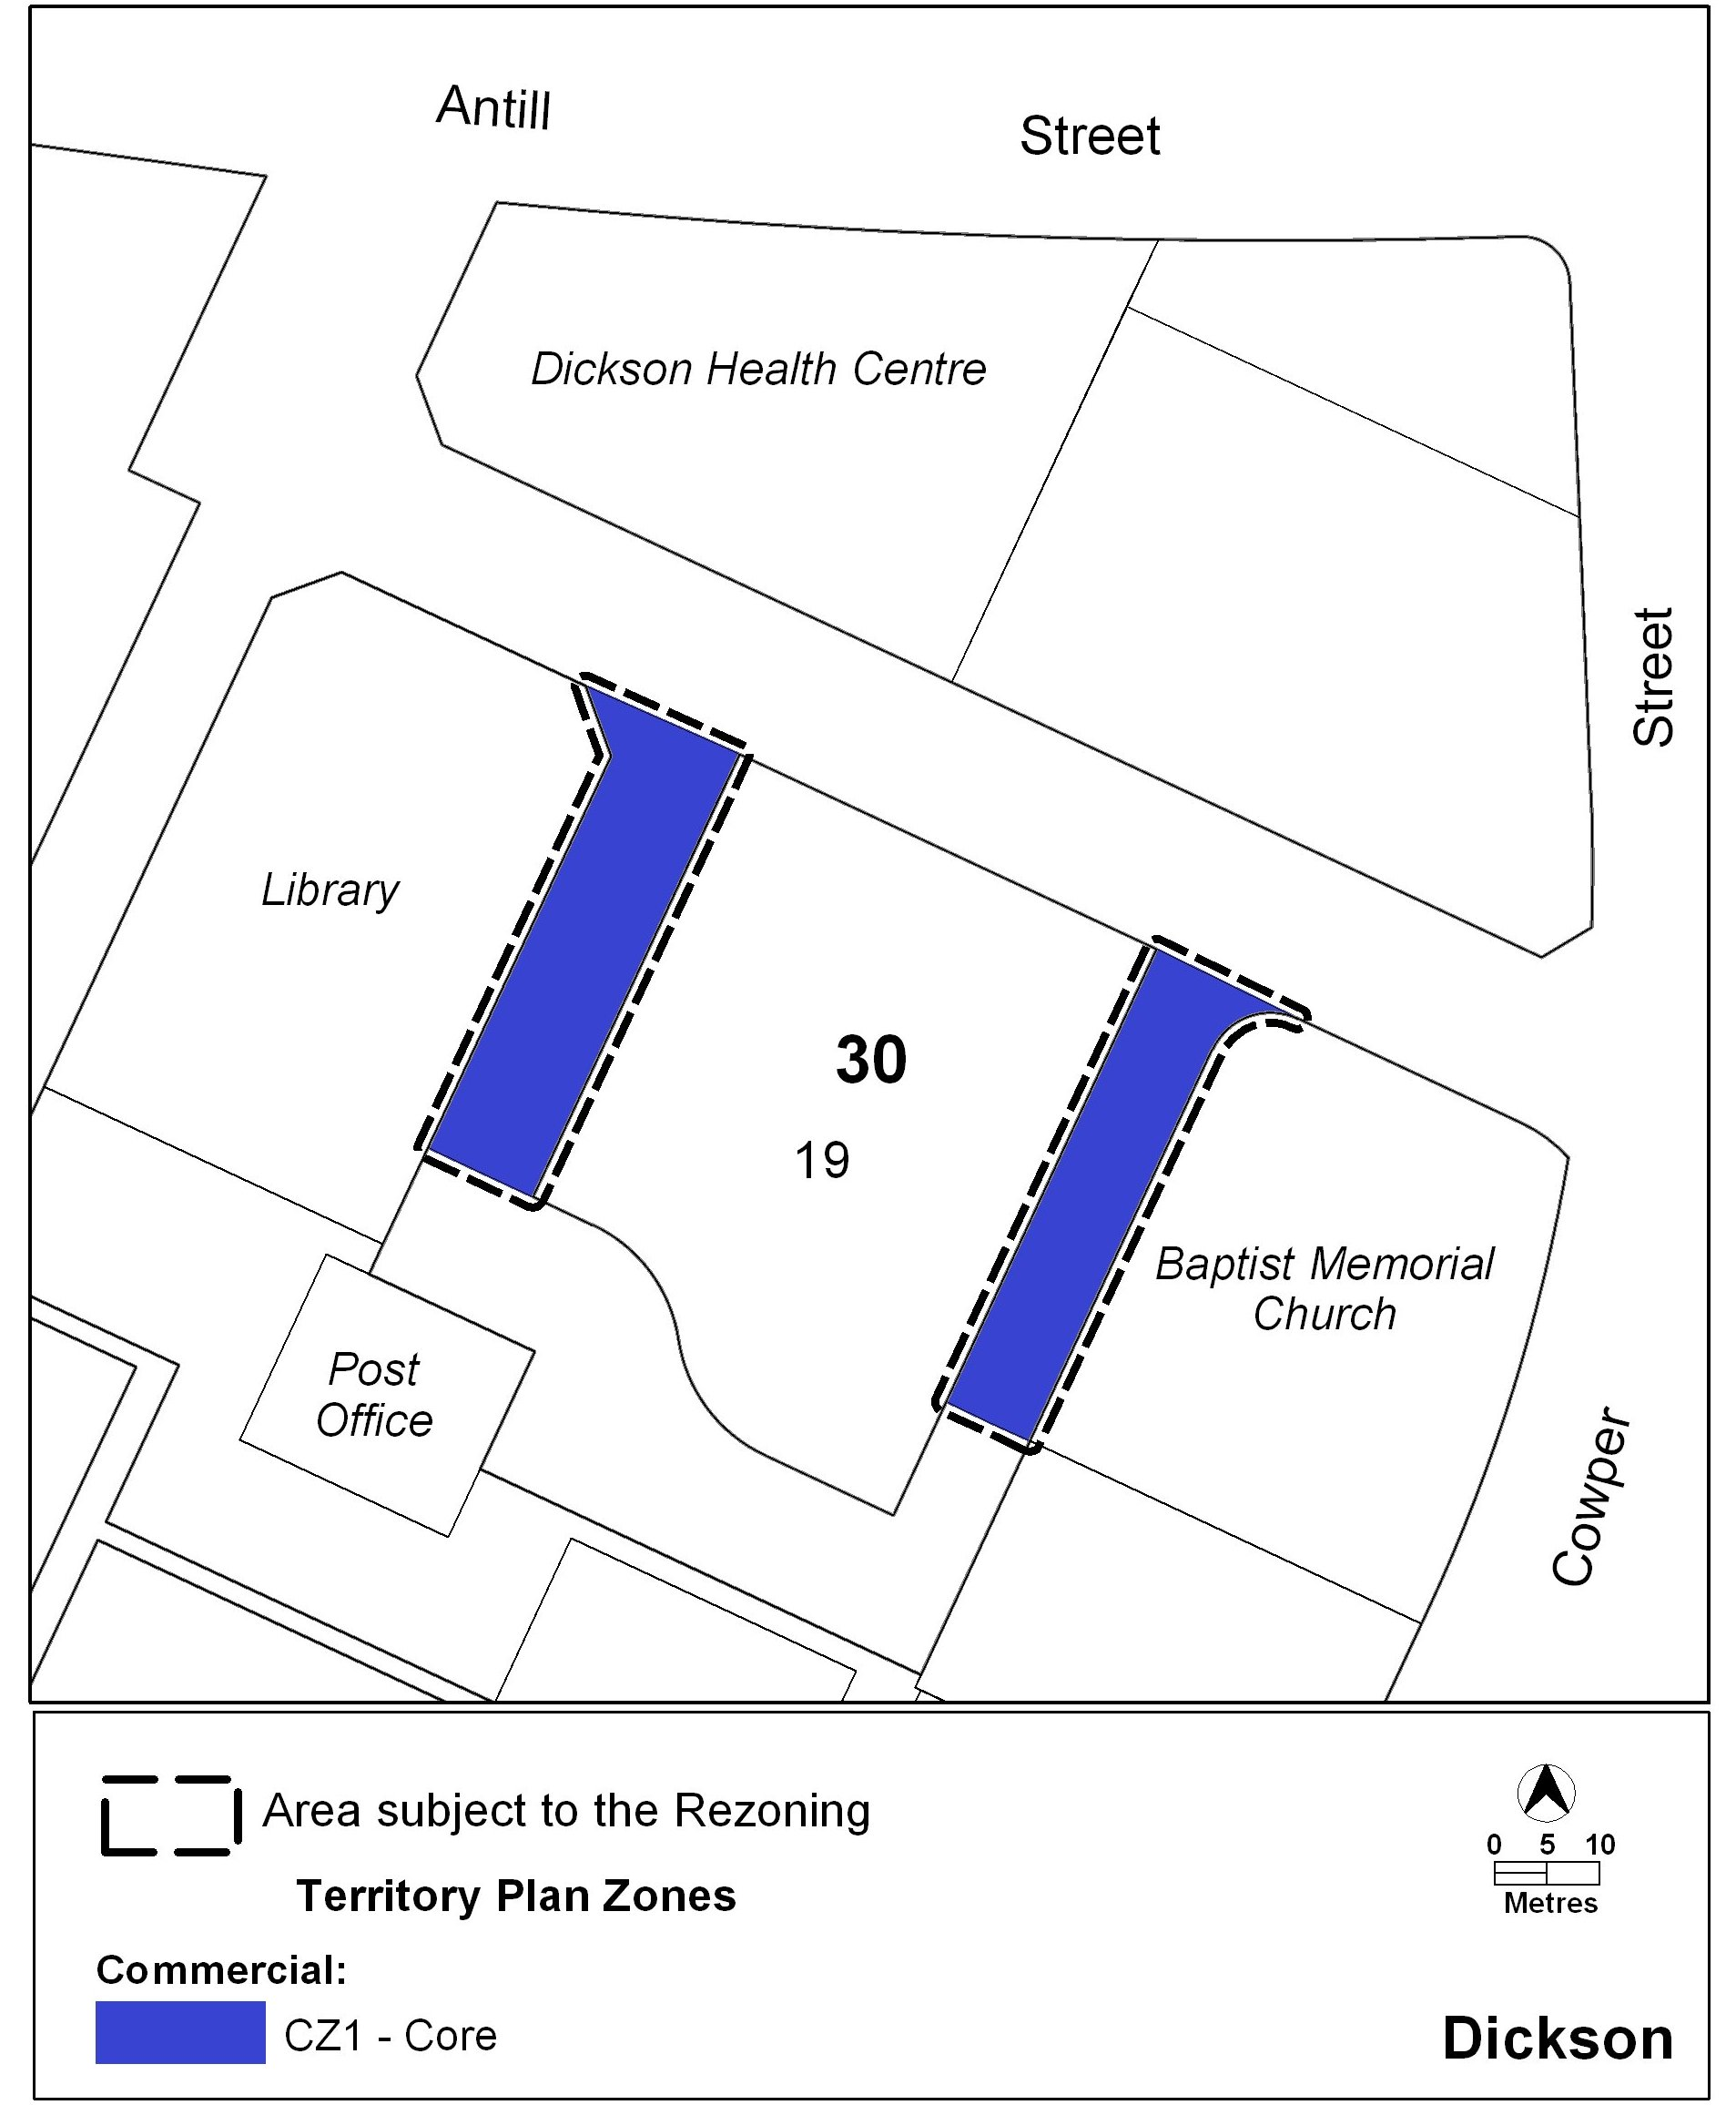

Neil Savery
Planning and Land Authority
12 May 2011

