Australian Capital Territory

Planning and Development (Technical Amendment—Bonner) Plan Variation 2011 (No 3)

Notifiable instrument NI2011—257
Technical Amendment No 2011-16
made under the
Planning and Development Act 2007, section 89 (Making technical amendments) (s96 land ceases to be in future urban area)

This plan variation commences on the day after it is notified.

Variation No 2011-16 to the Territory Plan has been approved by the Planning and Land Authority

Annexure A – The map specifies the land identified may be used for the purposes indicated on this map.

Annexure B – Introduces Bonner Precinct Code at Section 10 of the Territory Plan

Neil Savery
Planning and Land Authority
Date: 23 May 2011
THIS IS PAGE ONE OF ANNEXURE A
TO NOTIFIABLE INSTRUMENT NI2011 – 257

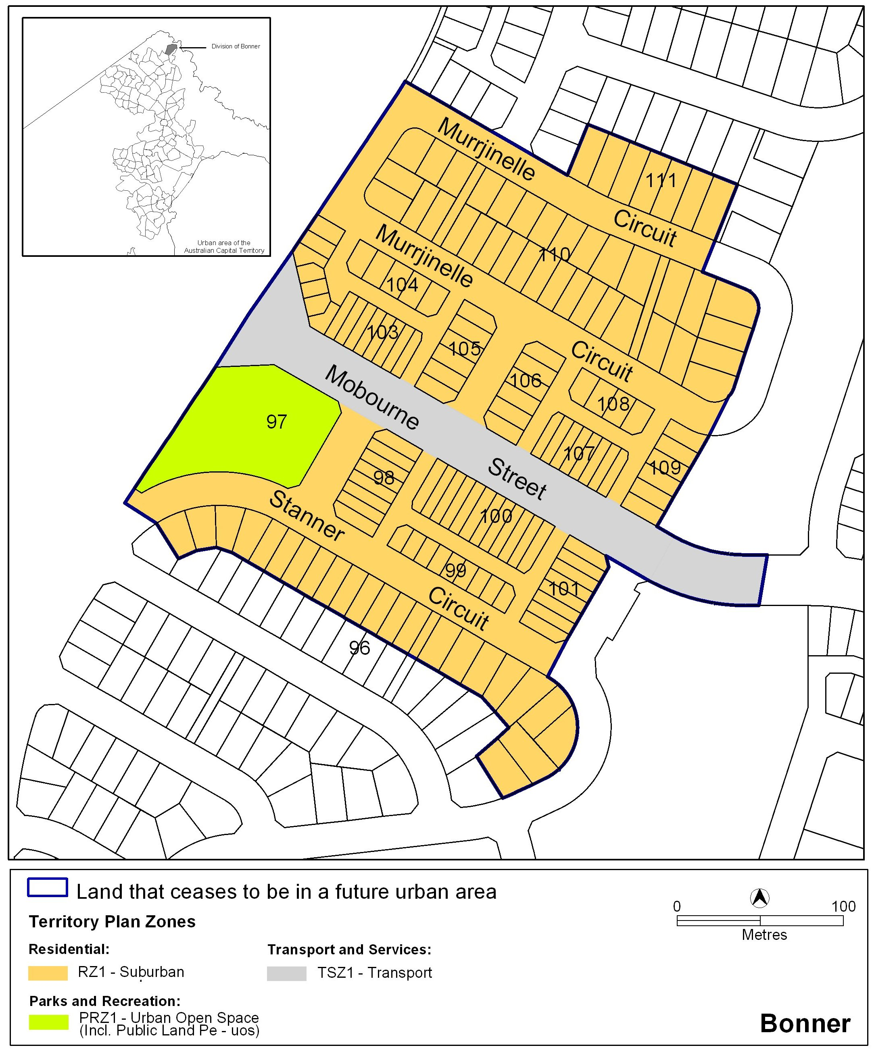

Neil Savery
Planning and Land Authority
Date 20 May 2011

THIS IS PAGE ONE OF ANNEXURE B
TO NOTIFIABLE INSTRUMENT NI2011 – 257

Bonner Precinct Code
Covering the Division of Bonner

Contents
Introduction 3
Bonner Precinct Code 3

Introduction

Name
The name of this code is the Bonner Precinct Code.

Application
This Precinct Code applies to the suburb of Bonner. The code identifies individual blocks or areas to which specific provisions apply as defined in the legend of the map attached.

Where more than one type of Code applies to a development, the order of precedence when there is inconsistency of provisions between Codes, as defined by the Act, is Precinct Code, then Development Code, and then General Code.

Purpose of code
Codes provide additional planning, design and environmental controls to support the zone objectives and assessable uses in the Development Tables.
The Codes are used by the Authority to assess development applications. The Codes therefore also provide guidance to intending applicants in designing their developments and preparing their development applications.

Further information
Please refer also to the Bonner Concept Plan for other relevant or applicable planning provisions.

Bonner Precinct Code

