Australian Capital Territory

Planning and Development (Technical Amendment—Casey) Plan Variation 2011 (No 2)

Notifiable instrument NI2011—283
Technical Amendment No 2011-18 Casey (2)
made under the
Planning and Development Act 2007, section 89 (Making technical amendments) (s96 land ceases to be in future urban area)

This plan variation commences on the day after it is notified.

Variation No 2011-18 to the Territory Plan has been approved by the Planning and Land Authority

Annexure A – The map specifies the land identified may be used for the purposes indicated on this map.

Annexure B – replaces the map on page 2 of Casey Precinct Code at Section 10 of the Territory Plan

Neil Savery
Planning and Land Authority
Date: 1 June 2011
THIS IS PAGE ONE OF ANNEXURE A
TO NOTIFIABLE INSTRUMENT NI2011 –283

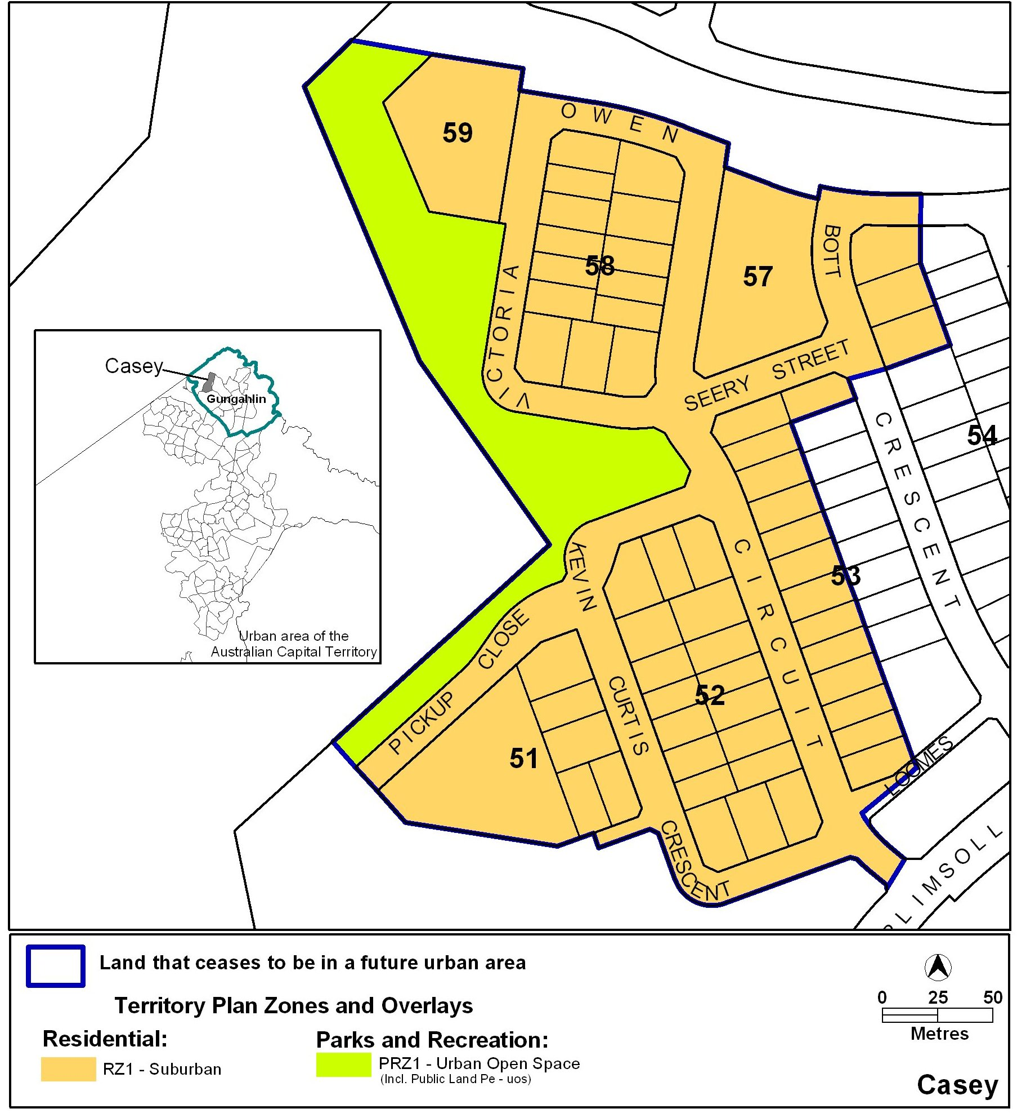

Neil Savery
Planning and Land Authority
Date: 1 June 2011

THIS IS PAGE ONE OF ANNEXURE B
TO NOTIFIABLE INSTRUMENT NI2011 –283

