Australian Capital Territory

Planning and Development (Technical Amendment—Code amendment to the Group Centres Development Code – Proposed supermarket site Chisholm section 598 block 7) Plan Variation 2011
Notifiable instrument NI2011– 353
Technical Amendment No. 2011–17
made under the
Planning and Development Act 2007, section 89 (Making technical amendments)

This technical amendment commences on 8 July 2011.

Technical amendment number 2011-17 to the Territory Plan has been approved by the Planning and Land Authority.

Ben Ponton
Delegate of Planning and Land Authority

30 June 2011

Planning & Development Act 2007

Technical Amendment
to the Territory Plan
Variation 2011-17

Code amendment to the Group Centres Development Code—Proposed Supermarket Site Chisholm (section 598 block 7)

July 2011

Table of Contents

1. INTRODUCTION 1
Outline of the process 1
2. EXPLANATORY STATEMENT 1
Background 1
Proposed Changes and Reasons 1
3. TECHNICAL AMENDMENT 1
3.1 Code Amendment 1

INTRODUCTION

Outline of the process
The Commonwealth’s Australian Capital Territory (Planning and Land Management) Act 1988 allows for the Legislative Assembly to make laws to establish a Territory Planning Authority and for that Authority to prepare and administer a territory plan.
The Planning and Development Act 2007 (the Act) establishes the ACT Planning and Land Authority as the Authority which prepares and administers the territory plan, including continually reviewing and proposing amendments as necessary.
Technical amendments to the territory plan are prepared in accordance with the Act. This technical amendment has been prepared in accordance with the following two sections of the Act:
A code variation (section 87(b) of the Act) is a technical amendment that
- would only change a code; and
- is consistent with the policy purpose and policy framework of the code; and
- is not an error variation.

Following the release of the variation under section 90 of the Act, submissions from the public were invited. At the conclusion of the limited consultation period, representations (if any) were considered by the ACT Planning and Land Authority (the Authority). The Authority then determines a day when the code variation commences by way of a commencement notice. The date of commencement is provided on the attached notifiable instrument (commencement notice).

EXPLANATORY STATEMENT

Background
The ACT Planning and Land Authority is undertaking a review of the commercial zones and has released a Commercial zones policy review Discussion Paper, Phase 1 dated May 2011. Comments on this paper are invited until 4 July 2011.
The discussion paper focuses on:

- the objectives and development table of the commercial zones
- the group centre development code
- the local centre development code

The discussion paper responds to the Review of ACT Supermarket Competition Policy, September 2009 prepared by John Martin (known as the Martin Report) which calls for ‘zoning reform’ generally across commercial centres to increase potential land supply for new supermarkets.

On 10 January 2011 the Chief Minister announced in-principle support to the direct sale of land to ALDI at various sites, including at the Chisholm Group Centre to increase choice and value for money for Canberra residents.

It is in the context of this review and the Government’s in-principle decision that the decision to undertake this technical amendment has been made. The technical amendment will enable the development of a 1500 m² supermarket at a site in the commercial CZ3 services zone at Chisholm.

The core area of the group centre at Chisholm was developed from 1986. The main shopping area was developed in the commercial CZ1 core zone and contains an anchor supermarket, being Coles and a variety of smaller shops, including a bakery, butcher, fruit and vegetable store, chemist and newsagency. The development also includes a medical facility, restaurants and other associated uses. These facilities are grouped around a central shared car park. Some tenancies are currently vacant.

The remainder of the group centre is located within the commercial CZ3 zone. The uses in this zone include a petrol station, the Vikings Club, a park and ride facility a fire station and a multi unit housing development. There are tenancy vacancies in a commercial building within the zone. There is one remaining vacant site in the CZ3 zone which is the subject of this variation.

Surrounding the Chisholm Group Centre are number of community facilities, including a child care centre and a church. These facilities are contained within the community facilities zone (CFZ).

Proposed Changes and Reasons
Area specific principle to enable the development of a supermarket of up to 1500m²

The site identified for a small supermarket at the Chisholm Group Centre is section 598 block 7 (see Figure 1 below). It is within the commercial CZ3 services zone which is intended to support the retail core by providing a mix of uses which contribute to an active and diverse character. The zone objectives are located within the CZ1 – CZ6 objectives and development tables in the Territory Plan. The provisions which guide development, including objectives for group centres and rules and criterion for the Chisholm Group Centre are contained within the group centres development code. The Chisholm Group Centre comprises the commercial CZ1 core and CZ3 services zones.

The group centres development code indicates that the CZ3 zone is intended for:

more fringe commercial activities, primarily non-retail commercial uses,
commercial accommodation, and some restaurants and indoor entertainment and recreation facilities. Residential and community uses are also permissible, subject to design and siting, provided they are
not incompatible with primary uses.

The CZ3 zone is designed to support rather than contain core retail anchor stores, so as not to unduly restrict the development of the retail core contained in the CZ1 core zone. In this instance, however, the core zone has been developed and the only undeveloped land is the subject site. Enabling the development of a small supermarket (being an anchor store) may assist to draw pedestrians from the core area across Benham Street and encourage the filling of the current vacant sites both within the core area and the partially vacant building in the CZ3 zone. The subject site has remained vacant since the development of the centre.

An analysis of the car parking requirements for the site and traffic management report indicates that traffic would be able to be managed appropriately. Some car parking would be provided on-site with additional parking being available within the existing centre. It is noted that as ALDI is not a full line supermarket it is likely that many visitors to the centre would visit both supermarkets, thereby limiting the additional number of vehicular trips generated. There are currently good pedestrian links provided between the existing core of the centre and the subject site. Consideration of their further enhancement to meet additional use needs would be made at the development application stage.

This technical amendment was prepared in the context of the broader commercial zones review, which is considering group centres in a more holistic manner, especially relating to restrictions on supermarkets (see under heading Background above).

Mandatory rule R25 in the group centres development code restricts a supermarket and a shop selling food to a maximum of 300m² per shop. Accordingly, the Territory Plan requires amendment to allow for a supermarket on this site of up to 1500m².

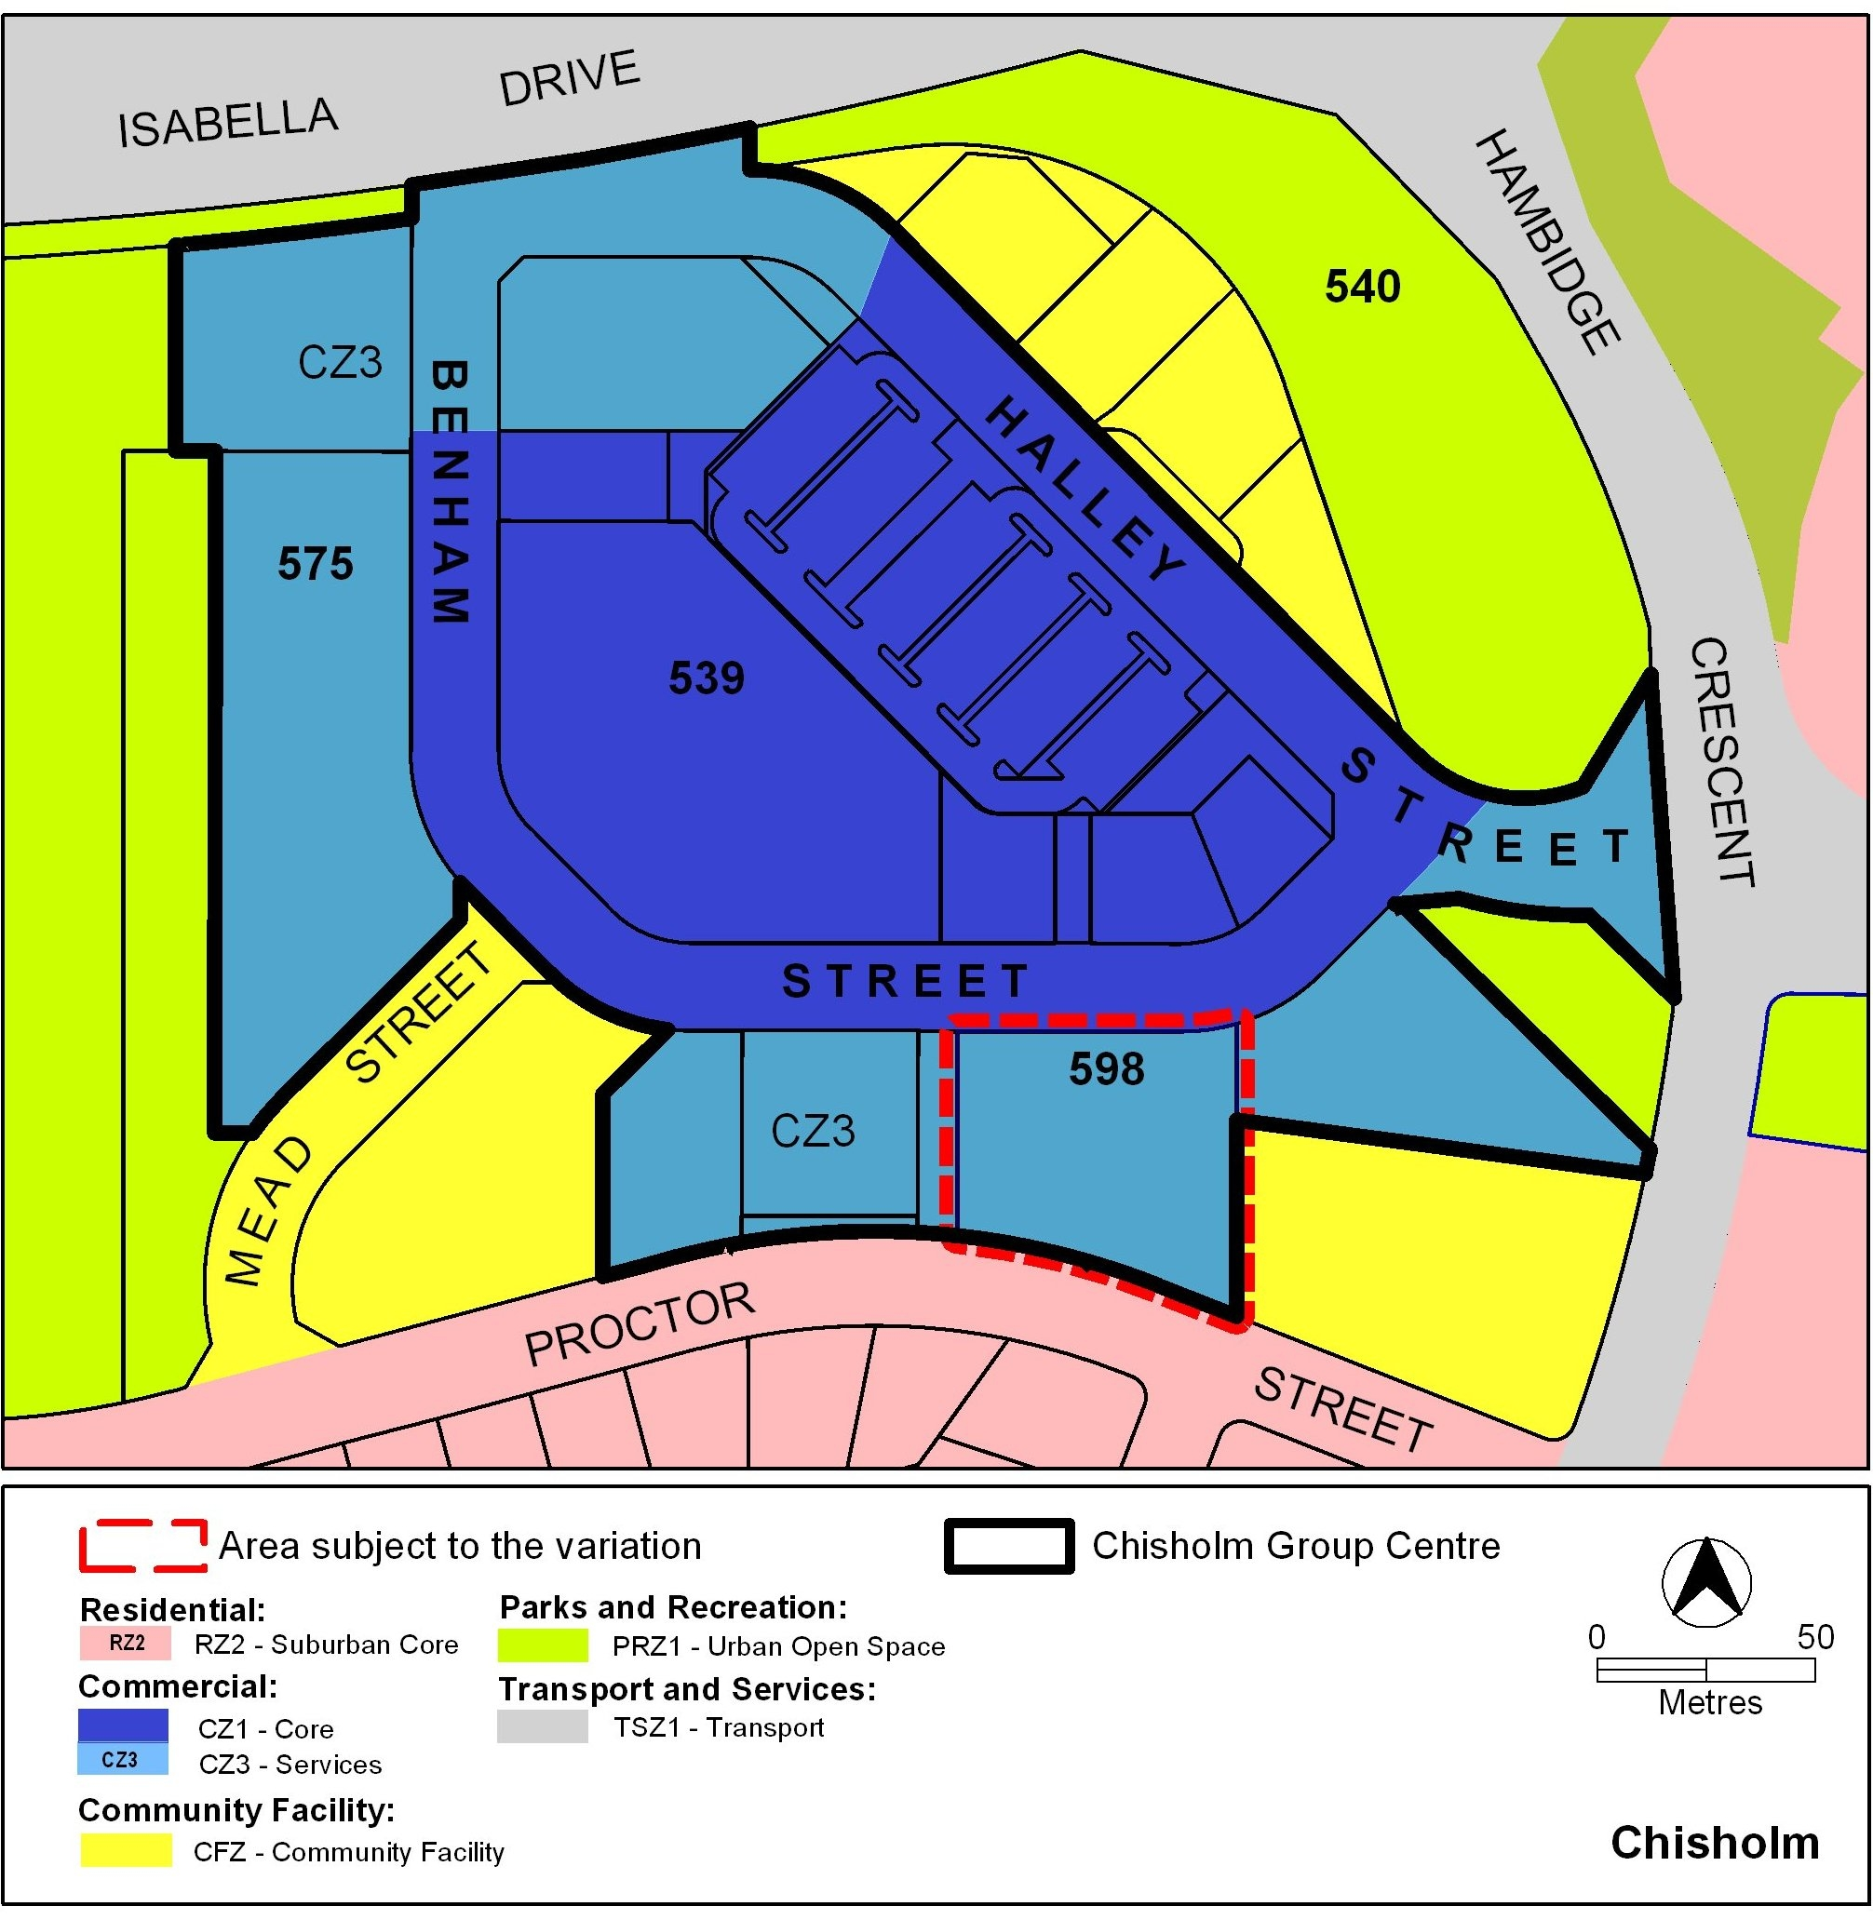

Figure 1 Area subject to the variation—Chisholm Group Centre

Section of Act | Statement of compliance with  Planning and Development Act, 2007
s87(b) a variation (a code variation) that -
(i) would only change a code; and | Would only modify a rule in the group centres development code
(ii) is consistent with the policy purpose and policy framework of the code; and | The purpose of the code is to provide additional planning, design and environmental controls to support the zone objectives and assessable uses in the Development Tables. The amendment is considered to be consistent with the purpose of the group centres development code.  The proposed additional provision which will enable a development of a supermarket of up to 1500 m² in the commercial CZ3 services area supports the policy purpose of the code as expressed in the objectives for group centres, especially the first objective which is to:  Provide for a wide range of shopping, community, business and recreation facilities predominantly serving the surrounding or nearby suburbs
(iii) is not an error variation | Is not a formal error

TECHNICAL AMENDMENT
    - Code Amendment

Variation to Group Centres Development Code
- Part A (3) – Group Centres – CZ3 Services Zone, Element 1: Restrictions on Use, 1.3 Supermarket, R25

Substitute R25 with

R25  The following GFA restrictions apply:  - supermarket or shop selling food maximum 300 m² per shop, except for:  Chisholm Section 598 Block 7 maximum 1500 m² (Figure 1). | This is a mandatory requirement. There is no applicable criterion.

Insert after rule R29:

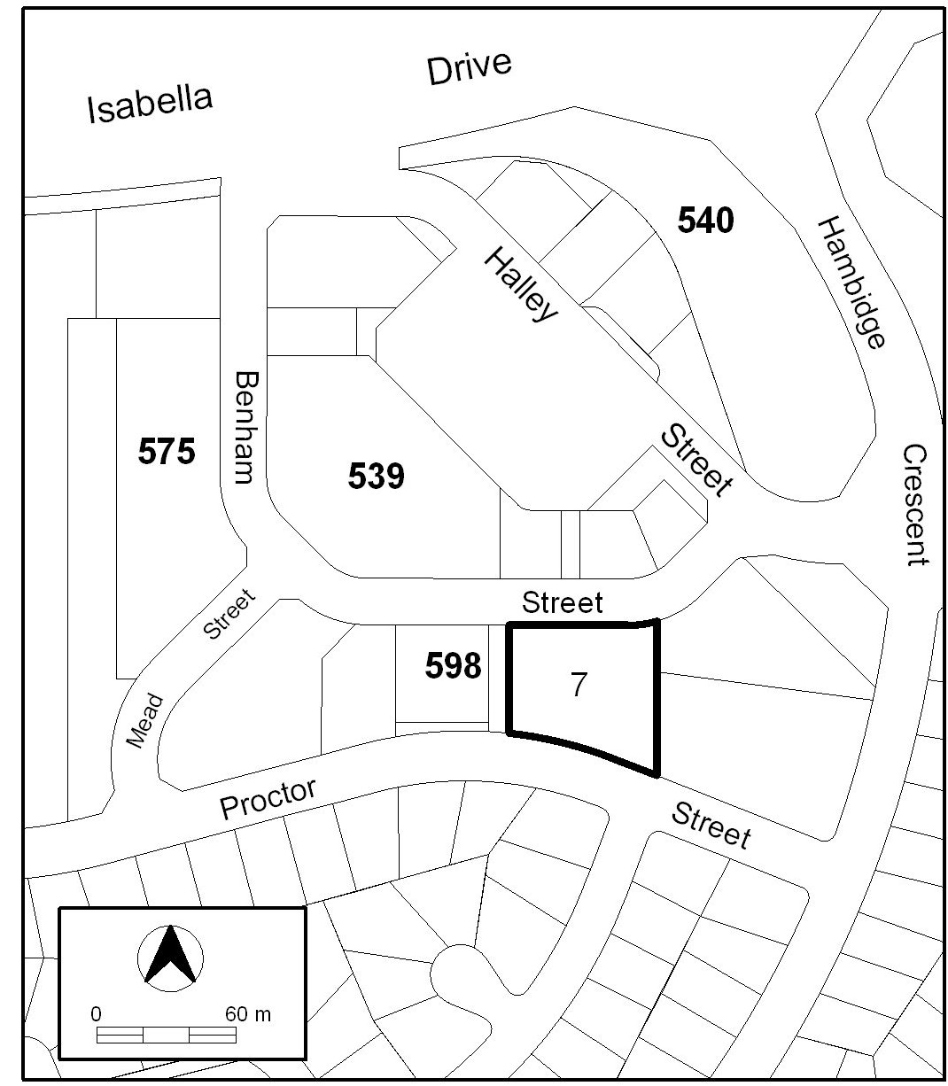

Figure 1 Chisholm

Interpretation service
