Australian Capital Territory
Heritage (Decision about Registration for St Patrick’s Church, Braddon) Notice 2011
Notifiable Instrument NI 2011 - 369
made under the
Heritage Act 2004 section 42 Notice of Decision about Registration

- Revocation
This instrument replaces NI 2010 – 526
- Name of instrument
This instrument is the Heritage (Decision about Registration for St Patrick’s Church, Braddon) Notice 2011 -
- Registration details of the place
Registration details of the place are at Attachment A: Register entry for St Patrick’s Church, Braddon.
- Reason for decision
The ACT Heritage Council has decided that St Patrick’s Church, Braddon meets one or more of the heritage significance criteria at s 10 of the Heritage Act 2004. The register entry is at Attachment A.
- Date of Registration
7 July 2011

Gerhard Zatschler
Secretary
ACT Heritage Council
7 July 2011

AUSTRALIAN CAPITAL TERRITORY

HERITAGE REGISTER
(Registration Details)

Place No:

For the purposes of s. 41 of the Heritage Act 2004, an entry to the heritage register has been prepared by the ACT Heritage Council for the following place:

St Patrick’s Church, Braddon (formerly St Patrick’s School and St Mary’s – Our Lady of Mercy)

Part Block 7, Section 57, Braddon, Canberra Central

DATE OF REGISTRATION

Notified: 7 July 2011 Notifiable Instrument: 2011/369

Copies of the Register Entry are available for inspection at the ACT Heritage Unit. For further information please contact:

The Secretary
ACT Heritage Council
GPO Box 158, Canberra, ACT 2601

Telephone: 13 22 81 Facsimile: (02) 6207 2229

IDENTIFICATION OF THE PLACE
- St Patrick’s Church (formerly St Patrick’s School and St Mary’s – Our Lady of Mercy), part Block 7, Section 57, Braddon, Canberra Central, ACT, Corner of Donaldson and Cooyong Streets. The boundary of the place as defined by Figure 1., bounded by Donaldson St to the northwest, Cooyong Street to the southwest, the Sisters of Mercy Convent to the northeast and car park to the southeast (between Favier House and St Patrick’s). This south eastern boundary has been determined appropriate to allow the south eastern elevation of the building to be viewed in its entirety.

STATEMENT OF HERITAGE SIGNIFICANCE

St Patrick’s Church is important in representing a distinctive function and tradition of a religious community in Canberra, for some 75 years. The location of a school from 1935 until approximately 1980 (a Catholic School from 1935-1973, formerly St Patrick’s School, then St Mary’s School-Our Lady of Mercy, and then the School Without Walls), the building has also been a worship centre, or church, from 1935 to the present. It provides evidence of changes to these functions and traditional uses—some of which are no longer practised in the same way, some of which have disappeared. The history of this place demonstrates those changes over time: changes to practices of a religious group formed in the newly established capital, with strong community ties being forged by newcomers through the support and focus provided by their church and school. During the first twenty years of its life, when St Patrick’s was the only Catholic school and church in North Canberra, religion was an important aspect of cultural self-identification. Since that time, changes at this school and church building reflect both shifts in demography in Canberra’s growth and in liturgy—such as the closing of the Catholic primary school in 1973 and Mass held by migrant groups in their own ethnic languages. These changes, and the physical changes in the Civic area, are seen in the parish and Archdiocese responses, including the diversification of the Church’s use in this space.

Saint Patrick’s Church has special associations with the history of Canberra, and with its educational and religious development, particularly in regard to church and community responses to the provision of education. Saint Patrick’s Church is strongly associated with the Roman Catholic Church, and with the role that the Church took in forging new communities during the growth of the national capital. This was achieved by providing a place and space to facilitate community connections, which was particularly important for those who came to live and work in Canberra without family or community ties.

FEATURES INTRINSIC TO THE HERITAGE SIGNIFICANCE OF THE PLACE

Features intrinsic to the heritage significance of the place which require conservation include:

- Existing church building comprising the original 1935 building as constructed and subsequent 1983 alterations
- Landscaped treatment to the Cooyong Street and Donaldson Street frontages defining the original boundary to St Patrick’s Church

APPLICABLE HERITAGE GUIDELINES

The Heritage Guidelines adopted under s27 of the Heritage Act 2004 are applicable to the conservation of St Patrick’s Church, Braddon, ACT.

The guiding conservation objective is that St Patrick’s Church, Braddon, ACT, shall be conserved and appropriately managed in a manner respecting its heritage significance and the features intrinsic to that heritage significance, and consistent with a sympathetic and viable use or uses. Any works that have a potential impact on significant fabric shall be guided by a professionally documented assessment and conservation policy relevant to that area or component (i.e. a Statement of Heritage Effects – SHE).

Ensure that any actions impacting on the significance of St Patrick’s Church are based on professional conservation planning and in accordance with social heritage values.

REASON FOR PROVISIONAL REGISTRATION

St Patrick’s Church, Braddon, ACT has been assessed against the heritage significance criteria and been found to have heritage significance when assessed against two criteria under the ACT Heritage Act 2004 including (c) and (h).

ASSESSMENT AGAINST THE HERITAGE SIGNIFICANCE CRITERIA

Pursuant to s.10 of the Heritage Act 2004, a place or object has heritage significance if it satisfies one or more of the following criteria. Significance has been determined by research as accessed in the references below. Future research may alter the findings of this assessment.

- it demonstrates a high degree of technical or creative achievement (or both), by showing qualities of innovation, discovery, invention or an exceptionally fine level of application of existing techniques or approaches;

The place is assessed as not meeting this criterion.
- it exhibits outstanding design or aesthetic qualities valued by the community or a cultural group;

The place is assessed as not meeting this criterion.

(c) it is important as evidence of a distinctive way of life, taste, tradition, religion, land use, custom, process, design or function that is no longer practised, is in danger of being lost or is of exceptional interest;

St Patrick’s Church is important in representing a distinctive function and tradition of a religious community in Canberra for some 75 years. As a school from 1935 until approximately 1980 (a Catholic School from 1935-1973, formerly St Patrick’s School, then St Mary’s School-Our Lady of Mercy, and then the School Without Walls), the building has also been a worship centre, or church, from 1935 to the present. It provides evidence of changes to functions and traditional uses —some of which are no longer practised in the same way, some of which have disappeared. The history of this place demonstrates those changes over time: changes to the practices of a religious group formed in the newly established capital, with strong community ties being forged by newcomers through the support and focus provided by their church and school.

During the first twenty years of its life, when St Patrick’s was the only Catholic school and church in North Canberra, religion was an important aspect of cultural self-identification. Since that time, changes at this school and church building reflect both shifts in demography in Canberra’s growth and in liturgy—such as the closing of the school in 1973 and Mass held by migrant groups in their own ethnic languages. These changes, and the physical changes in the Civic area, are seen in the parish and Archdiocese responses, including the diversification of the Church’s use in this space.

(d) it is highly valued by the community or a cultural group for reasons of strong or special religious, spiritual, cultural, educational or social associations;

The religious and educational value placed upon St Patricks as a former school and Church by current parishioners is demonstrative of the social value that may be attributed to any school or Church. Whilst the place clearly had special significance to the Catholic community in the past, this appears to be an historical rather than a contemporary social value, due to the changed demographics and social context in which the community now lives.

The Archdiocese of Canberra and Goulburn, as the obvious cultural group associated with the site have acknowledged the nomination of St Patrick’s however have not attributed a high level of either religious or educational value to the St Patrick’s, demonstrated by the well documented desire to redevelop the site.

The place does not satisfy this criterion.

(e) it is significant to the ACT because of its importance as part of local Aboriginal tradition

This criterion is not applicable.

(f) it is a rare or unique example of its kind, or is rare or unique in its comparative intactness

The place is assessed as not meeting this criterion.

(g) it is a notable example of a kind of place or object and demonstrates the main characteristics of that kind

The place is assessed as not meeting this criterion.

(h) it has strong or special associations with a person, group, event, development or cultural phase in local or national history

As the first Catholic school on the north side of Canberra Saint Patrick’s has special associations with the development of Canberra during and following World War II, and with its educational and religious development, particularly in regard to church and community responses to the provision of education and with the role that the Church took in forging new communities during the growth of the national capital. This was achieved by providing a place and space to facilitate community connections, which was particularly important for those who came to live and work in Canberra without family or community ties.

- it is significant for understanding the evolution of natural landscapes, including significant geological features, landforms, biota or natural processes

The place is assessed as not meeting this criterion.

(j) it has provided, or is likely to provide, information that will contribute significantly to a wider understanding of the natural or cultural history of the ACT because of its use or potential use as a research site or object, teaching site or object, type locality or benchmark site

The place is assessed as not meeting this criterion.

(k) for a place—it exhibits unusual richness, diversity or significant transitions of flora, fauna or natural landscapes and their elements

The place is assessed as not meeting this criterion.

(l) for a place—it is a significant ecological community, habitat or locality for any of the following:
(i) the life cycle of native species;
(ii) rare, threatened or uncommon species;
(iii) species at the limits of their natural range;
- distinct occurrences of species

The place is assessed as not meeting this criterion

SUMMARY OF THE PLACE
HISTORY AND PHYSICAL DESCRIPTION

HISTORY

Building Description

The external walls of the building are constructed of face brickwork, with a horizontal, white-painted rendered frieze that extends from below the window heads up the line of the underside of the eaves. Door and window frames are a combination of timber (from 1935 and 1983), and aluminium (from 1983) and the roof is covered with red/brown tiles.

The building consists of a main central element, rectangular in shape that contains the principal nave, sanctuary and confessional spaces. The longest elevations of this element run parallel to Donaldson Street and face northwest and southeast. This central form is capped with a pitched tiled roof, formed into hip shapes at either end. The centre of the roof is crowned by a small, central spire consisting of a square copper base topped with a pyramid-shaped cap and metal cross.

The rectilinear form of the building is offset by three contrasting elements that punctuate the northwest (Donaldson Street) façade. At either end of the building smaller return wings [with matching hipped roofs] project outwards towards Donaldson Street. These contain an office for the Saint Vincent de Paul Society and the Sacristy. The central entrance to the building, which opens on to a secondary nave, is marked by a free-standing, gabled brick wall with a flattened parapet whose shape is highlighted by decorative brick detailing including stepped corbels, raised courses and alternative stretcher and header courses.

A memorial plaque to the right of the main entrance on the northeast façade commemorates the official Blessing and Opening of Saint Patrick’s School by His Lordship the Bishop of Goulburn, Rt. Rev. Dr. John Barry, on 20 October 1935.

Background

Saint Patrick’s School, Braddon, opened in 1935 in North Canberra. It was the second Roman Catholic School in the new capital, following Saint Christopher’s School of 1928 in South Canberra. Pupils at both schools were taught by the Sisters of the Good Samaritan, who continued to live in their convent at Saint Christopher’s and travelled daily across to Saint Patrick’s. Both schools were also used as “Mass centres”, which means worship centre, or church. In the case of Saint Christopher’s, this arrangement continued until 1939 when the church was built. Prior to Saint Christopher’s, Catholics held Mass at the Acton Trades and Labour Hall, near the former Canberra Hospital. Before Saint Patrick’s, the Catholic community of North Canberra used Acton Hall for their services, and later Ainslie Primary School. Ainslie Primary School, which opened in 1927, is located near Saint Patrick’s on Donaldson Street, Braddon.

The design of Saint Patrick’s School, with its “Accordion” type doors on tracks, allowed it to be divided into separate classrooms, as well as being able to be opened up for parish services and for other community and congregational events.

As at Ainslie School, and at St Patrick’s once it opened, the classrooms were cleared each Saturday so that church services could be held, and the desks were replaced each Sunday evening ready for school on Monday. It is understood that this practice continued until the last school on the Saint Patrick’s site closed—this being the School Without Walls, which operated there from 1974 to 1979-1980. The original Saint Patrick’s School building has continued to be used as a Mass centre from its opening in 1935 until today.

In 1935 Canberra’s population was small. World War I had slowed building of the capital, which resumed again in the mid-to-late 1920s. Progress was once more slowed by the Great Depression in 1929. The 1933 census figures for the Federal Capital Territory show 7325 people living in Canberra. Of these, 3839 were males and 3486 were females. By the onset of World War II, the population had risen to 10,000.

The Roman Catholic population, who were primarily of Irish descent, represented some 19.6% of the total population at the time. At the opening of Saint Patrick’s, the Bishop of Goulburn, Rt. Rev. Dr. John Barry, made a point of emphasising the church’s strong commitment to religious teaching at Catholic schools. At that time, no government funding was allocated to Catholic schools.

Records, particularly those from parish newsletters and the Canberra Times, show the range of parish activities for the Catholic community up until the 1950s. The parish was not only central to religious observance and education, but was also essential for social activities. These included regular dances, evening suppers, sporting events, fund-raising activities such as school fêtes, and wider community events.

The continued growth of Canberra’s population, especially after World War II when it doubled every five years (said to be 79% from 1947 to 1954), resulted in a strong community at the school and at the church. Young families continued to arrive, particularly from Melbourne, as more government departments relocated or expanded. Many single workers also arrived in Canberra, where they lived in nearby hostels such as Gorman House. Many of these new residents became parishioners of the church, while their sons and daughters became pupils of the school. The school grew, and the diocese records show that new buildings were added to the school grounds, including an infants’ school building in 1945, which consisted of demountables, a tuck-shop and a toilet block. These were refurbished between 1967 and 1969.

Canberra’s population growth in the 1950s resulted in a new church, or “church hall”, being built in North Canberra. This was a “new” Saint Patrick’s—and was known as Saint Patrick’s War Memorial Church Hall. Located on Limestone Avenue in Braddon, this opened in late 1953. A much larger structure that could hold a congregation of 700 people, it reflected the growing population that had led to new suburbs being built beyond Haig Park in North Canberra. It also resulted from the continuing physical separation between the northern and southern suburbs of Canberra, and a sense of community divide. The wide physical gap between the two areas was only finally joined when the planned artificial lake, Lake Burley Griffin, was finally was in place in 1964.

From 1955, the nuns teaching at the school were the Sisters of Mercy, who had replaced the Sisters of the Good Samaritan. In 1958 the Sisters of Mercy built a convent on the site, next to the original school building, and they are still resident there. In 1955 the school name was changed to “Saint Mary’s—Our Lady of Mercy”. To avoid confusion with the new Saint Patrick’s War Memorial Church Hall in the same suburb (and in the same parish), the building—which still a served as a Worship centre—also adopted the name Saint Mary’s. From 1955, new parishes were established across Canberra, including in North Canberra. In later years demographic changes, and a general drift away from religious observance, resulted in fewer parishes and a reduction in the number of operational churches.

By 1960, the population of the archdiocese of Canberra and Goulburn had more than doubled, while that of Canberra had increased more than sixfold. This resulted in the construction of new Catholic primarily schools across Canberra. Those that opened in the North Canberra area included Saint Joseph’s, O’Connor (1956), Saint Brigid’s, Dickson (1960), Saint Michael’s, Lyneham (1961), and Rosary Primary, Watson (1963). From the late 1960s, new “town areas”—initially Woden and Belconnen—were established. Included in these were new State and Catholic schools.

Speeches made at the openings of Saint Patrick’s Church in 1935 alluded to concerns about lack of government financial support for Catholic schools. This culminated in the Goulburn Catholic Schools' strike of 1962, which resulted in the Menzies government agreeing to give financial support in 1963. This period also saw major changes in society, including within the Roman Catholic Church. The time of the Second Vatican Council—Vatican II, 1962-1965—led to changes in liturgy, particularly for parishioners in the shift from Latin mass to the vernacular. This led to situations where migrant groups held their Mass services in their own languages. At Saint Patrick’s German, Vietnamese, and Croatian communities all held their services in the building.

Vatican II was seen as a “time of plenty in vocations to the priesthood and religious life”. In 1960 the Archdiocese of Canberra and Goulburn had 35 seminarians in training for the priesthood. Yet in 1986 there were 15, and 10 years later there were only four. The Archdiocese records show the impact of this changing demography on the national capital. This included the presence of fewer children in the inner Canberra suburbs, decreasing attendances at church services, and falling numbers of those wishing to enter the priesthood. As a result of the falling numbers, the Archdiocese decided that Saint Mary’s—Our Lady of Mercy School, Braddon, could no longer remain open. In November 1973 the Archbishop wrote to all parents advising them of that fact.

The school buildings, including the original Saint Patrick’s School building, were sub-leased to the Department of Education for the new “School Without Walls”, which used the former Catholic primary school premises until approximately 1980.I In 1982 the Archdiocese obtained permission to sub-divide Block 2, Section 57 into smaller blocks, which were then sold to the Australian Episcopal Conference of the Roman Catholic Church, (Block 4) and the Sister’s of Mercy (Block 1). Favier house was constructed on Block 7 in 1990.

In 1983, the original Saint Patrick’s School building, still known under its later name of Saint Mary’s, was entirely refurbished and changed fully into a Mass/worship centre. The grounds, previously school playgrounds, were extensively landscaped.

In 2002 the building was renamed Saint Patrick’s, and is still functioning as a church. The Canberra City area has an increasing resident population and in recent years, daily attendances at Mass at Saint Patricks includes up to forty people. Many are workers from nearby office and commercial buildings. Weddings are still held at the church, but funerals have become logistically difficult to hold there because of the heavy traffic and parking difficulties.

Today’s use of the building reflects a continuity of over 75 years, as well as the considerable changes that have taken place. It was formerly central to where half of Canberra’s population resided, and a focus for education and religious worship for a considerable proportion of that society. Today it serves both as an ongoing church to Catholic observers in the inner city area of Canberra, and as a symbol of the past story of Catholic life in north Canberra.

The Architect
Louis Philip Burns graduated with a Bachelor of Architecture from the University of Sydney. On 3 September 1930 he became registered as an architect with the Board of Architects of New South Wales with Registration Number 786. He was an Associate of the Royal Australian Institute of Architects from 1933, and was still practising architecture in 1966. Burns was also an Associate of the Royal Institute of British Architects.

Describing the architectural intent of his design for Saint Patrick’s School, Burns wrote in The Angelus that the site, with its main frontage on the northwest side facing Northbourne Oval, was an ideal one for a school building. He was also optimistic about other works that would improve the amenity of the school, writing: “The site could not be bettered for aspect or prospect and it is understood that the Commonwealth Government has undertaken the task of re-grading [a] portion of the playground and surrounding the whole area with suitable trees.” What Burns did not mention was that Saint Patrick’s School was to be located in close proximity to another, much larger, early Canberra school: Ainslie Public School (Infants’ School), designed by John Smith Murdoch of the Commonwealth Department of Works for the Federal Capital Commission in 1927. By the time that the nearby Ainslie Primary School, designed by Departmental architects Eric Henderson and Cuthbert Whitely, was completed in 1938, Saint Patrick’s School was part of an inner northern Canberra educational precinct.

Burns described how the School was to consist of “a main block running East and West, containing the class rooms. On the main North elevation, bounded at each end by a projecting wing and running parallel with the main wall will be situated the verandah. In contrast with the lively nature of the Donaldson Street elevation, the southeast elevation would “present to the soft and even light of the South row of windows.” While it was to be built as a single storey building initially, the school was designed with provisions for a second storey to be added at a later date.

Accommodation was to include “five classrooms of ample dimensions, and contain 40 pupils, each separated by sound-proof partitions; a music room 15’ 0” x 12’ 0”; a teacher’s room; cloak room; offices, and a large verandah.” The partition between the classrooms was to be of the “Accordion door type” running on overhead tracks. When folded back into the recesses provided this door would finish flush with the walls and leave “the whole space of 100’ 0” x 26’ 0” unobstructed, and suitable for parochial functions”. A dancing floor was to be provided. Rooms were to be heated by “Kosi” type stoves, and light and air were to be admitted to the interior via “large windows on four sides and highlights placed above the level of the verandah roof

In early 1935 a tender of £2,900 from Messrs. Kennedy and Bird, of Sydney, was accepted for the construction of Saint Patrick’s School, Braddon.

In July 1935 The Angelus newsletter reported that the construction of Saint Patrick’s School was attracting the attention of residents of the Federal Capital: “The new school at Braddon is now well on the way to completion and with its structure developed to the tiling of the roof, is a centre of attraction for the week-end building inspectors and architects”.

The extremely enthusiastic tone of the review would appear to belie the modest scale and impact of the building. It is also interesting to note that the reviewer compares Saint Patrick’s School to earlier Canberra architecture: “Fitting snugly into its surroundings, it is already an asset to the “aesthetic beauty” which was topic of an earlier Canberra, and when at length it is ready for occupation and its grounds are levelled and planted, it may be regarded as one of the show places of the City”. Concluding that the architect and builders had “done their work faithfully and well”, the writer asked if a “good parishioner” could possibly donate or lend a piano for the students.

Saint Patrick’s School was opened to students on September 10, 1935, and was officially Blessed and opened by His Lordship the Bishop of Goulburn, Rt. Rev. Dr. John Barry, on 20 October. Father Haydon, who welcomed and thanked the Bishop, said that the blessing and opening of St. Patrick’s Church-school was the “realisation of a dream”, and their new building had “its own beautiful altar and statuary”, “appropriate seating”, and “suitable furnishings”. “The architect”, he said, “had designed a most appealing building, full of grace and dignity”, while the builders had “most capably followed him”. Mr. Frank Meere claimed that the new building was “recognised as an acquisition to the high standard of architecture in the National Capital”.

The estimated final cost of completion of Saint Patrick’s School was £3,500. The Very Rev. Father Matthew Hogan, P. P., of Dulwich Hill, Sydney, (a former Parish Priest of Queanbeyan and Canberra), donated a “Mignon” piano for use in the new school hall. Various items for the Sanctuary and other parts of the building—including altars, stations of the cross, statues, a crucifix, vestments, a ciborium, table, lamp, chimes, vases, cruets, a school bell and candelabra—were donated by parishioners.

The marble altar, a gift from Mrs. Mary Ryan of the Hotel Wellington as a memorial to her late husband, cost £150. It was designed by Burns, and manufactured in the studio of Anthony Hordern and Sons, Sydney. Constructed mainly from white Sicilian marble, the altar comprised supporting columns of coloured Borenore Australian marble, with footings and cappings of Florentine bronze, and with two panels of Australian Caleula marble recessed between each pair of columns. The tabernacle, which was constructed around a carcase consisting of a “Chubb” steel safe, was similarly encased in Sicilian marble with Florentine bronze trimmings. Rising above the rear of the tabernacle were white columns supporting a cupola of spun copper, which constituted the throne.

Much of the landscaping of the grounds, particularly the establishment of plants and shrubs, was carried out by parishioners on Saturday mornings during 1936. The original hedge has since been removed and replaced with wrought iron fencing and gates and native plantings. Large trees remain in the former playground.

Later alterations to the building

In 1983 Munns, Sly and Associates carried out extensive alterations to the exterior and interior of the building (known then as Saint Mary’s Church) for Rev. Fr. Brian Maher. The main reasons for this work, according to “Saint Mary’s Church Braddon Dedication” booklet of 16 March 1985, was “a decision to place the altar centrally, surrounded by pews on three axes”.

Because the Accordion door detailed by Burns had allowed the internal classroom spaces to be opened up into one large volume, no major removal of internal partitions was required as part of the 1983 alterations. However, many original internal fittings and fixtures, such as the Burns-designed marble altar and matching tabernacle, cupola and throne, were removed from the church.

The most visible of the external alterations was the removal of ten original columns that supported the front verandah, and the filling in of the verandah space to form a secondary nave. The verandah space was enclosed by a series of closely spaced, vertical brick fins, or piers, that extend from ground level to the underside of the roof eaves, and project out to the line of the eaves. Between these piers are narrow, vertical slot windows with frames of bronze anodised aluminium. A concrete slab was poured to the internal space that was gained, and this was carpeted over to form the second nave. A similar treatment of vertical brick piers was applied to the end walls of the church, while two pairs of similar piers flank the central entrance doors.

Most of the remainder of the 1983 alterations related to modification of doors and fenestration. Three new double external doors were added where the original verandah was enclosed. The highlight windows located above the level of the verandah roof were removed and the spaces filled in with fibre cement sheeting. To the rear (southeast) façade, some windows were removed and filled in with brick veneer, four doors were removed and replaced with windows, while behind the Sanctuary stained glass windows—depicting Baptismal and Eucharistic themes—were installed by Gerry Cummins of Melbourne. A number of coloured leadlight windows were installed by craftsman Jack Smith, while a cross and statue of Saint Mary were donated by members of the Saint Boniface German community.

Following a suggestion from parishioner, Aldo Ferrari, a decision was made to remove the original horizontal fibrous plaster ceiling over the central area of the principal nave. To this area a new Western Red Cedar boarded ceiling that followed the pitch of the roof was introduced, and the previously hidden original open timber trusses were exposed. This emphasised the central section of the nave by creating a higher internal volume which contrasts with the lower, flat sections of ceiling, finished in white painted fibrous plaster, to either end. All of the Western Red Cedar boarding to ceilings and wall surfaces dates from the 1983 alterations.

The combination of richly coloured Western Red Cedar panelling, white painted plaster surfaces, and coloured glass windows imparts a rich, warm glow to the interior that is balanced by simple, modern fittings and artefacts that grace the Sanctuary. It is important to note, however, that this is a 1983 interior built within the shell of a 1935 structure.

A later external intervention was the provision of a ramped entry for disabled access.

REFERENCES

Philip Leeson Architects 2010, ‘Saint Patrick’s Church Braddon (Section 57 Braddon) Heritage Assessment’, report prepared for Purdon Associates, June 2010.

Nomination of St Patrick’s Church, Braddon to ACT Heritage Register’, April 2010.

Sisters of the Good Samaritan website: www.goodsams.org.au

Archdiocese of Canberra and Goulburn website: www.cg.cathlolic.org.au

IMAGES

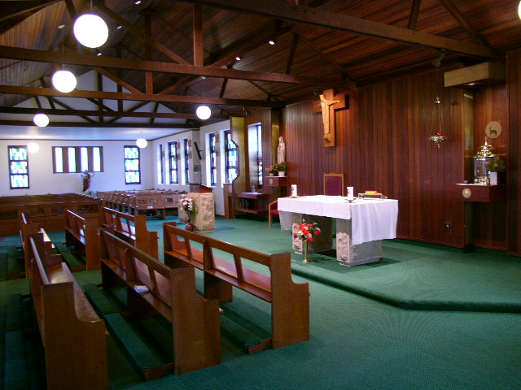

Interior St Patrick’s Church Braddon (Photograph Milton Cameron 2010)

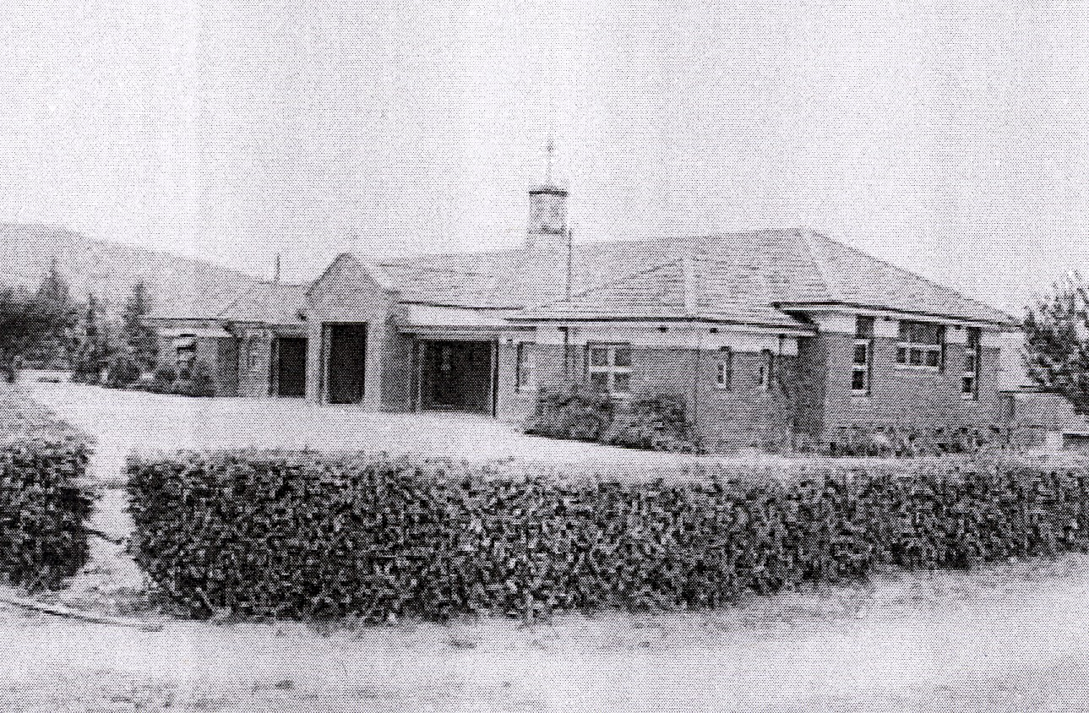

St Patrick’s School Braddon , 1951. National Archives of Australia.

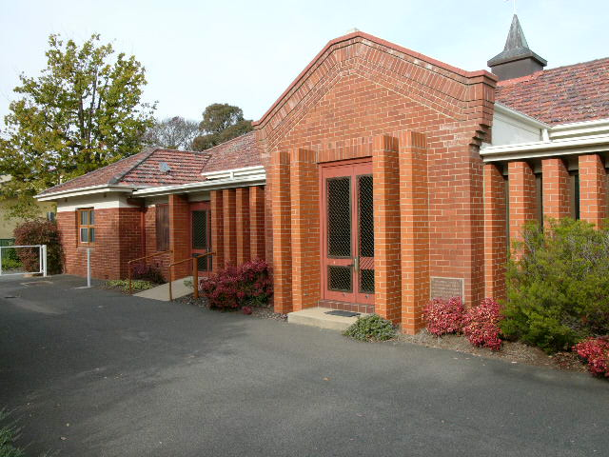

St Patrick’s Church Braddon 2010 (Photograph Milton Cameron)

SITE PLAN
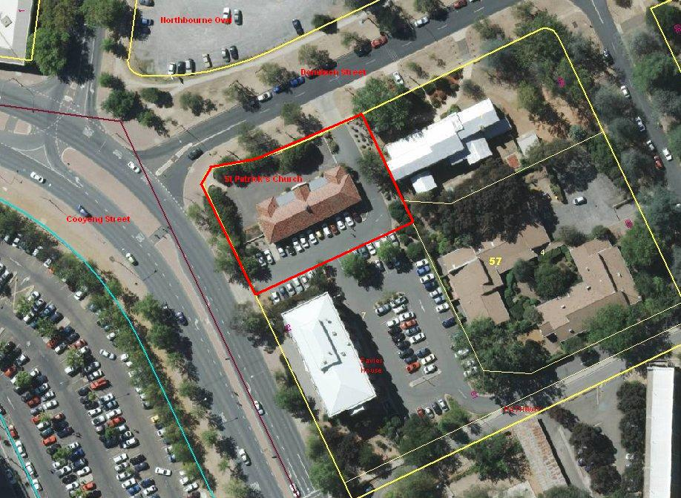

Figure 1. St Patrick’s Church, Braddon

