Australian Capital Territory
Heritage (Decision about Provisional Registration of Well Station Ploughlands, Gungahlin) Notice 2011
Notifiable Instrument NI2011−374
made under the
Heritage Act 2004 s34 Notice of decision about Provisional Registration

- Name of instrument
This instrument is the Heritage (Decision about Provisional Registration of Well Station Ploughlands, Gungahlin) Notice 2011 -

- Commencement
This instrument commences on the day after notification.

- Notice of Decision
Pursuant to Section 32 of the Heritage Act 2004 the ACT Heritage Council has decided not to provisionally register the Well Station Ploughlands, Gungahlin to the ACT Heritage Register.

…………………………….

Mr Gerhard Zatschler

Secretary

ACT Heritage Council

GPO Box 158

Canberra ACT 2601

7 July 2011

STATEMENT OF REASONS

DECISION REGARDING THE INCLUSION OF
Well Station Ploughlands, Horse Park Drive, Gungahlin
(Part Block 733, District of Gungahlin)
IN THE ACT HERITAGE REGISTER

Background
A nomination for the Well Station Ploughlands was made in 2002.

At Council meeting HCM37 on 7 July 2011 the ACT Heritage Council endorsed a Statement of Reasons which does not find the Well Station Ploughlands, Gungahlin eligible for provisional registration.

Detailed reasoning of why this place is not eligible for listing under the heritage significance criteria at Section 10 of the Heritage Act 2004 is included under ‘Assessment’.

History

The following information has been excerpted verbatim from Pearson, 2002.

Background
Ploughlands are areas of land cultivated with ploughs for the planting of crops. They are most commonly associated with cereal crop production and orchards. Such preparation of arable land has become rare in the ACT, with many previously ploughed paddocks being given over to grazing, subsumed within the spread of suburbia, or taken into land reserved for nature conservation or recreational purposes.

Ploughing was the basic means of tillage used in farming. It provided a deep seed bed for crops by turning over the soil, burying weeds and bringing fresh soil to the surface. Tillage with lighter tined implements, such as tine cultivators and harrows, simply stirred the soil, being used for preparation for some crops (such as pasture grasses), or for levelling the top of ploughed land.

Ridge and furrow ploughlands were created predominantly with a single share plough fitted with a coulter and mould board. The plough share made a horizontal cut through the soil, and the coulter in the form of a knife or small disc, set immediately above the point of the share, made a vertical cut. The mould board, twisted like a propeller and attached behind the share, threw the soil behind the cuts to one side forming a ridge of soil adjacent to a furrow left by the share.

Locally made wooden ploughs were commonly used in the early European settlement period in Australia, though manufactured iron ploughs were also imported. The iron plough had revolutionised farming in Britain from the late eighteenth and into the early nineteenth centuries. Iron ploughs largely replaced wooden ones in Australia in the 1850s and 60s. For the most part iron mould board ploughs, made first of caste and wrought iron, then from about the 1880s of steel, were used through the latter half of the nineteenth century. Two and four share ploughs were developed, though single share ploughs continued to be manufactured as they could be pulled by a smaller team of animals and better suited smaller and less wealthy settlers, a common characteristic of the ‘closer settlement’ farmer in parts of the ACT.

The steam engine was modified for ploughing in the USA and Britain from the mid-1800s, and by the 1870s ploughing using traction engines with winch drums located beneath their boilers became common there. Steam ploughing engines were used in the ACT, William Winter providing one for hire in the Gungahlin district in 1909, though the extent of their use is not clear.

The characteristic profile of simple ridge and furrow ploughlands in Australia is a broad roughly level-topped ridge, 2 to 6 or more metres wide, separated by ‘V’-shaped furrows cut to the full depth of the plough and two plough widths wide. The broad parallel ridges, often referred to as the ‘lands’, ran the length of the field being ploughed, a narrow space being left at each end in which to turn the plough for the next run. The lands were created by the ploughman ploughing up and down the field in an anti-clockwise direction, making each successive furrow close to the edge of the proceeding furrow, alternately on either side of the first cuts. The ridges of soil turned by the mould board therefore overlapped each other, creating a raised platform of ploughed soil, the land.

Ploughing field in long strips comprising raised lands separated by furrows is thought to have originated in Britain in Saxon times (4th to 7th centuries AD). This ‘ridge and furrow’ ploughing technique persisted in the English landscape until the late nineteenth century. The major difference between the older ‘open field’ ridge and furrow systems and those of the post-enclosure times (enclosure occurring progressively from the 17th to the19th century), other than the imposition of fences on the landscape, was that the earlier lands often took a reverse-‘S’ shape, reflecting the persistent turning of the plough at the end of the foraker. After enclosure the lands conformed to the enclosing fencelines, taking on a straighter form. This latter pattern is that common in Australia.

Ploughlands in the ACT

The Gungahlin area was first sighted by European explorers when Charles Throsby passed through the northern part of what was to become the ACT in October 1820. Agricultural development of the ACT followed soon after in close association with pastoral settlement. Land was first taken up in the Ginninderra district in about 1826 by George Thomas Palmer, who settled land (granted in 1831) at ‘Palmerville’ (later ‘Ginninderra’), his station buildings being located on Ginninderra Creek south of the Yass Road (Portion 20, Parish Canberra).

It has been suggested that Palmer acquired additional land in 1835-36 partly for the purpose of establishing or extending the cultivation of wheat. Palmer was followed by others, all on a smaller scale of rural operation, and gradually extending settlement into the north Gungahlin area.

Until 1861 the majority of landholders took up large blocks, or amalgamated smaller holdings into larger agglomerations (as in the case of the Rolfes and Gillespies, for example). The Robertson Land Act of 1861 saw a major increase in the selection of smaller holdings in the district. The selectors were limited, because of earlier land alienation, to the less desirable and less-well watered lands in the northern and western part of Gungahlin, and longer established landholders (and free selectors themselves) used the Robertson Act to extend their land holdings. Examples include John and Jemima Winter (‘Red Hill’, later Gungaderra), Henry Gozzard (‘Aston’), as well as Thomas Gribble, Archibald McKeahnie, Edward Ryan, Timothy Ryan, John Walsh and William and Walter Ginn.

The main land-use initially was sheep grazing, but from the 1830s through to the 1880s the arable land in the creek bottoms was being cleared, fenced and planted with grain crops, and some orchards. An example is the holding of Thomas Gribble on portions 64 and 73 (Parish Canberra) and related portions, which by 1887 had 60 acres under wheat and oats cultivation and 340 acres as grazing land.

The larger landholders also grew wheat. William Davis on Ginninderra experimented with wheat varieties to find rust-resistant strains, and in 1865 grew an excellent crop with seed developed in Adelaide, and had a bumper crop of oats the following year. In 1875 it was reported that high quality wheat had been grown at Weetangera by Shelton Smith and David Boon, prompting the Queanbeyan Age to boast that ‘Ginninderra may well be proud of growing perhaps the finest wheat produced in Australia’. During the 1870s it was also reported that farmers were purchasing reapers and mowers to be able to quickly harvest grain crops, and that grain production was increasing considerably.

The valuing of good ploughing skills prompted Canberra settlers to participate in the Queanbeyan Pastoral and Agricultural Association ploughing matches from the 1870s. The Queanbeyan Pastoral and Agricultural Association had held its first ploughing competition in 1872 on Duntroon near the old windmill, and its second at Jerrabomberra in 1872. The Ginninderra and Canberra Ploughing Match Association was formed in 1879, with matches held in a number of locations, and from 1886 matches were held at Ginninderra on ground opposite the Cricketers Arms Hotel (Hall).

Steam ploughing engines were used in the ACT, though the extent of their use is not clear. In 1909 William Winter was engaged by E.G. Crace of Gungahlin to plough 500 acres using his twenty horsepower traction engine, and clearly Winter, a local hirer of agricultural equipment, would have been engaged elsewhere in the district for the same purpose.

The decision in 1908 to make Canberra the national capital led to major changes in the land use of what was to become the ACT. Land acquisitions commenced in the central Canberra area, with Acton being acquired in 1911, and Duntroon and Yarralumla (which included land in Belconnnen) in 1913. Properties in the Ginninderra and Gungahlin districts were acquired between 1913 and 1917. While leases were offered for the properties, many chose to leave the district rather than stay on as lessees, and the depopulation of the closely settled district of Gininderra/ Gungahlin commenced. Rural land-uses survive in a shrinking number of properties around the Canberra urban edges.

The larger properties were subdivided into smaller lease areas, and on these and the smaller intact properties many lessees continued to grow oats and wheat, though the overall area under crop fell, for example at Weetangera dropping from 1,500 acres in 1914 to 300 acres by 1918.

A large percentage of the ploughlands of the ACT have been destroyed due to the development of Canberra, or have been reworked by later agricultural or grazing activity. Over about 90 former (pre 1915) cultivated areas (in 30 groups) have been identified as having been destroyed by urban development or agricultural activity, and another 28 (in 19 groups), while still agricultural or pastural land, have been found not to contain surviving ploughland features. In all only 16 examples have been found with substantial evidence of ridge and furrow plough features.

Of these, Pearson’s 2002 study found only six to be of heritage significance worthy of registration to the ACT Heritage Register.

These six ploughlands identified were:
- Well Station
- Mulligan’s Flat
- Blythburn
- Glenburn
- Old Orroral
- Orroral

Brief contextual history of Well Station homestead

The following information is taken verbatim from the ACT public library website http://www.library.act.gov.au/find/history/frequentlyaskedquestions/Place_Stories/Well_Station.

Until recently, it was known as the Well Station, because it had only one well on it. In the early days, a spring had been opened up, stoned all round and at one stage fitted with pumps. It provided good permanent water and was the pioneers’ main source of water until dams and water tanks were introduced later. More recently, an ‘s’ [Wells] has been added to the name. However, no family by the name of Wells has ever owned or lived at Well Station.

While John Flinn, E Ryan, A Cameron and James Burton were early purchasers of land in the area, the name most strongly associated with Well Station is that of Archibald McKeahnie who purchased block 72, on which as early homestead stood, some time in the 1870s or 1880s. This block had previously been owned by John Scott and it is believed that the house on it had been erected there by George Rolfe, perhaps as early as the 1850s. The whole area had probably been grazed by other people before that.

Archibald McKeahnie kept extending his property until, by 1915, he had acquired 2723 acres of freehold land in the area. This property, along with others in the same district, was resumed by the Commonwealth in March 1915. McKeahnie’s son-in-law, Charles Peden, then leased the land from the Commonwealth from 1915 to 1926, followed by John Joseland, the Gungaderra Pastoral Co, E A G Mawson and the Rose family.

McKeahnie family
Archibald McKeahnie was the son of pioneer Charles McKeahnie. Charles, a Scottish ploughman, arrived in Australia in 1838 with his wife, Elizabeth. In that same year he moved to Queanbeyan before becoming a successful landowner in 1860, purchasing the properties of Booroomba and the adjoining Blythburn (Barrow, 1998: 66).

References
- ACT Heritage Library, 2007, ‘Well Station’ contributed by Babette Scougall, http://www.library.act.gov.au/find/history/frequentlyaskedquestions/Place_Stories/Well_Station, accessed 2 March 2011.
- Barrow, G., 1998, Canberra’s Historic Houses – Dwellings and Ruins of the 19th Century, Dagraga Press, ACT.
- Pearson, M., 2002, ‘A Study of Ploughlands in the ACT’, report prepared for the ACT Heritage Unit.
Physical Description

Well Station ploughland is shown on the 1915 map as ‘old cultivation’, with clearly defined lands with furrow-to-furrow width of about 6 m, and associated with exotic trees and stock yards shown on the 1915 map. The track from Well Station to Bungendore passes through the ploughland (this track probably got little use after the railway reached Queanbeyan in 1887).

The Well Station ploughland lies immediately to the east of Sullivans Creek.

In Pearson’s 2002 study, the ridge and furrow pattern, aligned on 300º mag. was, in parts, clearly defined with furrow-to-furrow width of about 6 m. Ridge and furrows extended a width of about 160 m and ridges up to 120 m long (area approx. 1.9 ha or 4.7 acres). The edges of the ploughed area were not clearly defined. A stand of poplars marked location of a yards shown on 1915 map, and the track to the Bungendore road passes through the ploughland (this track probably got little use after the railway reached Queanbeyan in 1887).

Since this time, improvements in the quality of aerial imagery show that the Well Station Ploughlands has been cross-ploughed, such that the evidence of former ridge and furrows at this site, and the evidence of horse-drawn ploughing is no longer as distinct or characteristic of its type in the landscape at Well Station ploughlands.

Imagery from Google Earth in 2005 appears to show evidence of cross ploughing:

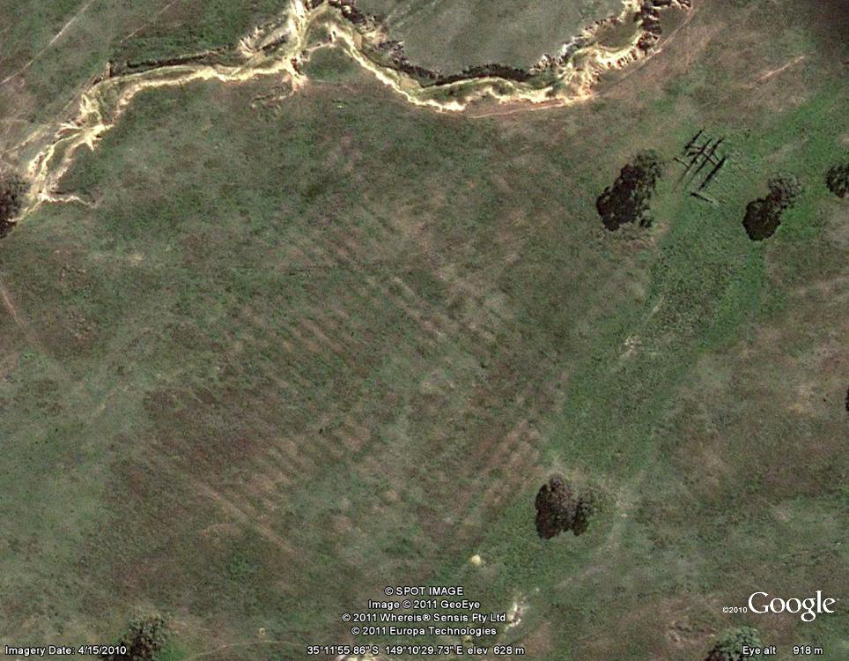

However, imagery in 2009 does not show much evidence of the ploughland due to drought conditions reducing vegetation cover that favours the ploughed furrows:

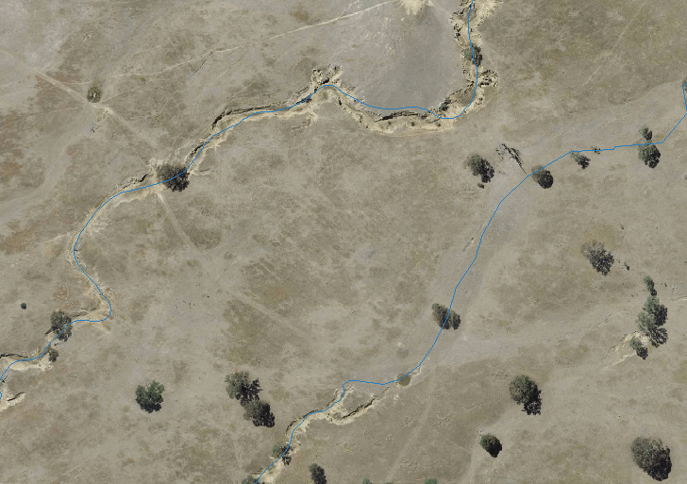
2009 aerial image of Well Station Ploughlands site

By way of comparison, aerial imagery from 2009 shows clear ridge and furrow lines still in existence at the Mulligan’s Flat Ploughlands site.

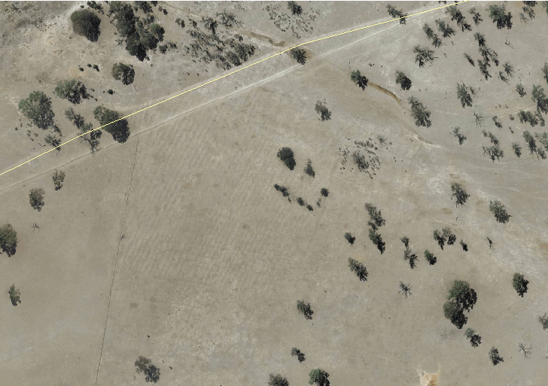
2009 aerial imagery of Mulligan’s Flat Ploughlands site for comparison purposes

Assessment
The Council’s assessment against the criteria specified in s.10 of the Heritage Act 2004 is as follows.

In assessing the nomination for the Well Station Ploughlands, Gungahlin, the Council considered:
- The material identified under the heading ‘References’, above;
- Aerial imagery; and
- The physical evidence including a site visit.

Criterion (a) it demonstrates a high degree of technical or creative achievement (or both), by showing qualities of innovation, discovery, invention or an exceptionally fine level of application of existing techniques or approaches
Heritage Council assessment:
The Well Station Ploughlands does not show a high degree of technical or creative achievement and therefore does not meet this criterion.

Criterion (b) it exhibits outstanding design or aesthetic qualities valued by the community or a cultural group
Heritage Council assessment:
The Well Station Ploughlands does not exhibit outstanding design or aesthetic qualities and therefore does not meet this criterion.

Criterion (c) it is important as evidence of a distinctive way of life, taste, tradition, religion, land use, custom, process, design or function that is no longer practiced, is in danger of being lost or is of exceptional interest
Heritage Council assessment:
The Well Station Ploughlands was originally created with animal-drawn ploughs bearing the pattern of broad ‘lands’ which were the result of a distinctive farming process and a way of life (using draught animals) that ceased with the adoption of motorised tractors.

The ploughing of ‘lands’ reflects the survival of a tradition of Saxon and medieval British agricultural practice in nineteenth and early twentieth century Australia, that is of exceptional interest. The ratio of surviving ploughlands to destroyed ploughlands in the ACT demonstrates that they are threatened as a type.

The Well Station ploughlands has associated with it a yards site and planted poplars that are likely to be associated with the ploughing activities.

At the time of its nomination, these lands appeared visible in the landscape as distinct ridge and furrow lines that bore the marks of animal-drawn ploughs.

However, since this time, improvements in aerial imagery shows that the area has been cross-ploughed with modern machinery, disrupting the evidence of animal-drawn ploughing techniques.

Unfortunately, the modification of the Well Station Ploughlands, probably by machine ploughing, reduces the ability of the site to demonstrate evidence of the early agricultural nature of the area including the farming tradition and processes, as the evidence of this now confused, and no longer possesses sufficient integrity to ‘important’ under this criterion. The yards and poplars which remain at the site are not of sufficient evidence in themselves to reflect this way of life.

The Well Station Ploughlands does not meet this criterion.

Criterion (d) it is highly valued by the community or a cultural group for reasons of strong or special religious, spiritual, cultural, educational or social associations
Heritage Council assessment:
No information has been provided to suggest that the Well Station Ploughlands is highly valued by the community or a cultural group.

The Well Station Ploughlands cannot be assessed in relation to this criterion.

Criterion (e) it is significant to the ACT because of its importance as part of local Aboriginal tradition
Heritage Council assessment:
This criterion is not applicable in the context of this assessment.

Criterion (f) it is a rare or unique example of its kind, or is rare or unique in its comparative intactness
Heritage Council assessment:
Within the ACT, remaining ploughland sites are rare. Of the 65 ploughlands which once existed, only six were identified in 2002 as being of a level of intactness sufficient for consideration for entry to the ACT Heritage Register.

Since this time, improved aerial imagery has shown that at least one ploughland (Well Station) has been impacted such that it can no longer be considered an example of its kind.

The Well Station Ploughlands does not meet this criterion.

Criterion (g) it is a notable example of a kind of place or object and demonstrates the main characteristics of that kind.
Heritage Council assessment:
Ploughlands constitute a class of cultural places that is of historical importance. The characteristics of a ‘notable example’ of a ploughland would include:
- relatively clear ridges and furrows forming visible ‘lands’ over a substantial area of paddock;
- lands that run across contour, demonstrating the limitations of draught animal ploughing;
- boundary demarcation by ditch, bank or fence (though this feature is not a universal characteristic of ploughlands).

The Well Station ploughlands no longer possesses any of these characteristics and, as such, does not meet this criterion.

Criterion (h) it has strong or special associations with a person, group, event, development or cultural phase in local or national history
Heritage Council assessment:
The Well Station ploughlands are associated with the cultural phase of the agricultural development of the area of the ACT when it was part of NSW prior to the establishment of the Federal Capital Territory.

There are today few ploughlands in the ACT that are able to bear testimony to this type of place.

At the time of their nomination, the ploughlands were among a small number of clear early ploughing features surviving in the ACT associated with historically documented settlement sites.

Unfortunately, due to recent evidence of cross-ploughing of this area, the Well Station Ploughlands is no longer able to bear testimony to this cultural phase.

The Well Station ploughlands does not meet this criterion.

Criterion (i) it is significant for understanding the evolution of natural landscapes, including significant geological features, landforms, biota or natural processes
Heritage Council assessment:
This criterion is not applicable.

Criterion (j) it has provided, or is likely to provide, information that will contribute significantly to a wider understanding of the natural or cultural history of the ACT because of its use or potential use as a research site or object, teaching site or object, type locality or benchmark site
Heritage Council assessment:
The Well Station Ploughland has not provided, and is not likely to provide information that will contribute significantly to a wider understanding of the natural or cultural history of the ACT and, as such, does not meet this criterion.

Criterion (k) for a place—it exhibits unusual richness, diversity or significant transitions of flora, fauna or natural landscapes and their elements
Heritage Council assessment:
This criterion is not applicable.

Criterion (l) for a place—it is a significant ecological community, habitat or locality for any of the following:
(i) the life cycle of native species;
(ii) rare, threatened or uncommon species;
(iii) species at the limits of their natural range;
(iv) distinct occurrences of species
Heritage Council assessment:
This criterion is not applicable.

Conclusion

The Well Station Ploughlands were developed by a distinctive farming process and a way of life (using draught animals) of exceptional interest. At the time of their nomination, they were considered a notable example of non-mechanised ploughing activities and demonstrated the key characteristics of this kind of place. They also had a special association with the cultural phase of the agricultural development of the area.

However, since the time of their nomination in 2002, improved aerial imagery shows that the site has undergone disturbance that has impacted on the ‘lands’ such that the ridge and furrows are no longer clearly evident at the site.

As such, the place can not be considered as evidence, or representative of this type of place, or able to reflect the history of this cultural phase, due to a loss of intactness and integrity.

The other five existing ploughlands within the ACT are either registered or nominated to the ACT Heritage Register.

The place does not meet the threshold for provisional registration to the ACT Heritage Register, due to the lack of evidence of animal-drawn ploughing which remains at the place.

Gerhard Zatschler (Secretary)
ACT Heritage Council

7 July 2011

