Australian Capital Territory
Heritage (Decision about Provisional Registration of the Buildings of the former CS&IR Experiment Station, Downer) Notice 2011
Notifiable Instrument NI 2011—375
made under the
Heritage Act 2004 section 34 Notice of Decision about Provisional Registration

- Name of instrument
This instrument is the Heritage (Decision about Provisional Registration for the Buildings of the former CS&IR Experiment Station. Downer) Notice 2011 -
- Registration details of the place
Registration details of the place are at Attachment A: Provisional Register entry for the Buildings of the former CS&IR Experiment Station, Downer.

- Reason for decision
The ACT Heritage Council has decided that the Buildings of the former CS&IR Experiment Station, Downer meet one or more of the heritage significance criteria at s 10 of the Heritage Act 2004. The provisional register entry is at Attachment A.

- Date of Provisional Registration
7 July 2011.

- Indication of council's intention
The Council intends to decide whether to register the place under Division 6.2.

- Public consultation period

The Council invites public comment by 4 August 2011 on the provisional registration of the Buildings of the former CS&IR Experiment Station, Downer to:

The Secretary

ACT Heritage Council

GPO Box 158

CANBERRA ACT 2601

Gerhard Zatschler
Secretary
ACT Heritage Council
7 July 2011
AUSTRALIAN CAPITAL TERRITORY

HERITAGE REGISTER
(Provisional Registration Details)

Place No:

For the purposes of s. 33 of the Heritage Act 2004, an entry to the heritage register has been prepared by the ACT Heritage Council for the following place:

Buildings of the former Council for Science & Industry Research (CS&IR) Dickson Experiment Station, Downer

Block 2, 5, 6 & 16 Section 61 Downer Canberra Central, ACT

DATE OF PROVISIONAL REGISTRATION

Notified: 7 July 2011 Notifiable Instrument: [2011]/[375]

PERIOD OF EFFECT OF PROVISIONAL REGISTRATION

Start Date 7 July 2011 End Date 7 December 2011

Extended Period (if applicable) Start Date ________ End Date ________

Copies of the Register Entry are available for inspection at the ACT Heritage Unit. For further information please contact:

The Secretary
ACT Heritage Council
GPO Box 158, Canberra, ACT 2601

Telephone: 13 22 81 Facsimile: (02) 6207 2229

IDENTIFICATION OF THE PLACE
Frencham Place - Blocks 2, 5, 6 & 16 Section 61 Downer

See also separate registration:
Trees of the Former Commonwealth Scientific and Industrial Research (CS & IR) Dickson Experiment Station, Downer

STATEMENT OF HERITAGE SIGNIFICANCE

The remaining buildings of the former CS&IR Dickson Experiment Station are of exceptional interest as evidence of the Division of Plant Industry’s field studies, being the first purpose built field research facility in the ACT and the only example of its kind up until 1965 when functions were transferred to Ginninderra.

Of additional interest is the way the Experiment Station was sited and designed to compliment and contribute to the main highway approach to Canberra. Trees planted along the entrance driveway now remain on the verges of Swinden Street, Downer. Further, the former Machine Shed, Workshop and Store and windbreak plantings surrounding the open playing fields (formerly research paddocks) were incorporated into the layout of suburban Downer, the buildings being utilised for public and shopping purposes from 1960.

The place is also significant for its strong associations with the research and activities of the CS&IR, and with the Director of the CS& IR Division of Plant Industry, Dr B T Dickson who sought the land and established the Experiment Station in 1940.

Other related Registration:

Trees of the former Commonwealth Scientific and Industrial Research (CS & IR) Dickson Experiment Station, Downer are entered to the ACT Heritage Register.

FEATURES INTRINSIC TO THE HERITAGE SIGNIFICANCE OF THE PLACE

Features intrinsic to the heritage significance of the place which require conservation include:

- former workshop and store (current community centre)
- former machine shed (the former shopping centre )

APPLICABLE HERITAGE GUIDELINES

The Heritage Guidelines adopted under s27 of the Heritage Act 2004 are applicable to the conservation of the Downer Shops and Community Hall (Buildings of the former Council for Science & Industry Research Dickson Experiment Station), Downer, ACT.

The guiding conservation objective is that the buildings of the former Council for Science & Industry Research (CS&IR Dickson Experiment Station), Downer, ACT, shall be conserved and appropriately managed in a manner respecting its heritage significance and the features intrinsic to that heritage significance, and consistent with a sympathetic and viable use or uses. Any works that have a potential impact on significant fabric shall be guided by a professionally documented assessment and conservation policy relevant to that area or component (i.e. a Statement of Heritage Effects – SHE).

Ensure that any actions impacting on the significance of the buildings of the former Council for Science & Industry Research (CS&IR) Dickson Experiment Station) are based on professional conservation planning.

REASON FOR PROVISIONAL REGISTRATION

The buildings of the former Council for Science & Industry Research (CS&IR) Dickson Experiment Station have been assessed against the heritage significance criteria and been found to have heritage significance when assessed against two criteria under the ACT Heritage Act 2004 including (c) and (h).

ASSESSMENT AGAINST THE HERITAGE SIGNIFICANCE CRITERIA

Pursuant to s.10 of the Heritage Act 2004, a place or object has heritage significance if it satisfies one or more of the following criteria. Significance has been determined by research as accessed in the references below. Future research may alter the findings of this assessment.

- it demonstrates a high degree of technical or creative achievement (or both), by showing qualities of innovation, discovery, invention or an exceptionally fine level of application of existing techniques or approaches;

The buildings of the former CS& IR Experiment Station do not demonstrate a high degree of technical or creative achievement in the way in which this criterion intends.

Whilst the scientific work undertaken at the former Experiment Station could be considered innovative or demonstrative of technical achievement, the extant buildings themselves do not demonstrate either a high degree of technical or creative achievement, nor show qualities of innovation, invention or discovery. The buildings are solidly constructed, originally for agricultural purposes and have subsequently been adapted for alternate commercial/community uses; and their retention within the suburban layout of Downer demonstrates pragmatism rather than creative or technical achievement.

The buildings of the former CS&IR Dickson Experiment Station do not meet this criterion.

- it exhibits outstanding design or aesthetic qualities valued by the community or a cultural group;

The buildings of the former CS&IR Experiment Station are set against the backdrop of Mt Ainslie and Mt Majura, and within an area that has a particularly pleasing and inviting aesthetic appeal.

The pine windbreaks of the former Experiment Station are highly visual components which provide shelter and character to the immediate landscape around the buildings of the former Experiment Station. The windbreak on three sides of the larger block comprising the former Experiment Station enhances the formal rectangular space containing the buildings and the former experimental paddocks converted to playing fields; providing integrity and a defined boundary to the area within.

Whilst this aesthetic may be valued by the immediate Downer community there is no evidence to suggest that the place is valued by the broader community.

The buildings of the former CS&IR Dickson Experiment Station) do not meet this criterion.

(c) it is important as evidence of a distinctive way of life, taste, tradition, religion, land use, custom, process, design or function that is no longer practised, is in danger of being lost or is of exceptional interest;

The remaining buildings of the former CS&IR Dickson Experiment Station are of exceptional interest. From 1940 to 1965 when functions were transferred to Ginninderra, the Experiment Station was the hub of Division of Plant Industry’s field studies being the first purpose built field research facility in the ACT and the only example of its kind up until 1965. The former Machine Shed, Workshop and Store and remaining windbreak tree plantings and Swinden street tree plantings are evidence of this phase of land use of the functions of the CS & IR.

Of additional interest is the way the Experiment Station was sited and designed to compliment and contribute to the main highway approach to Canberra. The former entrance driveway to the Experiment Station was planted with eucalypts (Camden Woolly Butts) and flowering plums. Many of the eucalypts remain on the verges along what is now Swinden Street. Further, the former machine Shed, Workshop and Store and windbreak plantings surrounding the open playing fields (formerly research paddocks) were incorporated into the layout of suburban Downer, the buildings being utilised for public and shopping purposes from 1960.

The buildings of the former CS&IR Experiment Station meet this criterion.

(d) it is highly valued by the community or a cultural group for reasons of strong or special religious, spiritual, cultural, educational or social associations;

Downer community interest in the buildings of the former Experiment Station has developed since the place was incorporated within the suburban layout of Downer in 1960.

The former Workshop and Store (Community centre) and Machine Shed (now vacant shops) and the adjacent Bicentennial Square provide a venue for the Downer community to gather, for social functions such as the recent 50th anniversary celebrations for Downer in 2010; and for the Downer Community Association. There is no evidence to suggest that the nature of these social associations are strong or special beyond those attributed by any local community to its neighbourhood shops or other community facilities.

Whilst the amenity of the buildings as a Community centre and former shopping centre has been valued by the local Downer community, the extent to which this value extends to the wider community is unknown. There is insufficient information available to satisfy this criterion.

The buildings of the former CS&IR Experiment Station do not meet this criterion

(e) It is significant to the ACT because of its importance as part of local Aboriginal tradition

The place is assessed as not meeting this criterion.

(f) It is a rare or unique example of its kind, or is rare or unique in its comparative intactness

The place is assessed as not meeting this criterion.

(g) it is a notable example of a kind of place or object and demonstrates the main characteristics of that kind

The place is assessed as not meeting this criterion.

(h) it has strong or special associations with a person, group, event, development or cultural phase in local or national history

The place has strong associations with the research and activities of the CS&IR, and with the Director of the CS& IR Division of Plant Industry, Dr B T Dickson who sought the land and established the 650 acre Experiment Station in 1940.

As the only remaining buildings from the former Experiment Station, the former Machine Shed and Workshop and Store have a strong association with the research activities of the former Experiment Station.

The remaining buildings of the former CS&IR Experiment Station meet this criterion.

- it is significant for understanding the evolution of natural landscapes, including significant geological features, landforms, biota or natural processes

The place is assessed as not meeting this criterion.

(j) it has provided, or is likely to provide, information that will contribute significantly to a wider understanding of the natural or cultural history of the ACT because of its use or potential use as a research site or object, teaching site or object, type locality or benchmark site

The place is assessed as not meeting this criterion.

(k) for a place—it exhibits unusual richness, diversity or significant transitions of flora, fauna or natural landscapes and their elements

The place is assessed as not meeting this criterion.

(l) for a place—it is a significant ecological community, habitat or locality for any of the following:
(i) the life cycle of native species;
(ii) rare, threatened or uncommon species;
(iii) species at the limits of their natural range;
- distinct occurrences of species.

The place is assessed as not meeting this criterion.

SUMMARY OF THE PLACE

HISTORY AND PHYSICAL DESCRIPTION

HISTORY

The Commonwealth resumed the land on which the Dickson Experiment Station was later located in 1914 for the purpose of National Capital development. The land was not included in Walter Burley Griffin's first plan of Canberra. However, in the revised version of 1918 the city boundaries were extended to include some of the subject land, which was set aside as an industrial area. However the city administration had no need for such a use at the time and the land was generally used for agriculture on short leases. Various interim uses of land in the vicinity included subdivision for soldier settlement, use as an airstrip in 1923-24 and as an easement for the Canberra - Yass railway.

The Council for Scientific and Industrial Research (CSIR) Division of Plant Industry relocated from the Sydney University to Black Mountain and sought suitable land for research purposes in 1930, following which an area at Pialligo was made available in 1931. However, the Director of the Division Dr Bertram T Dickson subsequently sought a larger, more permanent site in the Dickson district that had been set aside for an industrial area. On 21 November 1940 the Division was granted a 30 year lease on a large portion of land that covered the whole of present Downer and parts of Watson and Dickson. The 650 acres (approximate) of land sought for the Station by Dr Dickson was considered “some of the best agricultural land in the environs of the city”.

The site was developed promptly and the Machine shed was completed in July 1941. Other buildings followed, although slowly due to constraints on funding and materials imposed by WWII. The erection of a large shade house was completed in June 1943. In October 1945 a second barn, similar to the earlier one, was completed to house the considerable quantity of machinery that had accumulated in the intervening period.

The erection of a Manager’s cottage followed in 1946, and a Foreman’s cottage in 1947. By 1955, Shaw (1983:24) records that in addition to these buildings the Station infrastructure included stables, shearing sheds, sheep yards and a hayshed. A small animal laboratory was also constructed on the site in 1952 following an agreement with the ANU’s John Curtin School of Medical Research (Shaw 1983:24). It has since been demolished and replaced by Appleby Court.

Trial plantings of lucerne and poppies were developed, the latter to supply the growing demand for morphine during World War II.

The main entrance to the Station was via a long driveway (now Swinden Street) lined with two outer rows of Camden Woollybutt (Eucalyptus macarthurii) and two inner rows of flowering plums (possibly Prunus cerasifera) which intersected a rectangular enclosure around the centre of the Station. Two row windbreaks of Monterey Pine (Pinus radiata) formed the northern, western and southern boundaries of this enclosure, supplemented on the western boundary by two inner rows of Pin Oak (Quercus palustris). Apple Box (Eucalyptus bridgesiana) and Argyle Apple (Eucalyptus cinerea) formed the eastern boundary of the enclosure. These plantings still exist today. Gardens were also planted around the two residential cottages and remnants of these 1940s plantings are also still evident (Boden 1996: 3,17).

Plans and aerial photographs dating from the 1950s provide an overview of the Station at the time of its maturity. They depict a visually impressive and orderly array of farm buildings, cottages and gardens, windbreaks, tree-lined avenues, roadways and an extensive grid of paddocks. It was one of Dr Dickson’s objectives in developing the Station site that it would be “an asset to the main highway approach to the city” and such records as well as the surviving physical evidence demonstrate that this was achieved.

From 1955 to 1965 the land occupied by the Station was gradually resumed for urban development and the functions of the Station were transferred to its present site at Ginninderra (Shaw 1983:24, 26). The first of the stations houses were relinquished to the National Capital Development Commission in 1960. In 1961 a school was erected to the north of the workshop and storeroom block. Later in the year the Commission took over the buildings and converted them into shopping facilities to service the developing suburb of Downer. The Dickson Experiment Station ceased to exist when the last blocks of land, together with the second house, were finally handed over to the Commission on 2 February 1965.

Today there are still quite visible reminders of the former farm. The Downer Shops and Community Hall now occupy the former Machine Shed and the Workshop/Store respectively. The remaining farm buildings have all been demolished, as have the residential cottages, but as noted above, the latter sites contain remnant garden and screen plantings from almost 60 years ago. Many of the tree plantings have continued to grow and mature and some have now been entered to the ACT Heritage Register, while some of the original farmland has been retained as open green space in the Downer and District playing fields.

The area in between the two buildings has operated as a “public plaza” since the time of the shopping centres development. It contains street furniture, landscaping, pergolas and outdoor structures developed by the local community in a Bicentennial project in 1988.

DESCRIPTION

The place consists of the core of the former Experiment Station comprising a tree belt that is bound by Melba, Bradfield, Frencham and Bonython streets. These trees are entered to the ACT Heritage Register, Trees of the Former CS&IR Experiment Station. The area within the tree belt retains a large amount of open space that was once the experimental paddocks, and which have been adapted as playing fields for the former school and Downer community.

There are additional trees remaining from this phase that were part of the screen and garden planting around the former farm foreman's cottage in the south west corner. There are also remnant plantings around the manager's cottage in the NE corner, and a line of yellow box trees along the path that links Frencham and Melba Streets.

Within the core area are two buildings dating from the CSIR phase, namely the former workshop and store, now the Community Hall and home of the Downer Community Association, and the former machine shed, previously the Downer shops. The latter building is brick with a corrugated roof and awning along the north side. It has been extended and adapted in the past, for use as a shopping centre with supermarket, restaurant and shop outlets. The building is currently vacant and in poor condition with all door and window openings boarded up. The former workshop is also a brick building that has been sympathetically adapted for community use. The original form and fenestration of the building remains clearly legible.

The western external wall of the former workshop has been painted with a large mural depicting a field of poppies, which were grown as part of the operations of the former experiment station.

Between the two buildings is a landscaped garden, Bicentennial Square that was designed and built by the Downer community in 1988 to commemorate Australia's bicentenary. The garden includes a covered trellis, circular raised planting bed with brick edge, gravel footpath and feature planting, including mature deciduous trees. The garden is an attractive feature that visually and socially links the two buildings.

The former Downer Infants and Primary School is located immediately to the north of the former Workshop and Store.

REFERENCES

Boden Robert, Trees of the former CS & IR Dickson Experiment Station, Downer, ACT, A H heritage Study 1996

Downer Community Association, Nomination to an Interim ACT Heritage Places Register, February 2004

Downer Community Association, Downer at 50, - A Postscript, 2010

Shaw, Judith, Dickson Experiment Station: a case study of changing needs an conflicting priorities in land use in the Australian Capital Territory.

Trees of the Former CS&IR Experiment Station Downer, Entry to ACT Heritage Register

IMAGES

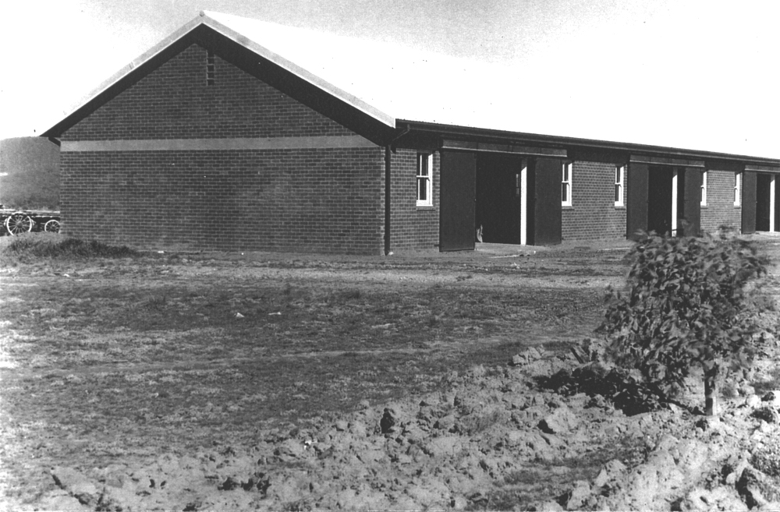

The completed Workshop in 1940.

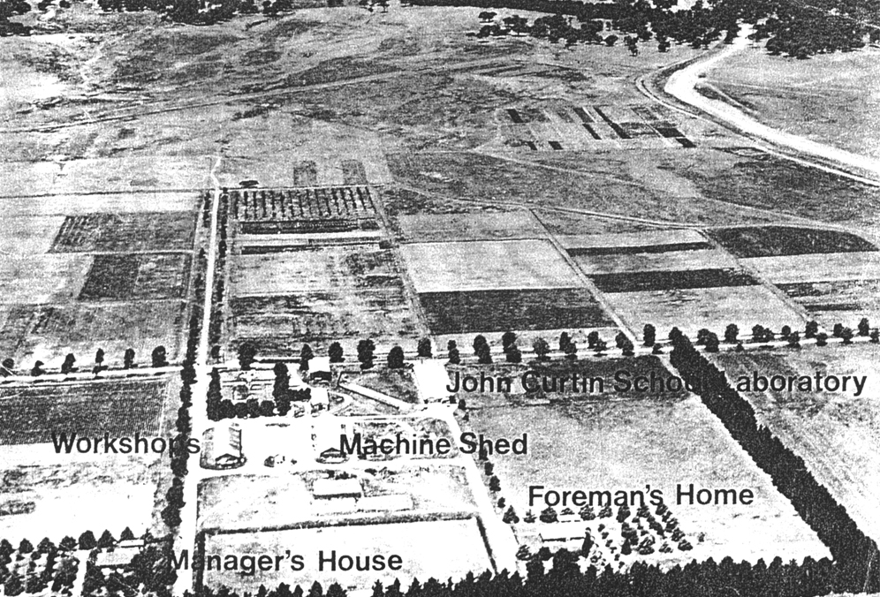

Experiment Station layout c.1950s

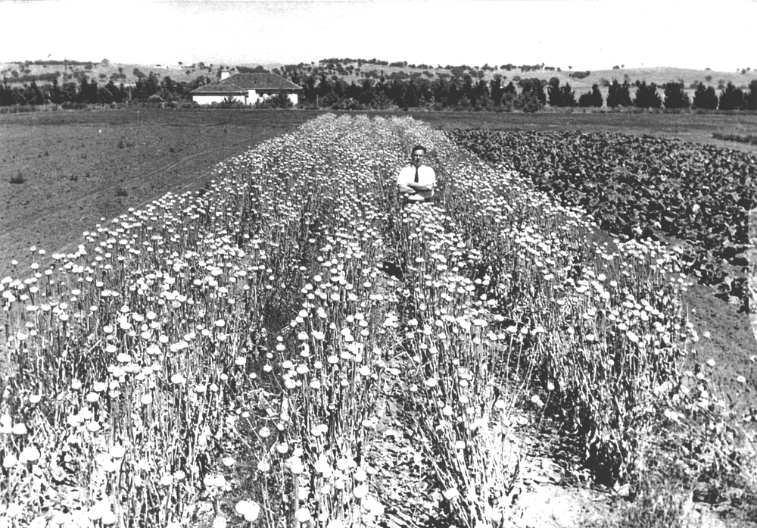

Poppy trial on Experiment Station c.1940s. O’Connor Ridge and Foreman’s Cottage in the background

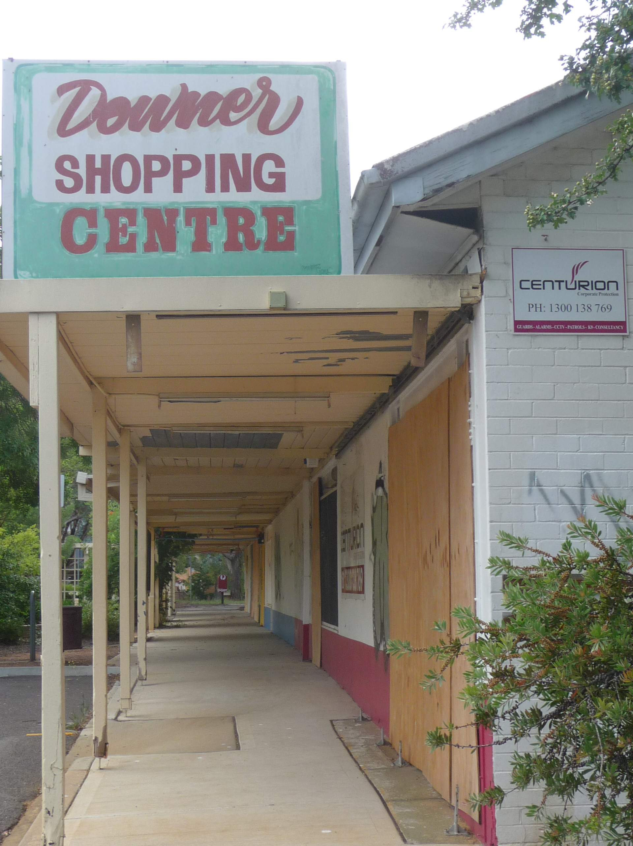

Former Machine Shed, January 2011

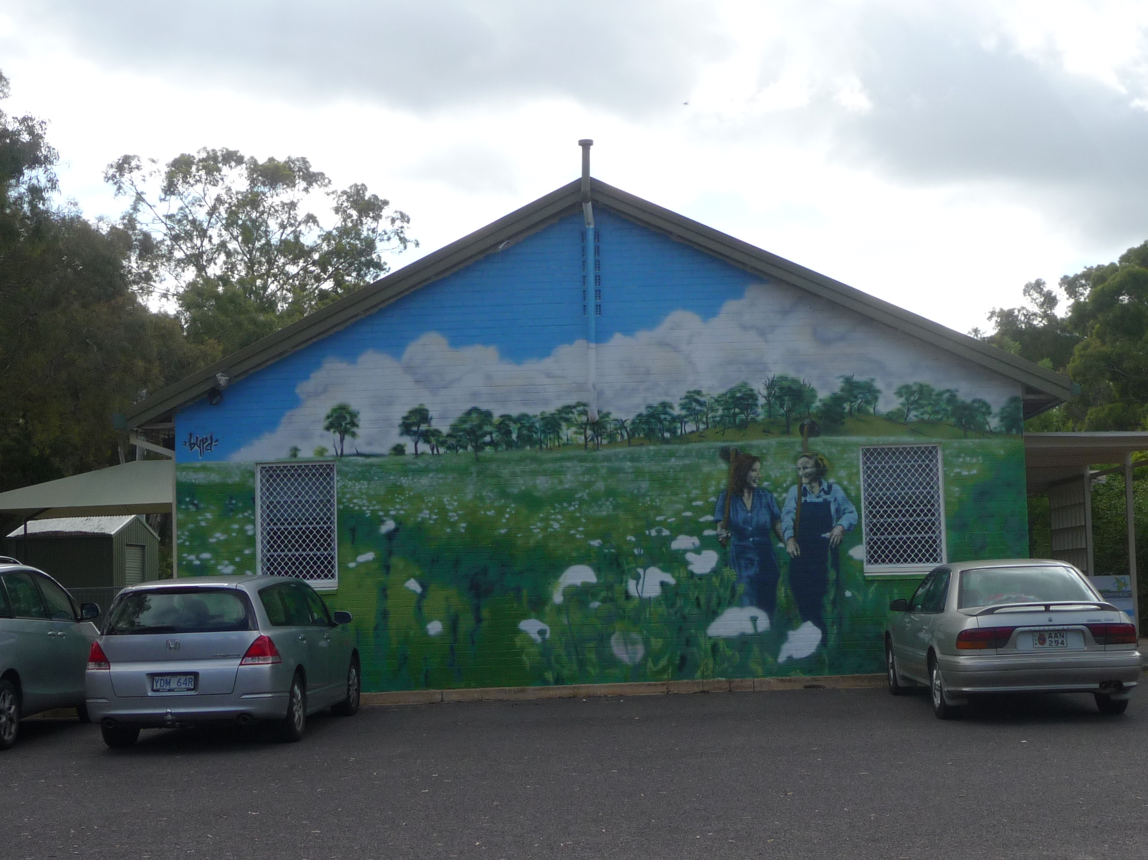

Former Workshop and Store, January 2011

SITE BOUNDARY

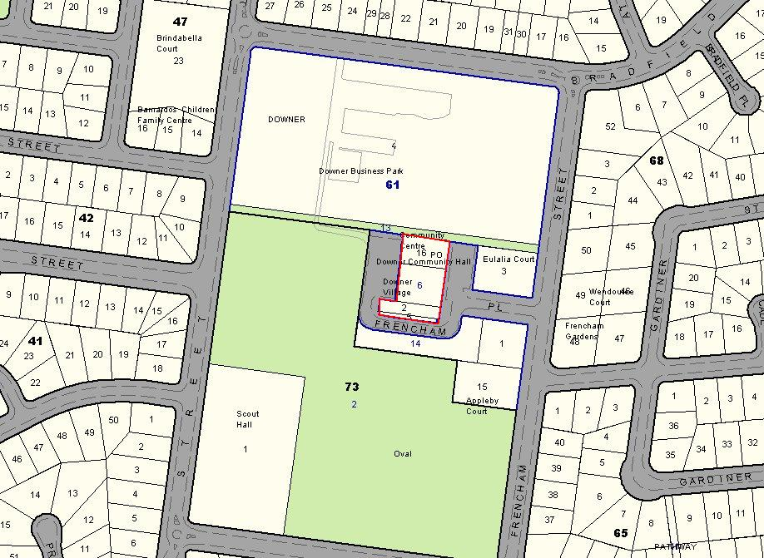

Boundary of the place highlighted in red.

