Australian Capital Territory

Planning and Development (Draft Variation No 307) Public Availability Notice 2011*

Draft Variation to the Territory Plan 307 Griffith, section 42, block 15 - change of zoning from commercial CZ6 leisure and accommodation zone to RZ4 medium density residential zone - consequential amendments to part C(5) multi unit housing development code

##### Notifiable instrument NI2011—462

made under the

*Planning and Development Act 2007*, section 70 (Public notice of documents given to Minister) and section 71 (Public availability notice – notice of interim effect etc)

The ACT Planning and Land Authority is making available for public inspection Draft Variation to the Territory Plan Number DV307 – Draft Variation to the Territory Plan 307 Griffith, section 42, block 15 - change of zoning from commercial CZ6 leisure and accommodation zone to RZ4 medium density residential zone - consequential amendments to part C(5) multi unit housing development code, given to the Minister for Planning.

Also available for inspection are related documents given to the Minister including background papers and a report on the issues raised in written comments on the previously notified draft variation and on consultation with the public.

The reports and background papers relating to this draft variation are available online at **www.actpla.act.gov.au**. Copies are available for inspection and purchase at ACTPLA Customer Service Centre, 16 Challis Street, Dickson, Monday to Friday between 8.30am and 4.30pm.

Section 72 applies in relation to the draft variation.

The variation has interim effect from 19 August 2011 to 19 August 2012 or until the end of the “defined period”, whichever is shorter. Under the *Planning and Development Act 2007*, section 72 (3) “defined period” for a draft variation means the period -

(a) starting on the day (the ***notification day***) when the draft variation given to the Minister is notified under the Legislation Act (see s70); and

(b) ending on the earliest of the following days:

(i) the day the corresponding plan variation, or part of it, commences;

(ii) the day the corresponding plan variation is rejected by the Legislative Assembly;

(iii) the day the corresponding plan variation is withdrawn in accordance with a requirement under section 76(3) (b) (v) or section 84 (3) (b);

(iv) the period of 1 year after notification day ends.

The Territory, the Executive, a Minister or a territory authority must not, during the defined period, do or approve the doing of anything that would be inconsistent with the Territory Plan if it were varied in accordance with the draft variation.

David Papps

Delegate of the Planning and Land Authority

12 August 2011

**ACT Planning and Land Authority**

Draft   
Variation to the   
Territory Plan 307

Griffith, Section 42 Block 15

– Change of zoning from commercial CZ6 leisure and accommodation zone to RZ4 medium density residential zone

– Consequential amendment to Part C(5) multi unit housing development Code

**August 2011**

Recommended version

Draft plan variation submitted to the Minister for Planning under section 69 of the *Planning and Development Act 2007*

Table of Contents

1. INTRODUCTION 1

1.1 Summary of the proposal 1

1.2 Outline of the process 1

1.3 This document 2

1.4 Public consultation 2

1.5 Revisions to the Exhibited Draft Variation 3

2. EXPLANATORY STATEMENT 3

2.1 Background 3

2.2 Site description 4

2.2.1 Current Territory Plan Provisions 5

2.3 Proposed changes 6

2.3.1 Proposed changes to the Territory Plan map 6

2.3.2 Proposed changes to Territory Plan multi unit housing development code - application of Part C5 6

2.4 Reasons for the proposed Draft Variation 6

2.5 Planning context 8

2.5.1 National Capital Plan 8

2.5.2 Territory Plan 8

2.5.3 Planning Strategy for the ACT 10

2.6 Consultation with Government agencies 10

3. INTERIM EFFECT 13

4. DRAFT VARIATION 14

4.1 Variation to the Territory Plan map 14

4.2 Variation to the Territory Plan 15

Variation to the Multi unit housing development code 15

1. INTRODUCTION
   1. Summary of the proposal

The intention of the draft variation is to change the zone of the land from commercial CZ6 leisure and accommodation to the residential RZ4 medium density residential zone to allow for medium density housing up to 3 storeys in height.

* 1. Outline of the process

The Commonwealth’s *Australian Capital Territory (Planning and Land Management) Act 1988* allows for the Legislative Assembly to make laws to establish a Territory Planning Authority and for that Authority to prepare and administer a Territory Plan.

The *Planning and Development Act 2007* (the Act) establishes the ACT Planning and Land Authority (ACTPLA) as the Authority which prepares and administers the Territory Plan, including continually reviewing and proposing amendments as necessary.

The Territory Plan is comprised of the written statement and a map. The written statement contains a number of parts, namely Governance; Strategic Directions; Zones; Precinct Codes; General Codes; Overlays; Definitions; Structure Plans, Concept Plans and Development Codes for Future Urban Areas.

The Territory Plan Map graphically represents the applicable land use zones (under the categories of Residential, Commercial, Industrial, Community Facility, Urban Parks and Recreation, Transport and Services and Non Urban), precincts and overlays. The zone, precinct and overlay requirements are detailed in the Territory Plan.

Draft variations to the Territory Plan are prepared in accordance with the Act. Following the release of the draft variation under section 63 of the Act, submissions from the public are invited.

At the conclusion of the consultation period ACTPLA submits a report on consultation and a recommended draft variation to the Minister for Planning for approval. The Minister has the discretion to determine if referral to the Legislative Assembly Standing Committee on Planning, Public Works and Territory and Municipal Services is warranted prior to approval, depending on the nature and significance of the proposal.

If the draft variation is referred to the Committee by the Minister or otherwise, the Minister must consider the findings of the Committee before deciding whether to approve the draft variation.

If the Minister approves the variation, the variation and associated documents will be tabled in the Legislative Assembly. Unless disallowed by the Legislative Assembly within five sitting days, the variation commences on a day nominated by the Minister.

* 1. This document

This document contains the background information in relation to the proposed variation. It comprises the following parts:

* Part 1 - This introduction
* Part 2 - An Explanatory Statement, which gives reasons for the proposed variation and describes its effect
* Part 3 - The Draft Variation, which details the precise changes to the Territory Plan that are proposed
  1. Public consultation

DV307 was released for public comment between 25 January 2011 and 15 March 2011 and a consultation notice under section 63 of the *Planning and Development Act 2007* was placed in the ACT Legislation Register on 25 January 2011. The draft variation 307 released for public consultation is at ***Attachment 1***.

A total of 116 written submissions were received, two (2) of which were late submissions accepted after 15 March 2011. The majority of submissions were made by individual members of the public. Submissions were also received from the following organisations:

* The Inner South Canberra Community Council
* The Griffith/Narrabundah Community Association Inc.
* The National Trust

Key concerns raised include:

* motives for the rezoning
* concessional lease status of the site
* alternative uses for the site, including community, open space or recreation uses
* compliance with the relevant strategic and statutory documents including the Canberra Spatial Plan, Territory Plan - Statement of Strategic Directions, the National Capital Plan and the Griffith Neighbourhood Plan
* justification for the proposal in terms of population and housing choice
* a range of potential impacts including flooding, traffic, amenity, character, heritage, garden city values and loss of trees.

The issues raised in the written submissions have been addressed in a report on consultation. This report was prepared by the Environment and Sustainable Development Directorate, which now incorporates the statutory responsibilities of the ACT Planning and Land Authority. The report on consultation is required under s 69 (2) of the *Planning and Development Act 2007*.

The public consultation process resulted in a number of minor amendments to DV307 which are outlined below.

* 1. Revisions to the Exhibited Draft Variation

After analysis of the comments received during the draft variation consultation period, the following changes were made to the exhibited draft variation:

1. Consequential changes to part C(5) of the multi unit housing development code to include Griffith in the list of suburbs to which part C(5) applies.
2. Changes to the draft variation document to:
   * 2.4 Reasons for the proposed draft variation - clarify the population decline which occurred since the peak of 1961
   * 2.5.2 Territory Plan – provide an explanation of the key elements of the Statement of Strategic Directions in support of DV307.
3. EXPLANATORY STATEMENT
   1. Background

Brumbies Rugby requested the ACT Planning and Land Authority (ACTPLA) to undertake a draft variation to the Territory Plan to rezone land at Austin Street, Griffith (section 42, block 15) from the commercial CZ6 leisure and accommodation zone to the RZ4 medium density residential zone.

The site is adjacent to the Brumbies’ training ground, Griffith oval no.1. Brumbies Rugby originally proposed to upgrade the oval and to build a new headquarters on the Griffith oval site. However, due to the heritage values of Griffith oval this proposal was not supported by ACTPLA. Accordingly, Brumbies Rugby intends to vacate the Griffith site altogether and is seeking to rezone and redevelop Griffith, section 42, block 15 for residential purposes.

ACTPLA, in consultation with the relevant ACT Government agencies, evaluated the planning report prepared by Brumbies Rugby in support of the proposal and has agreed to proceed with the preparation of this draft variation to the Territory Plan DV307. The planning report can be accessed at ACTPLA’s website at www.actpla.act.gov.au/brumbiesplanningreport.

The commercial CZ6 leisure and accommodation zoning of the land reflects the previous use of the site as the Canberra South Bowling and Recreation Club.

However, the CZ6 zone provides for a range of uses above and beyond the previous use of the site including indoor entertainment and recreation facilities, clubs, drink establishments, restaurants and commercial accommodation (such as hotels, motels serviced apartments and tourist resorts). Many of these uses can be accommodated within other commercial zones in nearby Manuka and Kingston.

The Canberra South Bowling and Recreation Club utilised the site until 1998, when by mutual arrangement the bowling club provided Brumbies Rugby with training and administrative facilities on the site. This continued until 2007 when the bowling club went into voluntary administration and in 2008 the site was sold to Brumbies Rugby. At that time, bowling activities were relocated to Canberra West and Forrest Bowling Clubs.

Brumbies Rugby has been the sole occupier of the site since then and it is currently used as the Brumbies Rugby headquarters and part of its training centre.

* 1. Site description

The site (**Figure 1**) is located at Austin Street, Griffith section 42, block 15. The site is surrounded on three sides by open space with Captain Cook Crescent to the east, La Perouse Street to the west and an open space corridor to the north. To the south across Austin Street are Wells Gardens and residential dwellings.

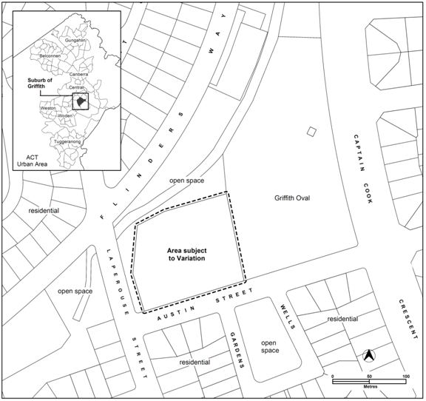

**Figure 1: Location of the site and surrounding uses.**

* + 1. Current Territory Plan Provisions

The Territory Plan Map zone for the area subject to this variation is shown in **Figure 2**. The site is surrounded on three sides by the parks and recreation PRZ1 urban open space zone. To the south across Austin Street the land is partly PRZ urban open space zone and partly residential RZ1 suburban zone.

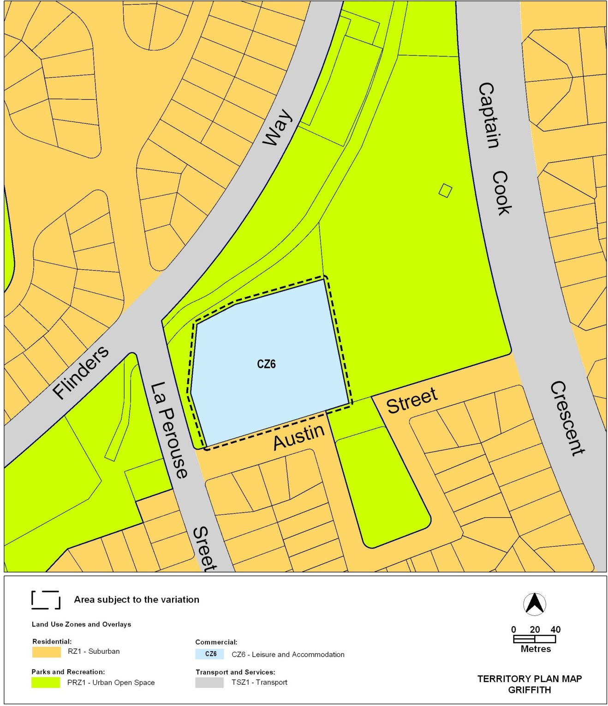

**Figure 2: Territory Plan Zones Map**

* 1. Proposed changes
     1. Proposed changes to the Territory Plan map

The proposed changes to the Territory Plan map are indicated in Figure 3 at Part 3 of this document and consist of removing Griffith section 42, block 15 from the commercial CZ6 leisure and accommodation zone and including it in the RZ4 medium density residential zone.

* + 1. Proposed changes to Territory Plan multi unit housing development code - application of Part C5

It is proposed to add Griffith to the application of part C(5) of the multi unit housing development code, to ensure that it will apply to medium density residential development on the site.

* 1. Reasons for the proposed Draft Variation

The reasons for the proposed rezoning are presented in detail in the planning report and are summarised as follows:

* The site is well proportioned and of sufficient size to accommodate medium density residential redevelopment
* The site is separated from surrounding low density residential areas by Austin Street to the south and open space area to the north, east and west
* The current zoning of the site primarily reflects a former use that has not operated on the site in three years. The uses permitted in the commercial CZ6 leisure and accommodation zone are unlikely to be developed on the site in the future
* Many of the uses permitted in the commercial CZ6 leisure and accommodation zone are permitted in other commercial zones and are more appropriately undertaken in commercial centres rather than in an established residential neighbourhood
* The site is well located close to commercial and employment centres at Manuka, Kingston and Civic and close to public transport along Captain Cook Crescent
* The proposal will increase housing choice in the Griffith/ Forrest area without directly affecting existing single dwelling housing.
* The proposal will further assist in offsetting the population decline that occurred in South Canberra after its peak in 1961
* The multi unit housing development code is made applicable to the site to ensure the provisions relevant to the development of medium density residential housing applies.

Population change

The population of South Canberra peaked in the mid 1960s at over 29,000. By 1986 as a result of population ageing it had fallen to under 21,000. As a result of redevelopment activity particularly in Griffith and Kingston the population of the district gradually began to increase reaching 22,700 in 1996. Primarily as a result of the development of Kingston Foreshore and redevelopments in other suburbs, particularly Barton, the population increased to 23,500 in 2006 and at June 2009 was estimated by the Australian Bureau of Statistics to have reached 26,000. Figure 1 indicates the population trend by suburb since 1961.



Increasing housing opportunities in South Canberra will contribute to a more sustainable city as it is likely to reduce the level of overall travel, particularly in relation to work trips.

At the 2006 Census there were an estimated 3.68 jobs in South Canberra for every resident worker, the highest of any district. In comparison the job to resident workers was 0.55 in Belconnen and 0.33 in Tuggeranong.

The RZ4 medium density residential zone permits a broad range of housing types. This presents an opportunity for redevelopment of the site to meet the housing needs of existing residents in South Canberra which would provide an opportunity for existing residents to down size into appropriate accommodation without having to relocate from the local area.

* 1. Planning context
     1. National Capital Plan

The Australian Capital Territory (Planning and Land Management) Act 1988 established the National Capital Authority (NCA) with two of its functions being to prepare and administer a National Capital Plan (NCP) and to keep the NCP under constant review and to propose amendments to it when necessary.

The NCP, which was published in the Commonwealth Gazette on 21 January 1990 is required to ensure that Canberra and the Territory are planned and developed in accordance with their national significance. The Planning and Land Management Act 1988 also required that the Territory Plan is not inconsistent with the NCP.

* + 1. Territory Plan

The proposal is consistent with the Territory Plan’s Statement of Strategic Directions in terms of environmental, economic and social sustainability and spatial planning and urban design principles. The following table outlines the key elements of the Statement of Strategic Directions supported by DV307:

| **Statement of Strategic Directions** | **DV307** |
| --- | --- |
| **1.1** Planning processes and decisions will be focused on the combined achievement of economic vitality, community wellbeing, and environmental quality. Broad community involvement will be a key element in the pursuit of sustainable development, as will complementary regional strategies and agreements. | Consultation undertaken to date has exceeded the requirements of the *Planning and Development Act 2007* and included: consultation by the proponent as part of the preparation of the planning report; pamphlet delivery within the area and at local shops; public notices in the Canberra Times and on ACT Government websites and signs on the land; the public notification period was in excess of the statutory 15 business days. |
| **1.3** Economic, social and environmental objectives will be pursued in a balanced and integrated way, having regard to both short-term and long-term factors, such that present needs can be met without prejudicing the welfare of future generations, and without serious or irreversible loss of life-supporting natural resources or damage to the environment. | The site provides a unique opportunity to increase housing choice in proximity to a large employment centre. It will assist in achieving the population levels in the region not experienced since 1961, without removing any existing dwelling stock, open space (public or restricted access) or any community uses. |
| **1.9** Urban expansion will be contained in order to minimise impacts on valuable natural and rural areas. | The site is within the existing urban footprint, is designated as being within the urban area of the National Capital Plan and is within 7.5km of the city centre. |
| **1.17** In planning future development and redevelopment, particular emphasis will be placed on cost-effective provision and management of existing and new infrastructure and services, taking into account whole-of-life and whole-of system costs, including the ecological footprint of proposed developments and activities. | The planning report concluded that existing water and sewer infrastructure have the capacity to service the site if redeveloped for multi units under the RZ4 medium density residential zone thereby reducing infrastructure costs. |
| **1.18** Provision will be made for a comprehensive range of readily accessible community, cultural, sporting and recreational facilities, distributed according to the varying needs of different localities and population groups. In major centres and developing areas, sites will be safeguarded where necessary for particular community needs. | Canberra Central is comparatively well serviced with community and sporting facilities. Development of the site would provide an opportunity for increased access to the existing facilities of this nature in the Griffith area generally and to the public open space adjoining the site (blocks 16 and 17). |
| **1.21** Provision of affordable, adaptable and special-needs housing will be promoted throughout the city, as well as modification or redevelopment of existing stock to meet emerging social needs. | The proposal provides an opportunity to further increase the housing mix in Griffith without the loss of existing single residential dwellings. The multi unit housing development code of the Territory Plan require 10% of multi units to be adaptable making them suitable for persons with a disability and the aged. There are provisions in the codes to ensure a mix of unit sizes. These provisions are expanded upon in the current review of the residential codes in DV306. |
| **2.2** Future residential settlement will be accommodated through development of greenfields areas, subject to detailed feasibility and suitability studies; some expansion of existing towns; and appropriate use of suitable vacant or underdeveloped sites. | The site is underutilised in its current commercial CZ6 leisure and accommodation zone. The previous use of the site as a bowling club ceased several years ago. The opportunity for redevelopment of the site under the current CZ6 zone is limited and may not result in the most appropriate form of development for the site. |
| **2.5** A wide range of housing types will be permitted in identified residential areas close to commercial centres and some major transport routes to increase choice; maximise opportunities for affordable housing; and secure some intensification of development consistent with maintaining residential amenity. Outside of these areas, planning policies will protect the typically low density, garden city character of Canberra’s suburban areas. | The subject site does not involve the redevelopment of an existing residential area. The site is zoned for commercial purposes. While the site is outside the existing residential area of Griffith it does share an interface across Austin St with low density residential development. There is a suite of provisions contained in the residential development codes to minimise impacts upon garden city values and character of existing residential areas. In addition, DV307 proposes rezoning to the RZ4 medium density residential zone which will increase the diversity of housing types including multi units. |
| **2.6** Higher density development will be encouraged within and near major centres, and in other suitable locations that are well served by public transport. | The site is located in proximity to key employment centres such as Barton and Parkes. Captain Cook Crescent is also provided with a ½ hourly bus service to Maunka, Kingston, Barton, Parks, Russell, Campbell and the city centre. |
| **2.7** Development will be planned to encourage use of public transport, walking and cycling, including commuter cycling. Routes will be reserved for an enhanced inter-town public transport system. Requirements for vehicle parking will be related to commercial needs and transport policy objectives. | The site is located in proximity to the employment centres of Barton and the city centre with access to the existing cycle and pedestrian network including a shared pedestrian/cycle pathway in the verge of Flinders Way to Manuka. This will serve as an encouragement for residents working locally to use alternative transport modes to reduce motor vehicle use. |
| **2.10** Adequate provision of open space throughout the Territory will remain a high priority. Open space will be planned and carefully maintained as an integrated, hierarchical system that provides for a diversity of sport and recreation activities, contributes to the legibility and character of urban development, is cost-effective to maintain, and assists in the effective management of stormwater. | DV307 will not result in the loss of any open space, sports or recreation facilities. The previous use of the site involved an outdoor recreation activity as defined under the Territory Plan. However, this use has not operated for several years. Additionally, the commercial CZ6 leisure and accommodation zoning of the site does not protect its long term future as a site for outdoor recreation uses. South Canberra has amongst the highest provision of urban open space of any District in Canberra. |

* + 1. Planning Strategy for the ACT
       1. Spatial Plan

The Spatial Plan outlines the strategic direction for growth to achieve social, environmental and economic sustainability for Canberra. This proposal is consistent with the following key principles of the Canberra Spatial Plan:

* Contain growth within 15km of the city centre
* At least 50% of all residential development will occur within 7.5 kilometres of the city centre
* Higher density residential development will be located on major centrally located urban renewal sites.
  + - 1. Sustainable Transport Plan

The proposed development meets the broad objectives of the Sustainable Transport Plan in terms of integration of transport and land use to reduce travel distances, to increase choice of transport modes and encourage greater use of sustainable transport modes (walking, cycling and public transport).

* 1. Consultation with Government agencies

ACTPLA is required to, in preparing a draft variation under section 61(b) consult with each of the following in relation to the proposed draft variation

1. the national capital authority
2. the conservator of flora and fauna
3. the environment protection authority
4. the heritage council
5. if the draft variation would, if made, be likely to affect unleased land or leased public land – each custodian for the land likely to be affected

**National Capital Authority**

The NCA provided the following comments 14 December 2010

Please note that the National Capital Authority has no objection to Draft Variation to the Territory Plan No. 307 proceeding.

Response

Noted.

**Conservator of Flora and Fauna**

The Conservator of Flora and Fauna made the following comments on 13 December 2010:

In accordance with Section 61(b) of the Planning and Development Act 2007, I advise that I have examined draft variation to the Territory Plan No. 307 – Griffith section 42, block 15, for the change of zoning from commercial CZ6 leisure and accommodation to RZ4 medium density residential, and provide the following comments.

I have no issues of concern with the proposed change of land use provided that there are adequate controls on the site to ensure the protection of the existing trees located on the adjoining area of urban open space. An ample set back from the block boundaries is required to ensure that will building work, including scaffolding, is outside the dripline of the trees. This requirement must also relate to the construction of any basements.

Response

Noted and agreed. The future development of the site would be subject to a development application which would be considered in consultation with the relevant ACT Government agencies including the Conservator of Flora and Fauna.

**Environment Protection Authority**

The Environment Protection Authority provided the following comments on 13 December 2010:

I refer to your letter of 9 December 2010 requesting agreement to release DV307 for public comment, on the basis that a site contamination assessment will be prepared concurrently with the public notification draft variation.

I consider that this is a reasonable approach; however the draft variation to the Territory Plan should not come into effect until the site has been found suitable for more sensitive purposes. Should the environmental assessment reveal significant levels of contamination, further assessment and remediation will be required. All assessment reports should be forwarded to the Environment Protection Unit for review and endorsement prior to draft variation coming into effect.

I draw to your attention my advice to ACTPLA in August 2009 and February, August and November 2010 that, predominately based on historic use of the chemical pesticides and herbicides in bowling greens management, there is a need for assessment prior to finalising changes to the Territory Plan.

Response

Noted and agreed. The Brumbies Rugby has been requested to undertake the necessary site contamination assessment and to provide the resultant report to the Environment Protection Authority (EPA). DV307 will not proceed beyond the public notification stage until the EPA has considered the site contamination assessment.

**Heritage Council**

The Heritage Council provided the following comments on 14 December 2010:

I refer to your letter and associated documentation in relation to draft variation 307 to the Territory Plan for Griffith section 42 block 15. I understand that the proposal involves the change of zoning from the current CZ6 leisure and accommodation to the RZ4 medium density residential zone.

The Heritage Council advises that the subject block is adjacent to the Griffith Oval site which is registered on the ACT Heritage Register. The Council, in its letters to the ACT Planning and Land Authority on 9 August 2010 and 10 November 1020 advised that the proposed rezoning of block 15 section 42 Griffith was unlikely to generate detrimental impacts on the heritage significance of the Griffith Oval provided that the trees bordering the Oval on the shared boundary were retained.

The Heritage Council advises that the proposed rezoning is acceptable provided that a condition is appended to any approval for this lease variation. This condition should require the retention of the trees on the common boundary, providing sufficient distance from these trees during planning and development to allow their continued good health, and replacing these trees when they reach the end of their lifespan.

Response

Noted and agreed. The future development of the site would be subject to a development application which would be considered in consultation with the relevant ACT Government agencies including the ACT Heritage Council.

1. INTERIM EFFECT

Section 72 applies in relation to the draft plan variation.

The variation has interim effect from 19 August 2011 to 19 August 2012 or until the end of the “defined period”, whichever is shorter. Under the Planning and Development Act 2007, section 72(3) “defined period” for a draft plan variation means the period -

1. starting on the day (the notification day) when the draft plan variation given to the Minister is notified under the Legislation Act (see s70); and
2. ending on the earliest of the following days:
   1. the day the corresponding plan variation, or part of it, commences
   2. the day the corresponding plan variation is rejected by the Legislative Assembly;
   3. the day the corresponding plan variation is withdrawn in accordance with a requirement under section 76(3) (b) (v) or section 84 (3) (b);
   4. the period of 1 year after notification day ends.

The Territory, the Executive, a Minister or a territory authority must not, during the defined period, do or approve the doing of anything that would be inconsistent with the territory plan if it were varied in accordance with the draft plan variation.

1. DRAFT VARIATION
   1. Variation to the Territory Plan map

**1.Territory Plan Map**

The Territory Plan map is varied as indicated in **Figure 3**

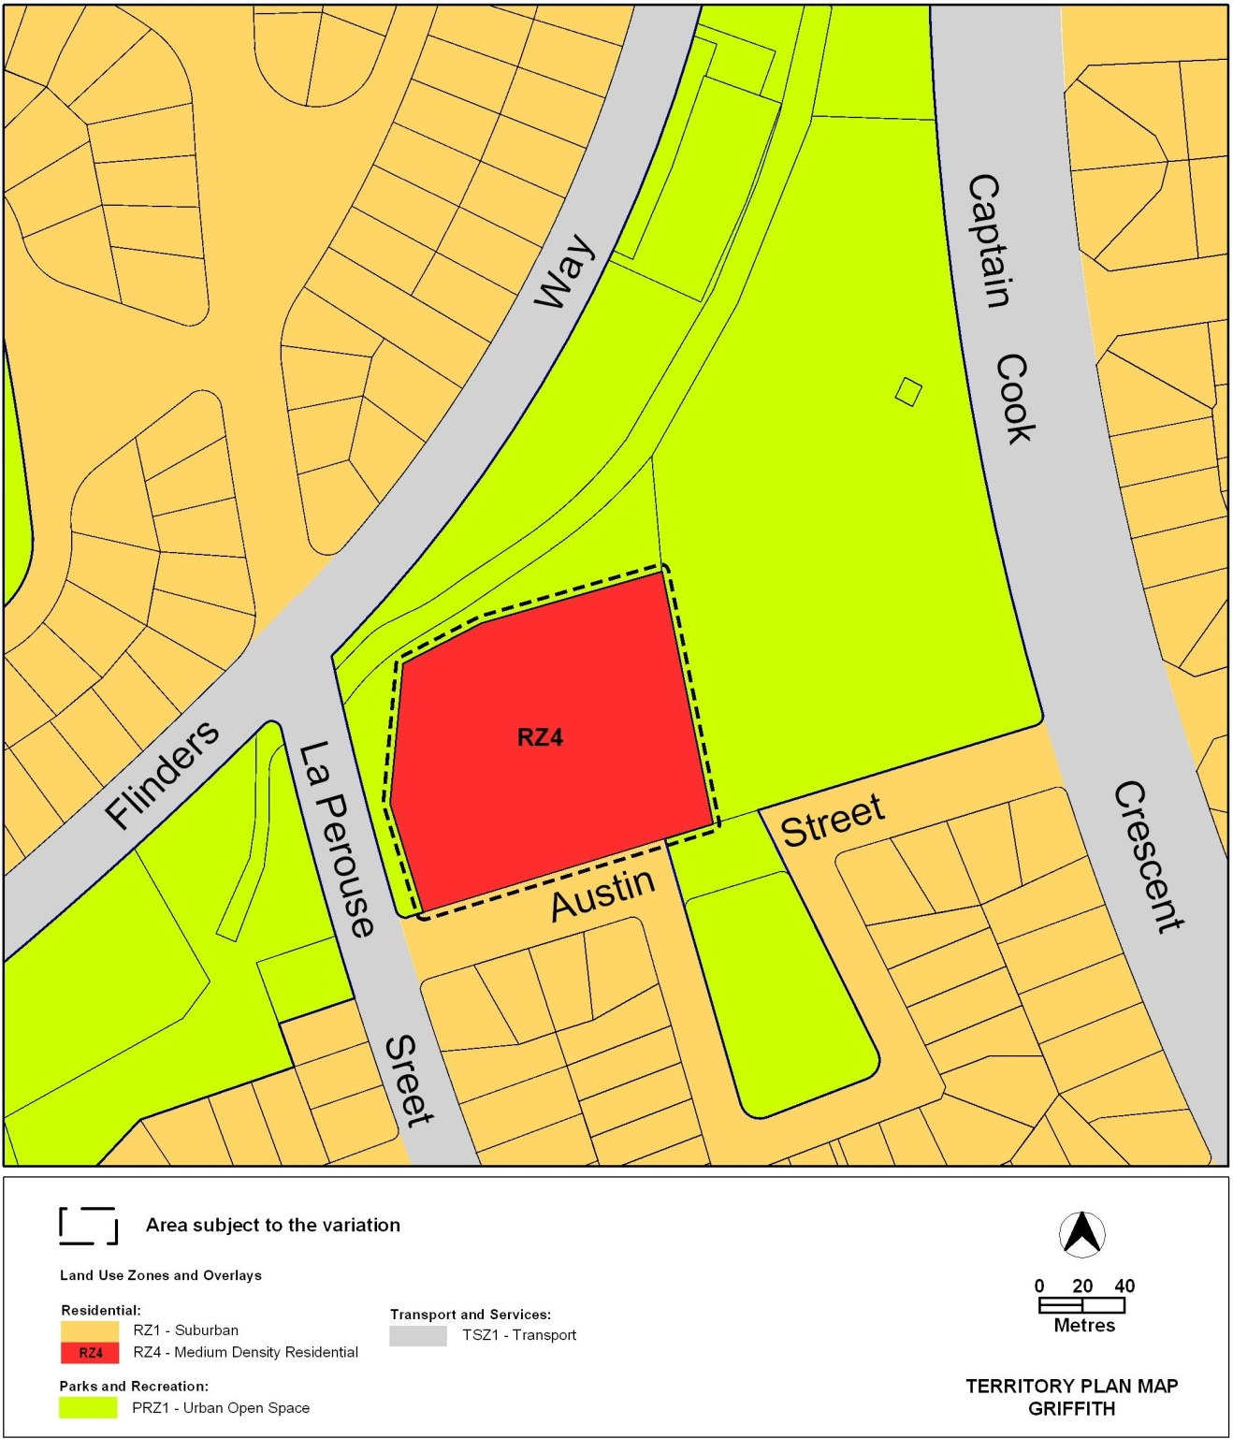

**Figure 3: Proposed Territory Plan Zones Map**

* 1. Variation to the Territory Plan

Variation to the Multi unit housing development code

**2. Part C (5) – Multi Unit Housing – Other Areas – RZ4 and RZ5 Zones and All Areas in the Commercial Zones**

*Substitute wording in the* first *sentence of the first paragraph under the heading* *as underlined below*:

This Part of the Code applies to development applications for multi unit housing in the RZ4 – Medium Density Residential and RZ5 – High Density Residential Zones as they apply in Belconnen, Bruce, Hawker, Narrabundah, Woden District and Tuggeranong District and the RZ4 - Medium Density Residential areas within Griffith.

Interpretation service

