Australian Capital Territory

Planning and Development (Technical Amendment—Bonner) Plan Variation 2011 (No 4)

Notifiable instrument NI2011—480
Technical Amendment No 2011-26
made under the
Planning and Development Act 2007, section 89 (Making technical amendments) (s96 land ceases to be in future urban area)

This plan variation commences on the day after it is notified.

Variation No 2011-26 to the Territory Plan has been approved by the Planning and Land Authority.

Annexure A – specifies that the land identified on the map being land within the Division of Bonner, may be used for the purposes indicated in the Annexure.

Annexure B – replaces the map on page 2 of the Bonner Precinct Code at section 10 of the Territory Plan.

Ben Ponton
Delegate of ACT Planning and Land Authority
Date : 26 August 2011

THIS IS PAGE ONE OF ANNEXURE A
TO NOTIFIABLE INSTRUMENT NI2011 – 480

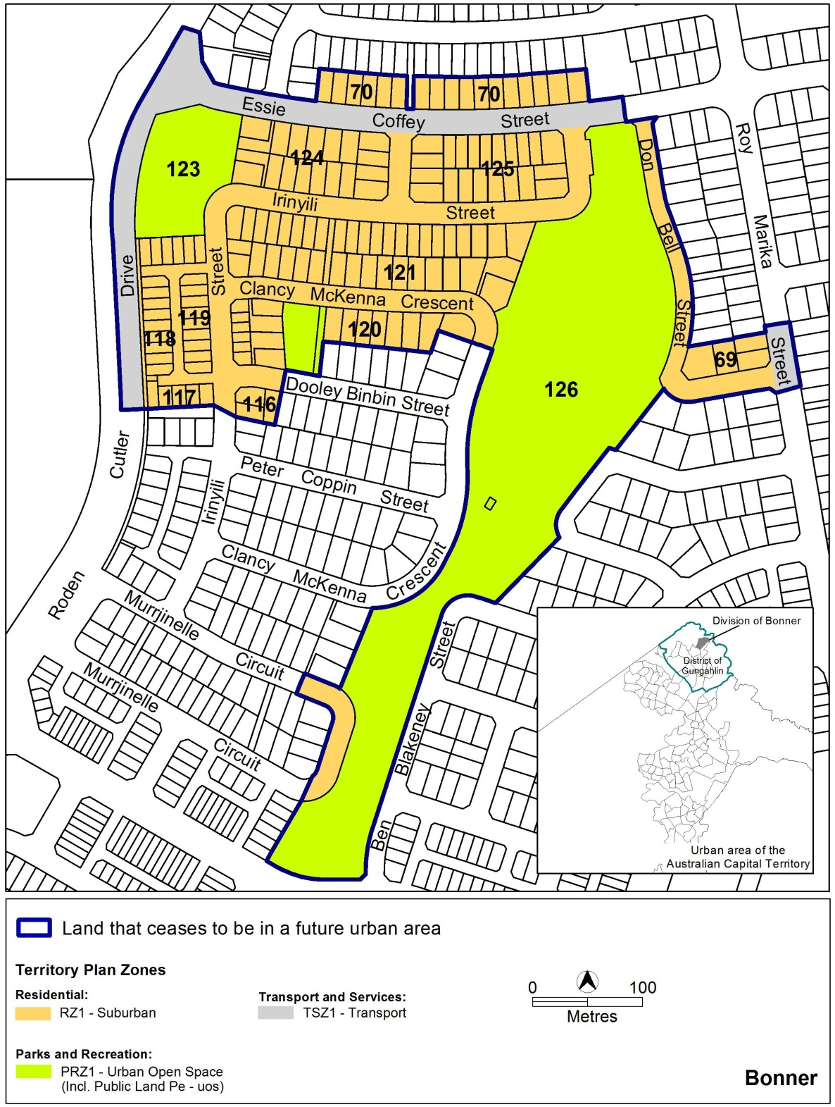

Ben Ponton
Delegate of ACT Planning and Land Authority
Date: 26 August 2011

THIS IS PAGE ONE OF ANNEXURE B
TO NOTIFIABLE INSTRUMENT NI2011 – 480

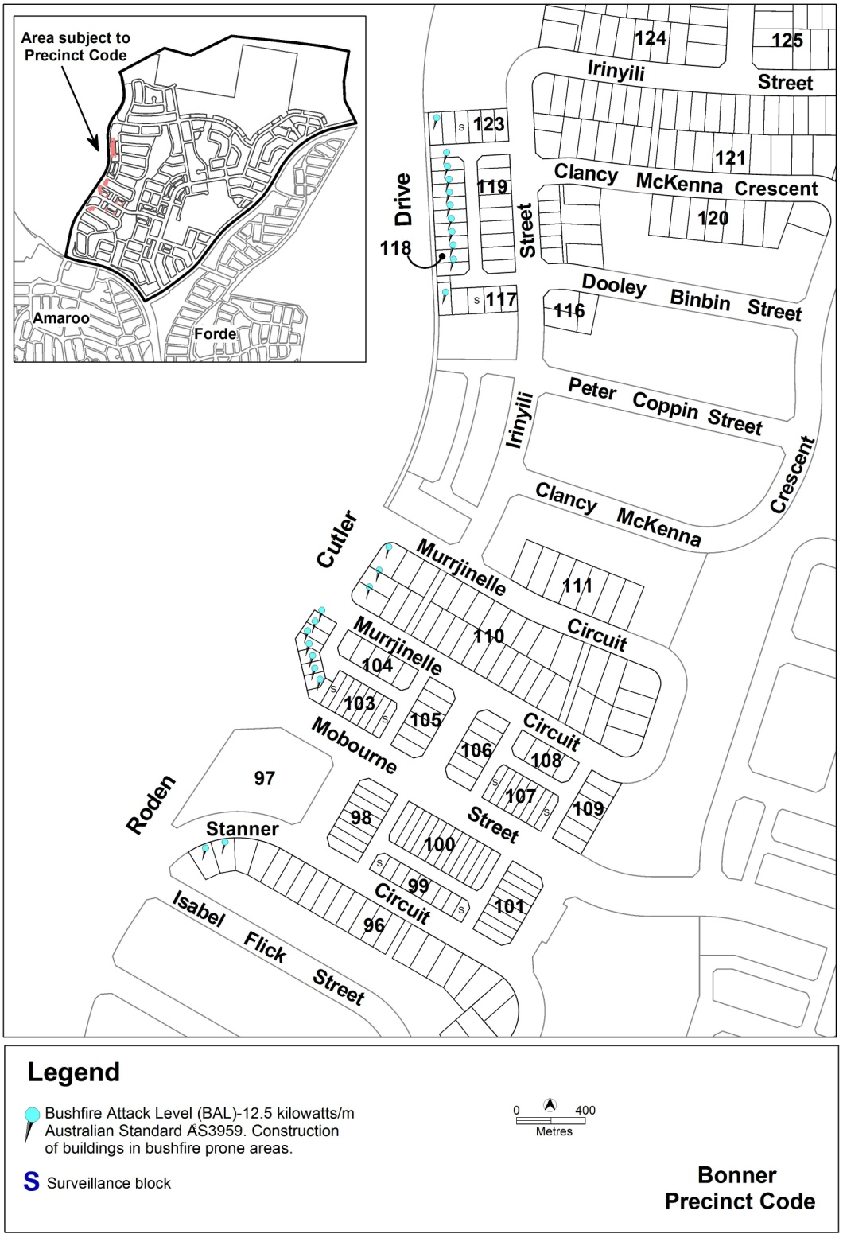

Ben Ponton
Delegate of ACT Planning and Land Authority
Date: 26 August 2011

