Australian Capital Territory

Planning and Development (Technical Amendment— Miscellaneous amendments and corrections) Plan Variation 2011 (No 2)*
Notifiable instrument 2011—590
Technical Amendment No 2011-27
made under the
Planning and Development Act 2007, section 89 (Making technical amendments)

This Technical Amendment commences on Friday 07 October 2011.

Technical Amendment Number 2011-27 to the Territory Plan has been approved by the Planning and Land Authority

Ben Ponton
Delegate of Planning and Land Authority

4 October 2011

Planning and
Land Authority

Planning & Development Act 2007

Technical Amendment
to the Territory Plan
Variation 2011-27

Miscellaneous amendments and corrections

October 2011
Table of Contents

1 INTRODUCTION 2
Outline of the process 2
2 EXPLANATORY STATEMENT 3
2.1 Proposed Changes and Reasons 3
3. TECHNICAL AMENDMENT 8

1 INTRODUCTION

Outline of the process

The Commonwealth’s Australian Capital Territory (Planning and Land Management) Act 1988 allows for the Legislative Assembly to make laws to establish a Territory Planning Authority and for that Authority to prepare and administer a Territory Plan.

The Planning and Development Act 2007 (the Act) establishes the ACT Planning and Land Authority as the Authority which prepares and administers the Territory Plan, including continually reviewing and proposing amendments as necessary.

Technical amendments to the Territory Plan are prepared in accordance with the Act. This technical amendment has been prepared in accordance with the following sections of the Act:

A variation under section 87(a) is a technical amendment that:
(i) would not adversely affect anyone’s rights if approved; and
(ii) has as its only object the correction of a formal error in the plan.

A variation under section 87(f) is a technical amendment to omit something that is obsolete or redundant in the Territory Plan.

This technical amendment has been approved by the ACT Planning and Land Authority.

2 EXPLANATORY STATEMENT

2.1 Proposed Changes and Reasons

- Correction to public land overlay classification for Albert Hall on the Territory Plan map (item 1)

The land identified as Yarralumla section 39 block 1 is the site of the Albert Hall. The public land overlay sport and recreation reserve (Pi) currently applies to this land. It is proposed to amend the public land overlay to special purpose Reserve (Pd) as this is more relevant to the use of the site.

Section of Act | Statement of compliance with Act
s87(a) a variation that -
(i) would not adversely affect anyone’s rights if approved; and | The change of public land overlay from sport and recreation reserve (Pi) to special purpose reserve (Pd) will not adversely affect anyone’s rights.
(ii) has as its only object the correction of a formal error in the plan | The public land overlay classification is being changed to correct a defect of form and appropriately reflect the use of the site.

- Correction to rule R33 and criterion C33 of communication facilities and associated infrastructure general code to better reflect the provision’s intent (items 26 and 27)

Rule R33 refers to the location of communications facilities where they will not cause interference with other telecommunications services. The corresponding criterion C33 states that ‘Development in community sensitive locations has no adverse impacts’. The criterion does not correlate with the rule. It is proposed that C33 be removed.

Rule R33 is written in a way that is better applied as a criterion rather than a rule. It is proposed that R33 be changed to become criterion C33. Rule R33 will state ‘There is no applicable rule’. The wording has also been amended in a minor way to replace ‘does not cause’ with ‘avoids’, which better interprets the intent of the provision as contained in the former Territory Plan (pre March 2008).

Section of Act | Statement of compliance with Act
s87(a) a variation that -
(i) would not adversely affect anyone’s rights if approved; and | It is not expected that the changes will adversely affect anyone’s rights.
(ii) has as its only object the correction of a formal error in the plan | The amendment will correct a formal error by reflecting the desired intent of the provision as expressed in the former telecommunications facility guidelines.

- Correction of provisions that were incorrectly inserted into the PRZ2 parks and recreation zone development code (item 22)

Technical amendment 2010-33 introduced a rule and criterion into the code which has the effect of restricting land uses which include club, educational establishment, guest house, hotel and motel, to 15% of the land area of any discrete PRZ2 zone.

The introduction of rule R7A and criterion C7A was intended to replace rule R7, however R7 was inadvertently not removed as part of the technical amendment. The insertion instructions and numbering of the provision were incorrect and the instruction should have been ‘substitute’ rather than ‘insert’. Therefore it is proposed to correct this by removing R7 and re-numbering accordingly.

Section of Act | Statement of compliance with Act
s87(a) a variation that -
(i) would not adversely affect anyone’s rights if approved; and | This amendment will not adversely affect anyone’s rights.
(ii) has as its only object the correction of a formal error in the plan | This amendment seeks to implement the initial intention to replace rule R7 of the code.

- Correction of zoning to the community facility zone for Gungahlin section 235 block 2 (item 2)

Technical amendment 2011-13 removed the FUA overlay from Gungahlin section 235 block 2.

The site, which involves the direct sale by the ACT Government for the development of a mosque, was intended to be zoned CFZ community facility, consistent with the intended use of the site.

Section of Act | Statement of compliance with Act
s87(a) a variation that -
(i) would not adversely affect anyone’s rights if approved; and | The intended use of the site will not be adversely affected by the correction to the zone.
(ii) has as its only object the correction of a formal error in the plan | The amendment will correct the zoning.

- Updating of the property description in the multi unit housing development code (item 5)

The multi unit housing development code contains a reference to block 4 section 69 Lyons. Block 4 has been amalgamated with block 6 and accordingly block 4 no longer exists. The land is now known as block 6.

Section of Act | Statement of compliance with Act
s87(a) a variation that -
(i) would not adversely affect anyone’s rights if approved; and | This amendment will not adversely affect anyone’s rights.
(ii) has as its only object the correction of a formal error in the plan | The amendment will correct a property description.

- Correction to the application of parts C(1) and C(5) of the multi unit housing development code (items 3, 4 and 6 - 18)

Correction to the multi unit housing development code to ensure the appropriate applicability of parts C(1) and C(5), for apartments three (3) storeys and above. These provisions were translated into the restructured Territory Plan, such that part C(5) became stand alone, rather than reflecting the intent of the former apartment guidelines to apply in addition to the other provisions (except in the event of any inconsistency).

Section of Act | Statement of compliance with Act
s87(a) a variation that -
(i) would not adversely affect anyone’s rights if approved; and | This amendment will not adversely affect anyone’s rights.
(ii) has as its only object the correction of a formal error in the plan | The amendment will correct the applicability of the multi unit housing development code, consistent with the intent of provisions contained within the former apartment guidelines and Territory Plan (prior to March 2008).

- Correction of a heading in the bicycle parking general code to improve consistency of the introduction to codes (item 25)

The title of section 1.3 of the bicycle parking general code is currently ‘When to and who will access this code’. The title should be ‘Application of this code’.

The first sentence of this section is currently ‘This code apply to all activities...’ The sentence should be ‘This code applies to all activities...’

The section contains a reference to ‘Planning and Development Act 2006’. The correct reference should be ‘Planning and Development Act 2007’.

Section of Act | Statement of compliance with Act
s87(a) a variation that -
(i) would not adversely affect anyone’s rights if approved; and | This amendment will not adversely affect anyone’s rights.
(ii) has as its only object the correction of a formal error in the plan | The amendment will correct the section title and reference to the Planning and Development Act 2007.

- Inserting missing criteria C46 of the industrial zones development code (item 19)

Rule R46 addresses hazardous material, however there is no text in the corresponding criterion C46. The wording of a criterion proposed in draft variation 302 for the community facility zone development code is to be inserted as C46.

Section of Act | Statement of compliance with Act
s87(a) a variation that -
(i) would not adversely affect anyone’s rights if approved; and | This amendment will not adversely affect anyone’s rights.
(ii) has as its only object the correction of a formal error in the plan | The amendment will correct a formal error by inserting a criterion that was absent.

- Removal of redundant solar access provisions in the community facility zone development code (items 20 and 21)

The multi unit housing development code applies to residential development and the solar access provisions are appropriate for development in the community facility zone, therefore this provision is considered redundant.

Section of Act | Statement of compliance with Act
s87(f) a variation to omit something that is obsolete or redundant in the Territory Plan | The solar access provisions for residential development are duplicated in the community facility development code and are therefore redundant.

- Removal of redundant solar access provisions in the parks and recreation zone development code (items 23 and 24)

Residential use is prohibited in the PRZ1 urban open space and PRZ2 restricted access recreation zones, therefore the solar access provisions are redundant.

Section of Act | Statement of compliance with Act
s87(f) a variation to omit something that is obsolete or redundant in the Territory Plan | Residential use is prohibited in the PRZ1 and PRZ2 zones, therefore the provision is redundant.

3. TECHNICAL AMENDMENT

Variation to Territory Plan Map

- Yarralumla section 39 block 1

Substitute with

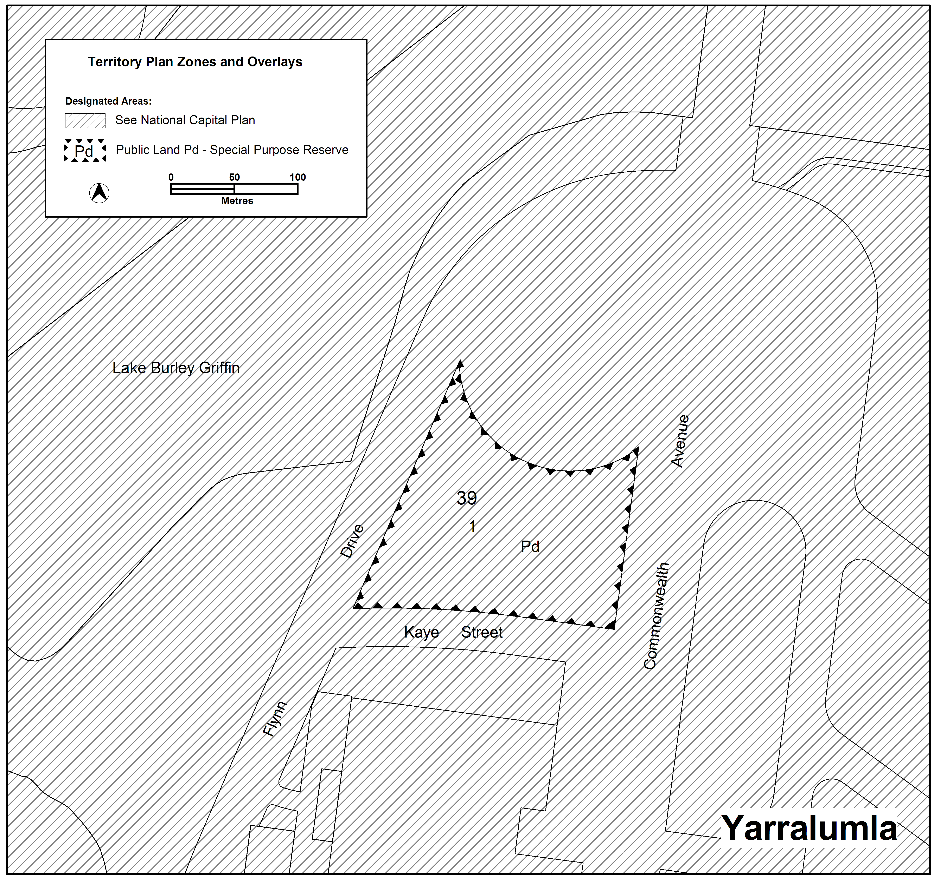

- Gungahlin section 235 block 2

Substitute with

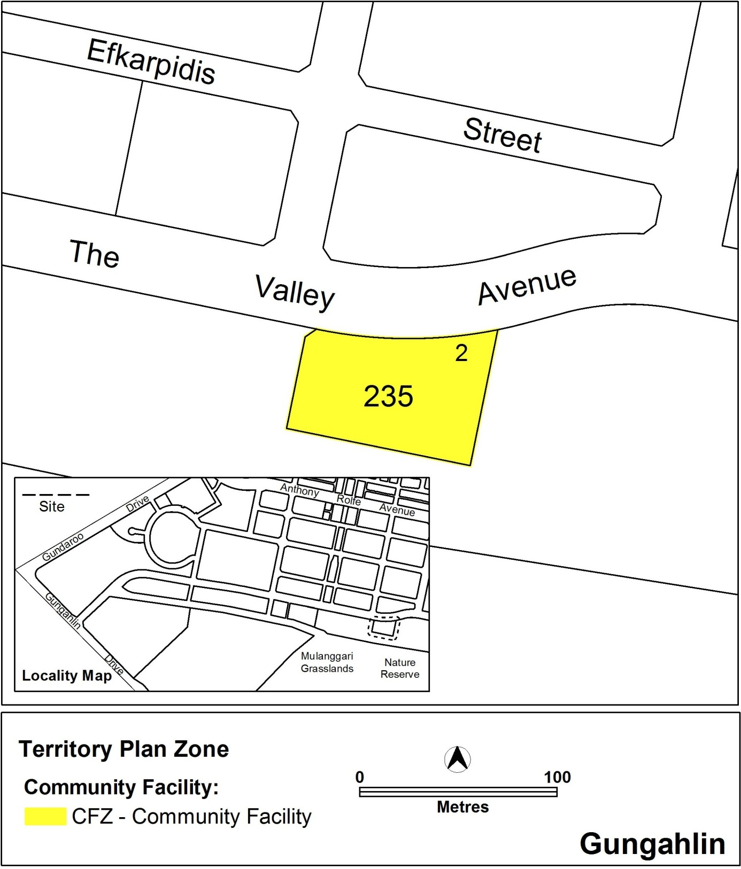

Variation to the Multi Unit Housing Development Code
- Introduction – Application of the code

Substitute first three paragraphs with

This code applies to development for multi unit housing in residential zones. It also applies to development for multi unit housing in other zones where the development table or development code for that zone states that it applies.

- Introduction – Structure of codes – Part C(5) Multi unit housing –

Substitute with

Apartments of three (3) storeys or more in other areas and all multi unit housing in the commercial zones provide the controls for apartments of three (3) storeys or more in areas not subject to Parts C(2) – C(4). Provisions of Part C(1) do not apply where specifically identified in provisions of Part C(5). For multi unit housing in the commercial zones Part C(5) applies instead of Part C(1).

- Part A(5) – RZ5 – High Density Residential Zone, Element 2: Building and Site Controls, 2.1 Height, R27A

Substitute ‘Block 4’ with

Block 6

- Part C – Development Type Controls

Substitute second paragraph with

Part C(1) provide the controls for multi unit housing in all zones except in the commercial zones and except where provided for by Parts C(2) - C(4). Part C(1) is therefore the default position for multi unit housing. Part C(2) provides additional controls in some areas. Parts C(3) and C(4) provide controls that apply instead of Part C(1) in other areas. Part C(5) provides controls for apartments of three (3) storeys or more in areas not subject to parts C(2) – C(4). Provisions of Part C(1) do not apply where specifically identified in provisions of Part C(5). For multi unit housing in the commercial zones Part C(5) applies instead of Part C(1).

- Part C – Development Type Controls

Substitute sixth paragraph with

Part C(5) – provide the controls for apartments of three (3) storeys or more in areas not subject to parts C(2) – C(4). Provisions of Part C(1) do not apply where specifically identified in provisions of Part C(5). For multi unit housing in the commercial zones Part C(5) applies instead of Part C(1).

- Part C (1) – Multi Unit Housing

Substitute first paragraph with

This section of the code applies to development applications for multi unit housing in all zones except for the commercial zones and except where provided for by Parts C(2)-C(5). As such, it is the default position for multi unit housing. It is to be read in conjunction with Parts A and B.

- Part C(5) – Multi unit housing – Other Areas – RZ4 and RZ5 Zones and All Areas in the Commercial Zones

Substitute above title with

Part C(5) – Multi unit housing – Apartments of three (3) storeys or more in other areas and all multi unit housing in the commercial zones

Substitute first two paragraphs with

This part of the code provides controls for apartments of three (3) or more storeys in areas not subject to parts C(2) – C(4). Provisions of Part C(1) do not apply where specifically identified in provisions of Part C(5). Except for commercial zones Parts A and B of this Code also apply.

For multi unit housing in the commercial zones Part C(5) applies instead of Part C(1). The requirements should be read in conjunction with the relevant Commercial Codes. Parts A and B of the relevant Commercial Zone Development Code or Precinct Code replace Parts A and B of this Code for development in the commercial zones.

- Part C(5) – Multi unit housing – Other Areas – RZ4 and RZ5 Zones and All Areas in the Commercial Zones, Element 3: Built Form, 3.1 Accommodation Diversity, R205

Insert new title above ‘R205’

3.1A Accessibility (mobility) (replaces 3.4 Accessibility (mobility) in Part C(1))

- Part C(5) – Multi unit housing – Other Areas – RZ4 and RZ5 Zones and All Areas in the Commercial Zones, Element 3: Built Form, 3.3 Interface

Insert (Replaces R68) after ‘R210’

Insert (Replaces C68) after ‘C210’

- Part C(5) – Multi unit housing – Other Areas – RZ4 and RZ5 Zones and All Areas in the Commercial Zones, Element 4: Parking and Site Access, 4.2 Parking

Insert (Replaces R82) after ‘R216’

Insert (Replaces C82) after ‘C216’

- Part C(5) – Multi unit housing – Other Areas – RZ4 and RZ5 Zones and All Areas in the Commercial Zones, Element 4: Parking and Site Access, 4.2 Parking

Insert (Replaces R81) after ‘R218’

Insert (Replaces C81) after ‘C218’

- Part C(5) – Multi unit housing – Other Areas – RZ4 and RZ5 Zones and All Areas in the Commercial Zones, Element 5: Amenity, 5.1 Visual privacy

Insert (Replaces R69) after ‘R219’

Insert (Replaces C69) after ‘C219’

- Part C(5) – Multi unit housing – Other Areas – RZ4 and RZ5 Zones and All Areas in the Commercial Zones, Element 5: Amenity, 5.2 Solar access

Insert

R222 (replaces 5.1 Solar Access in Part C(1))

- Part C(5) – Multi unit housing – Other Areas – RZ4 and RZ5 Zones and All Areas in the Commercial Zones, Element 5: Amenity, 5.6 Private Open Space - Heading

Substitute with

5.6 Private Open Space (Replaces 5.3 Private Open Space in Part (C1))

- Part C(5) – Multi unit housing – Other Areas – RZ4 and RZ5 Zones and All Areas in the Commercial Zones, Element 7: Services, 7.3 Clothes Drying

Insert (Replaces R97 and C97) after ‘C245’

- Part C(5) – Multi unit housing – Other Areas – RZ4 and RZ5 Zones and All Areas in the Commercial Zones, Element 7: Services, 7.4 Storage

Insert (Replaces R96) after ‘R246’

Insert (Replaces C96) after ‘C246’

Variation to Industrial Zones Development Code

- Part B – General Development Controls, Element 6: Environment, 6.7 Hazardous Material, C46

Insert

If an endorsed hazardous material survey is required however evidence of an endorsed
hazardous materials survey is not provided, the application will be referred to the relevant
agency in accordance with the requirements of the Planning and Development Act 2007.

Variation to Community Facility Zone Development Code

- Part A – General Development Controls, Element 5: Amenity, Intent

Omit

a) To ensure the development is designed and sited to maximise solar access
to private open space and living areas

- Part A – General Development Controls, Element 5: Amenity, Rule 5.1 Solar Access

Omit

5.1 Solar Access and all provisions under the heading

Variation to Parks and Recreation Zone Development Code

- Part A – Zone Specific Controls, Part A(2) – PRZ2 – Restricted Access Recreation Zone, Element 1: Restrictions on Use

Omit

R7 and renumber R7A and C7A to R7 and C7.

- Part B – General Development Controls, Element 5: Amenity, Intent

Omit

a) To ensure the development is designed and sited to maximise solar access
to private open space and living areas

- Part B – General Development Controls, Element 5: Amenity, 5.1 Solar Access

Omit

5.1 Solar Access and all provisions under the heading

Variation to Bicycle Parking General Code

- 1. Planning Context, 1.3 When to and who will access this code

Substitute with:

1.3 Application of this code

This Code applies to all activities that require development approval under the Planning and Development Act 2007, including development, redevelopment and refurbishment, for a range of developments that are likely to generate demand for end-of-trip cycling facilities. Developers should use this Code to determine the amount, design and location of bicycle parking, lockers and showers to include with a development.

The ACT Planning and Land Authority will use this Code to inform the consideration and assessment of development applications.

Building owners and tenants may wish to refer to this Code for guidance when planning improvements to the cycling facilities on their premises.

Variation to Communication Facilities and Associated Infrastructure General Code

- Part B: General Development Controls, Element 2: Building and Site Controls, R33

Substitute with

There is no applicable rule.

- Part B: General Development Controls, Element 2: Building and Site Controls, C33

Substitute with

Location of facilities avoids interference with other telecommunications networks and radio communications services such as but not limited to: defence, security services, emergency services facilities, Australian Federal Police, the Canberra Airport and any other relevant network operating within the Territory.

Interpretation service

