Australian Capital Territory
Heritage (Decision about Registration for Mulligan’s Flat Ploughlands, Gungahlin) Notice 2011
Notifiable Instrument NI 2011 - 631
made under the
Heritage Act 2004 section 42 Notice of Decision about Registration

- Revocation
This instrument replaces NI 2011-373
- Name of instrument
This instrument is the Heritage (Decision about Registration for Mulligan’s Flat Ploughlands, Gungahlin) Notice 2011 -
- Registration details of the place
Registration details of the place are at Attachment A: Register entry for Mulligan’s Flat Ploughlands, Gungahlin.
- Reason for decision
The ACT Heritage Council has decided that Mulligan’s Flat Ploughlands, Gungahlin meets one or more of the heritage significance criteria at s 10 of the Heritage Act 2004. The register entry is at Attachment A.
- Date of Registration
20 October 2011

Gerhard Zatschler
Secretary
ACT Heritage Council
20 October 2011

AUSTRALIAN CAPITAL TERRITORY

HERITAGE REGISTER
(Registration Details)

Place No:

For the purposes of s. 41 of the Heritage Act 2004, an entry to the heritage register has been prepared by the ACT Heritage Council for the following place:

Mulligan’s Flat Ploughlands, Horse Park Drive, Gungahlin

(Part) Block 733, District of Gungahlin

DATE OF REGISTRATION

Notified: 20 October 2011 Notifiable Instrument: 2011-631

Copies of the Register Entry are available for inspection at the ACT Heritage Unit. For further information please contact:

The Secretary
ACT Heritage Council
GPO Box 158, Canberra, ACT 2601

Telephone: 13 22 81 Facsimile: (02) 6207 2229

IDENTIFICATION OF THE PLACE

Mulligan’s Flat Ploughlands, (Part) Block 733, District of Gungahlin

STATEMENT OF HERITAGE SIGNIFICANCE

This statement refers to the Heritage Significance of the place as required in s12(d) of the Heritage Act 2004.

The Mulligan’s Flat ploughlands are of heritage significance as important evidence of a distinctive farming process and a way of life (using draught animals) of exceptional interest and in danger of being lost; as a rare example of a ploughlands of a relative degree of intactness; as a notable example of non-mechanised ploughing activities and demonstrating the key characteristics of this kind of place; and for its special association with the cultural phase of the agricultural development of the area.

The Mulligan’s Flat ploughlands are significant evidence of the cultivation of the area before the advent of tractors. The evidence of ridge and furrow features at the site is well conserved in comparison with most other such ploughlands in the ACT, and clearly indicates the nature of the agricultural activity.

The ploughlands remain as a tangible reminder in the landscape of the nineteenth century rural and agricultural activities, with clear ridges and furrows and lands running across the contour, reflecting the nature of animal-drawn ploughing.

Of 65 ploughlands sites which once existed in the ACT, only five retain a level of intactness sufficient to demonstrate the farming process and way of life of which they represent. Mulligan’s Flat is one of these five and, as such, is a rare example of this kind of place.

The association of the Mulligan’s Flat ploughland with this cultural phase is special, given the limited number of remaining ploughlands within the ACT.

Other related registrations
Other places which are of a similar history to the Mulligan’s Flat ploughlands include four ploughlands sites within the ACT which have been identified as having significance worthy of registration to the ACT Heritage Register. The following places form separate nominations/registrations to the ACT Heritage Register:
- Old Orroral homestead and ploughland
- Glenburn rural group
- Blythburn Cottage Group (Booroomba)
- Orroral Homestead ploughland

Other places located near the Mulligan’s Flat ploughlands, also related to nineteenth century agricultural development and European settlement, form separate nominations/registrations in the ACT Heritage Register:
- Gungaderra Homestead (& portion of Well Station Road);
- Well Station Homestead; and
- the Old Coach Road.

FEATURES INTRINSIC TO THE HERITAGE SIGNIFICANCE OF THE PLACE

Features intrinsic to the heritage significance of the place which require conservation include:
• ploughland
• enclosure of elms

APPLICABLE HERITAGE GUIDELINES

The guiding conservation objective is that Mulligan’s Flat Ploughlands, (Part) Block 733, District of Gungahlin, shall be conserved and appropriately managed in a manner respecting its heritage significance and the features intrinsic to that heritage significance, and consistent with a sympathetic and viable use or uses. Any works that have a potential impact on significant fabric (and / or other heritage values) shall be guided by a professionally documented assessment and conservation policy relevant to that area or component (i.e. a Statement of Heritage Effects – SHE).

Pearson, 2002 provides recommendations for the management of significant ploughlands within the ACT, as well as specific recommendations for the management of the Mulligan’s Flat ploughlands. This document should be referred to for all management decisions.

REASON FOR REGISTRATION

The Mulligan’s Flat Ploughlands, (Part) Block 733, District of Gungahlin has been assessed against the heritage significance criteria and been found to have heritage significance when assessed against four criteria under the ACT Heritage Act.

ASSESSMENT AGAINST THE HERITAGE SIGNIFICANCE CRITERIA

Pursuant to s.10 of the Heritage Act 2004, a place or object has heritage significance if it satisfies one or more of the following criteria. Significance has been determined by research as accessed in the references below. Future research may alter the findings of this assessment.

- it demonstrates a high degree of technical or creative achievement (or both), by showing qualities of innovation, discovery, invention or an exceptionally fine level of application of existing techniques or approaches;

The Mulligan’s Flat Ploughlands does not meet this criterion.

- it exhibits outstanding design or aesthetic qualities valued by the community or a cultural group;

The Mulligan’s Flat Ploughlands does not meet this criterion.

- it is important as evidence of a distinctive way of life, taste, tradition, religion, land use, custom, process, design or function that is no longer practised, is in danger of being lost or is of exceptional interest;

The Mulligan’s Flat ploughlands, being created with animal-drawn ploughs and bearing the pattern of broad ‘lands’, were the result of a distinctive farming process and a way of life (using draught animals) that ceased with the adoption of motorised tractors.

The ploughing of ‘lands’ reflects the survival of a tradition of Saxon and medieval British agricultural practice in nineteenth and early twentieth century Australia, that is of exceptional interest. The ratio of surviving ploughlands to destroyed ploughlands in the ACT demonstrates that they are threatened as a type.

The Mulligans Flat ploughlands is an integral component of a broader rural landscape (including the hut or yards enclosure of elms) that in combination demonstrates some of the farming traditions and processes that are distinctive to pre-mechanised farming.

It remains as an important historical marker in the landscape, reflecting the early agricultural character of the area.

The Mulligan’s Flat ploughlands meets this criterion.

- it is highly valued by the community or a cultural group for reasons of strong or special religious, spiritual, cultural, educational or social associations;

No information has been provided to suggest that the Mulligan’s Flat Ploughlands is highly valued by the community or a cultural group.

- it is significant to the ACT because of its importance as part of local Aboriginal tradition

not applicable.

- it is a rare or unique example of its kind, or is rare or unique in its comparative intactness

The Mulligan’s Flat Ploughlands is a rare example of a relatively intact ploughlands site in the ACT. In a 2002 study, 65 hisotrical ploughlands sites across the ACT were identified (Pearson, 2002: 37). Of these, only six were identified as being of a sufficient level of integrity to warrant nomination to the ACT Heritage Register. Since this time, at least one ploughland has been impacted such that it can no longer be considered for entry to the ACT Heritage Register.

Of the 65 ploughlands sites which were once evident in the ACT, only five have a level of intactness that renders them good examples of this type of place.

The Mulligan’s Flat Ploughlands meets this criterion.

- it is a notable example of a kind of place or object and demonstrates the main characteristics of that kind

Ploughlands constitute a class of cultural places that is of historical importance. The characteristics of a ‘notable example’ of a ploughland include:
- relatively clear ridges and furrows forming visible ‘lands’ over a substantial area of paddock;
- lands that run across contour, demonstrating the limitations of draught animal ploughing;
- boundary demarcation by ditch, bank or fence (though this feature is not a universal characteristic of ploughlands).

The Mulligan’s Flat ploughlands possess the first two characteristics and, as such, meets this criterion.

- it has strong or special associations with a person, group, event, development or cultural phase in local or national history

The Mulligan’s Flat ploughlands are associated with the cultural phase of the agricultural development of the area of the ACT when it was part of NSW prior to the establishment of the Federal Capital Territory. This association is special, given the limited number of ploughlands in the ACT that are able to bear testimony to this phase of development.

The Mulligan’s Flat ploughlands meets this criterion.

- it is significant for understanding the evolution of natural landscapes, including significant geological features, landforms, biota or natural processes

not applicable

- it has provided, or is likely to provide, information that will contribute significantly to a wider understanding of the natural or cultural history of the ACT because of its use or potential use as a research site or object, teaching site or object, type locality or benchmark site

The Mulligan’s Flat Ploughlands does not meet this criterion.

- for a place—it exhibits unusual richness, diversity or significant transitions of flora, fauna or natural landscapes and their elements

not applicable

- for a place—it is a significant ecological community, habitat or locality for any of the following:
(i) the life cycle of native species;
(ii) rare, threatened or uncommon species;
(iii) species at the limits of their natural range;
(iv) distinct occurrences of species.

Not applicable.

SUMMARY OF THE PLACE
HISTORY AND PHYSICAL DESCRIPTION

HISTORY

The following information has been excerpted verbatim from Pearson, 2002.

Background
Ploughlands are areas of land cultivated with ploughs for the planting of crops. They are most commonly associated with cereal crop production and orchards. Such preparation of arable land has become rare in the ACT, with many previously ploughed paddocks being given over to grazing, subsumed within the spread of suburbia, or taken into land reserved for nature conservation or recreational purposes.

Ploughing was the basic means of tillage used in farming. It provided a deep seed bed for crops by turning over the soil, burying weeds and bringing fresh soil to the surface. Tillage with lighter tined implements, such as tine cultivators and harrows, simply stirred the soil, being used for preparation for some crops (such as pasture grasses), or for levelling the top of ploughed land.

Ridge and furrow ploughlands were created predominantly with a single share plough fitted with a coulter and mould board. The plough share made a horizontal cut through the soil, and the coulter in the form of a knife or small disc, set immediately above the point of the share, made a vertical cut. The mould board, twisted like a propeller and attached behind the share, threw the soil behind the cuts to one side forming a ridge of soil adjacent to a furrow left by the share.

Locally made wooden ploughs were commonly used in the early European settlement period in Australia, though manufactured iron ploughs were also imported. The iron plough had revolutionised farming in Britain from the late eighteenth and into the early nineteenth centuries. Iron ploughs largely replaced wooden ones in Australia in the 1850s and 60s. For the most part iron mould board ploughs, made first of caste and wrought iron, then from about the 1880s of steel, were used through the latter half of the nineteenth century. Two and four share ploughs were developed, though single share ploughs continued to be manufactured as they could be pulled by a smaller team of animals and better suited smaller and less wealthy settlers, a common characteristic of the ‘closer settlement’ farmer in parts of the ACT.

The steam engine was modified for ploughing in the USA and Britain from the mid-1800s, and by the 1870s ploughing using traction engines with winch drums located beneath their boilers became common there. Steam ploughing engines were used in the ACT, William Winter providing one for hire in the Gungahlin district in 1909, though the extent of their use is not clear.

The characteristic profile of simple ridge and furrow ploughlands in Australia is a broad roughly level-topped ridge, 2 to 6 or more metres wide, separated by ‘V’-shaped furrows cut to the full depth of the plough and two plough widths wide. The broad parallel ridges, often referred to as the ‘lands’, ran the length of the field being ploughed, a narrow space being left at each end in which to turn the plough for the next run. The lands were created by the ploughman ploughing up and down the field in an anti-clockwise direction, making each successive furrow close to the edge of the proceeding furrow, alternately on either side of the first cuts. The ridges of soil turned by the mould board therefore overlapped each other, creating a raised platform of ploughed soil, the land.

Ploughing field in long strips comprising raised lands separated by furrows is thought to have originated in Britain in Saxon times (4th to 7th centuries AD). This ‘ridge and furrow’ ploughing technique persisted in the English landscape until the late nineteenth century. The major difference between the older ‘open field’ ridge and furrow systems and those of the post-enclosure times (enclosure occurring progressively from the 17th to the19th century), other than the imposition of fences on the landscape, was that the earlier lands often took a reverse-‘S’ shape, reflecting the persistent turning of the plough at the end of the foraker. After enclosure the lands conformed to the enclosing fencelines, taking on a straighter form. This latter pattern is that common in Australia.

Ploughlands in the ACT

The Gungahlin area was first sighted by European explorers when Charles Throsby passed through the northern part of what was to become the ACT in October 1820. Agricultural development of the ACT followed soon after in close association with pastoral settlement. Land was first taken up in the Ginninderra district in about 1826 by George Thomas Palmer, who settled land (granted in 1831) at ‘Palmerville’ (later ‘Ginninderra’), his station buildings being located on Ginninderra Creek south of the Yass Road (Portion 20, Parish Canberra).

It has been suggested that Palmer acquired additional land in 1835-36 partly for the purpose of establishing or extending the cultivation of wheat. Palmer was followed by others, all on a smaller scale of rural operation, and gradually extending settlement into the north Gungahlin area.

Until 1861 the majority of landholders took up large blocks, or amalgamated smaller holdings into larger agglomerations (as in the case of the Rolfes and Gillespies, for example). The Robertson Land Act of 1861 saw a major increase in the selection of smaller holdings in the district. The selectors were limited, because of earlier land alienation, to the less desirable and less-well watered lands in the northern and western part of Gungahlin, and longer established landholders (and free selectors themselves) used the Robertson Act to extend their land holdings. Examples include John and Jemima Winter (‘Red Hill’, later Gungaderra), Henry Gozzard (‘Aston’), as well as Thomas Gribble, Archibald McKeahnie, Edward Ryan, Timothy Ryan, John Walsh and William and Walter Ginn.

The main land-use initially was sheep grazing, but from the 1830s through to the 1880s the arable land in the creek bottoms was being cleared, fenced and planted with grain crops, and some orchards. An example is the holding of Thomas Gribble on portions 64 and 73 (Parish Canberra) and related portions, which by 1887 had 60 acres under wheat and oats cultivation and 340 acres as grazing land.

The larger landholders also grew wheat. William Davis on Ginninderra experimented with wheat varieties to find rust-resistant strains, and in 1865 grew an excellent crop with seed developed in Adelaide, and had a bumper crop of oats the following year. In 1875 it was reported that high quality wheat had been grown at Weetangera by Shelton Smith and David Boon, prompting the Queanbeyan Age to boast that ‘Ginninderra may well be proud of growing perhaps the finest wheat produced in Australia’. During the 1870s it was also reported that farmers were purchasing reapers and mowers to be able to quickly harvest grain crops, and that grain production was increasing considerably.

The valuing of good ploughing skills prompted Canberra settlers to participate in the Queanbeyan Pastoral and Agricultural Association ploughing matches from the 1870s. The Queanbeyan Pastoral and Agricultural Association had held its first ploughing competition in 1872 on Duntroon near the old windmill, and its second at Jerrabomberra in 1872. The Ginninderra and Canberra Ploughing Match Association was formed in 1879, with matches held in a number of locations, and from 1886 matches were held at Ginninderra on ground opposite the Cricketers Arms Hotel (Hall).

Steam ploughing engines were used in the ACT, though the extent of their use is not clear. In 1909 William Winter was engaged by E.G. Crace of Gungahlin to plough 500 acres using his twenty horsepower traction engine, and clearly Winter, a local hirer of agricultural equipment, would have been engaged elsewhere in the district for the same purpose.

The decision in 1908 to make Canberra the national capital led to major changes in the land use of what was to become the ACT. Land acquisitions commenced in the central Canberra area, with Acton being acquired in 1911, and Duntroon and Yarralumla (which included land in Belconnnen) in 1913. Properties in the Ginninderra and Gungahlin districts were acquired between 1913 and 1917. While leases were offered for the properties, many chose to leave the district rather than stay on as lessees, and the depopulation of the closely settled district of Gininderra/ Gungahlin commenced. Rural land-uses survive in a shrinking number of properties around the Canberra urban edges.

The larger properties were subdivided into smaller lease areas, and on these and the smaller intact properties many lessees continued to grow oats and wheat, though the overall area under crop fell, for example at Weetangera dropping from 1,500 acres in 1914 to 300 acres by 1918.

A large percentage of the ploughlands of the ACT have been destroyed due to the development of Canberra, or have been reworked by later agricultural or grazing activity. Over about 90 former (pre 1915) cultivated areas (in 30 groups) have been identified as having been destroyed by urban development or agricultural activity, and another 28 (in 19 groups), while still agricultural or pastural land, have been found not to contain surviving ploughland features. In all only 16 examples have been found with substantial evidence of ridge and furrow plough features. Of these, only five are found to be of heritage significance worthy of registration to the ACT Heritage Register.

These six ploughlands are:
- Mulligan’s Flat
- Blythburn
- Glenburn
- Old Orroral
- Orroral

Brief contextual history of Mulligan’s Flat Ploughlands

Mulligan’s Flat Ploughlands are located on land which was Portion 53, originally owned by John Dunn (several settlers of that name in district before turn of century). It is shown on the 1915 Federal Territory Feature Map as ‘old cultivation’.

It is expected that the area would have been ploughed by Dunn.

Archaeological surveys indicate that a hut may have been situated nearby. No building is marked on the 1915 map, but in several other cases known ruins are not noted on the map, so any prior building may have fallen out of use by 1915. No further historical details of a possible structure are known.

DESCRIPTION

The following is sourced from Pearson, 2002.

The Mulligan’s Flat ploughlands site is evidenced by faint but discernible furrows, running across the boundary of Mulligan’s Flat Nature Reserve, aligned to 17º magnetic, running down a gentle slope. The main ploughland and associated features are immediately east of the Nature reserve. The ridges are 4 to 4.8 m wide, and cover an area of 170 m x 150 m (foraker) (c.2.5 ha or 6.3 acres).

Within the field is a rectangular enclosure of elms and robinia, 50 m x 30 m in extent, which may have been a hut site (bricks with a diamond frog and fragments of building stone was found in the enclosure in 2002), or may have been a sheltered yard.

REFERENCES

Pearson, M., 2002, ‘A Study of Ploughlands in the ACT’, report prepared for the ACT Heritage Unit.

SITE PLAN AND IMAGES
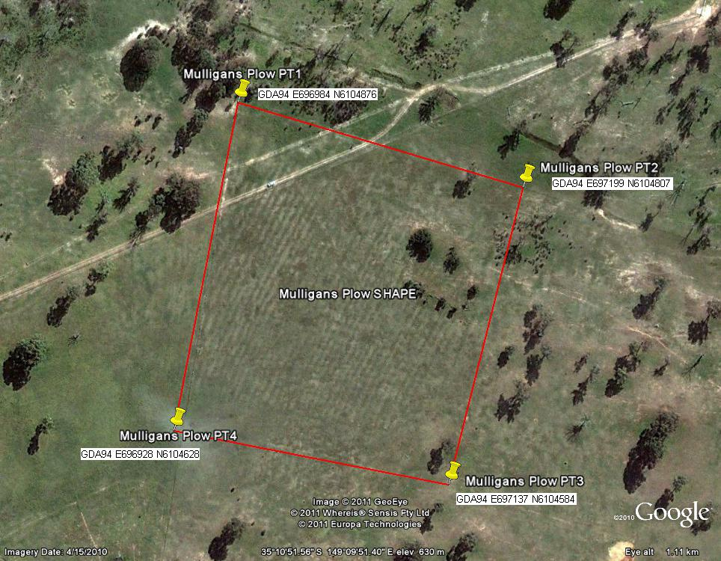
Mulligan’s Flat Ploughlands Site, as indicated by solid red line.
Boundary to the west follows a fence line.

Images taken 23 March 2011
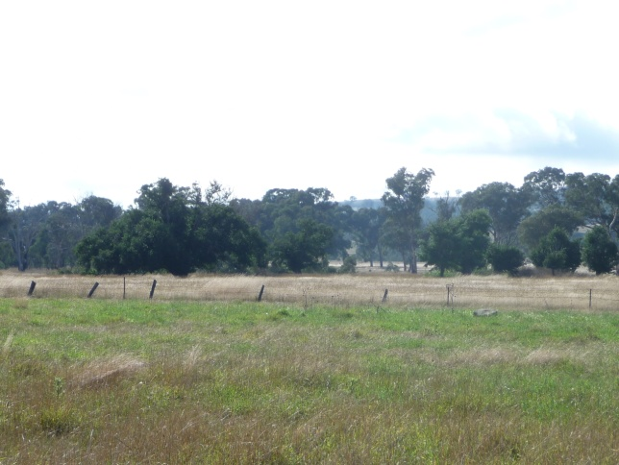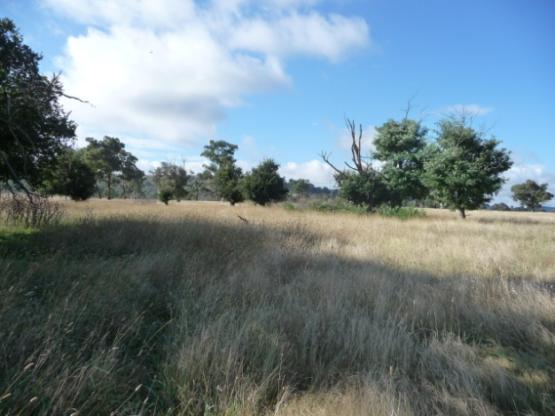
Mulligans Flat Ploughlands site – Mulligan’s Flat Ploughlands
shown as long, dry grassy paddock, with exotic plantings

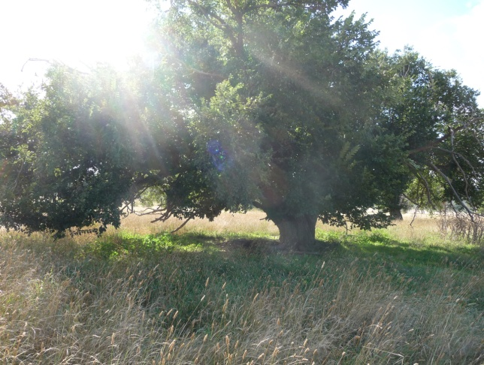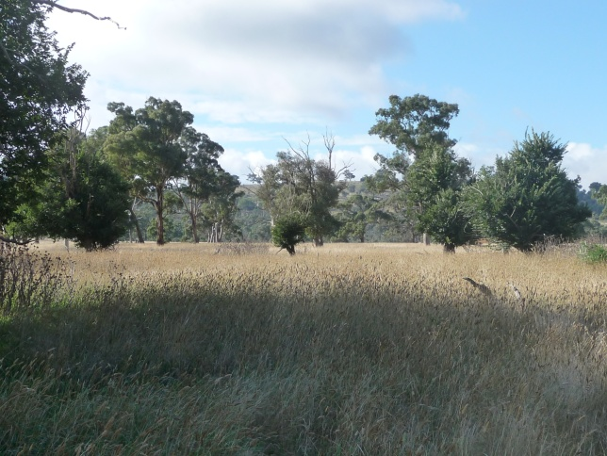
Mulligan’s Flat Ploughlands, exotic plantings Mulligan’s Flat Ploughlands

