Australian Capital Territory
Heritage (Decision about Provisional Registration of Canberra Park, Gungahlin) Notice 2011
Notifiable Instrument NI2011−632
made under the
Heritage Act 2004 s34 Notice of decision about Provisional Registration

- Name of instrument
This instrument is the Heritage (Decision about Provisional Registration of Canberra Park, Gungahlin) Notice 2011 -

- Commencement
This instrument commences on the day after notification.

- Notice of Decision
Pursuant to Section 32 of the Heritage Act 2004 the ACT Heritage Council has decided not to provisionally register Canberra Park, Gungahlin to the ACT Heritage Register.

…………………………….

Mr Gerhard Zatschler

Secretary

ACT Heritage Council

GPO Box 158

Canberra ACT 2601

20 October 2011

STATEMENT OF REASONS

DECISION NOT TO PROVISIONALLY REGISTER CANBERRA PARK
(Blocks (Part) 699, 459, 460, (part) 370, 666, and (Part) 462,
District of Gungahlin)
IN THE ACT HERITAGE REGISTER

Background
Canberra Park was nominated to the ACT Heritage Register some time ago. It has been held on a series of short term leases for many years, with documented evidence in the ACT Heritage files for the need for ongoing repairs and maintenance, given a deteriorating condition of the buildings.

At Council meeting #39 on 20 October 2011, the ACT Heritage Council endorsed a Statement of Reasons which does not find Canberra Park eligible for provisional registration.

Assessment
The Council’s assessment against the criteria specified in s.10 of the Heritage Act 2004 is as follows.

In assessing the nomination for the Canberra Park Homestead, the Council considered:

- documented history in the references listed below;
- a site visit conducted BY Heritage Unit staff in April 2011.

Criterion (a) it demonstrates a high degree of technical or creative achievement (or both), by showing qualities of innovation, discovery, invention or an exceptionally fine level of application of existing techniques or approaches
Heritage Council assessment:
Canberra Park does not meet this criterion.

Criterion (b) it exhibits outstanding design or aesthetic qualities valued by the community or a cultural group
Heritage Council assessment:
Canberra Park does not meet this criterion.

Criterion (c) it is important as evidence of a distinctive way of life, taste, tradition, religion, land use, custom, process, design or function that is no longer practiced, is in danger of being lost or is of exceptional interest
Heritage Council assessment:
The range of construction methods utilised at Canberra Park in 1874 and again in 1899, together with the predominance of local materials sourced from the property, demonstrates a nineteenth century custom of vernacular building techniques to create simple structures which are appropriate for their purpose.

The 1874 homestead and associated structures were constructed of vertical slab and stone. The later, 1899, homestead and associated structures were constructed of handmade bricks and pise, as well as slab construction. These construction techniques were typical of these eras within the Canberra region, though are no longer common today.

However, the condition and integrity of the homestead and outbuildings are such that the place no longer readily portrays these construction methods or the way of life for the early settlers in the area in the nineteenth century. Other places within the ACT have a greater ability to demonstrate these construction types and materials, including at Booroomba Station, Belconnen Farm, the Gungaderra Homestead, and Tralee.

Canberra Park is also evidence of a nineteenth century pastoral property, and demonstrates the changes of pastoral use from the time of settlement in 1874 to the present. There are other nineteenth century pastoral properties in the ACT which are nominated and/or entered in the ACT Heritage Register, including Well Station, Gungaderra, Horse Park and Gungahlin, which provide clearer (and therefore more important) evidence of this way of life, and changes over time. Given the modified state of Canberra Park, it is not considered ‘important as evidence’ of this way of life.

The place is no longer evocative of its early origins and does not meet this criterion.

Criterion (d) it is highly valued by the community or a cultural group for reasons of strong or special religious, spiritual, cultural, educational or social associations
Heritage Council assessment:
No information has been provided to suggest that Canberra Park is highly valued by the community or a cultural group.

Criterion (e) it is significant to the ACT because of its importance as part of local Aboriginal tradition
Heritage Council assessment:
Canberra Park does not meet this criterion.

Criterion (f) it is a rare or unique example of its kind, or is rare or unique in its comparative intactness
Heritage Council assessment:
Canberra Park does not meet this criterion.

Criterion (g) it is a notable example of a kind of place or object and demonstrates the main characteristics of that kind.
Heritage Council assessment:
Canberra Park does not meet this criterion.

Criterion (h) it has strong or special associations with a person, group, event, development or cultural phase in local or national history
Heritage Council assessment:
Canberra Park has an association with pioneer William Ginn and his family. William Ginn demonstrated great workmanship for Robert Campbell and was rewarded for his efforts through the construction of Blundells’ Cottage, and as the first occupant of this now famous place. However, Ginn’s association with Canberra Park is not considered strong or special. The place does not demonstrate the key aspects of Ginn’s prominence, as the first occupant of Blundells’ cottage.

Canberra Park also has an association with the cultural phase of nineteenth century settlement and development of the Canberra region. However, the level of integrity of Canberra Park is such that this association cannot be considered strong or special, given its altered state.

Canberra Park does not meet this criterion.

Criterion (i) it is significant for understanding the evolution of natural landscapes, including significant geological features, landforms, biota or natural processes
Heritage Council assessment:
Canberra Park does not meet this criterion.

Criterion (j) it has provided, or is likely to provide, information that will contribute significantly to a wider understanding of the natural or cultural history of the ACT because of its use or potential use as a research site or object, teaching site or object, type locality or benchmark site
Heritage Council assessment:
Canberra Park does not meet this criterion.

Criterion (k) for a place—it exhibits unusual richness, diversity or significant transitions of flora, fauna or natural landscapes and their elements
Heritage Council assessment:
Canberra Park does not meet this criterion.

Criterion (l) for a place—it is a significant ecological community, habitat or locality for any of the following:
(i) the life cycle of native species;
(ii) rare, threatened or uncommon species;
(iii) species at the limits of their natural range;
(iv) distinct occurrences of species
Heritage Council assessment:
Canberra Park does not meet this criterion.

History

ABORIGINAL HISTORY
Aboriginal people lived in the Ginninderra area for thousands of years before European settlers arrived. Many sacred Aboriginal sites remain in the district, including the nearby Red Hill Ochre Quarry, located to the north-east of Canberra Park. It is likely that Aboriginal people would have occupied the landscape within what is today Canberra Park.

Canberra Park has a close linkage to major drainage lines in the area, it is located in close proximity to an important Aboriginal resource (ochre), its large area and vegetated flats are ideal for hunting, and its many woodlands would also have been an important resource for Aboriginal people (McGrath, n.d: 32).

To the north of the Canberra Park property are two Aboriginal artefact scatters.

An Aboriginal survey has not been carried out. There is a potential that Aboriginal sites may be present within the boundary of this place.

CONTEXTUAL HISTORY
The Gungahlin area was first sighted by a European in 1820—by explorer Charles Throsby. The first European settlement of the district was circa 1826 by George Thomas Palmer at the area later known as ‘Ginninderra’. The Gungahlin area was soon opened up by other squatters and pastoralists who took up extensive areas of land.

‘Until 1861 the majority of landholders took up large blocks, or amalgamated smaller holdings into larger agglomerations’ (Pearson, 2002: 13). From 1861 with the introduction of the Robertson Land Act, selectors began to occupy smaller holdings, primarily the less desirable and less well-watered lands in the northern and western part of Gungahlin (Pearson 2002:13). These selections resulted in a denser and more varied population than the previous large pastoralist holdings.

The Robertson Land Act required selectors to reside on their land, resulting in an increase in the area’s population (Pearson, 2002: 14).

CANBERRA PARK
Canberra Park was the home of William Ginn and, later, his son Henry Thomas Ginn. The Ginns emigrated to Australia in 1857. Shortly after, the family travelled to Canberra and settled at Woolshed Creek, Duntroon in 1858 where William worked for Robert Campbell (McGrath, n.d.: 10).

William’s strong work ethics and efficiency were well regarded by Campbell. Campbell was quoted in Samuel Shumack’s autobiography Tales and Legends of Canberra Pioneers as stating: ‘I have the best farm hand now I ever had – William Ginn’ (McGrath, n.d: 10). However, comments such as this, when times were tough and competition among workers was great, could be considered a threat to other workers. Months after Campbell had made these comments, the Ginns were forced off the Duntroon property by vengeful actions from other employees. In his autobiography, Samuel Shumack (1938) states:

Several farm hands heard this compliment on Ginn’s efficiency and were offended… One of these was Alfred Mayo… Mayo handed Billy a frying pan handle and said, ‘Go down and knock on Ginn’s door and when he opens it knock him down with this, and I’ll give you a bottle of rum… Ginn opened the door and Billy then struck him with a blow across the mouth knocking out four teeth and splintering his jaw… Ginn staggered back dazed…(Billy) knocked him down, dragged him to the woodheap and had the axe in hand when Mrs Ginn intervened and prevented an awful tragedy (McGrath, n.d: 10).

Following this incident, Ginn approached Campbell to request alternative accommodation. Campbell agreed to lease him 90 acres of land for an annual fee of £1 per acre. A cottage was constructed for the Ginn family on this land, which later became known as ‘Blundells’ Cottage’.

As a result, in 1859 William Ginn and his family were the first to occupy Blundells’ Cottage on the Duntroon Estate and remained there until 1874 when William selected 2 lots of 40 acres of land for himself (McGrath, n.d.: 10).

Blundells’ Cottage went on to house other Duntroon farm workers and their families. It is named after a newly-wed couple, George and Fiona Blundell, who moved in to the cottage in 1874 after the Ginn’s vacated, and lived there for over 60 years.

It was in 1874 that the Ginns named their newly acquired property ‘Canberra Park’ and constructed a stone homestead there with stone and vertical slab outbuildings. (Surface remains of the stone homestead are extant).

The naming of this property as ‘Canberra Park’ predated the official naming of the capital as ‘Canberra’ by more than 40 years. The name ‘Canberra’ is an Aboriginal name for ‘meeting place’.

It is possible that Ginn named his property this either because Aboriginal people were in the area on his arrival, or due to his well known friendly relations with Aboriginal people, including his employment of them (McGrath, n.d: 32).

In 1899, William’s two sons, Walter and Henry, built a new homestead at Canberra Park of hand-made bricks, which remains standing and occupied today, as well as an associated pisé structure.

In that same year, Henry married Elizabeth Winter, daughter of John and Jemima Winter of the nearby Red Hill (Gungaderra) property. Together Henry and Elizabeth settled at the new Canberra Park Homestead, where Henry engaged in farming and agricultural pursuits.

William Ginn passed away at the Canberra Park property in 1904 (McGrath, n.d: 11).

In 1915 the property was acquired by the Commonwealth and the Ginn family continued to lease it, continuing their farming and grazing pursuits.

After Henry Ginn’s death in 1939, Henry and Elizabeth’s son, Jim, took over management of the Canberra Park property until 1960. It was in that year (1960) that Elizabeth died and Jim ceased management of the property, moving away from Canberra Park.

From this time (1960), Canberra Park was leased by the Gungaderra Pastoral Company, which also leased the nearby Well Station and Gungaderra Homesteads (McGrath, n.d: 13). The company employed Bernard McGrath as the farm manager for Canberra Park. The McGrath family remained there until 1977 (Mcgrath, n.d: 13).

The ACT Government acquired the lease on the Canberra Park homestead in 1977 for the future development of Gungahlin. The property has since become home to a number of short-term tenants.

GINN NOMENCLATURE
The memory of the Ginn family as early and successful pioneers in the region lives on through nomenclature in the Canberra region today. Just opposite Canberra Park is Mt Ginn, Canberra’s first motor racing track. This is fitting, given that Jim Ginn’s brother, Bill Ginn, who also once lived at Canberra Park, was the first person to register a car in the ACT—a 1948 FX Holden with the number 1 on its registration plates (McGrath, n.d: 11).

Ginn’s Gap is known as the saddle where the Federal Highway crosses Mt Majura, also named after this family.

Description

Original 1874 homestead
The original homestead precinct consists of the surface remains of the original stone homestead, and two smaller ruinous structures. The site also contains many historical exotic plantings including rose, bay, fig, plum and a kurrajong tree.

The original stone cottage constructed by William Ginn was located approximately 300m from the present homestead. Surface remains are evident, measuring around 14m x 7m. The structure contains a large stone oven. The exterior has been repaired with 1920s Canberra bricks.

A single roomed stone structure with two windows and a doorway is located nearby. This was possibly a kitchen.

A second structure of the original homestead is located adjacent, and is likely to have been constructed of vertical timber slabs (Boot, 1990). Foundation stones remain.

1899 Canberra Park Homestead
The Canberra Park homestead constructed in 1899 is a single storey building constructed of handmade bricks. The clay for the bricks is thought to be local (McGrath, n.d.: 18). The gabled roof is clad in corrugated iron sheeting, though was originally shingled timber. The main foundations of the homestead are Eucalyptus mellidora posts, most likely obtained locally, from trees on the property.

The 1899 Canberra Park homestead consisted of two verandahs, a kitchen, two rooms and an adjacent pisé hut. Alterations and additions by successive tenants over time have altered this original floorplan considerably.

During his later years at Canberra Park in the early twentieth century, Henry Ginn made many alterations. He built an adjoining structure with new bricks between the brick homestead and pisé structure, and enclosed the verandahs.

Successive tenants have made additional changes, including an extension to the western end of the property.

Rubbish tip
A former rubbish tip exists about 100m west of the 1899 homestead. It includes glass fragments and metal debris. Its origins are unknown, but it is possible that it was used as a rubbish tip at the time of construction of the 1899 homestead. The rubbish tip contains a collection of cultural material possibly related to the occupation of the homestead.

Woolshed
A woolshed is located within the homestead precinct, supported by Eucalypt posts and sheeted with corrugated iron. Associated water tanks are dated 1937, suggesting that the woolshed predates this time.

Evidence indicates that the woolshed’s use during the mid nineteenth century. Many quotes and tallies are written in lead pencil on the woolshed’s interior walls, illustrating busy shearing periods, as follows:

7th November 1939, 275 lambs, George 305 total
260 bags of oats in here 29th Oct 1943
17 aged ewes + 17x lambs ‘Cow Pad’ 25th Jan 1949
63 young ewes ‘horse pad’ 25 Jan 1949
25th Jan 1949 157 full mouth ewes
25th Jan 1949 77 aged ewes at creek
975 total crutched June 1949
G. Smith 479, J Rowley 496
Oil pots filled on 6th May 1953 by Lorna
Out of oil paste

Outbuildings
A number of small outbuildings, dating from the nineteenth and twentieth centuries are also located at Canberra Park. These include:
- garage
- two storage sheds constructed from wooden members
- hayshed constructed from wooden members
- chook pen (once a maintenance shed)
- milking shed
- dairy room

Plantings
A number of mature plantings remain at Canberra Park, including rose, bay, fig and plum trees, and one kurrajong tree.

The homestead is set behind stands of English Elms and Eucalypts.

Well and Travelling Stock Route
A well is also situated on the property. This was hand dug and edged with timber on all four sides. The well would have serviced stockmen in the mid 1950s. The remains of an old stock route runs to the north of Canberra Park where cattle and sheep were once herded through the Majura region (McGrath, n.d: 29).

COMPARATIVE ANALYSIS

There are many rural homesteads in the ACT region which demonstrate the rural and pastoral settlement of the region in the nineteenth and early twentieth centuries. Pastoral homesteads nominated to or entered in the ACT Heritage Register in the Gungahlin area include Elm Grove, Well Station, Horse Park, Gungaderra, and Gungahlin. Of these

Canberra Park provides an example of the smaller settler homestead in the ACT region. Horse Park, Well Station and Gungaderra Homesteads are considered to be a medium sized while Gungahlin is a large homestead.

Despite the size of the homesteads, they all demonstrate similar attributes in terms of outbuildings and pastoral landscapes and activity. There is little to be learned from or demonstrated at Canberra Park as a small homestead which would differentiate it from the medium sized homesteads, especially given its altered state.

Images taken 13 April 2011

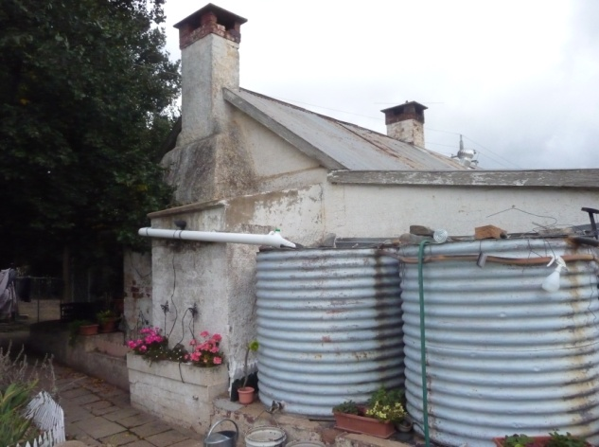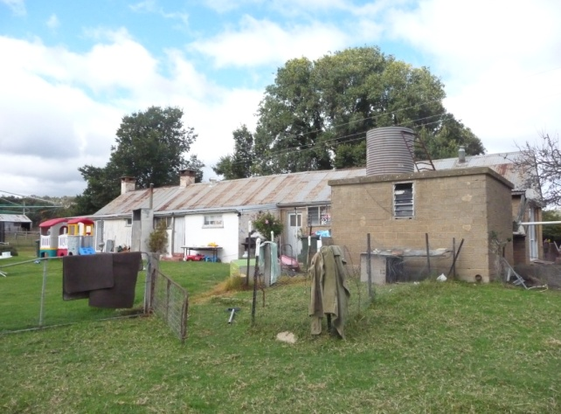
1899 homestead

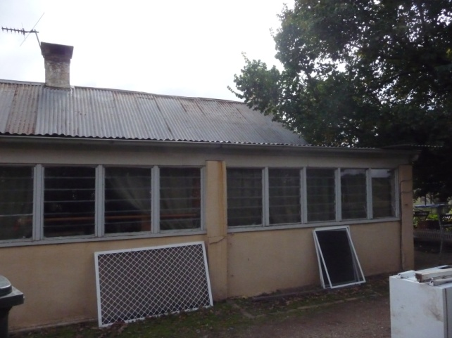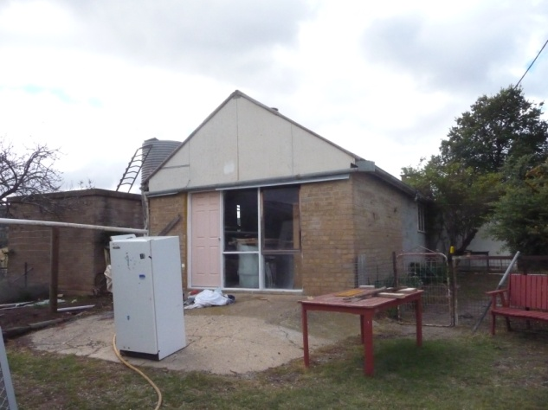
1899 homestead

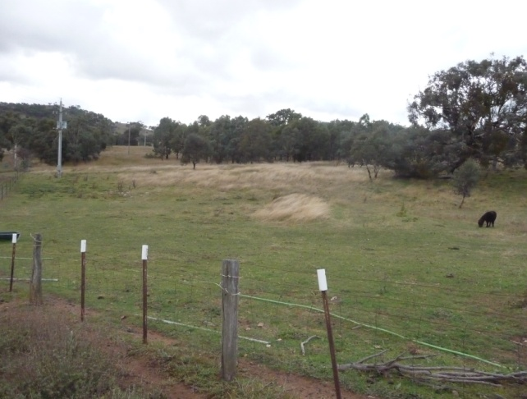
towards site of 1874 homestead and the travelling stock route reserve

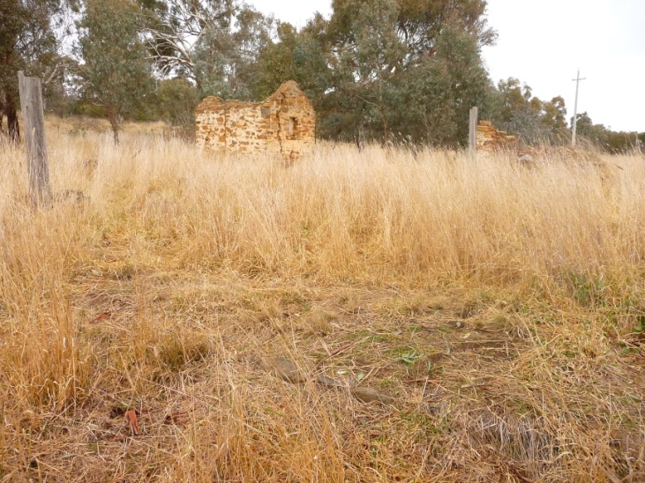
1874 homestead – extent indicated by foundations in foreground, timber beam to LHS and stone ruin to right. A stone outbuilding sits behind the homestead.

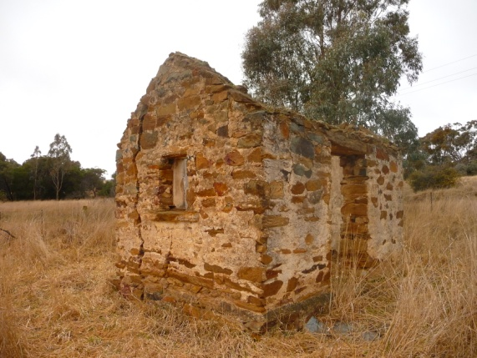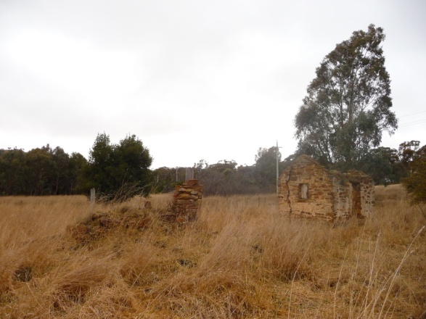
1874 stone outbuilding 1874 homestead ruin and stone outbuilding

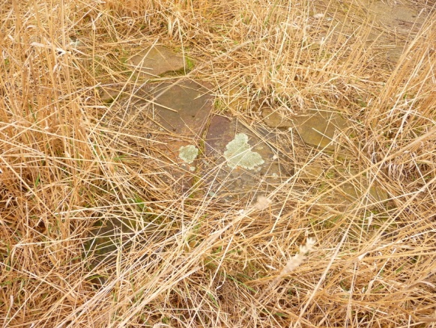
Foundation stones for what appears to be a second outbuilding near 1874 homestead

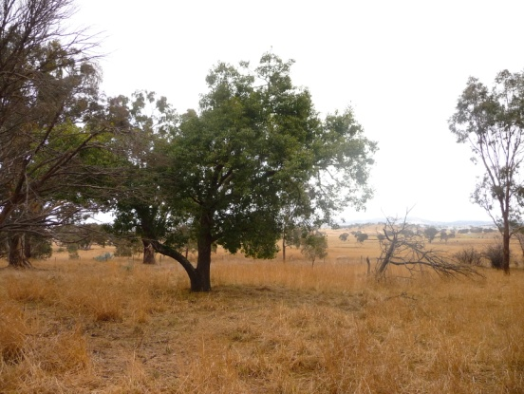
Kurrajong tree near 1874 homestead

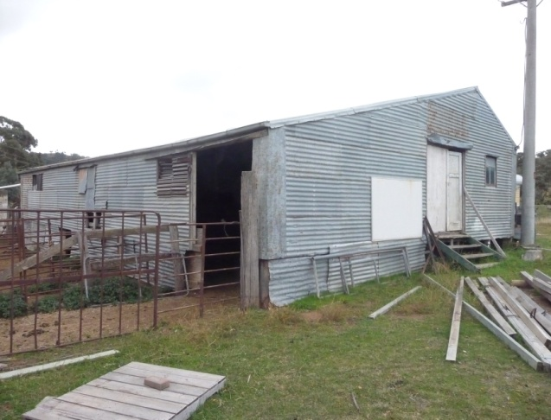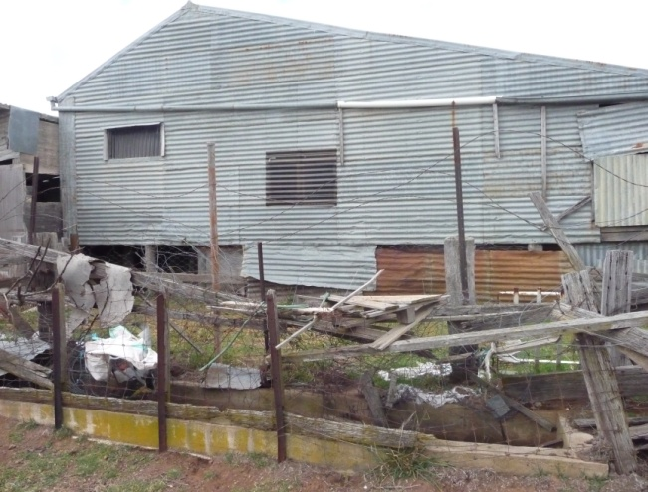
woolshed
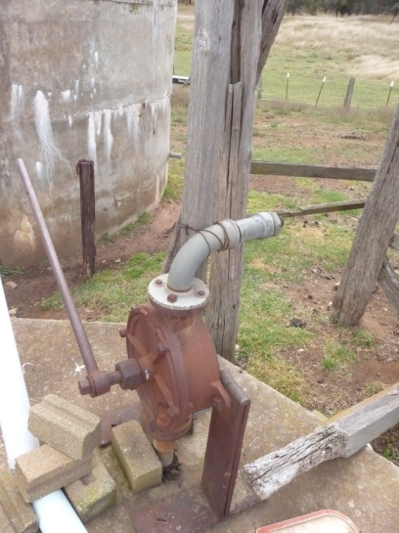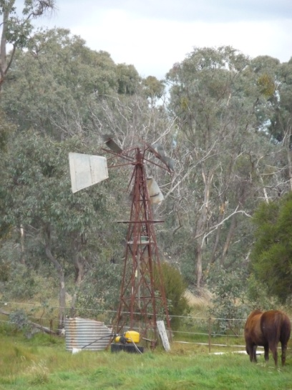
Hand pump windmill

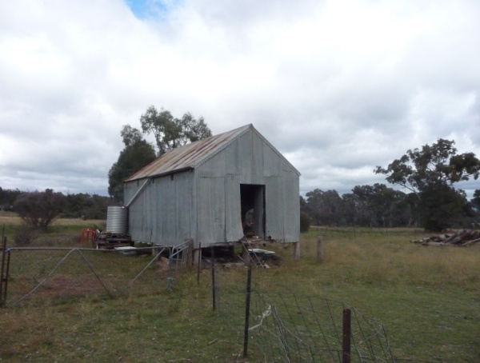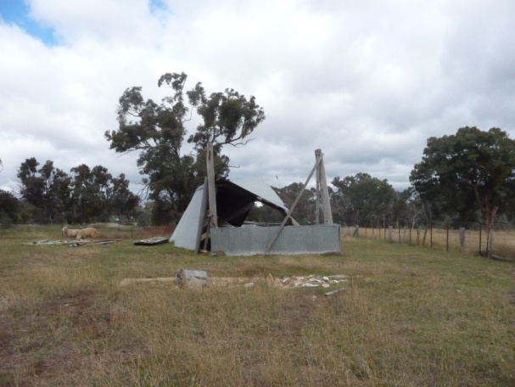
Machinery shed hayshed

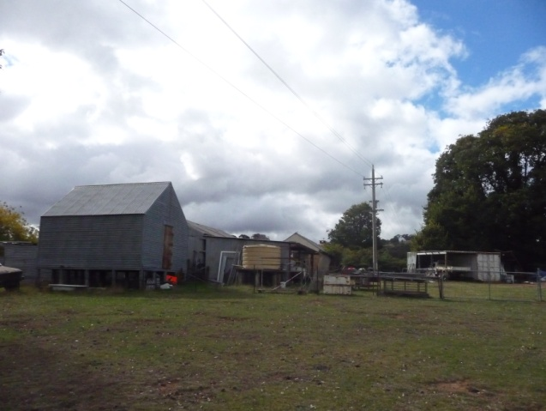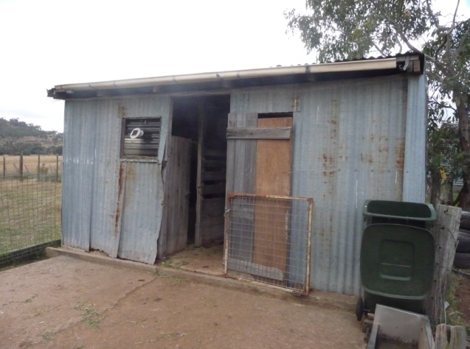
Homestead and outbuilding complex Milking shed
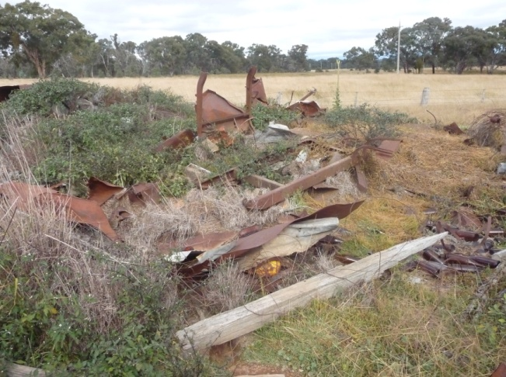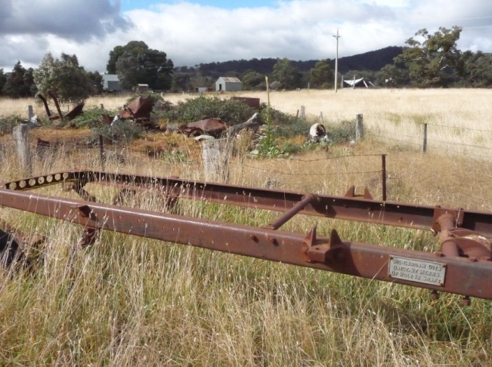
Rubbish tip

References

Boot, P. 1990, ‘Gungahlin, Freshford and Jerrabomberra Sites’, Field Work Report No.3, Canberra Archaeological Society Inc.

Cosgrove, C. & Dowling, P. 2002. ‘Pisé places, a report to the ACT Heritage Council on behalf of the National Trust of Australia (ACT)’.

Eric Martin and Associates, 2005, ‘Gungaderra Homestead – Conservation Management Plan’, report prepared for the Land Development Agency.

McGrath, T., n.d., ‘Canberra Park: Canberra’s Historical Gateway’, student report submitted for Cultural Heritage Management, University of Canberra.

Shumack, S., 1977, An Autobiography, or Tales and Legends of Canberra Pioneers, Australian University Press, ACT.

Conclusion

Canberra Park has an interesting history stretching back to its nineteenth century origins, and associated with prominent pioneer, William Ginn, who made a name for himself working for the Campbells at the Duntroon Estate.

However, the place – the main homestead in particular – has been so altered by extensions and modifications that it no longer demonstrates aspects of its early origins and has lost much of its nineteenth century character.

This Statement of Reasons provides an assessment of Canberra Park and finds that the place does not meet any of the criteria of the Heritage Act 2004.

Gerhard Zatschler (Secretary)
ACT Heritage Council

20 October 2011

