Australian Capital Territory
Heritage (Decision about Provisional Registration for the Starlight Drive-In Theatre Sign, Watson) Notice 2011
Notifiable Instrument NI 2011 -637
made under the
Heritage Act 2004 section 34 Notice of Decision about Provisional Registration

- Name of instrument
This instrument is the Heritage (Decision about Provisional Registration for the Starlight Drive-In Theatre Sign, Watson) Notice 2011 -
- Registration details of the place
Registration details of the place are at Attachment A: Provisional Register entry for the Starlight Drive-In Theatre Sign, Watson.
- Reason for decision
The ACT Heritage Council has decided that the Starlight Drive-In Theatre Sign, Watson meets one or more of the heritage significance criteria at s 10 of the Heritage Act 2004. The provisional register entry is at Attachment A.
- Date of Provisional Registration
20 October 2011
- Indication of council's intention
The Council intends to decide whether to register the entry under Division 6.2.
- Public consultation period

The Council invites public comment by Wednesday 23 November 2011 on the provisional registration of the Starlight Drive-In Theatre Sign, Watson to:

The Secretary

ACT Heritage Council

GPO Box 158

CANBERRA ACT 2601

Gerhard Zatschler
Secretary
ACT Heritage Council

20 October 2011

AUSTRALIAN CAPITAL TERRITORY

HERITAGE REGISTER
(Provisional Registration Details)

Place No:

For the purposes of s. 33 of the Heritage Act 2004, an entry to the heritage register has been prepared by the ACT Heritage Council for the following place:

Starlight Drive-In Theatre Sign, 20 Federal Highway, Watson, ACT

(Part) Block 14, Section 61, and (part) Block 2 Section 76, Watson, Canberra Central and adjacent road verge

DATE OF PROVISIONAL REGISTRATION

Notified: 20 October 2011 Notifiable Instrument: 2011-637

PERIOD OF EFFECT OF PROVISIONAL REGISTRATION

Start Date 20 October 2011 End Date 20 March 2012

Extended Period (if applicable) Start Date ________ End Date ________

Copies of the Register Entry are available for inspection at the ACT Heritage Unit. For further information please contact:

The Secretary
ACT Heritage Council
GPO Box 158, Canberra, ACT 2601

Telephone: 13 22 81 Facsimile: (02) 6207 2229

IDENTIFICATION OF THE PLACE

Starlight Drive-In Theatre Sign, 20 Federal Highway, Watson, ACT

(Part) Block 14, Section 61, and (part) Block 2 Section 76, Watson, Canberra Central and adjacent road verge

STATEMENT OF HERITAGE SIGNIFICANCE

This statement refers to the Heritage Significance of the place as required in s12(d) of the Heritage Act 2004.

The Starlight Drive-in Theatre Sign remains as the only tangible reminder in the ACT of the iconic era of drive-ins (outdoor theatres where patrons viewed films from parked cars) which dotted the Australian landscape from the mid twentieth century. Drive-in theatres were immensely popular as a form of entertainment of which the sign remains as an iconic symbol. They had their peak popularity from the 1950s until the 1970s, and have formed a strong component in the psyche and consciousness of the community who attended them. They are also an iconic symbol of this era for all.

The Starlight Drive-In Theatre Sign at Watson is thought to be the only original drive-in theatre sign in Australia which still stands in its original location.

The sign is important as evidence of a distinctive custom of the drive-in theatre era which is no longer practised in the ACT. As the only reminder of the drive-in era in the ACT, it also has a strong association with this cultural phase.

FEATURES INTRINSIC TO THE HERITAGE SIGNIFICANCE OF THE PLACE

The attributes listed below are assessed as features intrinsic to the heritage significance of the place and warrant conservation:
- Starlight Drive-In Theatre Sign including:
  - Double-sided ‘Starlight entrance’ signage panel including text font and size
  - Shape and form of steel frame
  - Two single-sided advertising spaces.
- Visibility of the sign from the highway; and
- Capacity for the sign to be illuminated.

APPLICABLE HERITAGE GUIDELINES

The ‘Heritage Guidelines: General Conservation Guidelines for Historic Heritage Places 2011’ adopted under s25 of the Heritage Act 2004 are applicable to the conservation of the Starlight Drive-In Theatre Sign, Watson.

The guiding conservation objective is that the Starlight Drive-In Theatre Sign, Watson, shall be conserved and appropriately managed in a manner respecting its heritage significance and the features intrinsic to that heritage significance, and consistent with a sympathetic and viable use or uses. Any works that have a potential impact on significant fabric (and / or other heritage values) shall be guided by a professionally documented assessment and conservation policy relevant to that area or component (i.e. a Statement of Heritage Effects – SHE).

REASON FOR PROVISIONAL REGISTRATION

The Starlight Drive-In Theatre Sign, Watson has been assessed against the heritage significance criteria and been found to have heritage significance when assessed against two criteria under the ACT Heritage Act 2004:

- it is important as evidence of a distinctive way of life, taste, tradition, religion, land use, custom, process, design or function that is no longer practised, is in danger of being lost or is of exceptional interest; and
- it has strong or special associations with a person, group, event, development or cultural phase in local or national history.

ASSESSMENT AGAINST THE HERITAGE SIGNIFICANCE CRITERIA

Pursuant to s.10 of the Heritage Act 2004, a place or object has heritage significance if it satisfies one or more of the following criteria. Significance has been determined by research as accessed in the references below. Future research may alter the findings of this assessment.

- it demonstrates a high degree of technical or creative achievement (or both), by showing qualities of innovation, discovery, invention or an exceptionally fine level of application of existing techniques or approaches;

The Starlight Drive-In Theatre Sign does not meet this criterion.

- it exhibits outstanding design or aesthetic qualities valued by the community or a cultural group;

The Starlight Drive-In Theatre Sign does not meet this criterion.

- it is important as evidence of a distinctive way of life, taste, tradition, religion, land use, custom, process, design or function that is no longer practised, is in danger of being lost or is of exceptional interest;

The Starlight Drive-In Theatre Sign is important as evidence of a distinctive function that is no longer practised. It serves as a tangible reminder of the drive-in era from the mid-twentieth century and is the only such reminder in the ACT. Drive-in theatres were immensely popular as a form of entertainment of which the sign remains as an iconic symbol.

Further, the sign is important as evidence of this function as the only original drive-in theatre sign in Australia which is still standing in its original location.

The Starlight Drive-in Theatre Sign meets this criterion.

- it is highly valued by the community or a cultural group for reasons of strong or special religious, spiritual, cultural, educational or social associations;

While it is acknowledged that many people have fond memories of the Starlight Theatre, there is insufficient evidence to suggest that the Starlight Theatre Sign is highly valued by the community or a cultural group, sufficient to meet the threshold level for this criterion.

The Starlight Drive-In theatre Sign does not meet this criterion based on current evidence.

- it is significant to the ACT because of its importance as part of local Aboriginal tradition

The Starlight Drive-In Theatre Sign does not meet this criterion.

- it is a rare or unique example of its kind, or is rare or unique in its comparative intactness

The Starlight Drive-In Theatre Sign does not meet this criterion.

- it is a notable example of a kind of place or object and demonstrates the main characteristics of that kind

The Starlight Drive-In Theatre Sign does not meet this criterion.

- it has strong or special associations with a person, group, event, development or cultural phase in local or national history

The Starlight Drive-in Theatre Sign has a strong association with the cultural phase of the era of drive-in theatres in the mid twentieth century. This was a distinctive era, of which the sign remains as an iconic reminder. The sign has a special association with this cultural phase as the only physical remnant of the drive-in phenomenon in the ACT.

The Starlight Drive-in Theatre Sign meets this criterion.

- it is significant for understanding the evolution of natural landscapes, including significant geological features, landforms, biota or natural processes

The Starlight Drive-In Theatre Sign does not meet this criterion.

- it has provided, or is likely to provide, information that will contribute significantly to a wider understanding of the natural or cultural history of the ACT because of its use or potential use as a research site or object, teaching site or object, type locality or benchmark site

The Starlight Drive-In Theatre Sign does not meet this criterion.

- for a place—it exhibits unusual richness, diversity or significant transitions of flora, fauna or natural landscapes and their elements

The Starlight Drive-In Theatre Sign does not meet this criterion.

- for a place—it is a significant ecological community, habitat or locality for any of the following:
(i) the life cycle of native species;
(ii) rare, threatened or uncommon species;
(iii) species at the limits of their natural range;
(iv) distinct occurrences of species.

The Starlight Drive-In Theatre Sign does not meet this criterion.

SUMMARY OF THE PLACE
HISTORY AND PHYSICAL DESCRIPTION

HISTORY
The world’s first drive-in theatre opened in 1933 in New Jersey, America. In America ‘the drive-in's peak popularity came in the late 1950s and early 1960s, particularly in rural areas, with some 4,000 drive-ins spreading across the United States. Among its advantages was the fact that a family with a baby could take care of their child while watching a movie, while teenagers with access to cars found drive-ins ideal for dates’ (Wikipedia).

Drive-In Theatres provided an outdoor screen which customers could watch from the privacy and comfort of their own cars. Sound was provided initially through speakers on the screen, and later individual speakers for each car. The system was later superseded by broadcasting through a car’s radio system.

Drive-In theatres experienced a surge in popularity during the 1950s and 1960s, particularly among young families and teenagers of driving age. The main drive-in theatre markets were in America, Canada and Australia, peaking from the 1950s till the 1970s.

Australia’s first drive-in theatre opened in 1954 in Melbourne.

The Starlight Drive-in Theatre was opened in Canberra in 1957 by George Kimlin, as the ACTs first drive-in theatre. It was also one of the first drive-ins in Australia (The Canberra Times, 29 November 1982: 10). Its construction was completed in December 1956 and on Wednesday 2 January 1957 the theatre was opened by Sir Allen Fairhall, KBE, Minister for Interior and Works.

Ahead of its opening, on 2 January 1957, the Canberra Times reported that:

‘the giant screen, 70 ft high and 100 ft wide is a combination of style and strength. Built of tubular steel it can withstand a 70 m.p.h gale... The builders are certain that the huge screen will give the viewers a clear and well defined picture. The electrical system of the theatre is a complex maze... Five miles of wiring went into the connecting of the intricate electrical system... A playground for the children is one of the happiest features of the theatre, to add new fun to their picture night... The management also had the palettes of their audience in mind. Ultra modern equipment has been installed in the kitchen and the experts should be able to cater for even fastidious tastes at the cafeteria. The ticket office is designed so that cars can approach from either side’.

The screen was claimed to be one of the largest in Australia at the time. In-car speakers for every car ensured that those parked at the back could hear just as well as those at the front.

The Starlight Drive-in operated from 1956 till 1993. During these 37 years, the Drive-In saw over six million visitors. ‘Even with two movie sessions per night, six nights per week, the Starlight Drive-in was so popular that cars were regularly being turned away by ‘house full’ signs’ (Motion-Wise, 2011: 4). At its opening, the drive-in had capacity to hold 500 cars.

Drive-In cinemas across Australia, established during the 1950s and 1960s ‘had their following and a distinctive culture’ (The Canberra Times, Thursday April 9 1987, p.9). At one time, Australia had over 330 drive-ins.

In 1982 Starlight Drive-In owner, George Kimlin of Canberra Enterprises Pty Ltd, stated that ‘while the video-film industry and cable television might threaten the theatre industry, patrons could still see two top-listing feature films for $4.75’ (The Canberra Times, 17 October 1982). With this in mind, Canberra Enterprises sought a $200,000 expansion program, including a second screen at the Starlight site.

Kimlin said that ‘although opposition technological challenges would continue to come to the film-making industry, (communities) would still want drive-ins. The convenience and comfort of viewing a top program at a twin, or even a triple, drive-in at a cost less than that of many other forms of entertainment would continue to attract large audiences. However, the drive-ins of the future might well be quite different from present ones’ (The Canberra Times, 29 November 1982:11).

Despite his optimistic prognosis, in 1987 the Starlight Drive-In was sold by Canberra Enterprises to IM and M Investments and was closed six years later in 1993. Residential apartments were built on the site, ready for occupation by 2003.

The 1987 sale came about due to the lack of economic viability of the Drive-In after the advent of video and a variety of other entertainment media. George Kimlin’s son, Chris has stated ‘the demise of the Drive-in stemmed from a national convention where film sellers would preference cinemas for first release, meaning the drive-ins only got movies on second release, sometimes months after the films had been shown in cinemas’ (City News, Oct 7-13 2010).

Canberra’s other Drive-In Theatre, the Sundown at Narrabundah, opened in 1969 and closed two years prior to the Starlight, in 1991 due to a lack of business.

Despite the large-scale construction work undertaken on the Starlight site during the building of the apartments, the original sign was left in its original location, and is now thought to be the only Drive-In sign in Australia which still stands in its original location.

The sign was built in Sydney in 1956 ahead of the opening of the theatre. It was the first neon sign in Canberra, used to mark the entry to the Drive-In from the Federal Highway.

In 2010 Canberra’s City News published a story about the state of neglect of the sign. ‘City News was flooded with letters from Drive-In movie lovers providing fond memories of family outings visiting Starlight time and again. The best letters were published representing the significance of the Starlight Drive-In sign as the vestige of nearly four decades of cinematic entertainment in Canberra during a time when no other entertainment venues were available’ (Motion-Wise, 2011: 4).

In 2010 four drive-ins remained open in New South Wales, three in Victoria, six in Queensland, five in Western Australia, two in south Australia, and none in either Tasmania or the Northern Territory (Kilderry, 2010).

DESCRIPTION

The Starlight Drive-In Theatre Sign at Watson is supported by an angular steel frame, painted white. The sign consists of three panels, only one of which remains in good condition, the ‘Starlight Entrance’ sign, in bold red with white writing. The sign stands approximately three metres high, and is approximately 1.5 metres wide.

Physical condition and integrity

The Starlight Drive-In Theatre Sign, Watson is, in 2011, in a poor state of repair. It remains structurally sound, though the advertisement signs have disappeared. Electrical connections to illuminate the sign are in need of repair.

REFERENCES

Kilderry, D., 2010, ‘Drive-Ins Downunder’, http://drive-insdownunder.com.au/default.htm, accessed 16 August 2011.

Wikipedia, http://en.wikipedia.org/wiki/Drive-in_theater accessed 16 August 2011.

Motion-Wise, M., 2011, ‘Nomination to the ACT Heritage Register – Starlight Drive-in Theatre Sign’.

The Canberra Times, 2 January 1957, 17 october 1982, 29 november 1982, 9 April 1987

CityNews, 7-13 October 2010

SITE PLAN
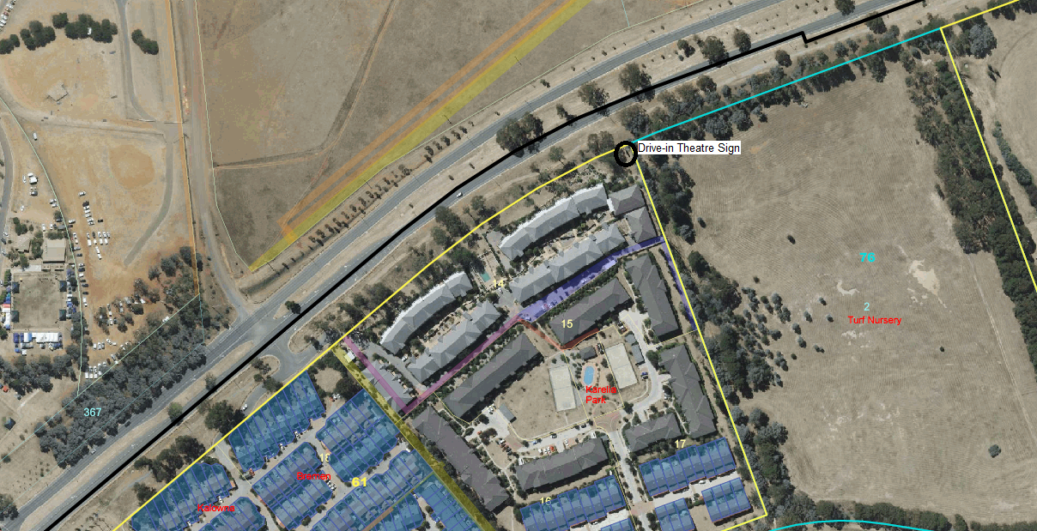
Contextual location

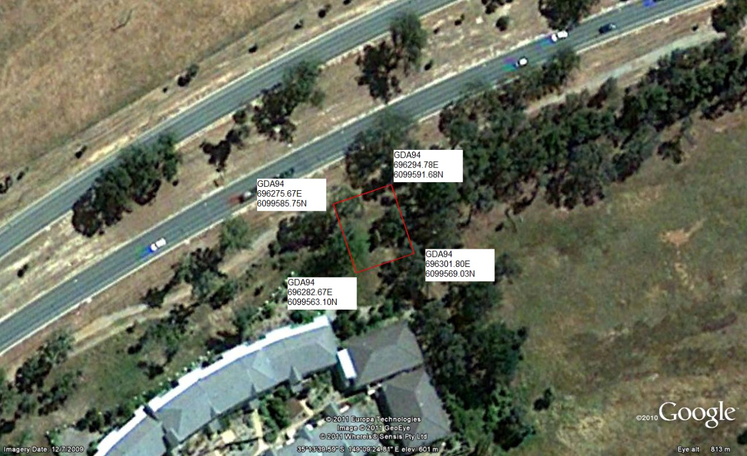
Place boundary identified by solid red line, indicating an area with a 10 metre boundary from the sign.

IMAGES
Images taken 8 April 2011

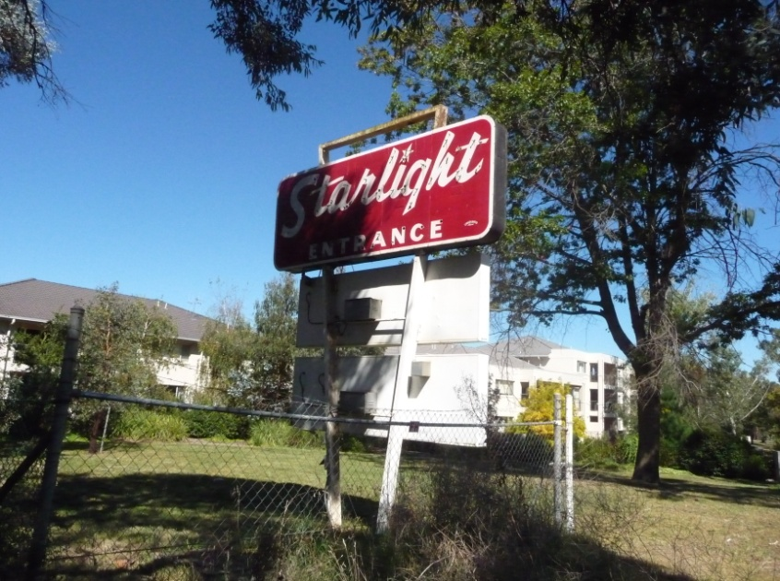

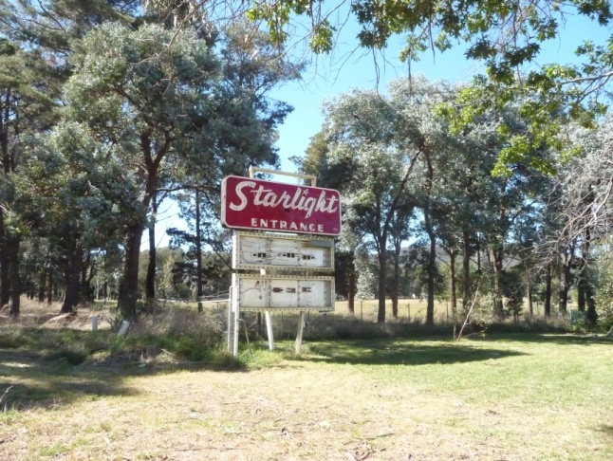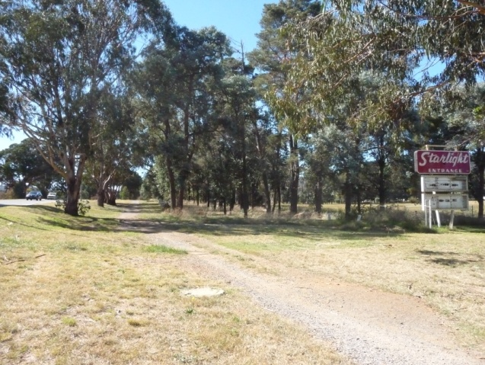

non-statutory background information

‘I was at the Starlight Drive-in the night it opened in 1957. I was just four years old. From then on mum and dad took my two sisters, my brother and me to the drive-in about twice a week for the duration of my childhood. I then started going there on dates as a teenager in the late ‘60s and early ‘70s.
We always had old cars without heaters so Dad used to heat house bricks in the oven and wrap them in a blanket that he would place on the floor in the back of the car. The bricks kept us warm for hours. It wasn’t until many years later that heaters were available on the speaker units.
We used to go Wednesday nights for ‘Ranch night’ and Saturday nights for the new feature. Intermission would see hundreds of pyjama-clad children racing to the playground to get the best position on the hurdy-gurdy.’ Judi Sindel, Kambah, CityNews, Oct28-Nov3 2010.

