Australian Capital Territory
Heritage (Decision about Registration for the former Coggan’s Bakery, Braddon) Notice 2011*
Notifiable Instrument NI 2011 -640
made under the
Heritage Act 2004 section 42 Notice of Decision about Registration

- Revocation
This instrument replaces NI 2011-370
- Name of instrument
This instrument is the Heritage (Decision about Registration for the former Coggan’s Bakery, Braddon) Notice 2011
- Registration details of the place
Registration details of the place are at Attachment A: Register entry for the former Coggan’s Bakery, Braddon.
- Reason for decision
The ACT Heritage Council has decided that the former Coggan’s Bakery, Braddon meets one or more of the heritage significance criteria at s 10 of the Heritage Act 2004. The register entry is at Attachment A.
- Date of Registration
20 October 2011

Gerhard Zatschler
Secretary
ACT Heritage Council
20 October 2011

AUSTRALIAN CAPITAL TERRITORY

HERITAGE REGISTER
(Registration Details)

Place No:

For the purposes of s. 41 of the Heritage Act 2004, an entry to the heritage register has been prepared by the ACT Heritage Council for the following place:

Former Coggan’s Bakery, 36 Mort Street, Braddon

(Part) Block 1, Section 28, Braddon, Canberra Central

DATE OF REGISTRATION

Notified: 20 October 2011 Notifiable Instrument: 2011-640

Copies of the Register Entry are available for inspection at the ACT Heritage Unit. For further information please contact:

The Secretary
ACT Heritage Council
GPO Box 158, Canberra, ACT 2601

Telephone: 13 22 81 Facsimile: (02) 6207 2229

IDENTIFICATION OF THE PLACE

Former Coggan’s Bakery, 36 Mort Street, Braddon

(Part) Block 1, Section 28, Braddon, Canberra Central

STATEMENT OF HERITAGE SIGNIFICANCE

This statement refers to the Heritage Significance of the place as required in s12(d) of the Heritage Act 2004.

The former Coggan’s Bakery building is important as evidence of a distinctive function of exceptional interest, and has a special association with a cultural phase in local ACT history.

The former Coggan’s Bakery building is important as evidence of a bakery established in the Federal Capital in the 1920s which operated continuously until 1991.

It has a special association with the early planning and design of Canberra. In particular, it demonstrates the intentions of the Federal Capital Committee (FCC) in planning the Braddon (formerly Ainslie) area as a light industrial zone, as part of the broader concept and overall vision for the early suburbs of Canberra.

Where once there were many buildings of similar construction, it is now one of few reminders of the 1920s origins of the area, and is an important historical marker in the streetscape as the most historically distinctive structure in the Braddon light industrial area.

FEATURES INTRINSIC TO THE HERITAGE SIGNIFICANCE OF THE PLACE

The features intrinsic to the heritage significance of the former Coggan's Bakery and which require conservation are:

- The building's historic form, which comprises elements of Inter-War Stripped Classical and Federal Capital Architecture style, including:
- The original windows to the upper façade and western wall;
- Rebated cornice with decorative element; and
- Division of vertical bays in the two storey section;
- Symmetrical proportions; and
- The controlled use of signage, including ongoing recognition of the historical date of the building.

APPLICABLE HERITAGE GUIDELINES

The Heritage Guidelines adopted under s25 of the Heritage Act 2004 are applicable to the conservation of the former Coggan’s Bakery building, 36 Mort Street, Braddon.

The guiding conservation objective is that the former Coggan’s Bakery, 36 Mort Street, Braddon, shall be conserved and appropriately managed in a manner respecting its heritage significance and the features intrinsic to that heritage significance, and consistent with a sympathetic and viable use or uses. Any works that have a potential impact on significant fabric (and / or other heritage values) shall be guided by a professionally documented assessment and conservation policy relevant to that area or component (i.e. a Statement of Heritage Effects – SHE).

REASON FOR REGISTRATION

The former Coggan’s Bakery, Braddon has been assessed against the heritage significance criteria and been found to have heritage significance when assessed against two criteria under the ACT Heritage Act.

ASSESSMENT AGAINST THE HERITAGE SIGNIFICANCE CRITERIA

Pursuant to s.10 of the Heritage Act 2004, a place or object has heritage significance if it satisfies one or more of the following criteria. Significance has been determined by research as accessed in the references below. Future research may alter the findings of this assessment.

- it demonstrates a high degree of technical or creative achievement (or both), by showing qualities of innovation, discovery, invention or an exceptionally fine level of application of existing techniques or approaches;

The former Coggan’s Bakery does not meet this criterion.

- it exhibits outstanding design or aesthetic qualities valued by the community or a cultural group;

No information has been provided to suggest that the former Coggan’s Bakery is highly valued by the community or a cultural group.

- it is important as evidence of a distinctive way of life, taste, tradition, religion, land use, custom, process, design or function that is no longer practised, is in danger of being lost or is of exceptional interest;

The former Coggan’s Bakery is important as evidence of a distinctive function of exceptional interest.

Opened as a bakery in 1926, the building continued this function through until 1991, trading under various different business names. Associated with the Coggan family since the 1940s and after formally establishing the brand ‘Coggan’s’ in 1969, the name has become synonymous with fine quality bread in Canberra, and the place developed into a social institution and landmark for the ACT community.

The former Coggan’s Bakery building meets this criterion.

- it is highly valued by the community or a cultural group for reasons of strong or special religious, spiritual, cultural, educational or social associations;

No information has been provided to suggest that the former Coggan’s Bakery is highly valued by the community or a cultural group.

- it is significant to the ACT because of its importance as part of local Aboriginal tradition

not applicable

- it is a rare or unique example of its kind, or is rare or unique in its comparative intactness

The former Coggan’s Bakery is a rare example of Federal Capital Architecture and the Inter-War Stripped Classical style of architecture within its local context of Braddon, but not within the broader context of the ACT.

The former Coggan’s Bakery does not meet the threshold for registration against this criterion at the State (Territory) level.

- it is a notable example of a kind of place or object and demonstrates the main characteristics of that kind

The former Coggan’s Bakery building is a notable example of the early Federal Capital and Interwar Stripped Classical styles of architecture in the Braddon area.

Whilst demonstrating the main characteristics of these styles including symmetrical façade with division into vertical bays, stepped parapet, red tile roof, plain wall surfaces and general appearance of simplicity and elegance and being a notable example of these styles of architecture within its local context of Braddon, the former Coggan’s Bakery does not meet the threshold for registration against this criterion at the State (Territory) level.

- it has strong or special associations with a person, group, event, development or cultural phase in local or national history

The former Coggan’s Bakery has a special association with the cultural phase of early planning and development of the nation’s capital in the 1920s.

It forms a component of the FCCs early planning and design of Canberra, including the designation of the Braddon area as a light industrial zone. There are few remaining buildings from this time in the area today. Coggan’s Bakery is an important historical marker from this period which has an ability to portray the area’s origins within the broader context of planning of the nation’s capital, including the zoning of suburbs for different purposes such as residential, shopping and light industrial.

It remains as the most historically distinctive structure in the Braddon industrial area.

The former Coggan’s Bakery building meets this criterion.

- it is significant for understanding the evolution of natural landscapes, including significant geological features, landforms, biota or natural processes

Not applicable

- it has provided, or is likely to provide, information that will contribute significantly to a wider understanding of the natural or cultural history of the ACT because of its use or potential use as a research site or object, teaching site or object, type locality or benchmark site

The former Coggan’s Bakery does not meet this criterion.

- for a place—it exhibits unusual richness, diversity or significant transitions of flora, fauna or natural landscapes and their elements

Not applicable

- for a place—it is a significant ecological community, habitat or locality for any of the following:
(i) the life cycle of native species;
(ii) rare, threatened or uncommon species;
(iii) species at the limits of their natural range;
(iv) distinct occurrences of species.

Not applicable

SUMMARY OF THE PLACE
HISTORY AND PHYSICAL DESCRIPTION

HISTORY

Overview

The Coggan’s Bakery building was constructed in 1925 and first opened in 1926 as the Tantau Bakery within the light industrial area of Braddon. It operated as a bakery, under a number of different business names until 1991.

Development of Ainslie/Braddon industrial area

In 1921 the Federal Capital Advisory Committee was established to advise the Minister of Home Affairs on the Construction of Canberra and to review the Griffin Plan. The first land auction for residential and business sites was held in December 1924, and included residential and business sites in the suburb of Ainslie (now Braddon).

Soon after, the Advisory Committee was abolished because of dissatisfaction with the pace of development. At this time, Canberra had about 3,000 residents, mostly workmen and their families living in camps and under canvas (http://www.nationalcapital.gov.au/index.php?option=com_content&view=article&id=136&Itemid=171).

On 1 January 1925 the Federal Capital Commission took over responsibility for the planning and development of Canberra. ‘In the first two years of operation, the Commission completed the construction of the Parliament House, the Prime Minister's Lodge, built 500 cottages, several hotels and schools, West Block Offices, the Albert Hall, the Institute of Anatomy, the Australian School of Forestry and an Observatory on Mount Stromlo. Further development included hostels for housing single public servants and construction of the Sydney and Melbourne commercial buildings’ as well as construction work in the light industrial area of Braddon (http://www.nationalcapital.gov.au/index.php?option=com_content&view=article&id=136&Itemid=171)..

The area of Ainslie now known as Braddon had been designated by Walter Burley Griffin as a ‘Manufacturing Section’ or industrial estate. Plans for the new industrial area included two new bakeries (The Canberra Times 1926).

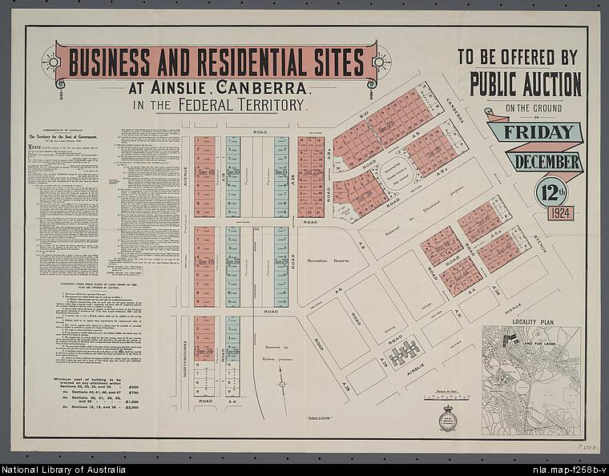
Business and residential sites at Ainslie, Canberra, in the Federal Territory to be offered by public auction ... on Friday December 12th 1924 [cartographic material]
The blue sites seem to indicate business sites along Mort Street, Braddon.
NLA 1924. MAP F 258B

Typically Kingston, Braddon and Ainslie were developed to accommodate lower income public servants and workmen who were involved with the construction of the capital.

The layout of Neighbourhood No.1, as Ainslie and Braddon were first called, was marked out in early 1917. The first cottages in Ainslie were constructed in 1921 though these are in today’s Braddon.

In 1926 the first small industrial premises at Braddon were constructed. The Canberra Steam Laundry, which opened on 12 July 1926, is thought to have been the first (Gibbney, 1988: 103).

The following pictorial timeframe shows the early development of the Mort Street, Braddon light industrial area, occurring concurrently with the development of the Sydney and Melbourne Buildings in Civic in 1927 and 1928. It also shows the architectural form and character of the buildings which occupied the area from that time, including the two bakeries, a steam laundry, garage and the Canberra Times office.

The early images of Mort Street and Braddon demonstrate the historical character of the area and its provision of light industrial services.

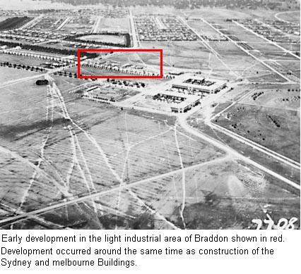
1928.
NAA A3560, 7708 barcode 3238575

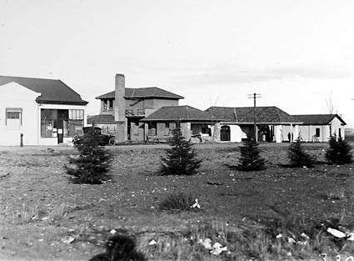
Commercial buildings in Mort St, Braddon including garage and Canberra Times office, 1927
NAA A3560, 3304 barcode 3059371

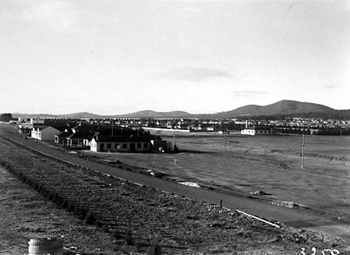
Mort St and Braddon from Civic centre buildings Canberra Steam Laundry at centre right. 1928
National Archives of Australia A3560, 3258 barcode 3059326

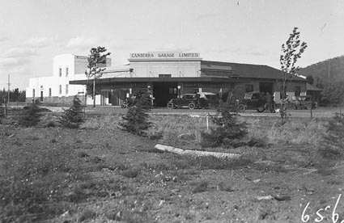
Canberra Garage in mort Street, adjacent to Meyer bakery, 1928.
MAA A3560, 6562 barcode 3197609

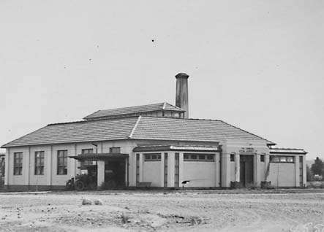
Canberra Steam Laundry in Braddon, 1928
NAA A3560, 4550 barcode 3149354

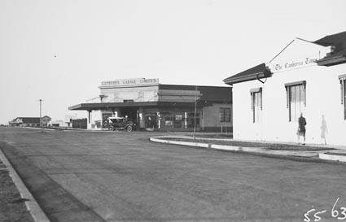
Mort Street, Braddon at Canberra Times corner, Canberra Garage on opposite corner, 1929
NAA A3560, 5563 barcode 3160622

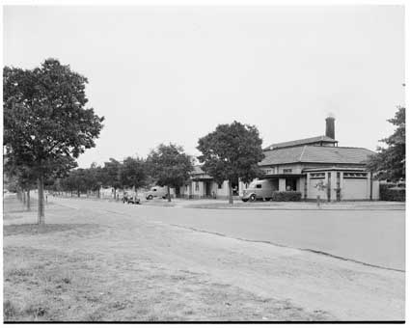
Braddon industrial area in 1951
NAA A7973, INT114 barcode 11713721

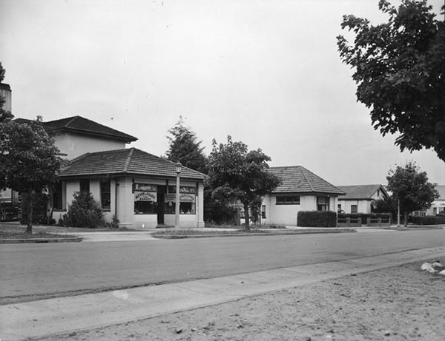
Mort Street in 1951 showing Mayer Bakery
Credit: ACT Heritage Library 009192

Coggan’s Bakery

On 18 December 1925, C.A. Tantau was granted one of the two new bakery leases on the building that was later to become Coggan’s Bakery. Tantau, a baker carrying on his family tradition, had arrived in Canberra around 1923. He was the son of Jacob August Tantau who had emigrated from Liverpool in England in 1825 (Walker 1865).

James W. Sproule of Queanbeyan and Canberra Architects designed the two new bakeries. Although the two bakeries were similar in design, Sproule incorporated some of Tantau’s specifications into the internal design of his bakery such as the configuration of the ovens. The bakeries were completed in 1925 and opened for business in 1926. Jim Grant leased the other bakery (which housed Reece's Plumbing in 2004) after moving his business, Canberra Bakeries Limited, from Molonglo (John Coggan, pers. comm. 2004; The Canberra Times 1979).

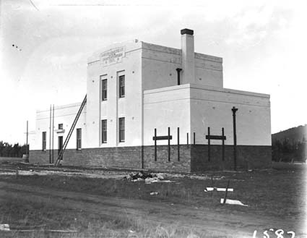
Canberra Bakeries Ltd building erected by Grant and Richardson in Mort Street, Braddon, Canberra, in 1925.
Similarities in design to Coggan’s Bakery are evident.
Image taken in 1926
Credit: National Archives of Australia, A3560, 1587 barcode 3122369

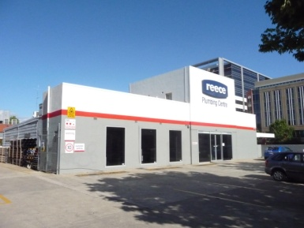
Former Canberra Bakeries building in Mort Street, February 2011.

The opening of Parliament House on 9 May 1927, combined with the transfer of public servants from Melbourne gave a boost to the developing city. That year, the light industrial area in Ainslie already encompassed the two bakeries, a steam laundry and a newspaper office (Linge 1975:19).

Canberra’s development suffered a setback during the 1930s Depression. This was a period when bread and milk were two locally produced food staples that families relied upon (Waterhouse 1992:47). Despite this, by 1932, Tantau’s business was detrimentally affected by the Depression and he found it necessary to transfer the lease of his bakery to Jim Grant. However, Grant did not operate the premises as a bakery. Instead, he used the building to store baking goods for Canberra Bakeries Limited. Grant also housed his single male staff in the building, as accommodation in Canberra was difficult to secure at that time (John Coggan, pers. comm. 2004).

In 1941, Peter and Doreen McIntyre bought Tantau’s Bakery from Jim Grant. Leo Arthur Coggan and his wife, Doreen Coggan, who had been managing McIntyre’s bakery in Queanbeyan then moved to Canberra to manage McIntyre’s new outlet (John Coggan, pers. comm. 2004).

During World War II, the government recognised the importance of Canberra’s bread supply by identifying baking as a protected industry. As a consequence of the labour shortage during this period, the government divided the suburbs into bread delivery zones for particular bakeries. Coggan’s Bakery delivered to Braddon, Reid and Duntroon (John Coggan, pers. comm. 2004). Meyer’s Bakery, also located in Mort Street, delivered to Turner. However, many Turner residents displayed a loyalty to Coggan’s Bakery and a preference for Coggan’s bread by purchasing it at the back of the bakery in preference to having it delivered by Meyers (John Coggan, pers. comm. 2004).

After World War II ended, basic medical equipment was in short supply. At this time, the bread supply increased in importance to the Canberra community when it was also utilised for medicinal purposes. This was an era when children suffered more from chilblains, ringworm, boils and carbuncles than today and the application of a hot bread poultice was an affordable and often efficacious remedy (Waterhouse 1992:50). The dietary benefits of bread were increased when, in 1963, the Health Department subsidised iodized salt for use by Canberra bakeries. The consumption of the iodine supplement assisted in reducing the high incidence of Goitre in Canberra’s children at the time (John Coggan, pers. comm. 2004; University of New South Wales 2002).

In 1946, Peter McIntyre was suffering from ill health and subleased the bakery to Leo Coggan who renamed it the Federal Bakery. Peter McIntyre died in 1947 and in 1953 Winifred McIntyre sold the bakery to Leo and Doreen Coggan.
With the exception of mixing machines, the Coggan’s continued to make their bread by hand. Leo Coggan replaced one of the two “Scotch” ovens, large arched-brick wood fired ovens, with a Steam Pipe oven that contained steel tubes that transferred the steam into the baking chamber (John Coggan, pers. comm. 2004). The fresh bread was delivered to the shops in a small van and to individual customers by horse and cart. This was a tradition that continued well into the 1950s (John Coggan, pers. comm. 2004; Davies, Hoffman and Price1990:89).

By the 1950s the area between Lonsdale and Mort Streets in Braddon was screened by trees on all sides and had become a well-established industrial area (White 1954: Plate XXXVIII). However, this was a decade when big business established bakeries in Canberra. Consequently, most of the small family owned bakeries that had previously dominated the bakery trade found it difficult to compete and were compelled to sell to Sunny Crust, Tip Top or Buttercup (John Coggan, pers. comm. 2004).

Coggan’s Bakery survived the competition largely due to the business generated by a sandwich and bread shop that they opened at the bakery in 1953. John Coggan baked bread, pies and cakes and Terry and Judy Alexander, John’s sister and her husband managed the shop and sandwich bar. In addition, Coggans Bakery supplied around 13 other Canberra sandwich shops and 51 school canteens (John Coggan, pers. comm. 2004).

In 1957 the shop was moved into newly completed premises adjacent to the bakery where groceries and alcoholic beverages were added to the stock. Groceries were delivered to customers by Terry Alexander every Friday. John Coggan recalled, ‘When Terry did the “grocery run” half the time people would say “the door’s open, just leave it on the kitchen table” (pers. comm. 2004).

Unusual circumstances led to the bakery’s name being changed. In 1969, Neil Armstrong landed on the moon and the Federal Bakery baked a commemorative loaf in the shape of a full moon complete with a flag on top. The Federal Bakery commemorative loaf was displayed in the shop window and featured in The Canberra Times the following day. As a result, the Coggans were contacted by the Registrar General’s Department informing them that they were operating under an illegal business name due to the use of the word “federal”. Consequently the name was changed to Coggan’s Bakery. Two years later, when it became legal to register a business name including the word Federal, the business was automatically re-registered as Federal Bakery by the Registrar of Titles. The name was subsequently changed to Coggan’s Federal Bakery in 1971 (John Coggan, pers. comm. 2004; Ricketson 1997:11).

Leo Coggan retired in 1969 and his son, John Coggan, took over the running of the business (John Coggan, pers. comm. 2004). By 1982, L.A. Coggan and Son, Tip Top Bakeries and Buttercup accounted for around 90 per cent of bread sold in the Canberra area (Canberra Times 1982).

During the 1970s and 1980s John Coggan regularly held bakery tours for Canberra’s primary students and secondary school Domestic Science students. The tour lasted approximately an hour and included a demonstration of bakery equipment. The opportunity to play with balls of dough was particularly popular with the younger students. When the tour concluded, the students were provided with project sheets printed by John Coggan and history sheets produced by the Bread Research Institute of Australia (John Coggan, pers. comm. 2004).

In 1985, Terry and Judy Alexander also retired and John Coggan bought their share of the business. Coggan leased the shop to Graham Lipman who refurbished the premises and opened a sandwich and a salad bar complete with tables and chairs for his patrons (Canberra Chronicle 1989). Lipman stayed until the bakery was sold to Berzins Riga Bakery in 1989. In 1991 Buttercup took over Berzins Riga and moved the bakery to premises at Fyshwick. Buttercup continued to sell wholemeal bread under the Coggan’s brand in recognition of the fact that the Coggan name had become recognised synonymous with a quality product (John Coggan, pers. comm. 2004).

After a nine-month period of disuse, in 1992, the bakery building was sold to Peter Makas. Makas had the ovens removed and remodeled the building but retained most of the original façade. As confirmation of the strong associations the Coggan’s name holds for many people of the Canberra region, Makas sought, and gained, permission from the Coggan family to retain the Coggan’s Bakery sign on the side of the building (John Coggan, pers. comm. 2004).

DESCRIPTION

The bakery was designed and drawn up by James W Sproule, Architect for Queanbeyan and Canberra and is understood to have been completed by December 1925.

The former Coggan's Bakery is a symmetrical brick building with a two-storey central section flanked on both sides by single storey wings. The brickwork has been texture rendered and painted. The render includes a band at approximately 1.2 metres above ground, however lower brickwork was originally exposed face brick. A rebated cornice includes roundels either side of a framed signage panel. The upper parapet falls gently to both sides in the form of a truncated pediment. The windows and door openings are set back from the rendered face of the building. The upper windows retain the original timber framed sashes, with six panes to the upper sash and one large pane below. The original details continue around either side of the two-storey section and include a pair of windows on the western wall.

The entry doors were formerly window openings that have been extended to ground level to include modern powder coated aluminium frames and doors.

The single storey wings initially had single windows, however these have been considerably enlarged to create modern shop windows. Both wings have rebated cornices and the left-hand wing retains its original rain head and down pipe, as does the two-storey section.

In spite of modification to the façade, the exterior of the building retains good integrity and appears to be in good condition. The interior has been extensively modified and is no longer recognisable as a former bakery.

REFERENCES

Documentary References

Commonwealth Government 1909, ‘Documenting a Democracy Australia's Story’,
Seat of Government Acceptance Act 1909 in www.foundingdocs.gov.au/places/cth/cth9.htm [Acc.10/4/04].

Davies, Hoffman & Price 1990, The History of Australia’s Capital, ACT Ministry for
Health, Education and the Arts, Canberra.

Gibbney, J., 1988, Canberra 1913-1953, AGPS Press publication, Canberra.

Gillespie L.L. 1991, Canberra 1820-1913, AGPS Press, Canberra.

Gray, J. 1994, Commonwealth Park, Canberra: A Review of its history 1913 to 1993,
ACT Heritage Council, Canberra.

Linge, G.J.R. 1975, Canberra Site and City, Australian National University Press,
Canberra.

Medical Officer 1913, ‘Report on John Murrays Bakery’, Series accession no.A207,
Control Symbol G1915/801, National Archives of Australia, Canberra.

Miller, D. 12 March 1915, ‘Establishment of a Bakery at Canberra’, Series
accession no. A207, Control symbol G1915/801, National Archives of Australia, Canberra.

Molonglo Bakery Lease 1922-1924, Series accession no. A192, Control symbol
FCL1924/246, National Archives of Australia, Canberra.

National capital Authority, 2009, ‘History of the NCA’, (http://www.nationalcapital.gov.au/index.php?option=com_content&view=article&id=136&Itemid=171), date accessed: 22 February 2011.

Ricketson, K. 1997, Conservation Survey: Coggans Bakery Braddon ACT,
Unpublished Report, University of Canberra, Canberra.

The Canberra Chronicle 12 September1989, ‘A salad bar, soon to be introduced, will
add new flavour to Coggans sandwich bar’, Fairfax Group, Canberra, p.14, held by Woden Heritage Library, Canberra

The Canberra Times 7 October 1926, Arthur Shakespeare (ed.), Canberra. Reproduced
in A. Gugler 1994 The Builders of Canberra 1909-1927: Part One – Temporary Camps & Settlements, C.P.N. Publications Pty. Ltd., Fyshwick.

The Canberra Times 6 February 1979, ‘First bakery owned by Jim Grant’,
John Fairfax & Sons, Canberra, Bakery File, Canberra and District Historical Society, Canberra.

The Canberra Times 3 February 1982, ‘Canberra’s first baker’, John Fairfax & Sons,
Canberra, Bakery File, Canberra and District Historical Society, Canberra.

University of New South Wales 2002, ‘UNSW Embryology – Abnormal Development-
Iodine Deficiency’ in http://anatomy.med.au/cbl/embryo/Defect/page11.htm
[Accessed 24/8/04].

Walker, J. W. 20 July 1865, ‘Tantau aka Tantan naturalisation’, Series accession no.
A712, Control symbol 1865/L7718, National Archives of Australia, Canberra.

Waterhouse, J. (ed.) 1992, Canberra: Early Days at the Causeway, (2nd Edition),
Environment, Culture and Heritage Department of the Environment, Land and Planning, Canberra.

White H.L. (ed.) 1954, Canberra a Nation’s Capital, Angus & Robertson Ltd., London.

Oral History

John Coggan, Master Baker interviewed 9 August 2004 and 24 August 2004 at Hackett.

SITE PLAN AND IMAGES

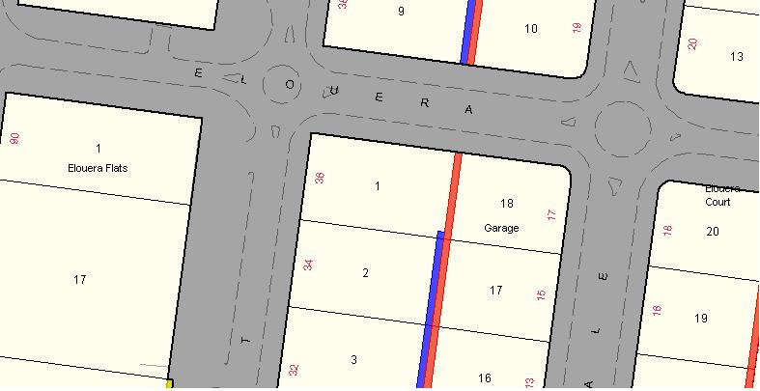
Block 1 Section 28 Braddon.

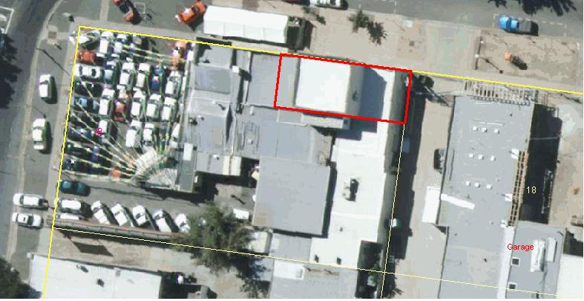
Boundary area for the former Coggan’s Bakery building shown in red
(Part) Block 1 Section 28 Braddon.

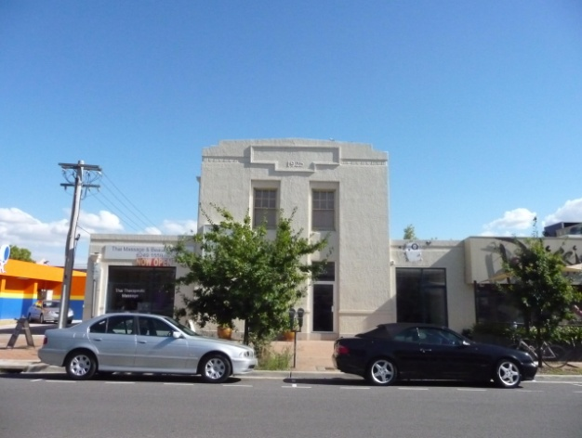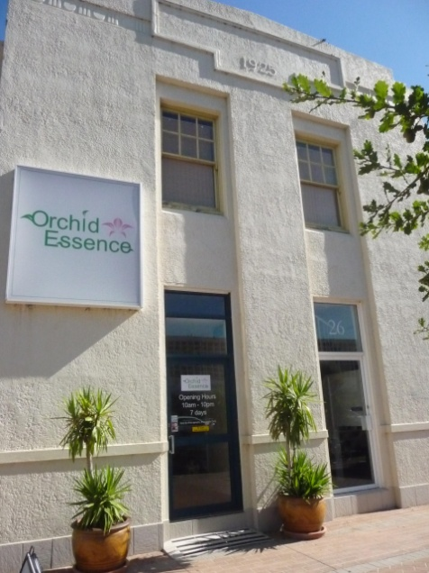

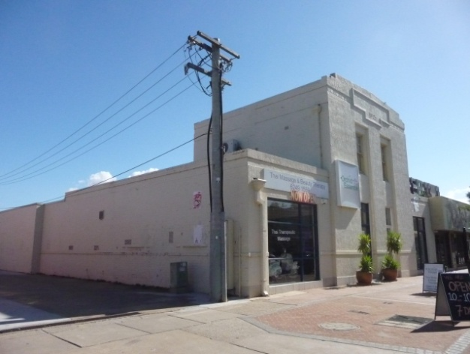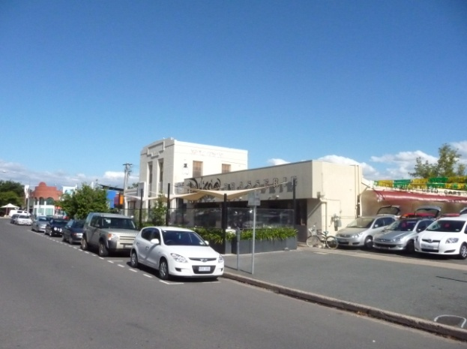

Images taken February 2011

NON-STATUTORY BACKGROUND INFORMATION

Contextual Background (early bakeries in the Canberra region)

In 1912, through the federal Seat of Government Acceptance Act 1909, an area of 900 square miles (233,107 hectares) was excised for the specific purpose of establishing the Federal Capital Territory (FCT). The government then reserved all the property in the FCT and those wishing to remain on their land were compelled to lease it back from the government. Large tracts of land previously belonging to landholders were divided into separate leases and the population of the region increased. Consequently, the need for basic food staples such as bread grew rapidly (Commonwealth Government 2004).

The first bakery in the Canberra region had begun operating in premises built by Ebenezer Booth, in 1874, in the eastern portion of what is now Commonwealth Park (Gray 1994:2). Booth was general storekeeper and postmaster in the Canberra region between 1878 and 1884 (Gillespie 1988:116). John Murray used the building as a bakery and store from 1911, until it burnt down in 1923 (Gray 1994:2).

In 1913, Murray was ordered by government health officials to improve the unsanitary conditions of his bakery (Medical Officer 1913). After Murray’s attempts to bring his bakery up to an acceptable health standard had failed, David Miller, the first Administrator of the FCT, developed plans for a new bakery (Miller 1915). The bakery was built at the Molonglo Internment Camp that had been built in 1918 to house Australians of German descent during World War I (The Canberra Times 1982).

By 1922, Murray, whose request to build a new bakery was denied, had been compelled to lease his bakery on a weekly basis and operate under close government supervision. Murray’s attempt to lease Miller’s new bakery failed when the Canberra Co-operative Society, made up of public servants, won the tender. The co-operative was granted a three-year lease on the Molonglo Camp Bakery on 19 March 1923. Murray fought the decision in court on the basis that he had been treated unfairly and won the case. As a result, just ten months after the Canberra Co-operative Society’s lease was granted, it was transferred to Murray for a period of three years at £48 per year; around half the amount the Co-operative Society had been paying (Ricketson 1997; Molonglo Bakery Lease 1922-24).

In 1925, Jim Grant who had been running a successful bakery in Sydney with his father, James, moved to Canberra and took over the Molonglo Bakery lease (The Canberra Times 1979 and 1982).

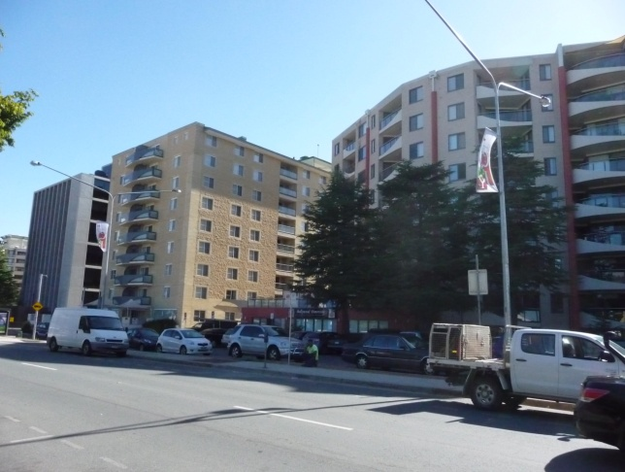

The character of Mort Street today is partly comprised of high-rise apartments, vastly different from the smaller scale light industrial businesses which once occupied the area.
Image taken February 2011.

