Australian Capital Territory
Heritage (Decision about Registration for Gungaderra Homestead and portion of Well Station Road, Harrison) Notice 2011
Notifiable Instrument NI 2011 - 641
made under the
Heritage Act 2004 section 42 Notice of Decision about Registration

- Revocation
This instrument replaces NI 2011-371
- Name of instrument
This instrument is the Heritage (Decision about Registration for Gungaderra Homestead and portion of Well Station Road, Harrison) Notice 2011 -
- Registration details of the place
Registration details of the place are at Attachment A: Register entry for Gungaderra Homestead and portion of Well Station Road, Harrison.
- Reason for decision
The ACT Heritage Council has decided that Gungaderra Homestead and portion of Well Station Road, Harrison meets one or more of the heritage significance criteria at s 10 of the Heritage Act 2004. The register entry is at Attachment A.
- Date of Registration
20 October 2011

Gerhard Zatschler
Secretary
ACT Heritage Council
20 October 2011

AUSTRALIAN CAPITAL TERRITORY

HERITAGE REGISTER
(Registration Details)

Place No:

For the purposes of s. 41 of the Heritage Act 2004, an entry to the heritage register has been prepared by the ACT Heritage Council for the following place:

Gungaderra (formerly Red Hill) Homestead (& portion of Well Station Road), Sapling Street, Harrison

Blocks 10 and 12, Section 4, and Block 12 Section 2, Harrison, Gungahlin

DATE OF REGISTRATION

Notified: 20 October 2011 Notifiable Instrument: 2011-641

Copies of the Register Entry are available for inspection at the ACT Heritage Unit. For further information please contact:

The Secretary
ACT Heritage Council
GPO Box 158, Canberra, ACT 2601

Telephone: 13 22 81 Facsimile: (02) 6207 2229

IDENTIFICATION OF THE PLACE

Gungaderra (formerly Red Hill) Homestead (& portion of Well Station Road), Sapling Street, Harrison

Blocks 10 and 12, Section 4, and Block 12 Section 2, Harrison, Gungahlin

STATEMENT OF HERITAGE SIGNIFICANCE

This statement refers to the Heritage Significance of the place as required in s12(d) of the Heritage Act 2004.

Gungaderra homestead (& portion of Well Station Road) is of heritage significance as important evidence of a distinctive way of life and design no longer practiced, as a notable example of a kind of place, and for strong and special association with a cultural phase in the history of the ACT.

Together, the homestead, machinery shed, mature plantings and Well Station Road portray the early European pastoral settlement of the area, and are indicative of the nineteenth and early twentieth century rural way of life in the region. The sequence of extensions to the main house illustrates the growth and change of the homestead over time.

Gungaderra is significant in demonstrating the development of local settlement in what is now the ACT, showing in particular the closer settlement of rural residential housing that occurred after the Robertson Land Act of 1861. It is also associated with John and Jemima Winter, members of a Gungahlin settler family who built the first cottage at the site (no longer extant) in the 1860s. They held considerable land through selection, and with their son William, who built and occupied the original section of the present homestead in 1904, were involved in the early mechanisation of farm activities in the region.

Well Station Road, linking Gungaderra Homestead with Well Station and other properties in the district, is a clear visible marker in the landscape today, reminiscent of a time before motorised transport. The alignment of Well Station Road is of significance as portraying the relationship of properties and the settlement patterns in the nineteenth century.

- The Well Station Road is a rare rural element in an increasingly urbanised environment. It provides a physical and visual link between Gungaderra Homestead and Well Station Homestead.

The 1904 pisé core of the present homestead, and later pisé extensions, demonstrate a distinctive construction style introduced into the ACT in the 1870s that utilised available materials and was well suited to the climate. Pisé is becoming uncommon in the ACT, and in the wider region, and is under threat from development, redundancy and erosion. The different periods of pisé construction in the building reflect changes in the technique (such as the use of thinner walls), and together with the relative intactness of the building, make it a notable example of pisé as a class of building construction.

The property is significant as a good example of a medium scale pastoral domestic and work environment of the second half of the nineteenth and early twentieth centuries. The close association with the Well Station Homestead demonstrates the pattern of small holdings typical of the region.

Other related nominations/registrations
The following places, located near Gungaderra Homestead, and also related to nineteenth century agriculture/pastoralism, form separate nominations/registrations in the ACT Heritage Register:
- Well Station Homestead;
- Mulligan’s Flat Ploughlands; and
- Canberra Park.

The following places are geographically related to Gungaderra Homestead, located in close proximity:

- The Red Hill Ochre Quarry (Gubur Dhuara) is located approximately 1km to the north-west of the Gungaderra Homestead and forms a separate nomination to the ACT Heritage Register. It is protected as an Aboriginal site under the Heritage Act 2004.

- While no Aboriginal sites have been identified within the Gungaderra homestead area (EMA, 2005, Saunders, 2003), it is likely that some Aboriginal values may exist, given numerous artefact findings in the Gungahlin area. These values have not been assessed.

FEATURES INTRINSIC TO THE HERITAGE SIGNIFICANCE OF THE PLACE

The attributes listed below are assessed as features intrinsic to the heritage significance of the place:
- The Homestead building (1902-04), and later pisé extensions;
- The machinery shed (1911-13);
- Early plantings including:
  - the Monterey pines lining the main entry drive and
  - eucalypts on Well Station Road east and south of homestead
- Historic fence lines
- Tank stand
- Part of the Well Station road alignment (as included within the boundary for this place).

APPLICABLE HERITAGE GUIDELINES

The Heritage Guidelines adopted under s25 of the Heritage Act 2004 are applicable to the conservation of Gungaderra Homestead

The guiding conservation objective is that Gungaderra Homestead, Sapling Street, Harrison, shall be conserved and appropriately managed in a manner respecting its heritage significance and the features intrinsic to that heritage significance, and consistent with a sympathetic and viable use or uses. Any works that have a potential impact on significant fabric (and / or other heritage values) shall be guided by a professionally documented assessment and conservation policy relevant to that area or component (i.e. a Statement of Heritage Effects – SHE).

The 2005 Conservation Management Plan for the Gungaderra Homestead, prepared by Eric Martin and Associates, should be referred to for specific conservation policies.

REASON FOR REGISTRATION

Gungaderra Homestead, Harrison has been assessed against the heritage significance criteria and been found to have heritage significance when assessed against four criteria under the ACT Heritage Act.

ASSESSMENT AGAINST THE HERITAGE SIGNIFICANCE CRITERIA

Pursuant to s.10 of the Heritage Act 2004, a place or object has heritage significance if it satisfies one or more of the following criteria. Significance has been determined by research as accessed in the references below. Future research may alter the findings of this assessment.

- it demonstrates a high degree of technical or creative achievement (or both), by showing qualities of innovation, discovery, invention or an exceptionally fine level of application of existing techniques or approaches;

The Gungaderra Homestead (and portion of Well Station Road) does not meet this criterion.

- it exhibits outstanding design or aesthetic qualities valued by the community or a cultural group;

The Gungaderra Homestead (and portion of Well Station Road) does not meet this criterion.

- it is important as evidence of a distinctive way of life, taste, tradition, religion, land use, custom, process, design or function that is no longer practised, is in danger of being lost or is of exceptional interest;

The Gungaderra Homestead (and portion of Well Station Road) is important as evidence of a distinctive way of life that is no longer practised.

It is a tangible reminder of the closer settlement in the area in the 1860s as a result of the Robertson Land Act 1861. It demonstrates the rural pastoral and agricultural settlement of the area from this time and into the twentieth century. The close association with Well Station Homestead demonstrates the pattern of small holdings typical of the region.

The 1902/04 homestead, machinery shed, mature landscaping and the alignment of Well Station Road are strong historical markers in the landscape, testament to the early European settlement and evolution of the district that subsequently became the ACT.

The original pisé core of the main house is the main physical evidence of the early development of the homestead. The various phases of additions to the main house and machinery shed reflect the evolution and growth of the property over time. The buildings illustrate a continuity of use of the site and the evolution of farm living and management in the region over a period of 100 years (1902 – 2003), and remain as strong historical markers in the landscape, in a setting contrasted by recent modern development.

The 1904 pisé core of the present homestead, and later pisé extensions, demonstrate a distinctive construction style and design introduced into the ACT in the 1870s that utilised available materials and was well suited to the climate.

Pisé construction was common in the region at the time of the building’s initial construction, but is no longer practiced.

Gungaderra Homestead (and portion of Well Station Road) meets this criterion.

- it is highly valued by the community or a cultural group for reasons of strong or special religious, spiritual, cultural, educational or social associations;

The Gungaderra Homestead (and portion of Well Station Road) does not meet this criterion.

- it is significant to the ACT because of its importance as part of local Aboriginal tradition

The place has not been assessed in relation to this criterion.

- it is a rare or unique example of its kind, or is rare or unique in its comparative intactness

The Gungaderra Homestead (and portion of Well Station Road) is a rare example of a nineteenth century rural homestead in the ACT region.

Rural homesteads within the region portray a time before the establishment of the Federal Capital Territory, when the area was largely occupied by small to medium scale pastoral operations.

The character of the ACT has changed dramatically since 1913, with today’s city landscape deceptive of its early origins. It is often difficult to read the past agricultural and pastoral land use of the region. Remaining rural properties in the ACT have become important in interpreting the early European history of the area.

Together, the homestead and portion of Well Station Road demonstrate the connectivity and relationships between nineteenth century rural properties in the region. In addition, the proximity of the homestead and machinery shed has an ability to demonstrate the spatial relationship of domestic and work life during this period, and portrays the way of life on a rural property at that time.

The Gungaderra Homestead (and portion of Well Station Road) meets this criterion.

- it is a notable example of a kind of place or object and demonstrates the main characteristics of that kind

Gungaderra Homestead is a notable example of pisé construction and of early European pastoral settlement. It demonstrates the main characteristics of these kinds, and is notable for the 1937 pisé extension—a late applications of this technology, and as an historical marker contrasting with modern development in the area.

Characteristics of an early European pastoral settlement are evident in the homestead precinct containing an outbuilding, mature landscape plantings and rural country road linking it to other nineteenth century properties in the area.

Pisé characteristics evident at Gungaderra are the internal and external rammed earth walls, and the simplicity of the building’s design. The different periods of pisé construction in the building reflect changes in the technique (such as the use of later thinner walls), and together with the relative intactness of the building, make it a notable example of pisé as a class of building construction.

Gungaderra Homestead is a notable example of this kind of place as the pisé extensions to the property in the 1930s represent a late use of this method and material. It is possible that this later pisé addition to the main house may be one of the last pisé structures erected in the ACT associated with historic sites. The thinner pisé walls in the later additions illustrate the evolution of the techniques with time.

Gungaderra Homestead (and portion of Well Station Road) meets this criterion.

- it has strong or special associations with a person, group, event, development or cultural phase in local or national history

Gungaderra Homestead (and portion of Well Station Road) has a strong and special association with a cultural phase in the history of the ACT.

The property remains testament to the early European settlement of the area and, in particular, the closer settlement and smaller holdings resulting from the Robertson Land Act 1860. Together with the nearby Well Station Homestead, the portion of Well Station Road linking the two homesteads remains as a strong visual reminder of the agricultural and pastoral nature of the area in the nineteenth and early twentieth centuries.

This association is special, given the relatively few pastoral properties in the area with an ability to demonstrate the rural character prior to the establishment of the Federal Capital Territory. Further, the association is strong, based on the landmark qualities of the place as an historical marker in an otherwise modern urban environment.

The property is also associated with many prominent early settlers in the region, most notably the Crace family, though also the earliest landholders, John and Jemima Winter. The Winters held considerable land through selection, and with their son William, who built and occupied the original section of the present homestead in 1904, were involved in the early mechanisation of farm activities in the region. William also provided assistance to wheat researcher William Farrer.

Gungaderra Homestead (and portion of Well Station Road) meets this criterion.

- it is significant for understanding the evolution of natural landscapes, including significant geological features, landforms, biota or natural processes

not applicable.

- it has provided, or is likely to provide, information that will contribute significantly to a wider understanding of the natural or cultural history of the ACT because of its use or potential use as a research site or object, teaching site or object, type locality or benchmark site

The Gungaderra Homestead (and portion of Well Station Road) does not meet this criterion.

- for a place—it exhibits unusual richness, diversity or significant transitions of flora, fauna or natural landscapes and their elements

not applicable.

- for a place—it is a significant ecological community, habitat or locality for any of the following:
(i) the life cycle of native species;
(ii) rare, threatened or uncommon species;
(iii) species at the limits of their natural range;
(iv) distinct occurrences of species.

Not applicable.

SUMMARY OF THE PLACE
HISTORY AND PHYSICAL DESCRIPTION

HISTORY
The material below has been extracted from EMA, 2005.

CONTEXTUAL HISTORY
The Gungahlin area was first sighted by a European in 1820—explorer Charles Throsby. The first European settlement of the district was about 1826 by George Thomas Palmer at the area later known as ‘Ginninderra’. The Gungahlin area was soon opened up by further squatters and pastoralists who took up extensive areas of land.

‘Until 1861 the majority of landholders took up large blocks, or amalgamated smaller holdings into larger agglomerations’ (Pearson, 2002: 13). From 1861 with the introduction of the Robertson Land Act, selectors began to occupy smaller holdings, primarily the less desirable and less well-watered lands in the northern and western part of Gungahlin (Pearson 2002:13). These selections resulted in a denser and more varied population than the previous large pastoralist holdings.

The Robertson Land Act required selectors to reside on their land, resulting in an increase of the area’s population (Pearson, 2002: 14).

GUNGADERRA
It was this small selection process that saw John Winter and his wife Jemima extend their prior holdings in the area by means of individual 40 acre selection, resulting in a property of almost 1000 acres at the end of the 19th century.

Upon their acquisition of the ‘Gungaderra’ property, they constructed a homestead of slabs with a shingle roof around 1861, naming it ‘Red Hill’ for the nearby ironstone outcrop. Here, they had nine children between 1862 and 1882, one dying in infancy. They also extended their holdings in their children’s names to total 1,000 acres (National Trust (ACT) 2000). Their homestead was surrounded by 40 acre blocks broken into small fenced areas of cultivation. Jemima’s family, the McPhersons, owned adjoining land.

Sheep grazing was the main land-use, followed by arable land planted with grain crops, it being argued that this latter primarily resulted from the denser settlement after the Robertson Land Act, with by 1897 some 3,085 acres under crop in the Ginninderra district (Pearson 2002:14).

‘Red Hill’ historically had two special features that distinguished it from other ‘large’/medium holdings in the district:

- It held importance as a source of white pipe-clay, primarily from shafts into the side of Red Hill lying about 0.5 – 1.00km NW from the Gungaderra Homestead, said to have been developed either by another syndicate in 1896 or by John Winter (National Trust (ACT) 2000). Commercial interest in this resource continued well into the 20th century. The Canberra Brickworks, seeking new clay sources for pipe production, surveyed the main shaft and found massive deposits, but did not develop them due to a low economic evaluation (Gillespie 1992; NT (ACT) 2000).

- Another role was as the centre of a mechanised ploughing business established in the late 19th century by John Winter’s son, William, and his three brothers, working the Canberra-Queanbeyan area with their machinery. Such mechanised ploughing gradually took over. Other formerly cultivated areas were subsequently grazed leaving evidence of earlier non-mechanised ploughlands, such as at Wells Station and Mulligan’s Flat, both near Gungaderra, but not at Gungaderra itself (Pearson 2002). William Winter appears to have had strong entrepreneurial traits, also introducing a wheat-harvesting machine for William Farrer of ‘Lambrigg’, during his experiments to produce rust-proof wheat, designing a sawmill in Tidbinbilla and owning the first motor-car in the district (Gillespie 1992; NT (ACT) 2000).

In 1902/4, a second homestead was constructed, of pisé for John Winter’s son, William at the time of his marriage. It comprised 5 rooms with a verandah along the northern elevation. Pisé is a method of building walls in which semi-dry earth with a low content of clay is rammed between a temporary framework, producing an artificial rock. This was a relatively common method of construction in the ACT area in the late nineteenth and early twentieth centuries.

In 1915, the Commonwealth resumed the property and William Winter, then managing the property for his father, John, became the lessee. In 1919, the lease was taken over by Charles Peden, who was part of the McKeachnie family leasing the neighbouring property, ’Well Station’, later being the leaseholder, starting a long, close association between the two holdings.

Extensions to the homestead were undertaken in 1925-28, including weatherboard additions which enclosed a kitchen and laundry.

After other changes of leaseholders, in 1935 Richard Crace bought the lease and re-named ‘Red Hill’ ‘Gungaderra’. His long lease of the area provides correspondence showing that the land-use was typical of such a property in the district. He ran sheep, and cultivated lucerne, wheat and oats. He was also afflicted by rabbit plagues so typical of that era. Crace undertook various changes to the main homestead and constructed two new houses at the site. To the existing 1902/04 homestead he added a porch, bedroom and bathroom to the south east and converted the 2 eastern bedrooms into one room. The 1937 extension to the southeast was constructed of pisé. In addition, extensions undertaken to the north-east in the late 1950s were also constructed of pisé.

Crace sold his lease in 1959 to the Gungaderra Pastoral Company, which still held the lease in 1976. Information about the property since then is limited in the secondary sources, although a transfer of the lease in 1980 to Eric Mawson, again provides a substantial description of the structures in the Homestead Block. The list indicates a multiple use of the property, grazing sheep and cattle, and growing grain.

In the 1960s and 1970s, weatherboard additions were undertaken to the 1902/04 homestead.

In 1985, a longer term lease was rescinded anticipating the urban development of Gungahlin. In 2011 the property is owned and managed by the not-for-profit affordable housing group CHC, and is expected to soon be transferred to the Northside Community Association.

A chronology of key development and events at Gungaderra is presented below.
1857 John Winter arrives in District
1861 40 acres selected at ‘Red Hill’ (Gungaderra) by John Winter.
Slab hut constructed.
1902/1904 Pisé House built at ‘Red Hill’
1911/1913 Machinery Shed built.
1914/1915 Property acquired by the Commonwealth and surveyed by Moriarty.
1919 Winter family leave ‘Red Hill’.
1925/1928 Property renamed ‘Iona’ and leased to Patrick Joseph Donnelly. Homestead extended during this period.
1935 Property renamed Gungaderra and leased to Richard Gregory Lingen Crace.
1937 Crace extends homestead to south east.
1953 Weatherboard manager’s cottage built for married station hand.
Late 1950s Homestead extended to north east.
1959 Lease sold to Gungaderra Pastoral Company Pty Ltd.
1960s Weatherboard worker’s cottage constructed.
1980 Lease sold to Eric A.G. Mawson. Homestead extended to east and alterations made during late 1970s.
1985 Long term lease withdrawn, tenant from this point operates on short term lease.
2005 Property lease held by Eric A.G. Mawson’s daughter. Residential subdivision construction commencing close to the site.

WELL STATION

The nearby Well Station Homestead was established by at least the 1850s. George Rolfe is thought to have constructed the first house on the property around that time. It is thought that during the 1880s Archibald McKeahnie moved to Well Station with his wife, Mary. The McKeahnies remained in occupation of the property until it was resumed by the Commonwealth in 1915 (Burrows, 1998: 17-18).

Today there is a homestead on the site, as well as a schoolroom and dairy block, stables, shearer’s quarters, a shearing shed and a hayshed.

The Well Station Homestead is located approximately 1km to the south-east of Gungaderra and is entered separately in the ACT Heritage Register. The register entry incorporates a section of the Well Station Road which was located to the west of this property and which connected the two properties.

WELL STATION ROAD

Soon after the earliest European settlement of the area, a number of tracks and routes were established connecting the various properties and nearby townships. Important early tracks included the road to Gundaroo and Gunning, and the track to Yass which provided access to the Campbell’s holding at Duntroon. Tracks to today’s areas of Ginninderra and Gungahlin were also important (Andrews, 1983: 4).

Baker’s circa 1840s ‘Map of the County of Murray’ provides an indication of the early tracks and roads in the district.

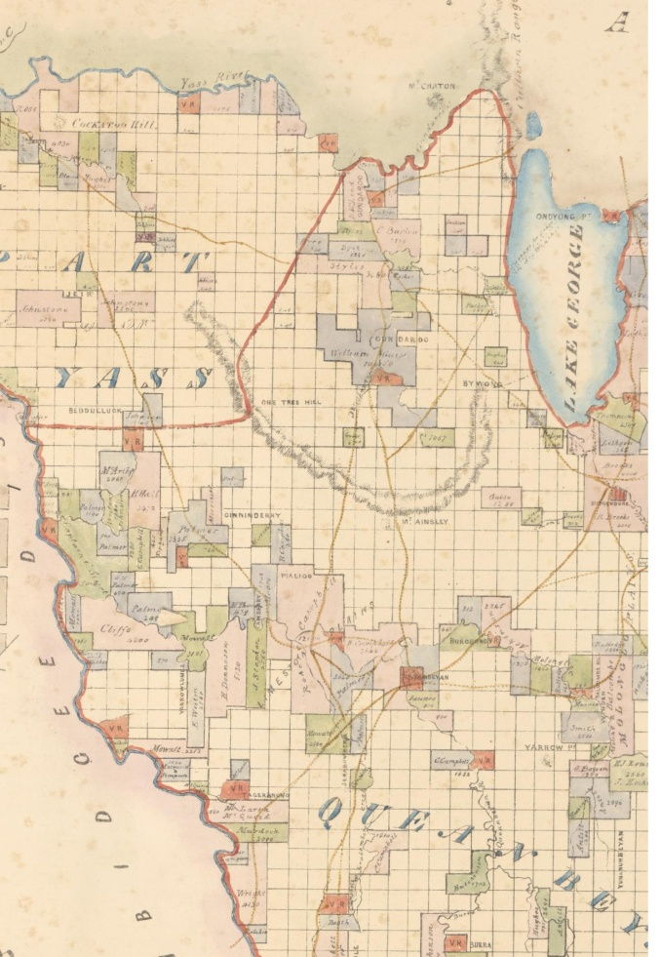
Map of the County of Murray cartographic material Eastern Division N.S.W.
compiled, awn and printed at the Department of Lands Sydney N.S.W , n.d.
NLA 5019246

Well Station Road was established as a track linking the Gungaderra and nearby Wells Station properties with other places and properties in the area, including Campbell’s Duntroon estate which was one of the major properties in the district at the time.

The alignment of the road remains visible in the landscape today. The track demonstrates the relationship between properties in the nineteenth century, and the connectivity between early settler families for pastoral and social activity.

The topographical map of the Canberra region circa 1916 clearly shows the Well Station Road route, traversing from Duntroon to connect to both the Well Station and Gungaderra homesteads.

Separate tracks and roads from the Gungaderra homestead then connected with the Mulligans Flat area further north, and extended in a separate branch towards Gundaroo in the north-east. Many other small tracks are evident within the area, connecting various properties.

The north-east branch to Gundaroo clearly connects two of John Winter’s properties.

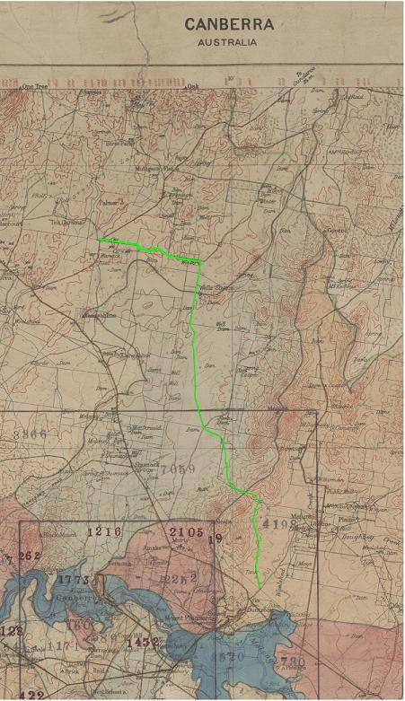
Canberra Australia cartographic material
Nla.map.nic 21
The green line on the map above shows the route of the Well Station Road.
The road turns a 90 degree angle at the corner of John Winter’s Red Hill (Gungaderra) property.

Another track extends eastwards from Well Station to the nearby Gungahlin (‘Gungahline’) property.

PLOUGHLANDS
‘Ploughlands are areas of land cultivated with ploughs for the planting of crops. They are most commonly associated with cereal crop production and orchards’ (Pearson, 2002: ii). Before the wide adoption of the motorised tractor for ploughing purposes, draught animals were used. The paddocks of Gungaderra and the nearby Wells Station and Gungahlin homesteads were ploughed in this way. Evidence of some ploughlands remains in the ACT landscape through visible ridges and furrows. Ploughlands near to Gungaderra homestead which demonstrate evidence of ploughing by draught animal include those at Mulligan’s Flat.

PISĒ CONSTRUCTION
The following excerpts are taken verbatim from Cosgrove and Dowling, 2001).

Pisé de terre is the method of earth building characterised by ramming earth into in situ formwork similar to that used today for mass concrete.

From the late 1800s pisé began to be accepted as an economical and elementary form of building, particularly in the rural areas of Australia. Small residences, station outbuildings and the occasional larger residence were built with this method. With the advent of machine-made and fired bricks, galvanised iron, asbestos cement and other forms of mass manufactured building materials which were becoming cheaper to obtain, pisé building fell from favour.

Not all Australian soils are suitable for pisé building, the best being the decomposed granite soils of the premier wheat-growing areas of eastern and southern Australia, and most of the known rammed-earth houses were erected in these districts. Pisé was never common in urban and city areas. One of the main advantages of building with pisé was that suitable soil was extracted from the earth near to the building site. This meant there was little or no financial outlay to obtaining building material and transporting it to the building site.

In the ACT and surrounding district, pisé building had its heyday during the last decade of the 19th century and the first two decades of the twentieth century… By the third decade of the twentieth century pisé began to fall from favour to be largely replaced by the quickly erected corrugated iron structures which were ultimately to dominate the rural landscapes of Australia.

--

Today, 25 pisé properties exist in the ACT. Of these, nine are in a ruinous condition, while the remaining 16 are in a fair condition, with the majority occupied (EMA, 2005). Good examples of pise constructions in the ACT include Glanburn, Rock Valley, Nil Desperandum and Winarlia at Hall Village, among others.

DESCRIPTION
Two key historical buildings remain at Gungaderra - the 1902/1904 homestead and the 1911-13 Machinery Shed. Historical plantings and other landscape elements surrounding these features also remain.

1902/04 homestead
The main house is a rambling single level building with a mixture of rendered pisé and painted weatherboard walls. The house has been extended a number of times and this is reflected in the varying material of wall construction and the roof forms. The exterior of the main house is generally in good condition, due to restoration works in 2010-2011.

The main roof of the house is a hipped roof clad in corrugated iron and is located over the original section of the house. Metal deck clad skillion roofs adjoin the main roof on the south and west elevation.

The main axis of the house plan runs east west and the entrances to the house are on the north and south elevation. The existing main entrance to the house is from the north and there is a service entry on the southern side.

The central half of the northern elevation is protected by a wide timber framed verandah (Figure 70). The low pitched roof is clad in corrugated iron. The timber floor to the verandah is built with minimal clearance to the ground.

Windows and doors throughout the house are timber framed and are generally double hung.

The earlier external doors of the house are panelled, latter doors are part glazed.

The interior of the house comprises some 16 rooms including 4 bedrooms, 2 ensuites, bathroom and 3 living rooms. The house has been altered internally but it is still possible to interpret the original plan and each stage of construction.

A large extension has been added to the east of the homestead building, replacing and enlarging the 1950s pise walls.

Machinery shed

The machinery shed is a vernacular bush pole framed rural structure. The roof and most of the walls are clad in corrugated iron. The roof has a central hipped section and gables to either side. The shed appears to be structurally sound. External weatherboard cladding is in fair to poor condition. The interior is compartmented by the pole frame layout and part height timber framed walls. The shearing area has timber flooring built on ground. The interior condition is fair with fabric worn and dirty. The building incorporates a garage and meat room.

Landscaping

The setting and landscaping around the homestead precinct comprises scattered eucalypts to the south-eastern side of the site and mature pines which define the entrance, rear drive and Well Station Road.

- Plantings
An avenue of Monterey pines (Pinus radiata) lines the southern entry drive into the homestead.

A row of Roman Cypress (Cupressus sempervirens) lines the northwest entrance nearest the homestead.

The pines were introduced by Crace after 1937 and reflect a phase in the development of the homestead. The pine trees in the vicinity of the drive illustrate Crace’s desire to create a formal entry and setting to the house.

The pines beside the shed provide a windbreak to it and the main house, and in later years provided a visual screen between the main house and Manager’s Cottage.

The concentration of mature trees around the buildings and the strong line of Well Station Road defined by mature trees, together provide strong visual markers to the site.

Well Station Road

Well Station Road is a surviving gravel track from the 19th Century, linking the early Well Station and Gungaderra Homesteads with other properties in the area, including Duntroon.

The Gungaderra precinct is bordered to the northern and eastern sides by the Well Station Road. The eastern section of the road is defined by remnant eucalypts (many pre 19th Century) and Monterey pine trees planted post 1930s. Fence-lines along the road still exist.

A gate in the eastern fence-line of the Gungaderra property allows for movement to and from Well Station Road.

Well Station road running to the east and extending south of the homestead is presently a strong visual marker in the landscape and reflects the historic road connection between Gungaderra and the neighbouring Well Station property, and others further afield.

To the north of the property, the alignment of the original Well Station Road has been used for the recent construction of Sapling Street.

An area of the Well Station Road alignment south of the Well Station Homestead is entered separately to the ACT Heritage Register as part of the Well Station property.

REFERENCES

Andrews, W., 1983, Canberra’s Engineering Heritage, Canberra Publishing and Printing Co., Fyshwick.

Armes, J. 1995. ‘Heritage assessment of Red Hill (Gungaderra) Homestead, Gungahlin’. Report to ACT Heritage Unit

Cosgrove, C. & Dowling, P. 2002. ‘Pisé places, a report to the ACT Heritage Council on behalf of the National Trust of Australia (ACT)’.

Eric Martin and Associates, 2005, ‘Gungaderra Homestead – Conservation Management Plan’, report prepared for the Land Development Agency.

Gillespie, L.L.2000. ‘Canberra’s pioneer families’. Canberra Times supplement, 15/2/2000.

Gillespie, L.L. 1992. Ginninderra: Forerunner to Canberra. The Wizard, Canberra Local History Series, Campbell, Act.

National Trust citation for ACT Heritage Register

National Trust of Australia (ACT) 5 June 2000 ‘Gungaderra / Red Hill. Nomination to a ACT Interim Heritage Places Register’, with attachments, including Att. 8, letter from Gordon Winter, 22 January 2000; prepared by Carol Cosgrove with assistance from Peter Dowling.

Pearson, M. 2002 ‘A Study of Ploughlands in the ACT’, a report by Dr Michael Pearson, Heritage Management Consultants for the Heritage Unit, Environment ACT.

Register of the National Estate Database

Saunders, P. & Kelvin Officer, 1998. ‘Gungahlin Urban Structure Review: Cultural heritage component’, Report to Sinclair Knight Merz Pty Ltd

SITE PLAN AND IMAGES

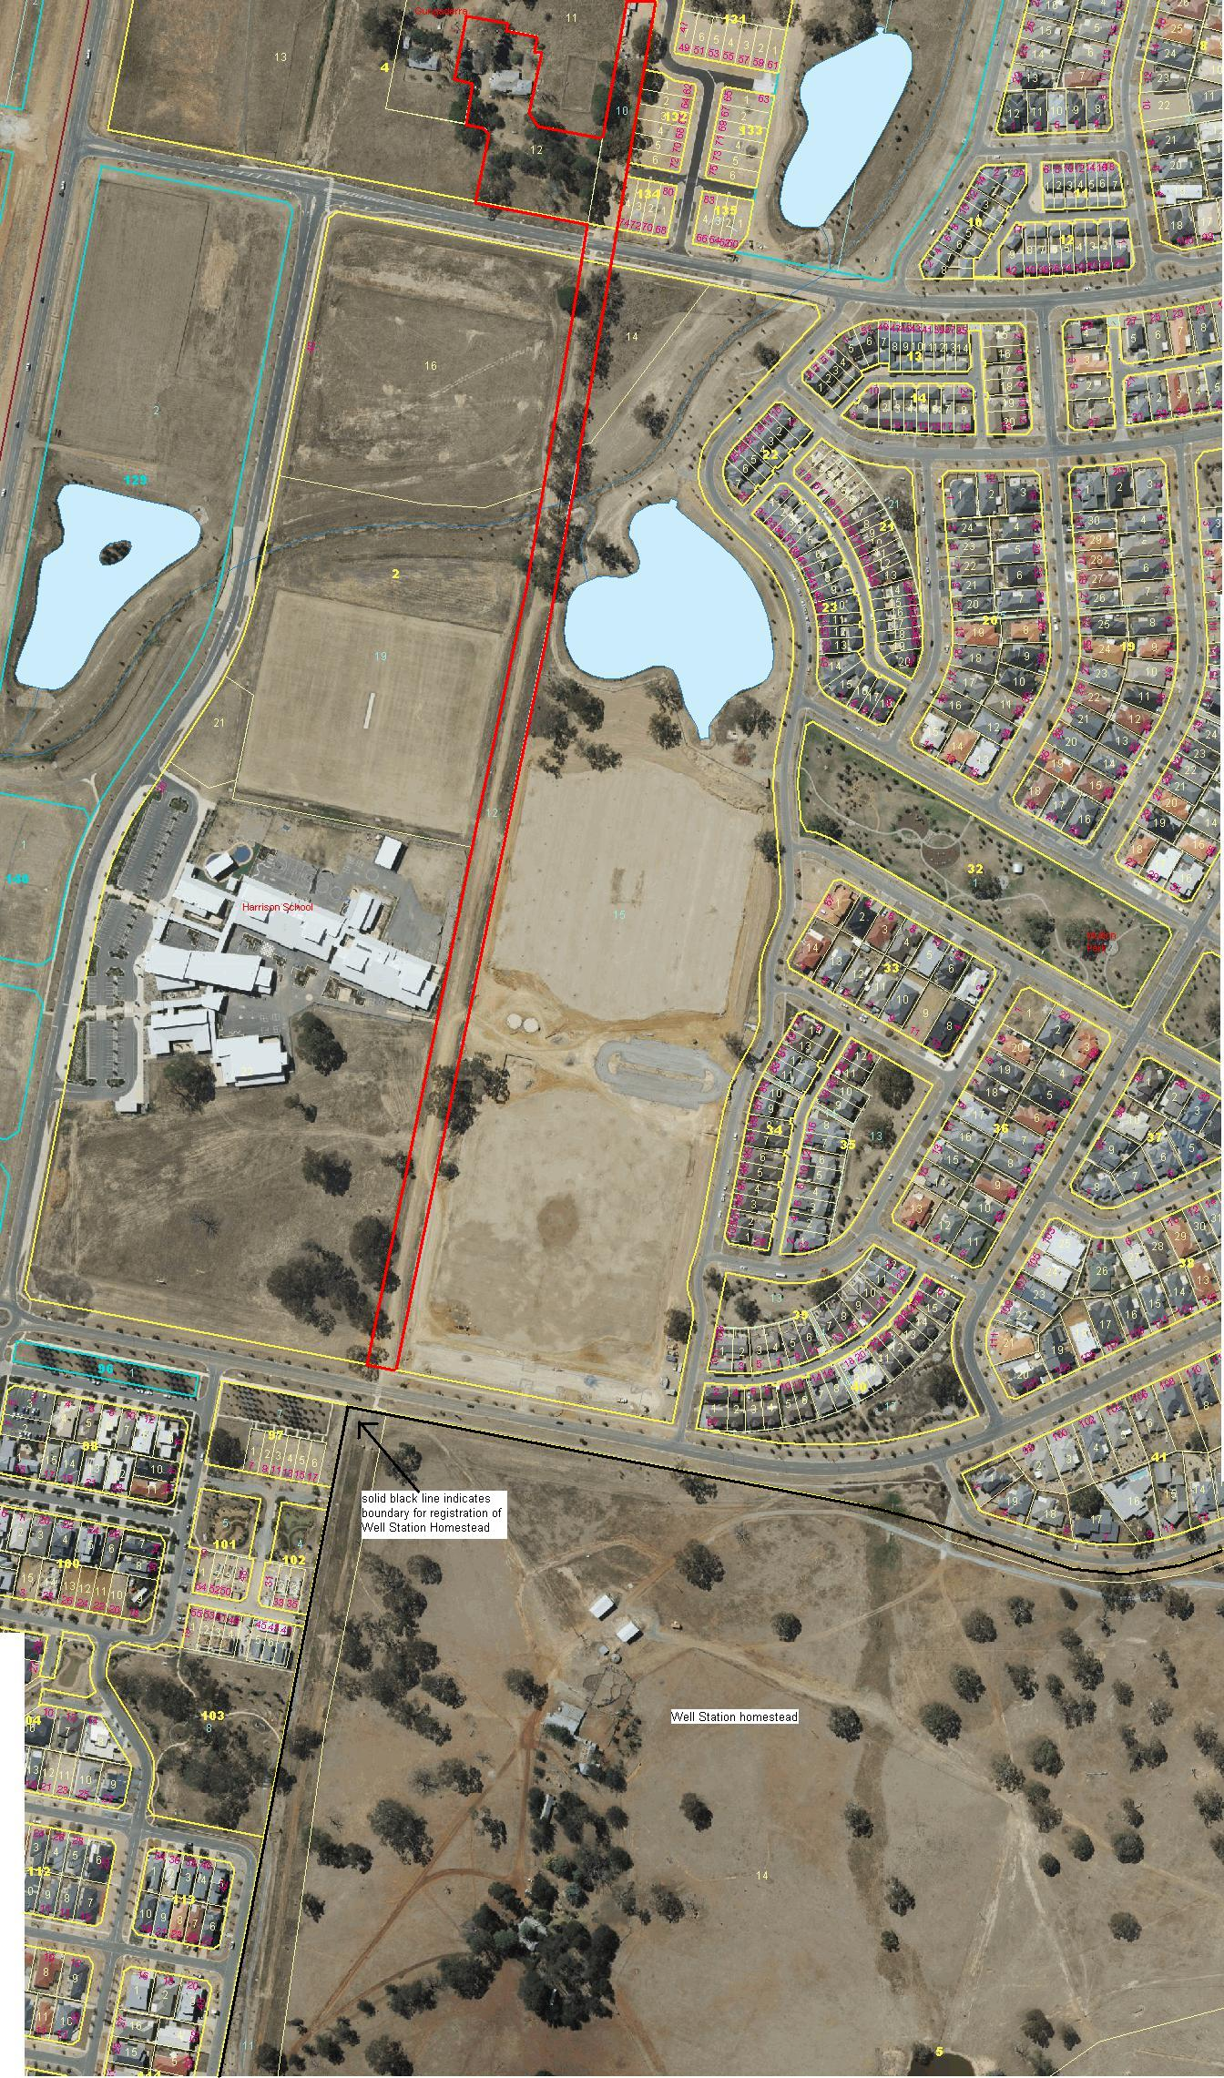
The boundary for the Gungaderra Homestead (& portion of Well Station Road) citation is indicated by the solid red line.
The proximity and relationship to Well Station homestead is also shown on this image.
The area immediately surrounding Gungaderra Homestead has been developed as townhouses and is no longer the pastoral landscape of this aerial image.

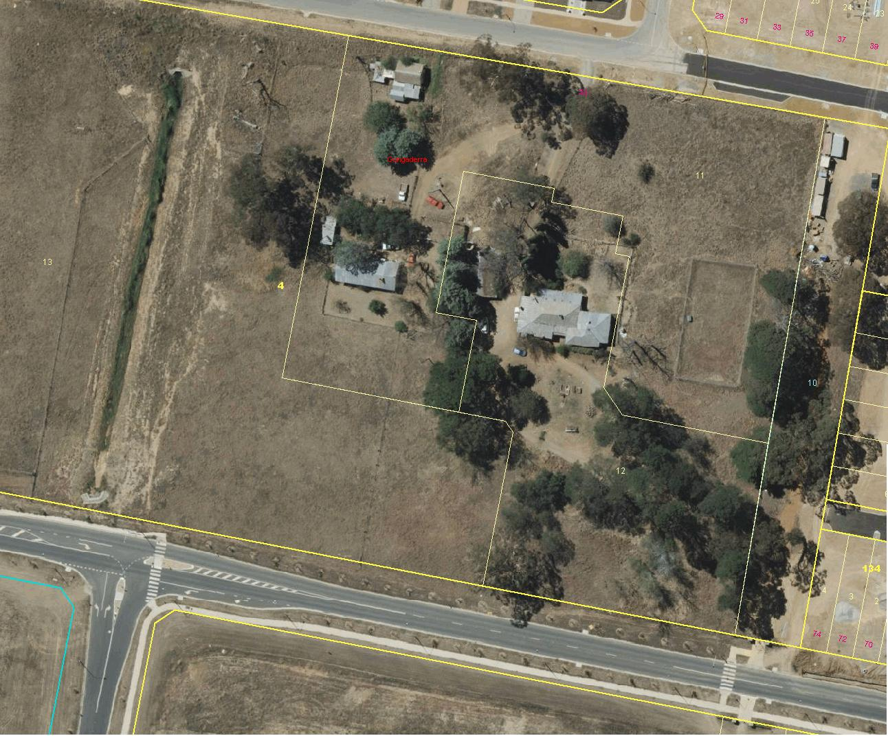
2009 aerial imagery of the Gungaderra homestead, showing individual features
n.b – the buildings to the west of Block 12 have been demolished to make way for new housing development.
The area immediately surrounding Gungaderra Homestead has been developed as townhouses and is no longer the pastoral landscape of this aerial image.

Images taken March 2011
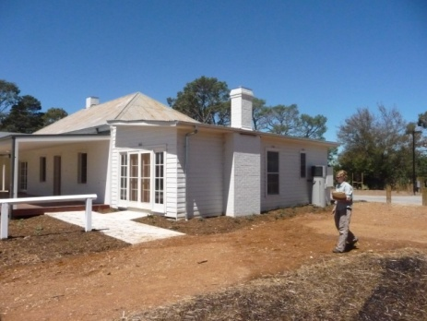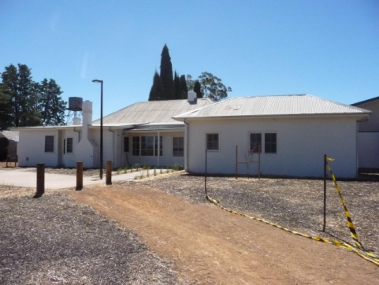
Gungaderra Homestead – front Gungaderra Homestead - rear

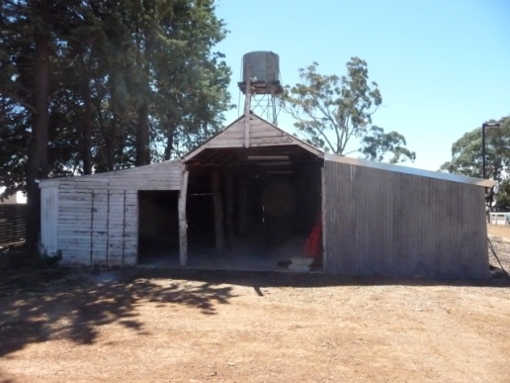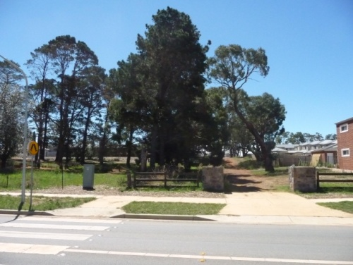
Machinery shed and water tank Mature plantings to the rear of Gungaderra Homestead
Located on Block 12 Section 4 Harrison

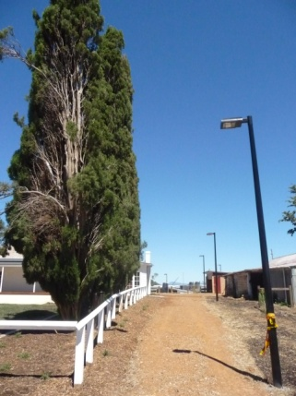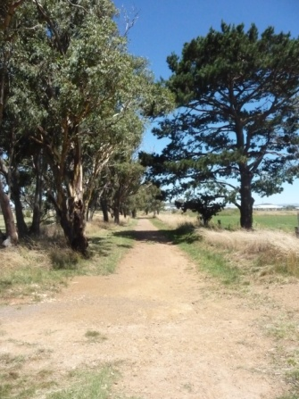
Roman cypresses lining entrance to homestead Well Station Road
Showing relationship of homestead and machinery shed

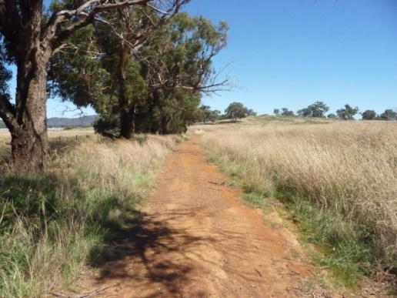
Well Station Road

