Australian Capital Territory
Heritage (Decision about Registration for the Old Coach Road, Gungahlin) Notice 2011
Notifiable Instrument NI 2011 - 642
made under the
Heritage Act 2004 section 42 Notice of Decision about Registration

- Revocation
This instrument replaces NI 2011-372
- Name of instrument
This instrument is the Heritage (Decision about Registration for the Old Coach Road, Gungahlin) Notice 2011 -
- Registration details of the place
Registration details of the place are at Attachment A: Register entry for the old Coach Road, Gungahlin.
- Reason for decision
The ACT Heritage Council has decided that the Old Coach Road, Gungahlin meets one or more of the heritage significance criteria at s 10 of the Heritage Act 2004. The register entry is at Attachment A.
- Date of Registration
20 October 2011

Gerhard Zatschler
Secretary
ACT Heritage Council
20 October 2011

AUSTRALIAN CAPITAL TERRITORY

HERITAGE REGISTER
(Registration Details)

Place No:

For the purposes of s. 41 of the Heritage Act 2004, an entry to the heritage register has been prepared by the ACT Heritage Council for the following place:

Old Coach Road, District of Gungahlin

(Part) Block 784, District of Gungahlin

DATE OF REGISTRATION

Notified: 20 October 2011 Notifiable Instrument: 2011-642

Copies of the Register Entry are available for inspection at the ACT Heritage Unit. For further information please contact:

The Secretary
ACT Heritage Council
GPO Box 158, Canberra, ACT 2601

Telephone: 13 22 81 Facsimile: (02) 6207 2229

IDENTIFICATION OF THE PLACE

Old Coach Road, District of Gungahlin
(Part) Block 784, District of Gungahlin

STATEMENT OF HERITAGE SIGNIFICANCE

This statement refers to the Heritage Significance of the place as required in s12(d) of the Heritage Act 2004.

The Old Coach Road is significant as an historical marker in the landscape, evocative of a time in the late nineteenth century when the bushman, the homesteader, the school child and churchgoer, the local magistrate or parson, the mail carrier and the bullock dray driver would use this roadway as a means of access to and from an isolated rural region. It is an important component in understanding the land use and function of nineteenth century rural road and transport systems in the region, and in understanding modes of travel and transport of those who lived in the area, as well as the provision of goods and services.

The remnant of this road today demonstrates an important layer of ACT history in that it was a vital aspect of daily life in an era prior to modern transportation and communication facilities and services. While there are a number of remaining nineteenth century rural homesteads and properties within the area which demonstrate aspects of domestic and work life from this time, there are few places which demonstrate the modes of transport and movement which are crucial to an understanding of the cultural phase of nineteenth century rural development and activity in the region.

Where once there were a number of roads linking the rural homesteads and properties in the region and providing access to and from the region, many of these have disappeared from the landscape due to more recent development. In some cases, the road alignment has been utilised for modern infrastructure. However, there are few roads which have a level of intactness comparable to the Old Coach Road, able to bear testimony to the rural character of the nineteenth century including its gravel nature and tree-lined corridor. As such, it is a rare and notable example of this kind of place.

Other related registrations
A number of rural places within the Gungahlin area, pre-dating the establishment of the Federal Capital Territory are separately nominated or registered on the ACT Heritage Register. Places within the vicinity of the Old Coach Road, and of the same history include:

- Gungaderra Homestead (and portion of Well Station Road);
- Well Station Homestead (and portion of Well Station Road);
- Horse Park Homestead;
- Elm Grove;
- Canberra Park; and
- Mulligan’s Flat ploughlands.

FEATURES INTRINSIC TO THE HERITAGE SIGNIFICANCE OF THE PLACE

The features intrinsic to the heritage significance of the Place and which require conservation comprise:

Old Coach Road
- The road corridor and surface elements
- A boundary 10 metres either side of the road verge
- Vegetation within the boundary, including:
  - Eucalypt species which edge the roadside and provide shading.

APPLICABLE HERITAGE GUIDELINES

The guiding conservation objective is that the Old Coach Road, Gungahlin, shall be conserved and appropriately managed in a manner respecting its heritage significance and the features intrinsic to that heritage significance, and consistent with a sympathetic and viable use or uses. Any works that have a potential impact on significant fabric (and / or other heritage values) shall be guided by a professionally documented assessment and conservation policy relevant to that area or component (i.e. a Statement of Heritage Effects – SHE).

REASON FOR REGISTRATION

The Old Coach Road, Gungahlin has been assessed against the heritage significance criteria and been found to have heritage significance when assessed against four criteria under the ACT Heritage Act.

ASSESSMENT AGAINST THE HERITAGE SIGNIFICANCE CRITERIA

Pursuant to s.10 of the Heritage Act 2004, a place or object has heritage significance if it satisfies one or more of the following criteria. Significance has been determined by research as accessed in the references below. Future research may alter the findings of this assessment.

- it demonstrates a high degree of technical or creative achievement (or both), by showing qualities of innovation, discovery, invention or an exceptionally fine level of application of existing techniques or approaches;

The Old Coach Road does not meet this criterion.

- it exhibits outstanding design or aesthetic qualities valued by the community or a cultural group;

No information has been provided to suggest that the aesthetic qualities of the Old Coach Road are highly valued by the community or a cultural group.

The Old Coach Road cannot be assessed in relation to this criterion.

- it is important as evidence of a distinctive way of life, taste, tradition, religion, land use, custom, process, design or function that is no longer practised, is in danger of being lost or is of exceptional interest;

The Old Coach Road is important as evidence of a distinctive land use and function of exceptional interest—that of nineteenth century rural road and transport systems.
These roads provided a mode of access between isolated rural homesteads and properties, and provided vital links for the bushman, the homesteader, the school child and churchgoer, the local magistrate or parson, the mail carrier and the bullock dray driver. The Old Coach Road also provided a major transportation link by which goods and services could reach the rural settlements of the Canberra area and by which the rural residents could travel and keep in contact with family members.

Nineteenth century rural roads were traversed by foot, coach or horse travel. These types of rural links and routes were prominent in the area prior to the formation of the Federal Capital Territory. From this time, their purpose as linking routes was diminished by other modes of transportation and communication and the roads were subsumed into modern road network development, rail and highway travel.
For a short period The Old Coach Road was the major link between the northern rural settlements and the railhead at Bungendore. The remnant of this road today demonstrates an important layer of ACT history in that it was a vital aspect of daily life, reflecting the connectivity and relationships between nineteenth century rural properties.

The section of road in its extant form is important as evidence of this land use history as an early transportation corridor, and remains as a strong and evocative historical marker in the landscape.

The Old Coach Road meets this criterion.

- it is highly valued by the community or a cultural group for reasons of strong or special religious, spiritual, cultural, educational or social associations;

No information has been provided to suggest that the community or a cultural group highly values this place.

The Old Coach Road cannot be assessed in relation to this criterion.

- it is significant to the ACT because of its importance as part of local Aboriginal tradition

Not applicable.

- it is a rare or unique example of its kind, or is rare or unique in its comparative intactness

The Old Coach Road is a rare example of a nineteenth century transport link in an isolated rural region of what has since become the ACT.

The character of the ACT has changed dramatically since 1913, with today’s city landscape deceptive of its early origins. It is often difficult to read the past agricultural and pastoral land use of the region, and the land uses and way of life of the early settlers.

Where once there were a number of roads linking the rural homesteads and properties in the region and providing access to and from the region, many of these have disappeared from the landscape due to more recent development. In some cases, the road alignment has been utilised for modern infrastructure. However, there are few roads which have a level of intactness comparable to the Old Coach Road, able to bear testimony to the rural character of the nineteenth century including its natural surface material of compacted earth and its tree-lined corridor.

The 1915 Federal Capital Territory Feature Map indicates the number of roads and tracks in the region at that time. Today, existing roads from this time which retain a high degree of intactness include Well Station Road and the Old Coach Road.

The Old Coach Road meets this criterion.

- it is a notable example of a kind of place or object and demonstrates the main characteristics of that kind

The Old Coach Road is a notable example of a nineteenth century rural road. It demonstrates the main characteristics of this kind of place through the tree-lined corridor of native vegetation of Yellow Box and Red Gum, the rural character of the road with its natural surface material of compacted earth, and the surrounding areas and vistas of native grasslands and woodlands, evocative of the nineteenth century.

This is notable example of such a road, as it provides a good indication of what the former nineteenth century road networks were like in the region. The Old Coach Road demonstrates how the former roads were surveyed to follow the contours of the landscape, how they were built from the natural geological structures through which they traversed, and the obstacles (rural property boundaries and creek lines) they had to traverse.

The Old Coach Road meets this criterion.

- it has strong or special associations with a person, group, event, development or cultural phase in local or national history

The Old Coach Road has a special association with a cultural phase in the history of the ACT.

While there are a number of remaining nineteenth century rural homesteads and properties within the area which demonstrate aspects of domestic and work life from this time, there are few places which demonstrate the modes of transport and movement, which are crucial to an understanding of the cultural phase of nineteenth century rural development and activity in the region.

This association is considered special, given the few places remaining which are able to portray aspects of nineteenth century rural development and activity outside of domestic and work spaces.

The Old Coach Road meets this criterion.

- it is significant for understanding the evolution of natural landscapes, including significant geological features, landforms, biota or natural processes

Not applicable.

- it has provided, or is likely to provide, information that will contribute significantly to a wider understanding of the natural or cultural history of the ACT because of its use or potential use as a research site or object, teaching site or object, type locality or benchmark site

The Old Coach Road does not meet this criterion.

- for a place—it exhibits unusual richness, diversity or significant transitions of flora, fauna or natural landscapes and their elements

Not applicable.

- for a place—it is a significant ecological community, habitat or locality for any of the following:
(i) the life cycle of native species;
(ii) rare, threatened or uncommon species;
(iii) species at the limits of their natural range;
(iv) distinct occurrences of species.

Not applicable.

SUMMARY OF THE PLACE
HISTORY AND PHYSICAL DESCRIPTION

HISTORY
Gungahlin and Mulligan’s Flat contextual history
Prior to European settlement archaeological evidence has shown that Aboriginal groups extensively used the area. A recent archaeological survey of Mulligans Flat has identified several stone artefact surface scatters, two of which are located in the immediate vicinity of the Old Coach Road (Saunders 2004).

The Gungahlin area was first sighted by European explorers when Charles Throsby passed through the northern part of what was to become the ACT in October 1820. Agricultural development of the ACT followed soon after in close association with pastoral settlement. Land was first taken up in the Ginninderra district in about 1826 by George Thomas Palmer, who settled land (granted in 1831) at ‘Palmerville’ (later ‘Ginninderra’), his station buildings being located on Ginninderra Creek south of the Yass Road (Portion 20, Parish Canberra).

It has been suggested that Palmer acquired additional land in 1835-36 partly for the purpose of establishing or extending the cultivation of wheat. Palmer was followed by others, all on a smaller scale of rural operation, and gradually extending settlement into the north Gungahlin area.

The first European settlers in the Mulligans Flat area of Gungahlin were William Ryan and John Gillespie. Ryan was living in the area when his son was born in 1844 and by 1856 he held a lease over a section of Mulligans Flat (Gillespie 1992:13). Gillespie lived in the Gungahlin area from 1844 and in 1852 he and his wife Mary Ann established the ‘Horse Park’ homestead, which is the oldest occupied homestead in the district.

Until 1861 the majority of landholders took up large blocks, or amalgamated smaller holdings into larger agglomerations (as in the case of the Rolfes and Gillespies, for example). The Robertson Land Act of 1861 saw a major increase in the selection of smaller holdings in the district. The selectors were limited, because of earlier land alienation, to the less desirable and less-well watered lands in the northern and western part of Gungahlin, and longer established landholders (and free selectors themselves) used the Robertson Act to extend their land holdings. Examples include John and Jemima Winter (‘Red Hill’, later Gungaderra), Henry Gozzard (‘Aston’), as well as Thomas Gribble, Archibald McKeahnie, Edward Ryan, Timothy Ryan, John Walsh and William and Walter Ginn.

Old Coach Road
Nineteenth century road development in the ACT region can be categorised into three phases. The first phase began with European settlement in the early 1820s and lasted until about 1860. This initial period saw the gradual formation of bush tracks originally following the course of well-frequented pathways, which criss-crossed the settled areas linking rural homesteads with burgeoning commercial centres.

The second phase was underway by the mid 1870s when the tracks were extensively surveyed and official road corridors were proclaimed. Following the proclamation of roads, formalised government construction, stabilisation and maintenance projects were put in place to keep the roads functioning and open.

The third phase, which stretched to the end of the nineteenth century, is characterised by the construction of new roads, as well as the realignment of former roads and tracks to serve the new centres of population created by the spread of small proprietors after the liberalisation of land legislation (Lea Scarlett 1968: 81). This third wave preceded the even larger redevelopment of the road system following the proclamation of the area for the Federal Capital Territory in 1911 (Gillespie 1991: 249).

The Old Coach Road, constructed in 1880 during the second phase of road development, was the main route which linked the early rural settlements in the Canberra/Queanbeyan region to Bungendore, Lake Bathurst and eventually Sydney. It was also a link between Bungendore and Gundaroo, offering a much shorter route than the former way via Queanbeyan and Canberra. It provided a valuable social function as well as essential services which included the mail coach, a means to get to school, church and other social activities and a supply route. The road was traversed on foot, by horse and cart, bullock drays and the single bushman/farmer on horseback. It soon became an important road linking dotted homesteads and isolated rural regions to the railhead at Bungendore after 1885. From there the train would make the long journey to Sydney more comfortable and efficient. The Old Coach Road also shortened the distance of traversing the region and thereby enhanced the quality of life for people on the land in the nineteenth and early twentieth centuries.

By the third phase of road development, however, it was not heavily utilised and most likely served only as a local link after the railway line linking Cooma, Queanbeyan and Bungendore was completed in September 1887 (Andrews et al. 1990: 6).

The 1915 Federal Capital Territory Feature Map (Sheet 1) shows the route beginning at Gundaroo Road and running east to pass out of the ACT border on the lower slopes of Gooroo Hill (NSW). The road then turned southeast and later south and then linked with Macs Reef Road to cross the Lake George Range and join the Great Southern Road at Bungendore.

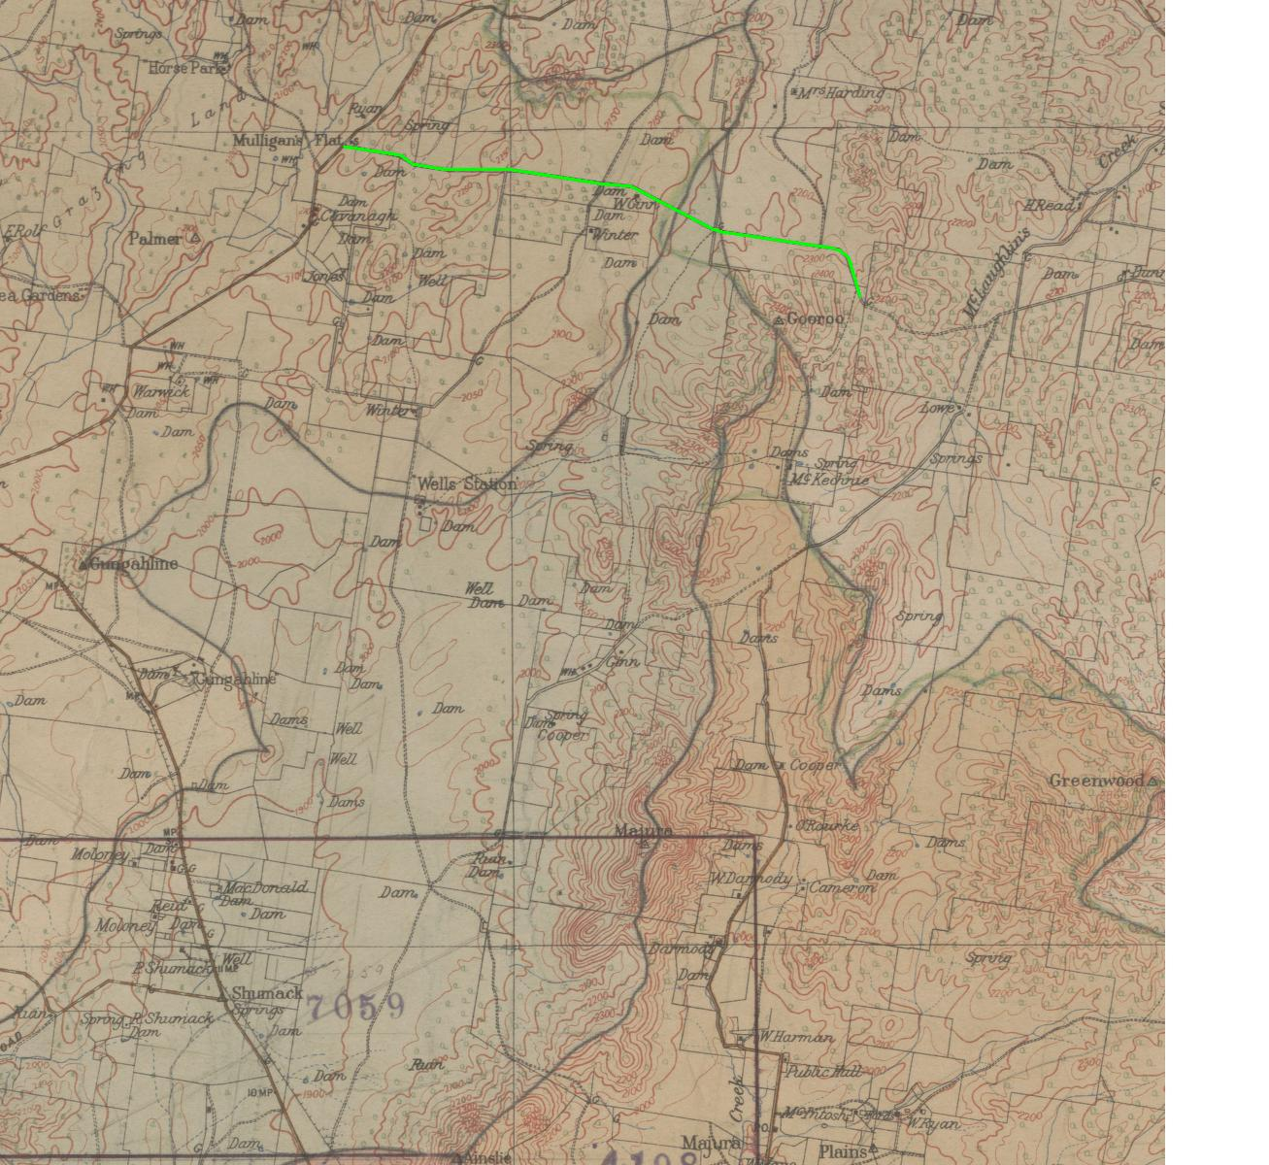
1915 Federal Capital Territory Feature Map (Sheet 1)
http://www.nla.gov.au/apps/cdview?pi=nla.map-nic21-v
The green line on the map above shows the route of the Old Coach Road.

In the ACT the road ran through gentle sloping country, first passing the Mulligans Flat School, which opened in April 1896, near the Gundaroo Road junction and several of the early settlements and dwellings in the area, such as, “East View” owned by the Cavanagh family, “The Retreat”, “Aston”, “Inglewood”—the home of Joseph and Elizabeth Winter, and finally Walter Ginn’s property and orchard at “Dungarvon” as it crossed the border. For most of its route through Mulligans Flat the road was confined between 6-wire fence on its northern side and a log fence on its southern side and crossed the property boundaries by gateways across the road.

The term ‘road’ when applied to the Old Coach Road, and indeed many of the other rural links in the last decades of the nineteenth century is somewhat a misnomer. Like many of the rural link roads, the Old Coach Road was rutted, poorly maintained, often deteriorating into watery morasses at creek lines and low lying areas. It sometimes proved more a hindrance to progress and “one which outlived a good many of those who struggled” along it (Lea-Scarlett 1968: 89). From Sydney to Berrima the road was well formed and passable in all but the most severe weather conditions. Between Berrima and Bungendore and then on to Canberra/Queanbeyan the route was more of a track than a road. One hardy traveller referred to it as “nothing but a bush track, with no bridges over the water courses”. Such a description can be seen in the section of the Old Coach Road as it passes through Mulligans Flat. Nevertheless it was an important ‘road’ and provided an essential travel way linking rural settlements until the railway put an end to the coaching days. Another traveller described the road networks as being “…quite lively … what with the whole travelling public, including such a large number of carriers, with hundreds of horses and working bullocks, and bells by hundreds tinkling, from the deep note of the bull-frog to the little sheep tinkle” (Lea-Scarlett 1968:81-82).

DESCRIPTION
The Old Coach Road formed a link between the Gundaroo Road, and Bungendore linking up with Macs Reef Road in New South Wales.

Although much of the original route of the Old Coach Road no longer exists in its original form, part of the section traversing Mulligans Flat Nature Reserve still retains a good deal of its original fabric and structural form.

This section of the Old Coach Road is clearly defined, extending from the visitors’ information board on the main walking trail east for approximately one km in an easterly direction towards the ACT/NSW border.

The road corridor traces its way through the grassy woodland of central Mulligans Flat. The corridor is lined by native vegetation species primarily Red Gum (Eucalyptus blakleyi) and Yellow Box (Eucalyptus melliodora) trees, which closely border the edge of the road. The road follows the natural topography of the area and was surveyed to run mainly along the lower sections of sloping land above the more gently sloping terrain in the southern section of the Flat. There are no discernable road cuttings through the higher parts of the route.

Approximately 100 metres from the beginning point near the visitors’ information board the road crosses a natural drainage line and a former crossing is evident immediately to the south of the existing route. The crossing follows the contours of the drainage line and embankment and is constructed of local stone cemented into the bed of the drainage line forming a floodway. At a point the road corridor crosses the saddle of a quartz ridge and the surface of the road is littered with quartzite debris. At another point an ‘S’ bend marks the original route through a former gate way.

The road surface is compacted earth made from the naturally occurring geological elements and was most likely the original surface for much of its route through Mulligans Flat. This surface is evident for approximately one kilometre to a point adjacent to where a walking trail and bird walk trail meet. At this point a drainage line and a small artificial embankment form a barrier across the road and mark the visible termination of the road surface.

REFERENCES

Andrews, W.C. et al. 1990 Canberra’s Engineering Heritage, Second edition, Canberra Division, The Institute of Engineers, Australia, Canberra.

Gillespie, L. 1991 Canberra 1820-1913. Australian Government Printing Service, Canberra.

Gillespie, L. 1992 Ginninderra, Forerunner to Canberra. A history of the Ginninderra District, The Wizard, Canberra Local History Series, Canberra.

Gillespie, L. 1999 Early Education and Schools in the Canberra Region, The Wizard, Canberra Local History Series, Canberra.

Lea-Scarlett, E. 1968 Queanbeyan. District and People, Queanbeyan Municipal Council, Queanbeyan.

Lindemayer, B. 1992 The natural and Cultural Significance of Mulligan’s Flat, Gungahlin, ACT. A Nature Reserve Proposal. Joint submission to Hon. Rosemary Follett, ACT Chief Minister.

McLeod, E. 1976 The Three Mulligan’s Flat Schools, compiled by one of the teachers, Miss Harris (now Mrs McLeod) 1917-21, Canberra and District historical Society Newsletter, August 1976.

Pearson, M. 2002 Gungahlin Pastoral Places Comparative Assessment, unpublished report for Heritage Unit, Environment ACT, Canberra.

Saunders, P. 2004 Investigation of Aboriginal Heritage Places along Fire trails in Canberra nature Parks, unpublished report, Archaeological Heritage Surveys, Canberra.

Williiams, D. & Barber, M. 1995 A Preliminary Cultural Resource Survey of an Area (Stage 2) of Mulligans Flat Reserve, Gungahlin, ACT, Williams and Barber Archaeological Services, Canberra.

SITE PLAN AND IMAGES

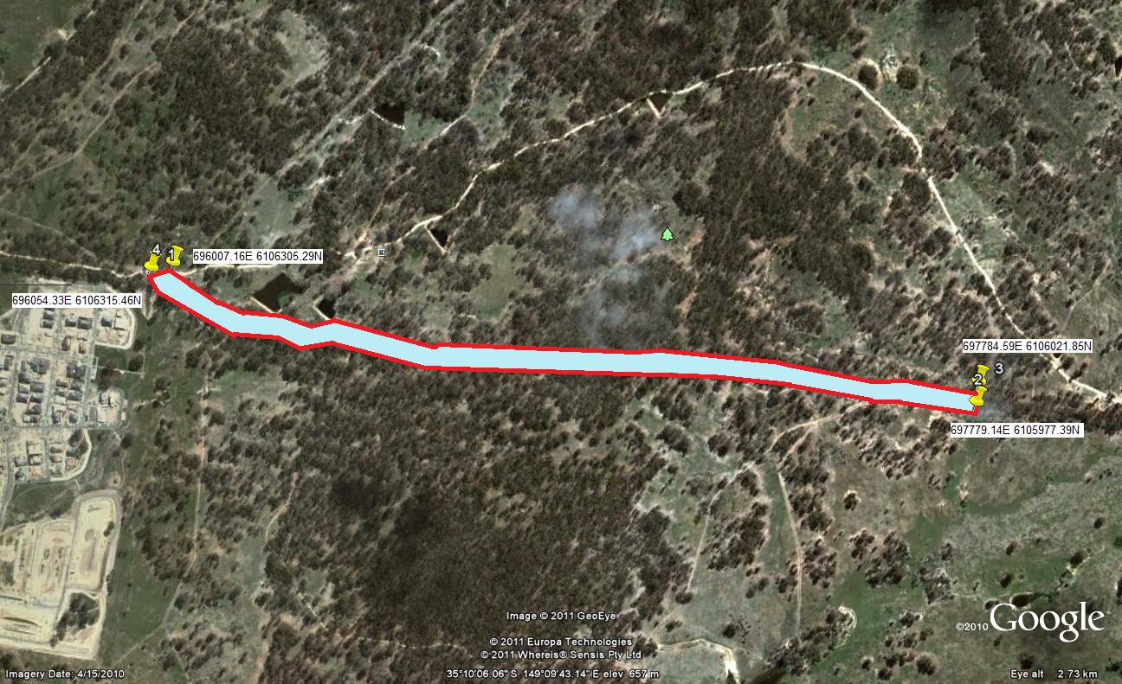

The boundary for this place is identified by the solid red line shown in the figure above.
The boundary includes the road corridor and buffer zone 10 metres either side of the road verge from AMG points 696007.16E 6106305.29N and 696054.33E 6106315.46N to 6977784.59E 6106021.85N and 697779.14E 6105977.39N.

Images taken 8 April 2011

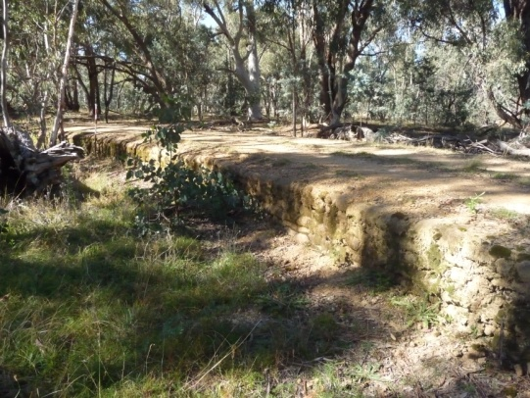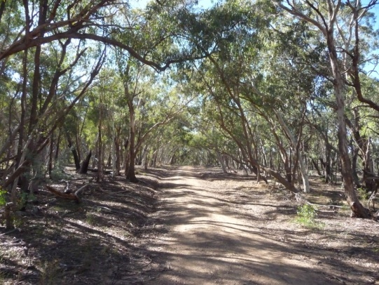

Stone embankment Road surface and tree corridor

NON-STATUTORY BACKGROUND INFORMATION

The Mulligan’s Flat School Site and the site of Walter Ginn’s Homestead (including orchard) are interesting historical elements which were developed alongside the Old Coach Road, soon after its construction. While there are no built structures which remain at either site, some features remain as markers in the landscape, evident of the history of the area. These features include brick scatters and tree plantings.

While these features have been assessed as not meeting the criteria of the Heritage Act 2004, their historical interest and contribution to the landscape is worth noting.

Old Coach Road corridor

The following component of the original Old Coach Road does not form part of this citation but is a noteworthy historical element:

From the eastern-most point of this citation’s boundary for the Old Coach Road, the tree-lined road corridor continues to the NSW border and is evident by a corridor bordered by Red Gum and Yellow Box trees. It forms a subtle element in the landscape, though the former road surface is no longer visible. It may still exist under the present surface of vegetative litter and humus. The road corridor reaches and terminates at the fence line marking the ACT/NSW border. Looking from the ACT side of the border into NSW there is no visible sign of the road surface or corridor (see aerial imagery below).

Mulligans Flat School
In 1894, as a response to the growing community of young families in Ginninderra, land was set aside for a small school at Mulligans Flat. The land was selected by the NSW Department of Education School Inspector, M. Willis, at the junction of Gundaroo Road and the recently constructed road to the Bungendore railhead (Old Coach Road). The site would have been readily accessible as both these roads were well-used transport links at the time. The inspector recommended that the local residents with school-age children provide a suitable building for the students. However, it was not until April 1896 that a building was erected and the first students began to attend the school with James Gibson as the first teacher. It began operation as a Provisional School. Provisional schools were established in rural areas where an attendance between 15 and 25 students could be expected and were under the charge of an itinerant teacher. They later became known as half-time schools with one teacher operating two schools in nearby areas.

There were two buildings erected on the site, one probably in late 1895 and a second in 1913. There are two varying descriptions of the 1895 schoolhouse. The earlier source by a former teacher at the school (Mcleod 1976) described the structure as being built in 1890 (almost certainly the wrong date) with timber slab walls, iron roof, boarded floor with a ceiling lined with hessian covered with paper for insulation. Water for the students was provided at first from a cask filled by rainwater from the iron roof and later by a square iron ship’s tank donated by William Ryan from the neighbouring property of Horse Park. A second description (Gillespie 1999:41) has the schoolhouse constructed in 1895 as a simple slab structure measuring 18 feet by 10 ½ feet by 7 feet high (4.5m by 3.2m by 2.1m) with a shingle roof and probably with just a single-room.

In later years this building was found to be insubstantial and uncomfortable for the students. In 1913, following an application by local residents, a new government school was erected on the site. Ethel McLeod (nee Harris) a schoolteacher at Mulligans Flat between 1917 and 1921 described it as:

‘…at that time a quite modern and commodious building, weatherboard, iron-roofed, pine lined and ceiled, well ventilated with three large windows and a hat, bag and washing porch running the full length of one side. Two good corrugated iron tanks were provided and two pit toilets well up the school ground, but no shelter shed’ (McLeod 1976).

This building was designed on a plan for New South Wales School Board plan and measured 18 feet by 17½ feet (5.4m by 5.3m). A shelter-shed was later built on site for the students with funds raised by a dance night in the Horse Park Granary (McLeod 1976).

Photographic evidence of the second school shows that it was a single room building constructed of weatherboard with a gabled roof of corrugated iron. The building was supported by stone and brick footings. Two concrete steps led up to a wide doorway. A circular corrugated iron tank resting on a circular stone and concrete base was connected by downpipes to the tank (Gillespie 1999).

The pine trees on the site date between 1917 and 1921. The Yarralumla Nursery donated the pine saplings to the school and Ethel Harris organized the children to plant them as a boundary around the yard. The older boys were responsible for digging the holes in the hard ground for the seedlings and the young girls, along with their teacher, were responsible for the alignment, measuring, planting and staking up the saplings (Mcleod 1976).

The school operated often as a half-time school but because of fluctuating numbers of students and the difficulty in keeping teachers it closed between October 1907 and May 1910 and again between October 1921 and March 1922. The school finally ceased operating in May 1931. By that time the young students in the Ginninderra region were attending several other schools and there were few from the immediate surrounds that would attend the small Mulligans Flat School. During its periods of operation 18 teachers were assigned to the school – most served for periods of less than 2 and ½ years; the longest to serve were Ethel Harris (later McLeod) 4 years 7 months and James Gormly for 3 years 7 months (Gillespie 1999:154). When it closed the school building, shelter shed and associated structures were dismantled, removed from the site and sold.

The Mulligans Flat School Ruin is situated on the junction of the former Old Gundaroo Road and Old Coach Road.

Little now remains on the surface of these two former school buildings, as both were largely timber constructions. Broken and scattered remains of the concrete front steps, stone and concrete footings of a circular corrugated iron tank stand are all that remain visible on the surface. Photographic evidence suggests that this material is associated with the second schoolhouse erected on the site in 1913. Several mounds and depressions and ground surface irregularities mark the site of the school building. There is a high possibility of sub surface remains, particularly relating to the second schoolhouse and possibly artefacts relating to the activities of the school and students within the former school yard.

The site is bordered on 4 sides by plantings of pine trees (Pinus radiata), which once formed the boundary of the schoolyard. The pine trees were planted by the school children between 1917 and 1921 and are nearing senescence - several have died and fallen. Another remnant species associated with the former school is a Photinia sp which would have grown in front of the former school house.

The Mulligan’s Flat School Site is situated to the west of this citation’s boundary for the Old Coach Road (see aerial imagery below).

Walter Ginn’s Homestead (Dungarvon)
Walter Ginn was born in 1854, the son of William and Mary Ginn of Herfordshire, England. Walter, his parents and a younger brother arrived in Australia in 1857 as Bounty Scheme immigrants. Bounty Scheme immigrants, usually young parents and families, had their fares from England to Australia wholly or partly paid for by the Colonial government. The families were screened in their home countries and had to be of first-rate character and ‘of good bodily health and strength’ (see Gillespie 1992: 252).

William Ginn was employed as a ploughman on Campbell’s Duntroon estate and the young family became the first residents of Blundell’s Cottage living there from c.1860 until 1874. Following the institution of the Robertson Land Act in 1861 William Ginn selected land in the parish of Goorooyaroo and built a small homestead there (Canberra Park).

Probably during the mid 1870s, Walter and his young brother, Harry, left the parental home at Duntroon and together farmed the Goorooyaroo holding. The land in the area was generally seen as poor farm land, hard, stony and thickly timbered but the two young Ginn brothers worked vigorously, acquired more land using the Robertson Land Act in the area and were able to turn their farm into productive holdings.

Walter, who remained a bachelor all his life, moved to one of the holdings nearby to the north of the original homestead in what is now the Mulligans Flat Nature Park. He built a small homestead probably around 1886 (Pearson 2002), shearing shed, yards and established an orchard and garden either side of the Old Coach Road. Walter named the holding ‘Dungarvon’. He farmed his holding until around 1920, when in his sixties, he moved to Canberra probably as a result of the land resumption in the area associated with the Federal Capital Territory.

Walter died in 1925 and is buried in St John’s cemetery. The saddle where the present Federal highway crosses Mt Majura on the ACT/NSW border is known as Ginn’s Gap, named after the family who farmed the area.

The eastern corridor of the Old Coach Road runs through the site of Walter Ginn’s homestead and orchard. The homestead site is located at the western foot of a slope leading up to the ACT/NSW border. Little remains of the homestead today apart from scattered brick fragments from the brick chimney of the house, stone footing sections of the house platform, and remnant fence wire from yards. The 1915 ACT feature map marks the site as W. Ginn’s orchard.

Fruit trees, including apple trees, are located on both sides of the Old Coach Road corridor and are the remnants of the orchard, which Walter planted.

The site of Ginn’s homestead and orchard is situated to the east of this citation’s boundary for the Old Coach Road (see aerial imagery below).

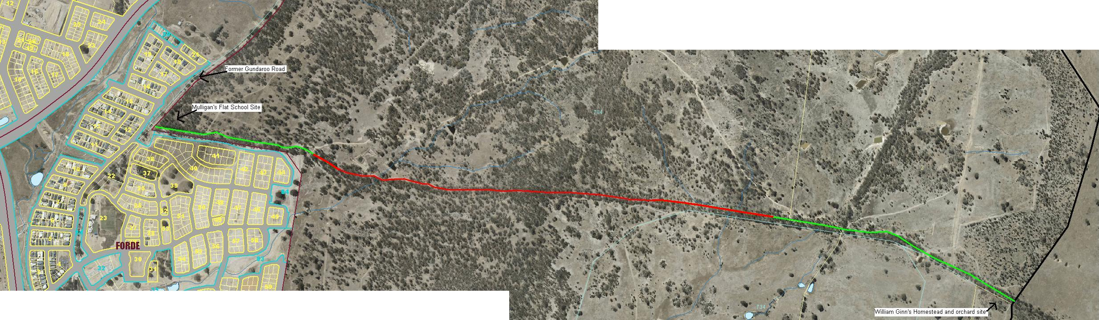

Indicative map of the Old Coach area, including the registered place and sites of historical interest.
The registered area of the Old Coach Road is shown in red.
Former areas of the Old Coach Road are shown in green, but do not form part of this citation, due to the loss of integrity of these areas of the road.
The former Gundaroo Road is shown to the west of the Old Coach Road.
The site of the Mulligan’s Flat School is shown at the junction of Gundaroo Road and the Old Coach Road.
The site of Walter Ginn’s homestead and orchard are shown to the eastern end of the former Old Coach Road, near the border with NSW.

