Australian Capital Territory
Road Transport (Public Passenger Services) Taxi Network Livery Approval 2011 (No 4)

Notifiable Instrument NI 2011 - 664
made under the
Road Transport (Public Passenger Services) Regulation 2002, s107 (Taxi Network Livery)

1. Name of instrument

This instrument is the Road Transport (Public Passenger Services) Taxi Network Livery Approval 2011 (No 4).

2. Commencement

This instrument commences on 17 October 2011.

3. Approval

I approve the use of the 100 Canberra Logo on vehicles for both Aerial Capital Group Ltd and Cabxpress Pty Limited specified in Schedule 1 of this instrument.

Kerry Bell
Delegate of the Road Transport Authority
17 October 2011

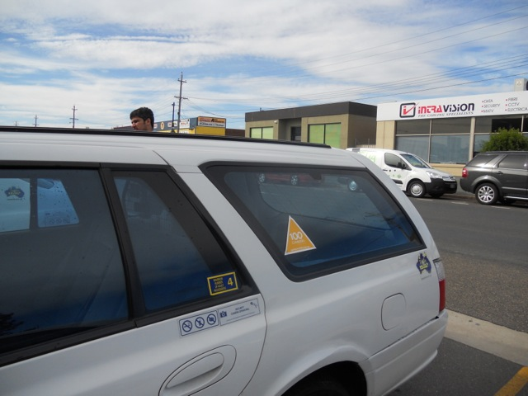

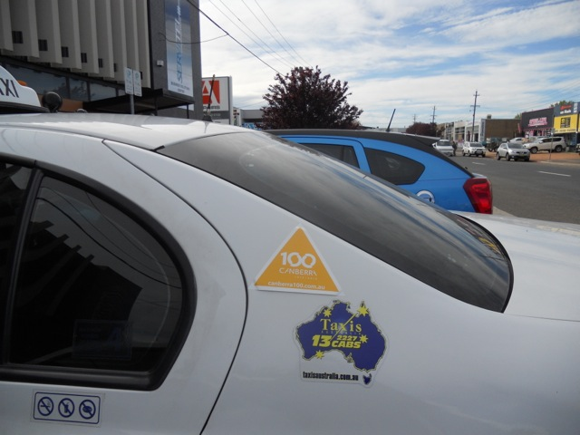

.............
Initials

