Australian Capital Territory
Planning and Development (Draft Variation Number 308) Consultation Notice 2011 (No 2)

Cooyong Street Urban Renewal Precinct
Notifiable instrument NI2011—727
Made under the
Planning and Development Act 2007, section 63 (Public consultation—notification) and section 64 (Public consultation—notice of interim effect etc)

- Revocation
This instrument revokes Planning and Development (Draft Variation Number 308) Consultation Notice 2011 Cooyong Street Urban Renewal Precinct (NI2011-721).
- Public consultation notice
Draft Variation 308 to the Territory Plan (see Annexure A) proposes to change the zoning of the Allawah, Bega and Currong Flats precinct in Braddon and Reid, which is currently used for public housing and various church uses. The draft variation also proposes to introduce a precinct code for the area. The proposed variation will allow high density residential and mixed-use development with some retail and office space.
Written comments from the public are invited by COB Monday 20 February 2012.

Comments should include reference to the draft variation, your name and contact details and be:
- emailed to terrplan@act.gov.au
- mailed to ‘Territory Plan Comments’, Environment and Sustainable Development Directorate GPO Box 1908, Canberra, ACT 2601, or
- delivered to ESDD’s Customer Service Centre at the above address

Comments received will be made available for public inspection for a period of no less than 15 business days at ESDD’s customer service centre in Dickson the day after the closing date for submissions and on ESDD’s website 10 business days after the closing date for submissions.

Comments made available will include personal contact details unless excluded under section 411 of the Planning and Development Act. A request for exclusion under section 411 must be in writing and clearly identify what you are seeking to exclude and how the request satisfies the exclusion criteria.

The draft variation does not have interim effect and therefore section 65 of the Planning and Development Act does not apply. The current Territory Plan will continue to apply while the variation remains in draft form.

John Meyer
Delegate of the ACT Planning and Land Authority
29 November 2011

Draft Variation to the Territory Plan 308

Cooyong Street Urban Renewal Precinct
Braddon sections 52 and 57 and Reid section 7 Zoning changes and introduction of a precinct code

November 2011

For consultation under section 63 of the Planning and Development Act 2007

This page is intentionally blank.

Contents
1. INTRODUCTION 1
1.1 Summary of the proposal 1
1.2 Outline of the process 1
1.3 This document 2
1.4 Public consultation 2
2. EXPLANATORY STATEMENT 3
2.1 Background 3
2.2 Site description 3
2.2.1 Current Territory Plan Provisions 3
2.3 Proposed changes 5
2.3.1 Proposed changes to the Territory Plan map 5
2.3.2 Proposed changes to Territory Plan 5
2.4 Reasons for the proposed draft variation 5
2.5 Planning context 6
2.5.1 National Capital Plan 6
2.5.2 Territory Plan 6
2.5.3 Planning strategy 6
2.6 Interim effect 7
2.7 Consultation with government agencies 7
3. DRAFT VARIATION 12

This page is intentionally blank.

- INTRODUCTION
  - Summary of the proposal
The purpose of this draft variation is to facilitate the redevelopment of land in Braddon and Reid which is currently used for public housing accommodation at Allawah, Bega and Currong Flats and various church uses. It is proposed to rezone the land to allow high density residential development and mixed-use development with some convenience retailing and office accommodation on part of the site. An area of urban open space is provided to protect a registered tree and improve amenity. A precinct code is to be established to guide development of the area and ensure key planning outcomes including the subdivision pattern, the provision of minimum floor space areas for community facilities, the location of on-street car parking and the maximum height of buildings across the site.
  - Outline of the process
The Commonwealth’s Australian Capital Territory (Planning and Land Management) Act 1988 allows for the Legislative Assembly to make laws to establish a Territory Planning Authority and for that Authority to prepare and administer a Territory Plan. The Planning and Development Act 2007 (the Act) establishes the ACT Planning and Land Authority (ACTPLA) as the Authority which prepares and administers the Territory Plan, including continually reviewing and proposing amendments as necessary. The functions of ACTPLA are administered by Environment and Sustainable Development Directorate (ESDD).
The Territory Plan is comprised of the written statement and a map. The written statement contains a number of parts, namely Governance; Strategic Directions; Zones; Precinct Codes; General Codes; Overlays; Definitions; Structure Plans, Concept Plans and Development Codes for Future Urban Areas.
The Territory Plan Map graphically represents the applicable land use zones (under the categories of Residential, Commercial, Industrial, Community Facility, Urban Parks and Recreation, Transport and Services and Non Urban), precincts and overlays. The zone, precinct and overlay requirements are detailed in the volumes of the Territory Plan.
Draft variations to the Territory Plan are prepared in accordance with the Act. Following the release of the draft variation under section 63 of the Act, submissions from the public are invited. Following consideration of the consultation comments, a report on consultation and the draft variation (which may be revised) has to be prepared for the Minister before the draft variation is approved. The Minister has the discretion to determine if referral to the Legislative Assembly Standing Committee on Planning, Public Works and Territory and Municipal Services is warranted prior to approval, depending on the nature and significance of the proposal. If the draft variation is referred to the Committee by the Minister or otherwise, the Minister must consider the findings of the Committee before deciding whether to approve the draft variation. If the Minister approves the variation, the variation and associated documents will be tabled in the Legislative Assembly. Unless disallowed by the Legislative Assembly within five sitting days, the variation commences on a day nominated by the Minister.
  - This document
This document contains the background information in relation to the proposed plan variation. It comprises the following parts:
- Part 1—this introduction.
- Part 2—an explanatory statement, which gives reasons for the proposed variation and describes its effect.
- Part 3—the draft variation, which details the proposed changes to the Territory Plan.

  - Public consultation
Written comments from the public are invited on the draft variation by COB Monday 20 February 2012.
Comments should include reference to the draft variation, your name and contact details, and be addressed to Territory Plan Review and Implementation Section.
Comments can be:
- emailed to terrplan@act.gov.au
- posted to ESDD, GPO Box 1908, Canberra ACT 2601
- delivered to ESDD’s customer service centre at 16 Challis Street, Dickson, ACT 2602
Comments received will be made available for public inspection for a period of no less than 15 business days at the customer service centre in Dickson the day after the closing date for submissions and on ESDD’s website 10 business days after the closing date for submissions.
Comments made available for public inspection will include personal contact details unless excluded under section 411 of the Planning and Development Act 2007. A request for exclusion under section 411 must be in writing and clearly identify what you are seeking to exclude and how the request satisfied the exclusion criteria.
The reports and background papers relating to this draft variation are available to view online via www.actpla.act.gov.au/territoryplan until the closing date for written comments. Copies of these documents are available for inspection at ESDD Customer Service Centre, 16 Challis Street Dickson, Monday to Friday between 8:30am and 4:30pm.

- EXPLANATORY STATEMENT
  - Background
Community Services Directorate (CSD), formerly the Department of Disability, Housing and Community Services, with the agreement of various church landowners has prepared a proposal for high density residential development with limited convenience retailing and office accommodation on land in Braddon and Reid. The subject sites are in the urban area and near the city centre. It is proposed to create a highly sustainable residential development that makes use of the site’s proximity to Canberra City and delivers sustainable, social, economic and environmental outcomes. A thorough discussion of the proposal is contained in the Planning Report for Urban Renewal Project at sections 52 and 57 Braddon and section 7 Reid, which is available as a background document to the draft variation. The final planning report was submitted to ESDD on 5 October 2011.
Public consultation on the proposal was carried out during April and June 2010 by CSD in preparing the planning report. According to the planning report, over 200 persons participated in public consultation activities and approximately 50 submissions or feedback sheets were received on the proposal. A report on consultation undertaken by CSD is included in Appendix D of the planning report.
National Capital Authority (NCA) was consulted on the planning report and noted its general support for redevelopment of the public housing site on 12 January 2011. Separate consultation on the draft variation was undertaken with NCA and its comments have been included in part 2.7 of this report together with comments from Conservator of Flora and Fauna, Environment Protection Authority and the Heritage Council of the ACT.
Following consultation with the relevant ACT Government agencies on the planning report prepared by CSD, ACTPLA agreed to prepare a draft variation to the Territory Plan and a precinct code for the site to guide development broadly consistent with the design concept of the planning report.
The ACT Heritage Council has advised that St Patrick’s Church at the corner of Cooyong Street and Donaldson Street, Braddon is the subject of possible heritage registration.
  - Site description
    - Current Territory Plan Provisions
Currently section 7 Reid and section 52 Braddon have a RZ4 medium density residential zone in the Territory Plan and section 57 Braddon has a CFZ community facility zone. Figure 1 shows the current Territory Plan zoning in the area covered by the draft variation. No additional development or prohibited uses for the land is noted in the Territory Plan, so the uses and form of development would be determined by the zone development tables and nominated codes.

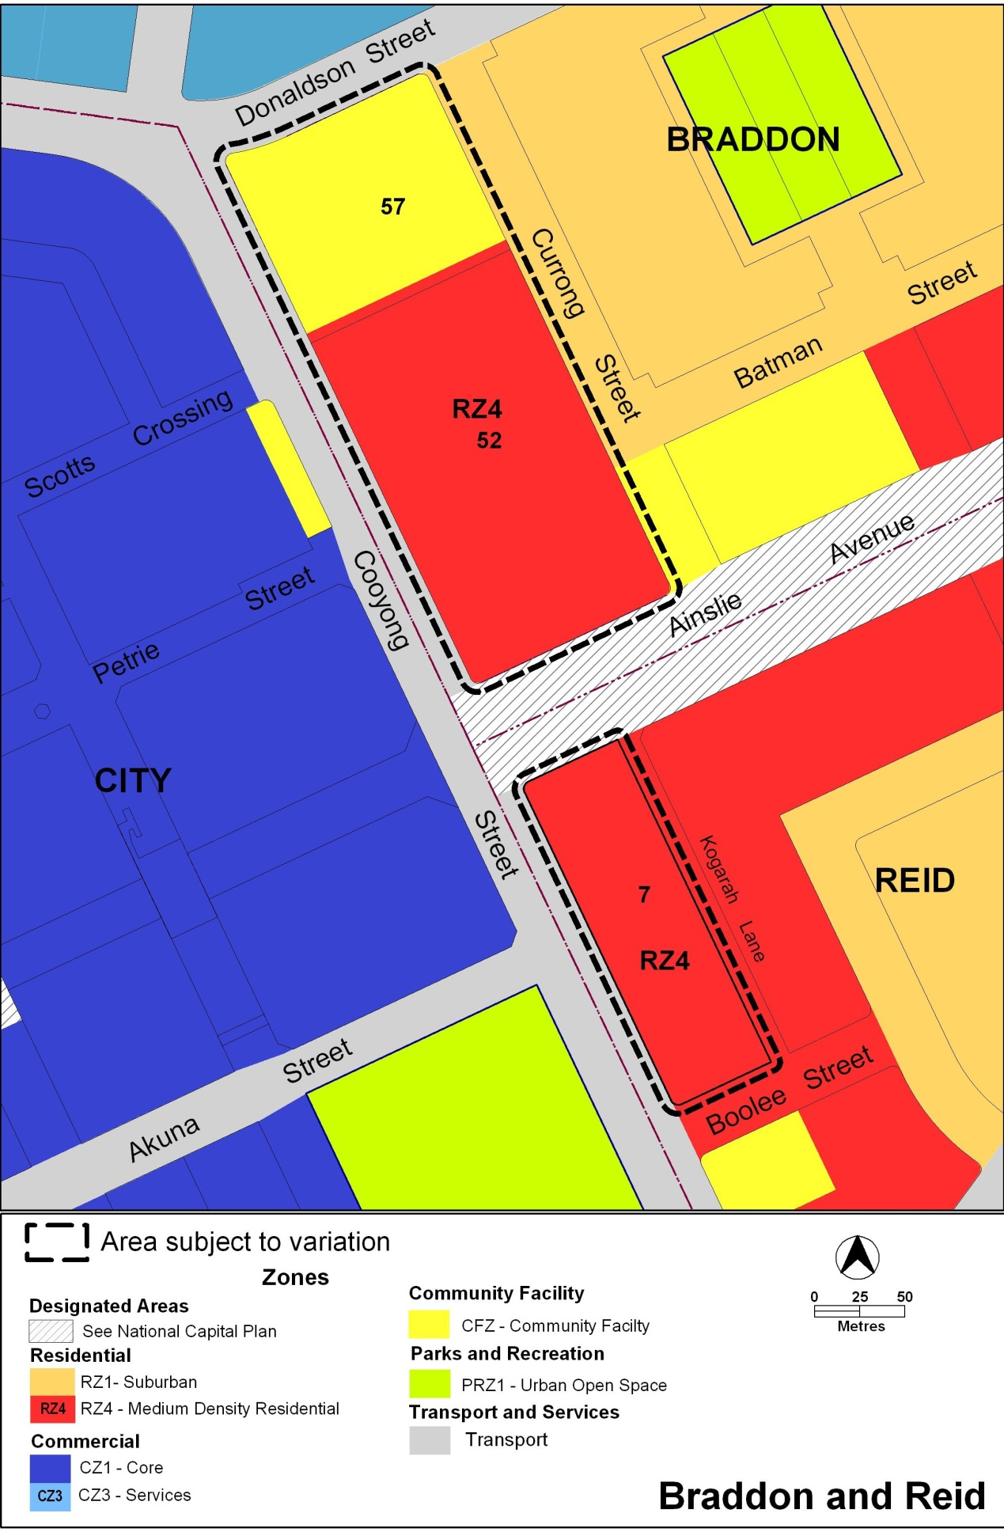
Figure 1 Current Territory Plan zones of area subject to the draft variation

  - Proposed changes
Both the Territory Plan map and written statement are proposed to be changed by this draft variation to support redevelopment of the site as proposed in the planning report. In addition to various zoning changes, a precinct code for the area is proposed for the site to guide development with site specific provisions that could not be realised under the current development codes.
    - Proposed changes to the Territory Plan map
The proposed map changes are shown in Figure 2 at Part 3 of this document and are outlined as follows:
- at Braddon section 57, CFZ community facility zone becomes
  - on part of the site fronting Currong Street, commercial CZ5 mixed use zone
  - on part of the site fronting Cooyong Street, RZ5 high density residential zone
- at Braddon section 52, RZ4 medium density residential zone becomes
  - on part of the land fronting Cooyong Street, commercial CZ5 mixed use zone
  - on part of the land fronting Currong Street, RZ5 high density residential zone and PRZ1 urban open space zone
- at Reid section 7, RZ4 medium density residential zone becomes
  - commercial CZ5 mixed use zone
    - Proposed changes to Territory Plan
The proposed change to the written statement involves the inclusion of the Cooyong Street Urban Renewal Precinct Code as detailed in Part 3 of this document.
  - Reasons for the proposed draft variation
ACTPLA has agreed to prepare a draft variation to the Territory Plan to support the redevelopment of the subject sites because the proposal is consistent with the Planning Strategy for the ACT. In particular, redevelopment of the site would enable an increase in the amount of residential accommodation in a location with convenient access to a major commercial and employment centre. The proposal is consistent with the planning strategy, particularly the goal of improving urban sustainability by making better use of existing infrastructure, supporting shifts in personal travel modes by reducing reliance on private motor vehicle use and increasing the variety of residential accommodation available to Canberra residents. Redistribution of community facilities across the site and retention of pedestrian connections through the site will enhance both accessibility and amenity of existing and future residents in the area.

  - Planning context
    - National Capital Plan
The Australian Capital Territory (Planning and Land Management) Act 1988 established the National Capital Authority (NCA) with two of its functions being to prepare and administer a National Capital Plan (NCP) and to keep the NCP under constant review and to propose amendments to it when necessary.
The National Capital Plan, which was published in the Commonwealth Gazette on 21 January 1990, is required to ensure that Canberra and the Territory are planned and developed in accordance with their national significance. The Planning and Land Management Act 1988 also requires that the Territory Plan is not inconsistent with the NCP.
NCA was consulted during the preparation of this draft variation and its comments have been included in part 2.7 of this report.
    - Territory Plan
The Statement of Strategic Directions sets out the principles for giving effect to the main objective of the Territory Plan as required by the Planning and Development Act 2007. The proposal supports the following key principles in the strategic directions
2.4 Planning policies will support revitalisation of the City Centre as the pre-eminent centre of governance, commerce and entertainment for the ACT and its region, while keeping the City Centre in appropriate balance with other town centres. Within the City Centre, provision will also be made for a range of major community facilities and opportunities for high-density residential development.
2.5 A wide range of housing types will be permitted in identified residential areas close to commercial centres and some major transport routes to increase choice; maximise opportunities for affordable housing; and secure some intensification of development consistent with maintaining residential amenity. Outside of these areas, planning policies will protect the typically low density, garden city character of Canberra’s suburban areas.
2.6 Higher density development will be encouraged within and near major centres, and in other suitable locations that are well served by public transport.
    - Planning strategy
The Canberra Spatial Plan and Sustainable Transport Plan comprise the current planning strategy under the Planning and Development Act 2007. On 17 October 2011, a draft planning strategy was released on public consultation. The existing planning strategy remains in place until the revised planning strategy has been finalised.
Canberra Spatial Plan outlines the strategic direction for growth to achieve social, environmental and economic sustainability for Canberra. Sustainable Transport Plan promotes alternative modes of transport to private cars in order to shift transport patterns towards more use of walking, cycling and public transport.
      - Canberra spatial plan
Key principles of the spatial plan, which include encouraging residential intensification within a 7.5 kilometre radius of city, supporting intensification at major employment centres and increasing housing choice, are addressed by the proposal.
      - Sustainable transport plan
Redevelopment of the site to enable a higher resident population in close proximity to Canberra City supports accessibility of future residents to employment, shopping and recreational activity through alternative travel modes to a private motor vehicle. Thus the proposal is consistent with the goals of the Sustainable Transport Plan.
  - Interim effect
The draft variation does not have interim effect and therefore section 65 of the Act does not apply. The current Territory Plan will continue to apply while the variation remains in draft form.
  - Consultation with government agencies
ACTPLA is required to, in preparing a draft variation under section 61(b), consult with each of the following in relation to the proposed draft variation
- the national capital authority
- the conservator of flora and fauna
- the environment protection authority
- the heritage council
- if the draft variation would, if made, be likely to affect unleased land or leased public land – each custodian for the land likely to be affected
National Capital Authority
The NCA provided the following comments on 12 October 2011
Public Realm Development
Consideration could be given to strengthening the provisions relating to the scale and character of landscape. Referral to Territory and Municipal Services (TaMS) standards make it difficult to understand the quality of the urban environment that is being created. Landscape criteria could require the protection and reinforcement of existing street trees along Cooyong and Donaldson Streets and Ainslie Avenue. Where street trees require replacement, these could reinforce the existing planting pattern. New street trees should consider environmental benefits arising from use of species that have canopies to provide shade over street verges and pedestrian paths in summer, and allow sunlight at street level during winter.
Building Height
The draft variation describes building height measures in a number of different ways. This could result in claims of a lack clarity from the community and developers. The NCA has, where appropriate, adopted RL's as a measure of building height. Our experience is that this measure is unambiguous and easily administered.
Adopting this approach would result in references to plant rooms, datum ground levels and storeys being removed.
This approach would require ACTPLA to establish the datum ground level and from that determine the maximum permitted building height and calculate the RL.
Building Design
The NCA is committed to design excellence in architecture and urban design. The building design provisions could be strengthened to promote design quality. This could be through description of articulation of facades, quality of materials and responsiveness to site.
A maximum unarticulated length could be prescribed, along with suggested ways to achieve articulation (for example, changes in wall places, balconies, horizontally stepping facades). Ideally, blank building walls that are visible from streets and public spaces should be avoided.
Additional criteria could be included which require building form and materials to be site responsive, and to take advantage of the characteristics and features of each site and surrounding development. Environmental conditions should be required to be addressed through appropriate site layout, building forms and materials which respond to issues such as solar access and local wind patterns.
Response
The planning report prepared for the development contains an indicative landscaped plan for the entire site including an area that is proposed to be rezoned PRZ1 Urban Open Space in the draft variation. While the developer will be responsible for landscaping within the site, the area of urban open space will be transferred to and maintained by the Territory and Municipal Services (TAMS) Directorate. The landscaping provision in the precinct code supports the harmonisation of landscaping across the public and private realms and ensure areas of the site that will be transferred to TAMS achieve the required standards.
Building height controls and the identification of taller building elements in the precinct code has been included in the precinct code to support the development of the building form proposed in the final Planning Report. Illustrations of the proposed development are included in the planning report, which will be released with the draft variation for public consultation.
A high standard of building design at the site is to be achieved through an assessment of the development proposal against the building design and materials provision in relevant development codes in the Territory Plan. Additional provisions in the precinct code are not required.
Conservator of Flora and Fauna
The Conservator of Flora and Fauna made the following comments on 27 September 2011
In accordance with Section 61(b) of the Planning and Development Act 2007, I advise that I have examined Draft Variation to the Territory Plan No. 308 Cooyong Street Urban Renewal Precinct, Braddon Sections 52 and 57 and Reid Section 7. The variation is to rezone the land to allow high density residential development and mixed-use development with some convenience retailing and office accommodation on part of the site and to include a precinct code for area.
The redevelopment of the site will require the removal of some trees. To ensure the highest quality trees are retained, seven trees have been included in the ACT Tree Register. This is recognised in the Figure 3 (landscape plan) of the precinct code but needs to be strengthened in the Rules and Criteria.
1.3 Public realm development Rule (b) needs to be amended to state 'the Tree Protection Zone, being drip line plus 5.0m, of all registered trees are protected from development impacts including basements', and Criteria (b) amended to 'a Tree Management Plan approved by the Conservator is submitted detailing the impacts on any registered tree'.
lt should be noted that the tree shown on Figure 3 as a registered tree and located on the verge of Cooyong Street near the corner of Ainslie Ave, has not been included on the Register to date. The tree is of excellent quality and should be retained.
Response
The draft variation does not propose to change provisions in the Territory Plan for the protection of trees, including registered trees at the site. Development at the site will be subject to various tree provisions in the multi unit housing development code and the CZ5 mixed use development code. This situation has been confirmed by the addition of a note after rule R7 and criterion C7 in the precinct code to confirm that provisions in the code do not change the requirements in other codes for the preparation of a tree management plan. The unregistered tree on the verge of Cooyong Street near the corner of Ainslie Avenue has been removed from Figure 3, which shows only registered trees on the site.
Environment Protection Authority
The Environment Protection Authority provided the following comments on 17 October 2011.
Contaminated Sites:
The final planning report does not comment on the assessment and management of identified and potential contamination at the site.
The Environment Protection Unit (EPU) has reviewed the Phase 1 Environmental Assessment report dated 16 June 2010 by Coffey Environments appended to the draft planning report and concurs with the consultant's findings that a phase 2 assessment of the identified areas of environmental concern be undertaken prior to redevelopment of the site.
The results of the phase 2 assessment must be reviewed and endorsed by the EPU prior to redevelopment of the site.
Noise:
The submitted noise report by Acoustic Logic Consultancy mainly concentrates on noise affecting the development from offsite, such as nearby club noise and traffic noise. It does not discuss possible noise being generated from commercial areas within the development that could potentially affect tenants and/or neighbours.
The EPA concurs with the planning report that further details of acoustic treatments should be provided at the development application stage. These details should be in the form of a noise management plan prepared by a person suitably qualified in the assessment of environmental noise. The plan should detail the design, siting and construction methods which will be used to minimise the impact of noise on neighbours and tenants, and ensure compliance with the Environment Protection Act 1997 and Environment Protection Regulation 2005. Please note that the EPA requires measurements to use the LA1O parameter.
Greywater/blackwater re-use:
If the proposal involves (a) the treatment for the purpose of reuse of wastewater (including effluent) in a treatment plant that has a capacity of greater than 3ML per year, or (b) the reuse of more than 3ML per year, the applicant must enter into an Environment Protection Agreement with the EPA.
Non-potable water use:
If the proponent intends on using non-potable water (other than rainwater) they are encouraged to discuss availability of groundwater/surface water with the EPA.
Response
Draft Variation 308 proposes to rezone land and introduce a precinct code to guide future development at the site. The assessment of any on-site contamination, the preparation of noise management plans and the application for various water licences will be considered when a development proposal is assessed.
Heritage Council
The Heritage Council provided the following comments on 28 October 2011.
Thank you for your letter dated 26 October 2011 in relation to the Council’s advice about the draft variation 308 provided on 17 October 2011, and for the meeting on 25 October 2011 to clarify related matters.
Your advice states that the Council's proposed changes are not considered necessary as the draft variation does not change the protections afforded to a place or object registered under the Heritage Act 2004, and the Planning and Development Act 2007 requires ESDD to consider heritage advice in deciding a development proposal. I acknowledge that further protection is afforded to heritage places and object in schedule 4 of the Act which could have an adverse impact on the heritage significance of a heritage registered place or object.
In the light of the above, the Heritage Council considers that the draft variation 308 will not generate detrimental heritage impacts provided heritage requirements associated with the future registration of the St Patrick's site would already be enforced over the Territory Plan requirements at the time of development application. Those requirements may include retention of the St Patrick’s Church and height restrictions for new development adjacent to that site. None the less, given the degree of public interest in the St Patrick's matter, it would be very helpful to all concerned if the draft variation makes reference to the possible heritage registration of the St Patrick’s Church.
Response
The explanatory statement of Draft Variation to the Territory Plan 308 has been revised to include reference to the ACT Heritage Council’s consideration of the heritage registration of St Patrick’s Church.
Community Services Directorate
CSD is the custodian of unleased land at Braddon section 57 block 3, which includes the pedestrian pathway between sections 57 and 52 Braddon. DV308 was formally referred to CSD for comment. CSD provided the following comments on 19 October 2011.
The Community Services Directorate is the custodian of Block 2 Section 57 Braddon, which provides pedestrian access between the suburb of Braddon and the City area.
The Planning Report for the Urban Renewal Project of Section 52 and 57 Braddon and Section 7 Reid shows this connection will be enhanced through the development of the site. lt is proposed to extend Scotts Crossing to a service lane which will transverse the site. This will connect with a landscaped area of open space.
Improved connections will be provided for pedestrians and cyclists. The appearance of the area will be improved and current concerns about public safety will be addressed both in the design of the road and associated streetscape, and the relationship of this area to the surrounding buildings.
Response
Noted.
- DRAFT VARIATION
Variation to the Territory Plan
The Territory Plan map is varied as shown in Figure 2 for the area shown as subject to the variation.
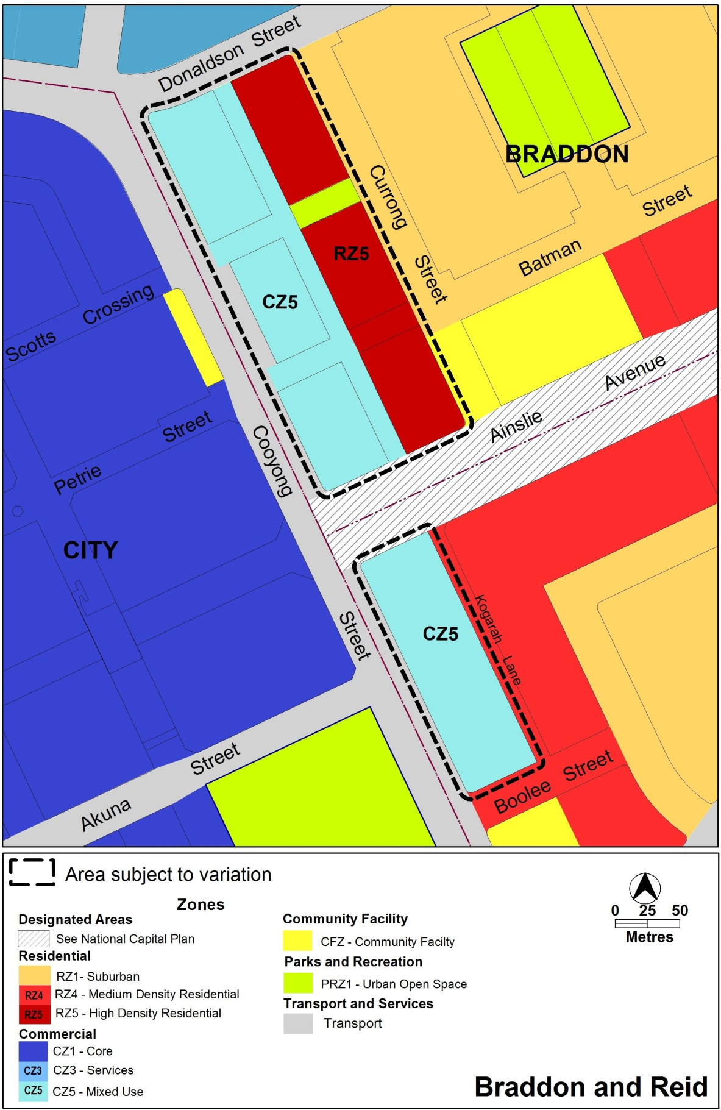
Figure 2 Proposed Territory Plan map

Variation to precinct codes

Precinct Codes

Insert Appendix A (Cooyong Street Urban Renewal Precinct Code)

Interpretation service
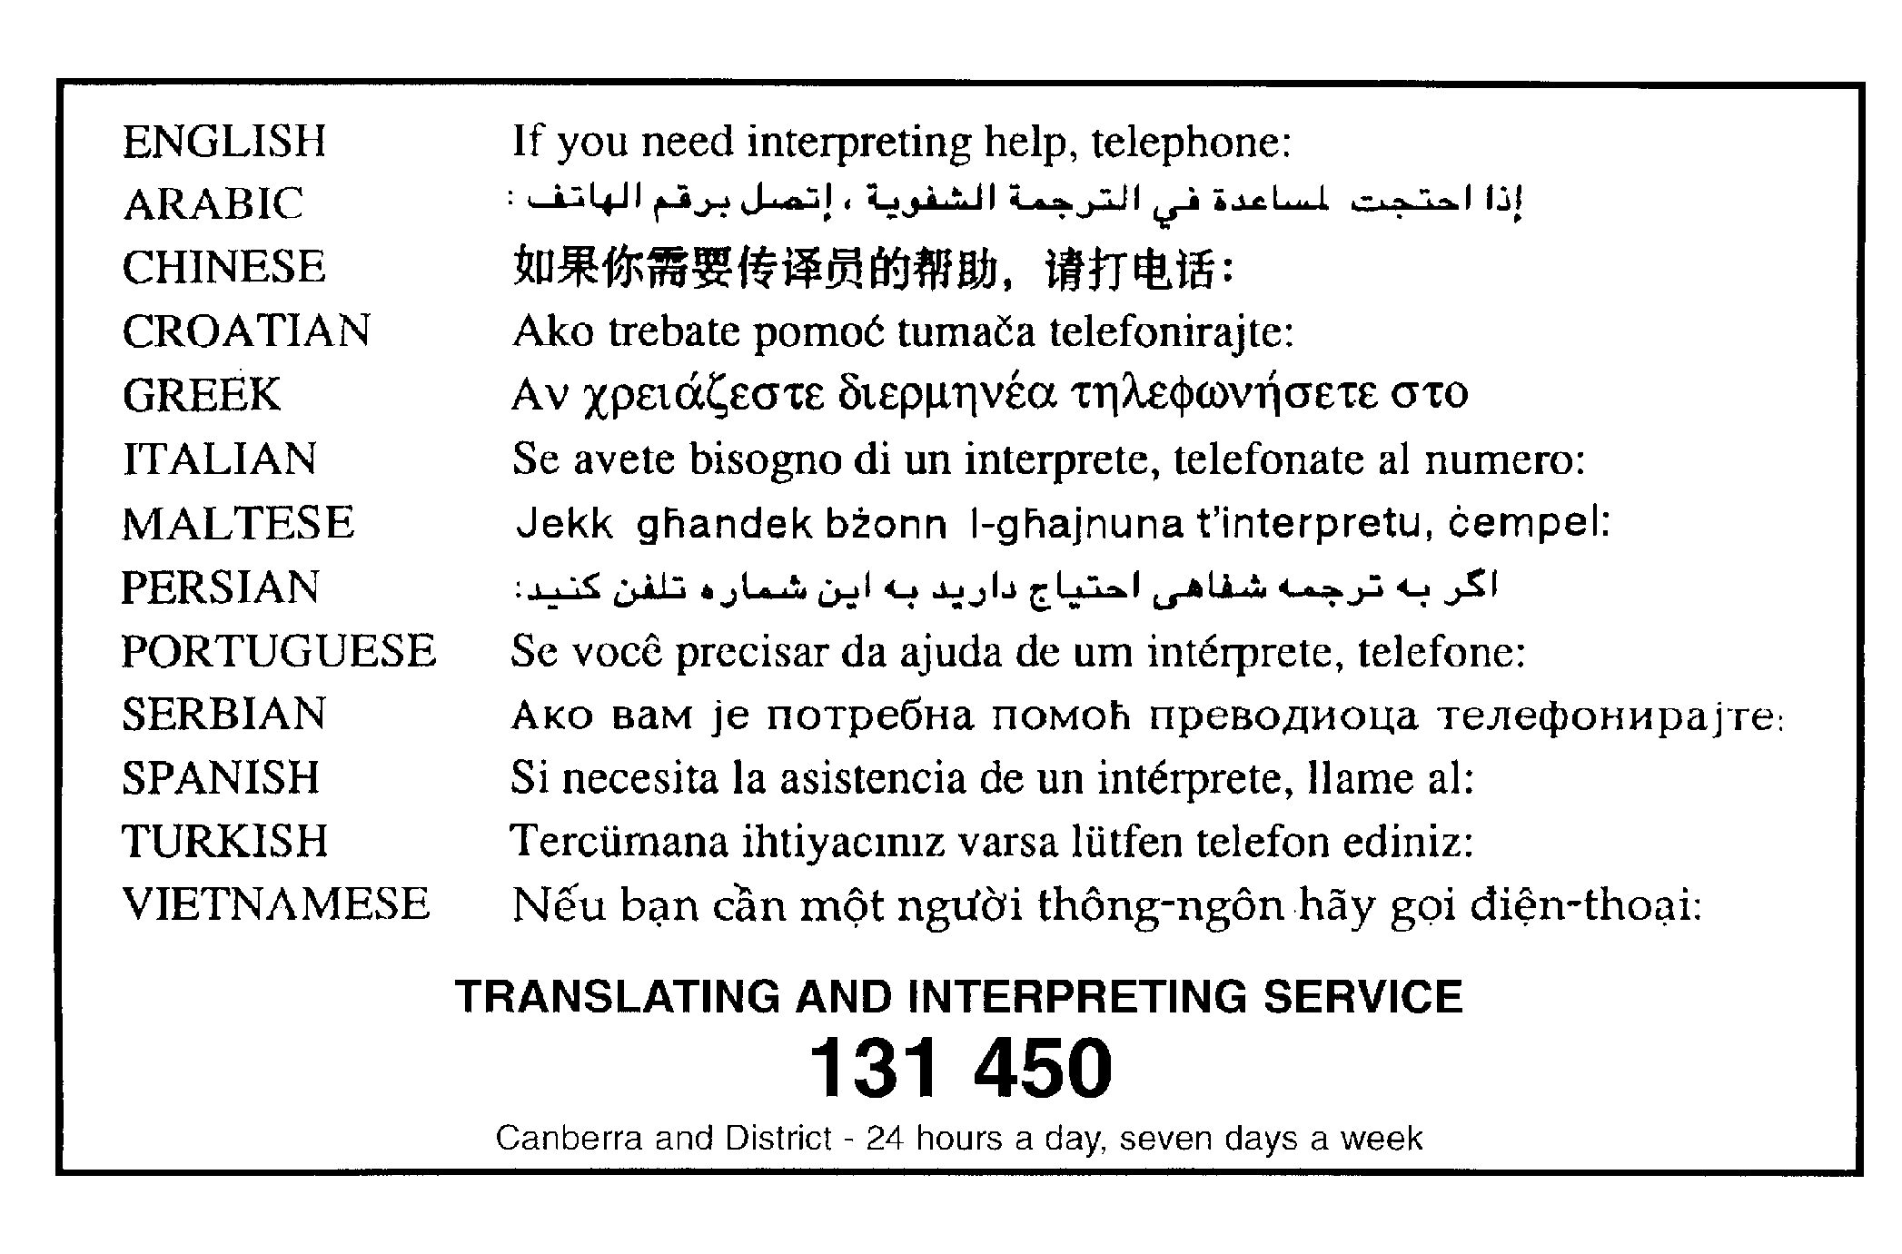

Cooyong Street Urban Renewal Precinct Code

This page is intentionally blank.

Contents
Introduction 1
Part A – General controls 3
Element 1: Site 3
1.1 Subdivision 3
1.2 Car parking and site access 5
1.3 Public realm development 5
Element 2: Use 7
1.4 Restrictions on use 7
1.5 Convenience retailing area 7
Element 3: Buildings 9
1.6 Height of buildings 9
1.7 Setback to Cooyong Street 10
1.8 Building design 11
1.9 Rooftop gardens 11

List of Figures
Figure 1 Area covered by this code 1
Figure 2 Subdivision and other works 4
Figure 3 Landscaping 6
Figure 4 Building elements 8

This page is intentionally blank.

Introduction
Name
The name of this code is Cooyong Street Urban Renewal Precinct Code.
Application
This Precinct Code applies to development of land in Braddon and Reid, separated by Ainslie Avenue, as shown in Figure 1.

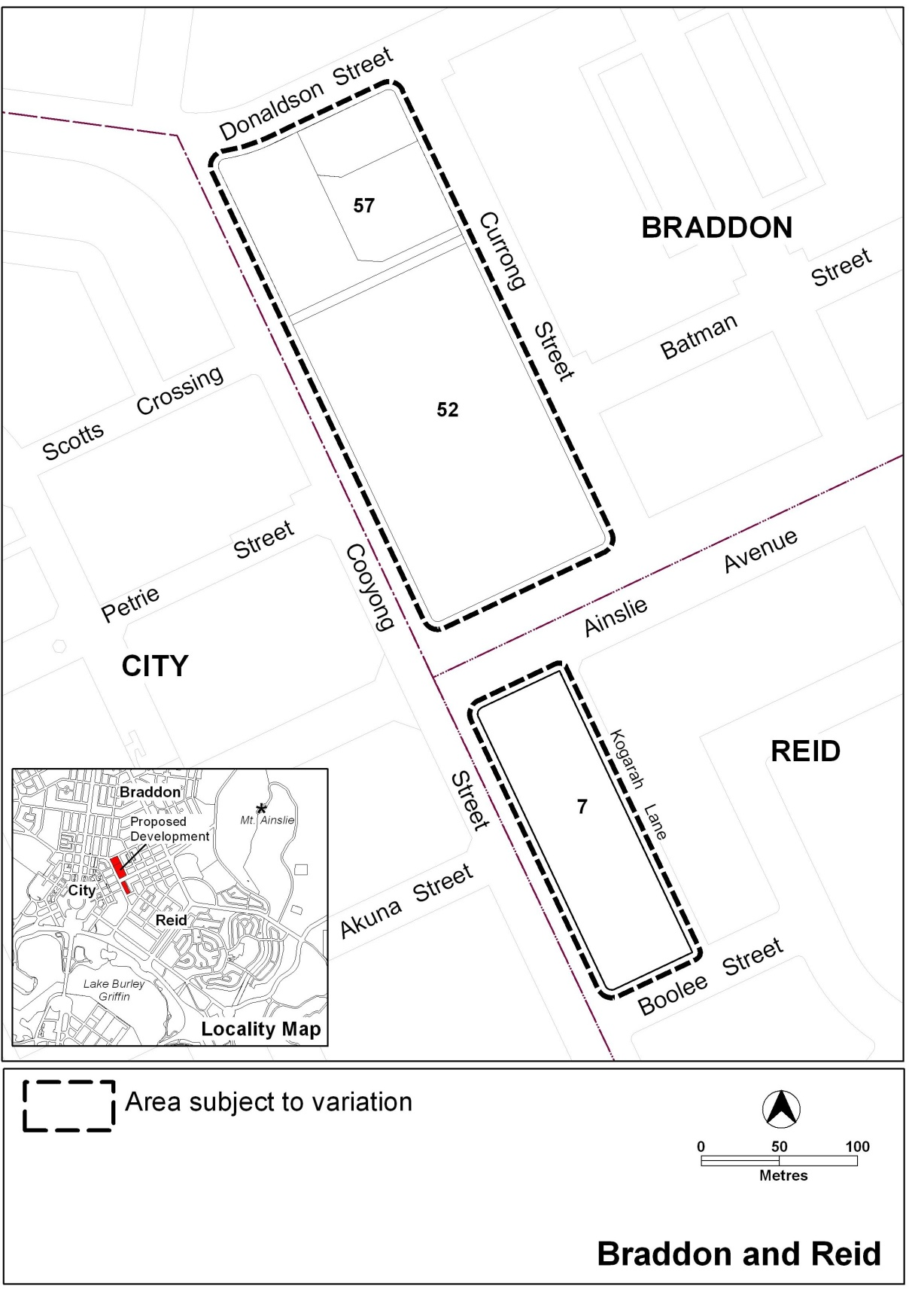
- Area covered by this code

National Capital Plan
Where a development is subject to special requirements under the National Capital Plan, or any relevant development control plan prepared under the National Capital Plan, the development cannot be inconsistent with the special requirements or development control plan. Where any provision of this code is inconsistent with special requirements under the National Capital Plan, or any relevant development control plan prepared under the National Capital Plan, that provision has no effect.
Purpose
The site is proposed to be redeveloped for high density housing including community and convenience retail facilities adjacent to the commercial centre of Canberra.

This code provides additional planning, design and environmental controls to support the objectives of the Cooyong Street Urban Renewal Precinct, which were described in the Planning Report Volume One of the Urban Renewal Project for Sections 52 and 57 and Section 7 Reid.

It will be used by the Authority to:
- guide the design and assessment of subdivision on the site shown in Figure 1
- guide the development of individual blocks in the precinct together with other relevant codes under the Territory Plan
- support zone objectives and assessable uses in the development tables
- guide the development and management of the public realm.
Structure
This code has nine elements. Each element has one or more rules, each having an associated criterion (unless the rule is mandatory).
Assessment tracks
Assessment track for a particular developments are specified in the relevant residential zone development table.

Proposals in the code track must comply with all rules relevant to the development.

Proposals in the merit track and impact track must comply with a rule or its associated criterion, unless the rule is mandatory (i.e. it has no related criterion). Where a rule is fully met, no reference to the related criterion needs to be made. Where there is a departure from a rule, or where a criterion only applies, the onus is on the applicant to demonstrate, through supporting drawings and/or written documentation, that the relevant criterion is satisfied. In addition, the applicant for proposals in the impact track must justify any non-compliance by reference to the Statement of Strategic Directions.
Code hierarchy
Under the Planning and Development Act 2007, where more than one type of code applies to a development and there is inconsistency between provisions, the order of precedence is: precinct code, development code, and general code.
Definitions
Defined terms, references to legislation and references to other documents are italicised.
Definitions of terms used in this code are listed in the Territory Plan or, for terms applicable only to this code, associated with the respective rule.

Part A – General controls

Element 1: Site
Rules | Criteria
1.1 Subdivision
Subdivision of the site is carried out in accordance with the plan shown at Figure 2. | Subdivision of the site is generally consistent with the pattern of proposed roads in Figure 2.
The design of each street complies with the road reserves shown in Figure 2.  Road design is to be endorsed by TAMS. TAMS will endorse the plan if it complies with the relevant TAMS standards.  TAMS may endorse departures. | Road reserves achieve all of the following:  - reasonable functionality  - reasonable safety  - provision for pedestrians and landscaping  - provision of adequate on street parking.
A plan of off-site works is consistent with Figure 2 and shows the location across the site of all of the following:  - on-street car parking for a minimum of 180 car parking spaces  - cycle paths  - pedestrian connections  - footpaths  - signalised intersections  - in Braddon sections 52 and 57, a service lane and car parking adjacent to convenience retailing area and Cooyong Street.  Off-site works are to be endorsed by TAMS.  TAMS will endorse the plan if it complies with the relevant TAMS standards.  TAMS may endorse departures. | Development of off-site works achieve all of the following:  - adequate on-street car parking  - provision for cyclists, pedestrians and motor vehicles with connections to the surrounding networks  - reasonable footpath widths  - provision for a service lane in Braddon and an access way in Reid.

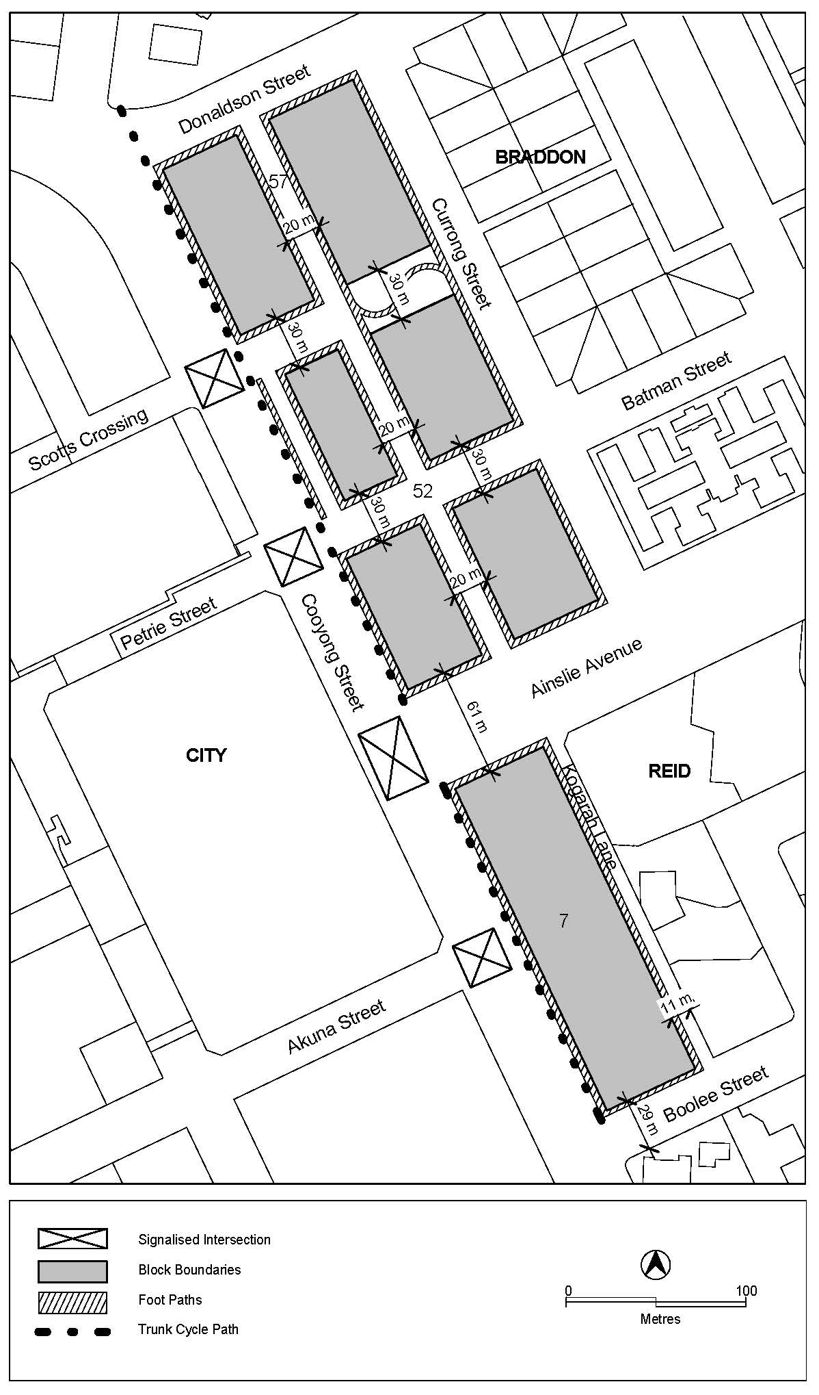
- Subdivision and other works
Rules | Criteria
1.2 Car parking and site access
There is no applicable rule. | Public car parking achieves all of the following:  - adequate on-street parking  - provides accessibility to the existing road, cycling and pedestrian networks  - provides spaces for dedicated moped / motor bike and small vehicles  - is endorsed by TAMS.
Access to on–site car parking and utility services of buildings in Braddon is from the nominated service lane shown in Figure 2. | This is a mandatory requirement. There is no applicable criterion.
Driveway access or egress to buildings from Ainslie Avenue, Cooyong Street and Donaldson Street is not permitted. | This is a mandatory requirement. There is no applicable criterion.
1.3 Public realm development
A landscaping plan for the public realm is consistent with Figure 3 and shows the location across the site of all of the following:  - in Braddon, area of urban open space  - trees (including registered trees) in Figure 3  - street trees, both new and retained trees  - ground level and above front setback area.  The landscaping plan is to be endorsed by TAMS.  TAMS will endorse the landscaping plan if it complies with the relevant TAMS standards, which includes Standard Specification 4 Urban Infrastructure Work Section 9, Design Specifications DS-4, DS-22 and DS-23.  TAMS may endorse departures. | Landscaping achieves all of the following:  - quality space for recreation and relaxation of residents  - provision for on-site infiltration of stormwater run-off  - quality landscaping adjacent to Cooyong Street and Ainslie Avenue  The landscaping plan is to be endorsed by TAMS.  TAMS will endorse the landscaping plan if it complies with the relevant TAMS standards.  TAMS may endorse departures.
Note: Neither rule R7 nor criterion C7 changes any requirement in the Territory Plan for the preparation of a tree management plan approved under the Tree Protection Act 2005.

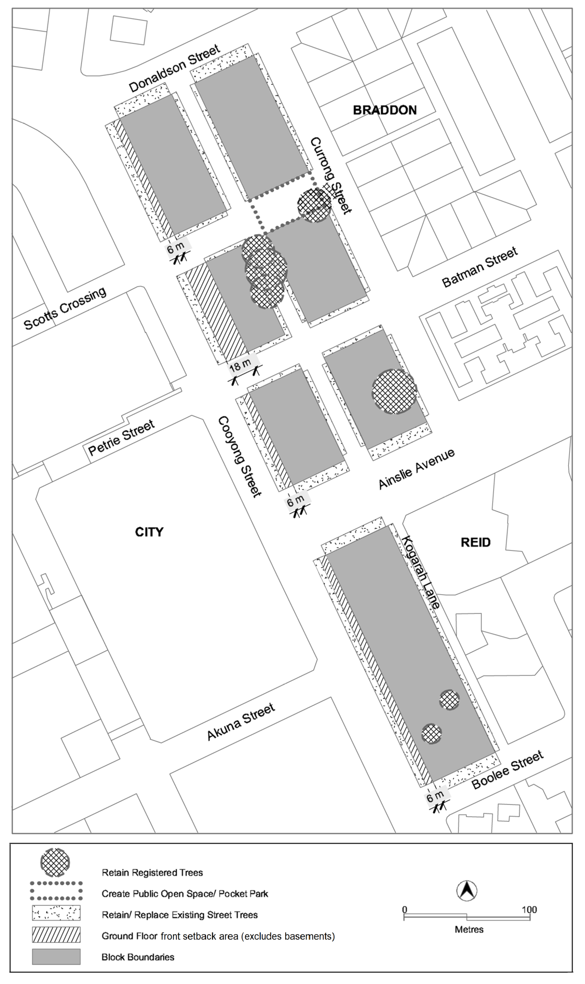
- Landscaping
Element 2: Use
Rules | Criteria
1.4 Restrictions on use
The following uses are not permitted in buildings fronting Cooyong Street above the ground floor:  - restaurant  - SHOP | This is a mandatory requirement. There is no applicable criterion.
The following uses are not permitted in buildings fronting Cooyong Street above the first floor:  - COMMUNITY USE  - indoor recreation facility  - NON RETAIL COMMERCIAL USE | This is a mandatory requirement. There is no applicable criterion.
The following gross floor area (GFA) restrictions apply to land with CZ5 mixed use zone, except for the convenience retailing area:  - NON RETAIL COMMERCIAL USE: maximum GFA of 100m² per tenancy or premises  - COMMUNITY USE and indoor recreation facility (where it is operated or subleased by a community organisation):  minimum GFA of 5 800 m² in total  - SHOP: maximum GFA of 200m² per tenancy  - Restaurant: maximum of 200m² per tenancy. | This is a mandatory requirement. There is no applicable criterion.
1.5 Convenience retailing area
RESIDENTIAL USE is not permitted at the ground floor level in the convenience retailing area as shown in Figure 4. | This is a mandatory requirement. There is no applicable criterion.
The following gross floor area (GFA) restrictions apply to the convenience retailing area:  - SHOP: maximum 800m² per tenancy or premises  - NON RETAIL COMMERCIAL USE: maximum 200m² per tenancy or premises. | This is a mandatory requirement. There is no applicable criterion.

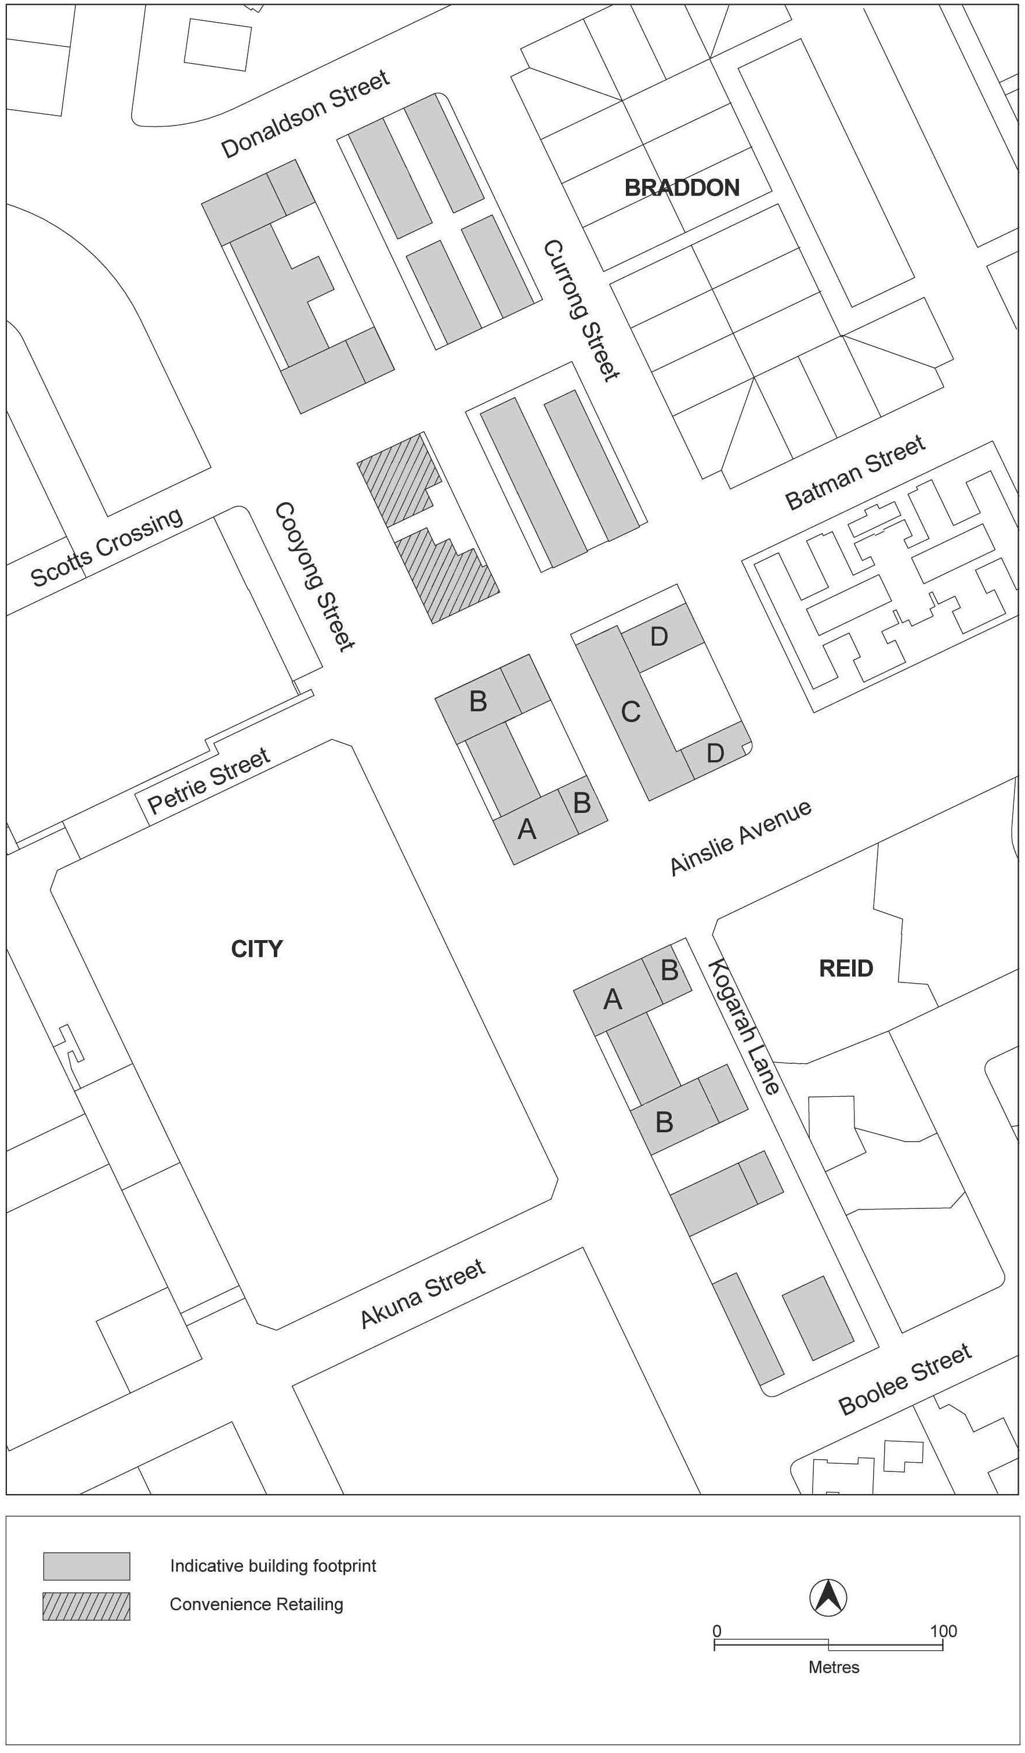
- Building elements
Element 3: Buildings
Rules | Criteria
1.6 Height of buildings
Maximum height of buildings on the site is consistent with all of the following:  - for land zoned CZ5 mixed use:  - buildings are contained within an envelope which rises 25 metres above datum ground level at the building line then returns at 45 degrees to a maximum of 28 metres (excluding rooftop plant and equipment) except for taller building elements shown in Figure 4  - elements at location A are no higher than RL617 and 15 storeys (including rooftop plant and equipment) and a maximum of 20 metres in length fronting Cooyong Street and 38 metres in length along the other frontage  - elements at location B are no higher than 35 metres above datum ground level (including rooftop plant and equipment) and a maximum of 20 metres in length fronting Cooyong Street and 38 metres in length along the other frontage  - for land zoned RZ5 high density residential:  - elements at location C are no higher than 28 metres (excluding rooftop plant and equipment) above datum ground level  - elements at location D are no higher than 16 metres (excluding rooftop plant and equipment) above datum ground level  Note: except where stated, heights on land with RZ5 high density residential zone are set by the multi unit housing development code. | This is a mandatory requirement. There is no applicable criterion.
Minimum height of buildings is three (3) storeys. | This is a mandatory requirement. There is no applicable criterion.
1.7 Setback to Cooyong Street
Buildings along Cooyong Street are setback a minimum of 6 metres to the boundary of blocks, at the locations shown in Figure 3. | Buildings and other structures achieve all of the following:  - presents a hard edge to the street  - provision of a landscaped area fronting Cooyong Street that satisfies criterion C7  - reasonable solar access to the public realm on Cooyong Street.
Note: Neither rule R15 nor criterion C15 applies to underground car parking fronting Cooyong Street. The transfer of land above underground car parking to the Territory is not prevented by this provision.
Development in the convenience retailing area complies with all of the following:  - buildings fronting Cooyong Street include at ground floor, display windows and shopfronts  - buildings include at-grade direct pedestrian access with verge level access and egress. | This is a mandatory requirement. There is no applicable criterion.
Display windows and pedestrian access are provided at the ground floor of buildings fronting all of the following areas:  - Cooyong Street  - Ainslie Avenue  - public open space areas. | Development can be adapted to incorporate active frontage with direct pedestrian access at ground floor of buildings fronting Cooyong Street and Ainslie Avenue.
There is no applicable rule. | Floor to ceiling heights at the ground level of buildings fronting Cooyong Street and Ainslie Avenue can accommodate commercial use.
A maximum of 20 percent of the length of the ground floor of buildings in each section in CZ5 mixed use zone fronting Cooyong Street and Ainslie Avenue has a blank façade. | Ground floor facades of buildings fronting Cooyong Street and Ainslie Avenue present a varied and interesting design.
1.8 Building design
There is no applicable rule. | Development complies with all of the following:  - corner buildings contain focal points providing architectural interest and variety to the building design  - entrances to common areas for residential use provides strong visual connection to the street and ensure a high level of surveillance  - driveways and pedestrian entrances to the site are visible from the boundary  - west-facing facades incorporate sun shading into building designs  - desired planning outcomes of  - contributing to a high quality, environmentally sustainable residential development near Canberra’s main commercial centre  - balancing and protecting the high quality residential amenity while providing for community facilities and limited commercial use  - encouraging innovation in high quality design of the built form and open space  - minimising adverse impacts on environmental and heritage qualities within the precinct and adjacent sites  - supporting a street network that is designed for low vehicle speed and easy pedestrian access.
1.9 Rooftop gardens
There is no applicable rule. | Common open space in the form of rooftop gardens are provided and achieve all of the following:  - adequate access for residents, particularly on the higher floors  - sufficient space for recreation of residents  - reasonable solar access for gardening activities.

