Australian Capital Territory
Heritage (Decision about Registration for St Ninian’s Church – nineteenth century elements, Lyneham). Notice 2011
Notifiable Instrument NI 2011 - 740
made under the
Heritage Act 2004 section 42 Notice of Decision about Registration

- Revocation
This instrument replaces NI 2011 – 491
- Name of instrument
This instrument is the Heritage (Decision about Registration for St Ninian’s Church – nineteenth century elements, Lyneham )Notice 2011 -
- Registration details of the place
Registration details of the place are at Attachment A: Register entry for St Ninian’s Church – nineteenth century elements, Lyneham.
- Reason for decision
The ACT Heritage Council has decided that St Ninian’s Church – nineteenth century elements, Lyneham meets one or more of the heritage significance criteria at s 10 of the Heritage Act 2004. The register entry is at Attachment A.
- Date of Registration
1 December 2011

Gerhard Zatschler
Secretary
ACT Heritage Council
1 December 2011

AUSTRALIAN CAPITAL TERRITORY

HERITAGE REGISTER
(Registration Details)

Place No:

For the purposes of s. 41 of the Heritage Act 2004, an entry to the heritage register has been prepared by the ACT Heritage Council for the following place:

St Ninian’s Church (nineteenth century elements)

Block 1, Section 41, Lyneham

DATE OF REGISTRATION

Notified: 1 December 2011 Notifiable Instrument: 2011/

Copies of the Register Entry are available for inspection at the ACT Heritage Unit. For further information please contact:

The Secretary
ACT Heritage Council
GPO Box 158, Canberra, ACT 2601

Telephone: 13 22 81 Facsimile: (02) 6207 2229

IDENTIFICATION OF THE PLACE

St Ninian’s Church – nineteenth century elements, Brigalow Street, Lyneham, ACT.

Block 1, Section 41, Lyneham, Canberra Central

STATEMENT OF HERITAGE SIGNIFICANCE

This statement refers to the Heritage Significance of the place as required in s12(d) of the Heritage Act 2004.

St Ninian’s Church – nineteenth century elements, Lyneham is of heritage significance, evocative of its origins in 1873 as a modest stone Church serving a rural community in the mid-late nineteenth century. Its tangible fabric represents the success and independence of the Scottish Presbyterian community in the district from this time. It is the second permanent Church constructed in the region, after St John’s Reid, and the first Presbyterian Church in the region. St Ninian’s has a special association with the religious development of the region prior to the formation of the Federal Capital Territory, and with the Scottish Presbyterian community in particular.

FEATURES INTRINSIC TO THE HERITAGE SIGNIFICANCE OF THE PLACE

The attributes listed below are assessed as features intrinsic to the heritage significance of the place and warrant conservation:

- Rectangular nineteenth century stone church building with gabled roof and three arched windows on either side.

APPLICABLE HERITAGE GUIDELINES

The ‘Heritage Guidelines: General Conservation Guidelines for Historic Heritage Places 2011’ adopted under s25 of the Heritage Act 2004 are applicable to the conservation of St Ninian’s Church – nineteenth century elements, Lyneham.

The guiding conservation objective is that St Ninian’s Church – nineteenth century elements, Lyneham shall be conserved and appropriately managed in a manner respecting its heritage significance and the features intrinsic to that heritage significance, and consistent with a sympathetic and viable use or uses. Any works that have a potential impact on significant fabric (and / or other heritage values) shall be guided by a professionally documented assessment and conservation policy relevant to that area or component (i.e. a Statement of Heritage Effects – SHE).

REASON FOR REGISTRATION

St Ninian’s Church – nineteenth century elements, Lyneham has been assessed against the heritage significance criteria and been found to have heritage significance when assessed against two criteria under the ACT Heritage Act including (c) and (h).

ASSESSMENT AGAINST THE HERITAGE SIGNIFICANCE CRITERIA

Pursuant to s.10 of the Heritage Act 2004, a place or object has heritage significance if it satisfies one or more of the following criteria. Significance has been determined by research as accessed in the references below. Future research may alter the findings of this assessment.

(a) it demonstrates a high degree of technical or creative achievement (or both), by showing qualities of innovation, discovery, invention or an exceptionally fine level of application of existing techniques or approaches
St Ninian’s Church – nineteenth century elements, Lyneham does not meet this criterion.

(b) it exhibits outstanding design or aesthetic qualities valued by the community or a cultural group
St Ninian’s Church – nineteenth century elements, Lyneham does not meet this criterion.

(c) it is important as evidence of a distinctive way of life, taste, tradition, religion, land use, custom, process, design or function that is no longer practiced, is in danger of being lost or is of exceptional interest
St Ninian’s Church – nineteenth century elements, is important as evidence of a distinctive function and tradition of a religious service in Canberra since 1873.

The original rectangular stone church provided religious services to a small rural community which is no longer practiced.

Its materials and architecture are evocative of its time of construction, in the mid nineteenth century, when the rural farming families of the district, particularly the Scottish Presbyterian community, and the Minister visiting from other areas, would travel across a rural landscape to attend religious services.

Serving the rural population in the late nineteenth century, religion was an important aspect of cultural self-identification and independence for the Scottish settlers in the area.

The church today serves an urban community, quite different to the rural Scottish Presbyterian congregation for which it was first constructed.

St Ninian’s Church – nineteenth century elements, Lyneham meets this criterion.

(d) it is highly valued by the community or a cultural group for reasons of strong or special religious, spiritual, cultural, educational or social associations
Although attended by regular church-goers, there is insufficient evidence to suggest that St Ninian’s Church, Lyneham is highly valued by the community or a cultural group for reasons of strong or special religious, spiritual, cultural, educational or social associations, sufficient to meet this criterion.

There is no evidence before Council to indicate that the place meets this criterion.

(e) it is significant to the ACT because of its importance as part of local Aboriginal tradition
St Ninian’s Church – nineteenth century elements, Lyneham does not meet this criterion.

(f) it is a rare or unique example of its kind, or is rare or unique in its comparative intactness
St Ninian’s Church – nineteenth century elements, Lyneham does not meet this criterion.

(g) it is a notable example of a kind of place or object and demonstrates the main characteristics of that kind.
St Ninian’s Church – nineteenth century elements, Lyneham does not meet this criterion.

(h) it has strong or special associations with a person, group, event, development or cultural phase in local or national history
As the second church in the region, and the first Presbyterian Church, St Ninian’s has a special association with the religious worship of the region prior to the formation of the Federal Capital Territory, and with the Scottish Presbyterian community in particular.

The original small church building links a phase of Canberra’s history to the present. It provides physical evidence of the social and cultural aspirations of the early Scottish small land holding community of Canberra who played an important part in the development of Canberra’s rural historic roots.

St Ninian’s Church – nineteenth century elements, Lyneham meets this criterion.

(i) it is significant for understanding the evolution of natural landscapes, including significant geological features, landforms, biota or natural processes
St Ninian’s Church – nineteenth century elements, Lyneham does not meet this criterion.

(j) it has provided, or is likely to provide, information that will contribute significantly to a wider understanding of the natural or cultural history of the ACT because of its use or potential use as a research site or object, teaching site or object, type locality or benchmark site
St Ninian’s Church – nineteenth century elements, Lyneham does not meet this criterion.

(k) for a place—it exhibits unusual richness, diversity or significant transitions of flora, fauna or natural landscapes and their elements
St Ninian’s Church – nineteenth century elements, Lyneham does not meet this criterion.

(l) for a place—it is a significant ecological community, habitat or locality for any of the following:
(i) the life cycle of native species;
(ii) rare, threatened or uncommon species;
(iii) species at the limits of their natural range;
(iv) distinct occurrences of species
St Ninian’s Church – nineteenth century elements, Lyneham does not meet this criterion.

SUMMARY OF THE PLACE
HISTORY AND PHYSICAL DESCRIPTION

HISTORY

The first Presbyterian service on the Limestone Plains was held in June 1838 by the Reverend William Hamilton of Goulburn. Subsequent services were held on an irregular basis in the Duntroon woolshed on the Campbell Estate, among other places, with Ministers from Yass, Gundaroo and Queanbeyan officiating. From the mid 1850s the Campbell’s allowed regular Presbyterian services to be held at St John’s schoolhouse, which had been built near St John’s Church of England in 1845. After a disagreement between George Campbell and Andrew Wetherspoon, the teacher at St John’s, the Presbyterians were denied the use of the schoolroom as a place of worship (Shumack, 1967: 25).

It was the withdrawal of the use of the schoolhouse that convinced the local Presbyterian congregation of the need for their own place of worship. In 1862 a small slab and bark church was built near the present site by the Kinlyside family, on half an acre of land donated by Pemberton Campbell Palmer of Jerrabomberra. It was opened by Reverend W F Reid in January 1863 and served as a centre for worship for the surrounding farming communities and the local Scottish settlers (Thompson, 2005: 5). The small church was the second church building, after St John’s at Reid opened in the 1840s, and was the first Presbyterian Church in the district. It became the focal point for worship among the considerable Scottish population of the district.

In about 1870 the heads of the Cameron, McDonald, Gillespie, Kinlyside, McKeahnie and McInnes families held a private meeting at which it was decided to call a public meeting with the object of drawing up plans for the construction of a suitable structure to replace the wooden church building (Thompson, 2005: 24). The result was the construction, in 1873, of the present stone church.

Located on the old Yass Road, the stone church became an important part of the district’s Presbyterian fraternity. Ministers from Queanbeyan, Yass and Braidwood would travel to the small church to conduct services (Gardiner, 1958: 2). The church was also used as a place of worship for other Protestant faiths who for one reason or another found the small church on the Yass road more convenient.

St John’s Church of England at Duntroon (now Reid) and the dominating social and economic position of the Campbell family and the colonial gentry of Canberra (the Squires) were somewhat of an anathema to many of the rural Scots in the area. They represented the type of class structured society many of the emigrant Scots had left behind in their homeland. They had no wish to perpetuate and live within these conditions on the farming lands of the region. The construction of the small wooden church represented another world – a world where men and women worked their own land for their own gain. They saw the church as a symbol of democracy, independence and egalitarianism in their new country (Gardiner, 1958: 6-10; Howie-Willis 1996: 53).

The Church prospered under these ideals. The first year saw a high attendance: often 50 in the morning and up to 70 in the afternoon services. More would attend the special functions such as church tea meetings. These were often attended by local Methodists, Anglicans and Catholics who would all put aside their sectarian differences to join with the Scottish Presbyterian neighbours. The inauguration of the new stone church saw about 140 people gathered for the tea meeting (Howie-Willis, 1996: 54).

A small stone extension was added to the western end of the building, thought to have most likely been between 1898-1901.

In the first decades of the twentieth century much of the surrounding pastoral lands were compulsorily acquired by the Commonwealth Government for the development of Canberra. Included in the lands was the small plot on which the church stood. In 1911 the Commonwealth acquired the land and leased it back to the Presbyterian Church on a 10 year lease. As a consequence of the change from freehold to leasehold land tenure, many people began to move away from the district, preferring to live on land they owned rather than on rented properties. Previously, the local population of the district had declined during the depression of the 1890s and the drought between 1895 and 1903. Attendance at the church fell. On 1 September 1920 the small church was closed and did not reopen until 1942. At the time of its closure, the original furniture went to Queanbeyan Presbyterian (now Uniting) Church. The building became derelict, its windows were broken and the floorboards removed. During the period of closure the lease was transferred from the Presbyterian Church to F.S Southwell who used the land for grazing. The small stone church was used for many years as a barn to store hay (Thompson, 2005: 1; Gardiner, 1958: 44).

In 1941 the reverend Hector Harrison, the Minister at St Andrew’s Presbyterian Church (from 1940-1978), moved to have the small church restored and reused as a place of worship. When it reopened the following year the congregation was different. They were not the Scottish small landholders of the past but public servants drawn to Canberra to administer the new Federal Capital. By this time none of the original Scottish founders were alive and their descendants were third, fourth or fifth generation Australians with little direct links to their ancestral homelands (Howie-Willis, 1996: 54). Nevertheless, the new church was deliberately named after a Scottish saint, St Ninian, who was reputedly the first Christian missionary to Scotland, and a pioneers’ memorial garden was created in memory of its Scottish founders. Prior to this, the church had been known as the Canberra Presbyterian Church. It was reopened for public worship in February 1942 and some 200 people attended the reopening ceremony.

A church hall and office block were built in 1961. A covered walkway links the extension to the original stone building.

The small stone church began its second life as a branch of St Andrew’s, Canberra’s principal Presbyterian Church, which had opened in 1934 in an imposing building on the slopes of Capitol Hill. In 1950 St Ninian’s was transferred to the care of St Columba’s, a parish nearer to its location.

Nine years later when the suburbs of North Canberra were expanding, St Ninian’s became a parish in its own right with a full-time Minister and in 1977 it became a parish of the newly constituted Uniting Church in Australia. In 1978-79, extensions to the church were completed to the design of Eggleston, MacDonald and Secombe.

Today the church maintains a popular and special place among members of its parish with a strong and regular attendance at its services and a dedicated group of parishioners who have not forgotten the small church’s pioneer heritage.

DESCRIPTION

The early stone church building was rectangular in shape and constructed of sandstone rubble extracted from Black Mountain. It has a medium-pitched gabled roof. Double rows of brick were used to form arched windows on the north and south sides and one on the western (rear) wall. The latter window was removed when the wall was dismantled for extensions in 1978-79.

The original building had two arched windows on either side. The building was extended westwards, and a third arched window added to each side. There is no known account of the extension or who undertook the work, but it is evidenced by a change in window arch brick type, slight changes in the technique of stone laying, and by a distinct alteration in the internal ceiling board lining. The date of this extension is thought to have most likely been between 1898-1901.

Restoration work was carried out in 1940-41 after the church had been unused for 20 years. No records of the works were kept and it is believed they were carried out by volunteers.

Further extensions were undertaken in 1978-79, designed by Eggleston, MacDonald and Secombe, which further enlarged the church, again on its western end. The stonework of the extensions was constructed in the same manner as the original using similar stone from Black Mountain. The extended area is six-sided (one side being open to the original Church). The extended area increased the seating capacity of the church and embodies the altar, dais and organ space. The extensions generally blend with the original building, although the design is non-traditional and the full-length corner windows/doors clash with the original Gothic windows.

A small memorial garden on the eastern side of the church building commemorates the pioneering heritage and history of the church and its reopening in February 1942. The garden was centred around two large elms, which are no longer extant. The garden is mainly lawn, bounded on the north and east sides by a low stone wall and three square stone planters on the west side. The wall and the planters are made from stone removed from the ruins of the Gribble homestead, the Valley Ruin, in Gungahlin.

Physical condition and integrity

Despite the diminished integrity of this place through a series of twentieth century alterations and modifications, the place still retains sufficient integrity to demonstrate its 1870s origins.

The structure of the church is in good condition and has been well maintained.

Despite extensions and alterations, the original modest stone church is still recognisable as a church of some antiquity.

REFERENCES

Gardiner, L., 1958, Witness in Stone. The Story of the Presbyterian Church in North Canberra, Verity Hewitt, Canberra.

Howie-Willis, I., 1996, Canberra and the Scots: The Canberra Highland Society and Burns Club, it’s First 71 years, The Canberra Highland Society, Canberra.

National Capital Development Committee, 1988, Sites of Significance in the ACT Volume 2, Inner Canberra, National Capital Development Commission, Canberra.

Shumack, S., 1967, Tales and Legends of Canberra Pioneers, ANU Press, Canberra.

Thompson, G, 2005, ‘Sermon delivered by the Rev. Greg Thompson on the occasion of the 160th anniversary of the consecration of the Church of St John the Baptist, Reid Sunday 13 March 2005’, Friends of the Church of St John the Baptist, Canberra.

Trezise, R., 2000, ‘St Ninian’s Uniting Church’, in Heritage in Trust Journal, Autumn, 2000.

Images (and maps/plans)

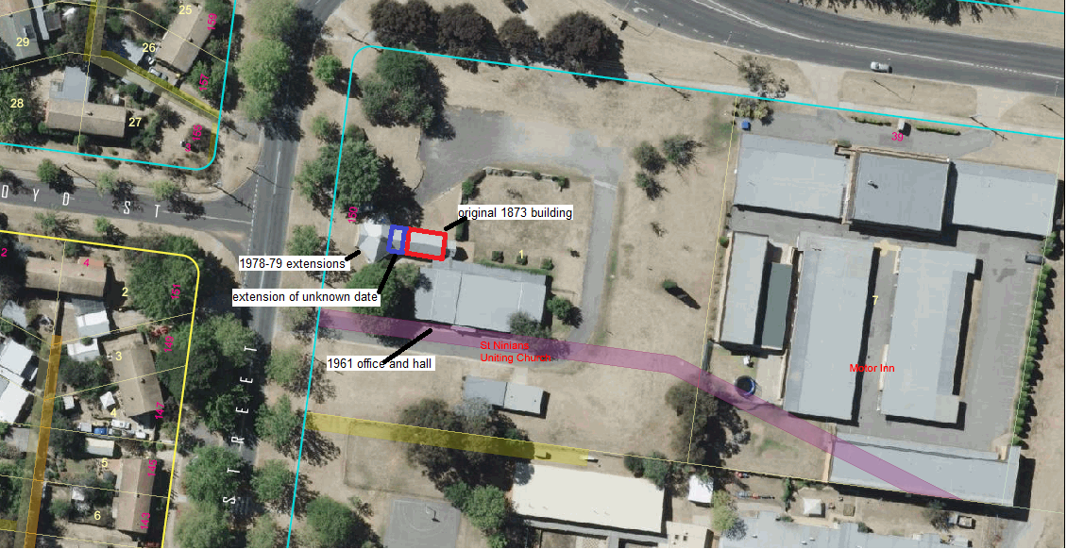
The boundary for this place includes the areas defined by both the solid red and blue lines.
The original building is outlined in a solid red line
The place comprising the intrinsic features of this citation include the original church outlined by solid red line, and the sympathetic extensions, thought to date from the late nineteenth century, outlined in a solid blue line.

The following images were taken on 24 June 2011
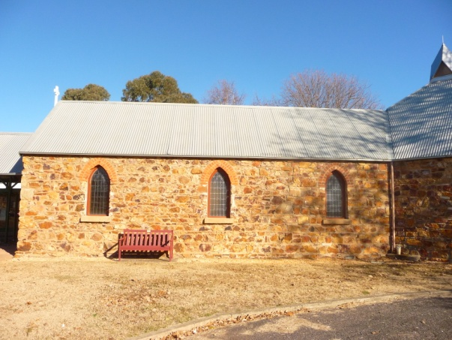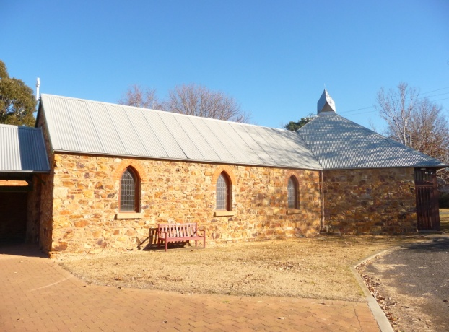
Original church building Original church building and 1978-79 extension

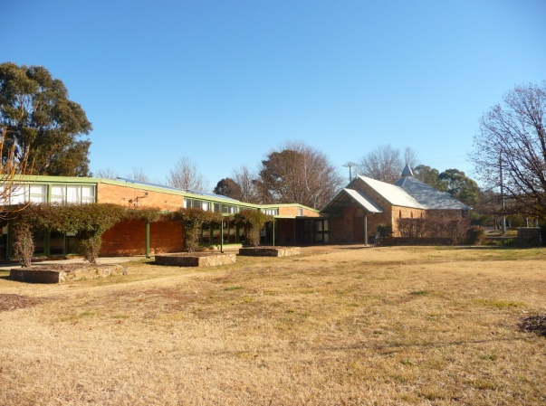
Original church with 1978-79 extension to rear, and 1961 office and hall to the left of image

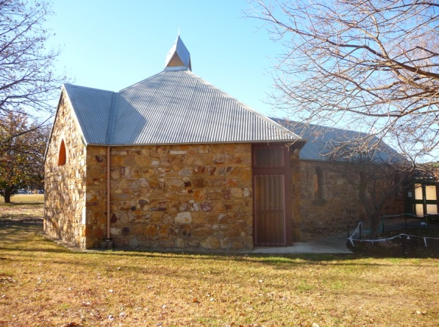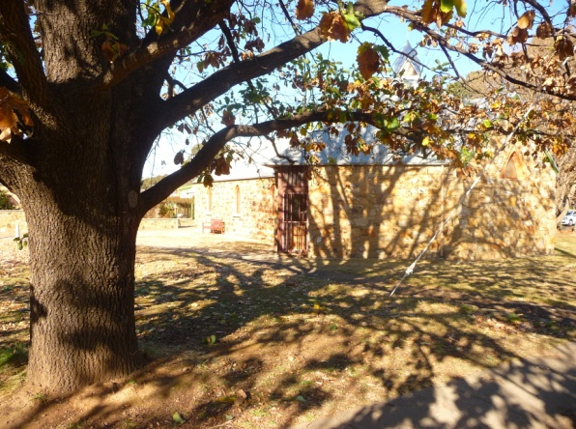
1978-79 extension with original church Elm tree and church

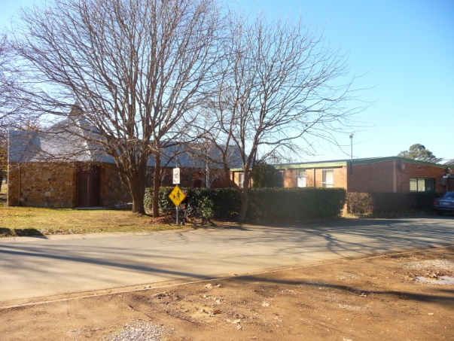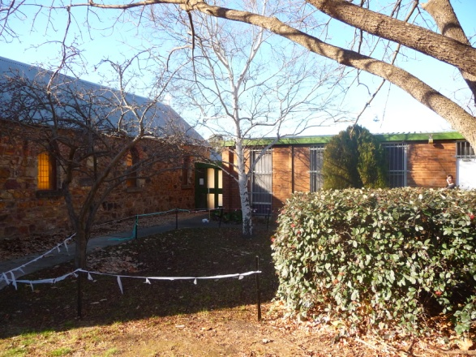
Original church and 1961 office

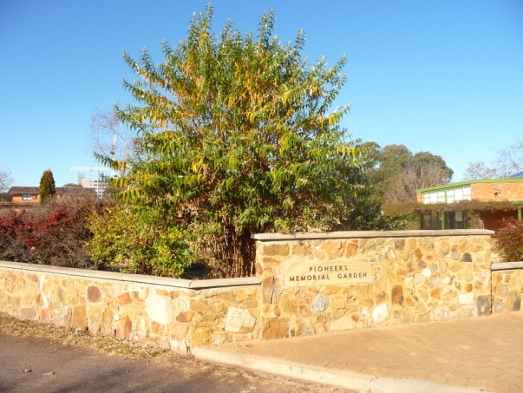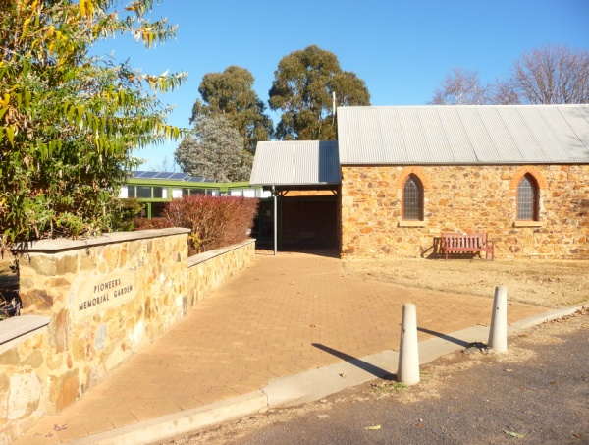
1942 Pioneer Memorial Garden

