Australian Capital Territory

Planning and Development (Technical Amendment—Code, clarification and miscellaneous) Plan Variation 2011
Notifiable instrument NI2011—787
Technical Amendment No 2011-31
made under the
Planning and Development Act 2007, section 89 (Making technical amendments)

This Technical Amendment commences on 16 December 2011.

Technical Amendment Number 2011-31 to the Territory Plan has been approved by the Planning and Land Authority.

Ben Ponton
Delegate of the ACT Planning and Land Authority

13 December 2011

Planning & Development Act 2007

Technical Amendment
to the Territory Plan
Variation 2011-31

Code, clarification and miscellaneous amendment, including changes to various codes

December 2011

Table of Contents

1. INTRODUCTION 2
Outline of the process 2
2. EXPLANATORY STATEMENT 3
Proposed Changes, Reasons and Compliance with the Planning and Development Act 2007 3
2.1 Code variations 3
2.2 Clarification and s87(a) variations 6
3. TECHNICAL AMENDMENT 8
3.1 Code Amendments 8
3.2 Clarification amendments 11
3.3 Clarification and section 87(a) amendments 13

INTRODUCTION

Outline of the process
The Commonwealth’s Australian Capital Territory (Planning and Land Management) Act 1988 allows for the Legislative Assembly to make laws to establish a Territory Planning Authority and for that Authority to prepare and administer a territory plan.
The Planning and Development Act 2007 (the Act) establishes the ACT Planning and Land Authority as the Authority which prepares and administers the territory plan, including continually reviewing and proposing amendments as necessary.
Technical amendments to the territory plan are prepared in accordance with the Act. This technical amendment has been prepared in accordance with the following three sections of the Act:

A variation under section 87(a) of the Act is a technical amendment that:
(i) would not adversely affect anyone’s rights if approved; and
(ii) has as its only object the correction of a formal error in the plan.

A code variation (section 87(b) of the Act) is a technical amendment that
- would only change a code; and
- is consistent with the policy purpose and policy framework of the code; and
- is not an error variation.

A variation under section 87(g) of the Act is a technical amendment that clarifies the language in the territory plan, provided it does not change the substance of the plan.

Following the release of the variation under section 90 of the Act, submissions from the public were invited. At the conclusion of the limited consultation period, any representations are considered by the ACT Planning and Land Authority (the Authority). The Authority then determines a day when the code variation is to commence by way of a commencement notice.

EXPLANATORY STATEMENT

Changes, Reasons and Compliance with the Planning and Development Act 2007
    - Code variations
- Single dwelling housing development code – introducing criteria for setbacks for compact blocks (item 1)

The technical amendment to the single dwelling housing development code inserts criteria for setbacks for compact blocks. This brings the setback provisions for compact blocks in line with setbacks for other forms of single dwellings including standard and midsized blocks.

Section of Act | Statement of compliance with Act
s87(b) a variation (a code variation) that -
(i) would only change a code; and | Only changes sections 2.3, 2.4, 2.5 and 2.6 in the single dwelling housing code setback provisions for compact blocks.
(ii) is consistent with the policy purpose and policy framework of the code; and | The purpose of the code is to provide additional planning, design and environmental controls to support the zone objectives and assessable uses in the Development Tables.  The change adds criteria for setbacks for compact blocks.  The amendment is considered to be consistent with the purpose of the single dwelling housing development code.  The change is consistent with the objectives for the general residential zone.
(iii) is not an error variation | Is not a formal error

- CZ5 Mixed use zone development code - Changes to size restriction per lease to per tenancy and providing a total quantum of office space per lease within a specified area in the Kingston CZ5 commercial zone (item 2)

The change to the commercial CZ5 mixed use development code removes the restriction of 500m² for office gross floor area (GFA) per lease within certain areas of the Kingston CZ5 zone, by introducing a rule providing for a maximum of 500m² office GFA per tenancy (instead of per lease), with an overall maximum total of 2000m² per lease.

The current provision restricts office GFA to 500m² per lease for specified areas in Kingston. This restriction prevents the realisation of the planning objectives outlined in the initial Development Control Plan (DCP) for the Kingston Foreshore (2002). The DCP anticipated subdivision of sites in the specified areas, which were subsequently released as large single leases. Subdivision of these sites would have created multiple leases therefore resulting in a multiplicity of small scale office development.

The change will potentially allow for a range of mixed use development in the Kingston Foreshore area, including more small office tenancies than would currently be achieved though a maximum of 500m² per lease. The use of the term “per tenancy” is consistent with that used in other parts of the CZ5 mixed use zone development code to control the quantum of permissible uses while allowing flexibility in future subdivision.

An overall restriction of 2000m² office GFA per lease will make provision for non-retail commercial activities which are complimentary, but secondary to the primary retail role of the Kingston and Manuka Group centres.

Section of Act | Statement of compliance with Act
s87(b) a variation (a code variation) that -
(i) would only change a code; and | Only changes parts of section 1.6 in the CZ5 mixed use development code relating to maximum office GFA restrictions in certain areas of Kingston Foreshore.
(ii) is consistent with the policy purpose and policy framework of the code; and | The purpose of the code is to provide additional planning, design and environmental controls to support the zone objectives and assessable uses in the Development Tables.  The amendment changes the per lease restriction to a per tenancy restriction and introduces a total quantum for office development per lease in specified areas of the CZ5 zone of Kingston Foreshore.  The amendment is considered to be consistent with the purpose of the CZ5 mixed use development code.  The change is consistent with the objectives for the CZ5 mixed use development code.
(iii) is not an error variation | Is not a formal error

- Industrial zones development code – introduction of limited flexibility for block sizes in the IZ1 general industrial zone for subdivision of existing leases (item 3)

The change to the industrial zones development code removes the restriction of a minimum of 5000m² block size for subdivision of existing leases within the IZ1 general industrial zone, by introducing a rule providing for an average (instead of a minimum) of 5000m² within the subdivision. This will potentially allow for a range of site sizes, including sites smaller than the current requirement of a minimum of 5000m², while simultaneously ensuring the continuing provision of large industrial blocks in the ACT to meet possible future demand. This change is made in light of the changes to industrial land use in the ACT over the past decade, which has resulted in market demand for a mixed range of smaller block sizes in IZ1 zoned industrial areas, not currently being provided under the existing restrictions.

Section of Act | Statement of compliance with Act
s87(b) a variation (a code variation) that -
(i) would only change a code; and | Only changes section 2.1 in the industrial zones development code relating to minimum block size restrictions when subdividing existing leases in the IZ1 general industrial zone.
(ii) is consistent with the policy purpose and policy framework of the code; and | The purpose of the code is to provide additional planning, design and environmental controls to support the zone objectives and assessable uses in the Development Tables.  The change provides limited flexibility in the provision of block sizes within the IZ1 general industrial zone.  The amendment is considered to be consistent with the purpose of the industrial zones development code.  The change is consistent with the objectives for the general industrial zone.
(iii) is not an error variation | Is not a formal error

    - Clarification and s87(a) variations

- Single dwelling housing development code – to clarify standards used for water conservation measures in plumbing (items 4 and 5)

The change to the single dwelling housing code inserts a reference to the water efficiency labelling and standards (WELS) scheme where water efficiency star ratings are mentioned in the code. This change will clarify the rating system for water efficient plumbing used in the code.

Section of Act | Statement of compliance with Act
s87(g) a variation to clarify the language in the territory plan if it does not change the substance of the plan | The change will clarify the rating system for water efficient plumbing.

- Crace concept plan – transfer of ongoing block specific provisions to a suburb precinct code (item 6 and 7)

The amendment to the Crace Concept Plan removes the ongoing block specific provisions regarding fencing controls and relocates it into a suburb precinct code for Crace. A suburb precinct code is the most appropriate place for these provisions, and is consistent with other suburb precinct codes in the Territory Plan.

Section of Act | Statement of compliance with Act
S87(a) a variation that -
(i) would not adversely affect anyone’s rights if approved; and | The variation will not adversely affect anyone’s rights.
(ii) has as its only object the correction of a formal error in the plan | Minor formatting changes are made to the written provisions and a suburb precinct code for Crace is established, to maintain consistency with other suburb precinct codes in the Territory Plan, as a defect of form. Ongoing block specific provisions are more appropriately located in a suburb precinct code.

As part of the amendment, minor formatting changes are made to ensure they work correctly. Two figures are inserted to provide visual clarification of the ongoing fencing provisions contained in Rules R1, R2 and R3.

Section of Act | Statement of compliance with Act
s87(g) a variation to clarify the language in the territory plan if it does not change the substance of the plan | The insertion of two figures is intended to graphically clarify the ongoing fencing provisions in the code.

TECHNICAL AMENDMENT
    - Code Amendments

Variation to the Residential zones – single dwelling housing development code
- Residential zones – Single dwelling housing development code, Part C – Development Type Controls, Part C(3) – Single Dwelling Housing – Compact Blocks in New Estates, Element 2 – Building and Site Controls, Sections 2.3, 2.4, 2.5 and 2.6

Substitute with the following as underlined below

Rules | Criteria
2.3 Front Street Setback (including both frontages on a corner block)
R62  Front setbacks are a minimum of:  - 3m to lower floor level and upper floor level of the dwelling;  - 5.5m to the garage or carport.  Except  - for a rear loading block, minimum front setback to the rear lane:  - 0m to lower floor level and upper floor level of the dwelling;  - 0m to the garage or carport.  Or  - Where adjoining pedestrian paths with a width of 6 metres or less, minimum front setback to the pedestrian path:  - 0m to lower floor level and upper floor level of the dwelling;  - 0m to the garage or carport. | C62  The front setback:  - reflects the existing or proposed streetscape character  - provides for the most efficient use of the site  - will not significantly compromise the amenity of residents of the proposed building and residents of adjoining and adjacent dwellings  - is related to the height of the building and to the width of the street to ensure pedestrian scale at street level  - space is provided for street trees to grow to maturity  - parking and garages do not dominate the frontage of the development.
2.4 Rear Setback
R63  Rear setbacks are a minimum of:  - for single storey dwelling – 3m;  - for two storey dwelling – 4m to lower floor level and upper floor level. | C63  Buildings and other structures are sited and reflect residential (suburban) scale, height and length to ensure:  - sufficient spatial separation between adjoining developments  - the protection of a reasonable amount of privacy and solar access to the dwelling (or adjacent dwellings) and outdoor spaces (or adjacent outdoor spaces).
2.5 Side Setback
R64  Side setbacks are a minimum of:  - Lower floor level:  - 0 m to both side boundaries; or  - 0 m to one side boundary and 900mm to blank wall or 1.5 m to windows or doors facing the side boundary.  b) Upper floor level:  i) 0 m to both side boundaries; or  ii) 0 m to one side boundary and 900mm to blank wall or 1.5 m to windows facing the side boundary, with sill heights to be ≥1.7 m from the floor or with permanently fixed panes of obscure glass. | C64  Buildings and other structures are sited and reflect residential (suburban) scale, height and length to ensure:  - sufficient spatial separation between adjoining developments  - the protection of a reasonable amount of privacy and solar access to the dwelling (or adjacent dwellings) and outdoor spaces (or adjacent outdoor spaces).
2.6 Side Setback – Corner Block
R65  Side setbacks for a corner block are a minimum of:  - for lower floor level:  - 3m to the shorter side boundary and 0m to the longer side boundary; or  - 3m to the shorter side boundary and 900mm to blank walls and 1.5m to windows and doors facing the longer side boundary.  Except for a rear loading block:  - 0m to both side boundaries; or  - 0m to the shorter side boundary and 900mm to blank walls and 1.5m to windows or doors facing the longer side boundary.  - for upper floor level:  - 3m to the shorter boundary and 0m to the longer boundary; or  - 3m to the north facing boundary and 0m where the lower floor level is built to the side boundary, otherwise 900mm to blank walls and 1.5m to windows facing the side boundary with a sill height ≥ 1.7m above the upper floor level finished floor level or to windows with permanent fixed panes of obscure glass  except for a rear loading block;  - 0m where the lower floor level is built to the side boundary, otherwise 900mm to blank walls and 1.5m to windows facing the side boundary with a sill height ≥1.7m above the upper floor level finished floor level or to windows with permanent fixed panes of obscure glass. | C65  Buildings and other structures are sited and reflect residential (suburban) scale, height and length to ensure:  - sufficient spatial separation between adjoining developments  - the protection of a reasonable amount of privacy and solar access to the dwelling (or adjacent dwellings) and outdoor spaces (or adjacent outdoor spaces).

Variation to the Commercial zones – CZ5 mixed use zone development code
- CZ5 Mixed use development code, Part B – Site specific controls, Element 1: Restrictions on Use, Section 1.6 Kingston, Rule R65

Substitute with the following

The following maximum GFA restrictions apply to Office in Kingston (Figure B2):

a) areas ‘b’, ‘c’ and ‘e’: 500m² per tenancy, with the total Office GFA not exceeding 2000m² per lease
b) area ‘d’: 2000m² per lease.

Variation to the Industrial zones development code
- Industrial zones development code, Part A – Zone specific controls, Part A(1) – IZ1 – General Industrial Zone, Element 2: Building and Site Controls, Section 2.1 Subdivision, Rule R1

Substitute with the following

Unless stated otherwise in the lease, or where located within AMTECH Estate, Symonston (Figure 3):

- the minimum block size for blocks subdivided from existing leases is 2000m²
- the average of all blocks to be created via subdivision of the original lease is to be not less than 5000m²

    - Clarification amendments

Variation to the Residential zones – single dwelling housing development code
- Single dwelling housing development code, Part C – Development type controls, Part C(1) – Single dwelling housing, Element 6: Environment, Section 6.1 - Water sensitive urban design, Rule R51

Insert wording as underlined below

Rules | Criteria
6.1 Water sensitive urban design
R51  For all new dwellings (including in established  areas), as well as extensions and alterations that  increase the roof area by more than 50%, then  water storage of the following capacity are  provided on-site for each dwelling:  a) <300m² block  i) No minimum water storage requirement  ii) minimum *** WELS*-rated plumbing fixtures  b) small block: 300 – 499m²  i) minimum storage: 2,000 litres  ii) 50% or 75m² of roof area, whichever is the lesser, is connected to the tank and the tank is connected to at least the toilet, laundry cold water and all external taps  c) medium block: 500-800m²  i) minimum storage: 4000 litres  ii) 50% or 100m² of roof area, whichever is the lesser, is connected to the tank and the tank is connected to at least the toilet, laundry cold water and all external taps  d) large block: >800m²  i) minimum storage: 5,000 litres  ii) 50% or 125m² of roof area, whichever is the lesser, is connected to the tank and the tank is connected to at least the toilet, laundry cold water and all external taps, or  b) Rule 52 applies.  *Water efficiency labelling and standards (WELS) scheme | C51  For all new dwellings (including in established  areas), as well as extensions and alterations that  increase the roof area by more than 50%,  evidence is provided that shows the development  achieves a minimum 40% reduction in mains  water consumption compared to an equivalent  development constructed in 2003, using the  ACTPLA on-line assessment tool or another tool.  The 40% target is met without any reliance on  landscaping measures to reduce consumption.

- Single dwelling housing development code, Part C(3) – Single dwelling housing – compact blocks in new estates, Element 6: Environment, Section 6.1 - Water sensitive urban design, Rule R78

Insert wording as underlined below

Rules | Criteria
6.1 Water sensitive urban design
R78  Minimum *** WELS* rated plumbing fixtures are provided to the dwelling.  *Water efficiency labelling and standards (WELS) scheme | This is a mandatory rule. There is no criterion.

    - Clarification and section 87(a) amendments

Variation to the Crace concept plan
- Crace Concept Plan, Section 7

Omit

Variation to Precinct codes
- Precinct Codes, Precinct Code by Suburb

Insert Crace Precinct Code (Appendix A)

Interpretation service
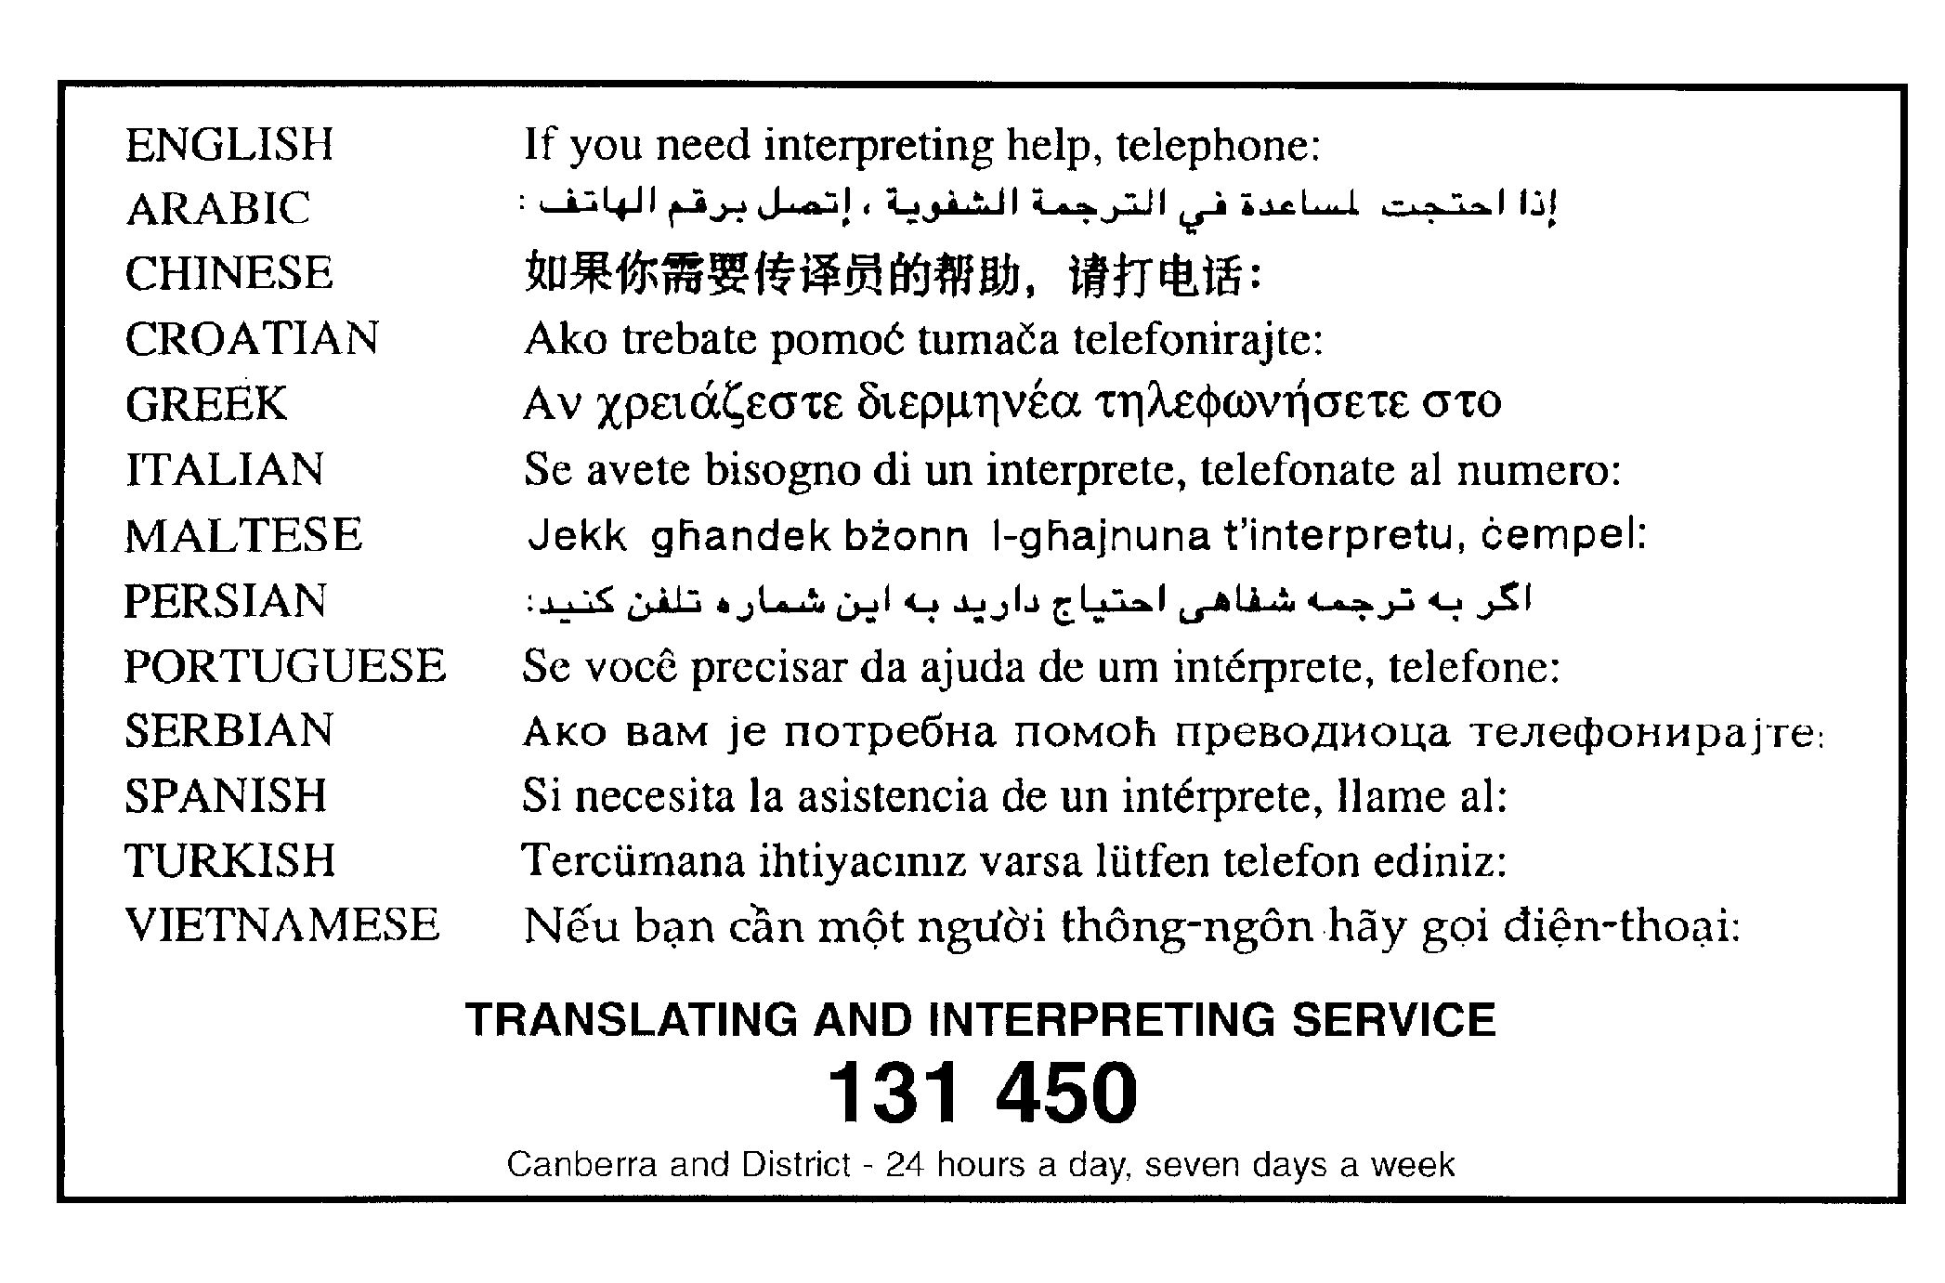

Appendix A: Crace Precinct Code

This page is intentionally blank

Crace Precinct Code
Covering the Division of Crace

Suburb of Crace – ongoing block specific provisions assessment criteria

1 Ongoing block specific provisions

The following rules are intended to apply to areas covered within the maps identifying the location of fencing controls.

Rules | Criteria
Interface
R1  This rule applies to all boundary fencing corner blocks identified on the Crace ongoing block specific provisions map.  For a minimum of 9m from the corner of the primary and secondary frontages, any fencing forward of the building must comply with all of the following:  - is between 600mm and 900mm high  - is located on the boundary.  Beyond 9m of the corner of the primary and secondary frontages, any fencing forward of the building line must comply with all of the following:  - is located on or adjacent to the block’s secondary frontage (except for north fronting blocks)  - not less than 50% of the fencing is set back at least 600mm from the front boundary  - is not more than 1.5m high.  Note: Figure 1 refers. | This is a mandatory rule. There is no applicable criterion.
R2  This rule applies to all boundary fencing blocks adjacent to open space identified on the Crace ongoing block specific provisions map.  For a minimum of 9m from the corner of the primary and secondary frontages, any fencing forward of the building must comply with all of the following:  - is a maximum of 1m high  - is located on the boundary.  Beyond 9m of the corner of the primary and secondary frontages, any fencing forward of the building line must comply with all of the following:  - is located on or adjacent to the block’s secondary frontage  - not less than 50% of the fencing is set back at least 600mm from the front boundary  - is not more than 1.5m high.  Note: Figure 1 refers. | This is a mandatory rule. There is no applicable criterion.
R3  This rule applies to all boundary fencing north facing blocks identified on the Crace ongoing block specific provisions map.  Any fencing forward of the building line must comply with all of the following:  - not less than 50% of the fencing is set back at least 600mm from the front boundary  - is adjacent to the block’s principal private open space  - is not more than 1.5m high.  Note: Figure 2 refers. | This is a mandatory rule. There is no applicable criterion.
R4  This rule applies to all boundary fencing blocks identified on the Crace ongoing block specific provisions map.  Any fencing forward of the building line complies with all of the following:  - is constructed of masonry or stone work and includes infill panels of timber slats (excluding raw treated pine or palings) or metal slats (excluding metal cladding or swimming pool fencing) and contains planting to minimum 50% of the solid masonry walls. | C4  This criterion applies to all boundary fencing blocks shown on the Crace ongoing block specific provisions map.  Boundary fencing forward of the building line is partially transparent and is constructed of quality materials that complement those used in the dwelling.

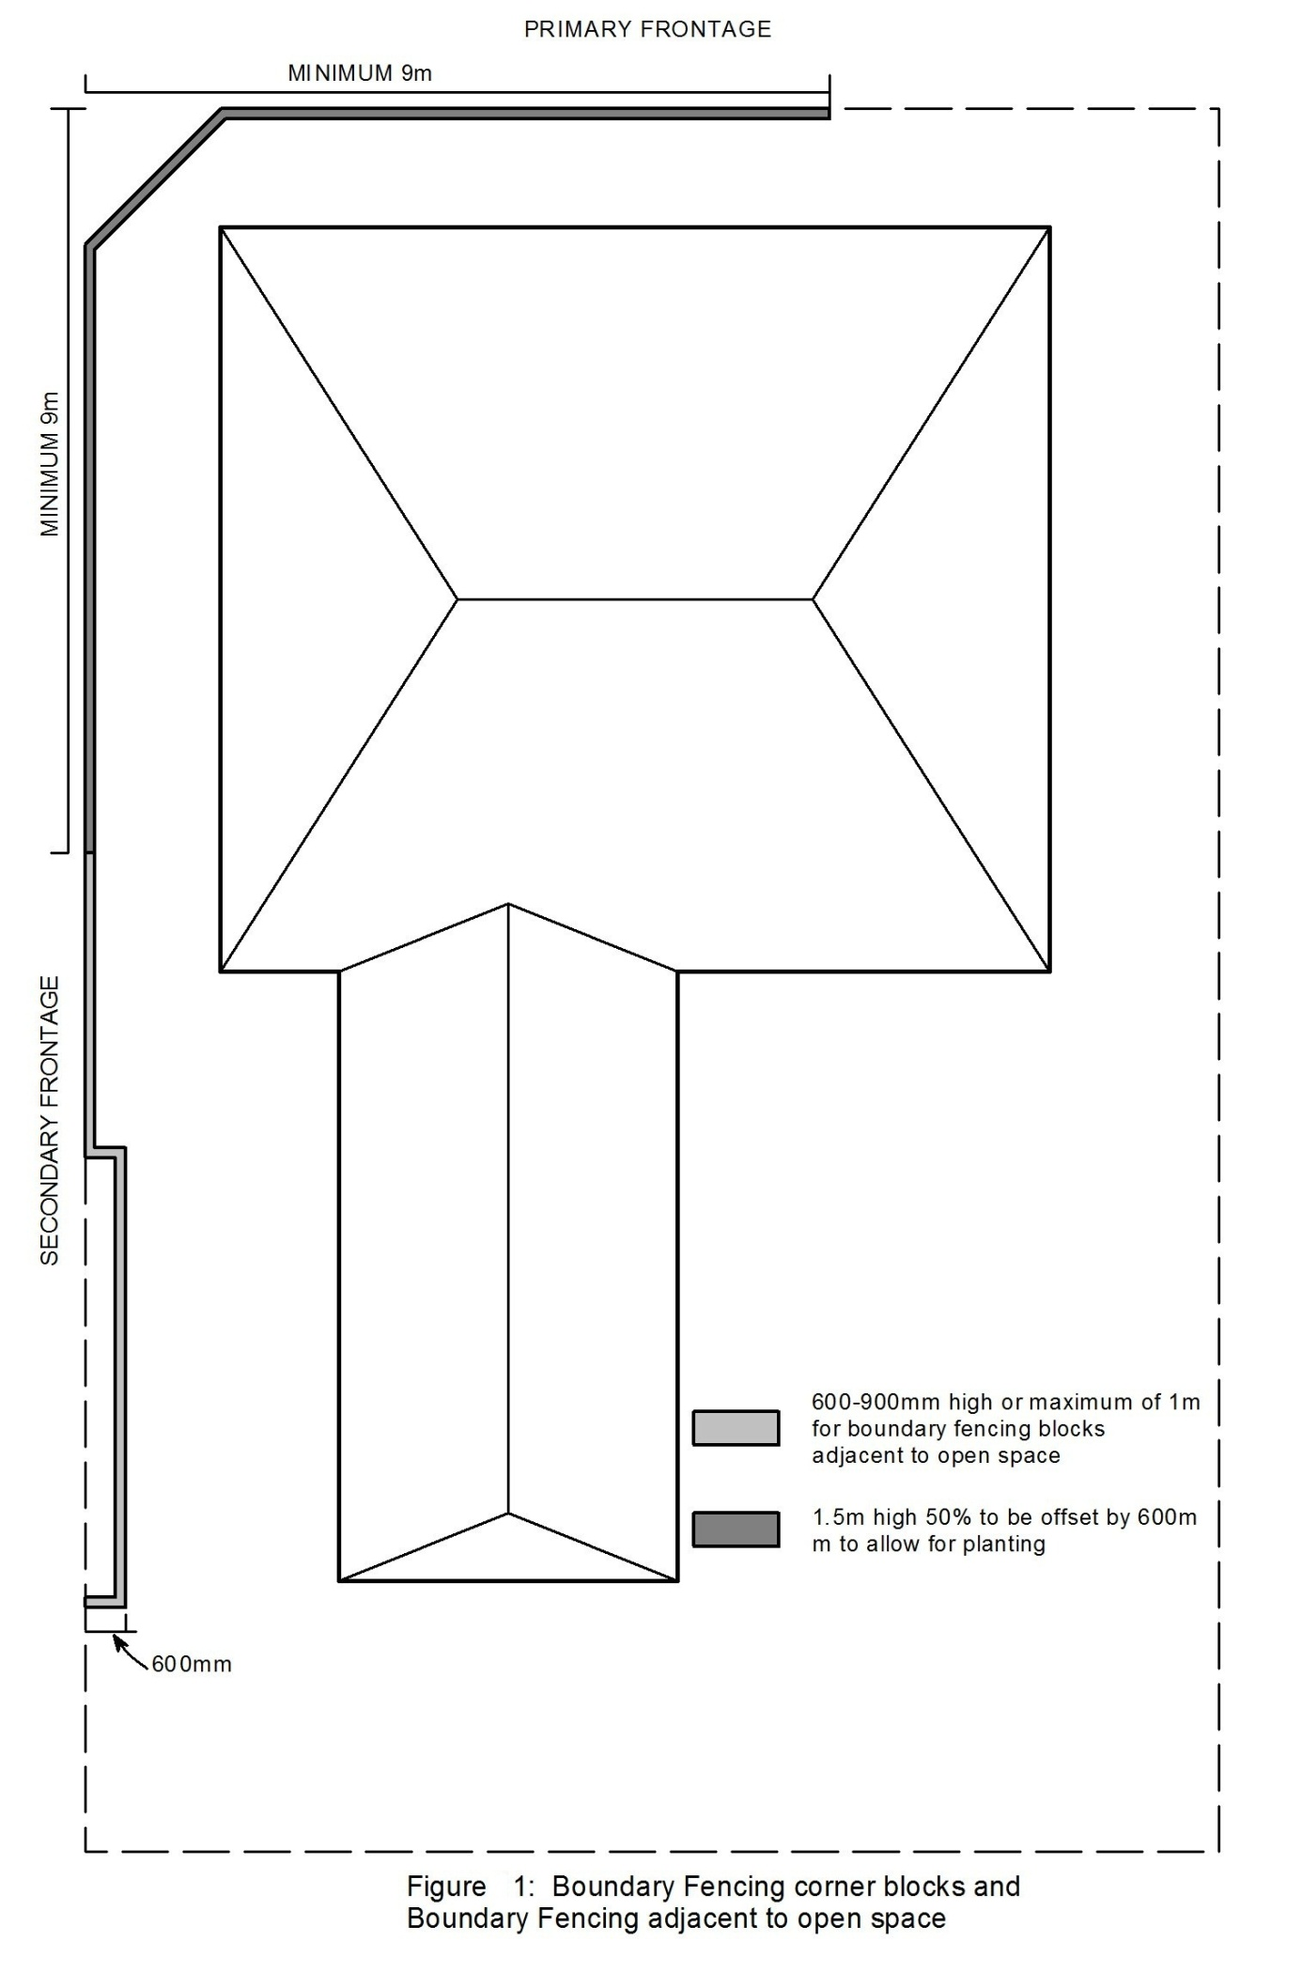

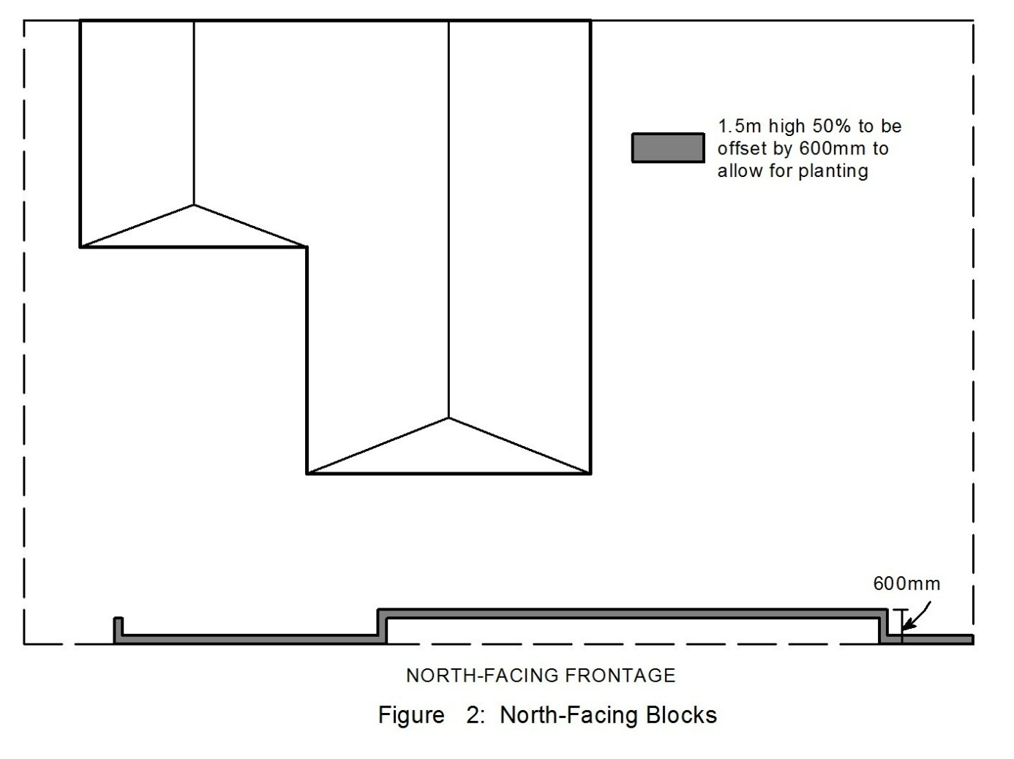

Part B Suburb of Crace – maps identifying blocks subject to ongoing block specific provisions

