Australian Capital Territory

Planning and Development (Technical Amendment—Miscellaneous amendments and corrections) Plan Variation 2011 (No 3)*
Notifiable instrument NI2011—788
Technical Amendment No 2011-39
made under the
Planning and Development Act 2007, section 89 (Making technical amendments)

This Technical Amendment commences on 16 December 2011.

Technical Amendment Number 2011-39 to the Territory Plan has been approved by the Planning and Land Authority.

Ben Ponton
Delegate of the ACT Planning and Land Authority

13 December 2011

Planning and
Land Authority

Planning & Development Act 2007

Technical Amendment
to the Territory Plan
Variation 2011-39

Miscellaneous amendments and corrections

December 2011
Table of Contents

1 INTRODUCTION 2
Outline of the process 2
2 EXPLANATORY STATEMENT 3
2.1 Proposed Changes and Reasons 3
3. TECHNICAL AMENDMENT 7

1 INTRODUCTION

Outline of the process

The Commonwealth’s Australian Capital Territory (Planning and Land Management) Act 1988 allows for the Legislative Assembly to make laws to establish a Territory Planning Authority and for that Authority to prepare and administer a Territory Plan.

The Planning and Development Act 2007 (the Act) establishes the ACT Planning and Land Authority as the Authority which prepares and administers the Territory Plan, including continually reviewing and proposing amendments as necessary.

Technical amendments to the Territory Plan are prepared in accordance with the Act. This technical amendment has been prepared in accordance with the following sections of the Act:

A variation under section 87(a) is a technical amendment that:
(i) would not adversely affect anyone’s rights if approved; and
(ii) has as its only object the correction of a formal error in the plan.

A variation under section 87(f) is a technical amendment to omit something that is obsolete or redundant in the Territory Plan.

This technical amendment has been approved by the ACT Planning and Land Authority.

2 EXPLANATORY STATEMENT

2.1 Proposed Changes and Reasons

- Removal of redundant Bruce central precinct structure plan from the Territory Plan (item 99)

The future urban area overlay which applied to land within the Bruce Structure Plan has now been uplifted and no longer applies. The provisions contained in the plan regarding setbacks can be found in the commercial CZ5 mixed use zone development code. The structure plan is now redundant and it is proposed that it be omitted from the Territory Plan.

Section of Act | Statement of compliance with Act
s87(f) a variation to omit something that is obsolete or redundant in the Territory Plan | No land specified in the structure plan remains under FUA and all ongoing area specific provisions have been translated into the Territory Plan, therefore the structure plan is now redundant.

- Removal of ‘street’ from ‘front street setbacks’ to reflect the intent of the provision in part C3 of the multi-unit housing development code
(items 18 – 21)

Element 2.2 refers to front street setbacks. However, in accordance with Table 5, the intent of the provision is to ensure that setbacks are also applied to other frontages and not only to street frontages. Therefore ‘street’ is removed from heading 2.2 and criterion C105 and removed from the heading of Table 5 and the corresponding notes.

Section of Act | Statement of compliance with Act
s87(a) a variation that -
(i) would not adversely affect anyone’s rights if approved; and | This amendment will not adversely affect anyone’s rights.
(ii) has as its only object the correction of a formal error in the plan | This amendment will remove the word ‘street’ from the title of both Element 2.2 and Table 5, criterion C105 and the notes in Table 5, to ensure the original intent of the provisions.

- Addition of a note to schedules 1 – 9 of the parking and vehicular access general code which reflects the intention that ‘spaces’ mean ‘car spaces’ (items 84 –92)

The schedules list the number of parking spaces that are required according to zone and development type, however the spaces are not specifically referred to as ‘car’ spaces. Therefore a note is to be included at the end of the Schedule to make it clear that, unless otherwise stated, ‘spaces’ refer to ‘car parking spaces’.

Section of Act | Statement of compliance with Act
s87(a) a variation that -
(i) would not adversely affect anyone’s rights if approved; and | This amendment will not adversely affect anyone’s rights.
(ii) has as its only object the correction of a formal error in the plan | This amendment will include a note to ensure the original intent of the provisions, namely that ‘spaces’ refer to ‘car parking spaces’ unless otherwise stated.

- Correction to the term ‘Retirement complex’ by correcting to ‘Retirement Village’ (items 3, 6, 9,12, 15, 49, 54, 57, 61, 64, 70, 73, 76, 79, 83, 93 - 98)

Variation 302 Community Facilities resulted in changing the term ‘retirement complex’ to ‘retirement village’ within the CFZ development table. To ensure consistency, ‘retirement complex’ is corrected throughout the Territory Plan to reflect the intent of this change.

Section of Act | Statement of compliance with Act
s87(a) a variation that -
(i) would not adversely affect anyone’s rights if approved; and | This amendment will not adversely affect anyone’s rights.
(ii) has as its only object the correction of a formal error in the plan | This amendment will correct the term ‘retirement complex’ by correcting it to ‘retirement village’ in accordance with the intention of variation 302.

- Correction to zone boundaries in the town centres and group centres development codes (items 35, 37 and 38)

The commencement of TA2010-15 under section 96A (Rezoning – boundary changes) of the Planning and Development Act 2007 resulted in a number of changes to zone boundaries. To ensure consistency with amendments to block boundaries in the districts of Belconnen, Woden and Tuggeranong, the following figures are corrected:
- A4 Woden Town Centre Zones
- A3 Jamison Group Centre Zones (Macquarie)
- A12 Erindale Group Centre Zones (Wanniassa)

Section of Act | Statement of compliance with Act
s87(a) a variation that -
(i) would not adversely affect anyone’s rights if approved; and | This amendment will not adversely affect anyone’s rights.
(ii) has as its only object the correction of a formal error in the plan | This amendment will replace the relevant figures with an accurate representation of the Territory Plan zoning.

- Insertion of statement into all development tables requiring development on leased land to be authorised by a lease (items 1, 2, 4, 5, 7, 8, 10, 11, 13, 14, 22 – 33, 44, 45, 47, 48, 52, 53, 55, 56, 59, 60, 62, 63, 66, 67, 68, 69, 71, 72, 74, 75, 77, 78)

Variation 302 Community Facility Zone inserted ‘On leased land, development must be authorised by a lease’ into the CFZ – Community Facility Zone Development Table under both Exempt Development and Assessable Development headings.

This requirement reinforces the requirements under the Planning and Development Act 2007.

Section of Act | Statement of compliance with Act
s87(a) a variation that -
(i) would not adversely affect anyone’s rights if approved; and | This amendment will not adversely affect anyone’s rights.
(ii) has as its only object the correction of a formal error in the plan | This statement is being inserted as it is considered to be a defect in form of the development tables.

- Correction to tree protection provisions in zone(s) development codes, commercial centres development codes and the Northbourne Avenue precinct code (item 16, 17, 34, 36, 39, 40, 41, 42, 43, 50, 51, 58, 65, 80, 82)

The provisions relating to tree protection in the Territory Plan are not consistent. The changes will make the provisions consistent by making it clear that the Planning and Land Authority will refer applications to the Conservator of Flora and Fauna, and the circumstances under which such referrals are made, in accordance with clause 26 of the Planning and Development Regulation 2008.

On this basis, it is considered a defect of form that this rule is not applied
consistently throughout the Territory Plan.

Section of Act | Statement of compliance with Act
s87(a) a variation that -
(i) would not adversely affect anyone’s rights if approved; and | This amendment will not adversely affect anyone’s rights.
(ii) has as its only object the correction of a formal error in the plan | This amendment will correct the relevant provisions and will apply consistently throughout the Territory Plan.

- Correction to building height controls in the Gungahlin town centre precinct code (item 81)

The current building height in precinct 2b – Office park in the Gungahlin town centre precinct code is 18 metres. The precinct code is part of draft variation 300 Gungahlin Town Centre which has been approved but has not yet commenced. It is proposed to increase the height limit to 23 metres in line with outcomes contained within the planning report.

Section of Act | Statement of compliance with Act
s87(a) a variation that -
(i) would not adversely affect anyone’s rights if approved; and | This amendment will not adversely affect anyone’s rights.
(ii) has as its only object the correction of a formal error in the plan | This amendment will correct the precinct code in line with the outcomes contained within the planning report.

3. TECHNICAL AMENDMENT

Variation to RZ1 Suburban Zone Development Table

- Exempt development

Insert second line:

On leased land, development must be authorised by a lease.

- Assessable development

Insert second line:

On leased land, development must be authorised by a lease.

- Minimum Assessment Track Merit

Substitute Retirement Complex with:

Retirement Village

Variation to RZ2 Suburban Core Zone Development Table

- Exempt development

Insert second line:

On leased land, development must be authorised by a lease.

- Assessable development

Insert second line:

On leased land, development must be authorised by a lease.

- Minimum Assessment Track Merit

Substitute Retirement Complex with:

Retirement Village

Variation to RZ3 Urban Residential Zone Development Table

- Exempt development

Insert second line:

On leased land, development must be authorised by a lease.

- Assessable development

Insert second line:

On leased land, development must be authorised by a lease.

- Minimum Assessment Track Merit

Substitute Retirement Complex with:

Retirement Village

Variation to RZ4 Medium Density Residential Zone Development Table

- Exempt development

Insert second line:

On leased land, development must be authorised by a lease.

- Assessable development

Insert second line:

On leased land, development must be authorised by a lease.

- Minimum Assessment Track Merit

Substitute Retirement Complex with:

Retirement Village

Variation to RZ5 High Density Residential Zone Development Table

- Exempt development

Insert second line:

On leased land, development must be authorised by a lease.

- Assessable development

Insert second line:

On leased land, development must be authorised by a lease.

- Minimum Assessment Track Merit

Substitute Retirement Complex with:

Retirement Village

Variation to Single Dwelling Housing Development Code

- Part B – General Development Controls, Element 6.2 Trees, R22

Substitute:

R22  This rule applies to a development that has one or more of the following characteristics:  - requires groundwork within the tree protection zone of a protected tree  - is likely to cause damage to or removal of any protected trees  The authority shall refer the development application to the Conservator of Flora and Fauna.  Notes:  - Under the Planning and Development Regulation 2008 a development application for a declared site under the Tree Protection Act 2005, must be referred to the Conservator of Flora and Fauna.  - The authority will consider any advice from the Conservator of Flora and Fauna before determining the application in accordance with the Planning and Development Act 2007.  - Protected tree and declared site are defined under the Tree Protection Act 2005. | This is a mandatory requirement. There is no applicable criterion.

Variation to Multi Unit Housing Development Code

- Part B – General Development Controls, Element 6.2 Trees, R40

Substitute:

R40  This rule applies to a development that has one or more of the following characteristics:  - requires groundwork within the tree protection zone of a protected tree  - is likely to cause damage to or removal of any protected trees  The authority shall refer the development application to the Conservator of Flora and Fauna.  Notes:  - Under the Planning and Development Regulation 2008 a development application for a declared site under the Tree Protection Act 2005, must be referred to the Conservator of Flora and Fauna.  - The authority will consider any advice from the Conservator of Flora and Fauna before determining the application in accordance with the Planning and Development Act 2007.  - Protected tree and declared site are defined under the Tree Protection Act 2005. | This is a mandatory requirement. There is no applicable criterion.

- Part C(3) – Multi Unit Housing – Inner North Canberra and Gungahlin District – RZ3 and RZ4 Zones, Element 2: Building and Site Controls, 2.2 Front Street Setback

Substitute Front Street Setback with:

Front Setback

- Part C(3) – Multi Unit Housing – Inner North Canberra and Gungahlin District – RZ3 and RZ4 Zones, Element 2: Building and Site Controls, 2.2 Front Street Setback, Criterion C105

Omit:

street

- Part C(3) – Multi Unit Housing – Inner North Canberra and Gungahlin District – RZ3 and RZ4 Zones, Element 2: Building and Site Controls, Table 5: Front Street Setback

Omit from title:

Street

- Part C(3) – Multi Unit Housing – Inner North Canberra and Gungahlin District – RZ3 and RZ4 Zones, Element 2: Building and Site Controls, Table 5: Front Street Setback, Note

Omit from note:

Street

Variation to CZ1 Core Zone Development Table

- Exempt development

Insert second line:

On leased land, development must be authorised by a lease.

- Assessable development

Insert second line:

On leased land, development must be authorised by a lease.

Variation to CZ2 Business Zone Development Table

- Exempt development

Insert second line:

On leased land, development must be authorised by a lease.

- Assessable development

Insert second line:

On leased land, development must be authorised by a lease.

Variation to CZ3 Services Zone Development Table

- Exempt development

Insert second line:

On leased land, development must be authorised by a lease.

- Assessable development

Insert second line:

On leased land, development must be authorised by a lease.

Variation to CZ4 Local Centres Zone Development Table

- Exempt development

Insert second line:

On leased land, development must be authorised by a lease.

- Assessable development

Insert second line:

On leased land, development must be authorised by a lease.

Variation to CZ5 Mixed Use Zone Development Table

- Exempt development

Insert second line:

On leased land, development must be authorised by a lease.

- Assessable development

Insert second line:

On leased land, development must be authorised by a lease.

Variation to CZ6 Leisure and Accommodation Zone Development Table

- Exempt development

Insert second line:

On leased land, development must be authorised by a lease.

- Assessable development

Insert second line:

On leased land, development must be authorised by a lease.

Variation to City Centre Development Code

- Part B – General Development Controls, Element 6.3 Trees, R88

Substitute:

R88  This rule applies to a development that has one or more of the following characteristics:  - requires groundwork within the tree protection zone of a protected tree  - is likely to cause damage to or removal of any protected trees  The authority shall refer the development application to the Conservator of Flora and Fauna.  Notes:  - Under the Planning and Development Regulation 2008 a development application for a declared site under the Tree Protection Act 2005, must be referred to the Conservator of Flora and Fauna.  - The authority will consider any advice from the Conservator of Flora and Fauna before determining the application in accordance with the Planning and Development Act 2007.  - Protected tree and declared site are defined under the Tree Protection Act 2005. | This is a mandatory requirement. There is no applicable criterion.

Variation to Town Centres Development Code

- Part A – Centre and Zone Specific Controls, Part A - Town Centres – Overview

Substitute Figure A4 with:

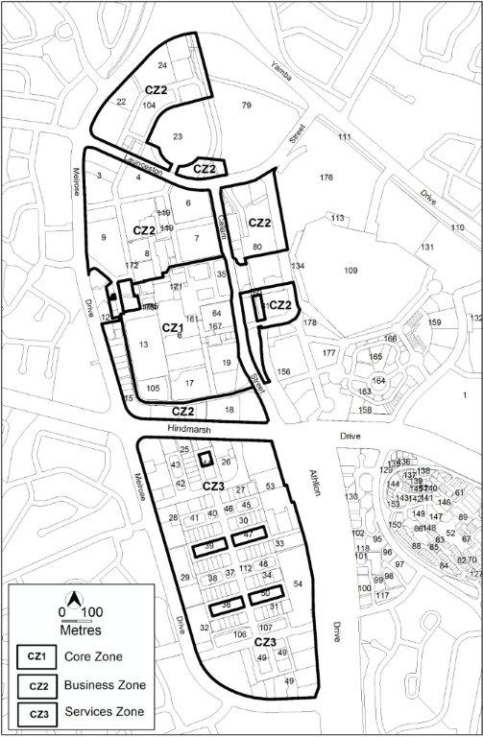

- Part B – General Development Controls, Element 6.3 Trees, R88

Substitute:

R88  This rule applies to a development that has one or more of the following characteristics:  - requires groundwork within the tree protection zone of a protected tree  - is likely to cause damage to or removal of any protected trees  The authority shall refer the development application to the Conservator of Flora and Fauna.  Notes:  - Under the Planning and Development Regulation 2008 a development application for a declared site under the Tree Protection Act 2005, must be referred to the Conservator of Flora and Fauna.  - The authority will consider any advice from the Conservator of Flora and Fauna before determining the application in accordance with the Planning and Development Act 2007.  - Protected tree and declared site are defined under the Tree Protection Act 2005. | This is a mandatory requirement. There is no applicable criterion.

Variation to Group Centres Development Code

- Part A - Centre and Zone Specific Requirements, Part A – Group Centres Overview

Substitute Figure A3 with:

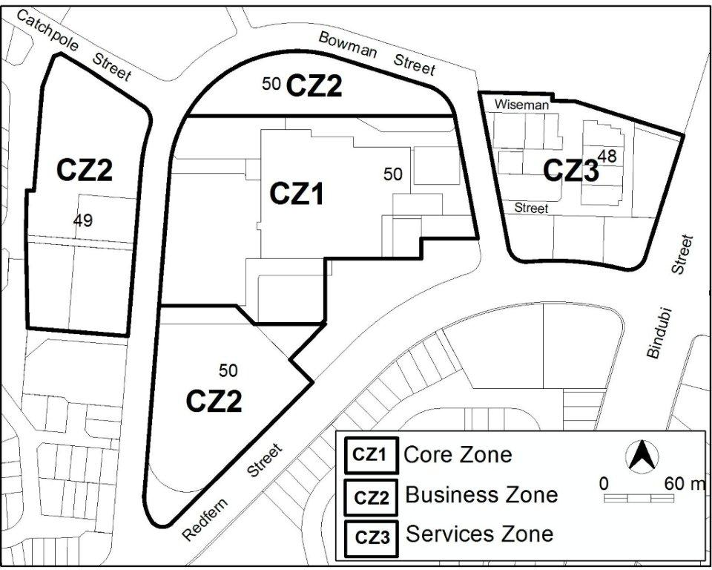

- Part A - Centre and Zone Specific Requirements, Part A – Group Centres Overview

Substitute Figure A12 with:

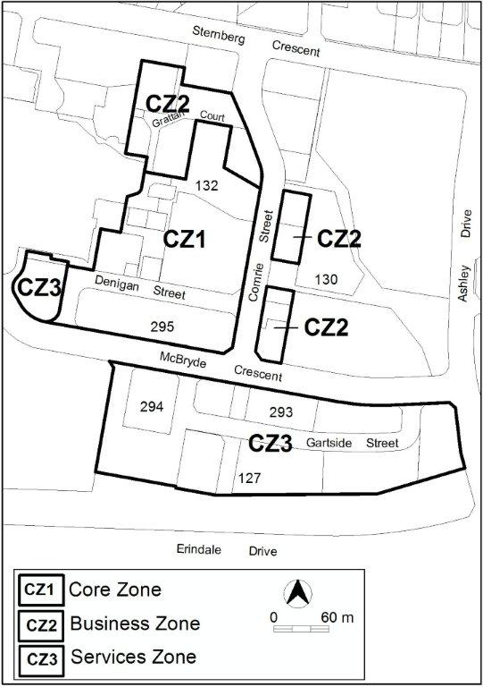

- Part B – General Development Controls, Element 6.3 Trees, R62

Substitute:

R62  This rule applies to a development that has one or more of the following characteristics:  - requires groundwork within the tree protection zone of a protected tree  - is likely to cause damage to or removal of any protected trees  The authority shall refer the development application to the Conservator of Flora and Fauna.  Notes:  - Under the Planning and Development Regulation 2008 a development application for a declared site under the Tree Protection Act 2005, must be referred to the Conservator of Flora and Fauna.  - The authority will consider any advice from the Conservator or Flora and Fauna before determining the application in accordance with the Planning and Development Act 2007.  - Protected tree and declared site are defined under the Tree Protection Act 2005. | This is a mandatory requirement. There is no applicable criterion.

Variation to Local Centres Development Code

- Part A – General Development Controls, Element 6.3 Trees, R39

Substitute:

R39  This rule applies to a development that has one or more of the following characteristics:  - requires groundwork within the tree protection zone of a protected tree  - is likely to cause damage to or removal of any protected trees  The authority shall refer the development application to the Conservator of Flora and Fauna.  Notes:  - Under the Planning and Development Regulation 2008 a development application for a declared site under the Tree Protection Act 2005, must be referred to the Conservator of Flora and Fauna.  - The authority will consider any advice from the Conservator of Flora and Fauna before determining the application in accordance with the Planning and Development Act 2007.  - Protected tree and declared site are defined under the Tree Protection Act 2005. | This is a mandatory requirement. There is no applicable criterion.

Variation to CZ2 Office Areas Outside Centres Development
Code

- Part A – General Development Controls, Element 6.3 Trees, R32

Substitute:

R32  This rule applies to a development that has one or more of the following characteristics:  - requires groundwork within the tree protection zone of a protected tree  - is likely to cause damage to or removal of any protected trees  The authority shall refer the development application to the Conservator of Flora and Fauna.  Notes:  - Under the Planning and Development Regulation 2008 a development application for a declared site under the Tree Protection Act 2005, must be referred to the Conservator of Flora and Fauna.  - The authority will consider any advice from the Conservator of Flora and Fauna before determining the application in accordance with the Planning and Development Act 2007.  - Protected tree and declared site are defined under the Tree Protection Act 2005. | This is a mandatory requirement. There is no applicable criterion.

Variation to CZ5 Mixed Use Zone Development Code

- Part A – General Development Controls, Element 6.3 Trees, R32

Substitute:

R32  This rule applies to a development that has one or more of the following characteristics:  - requires groundwork within the tree protection zone of a protected tree  - is likely to cause damage to or removal of any protected trees  The authority shall refer the development application to the Conservator of Flora and Fauna.  Notes:  - Under the Planning and Development Regulation 2008 a development application for a declared site under the Tree Protection Act 2005, must be referred to the Conservator of Flora and Fauna.  - The authority will consider any advice from the Conservator of Flora and Fauna before determining the application in accordance with the Planning and Development Act 2007.  - Protected tree and declared site are defined under the Tree Protection Act 2005. | This is a mandatory requirement. There is no applicable criterion.

Variation to CZ6 Leisure and Accommodation Zone
Development Code

- Part A – General Development Controls, Element 6.3 Trees, R34

Substitute:

R34  This rule applies to a development that has one or more of the following characteristics:  - requires groundwork within the tree protection zone of a protected tree  - is likely to cause damage to or removal of any protected trees  The authority shall refer the development application to the Conservator of Flora and Fauna.  Notes:  - Under the Planning and Development Regulation 2008 a development application for a declared site under the Tree Protection Act 2005, must be referred to the Conservator of Flora and Fauna.  - The authority will consider any advice from the Conservator of Flora and Fauna before determining the application in accordance with the Planning and Development Act 2007.  - Protected tree and declared site are defined under the Tree Protection Act 2005. | This is a mandatory requirement. There is no applicable criterion.

Variation to IZ1 General Industrial Zone Development Table

- Exempt development

Insert second line:

On leased land, development must be authorised by a lease.

- Assessable development

Insert second line:

On leased land, development must be authorised by a lease.

- Prohibited Development

Substitute Retirement Complex with:

Retirement Village

Variation to IZ2 Mixed Use Industrial Zone Development Table

- Exempt development

Insert second line:

On leased land, development must be authorised by a lease.

- Assessable development

Insert second line:

On leased land, development must be authorised by a lease.

- Prohibited Development

Substitute Retirement Complex with:

Retirement Village

Variation to Industrial Zones Development Code

- Part B – General Development Controls, Element 6.6 Trees, R44

Substitute:

R44  This rule applies to a development that has one or more of the following characteristics:  - requires groundwork within the tree protection zone of a protected tree  - is likely to cause damage to or removal of any protected trees  The authority shall refer the development application to the Conservator of Flora and Fauna.  Notes:  - Under the Planning and Development Regulation 2008 a development application for a declared site under the Tree Protection Act 2005, must be referred to the Conservator of Flora and Fauna.  - The authority will consider any advice from the Conservator of Flora and Fauna before determining the application in accordance with the Planning and Development Act 2007.  - Protected tree and declared site are defined under the Tree Protection Act 2005. | This is a mandatory requirement. There is no applicable criterion.

Variation to Community Facility Zone Development Code

- General Development Controls, Element 5.4 Tree protection, R21

Substitute:

R21  This rule applies to a development that has one or more of the following characteristics:  - requires groundwork within the tree protection zone of a protected tree  - is likely to cause damage to or removal of any protected trees  The authority shall refer the development application to the Conservator of Flora and Fauna.  Notes:  - Under the Planning and Development Regulation 2008 a development application for a declared site under the Tree Protection Act 2005, must be referred to the Conservator of Flora and Fauna.  - The authority will consider any advice from the Conservator of Flora and Fauna before determining the application in accordance with the Planning and Development Act 2007.  - Protected tree and declared site are defined under the Tree Protection Act 2005. | This is a mandatory requirement. There is no applicable criterion.

Variation to PRZ1 Urban Open Space Development Table

- Exempt development

Insert second line:

On leased land, development must be authorised by a lease.

- Assessable development

Insert second line:

On leased land, development must be authorised by a lease.

- Prohibited Development

Substitute Retirement Complex with:

Retirement Village

Variation to PRZ2 Restricted Access Recreation Zone Development Table

- Exempt development

Insert second line:

On leased land, development must be authorised by a lease.

- Assessable development

Insert second line:

On leased land, development must be authorised by a lease.

- Restricted Access Recreation Zone Development Table, Prohibited Development

Substitute Retirement Complex with:

Retirement Village

Variation to Parks and Recreation Zone Development Code

- Part B – General Development Controls, Element 6.7 Trees, R38

Substitute:

R38  This rule applies to a development that has one or more of the following characteristics:  - requires groundwork within the tree protection zone of a protected tree  - is likely to cause damage to or removal of any protected trees  The authority shall refer the development application to the Conservator of Flora and Fauna.  Notes:  - Under the Planning and Development Regulation 2008 a development application for a declared site under the Tree Protection Act 2005, must be referred to the Conservator of Flora and Fauna.  - The authority will consider any advice from the Conservator of Flora and Fauna before determining the application in accordance with the Planning and Development Act 2007.  - Protected tree and declared site are defined under the Tree Protection Act 2005. | This is a mandatory requirement. There is no applicable criterion.

Variation to TSZ1 Transport Zone Development Table

- Exempt development

Insert second line:

On leased land, development must be authorised by a lease.

- Assessable development

Insert second line:

On leased land, development must be authorised by a lease.

- Prohibited Development

Substitute Retirement Complex with:

Retirement Village

Variation to TSZ2 Services Zone Development Table

- Exempt development

Insert second line:

On leased land, development must be authorised by a lease.

- Assessable development

Insert second line:

On leased land, development must be authorised by a lease.

- Prohibited Development

Substitute Retirement Complex with:

Retirement Village

Variation to Transport and Services Zone Development Code

- Part B – General Development Controls, Element 6.7 Trees, R29

Substitute:

R29  This rule applies to a development that has one or more of the following characteristics:  - requires groundwork within the tree protection zone of a protected tree  - is likely to cause damage to or removal of any protected trees  The authority shall refer the development application to the Conservator of Flora and Fauna.  Notes:  - Under the Planning and Development Regulation 2008 a development application for a declared site under the Tree Protection Act 2005, must be referred to the Conservator of Flora and Fauna.  - The authority will consider any advice from the Conservator of Flora and Fauna before determining the application in accordance with the Planning and Development Act 2007.  - Protected tree and declared site are defined under the Tree Protection Act 2005. | This is a mandatory requirement. There is no applicable criterion.

Variation to NUZ1 Broadacre Zone Development Table

- Exempt development

Insert second line:

On leased land, development must be authorised by a lease.

- Assessable development

Insert second line:

On leased land, development must be authorised by a lease.

Variation to NUZ2 Rural Zone Development Table

- Exempt development

Insert second line:

On leased land, development must be authorised by a lease.

- Assessable development

Insert second line:

On leased land, development must be authorised by a lease.

- Prohibited Development

Substitute Retirement Complex with:

Retirement Village

Variation to NUZ3 Hills, Ridges and Buffer Zone Development Table

- Exempt development

Insert second line:

On leased land, development must be authorised by a lease.

- Assessable development

Insert second line:

On leased land, development must be authorised by a lease.

- Prohibited Development

Substitute Retirement Complex with:

Retirement Village

Variation to NUZ4 River Corridor Zone Development Table

- Exempt development

Insert second line:

On leased land, development must be authorised by a lease.

- Assessable development

Insert second line:

On leased land, development must be authorised by a lease.

- Prohibited Development

Substitute Retirement Complex with:

Retirement Village

Variation to NUZ5 Mountains and Bushland Zone Development Table

- Exempt development

Insert second line:

On leased land, development must be authorised by a lease.

- Assessable development

Insert second line:

On leased land, development must be authorised by a lease.

- Prohibited Development

Substitute Retirement Complex with:

Retirement Village

Variation to Non-Urban Zones Development Code

- Part B – General Development Controls, Element 6.6 Trees, R38

Substitute:

R38  This rule applies to a development that has one or more of the following characteristics:  - requires groundwork within the tree protection zone of a protected tree  - is likely to cause damage to or removal of any protected trees  The authority shall refer the development application to the Conservator of Flora and Fauna.  Notes:  - Under the Planning and Development Regulation 2008 a development application for a declared site under the Tree Protection Act 2005, must be referred to the Conservator of Flora and Fauna.  - The authority will consider any advice from the Conservator of Flora and Fauna before determining the application in accordance with the Planning and Development Act 2007.  - Protected tree and declared site are defined under the Tree Protection Act 2005. | This is a mandatory requirement. There is no applicable criterion.

Variation to Gungahlin Precinct Code

- Element 2.1 Building height, R41

Substitute 18 metres with:

23 metres

Variation to Northbourne Avenue Precinct Code

- Part B – General Development Controls, Element 6.3 Trees, R62

Substitute:

R62  This rule applies to a development that has one or more of the following characteristics:  - requires groundwork within the tree protection zone of a protected tree  - is likely to cause damage to or removal of any protected trees  The authority shall refer the development application to the Conservator of Flora and Fauna.  Notes:  - Under the Planning and Development Regulation 2008 a development application for a declared site under the Tree Protection Act 2005, must be referred to the Conservator of Flora and Fauna.  - The authority will consider any advice from the Conservator of Flora and Fauna before determining the application in accordance with the Planning and Development Act 2007.  - Protected tree and declared site are defined under the Tree Protection Act 2005. | This is a mandatory requirement. There is no applicable criterion.

Variation to Parking and Vehicular Access General Code

- 3.Parking and vehicular access

Substitute retirement complex with:

retirement village

- 3.1.5 Schedules of parking provision rates for residential zones, Schedule 1 – Residential zones

Insert note at the end of the schedule:

Note
‘Spaces’ refer to ‘car parking spaces’ unless otherwise stated.

- 3.2.5 Schedules of parking provision rates for commercial zones, Schedule 2 – Parking provision rates for commercial zones

Insert note at the end of the schedule:

Note
‘Spaces’ refer to ‘car parking spaces’ unless otherwise stated.

- 3.3.5 Schedule of parking provision rates for commercial CZ5 mixed use zone, Schedule 3 – mixed use zone

Insert note at the end of the schedule:

Note
‘Spaces’ refer to ‘car parking spaces’ unless otherwise stated.

- 3.4.5 Schedules of parking provision rates for CZ6 leisure and accommodation zone, Schedule 4 – Leisure and accommodation zone

Insert note at the end of the schedule:

Note
‘Spaces’ refer to ‘car parking spaces’ unless otherwise stated.

- 3.5.5 Schedule of parking provision rates for industrial zones, Schedule 5 – Industrial zones

Insert note at the end of the schedule:

Note
‘Spaces’ refer to ‘car parking spaces’ unless otherwise stated.

- 3.6.5 Schedule of parking provision rates for community facility zone, Schedule 6 – Community facility zone

Insert note at the end of the schedule:

Note
‘Spaces’ refer to ‘car parking spaces’ unless otherwise stated.

- 3.7.5 Schedule of parking provision rates for restricted access recreation zone, Schedule 7 – Restricted access recreation zone

Insert note at the end of the schedule:

Note
‘Spaces’ refer to ‘car parking spaces’ unless otherwise stated.

- 3.8.5 Schedules of parking provision rates for services zone, Schedule 8 Services zone

Insert note at the end of the schedule:

Note
‘Spaces’ refer to ‘car parking spaces’ unless otherwise stated.

- 3.9.5 Schedules of parking provision rates for all other zones, Schedule 9 – Other zones

Insert note at the end of the schedule:

Note
‘Spaces’ refer to ‘car parking spaces’ unless otherwise stated.

Variation to Bicycle Parking General Code

- Bicycle Parking General Code

Substitute retirement complex with:

retirement village

Variation to Access and Mobility General Code

- Application of the Code, Table 1: Development required to meet the Access and Mobility General Code

Substitute Retirement Complex with:

Retirement Village

Variation to Crime Prevention Through Environmental Design General Code

- Part A – General Requirements, Element 2: Use, Table 1: Development required to meet the Crime Prevention Through Environmental Design General Code

Substitute Retirement Complex with:

Retirement Village

Variation to Community and Recreation Facilities Location Guidelines General Code

- Community and Recreation Facilities Location Guidelines General Code

Substitute Retirement Complex with:

Retirement Village

Variation to Definitions

- Residential Care Accommodation, Some Common Terminology

Substitute Retirement Complex with:

Retirement Village

- Residential Use, Retirement complex

Substitute ‘Retirement complex see RESIDENTIAL USE’ with:

Retirement village see RESIDENTIAL USE

Variation to Bruce Central Precinct Structure Plan

- Bruce Central Precinct Structure Plan

Omit:

Bruce Central Precinct Structure Plan

Interpretation service

